Negative Brief: Forced Labor CBP Enforcement Funding
By “Coach Vance” Trefethen
The AFF plan increases funding for Customs & Border Patrol (CBP) to screen out imported goods that were made with forced labor. Specifically, they want to increase enforcement of the Status Quo law UFLPA (Uighur Forced Labor Prevention Act). The "Uighurs" (pronounced "We-gurrs") are a persecuted minority group in China. It's already status quo law, AFF just wants to fund it more for better enforcement.
Negative: Forced Labor CBP Enforcement Funding 2
TOPICALITY 2
1. No policy reform 2
Problem: AFF agrees we're already doing their policy 2
First Violation: Doing more of the Status Quo policy isn't a policy reform 2
Second Violation: "Increasing the budget" is also Status Quo policy. The $70 million AFF wants is on top of a $27.5 million increase that was given already 2
Impact: No actual Affirmative team in the round 2
INHERENCY 2
1. Enforcement already increasing without the plan 2
Sept. 2022: Massive enforcement action against forced labor products 2
SOLVENCY 3
1. No moral advantage 3
Link: Federal definition of "Forced Labor" 3
Link: U.S. has "forced labor" too: Prisoners (one of the categories DHS says is illegal in definition above) 3
Impact: No moral leadership with an AFF ballot 3
2. Unilateral US action fails 3
US action won't accomplish anything (they'll export the same stuff to someone else if other countries don't also do trade restrictions) 3
3. More study needed 4
UFLPA is so complicated that we need to stop and rewrite it so it can be enforced fairly 4
4. Other barriers besides funding and personnel 4
AFF supplies funding and personnel but other barriers will still block effective enforcement 4
5. Nothing will change 5
You can sanction China all you want, and you may feel better, but nothing will change 5
6. Root cause not addressed 5
Import restrictions are ineffective at stopping forced labor because they treat the symptom, not the root cause 5
DISADVANTAGES 5
1. Cancer 5
Link: Increased enforcement of UFLPA (Uighur Forced Labor Prevention Act) will block importation of cancer drugs 5
Impact: Human suffering. We absolutely should not tell cancer patients they can't have treatment 6
2. Supply chain disruption 6
Link: Increased enforcement of UFLPA will further disrupt already bad supply chain problems 6
Link: UFLPA is so vague and poorly written that the supply chain will be hopelessly disrupted waiting for them to figure out what's legal or not to be imported 6
Impacts: Supply chain disruption causes multiple bad impacts on the economy and national security 7
Negative: Forced Labor CBP Enforcement Funding
TOPICALITY
1. No policy reform
Problem: AFF agrees we're already doing their policy
All through their 1AC they tell you that importation of "forced labor" products is already illegal and Status Quo policy already opposes it.
First Violation: Doing more of the Status Quo policy isn't a policy reform
The Affirmative doesn't reform the policy, they just provide more money to do more of the existing policy. Nothing about the policy itself changes. In this context, a policy reform would have been legalizing importation of forced labor products, since that would have been the opposite of what we're doing now.
Second Violation: "Increasing the budget" is also Status Quo policy. The $70 million AFF wants is on top of a $27.5 million increase that was given already
Miller & Chevalier 2022 (international trade law firm) 21 June 2022 (accessed 3 Oct 2022) "Trade Compliance Flash: Analysis: U.S. Government's UFLPA Enforcement Strategy and Guidance to Importers" (accessed 3 Oct 2022) https://www.millerchevalier.com/publication/trade-compliance-flash-analysis-us-governments-uflpa-enforcement-strategy-and-guidance
These case management upgrades are undoubtedly spurred by the anticipated "significant increase" in both scope and volume of CBP reviews due to the UFLPA, which will require increased resources by CBP to effectively manage. CBP has secured $27.5 million in the fiscal year (FY) 2022 budget to help it effectively implement the UFLPA and has requested an additional $70.3 million for FY 2023.
Impact: No actual Affirmative team in the round
The AFF is advocating for an existing US trade policy that opposes importation of forced labor products. And AFF is advocating more funding for a policy that is already receiving more funding. The Affirmative has abandoned its duty to affirm significant policy reform. In effect there is no one affirming the resolution, so no matter who wins this round, you should write Negative on the ballot.
INHERENCY
1. Enforcement already increasing without the plan
Sept. 2022: Massive enforcement action against forced labor products
Kharon Company 2022 (global financial risk management and security consulting firm) 22 Sept 2022 " U.S. Announces Targeting of Hundreds of Millions of Dollars in Imports for Suspected Use of Forced Labor" (accewssed 3 Oct 2022)https://www.kharon.com/updates/us-announces-targeting-of-hundreds-of-millions-of-dollars-in-imports-for-suspected-use-of-forced-labor/
On Monday, the U.S. Department of Homeland Security’s Customs and Border Protection (CBP) said that in August they targeted hundreds of millions of dollars of imported goods for the suspected use of forced labor in their production. This week’s announcement was the first time CBP has published such numbers since the Uyghur Forced Labor Prevention Act (UFLPA) became effective on June 21 of this year. The UFLPA was signed into law by President Biden in December 2021. CBP disclosed that in August they targeted 838 import entries valued at more than $266 million USD. While CBP indicated that the targeted goods included items subject to the UFLPA and Withhold Release Orders (WROs), they did not provide a breakdown of the items detained or points of origin.
SOLVENCY
1. No moral advantage
Link: Federal definition of "Forced Labor"
Dept of Homeland Security 2022. (last updated 18 Aug 2022) (accessed 3 Oct 2022) Forced Labor Enforcement Task Force https://www.dhs.gov/forced-labor-enforcement-task-force
The Forced Labor Enforcement Task Force, or the FLETF, is a DHS-led Task Force of interagency partners that are dedicated to monitoring the enforcement of the prohibition on importing goods made wholly or in part with forced labor into the United States. Forced labor includes the use of forced, convict, and indentured labor, including forced or indentured child labor.
Link: U.S. has "forced labor" too: Prisoners (one of the categories DHS says is illegal in definition above)
Rep. Robert Scott 2008. (member of the House of Reps. from Virginia) 6 May 2008 “FEDERAL PRISON INDUSTRIES--EXAMINING THE EFFECTS OF SECTION 827 OF THE NATIONAL DEFENSE AUTHORIZATION ACT OF 2008” HEARING BEFORE THE SUBCOMMITTEE ON CRIME, TERRORISM, AND HOMELAND SECURITY OF THE COMMITTEE ON THE JUDICIARY, HOUSE OF REPRESENTATIVES https://www.govinfo.gov/content/pkg/CHRG-110hhrg42213/html/CHRG-110hhrg42213.htm (accessed 6 Dec 2021)
All able-bodied prisoners are required by law to work. Over 80 percent of them work for menial, mostly make-work jobs which are paid 12 cents to 40 cents per hour. In comparison, Federal Prison Industry jobs are held by about 18 percent of the prisoners and they earn from 24 cents to $1.15 per hour. This additional pay is a significant financial incentive, making FPI jobs most desirable. Also, prisoners in FPI--those on the waiting list and those seeking to be eligible for the waiting list--must have their high school diploma or a GED or show that they are making progress to obtain a GED. That is why prisoners in the FPI program are less likely to engage in institutional misconduct, thereby enhancing the safety of staff and other prisoners and lessening the management burden and expense.
Impact: No moral leadership with an AFF ballot
If "forced labor" is wrong and you think an AFF ballot will set an example and provide moral leadership, quite simply, it won't. Not as long as the same federal government in the AFF plan has thousands of people doing forced labor for it, under conditions that meet the DHS definition of illegal forced labor.
2. Unilateral US action fails
US action won't accomplish anything (they'll export the same stuff to someone else if other countries don't also do trade restrictions)
Marti Flacks 2022. (Khosravi Chair in Principled Internationalism and Director, Human Rights Initiative at Center for Strategic & International Studies) 27 June 2022 (accessed 3 Oct 2022) "The Uyghur Forced Labor Prevention Act Goes into Effect" https://www.csis.org/analysis/uyghur-forced-labor-prevention-act-goes-effect (brackets added)
Efforts to end forced labor in the XUAR [Xinjiang Uyghur Autonomous Region] is made more complicated by its state-sponsored nature, as well as the breadth of exports from the region and their destinations. Although the United States is a destination for many products from the XUAR (including goods whose components originate in the XUAR, but are finished in third countries), there are other markets for these goods as well, including significant domestic markets within China. Central Asian countries and Russia make up the top five destinations for XUAR products, with over half of shipments from the XUAR going to Kazakhstan. Germany, Poland, the Netherlands, France, and Hungary all significantly increased their trade with the XUAR in 2021. Without parallel import bans in other importing countries, the impact of the U.S. ban will be significantly reduced.
3. More study needed
UFLPA is so complicated that we need to stop and rewrite it so it can be enforced fairly
Phelim Kine 2022. (more than two decades of experience reporting in and on China in roles ranging from Beijing-based foreign correspondent at Dow Jones Newswires in Beijing and Hong Kong-based human rights researcher at Human Rights Watch ) "U.S. importers brace for chaos as Uyghur Act looms" 16 June 2022 https://www.politico.com/newsletters/politico-china-watcher/2022/06/16/u-s-importers-brace-for-chaos-as-uyghur-act-looms-00040072 (accessed 3 Oct 2022) (brackets added; ellipses in original)
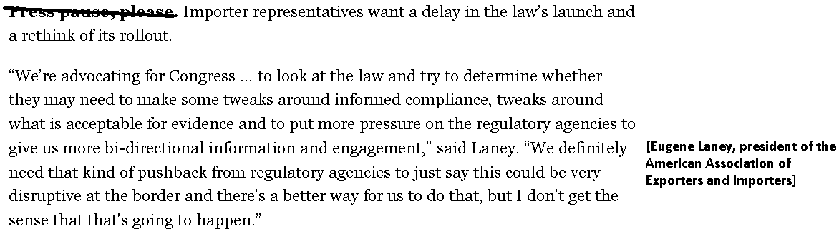
4. Other barriers besides funding and personnel
AFF supplies funding and personnel but other barriers will still block effective enforcement
Phelim Kine 2022. (more than two decades of experience reporting in and on China in roles ranging from Beijing-based foreign correspondent at Dow Jones Newswires in Beijing and Hong Kong-based human rights researcher at Human Rights Watch ) "U.S. importers brace for chaos as Uyghur Act looms" 16 June 2022 https://www.politico.com/newsletters/politico-china-watcher/2022/06/16/u-s-importers-brace-for-chaos-as-uyghur-act-looms-00040072 (accessed 3 Oct 2022)
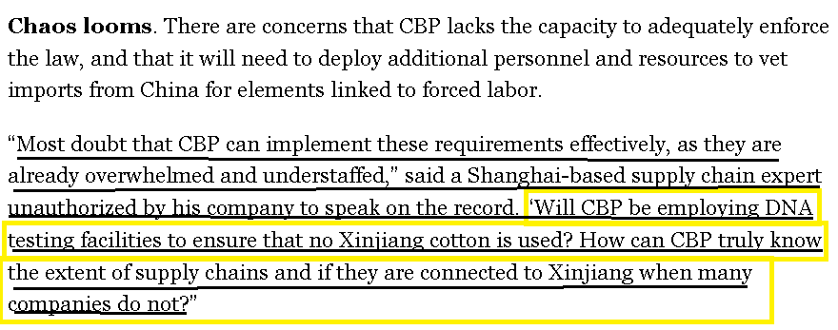
5. Nothing will change
You can sanction China all you want, and you may feel better, but nothing will change
Simon Lester 2020 (Former Associate Director, Herbert A. Stiefel Center for Trade Policy Studies, Cato Institute) " U.S. Policy Options Toward China: An Appraisal" Fall 2020 (accessed 3 Oct 2022) https://www.cato.org/cato-journal/fall-2020/us-policy-options-toward-china-appraisal#us-policy-should-focus-cooperating
Sanctions might assuage a few people’s anger and give the impression that something is being done. But do they actually change behavior? Their success rate in achieving their goals is not great (Taylor 2017). It can be difficult to use them effectively even on small countries, as 60 years of Cuba sanctions have shown (these sanctions may have even helped strengthen communist rule there). The likelihood that they will work on a major power such as China is even lower—especially if the United States is acting alone. A more effective approach would be to work with like‐​minded countries to achieve our shared goals. In essence, we should cooperate with our allies rather than penalize our opponents.
6. Root cause not addressed
Import restrictions are ineffective at stopping forced labor because they treat the symptom, not the root cause
Angela Santos and Christine Hintze 2022 (Santos - Partner, Hintze - Associate, both are with ARENT FOX SCHIFF, a law firm) 16 Mar 2022 (accessed 3 Oct 2022) Forced Labor Working Group Comment Regarding Enforcement of the Uyghur Forced Labor Prevention Act https://www.regulations.gov/comment/DHS-2022-0001-0180
U.S. businesses, the U.S. Government, and other stakeholders are aligned in the need to combat forced labor. Industry is committed to working in partnership with the U.S. Government and other stakeholders, including multilateral organizations and other governments, to combat this ongoing challenge. However, to date the U.S. Government approach to combating forced labor has largely been through restrictions on the importation of merchandise allegedly produced with forced labor, rather than rooting out forced labor at the source. This indirect approach and the current inconsistent enforcement scheme is not effective at achieving the ultimate goal of eliminating forced labor.
DISADVANTAGES
1. Cancer
Link: Increased enforcement of UFLPA (Uighur Forced Labor Prevention Act) will block importation of cancer drugs
Marti Flacks 2022. (Khosravi Chair in Principled Internationalism and Director, Human Rights Initiative at Center for Strategic & International Studies) 27 June 2022 (accessed 3 Oct 2022) "The Uyghur Forced Labor Prevention Act Goes into Effect" https://www.csis.org/analysis/uyghur-forced-labor-prevention-act-goes-effect (brackets added)
Less clear will be the impacts of the UFLPA on other supply chains, particularly consumer products such as vinyl flooring, and chemical components such as calcium carbide and beryllium. In the first quarter of 2021, the XUAR’s [Xinjiang Uyghur Autonomous Region] top exports to the United States were chemical ingredients used in cancer drugs and amino acids. While none of these sectors have been identified as high priority by CBP, public reporting on forced labor in these industries may force CBP’s hand to focus enforcement on shipments in these sectors.
Impact: Human suffering. We absolutely should not tell cancer patients they can't have treatment
Mustaqeem Siddiqui and S. Vinent Rajkumar 2012. (Siddiqui is with Division of Hospital Internal Medicine, Mayo Clinic. Rajkumar - Division of Hematology, Mayo Clinic) " The High Cost of Cancer Drugs and What We Can Do About It" Oct 2012 (accessed 3 Oct 2022) MAYO CLINIC PROCEEDINGS https://www.ncbi.nlm.nih.gov/pmc/articles/PMC3538397/
Except for early-stage cancers, testicular cancer, and certain blood cancers, such as large cell lymphoma and childhood leukemia, most cancers are incurable. There are many things patients are willing to do without; however, medication for a fatal disease is not and should not be one of them.
2. Supply chain disruption
Link: Increased enforcement of UFLPA will further disrupt already bad supply chain problems
Marti Flacks 2022. (Khosravi Chair in Principled Internationalism and Director, Human Rights Initiative at Center for Strategic & International Studies) 27 June 2022 (accessed 3 Oct 2022) "The Uyghur Forced Labor Prevention Act Goes into Effect" https://www.csis.org/analysis/uyghur-forced-labor-prevention-act-goes-effect (brackets added)
As described above, products from the XUAR are found in dozens of supply chains across the manufacturing, agriculture, apparel, energy, healthcare, and chemicals sectors. At a time of unprecedented supply chain disruption, companies have expressed concern that implementation of the UFLPA will cause further tightening of the market for goods in high demand in the United States.
Link: UFLPA is so vague and poorly written that the supply chain will be hopelessly disrupted waiting for them to figure out what's legal or not to be imported
Phelim Kine 2022. (more than two decades of experience reporting in and on China in roles ranging from Beijing-based foreign correspondent at Dow Jones Newswires in Beijing and Hong Kong-based human rights researcher at Human Rights Watch ) "U.S. importers brace for chaos as Uyghur Act looms" 16 June 2022 https://www.politico.com/newsletters/politico-china-watcher/2022/06/16/u-s-importers-brace-for-chaos-as-uyghur-act-looms-00040072 (accessed 3 Oct 2022)
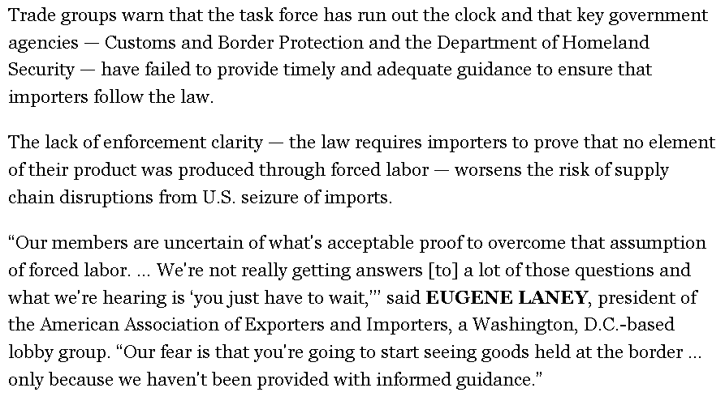
Impacts: Supply chain disruption causes multiple bad impacts on the economy and national security
Bradley Martin 2021 (director of the RAND National Security Supply Chain Institute, and a senior policy researcher at the nonprofit, nonpartisan RAND Corporation ) 15 Nov 2021 " Supply Chain Disruptions: The Risks and Consequences" https://www.rand.org/blog/2021/11/supply-chain-disruptions-the-risks-and-consequences.html
By now the impacts of supply chain disruption are becoming all too familiar: shortages, inflation, factory closures, goods waiting at ports to be unloaded. All these impacts are serious enough, but another more-hidden concern lurks just beneath the surface: the impact of supply chain failure on national security, broadly defined as a nation's ability to protect and ensure the well-being of its population. This definition of “national security” is broader than just the defense industry or military-related efforts; it also could encompass the very ability of a nation to ensure economic well-being, public health, and protection of a nation's key infrastructure. Supply chain disruptions cause general economic disruption and key commodity shortages, which then in turn can, in fact, drive aggressive national behavior and international instability.

