Generic Negative: Human Trafficking
By “Coach Vance” Trefethen
Note: THIS BRIEF DEALS WITH A SENSITIVE TOPIC THAT SOME MAY FIND DIFFICULT TO DISCUSS OR MAY WANT CENSORED. We bring it up only because we expect Affirmatives to raise it, which has happened in all other debate seasons when cases on this topic have been possible. This material is designed to help you defeat such cases. It is not intended to introduce this topic to people who don't want to talk about it. We do our very best to present the arguments in a careful and sensitive way.
We (Monument Publishing, Coach Vance) do not intend to write any AFF team policy cases on this topic. If you would prefer not to be prepared to debate Negative against this topic, just hit delete and don't read or use this brief.
Case Summary: This is a generic NEG brief that could apply to lots of different and unexpected cases involving either trade policy (NCFCA) and/or some other foreign policy (Europe - Stoa). We don't know in advance what types of plans will be run, but historically this topic has been frequently raised in Affirmative cases in past years in both leagues.
Human trafficking traditionally involved forcing people to travel to other locations against their will to be used for some type of activity against their will by others profiting from them. Traditionally, this meant either slave labor (e.g. farm workers) or prostitution. But the definition is evolving, which is part of the NEG's argument. Lots of things are being called "trafficking" just to inflate the numbers and justify bigger budgets for government agencies or charitable groups who get paid to solve a problem that isn't very large. The numbers get inflated several ways:
1) Consensual "sin" (prostitution, selling sex for money by consenting adults) gets conflated with violent crime. It has even happened that a prostitute has been charged with "trafficking" herself for her own voluntary lifestyle.
This brief makes a distinction between consensual activity (e.g. prostitution) and coerced activity (victims of trafficking). This doesn’t imply we’re endorsing improper consensual activity. We’re merely distinguishing it from the harms in the Affirmative case. Consensual activity is a sin, but not necessarily a crime (or not necessarily should be treated as one, given all the “real” violent crimes going on that should get law enforcement’s priority). Time, money and police resources spent chasing after people engaged in consensual sin is bad for society because all of those resources could have been used to fight “real” crime that actually harms others.
2) Statistics on "human trafficking" often conflate both consensual and non-consensual activity and make it sound like the "non-consensual" (slavery-type) thing is way bigger than it really is. Well, yes, when you add the two together, it's a big number. But if 98% of that is consensual, the real "trafficking" crime problem that the Affirmative claims to be resolving (where non-consensual victims are being harmed) is tiny. The rest is consensual sin that, though morally wrong, is not a big "problem" we have to solve.
3) Distinguish between "arrests" for human trafficking and "convictions" for it. Very often law enforcement or the media will announce someone was caught and arrested for "human trafficking." But that's just for the headlines. It will often turn out that they are simply charged with operating a prostitution business. In fact, the alleged "victims," the women employed by the illicit operation, are themselves often arrested and punished as well. That's an odd thing to do if they were truly victims.
4) “Trafficking” used to mean moving victims across international boundaries to other nations under coercion. It has morphed into, in some definitions and sources, anything involving coerced / controlled labor even if no movement is involved. At some point it gets conflated with “slavery” involving no travel or movement at all. This partly explains why the alleged numbers keep “growing”: What’s growing is the definition, not the actual problem itself.
5) There is a kind of trafficking rescue industry that has popped up in recent years. Celebrities, businessmen, philanthropists and government agencies have discovered this is a heart-wrenching issue (even if it’s totally insignificant in numbers). It’s “coolness” attracts donations and taxpayer funding, so these groups have a vested interest in magnifying the problem to justify their existence and their budgets. They actually find and rescue very few “victims.” Many of those they find and “rescue” turn out to be voluntary sinners, not coerced victims, and lacking economic alternatives (or the ability to break their drug addiction), they often voluntarily return to their sad lifestyle after being “rescued.”
6) Cut through the urban legends and myths. No, there is no big increase in trafficking at the host site of the Super Bowl each year - that's an urban legend. No, it is not likely that your child will be snatched out of the grocery store while you are reading the soup labels. No, every story, email, and rumor on the internet is not evidence of an epidemic of trafficking. The fact is, nobody really has any valid statistics on it. Most of the evidence will simply be someone quoting someone else's numbers (who was quoting someone else who was quoting someone else…), not any actual original research.
As a Negative, don't be afraid to frankly deny that it's a serious problem. Yes, it's a terrible thing if it's happening. But it's not a big deal if it almost never happens. Getting hit by lightning is a terrible thing if it happens to you - but it almost never happens. In a world of limited resources, dollars spent on problems that almost never happen are taken away from problems that really do happen, thus harming society in the end.
Generic Negative: Human Trafficking 4
OPENING QUOTES / NEG PHILOSOPHY 4
The Negative philosophy is summed up by Will Rogers’ famous line 4
SOURCE INDICTMENTS 4
US State Dept. “TIP” Office and US Agency for International Development (USAID) trafficking information is unreliable 4
USAID publishes phony numbers on trafficking (by their own admission) 4
NGO’s (Non-Governmental Organizations) have no real trafficking numbers, so they use made-up exaggerated numbers 5
MINOR REPAIR – Increase funding for shelters 5
We could save a lot more of them by funding emergency shelters and rehabilitation than anything else 5
HARMS / SIGNIFICANCE 6
1. “Human Trafficking” epidemic is exaggerated by mixing consensual sin with violent crime 6
A lot of so-called “trafficking” cases are really consensual. These get into the statistics, making it look like a huge problem 6
Must distinguish between prostitution and trafficking. Trafficking isn’t the same as voluntary prostitution 6
US standards of “international trafficking” keep growing to include consensual activity and maintain US dominance [not because the problem is growing] 6
Big investigations and sting operations find few, if any, trafficking victims, child or adult 6
A lot of those “thousands of cases” aren’t actually trafficking. They’re consensual sins, not violent crimes 7
Example: Samir Elias. US Justice Dept. declared he was “sex trafficking” – and then didn’t charge him with it 7
2. Manufactured crisis to get funding 7
It’s commendable to care about the suffering of others. But politicians and activists are exploiting your sympathy by manufacturing a crisis to get more federal money 7
NGO’s and politicians conflate the numbers and exaggerate the problem to get more funding 7
3. Manufactured victims 8
Many of the so-called “victims” aren’t. If law enforcement has to persuade you you’re a victim, then you’re not 8
4. A/T “Even if it’s exaggerated, we should still DO SOMETHING!” 8
Using exaggerated numbers makes a huge difference in public policy, and inflicts real-world damage 8
5. A/T “Hundreds of thousands of kids!” 8
No, there aren’t thousands of kids being trafficked. Those numbers are totally bogus 8
Numbers and estimates on trafficked kids are bogus. Originator of the numbers has retracted his claims 9
6. State statistics disprove significance. [States in the US handle the vast majority of cases, not the federal govt.] 9
States in 2019 handled 1,883 human trafficking cases 9
Federal government filed only 149 trafficking cases in 2019, and the federal numbers are steadily declining 9
Example: Delaware. Created a special Human Trafficking Court … then shut it down because they couldn't find any victims 10
Failure: All states report very few human trafficking cases solved. 11
7. Changing definition guarantees increasing statistics 12
A/T "Trafficking is a growing problem" - No, its definition keeps getting bigger, not the problem itself 12
SOLVENCY 12
1. Missing systemic issues & root causes 12
History proves prosecution of traffickers and “rescue” of victims won’t solve. We must address root causes in the global economy 12
In-depth explanation of the global economic factors leading to human trafficking that aren’t solved by AFF plan 13
No benefit to policies that exaggerate the problem or don’t address root causes 13
Trafficking will never be solved by law enforcement. It has to be addressed at the economic root causes 13
2. Vague definitions 14
Vague and undefined terms allow divergent interpretations of trafficking 14
3. Exaggeration blocks solution 14
Inflated estimates make effective response to human trafficking impossible. 14
DISADVANTAGES 14
1. Punishing victims (if that’s what they are) 14
Law enforcement punishes the “trafficking victims” for the crime of prostitution 14
Anti-trafficking efforts end up arresting and punishing the “victims,” making them worse off 15
International trafficking policies promote prosecution of victims for the things they do while under coercion 15
International trafficking policies promote prosecution of consensual activity over actually upholding human rights 15
2. Sanctions set back the overall goal 16
"Sanctions" policy on human trafficking undermines other diplomatic engagements and redirects resources away from structural reform 16
3. Distracts us from real solutions 16
Increasing “trafficking” law enforcement doesn’t get results, it just makes things worse by distracting us from real solutions 16
Hype backfires: Exaggeration and inflated estimates (to “call attention to the problem”) make things worse 17
Increased enforcement diverts attention and money away from programs that actually help victims 17
Law enforcement “solutions” to social problems make things worse by distracting from finding real solutions 17
4. Distracts from bigger social problems 18
Allocation of resources to an exaggerated trafficking “problem” takes resources away from bigger social problems 18
5. Hegemony Backlash 18
Link: Acting as the world’s policeman telling other nations what to do about trafficking creates resentment of US hegemony 18
Impact: Increased risk of conflict. Empires provoke resistance and nations that resent US dominance find violent ways to resist it 19
6. Failed Drug War II 19
Link: Escalating the war on human trafficking is just like the failed “War on Drugs” and produces the same bad results 19
Impacts: Waste, violence, corruption and death 19
Pure motives don’t matter: War on trafficking is just like the “War on Drugs” and will have the same bad consequences 20
Impact: US at war with its own citizens. And it explains some of the hype and exaggeration in our Harm responses: Law enforcement agencies use the “crisis” to inflate their budgets 20

Generic Negative: Human Trafficking

OPENING QUOTES / NEG PHILOSOPHY
The Negative philosophy is summed up by Will Rogers’ famous line
“It isn’t what we don’t know that gives us trouble. It’s what we know that ain’t so.”
The Affirmative team’s case and plan are based on bogus statistics and myths coming from internet memes repeated so often that everyone thinks they’re true. In reality, it’s a plan that doesn’t work to solve a problem that doesn’t exist.

SOURCE INDICTMENTS

US State Dept. “TIP” Office and US Agency for International Development (USAID) trafficking information is unreliable
GAO 2018. (Government Accountability Office) Dec 2018 “State and USAID Should Improve Their Monitoring of International Counter-trafficking Projects” https://www.gao.gov/assets/700/695792.pdf (brackets added)(accessed 9 July 2022)
Neither State TIP [Trafficking in Persons] Office nor USAID has sufficient controls to ensure consistent and complete performance information, and both face challenges to data reliability stemming from information reported in nonstandard formats, implementing partners with limited capacities to report performance information, and the time-consuming nature of reviewing reported information.

USAID publishes phony numbers on trafficking (by their own admission)
GAO 2018. (Government Accountability Office) Dec 2018 “State and USAID Should Improve Their Monitoring of International Counter-trafficking Projects” https://www.gao.gov/assets/700/695792.pdf (brackets added)(accessed 9 July 2022)
For one USAID project, the indicator “number of assisted communes allocating and accessing funds for trafficking in persons prevention activities” showed that annual results were 60, while quarterly report data combined showed that the number was 6, which USAID officials confirmed was the correct figure.

NGO’s (Non-Governmental Organizations) have no real trafficking numbers, so they use made-up exaggerated numbers
Dr. Chandre Gould 2006. (PhD in History from Rhodes University. Between 1992 and 1994 she worked for the Institute for a Democratic South Africa) CHEAP LIVES Countering human trafficking: considerations and constraints SOUTH AFRICA CRIME QUARTERLY JUNE 2006 https://www.researchgate.net/publication/301275903_CHEAP_LIVES_Countering_human_trafficking_-_considerations_and_constraints/link/57369b3a08ae9ace840af9d6/download (accessed 9 July 2022) (brackets in original)
Steinfatt et al critique the tendency of NGO researchers to reach estimations of prevalence on the basis of interviews with so-called experts:
This process of asking people who work for an NGO or governmental agency in a specific content area how big they think a problem is, may be likened to asking expert baseball players of long standing to estimate the number of persons currently playing baseball in their country. Being an expert at baseball does not imply knowledge or credibility concerning the number of baseball players. Without a scientific study to back up the estimate, players can offer no more than a wild guess even though they are quite familiar with the game of baseball, with many other baseball players and managers, and with the lore of baseball which may contain a ‘number of players’ guess that ‘everyone knows is true’. The average of a set of wild guesses is simply an average wild guess. It does not take much effort to ‘make public’ a wild guess, and then have a second party refer to this guess as a ‘statistic’, attempting to provide the guess with an aura of credibility.
The authors argue that the large numbers frequently quoted in anti-trafficking literature often serve the interests of the quoted organisations, those that benefit from funding for anti-trafficking work. They state that “[I]f persons with a financial stake in the outcome are allowed to create numbers that affect the size of these donations, then the recipe and motivation for cheating have been created.”

MINOR REPAIR – Increase funding for shelters
We could save a lot more of them by funding emergency shelters and rehabilitation than anything else
Elizabeth Nolan Brown 2015 (editor, Reason magazine) REASON Nov 2015 The War on Sex Trafficking Is the New War on Drugs https://reason.com/2015/09/30/the-war-on-sex-trafficking-is/ (accessed 11 Jan 2022)
For a fraction of the money spent on these measures, state governments or private foundations could fund more beds at emergency shelters. The resources that churches, charities, and radical feminists use trying to convince people that all sex workers are victims (and their clients predators) could go toward helping that minority of sex workers who do feel trapped in prostitution with job placement or getting an education. For the vast majority of vulnerable sex workers, the greatest barriers to exit aren't ankle-cuffs, isolation, and shadowy kidnappers with guns, but a lack of money, transportation, identification, or other practical things. Is helping with this stuff not sexy enough? As it stands, many of those "rescued" by police or abolitionist groups find that their self-appointed saviors can't actually offer them housing, food, a job, or anything else of urgent value in starting a life outside the sex trade. Awareness doesn't pay the bills.

HARMS / SIGNIFICANCE

1. “Human Trafficking” epidemic is exaggerated by mixing consensual sin with violent crime
A lot of so-called “trafficking” cases are really consensual. These get into the statistics, making it look like a huge problem
Elizabeth Nolan Brown 2016. (editor, Reason magazine) Sex-Trafficking Victim Arrested for Selling Sex 16 Feb 2016 https://reason.com/2016/02/16/kansas-sex-trafficking-victim-arrested/ (accessed 11 Jan 2022)
The idea behind America's strict laws against sex-trafficking is, theoretically, to punish activity that goes beyond consensual prostitution between adults; implicit in the crime of sex trafficking is supposed to be some element of force, fraud, or coercion employed by the perpetrator. But all too often, prosecutors have started using anti-human-trafficking statutes to go after people for whom this glove doesn't fit. And even when they don't actually bring sex-trafficking charges against adults engaged in prostitution, they both use them for leverage in getting pleas to lesser charges and talk to the press and public as if they have—thereby further sowing the seeds of sex-trafficking "epidemic" in everyone's minds.

Must distinguish between prostitution and trafficking. Trafficking isn’t the same as voluntary prostitution
We’re not endorsing prostitution (or “sex work”): it’s a sin between consenting adults and God. Trafficking is a crime with actual victims coerced against their will. Unfortunately, the AFF advocates and statistics conflate them as if they were the same thing, which exaggerates the size of the real problem.
Global Alliance Against Traffic in Women 2011. (anti-trafficking advocacy organization) “What’s the Cost of a Rumor?” https://www.nswp.org/sites/nswp.org/files/WhatstheCostofaRumour.11.15.2011%5B1%5D.pdf (accessed 9 July 2022)
Trafficking is not the same thing as sex work. There is a difference between women trafficked into prostitution and sex workers who migrate to other countries for work.

US standards of “international trafficking” keep growing to include consensual activity and maintain US dominance [not because the problem is growing]
Prof. Janie Chuang 2014 (law professor, American Univ. Washington College of Law) “EXPLOITATION CREEP AND THE UNMAKING OF HUMAN TRAFFICKING LAW” The American Journal of International Law Vol. 108, No. 4 October 2014 https://www.jstor.org/stable/10.5305/amerjintelaw.108.4.0609?seq=5 (accessed 7 July 2022)
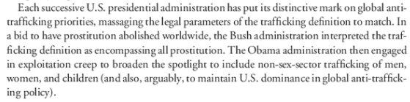

Big investigations and sting operations find few, if any, trafficking victims, child or adult
Elizabeth Nolan Brown 2015 (editor, Reason magazine) REASON Nov 2015 The War on Sex Trafficking Is the New War on Drugs https://reason.com/2015/09/30/the-war-on-sex-trafficking-is/ (accessed 11 Jan 2022)
The goal of Operation Cross Country, according to the FBI's website, is "to recover victims of child sex trafficking." In 2014, more than a dozen cities took part. Knoxville, Tennessee, to cite one participant, uncovered zero underage victims of sex trafficking, but it did arrest eight women for prostitution, four women for promoting prostitution, two women for human trafficking, and four men for solicitation. In Newark, New Jersey, one 14-year-old victim was identified and 45 people were arrested for prostitution or pimping. Richmond, Virginia, found no child victims but charged 26 people with prostitution and two with pimping. In Atlanta, dozens were arrested for prostitution, loitering, soliciting, and drug possession.

A lot of those “thousands of cases” aren’t actually trafficking. They’re consensual sins, not violent crimes
Elizabeth Nolan Brown 2015 (editor, Reason magazine) REASON Nov 2015 The War on Sex Trafficking Is the New War on Drugs https://reason.com/2015/09/30/the-war-on-sex-trafficking-is/ (accessed 11 Jan 2022)
Forcing others into sex or any sort of labor is abhorrent, and it deserves to be treated like the serious violation it is. But the activity now targeted under anti-trafficking efforts includes everything from offering or soliciting paid sex, to living with a sex worker, to running a classified advertising website.

Example: Samir Elias. US Justice Dept. declared he was “sex trafficking” – and then didn’t charge him with it
Elizabeth Nolan Brown 2016. (journalist) Sex-Trafficking Victim Arrested for Selling Sex 16 Feb 2016 https://reason.com/2016/02/16/kansas-sex-trafficking-victim-arrested/ (accessed 11 Jan 2022)
The owner of the massage parlor, Samir F. Elias, 60, was also arrested. Last Friday, he was charged in federal court with one count of transporting an illegal alien, one count of harboring an illegal alien, one count of harboring an alien for the purpose of prostitution, and two counts of money laundering. Though headlines on a Justice Department press release and local-news reports all announce that he was arrested for sex trafficking, no such charges were actually brought.

2. Manufactured crisis to get funding
It’s commendable to care about the suffering of others. But politicians and activists are exploiting your sympathy by manufacturing a crisis to get more federal money
Elizabeth Nolan Brown 2015 (editor, Reason magazine) REASON Nov 2015 The War on Sex Trafficking Is the New War on Drugs https://reason.com/2015/09/30/the-war-on-sex-trafficking-is/ (accessed 11 Jan 2022)
What's more, these new laws aren't organic responses by legislators in the face of an uptick in human trafficking activity or inadequate current statutes. They are in large part the result of a decades-long anti-prostitution crusade from Christian "abolitionists" and anti-sex feminists, pushed along by officials who know a good political opportunity when they see it and by media that never met a moral panic they didn't like. The fire is fueled by federal money, which sends police departments and activist groups into a grant-grubbing frenzy. The anti-trafficking movement is "just one big federal grant program," Michael Hudson, a scholar with the conservative Hudson Institute, told the Las Vegas Review-Journal. "Everybody is more worried about where they're going to get their next grant" than helping victims, Hudson said.

NGO’s and politicians conflate the numbers and exaggerate the problem to get more funding
Elena Jeffreys 2010 (president of Australian national sex worker association Scarlet Alliance) 13 Feb 2010 “The numbers of sex trafficking victims are exaggerated” https://www.policeprostitutionandpolitics.com/pdfs_all/Trafficking_All%20/Pro%20Decrim%20PDFS%20Trafficking/The%20numbers%20of%20sex%20trafficking%20victims%20are%20exaggerated%20-%20The%20Scavenger.pdf (ellipses in original)
The exaggeration of numbers of trafficked sex workers and sex slaves has been going on for over a decade.[END QUOTE] Much of this stems from a general misunderstanding about the differences between sex work per se, sex slavery and trafficking…a misunderstanding amplified by the fact that in many countries, ALL of these activities are crimes, and ALL are under the gaze of a migration-sensitive and politically astute police force, media and government trying to jockey for brownie points among a difficult public landscape of financial crisis and celebrity sensationalism. [SHE CONTINUES LATER IN THE CONTEXT QUOTE:] Career politicians, conservative feminists and desperate journalists have exploited the public’s penchant for stories about sex and the ethnic ‘other’ to replicated the lie that all migrant sex workers are trafficked sex slaves. To make matters worse, government and non-government organisations with a vested interest in bumping up trafficking numbers have been on a spree of deceit in order to justify their own funding.
3. Manufactured victims

Many of the so-called “victims” aren’t. If law enforcement has to persuade you you’re a victim, then you’re not
Dr. Chandre Gould 2006. (PhD in History from Rhodes University. Between 1992 and 1994 she worked for the Institute for a Democratic South Africa) CHEAP LIVES Countering human trafficking: considerations and constraints SOUTH AFRICA CRIME QUARTERLY JUNE 2006 https://www.researchgate.net/publication/301275903_CHEAP_LIVES_Countering_human_trafficking_-_considerations_and_constraints/link/57369b3a08ae9ace840af9d6/download (accessed 9 July 2022)
In one interview a law enforcement official raised the problem that victims of trafficking do not wish to be regarded as such – a point that Kauko later picks up again in relation to victim assistance, saying that the reluctance of ‘victims’ to identify themselves as such hampers investigations which invariably rely on victim statements. He quotes the police officer saying:
It is very hard to identify a victim who does not co-operate, or as often happens, denies his/her victim status, does not accept our view of him/her as a potential or real victim. Then he/she has no reason to co-operate, on the contrary, he/she will try to escape us who are trying to help him/her. It is also not clear that if the victim’s role is not beneficial to the presumed victim he/she will have no reason to come to us – all we can do is send him/her back and he/she knows this. The only way to improve this situation could be if we would adopt a solution where the victim status is accompanied by some significant benefits – such as a permit to stay in the country, witness protection schemes, etc.
What is not clear is why, when so-called victims do not wish to be defined as such, there is an insistence that they should be. This kind of thinking is pervasive in the anti-trafficking movement and appears to be a consequence of the view that no woman would choose to do sex work and that all sex workers are by definition exploited. In fact, Kauko and the law enforcement official he quotes go even further, suggesting that some inducement should be offered to supposed victims to define themselves as such, so that a prosecution can follow.

4. A/T “Even if it’s exaggerated, we should still DO SOMETHING!”

Using exaggerated numbers makes a huge difference in public policy, and inflicts real-world damage
Elizabeth Nolan Brown 2015 (editor, Reason magazine) REASON Nov 2015 The War on Sex Trafficking Is the New War on Drugs https://reason.com/2015/09/30/the-war-on-sex-trafficking-is/ (accessed 11 Jan 2022)
"Regardless of whether the number is 300,000 or 30,000, something must be done to protect these children at risk of exploitation and trafficking," said Moira Bagley Smith, a spokeswoman for Rep. Wagner, when Kessler challenged the figure. But it's exactly this kind of thinking that inflicts real-world policy damage. Whether there are 30,000 or 300,000 crime victims makes a great deal of difference in terms of fashioning an appropriate response, as does the context of the victims' circumstances. Separating the mythology of sex trafficking from the facts is crucial for addressing problems as they exist, not problems as we might want, fear, or imagine them to be.

5. A/T “Hundreds of thousands of kids!”
No, there aren’t thousands of kids being trafficked. Those numbers are totally bogus
John Stossel 2019 (journalist) REASON magazine 15 May 2019 “The Sex Trafficking Panic’ https://reason.com/2019/05/15/the-sex-trafficking-panic/ (accessed 11 Jan 2022)
Politicians tell us that thousands of children are forced into the sex trade. "Three-hundred thousand American children are at risk!" said Rep. Ann Wagner on the floor of Congress. That 300,000 number comes from just one study, and that study's lead author, Richard Estes, has disavowed it. "The National Crimes Against Children Center says, 'Do not cite this study'!" says Brown. It's "total bull."

Numbers and estimates on trafficked kids are bogus. Originator of the numbers has retracted his claims
Elizabeth Nolan Brown 2015 (editor, Reason magazine) REASON Nov 2015 The War on Sex Trafficking Is the New War on Drugs https://reason.com/2015/09/30/the-war-on-sex-trafficking-is/ (accessed 11 Jan 2022)
For instance, Rep. Joyce Beatty (D–Ohio) declared in a May statement that "in the U.S., some 300,000 children are at risk each year for commercial sexual exploitation." Rep. Ann Wagner (R–Mo.) made a similar statement that month at a congressional hearing, claiming the statistic came from the Department of Justice (DOJ). The New York Times has also attributed this number to the DOJ, while Fox News raised the number to 400,000 and sourced it to the Department of Health and Human Services (HHS). But not only are these not DOJ or HHS figures, they're based on 1990s data published in a non-peer-reviewed paper that the primary researcher, Richard Estes, no longer endorses. The authors of that study came up with their number by speculating that certain situations—i.e., living in public housing, being a runaway, having foreign parents—place minors at risk of potential exploitation by sex traffickers. They then simply counted up the number of kids in those situations. To make a bad measure worse, anyone who fell into more than one category was counted multiple times. "PLEASE DO NOT CITE THESE NUMBERS," wrote Michelle Stransky and David Finkelhor of the respected Crimes Against Children Research Center in 2008. "The reality is that we do not currently know how many juveniles are involved in prostitution. Scientifically credible estimates do not exist." A lengthy 2013 report on child sex trafficking from the Justice Department concluded that "no reliable national estimate exists of the incidence or prevalence of commercial sexual exploitation and sex trafficking of minors in the United States."

6. State statistics disprove significance. [States in the US handle the vast majority of cases, not the federal govt.]

States in 2019 handled 1,883 human trafficking cases
FBI Uniform Crime Report for Human Trafficking in 2019. https://ucr.fbi.gov/crime-in-the-u.s/2019/crime-in-the-u.s.-2019/additional-data-collections/human-trafficking/human-trafficking.pdf (accessed 11 Jan 20220
Human Trafficking, 2019, is the seventh report from the national Uniform Crime Reporting (UCR) Program’s Human Trafficking data collection. Forty-eight (48) states and the U.S. territory of Puerto Rico participated. The 2019 report shows a total of 1,883 incidents of human trafficking were reported: 1,607 were in the category of commercial sex acts, and 274 were instances of involuntary servitude. (Puerto Rico submitted two incidents in the Total column and did not specify whether those incidents were under the category of commercial sex acts or involuntary servitude.) Agencies arrested 708 offenders in correlation with these incidents. Of these, 684 were adults and 24 were juveniles.
Federal government filed only 149 trafficking cases in 2019, and the federal numbers are steadily declining
Human Trafficking Institute 2020. (report was written by Kyleigh Feehs and Alyssa Currier, associate legal counsel for the Human Trafficking Institute, an advocacy and training organization combatting human trafficking) “2019 Human Trafficking Report” https://www.traffickinginstitute.org/wp-content/uploads/2020/05/2019-Federal-Human-Trafficking-Report_Low-Res.pdf (accessed 12 Jan 2022)
One hundred and forty-five (23.9%) of the human trafficking cases active in 2019 were new cases, meaning prosecutors filed the first charges in 2019. This is a 14.7% decline from 2018, when prosecutors filed 170 new cases. The decrease follows an even bigger decline during the preceding year, from 218 new cases in 2017 to 170 in 2018. Altogether, prosecutors filed 33.5% fewer new cases over the past two years, which the available data indicate is the longest decline since the enactment of the TVPA in 2000. The decline in new cases is due to prosecutors filing fewer sex trafficking cases—not fewer forced labor cases.

Example: Delaware. Created a special Human Trafficking Court … then shut it down because they couldn't find any victims
Elizabeth Nolan Brown 2018 (editor, Reason magazine) “Human Trafficking Court in Delaware Shuts Down for Lack of Human-Trafficking Victims” 8 May 2018 https://reason.com/2018/05/08/human-trafficking-intervention-court-in/ (accessed 13 Jan 2022)
Human Trafficking Court in Delaware Shuts Down for Lack of Human-Trafficking Victims
The Delaware Criminal Justice Council found it difficult to "justify the resources that have been expend on so few" participants with such a "low rate of success."
After just a few years in operation, Delaware's Human Trafficking Court is shutting down.[END QUOTE] The court's rise and fall offers valuable lessons for similar systems across the country and shines a light on how trending problems lead to stupid policy—something those in the throes of the "opioid epidemic" panic would do well to remember. The court was killed by Judge Alex Smalls, chief of Delaware's Court of Common Pleas, citing a plan to consolidate several community court programs into one multipurpose court. The shift will save money and streamline responses to cases with a social-service component, said Smalls. But the trafficking court's closure goes beyond simple bureaucratic shuffling. [SHE GOES ON LATER IN THE CONTEXT QUOTE:] It comes following a 2016 report from the Delaware Criminal Justice Council, which found less than a third of people who started the alternative-to-jail program actually completed it and that there was "little evidence to suggest the defendants of this court are the subjects" of sex-trafficking enterprises.

Failure: All states report very few human trafficking cases solved.
We have a chart published by the FBI Uniform Crime Report for Human Trafficking in 2019. We can’t hold up the chart and show you, but we can read numbers from it and make it available to the Affirmative team and to you Judge, to verify we’re reading it correctly.
The state with by far the highest number of cases solved in 2019 was Texas with 213. Out of those, only 10 involved victims under 18 years old. Alabama reported zero cases, zero solved and zero victims for all of 2019. Florida reported 72 cases solved with zero involving victims under 18. The entire state of Ohio reported 8 cases, of which 1 was solved, with zero victims under age 18. If trafficking really involved tens of thousands of victims, these numbers should be in the thousands. There’s simply no epidemic of child or adult human trafficking.
FBI Uniform Crime Report for Human Trafficking in 2019. https://ucr.fbi.gov/crime-in-the-u.s/2019/crime-in-the-u.s.-2019/additional-data-collections/human-trafficking/human-trafficking.pdf (accessed 11 Jan 20220
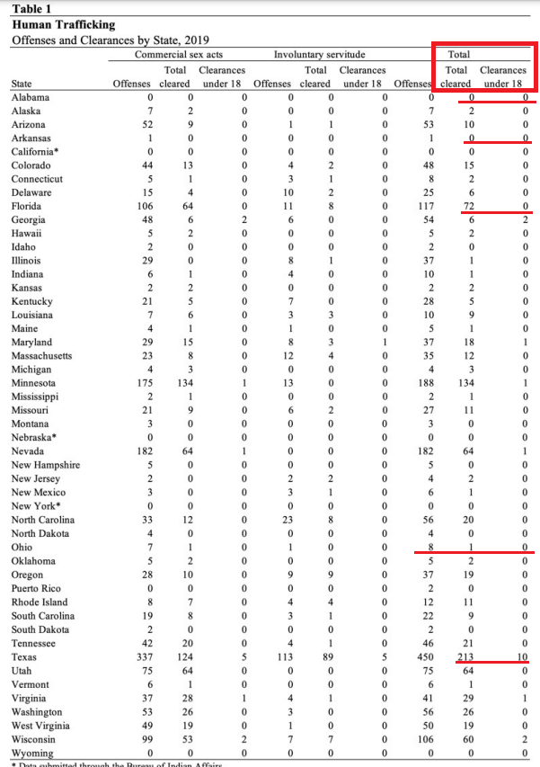

7. Changing definition guarantees increasing statistics

A/T "Trafficking is a growing problem" - No, its definition keeps getting bigger, not the problem itself
Prof. Janie Chuang 2014 (law professor, American Univ. Washington College of Law) “EXPLOITATION CREEP AND THE UNMAKING OF HUMAN TRAFFICKING LAW” The American Journal of International Law Vol. 108, No. 4 October 2014 https://www.jstor.org/stable/10.5305/amerjintelaw.108.4.0609?seq=5 (accessed 7 July 2022)
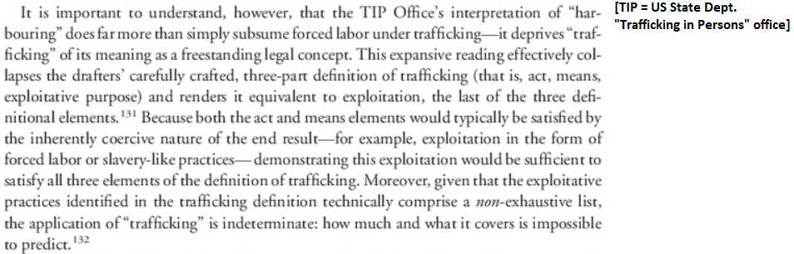

SOLVENCY

1. Missing systemic issues & root causes

History proves prosecution of traffickers and “rescue” of victims won’t solve. We must address root causes in the global economy
Prof. Janie Chuang 2014 (law professor, American Univ. Washington College of Law) “EXPLOITATION CREEP AND THE UNMAKING OF HUMAN TRAFFICKING LAW” The American Journal of International Law Vol. 108, No. 4 October 2014 https://www.jstor.org/stable/10.5305/amerjintelaw.108.4.0609?seq=5 (accessed 7 July 2022)
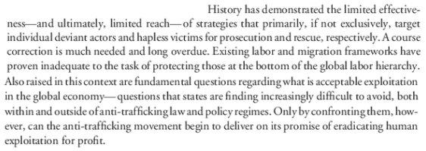

In-depth explanation of the global economic factors leading to human trafficking that aren’t solved by AFF plan
Prof. Janie Chuang 2014 (law professor, American Univ. Washington College of Law) “EXPLOITATION CREEP AND THE UNMAKING OF HUMAN TRAFFICKING LAW” The American Journal of International Law Vol. 108, No. 4 October 2014 https://www.jstor.org/stable/10.5305/amerjintelaw.108.4.0609?seq=5 (accessed 7 July 2022)
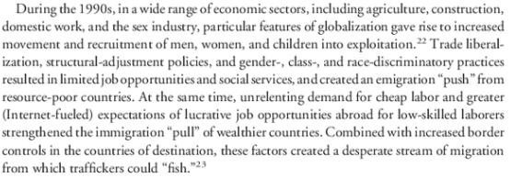

No benefit to policies that exaggerate the problem or don’t address root causes
Dr. Chandre Gould 2007. (PhD in History from Rhodes University. Between 1992 and 1994 she worked for the Institute for a Democratic South Africa) SOUTH AFRICA CRIME QUARTERLY Dec 2007 “COUNTERING THE ‘SCOURGE’ The time for evidence and reason on human trafficking” https://www.researchgate.net/publication/301276020_COUNTERING_THE_'SCOURGE'_The_time_for_evidence_and_reason_on_human_trafficking/link/57369b2208ae298602e0a9cd/download (accessed 9 July 2022)
Where there is exploitation it too should be detected and stopped. But when it comes to making policy to deal with the social ills of exploitation and abuse we have to be very specific. It doesn’t help to make policies to end trafficking that ignore the very reasons why people are vulnerable to abuse in the first place. It also does not help to have an exaggerated sense of the scale of the problem.

Trafficking will never be solved by law enforcement. It has to be addressed at the economic root causes
Dr. Chandre Gould 2007. (PhD in History from Rhodes University. Between 1992 and 1994 she worked for the Institute for a Democratic South Africa) SOUTH AFRICA CRIME QUARTERLY Dec 2007 “COUNTERING THE ‘SCOURGE’ The time for evidence and reason on human trafficking” https://www.researchgate.net/publication/301276020_COUNTERING_THE_'SCOURGE'_The_time_for_evidence_and_reason_on_human_trafficking/link/57369b2208ae298602e0a9cd/download (accessed 9 July 2022)
To date consideration of and response to the problem of ‘human trafficking’ has been framed as a matter for law enforcement. All the more so since the most recent iteration of international concern about human trafficking comes in the context of the ‘war on organised crime’ and even the ‘war on terror’. As human rights activists, certain feminists and those concerned with social justice will attest, trafficking is little more than advantage being taken by those in a position of power of those who wish to migrate, and find the obstacles to migration to be so great as to be unable to overcome them alone. Indeed, for as long as it is impossible for women who do not have access to resources to move to seek a better future, we shall continue to see cases of trafficking, exploitation and abuse, as such women place their futures in the hands of those who can work the system.

2. Vague definitions

Vague and undefined terms allow divergent interpretations of trafficking
Prof. Janie Chuang 2014 (law professor, American Univ. Washington College of Law) “EXPLOITATION CREEP AND THE UNMAKING OF HUMAN TRAFFICKING LAW” The American Journal of International Law Vol. 108, No. 4 October 2014 https://www.jstor.org/stable/10.5305/amerjintelaw.108.4.0609?seq=5 (accessed 7 July 2022)
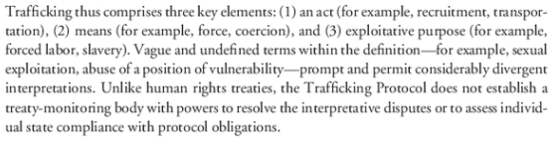

3. Exaggeration blocks solution

Inflated estimates make effective response to human trafficking impossible.
Dr. Chandre Gould 2006. (PhD in History from Rhodes University. Between 1992 and 1994 she worked for the Institute for a Democratic South Africa) CHEAP LIVES Countering human trafficking: considerations and constraints SOUTH AFRICA CRIME QUARTERLY JUNE 2006 https://www.researchgate.net/publication/301275903_CHEAP_LIVES_Countering_human_trafficking_-_considerations_and_constraints/link/57369b3a08ae9ace840af9d6/download (accessed 9 July 2022)
The article argues that the numbers of trafficking victims quoted by NGOs and governments tend to be based on estimates that are frequently inflated. Such overestimations, while successful in capturing public attention and generating moral outrage, do not provide a sound basis for policy making and resource allocation. Furthermore, it is vital for law enforcement agencies to have a clear understanding of what practices constitute trafficking, in order to successfully identify, investigate and prosecute such cases. Without a clear definition and understanding of what needs to be prevented and controlled, an effective response is impossible.

DISADVANTAGES

1. Punishing victims (if that’s what they are)

Law enforcement punishes the “trafficking victims” for the crime of prostitution
Elizabeth Nolan Brown 2016. (journalist) Sex-Trafficking Victim Arrested for Selling Sex 16 Feb 2016 https://reason.com/2016/02/16/kansas-sex-trafficking-victim-arrested/ (accessed 11 Jan 2022)
Another week, another example of how topsy-turvy our understanding of "sex trafficking" has become in America. This latest case comes out of Kansas, where a Chinese woman offering sexual services from a Wichita massage parlor has both been described by law enforcement as a victim of sex trafficking and been convicted of prostitution. The owner of the massage parlor, Samir F. Elias, 60, was also arrested. Last Friday, he was charged in federal court with one count of transporting an illegal alien, one count of harboring an illegal alien, one count of harboring an alien for the purpose of prostitution, and two counts of money laundering. Though headlines on a Justice Department press release and local-news reports all announce that he was arrested for sex trafficking, no such charges were actually brought.

Anti-trafficking efforts end up arresting and punishing the “victims,” making them worse off
Elizabeth Nolan Brown 2015 (editor, Reason magazine) REASON Nov 2015 The War on Sex Trafficking Is the New War on Drugs https://reason.com/2015/09/30/the-war-on-sex-trafficking-is/ (accessed 11 Jan 2022)
What's more, many of the policies in place to fight trafficking actively work against their own stated mission. The criminalization of prostitution keeps sex workers from reporting abuse and keeps clients from coming forward if they suspect someone is being trafficked. Victims themselves are afraid to go to police for fear they'll be arrested for prostitution—and indeed, they often are. In 2012, 579 minors were reported to the federal government as having been arrested for prostitution and commercialized vice. Prosecutors say they need this as a "bargaining chip" to make the victims testify against their perpetrators. We're just using state violence and the threat of incarceration against children in order to save them!

International trafficking policies promote prosecution of victims for the things they do while under coercion
Prof. Janie Chuang 2014 (law professor, American Univ. Washington College of Law) “EXPLOITATION CREEP AND THE UNMAKING OF HUMAN TRAFFICKING LAW” The American Journal of International Law Vol. 108, No. 4 October 2014 https://www.jstor.org/stable/10.5305/amerjintelaw.108.4.0609?seq=5 (accessed 7 July 2022)
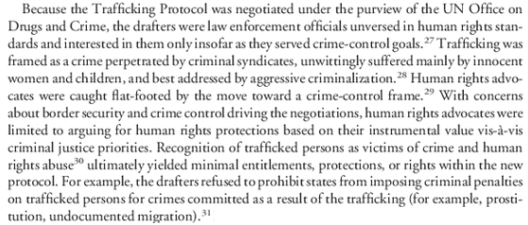

International trafficking policies promote prosecution of consensual activity over actually upholding human rights
Prof. Janie Chuang 2014 (law professor, American Univ. Washington College of Law) “EXPLOITATION CREEP AND THE UNMAKING OF HUMAN TRAFFICKING LAW” The American Journal of International Law Vol. 108, No. 4 October 2014 https://www.jstor.org/stable/10.5305/amerjintelaw.108.4.0609?seq=5 (accessed 7 July 2022)
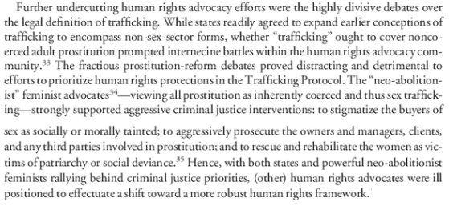

2. Sanctions set back the overall goal

"Sanctions" policy on human trafficking undermines other diplomatic engagements and redirects resources away from structural reform
Prof. Janie Chuang 2014 (law professor, American Univ. Washington College of Law) “EXPLOITATION CREEP AND THE UNMAKING OF HUMAN TRAFFICKING LAW” The American Journal of International Law Vol. 108, No. 4 October 2014 https://www.jstor.org/stable/10.5305/amerjintelaw.108.4.0609?seq=5 (accessed 8 July 2022) (brackets added)
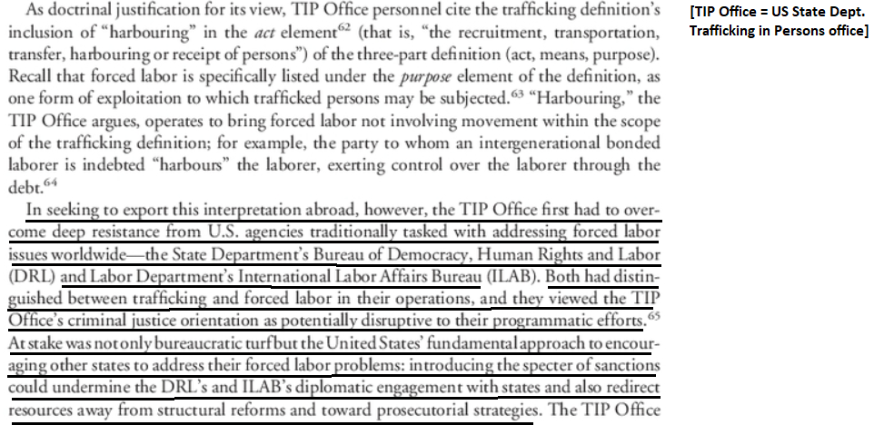

3. Distracts us from real solutions

Increasing “trafficking” law enforcement doesn’t get results, it just makes things worse by distracting us from real solutions
Elizabeth Nolan Brown 2015 (editor, Reason magazine) REASON Nov 2015 The War on Sex Trafficking Is the New War on Drugs https://reason.com/2015/09/30/the-war-on-sex-trafficking-is/ (accessed 11 Jan 2022)
Sixty-eight percent of minors engaged in street-based prostitution in New York City say they've sought help from youth services organizations, according to Kate D'Adamo of the Sex Workers Project. "New York City funds roughly 200 beds for a population of 4,000 unaccompanied, homeless youth," D'Adamo told TechCrunch. "When all the beds are full, it is street economies like the sex trade which they turn to in order to provide basic needs. If we want to identify the most vulnerable, all we have to do is provide support when someone stands up and says 'I need a place to sleep tonight.'" Instead, we fund police task forces to monitor Internet ads for weeks in search of suspect code words or tattoos. We pass laws mandating more prison time for pimps. We set up elaborate sting operations for both sex workers and their customers. We hang "Are you being trafficked?" signs at strip clubs and highway rest stops, and train airport staff on how they can spot the signs of sex trafficking. We act as if sex traffickers are organized, jet-setting, diabolical, and legion. We are chasing our own mythology, to the detriment of actual results.

Hype backfires: Exaggeration and inflated estimates (to “call attention to the problem”) make things worse
Kate Wilkinson & Sintha Chiumia 2018. (Wilkinson – researcher, acting Chief Deputy Editor with Africa Check. Chiumia – Dept of Journalism, Univ. of Witwatersrand, South Africa) 18 Oct 2018 “Are 30,000 children really ‘trafficked’ in South Africa every year? The claim exaggerates the problem” https://africacheck.org/fact-checks/reports/fact-checked-2-claims-about-slavery-child-prostitutes-sa
The estimated number of human trafficking victims reported recently are exaggerated, and sensational. As researcher Chandre Gould points out: “Such overestimations, while successful in capturing public attention and generating moral outrage, do not provide a sound basis for policy-making and resource allocation”. Similarly, claims regarding the trafficking of children for prostitution and the increase of human trafficking during sporting events are not supported by research. While research focussing solely on convictions undoubtedly underestimates the frequency of human trafficking, it is based on rigorous quantitative analysis – not anecdotal evidence. South Africa’s new anti-trafficking legislation requires annual reports to Parliament on the implementation of the Act and the number of cases of human trafficking. Hopefully this will result in more reliable statistics. There is need for real, reliable data to enable the implementation of government policies and the proper allocation of resources to combat genuine cases of human trafficking. NGO’s that cry wolf to secure donor funding and newspapers that publish sensational reports without interrogating the figures hurt efforts to combat a real problem.

Increased enforcement diverts attention and money away from programs that actually help victims
Elizabeth Nolan Brown 2015 (editor, Reason magazine) REASON Nov 2015 The War on Sex Trafficking Is the New War on Drugs https://reason.com/2015/09/30/the-war-on-sex-trafficking-is/ (accessed 11 Jan 2022)
Undoubtedly, many lawmakers do legitimately want to help trafficking victims and hold bad guys accountable; political point-scoring is just a happy side effect. But a less happy side effect is a slew of bad laws, violated rights, and squandered money. The federal government has given away scores of millions in grant dollars for this quixotic crusade. The resources spent on prostitution stings and public awareness campaigns are resources diverted from mundane but more effective strategies for helping at-risk youth, such as adding more beds at emergency shelters. The State Department's latest Trafficking in Persons report notes that "shelter and housing for all trafficking victims, especially male and labor trafficking victims, continue to be insufficient." Advocates routinely say the biggest barrier to escape for many trafficking victims is simply a lack of places to go.

Law enforcement “solutions” to social problems make things worse by distracting from finding real solutions
Dr. Chandre Gould 2007. (PhD in History from Rhodes University. Between 1992 and 1994 she worked for the Institute for a Democratic South Africa) SOUTH AFRICA CRIME QUARTERLY Dec 2007 “COUNTERING THE ‘SCOURGE’ The time for evidence and reason on human trafficking” https://www.researchgate.net/publication/301276020_COUNTERING_THE_'SCOURGE'_The_time_for_evidence_and_reason_on_human_trafficking/link/57369b2208ae298602e0a9cd/download (accessed 9 July 2022)
Until we shift our thinking and begin to deal with the more difficult, messy social causes of crime we are unlikely to see the statistics dropping. Just as, unless we take a humanitarian approach to migration, stop quibbling about numbers and the difficult politics of our neighbours, we are unlikely to see an end to the human rights abuses associated with illegal immigration. The tendency of policy makers to respond to social problems as if they are law enforcement problems only leads us further and further from finding long term solutions to social dysfunction, and contributes towards undermining human rights and the ability of the police to do their job effectively.

4. Distracts from bigger social problems

Allocation of resources to an exaggerated trafficking “problem” takes resources away from bigger social problems
Dr. Chandre Gould 2006. (PhD in History from Rhodes University. Between 1992 and 1994 she worked for the Institute for a Democratic South Africa) CHEAP LIVES Countering human trafficking: considerations and constraints SOUTH AFRICA CRIME QUARTERLY JUNE 2006 https://www.researchgate.net/publication/301275903_CHEAP_LIVES_Countering_human_trafficking_-_considerations_and_constraints/link/57369b3a08ae9ace840af9d6/download (accessed 9 July 2022) (brackets in original)
Kauko Aromaa correctly identifies that uniform definitions and accurate measurements of trafficking are essential since “any reallocation of control or support resources is done in the face of competition where the ‘larger’ social problem receives more than the ‘smaller’ one.” He notes the enormous difficulties associated with quantifying something that is so difficult to define: “[T]he situation where a crime is characterised by an absence of the unity of time, place, perpetrator and activity makes the counting exercise particularly demanding [as in the case of trafficking].” Not only do these factors hinder quantification of the problem of trafficking, they also hinder law enforcement.

5. Hegemony Backlash

Link: Acting as the world’s policeman telling other nations what to do about trafficking creates resentment of US hegemony
Prof. Janie Chuang 2014 (law professor, American Univ. Washington College of Law) “EXPLOITATION CREEP AND THE UNMAKING OF HUMAN TRAFFICKING LAW” The American Journal of International Law Vol. 108, No. 4 October 2014 https://www.jstor.org/stable/10.5305/amerjintelaw.108.4.0609?seq=5 (accessed 7 July 2022)
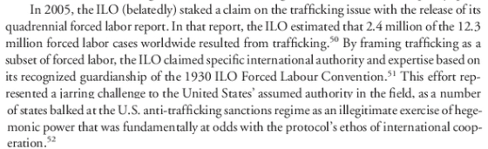

Impact: Increased risk of conflict. Empires provoke resistance and nations that resent US dominance find violent ways to resist it
Prof. Christopher Layne 2009. (Research Fellow with the Center on Peace and Liberty at The Independent Institute and Mary Julia and George R. Jordan Professorship of International Affairs at the George Bush School of Government and Public Service at Texas A&M University) REVIEW OF INTERNATIONAL STUDIES, "America’s Middle East grand strategy after Iraq: the moment for offshore balancing has arrived" Jan 2009 https://hi.art1lib.com/book/38711743/97e7ea (accessed 8 July 2022)
In addition to soft balancing, asymmetric strategies are another type of nontraditional balancing that is being employed to contest US primacy. When employed by states, asymmetric strategies mean the acquisition of weapons of mass destruction (WMD) capabilities. Regional powers – especially those on the US hit list like Iran and Saddam Hussein’s Iraq – cannot slug it out toe-to-toe against the US’ dominant high-tech conventional forces. Because they are threatened by the US, however, these states seek other methods of offsetting American power, and dissuading Washington from using its military muscle against them. WMD – especially the possession of nuclear weapons – is one way these states can level the strategic playing field and deter the US from attacking them. Terrorism is another asymmetric strategy – one employed by non-state actors like Al-Qaeda and similar jihadist groups – to resist US dominance. The use of asymmetric strategies to oppose American power – especially in the Middle East where US policy has an imperial dimension – illustrates the dictum that empires inevitably provoke resistance.

6. Failed Drug War II

Link: Escalating the war on human trafficking is just like the failed “War on Drugs” and produces the same bad results
Elizabeth Nolan Brown 2015 (editor, Reason magazine) REASON Nov 2015 The War on Sex Trafficking Is the New War on Drugs https://reason.com/2015/09/30/the-war-on-sex-trafficking-is/ (accessed 11 Jan 2022)
The tactics employed to "get tough" on drugs ended up entangling millions in the criminal justice system, sanctioning increasingly intrusive and violent policing practices, worsening tensions between law enforcement and marginalized communities, and degrading the constitutional rights of all Americans. Yet even as the drug war's failures and costs become more apparent, the Land of the Free is enthusiastically repeating the same mistakes when it comes to sex trafficking. This new "epidemic" inspires the same panicked rhetoric and punitive policies the war on drugs did—often for activity that's every bit as victimless.

Impacts: Waste, violence, corruption and death
Prof. Christopher J. Coyne and Prof. Abigail R. Hall 2017. (Coyne – prof. of economics, George Mason Univ. Hall – prof. of economics, Bellarmine Univ.) 12 Apr 2017 “Four Decades and Counting: The Continued Failure of the War on Drugs” https://www.cato.org/policy-analysis/four-decades-counting-continued-failure-war-drugs (accessed 11 Jan 2022)
Since the War on Drugs began more than 40 years ago, the U.S. government has spent more than $1 trillion on interdiction policies. Spending on the war continues to cost U.S. taxpayers more than $51 billion annually. While the domestic impact of the War on Drugs is profound, its consequences do not stop at the border. American‐​backed anti‐​drug operations in Mexico, for example, have resulted in some of the bloodiest years in Mexican history.https://www.cato.org/policy-analysis/four-decades-counting-continued-failure-war-drugs - _idTextAnchor009 In fact, since former Mexican president Felipe Calderón began using the military to fight cartels, more than 85,000 people have been killed. Efforts by the U.S. government to eradicate opium cultivation in Afghanistan have not only failed to reduce global supply but have also empowered and funded the Taliban. The U.S. War on Drugs, like the ill‐​fated war on alcohol of the early 20th century, is a prime example of disastrous policy, naked self‐​interest, and repeated ignorance on the part of elected officials and other policymakers. From its inception, the drug war has repeatedly led to waste, fraud, corruption, violence, and death.
Pure motives don’t matter: War on trafficking is just like the “War on Drugs” and will have the same bad consequences
Elizabeth Nolan Brown 2015 (editor, Reason magazine) REASON Nov 2015 The War on Sex Trafficking Is the New War on Drugs https://reason.com/2015/09/30/the-war-on-sex-trafficking-is/ (accessed 11 Jan 2022)
Yet when it comes to the way we talk about commercial sex, you have to be a victim or a predator. We've created a narrative with no room for nuance. We traffic not in facts but in melodrama. In TV broadcasts, campus panels, and congressional hearings, the most lurid and sensational stories are held up as representative. Legislators assure us that their intent is noble and pure. But remember: Tough-on-drugs legislation was never crafted or advertised as a means to send poor people to prison for life over a few grams of weed. It was a way to crack down on drug kingpins, violent gang leaders, evil crack fiends, and all those who would lure innocent children into addiction, doom, and death. Yet in mandating more police attention for drug crimes, giving law enforcement new technological tools and military gear with which to fight it, and adding ever-stricter prison sentences and punishments for drug offenders, we unleashed a corrupt, authoritarian, biased, and fiscally untenable mess on American cities without any success in decreasing drug rates or the violence and danger surrounding an activity that human beings stubbornly refuse to give up. Unless we can learn the lessons of our past failed crusades, the war on sex trafficking could result in every bit as much misery as its panicky predecessors.

Impact: US at war with its own citizens. And it explains some of the hype and exaggeration in our Harm responses: Law enforcement agencies use the “crisis” to inflate their budgets
Prof. Christopher J. Coyne and Prof. Abigail R. Hall 2017. (Coyne – prof. of economics, George Mason Univ. Hall – prof. of economics, Bellarmine Univ.) 12 Apr 2017 “Four Decades and Counting: The Continued Failure of the War on Drugs” https://www.cato.org/policy-analysis/four-decades-counting-continued-failure-war-drugs (accessed 11 Jan 2022)
The “enemies” in the War on Drugs however, consist not only of external threats (such as the Latin American drug cartels), but also American citizens on domestic soil. This addition of a domestic “enemy” links a variety of government agencies, including state and local law enforcement, to the broader missions of the U.S. federal government. Domestic law enforcement, recognizing that linking their missions with the drug war could increase their discretionary budgets and number of personnel, would benefit from joining the operations. Federal authorities would have additional personnel to fulfill their goals. The War on Drugs has created a domestic battle zone where U.S. citizens are viewed as potential enemies to be defeated by an array of government agencies working in conjunction to enforce prohibition.

