Generic Brief: Free Trade – Bad, not needed
By “Coach Vance” Trefethen
NEGATIVE PHILOSOPHY / OPENING QUOTES 3
Free trade can break down. And when it does, it stops being a good idea 3
INHERENCY 3
1. Status Quo already doing free trade 3
US trade is already mostly “free” anyway – very little remaining trade barriers 3
Global trade is more free than ever. US tariffs are now less than 3% 3
SOLVENCY 4
1. Other policies and growth factors needed besides trade liberalization 4
Trade liberalization alone doesn’t produce economic growth: Other economic policies are needed 4
Tariffs and non-tariff trade restrictions aren’t significant factors for economic growth – other factors are more important 4
Trade liberalization advocates are making a lot of assumptions about the economy that aren’t actually true in the real world 5
2. No proven link between trade liberalization and economic growth 5
No evidence that countries that trade freely grow faster 5
Trade liberalization follows growth, it isn’t the cause. Examples: China and India grew first, then opened their markets later 5
Correlation doesn’t prove cause: Increased growth after trade liberalization doesn’t prove trade policy caused the growth 6
No specific correlation between trade openness and economic success 6
Estimated benefits of trade liberalization are surprisingly small 6
3. Not solving for VAT (Value Added Tax) 7
Link: USA has no VAT, but other countries do, and it affects export/import trade 7
Link: China, Japan, Taiwan and Korea all have VAT 7
Impact: VAT cancels out any benefits of trade deals – the effects are massive and harmful 7
4. Trade agreements don’t change very much 8
Very little trade actually changes: Either the tariff was zero already, or the tariffs continue under an exemption to the agreement 8
5. Capital mobility 8
If investment capital could not move, then free trade would benefit our economy. But since it can move, the benefits can go elsewhere. The world economy benefits, but not us. 8
6. Won’t reduce terrorism 8
Poverty isn’t the cause of terrorism. Millions of poor people around the world do not blow things up 8
7. Empirically denied - Historical examples of failure 9
Africa: Free trade hasn’t benefited African countries’ economies 9
China: Freer trade with China killed 2.4 million American jobs 9
Canada & Mexico: North American Free Trade Agreement was a disaster for the US economy 9
Korea: Free trade agreement didn't help the US at all 10
8. More study needed 10
Normal FTA process is to conduct a feasibility study first, to avoid entering a bad FTA 10
DISADVANTAGES 10
1. Unsustainability 10
Free trade leads to short-term behaviors that are not sustainable, and reduce long-term living standards 10
2. Increased inequality 10
Link: Free trade increases inequality by raising the value of capital over labor 10
Impact: Inequality fuels credit bubbles that crash the economy 11
3. Enables mercantilism 11
Link: What is mercantilism? Government intervention to help its domestic industries and damage foreign competitors 11
Link: Free trade enables other countries to practice mercantilist policies against us 11
Impact: US economic and political decline and rise of Chinese totalitarianism 12
Impact: Mercantilism will kill US jobs and economic growth 12
4. Negative economic side effects of trade agreements 12
Lower wages: Trade agreements put downward pressure on workers' wages in order to boost corporate profits 12
Lost jobs: If you believe AFF's claim that exports create jobs, then in total, a balanced trade agreement destroys jobs 13
Voting Impact: We shouldn't adopt any new trade agreements without a plan in place to offset the adverse effects on those negatively affected 13

NEGATIVE PHILOSOPHY / OPENING QUOTES
Free trade can break down. And when it does, it stops being a good idea
Ian Fletcher 2010 (adjunct fellow at the U.S. Business and Industry Council; formerly an economist in private practice serving mainly hedge funds and private equity firms) 10 myths about free trade http://dailycaller.com/2010/04/14/10-myths-about-free-trade/ (accessed 26 June 2022)
The point is not to baffle the reader, but to pry open the mysterious “black box” of free trade economics a little, and let non-economists in on the big secret that economists regard as dangerous to talk about too loudly: free trade economics is a package of mechanisms that, like any piece of machinery, can and do break down all the time. And when they break down, free trade ceases to be a good idea
INHERENCY
1. Status Quo already doing free trade
US trade is already mostly “free” anyway – very little remaining trade barriers
Dr. Paul Krugman 2014 (PhD economics; Professor of Economics at the Graduate Center of the City University of New York; won the 2008 Nobel prize in economics for his work in the study of international trade) 27 Feb 2014 “No Big Deal” NEW YORK TIMES http://www.nytimes.com/2014/02/28/opinion/krugman-no-big-deal.html?_r=0 (accessed 26 June 2022)
The first thing you need to know about trade deals in general is that they aren’t what they used to be. The glory days of trade negotiations — the days of deals like the Kennedy Round of the 1960s, which sharply reduced tariffs around the world — are long behind us. Why? Basically, old-fashioned trade deals are a victim of their own success: there just isn’t much more protectionism to eliminate. Average U.S. tariff rates have fallen by two-thirds since 1960. The most recent report on American import restraints by the International Trade Commission puts their total cost at less than 0.01 percent of G.D.P.
Global trade is more free than ever. US tariffs are now less than 3%
Dr. Jagdish Bhagwati, Dr. Pravin Krishna and Dr. Arvind Panagariya 2014 (Bhagwati – PhD; prof. of economics at Columbia Univ. Krishna – PhD; Professor of International Economics and Business, Johns Hopkins Univ. Panagariya – PhD; prof. of economics at Columbia Univ.) 3 May 2014 “The World Trade System: Trends and Challenges” https://www.sais-jhu.edu/sites/default/files/JB-PK-AP-SIPA-SAIS%20Draft.pdf (accessed 26 June 2022)
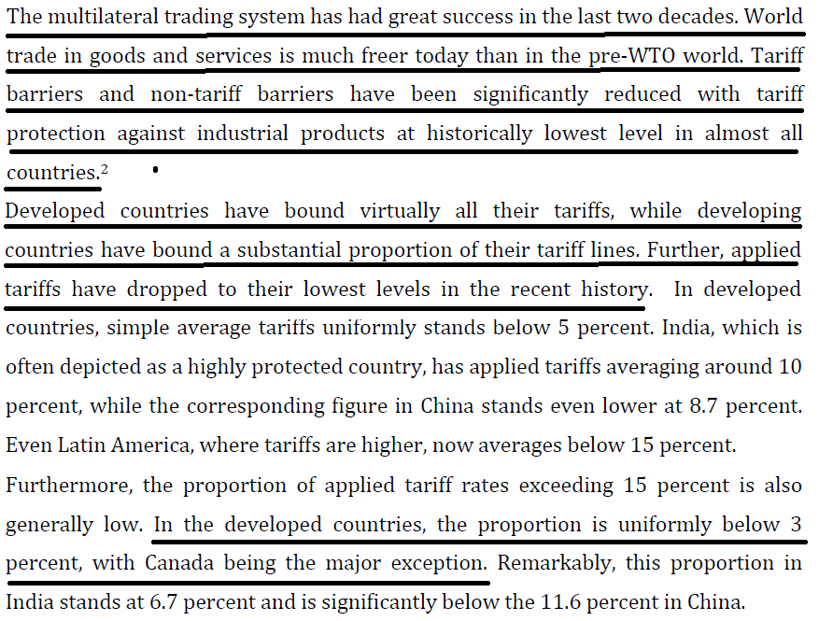
SOLVENCY
1. Other policies and growth factors needed besides trade liberalization
Trade liberalization alone doesn’t produce economic growth: Other economic policies are needed
Prof. Robert E. Baldwin 2004 (professor emeritus of economics at Univ. of Wisconsin and research associate of the National Bureau of Economic Research) Challenges to Globalization: Analyzing the Economics https://books.google.fr/books?id=Bc35EC5BFZYC&pg=PA517&lpg=PA517&dq=other+policy+changes+aimed+at+eliminating+large+government+deficits,+curtailing+monetary+policy&source=bl&ots=AXaT80e-mx&sig=LfWdZSQabiTu6Wh8zI_pptxlZXU&hl=en&sa=X&ved=0CCIQ6AEwAGoVChMImqiRj_W3yAIVytsaCh3vVAuH#v=onepage&q&f=false (accessed 26 June 2022)
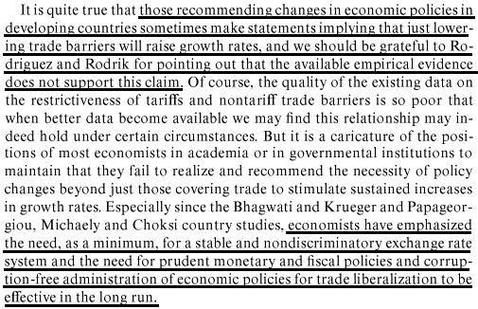
Tariffs and non-tariff trade restrictions aren’t significant factors for economic growth – other factors are more important
Prof. Robert E. Baldwin 2004 (professor emeritus of economics at Univ. of Wisconsin and research associate of the National Bureau of Economic Research) Challenges to Globalization: Analyzing the Economics https://books.google.fr/books?id=Bc35EC5BFZYC&pg=PA517&lpg=PA517&dq=other+policy+changes+aimed+at+eliminating+large+government+deficits,+curtailing+monetary+policy&source=bl&ots=AXaT80e-mx&sig=LfWdZSQabiTu6Wh8zI_pptxlZXU&hl=en&sa=X&ved=0CCIQ6AEwAGoVChMImqiRj_W3yAIVytsaCh3vVAuH#v=onepage&q&f=false (accessed 26 June 2022)
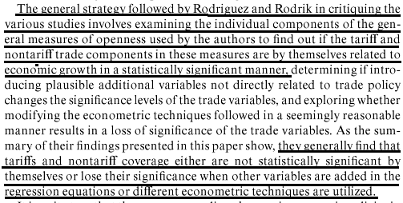
Trade liberalization advocates are making a lot of assumptions about the economy that aren’t actually true in the real world
Dr. Frank Ackerman & Dr. Kevin P. Gallagher 2008 (Ackerman – PhD economics; Director of the Research and Policy Program at the Global Development and Environment Institute, Tufts Univ. Gallagher – PhD; Professor of Global Development Policy at Boston Univ.) The Shrinking Gains from Global Trade Liberalization in Computable General Equilibrium Models International Journal of Political Economy, vol. 37, no. 1, Spring 2008, pp. 50–77. (brackets added) https://www.jstor.org/stable/40471021 (accessed 26 June 2022)
This issue is highlighted in a literature review by Joseph Stiglitz and Ed Charlton, who write that the standard analysis of the benefits of trade liberalization “is predicated on a set of assumptions that is not satisfied in most developing countries: full employment, perfect competition, and perfect capital and risk markets” (2004: 7).They list a series of problems with CGE models, including the failure to account for the presence of persistent unemployment in developing countries and the failure to incorporate costs of transition, implementation, and adjustment to policy changes—costs that are likely to be larger in developing countries.
2. No proven link between trade liberalization and economic growth
No evidence that countries that trade freely grow faster
Dr. Nicole Hassoun 2011 (PhD philosopy; Assistant Professor, Department of Philosophy, Carnegie Mellon University) Free Trade, Poverty, and Inequality (brackets added) https://global-health-impact.org/nhassoun/Disclaimer_FreeTradePovertyInequality.php (accessed 26 June 2022)
Next, consider the [World] Bank’s argument for the conclusion that free trade is reducing poverty because it has increased growth rates without increasing inequality in recent decades. Or, as they put it, “the combination of rapid growth with no systematic change in inequality has dramatically reduced absolute poverty in the globalizing countries”. The first problem with this argument is that it does little to show that countries that trade freely grow more than those that do not. Consider the Bank’s evidence for a link between free trade and growth. The Bank only establishes a correlation between population weighted trade to GDP ratios and real GDP per capita in developing countries but, even setting aside the distinction between liberalization and free trade, this is not enough to show that free trade increases growth.
Trade liberalization follows growth, it isn’t the cause. Examples: China and India grew first, then opened their markets later
Dr. Nicole Hassoun 2011 (PhD philosopy; Assistant Professor, Department of Philosophy, Carnegie Mellon University) Free Trade, Poverty, and Inequality (brackets added) https://global-health-impact.org/nhassoun/Disclaimer_FreeTradePovertyInequality.php (accessed 26 June 2022)
Including countries like China and India, which have low trade/GDP ratios, in the group of globalized countries virtually “guarantees that the globalizers, weighted by population, show better performance than the nonglobalizers.” It is not clear why the IFIs [International Financial Institutions] would consider trade to GDP [Gross Domestic Product] ratios a good measure of free trade. They are probably just confusing free trade with liberalization although some have accused the Bank of trying to confuse others. This is worrisome because the kinds of policies pursued by countries like China in achieving growth were a-liberal. China and India began to open up their markets only after their growth rates increased. The World Bank may have the causality backwards.
Correlation doesn’t prove cause: Increased growth after trade liberalization doesn’t prove trade policy caused the growth
Prof. Robert E. Baldwin 2004 (professor emeritus of economics at Univ. of Wisconsin and research associate of the National Bureau of Economic Research) Challenges to Globalization: Analyzing the Economics https://books.google.fr/books?id=Bc35EC5BFZYC&pg=PA517&lpg=PA517&dq=other+policy+changes+aimed+at+eliminating+large+government+deficits,+curtailing+monetary+policy&source=bl&ots=AXaT80e-mx&sig=LfWdZSQabiTu6Wh8zI_pptxlZXU&hl=en&sa=X&ved=0CCIQ6AEwAGoVChMImqiRj_W3yAIVytsaCh3vVAuH#v=onepage&q&f=false (accessed 26 June 2022)
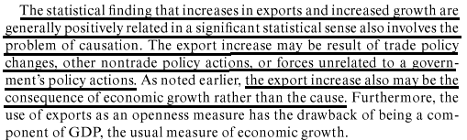
No specific correlation between trade openness and economic success
Prof. Richard B. Freeman 2003. (prof. of economics, Harvard Univ.; Senior Research Fellow in Labour Markets at the London School of Economics' Centre for Economic Performance) Trade Wars: The Exaggerated Impact of Trade in Economic Debate, World Economy Annual Lecture, 26 June 2003, revisions Sept 2003 http://citeseerx.ist.psu.edu/viewdoc/summary?doi=10.1.1.198.1253 (accessed 26 June 2022)
In any case, my reading of country cases is that they do not line up on one side or the other of the trade wars. Granted that Hong Kong succeeded with openness policies; that Singapore did as well, although under much greater government control; that Korea grew through increased exports, though again with considerable government control and a national industrial policy, and that Taiwan benefited from openness. But South Africa did just about everything the World Bank wanted it to do as part of its GEAR (Growth, Employment, and Redistribution) program and failed to deliver either growth, employment or redistribution.
Estimated benefits of trade liberalization are surprisingly small
Dr. Frank Ackerman & Dr. Kevin P. Gallagher 2008 (Ackerman – PhD economics; Director of the Research and Policy Program at the Global Development and Environment Institute, Tufts Univ. Gallagher – PhD; Professor of Global Development Policy at Boston Univ.) The Shrinking Gains from Global Trade Liberalization in Computable General Equilibrium Models International Journal of Political Economy, vol. 37, no. 1, Spring 2008, pp. 50–77. (brackets added) https://www.jstor.org/stable/40471021 (accessed 26 June 2022)
First, although the results of global trade modeling are often touted as evidence of large gains available from further trade liberalization, the most widely discussed CGE [computable general equilibrium ] models now make surprisingly small estimates of the benefits of liberalization of merchandise trade. The estimates are especially small for developing countries, particularly under realistic assumptions about the likely extent of future trade liberalization. As a consequence, the estimated potential for free trade to reduce global poverty is also quite limited.
3. Not solving for VAT (Value Added Tax)
Link: USA has no VAT, but other countries do, and it affects export/import trade
Alan Tonelson 2015 (Research Fellow at the U.S. Business and Industry Council Educational Foundation) 31 Mar 2015 “Opinion: Pacific trade deal won’t close massive tax loophole that kills American jobs“ http://www.marketwatch.com/story/pacific-trade-deal-wont-close-massive-tax-loophole-that-kills-american-jobs-2015-03-31 (accessed 26 June 2022)
But even if currency manipulation is truly banned, TPP signatories have been using another major protectionist device to disadvantage the United States that most critics so far have overlooked: value-added taxes (VATs). VATs function not only as hidden barriers to imports, but as hidden subsidies for exports. VATs represent taxes on all goods and services consumed in VAT countries, whether produced domestically or abroad. But producers in those VAT countries typically receive a rebate for all of their domestic production that they sell overseas. The United States is one of the few major economies with no such levy, and given the complexities of tax-reform politics, it’s likely to remain VAT-less for the foreseeable future. But 10 of the other current TPP countries do maintain VATs (the exception is tiny Brunei) and of these, seven subject imports to the equivalent of double-digit tariffs, and hand their exporters comparable subsidies.
Link: China, Japan, Taiwan and Korea all have VAT
Alan Tonelson 2015 (Research Fellow at the U.S. Business and Industry Council Educational Foundation) 31 Mar 2015 “Opinion: Pacific trade deal won’t close massive tax loophole that kills American jobs“ http://www.marketwatch.com/story/pacific-trade-deal-wont-close-massive-tax-loophole-that-kills-american-jobs-2015-03-31 (accessed 26 June 2022)
Japan, the biggest TPP economy after America’s by far, raised its version of a VAT (called a consumption tax) in November from 5% to 8%, and scheduled a rise to 10% in October. Peru, by contrast, has announced it will lower its VAT next year — but only to 14%. Moreover, most of the countries likely to join a new TPP later use VATs as well — like Korea, another American trade partner with a 10% VAT; Taiwan, with a 5% levy; and China, which operates an unusually complex VAT system but whose main rate is 17% — along with consumption taxes ranging from 5% to 10%.
Impact: VAT cancels out any benefits of trade deals – the effects are massive and harmful
Alan Tonelson 2015 (Research Fellow at the U.S. Business and Industry Council Educational Foundation) 31 Mar 2015 “Opinion: Pacific trade deal won’t close massive tax loophole that kills American jobs“ http://www.marketwatch.com/story/pacific-trade-deal-wont-close-massive-tax-loophole-that-kills-american-jobs-2015-03-31 (accessed 26 June 2022)
The VAT-less United States keeps signing trade deals with active VAT users and accepting the resulting inequities because world trade law defines these levies as domestic taxes that sovereign governments are fully entitled to impose. Moreover, the multinational companies that have dominated recent U.S. trade policy making are fine with VATs, since their foreign factories benefit too. Yet their effects on trade and the domestic American economy have been massive and harmful. The Washington, D.C. law firm of Stewart and Stewart, which specializes in trade law, estimates that the VAT gap globally inflicted $440 billion worth of damage on American producers exposed to foreign competition in 2013. The total equaled nearly two-thirds of that year’s U.S. merchandise trade deficit.
4. Trade agreements don’t change very much
Very little trade actually changes: Either the tariff was zero already, or the tariffs continue under an exemption to the agreement
Dr. Jagdish Bhagwati, Dr. Pravin Krishna and Dr. Arvind Panagariya 2014 (Bhagwati – PhD; prof. of economics at Columbia Univ. Krishna – PhD; Professor of International Economics and Business, Johns Hopkins Univ. Panagariya – PhD; prof. of economics at Columbia Univ.) 3 May 2014 “The World Trade System: Trends and Challenges” https://www.sais-jhu.edu/sites/default/files/JB-PK-AP-SIPA-SAIS%20Draft.pdf (accessed 26 June 2022) (brackets added)
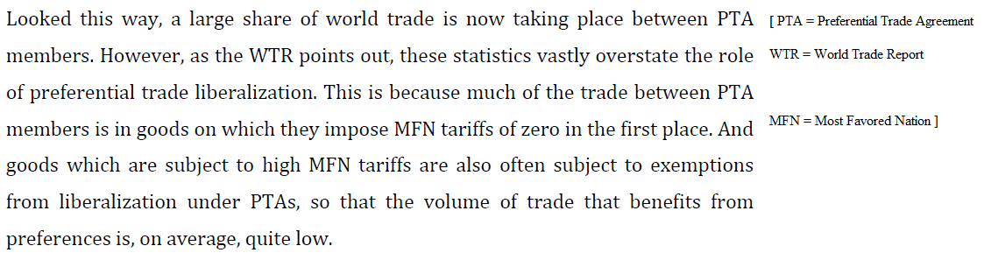
5. Capital mobility
If investment capital could not move, then free trade would benefit our economy. But since it can move, the benefits can go elsewhere. The world economy benefits, but not us.
Ian Fletcher 2010 (adjunct fellow at the U.S. Business and Industry Council; formerly an economist in private practice serving mainly hedge funds and private equity firms) Six Reasons for U.S. to Abandon Free-Trade Myth 26 Oct 2010 http://www.bloomberg.com/news/articles/2010-10-26/six-reasons-for-u-s-to-drop-free-trade-myth-commentary-by-ian-fletcher (accessed 26 June 2022)
The fourth dubious assumption is that capital isn’t internationally mobile. If it can’t move between nations, then free trade will (if the other assumptions hold true) steer it to the most-productive use in our own economy. But if capital can move between nations, then free trade may reveal that it can be used better somewhere else. This will benefit the nation that the money migrates to, and the world economy as a whole, but it won’t always benefit us.
6. Won’t reduce terrorism
Poverty isn’t the cause of terrorism. Millions of poor people around the world do not blow things up
Salil Tripathi 2005 (director of policy at the Institute for Human Rights and Business) 23 Feb 2005 “Debunking the Poverty-Terrorism Myth” WALL STREET JOURNAL http://www.wsj.com/articles/SB110911119848561282 (accessed 26 June 2022)
A bad idea, repeated often by authoritative people, can appear good; it is therefore time to debunk the bogus link between poverty and terror. Some development experts assert that if only more money were spent to alleviate poverty, terrorism would disappear. Poverty breeds a sense of deprivation among the poor, and because in their view the current economic system perpetuates inequality, it would compel the poor -- driven to desperation because of social injustices -- to turn to terror. This is reductive revolutionary rhetoric masquerading as an explanation. What's surprising is not the vacuity of this idea, but its resilience. It plays on collective guilt, seeking to rationalize the unjustifiable. Think of the millions of poor people who live in abject conditions in Africa and Asia. They suffer from widespread diseases and persistent malnutrition. Parents can't assume that their children will have a better future than their own. Many of these countries have experienced strife and violence. But the poor there do not routinely blow up buses or turn their bodies into bombs. To suggest that the poor will become terrorists unless their plight is addressed is gratuitous; worse, it insults them -- most poor lead dignified lives, trying heroically to improve their lives when they have little control over their destinies.
7. Empirically denied - Historical examples of failure
Africa: Free trade hasn’t benefited African countries’ economies
Betsy M. Oloyede, Evans S. Osabuohien and Jeremiah O. Ejemeyovwic 2021 (Oloyede - Department of Economics & Development Studies, Covenant University, Nigeria, Statistics Dept, Central Bank of Nigeria. Osabuohien - Centre for Economic Policy and Development Research-CEPDeR, Covenant University, Ota, Nigeria. Ejemeyovwi - Department of Economics & Development Studies & Research Fellow at CEPDeR, Covenant University, Nigeria ) “Trade openness and economic growth in Africa's regional economic communities: empirical evidence from ECOWAS and SADC” May 2021 https://www.ncbi.nlm.nih.gov/pmc/articles/PMC8141770/ (accessed 22 June 2022)
Regional integration and by implication, trade liberalisation is not without consequences and impact. Some critics posit that the introduction of free trade leads to a hike in social and environmental challenges, particularly in developing countries. Furthermore, regardless of the perceived benefits of the north-south cooperation, incomes of most of the sub-Saharan African (SSA) countries either dwindled or remained stagnant. A significant part of this low-level economic development was that these economies were reliant on high-cost western technology that were not suitable or did not match their primary production systems (Osabohien et al., 2021).
China: Freer trade with China killed 2.4 million American jobs
NEW YORK TIMES 2021 (journalist Ana Swanson) published 17 March 2021, updated 3 Nov 2021 "In Washington, ‘Free Trade’ Is No Longer Gospel" https://www.nytimes.com/2021/03/17/business/economy/free-trade-biden-tai.html (accessed 26 June 2022)
David Autor, an economist at the Massachusetts Institute of Technology, said economic theory had never claimed that trade made everybody better off — it had said trade would raise overall economic output, but lead to gains and losses for different groups. But economists and politicians alike underestimated how jarring some of those losses could be. Mr. Autor’s influential research shows that expanded trade with China led to the loss of 2.4 million American jobs between 1999 and 2011. China’s growing dominance of a variety of global industries, often accomplished through hefty government subsidies, also weakened the argument that the United States could succeed through free markets alone.
Canada & Mexico: North American Free Trade Agreement was a disaster for the US economy
Jeff Ferry 2017 (Research Director, Coalition for a Prosperous America) 24 Feb 2017 " However you measure it, free trade agreements have failed" https://thehill.com/blogs/congress-blog/economy-budget/321030-however-you-measure-it-free-trade-agreements-have-failed/ (accessed 26 June 2022)
But the plain fact is that whatever measures you use, the data shows that free trade agreements (FTAs) have been a disaster for U.S. trade and the U.S. economy. In the last 25 years, our trade position with our two NAFTA partners has changed from rough balance in 1992 to a whopping huge deficit of $160 billion last year. The fundamental cause of this deterioration is a U.S. economic system that is heavily weighted against manufacturing. Under NAFTA, Mexico benefits strongly from its low wages, its more lax environmental standards, and other features making it an attractive place for a multinational to do business. Canada doesn’t have dramatically cheaper wages than the U.S., but in other ways, its costs are lower. At least one auto multinational has said it chose to build a plant in Canada because it could save some $1,300 per vehicle on health care costs.
Korea: Free trade agreement didn't help the US at all
Jeff Ferry 2017 (Research Director, Coalition for a Prosperous America) 24 Feb 2017 " However you measure it, free trade agreements have failed" https://thehill.com/blogs/congress-blog/economy-budget/321030-however-you-measure-it-free-trade-agreements-have-failed/ (accessed 26 June 2022)
After the Korean-US trade agreement was approved in 2011, our trade deficit with Korea more than doubled to $32 billion on the narrower measure last year–or $28 billion on the wider measure. Whichever measure you look at, the story is the same. Many of our trading partners are skilled at keeping the lid on their imports from the U.S., whatever it says in these agreements. One of the most contentious issues in the Korean negotiations was on the auto industry. According to last year’s figures, our motor vehicle exports to Korea were $2.6 billion. Their motor vehicle exports to the U.S. were $25 billion, nearly ten times our figure!
8. More study needed
Normal FTA process is to conduct a feasibility study first, to avoid entering a bad FTA
Shintaro Hamanaka 2018 (Research Fellow, Institute of Developing Economies) Feb 2018 " Why Breakup? Looking into Unsuccessful FTA Negotiations" https://ir.ide.go.jp/?action=repository_uri&item_id=50229&file_id=22&file_no=1 (accessed 26 June 2022)
Countries can freely select favorable potential FTA partners and voluntarily decide whether or not to engage in negotiations, usually after conducting feasibility studies. In fact, countries sometimes decide against initiating negotiations based on the unfavorable results of such studies. Hence, once officials confirm the desirability of the FTA and launch negotiation, it usually, but not always, brings an output: namely, a signed FTA, which is different from negotiations in other fields.
DISADVANTAGES
1. Unsustainability
Free trade leads to short-term behaviors that are not sustainable, and reduce long-term living standards
Ian Fletcher 2010 (adjunct fellow at the U.S. Business and Industry Council; formerly an economist in private practice serving mainly hedge funds and private equity firms) 10 myths about free trade http://dailycaller.com/2010/04/14/10-myths-about-free-trade/ (accessed 26 June 2022)
Free trade has roughly ten very serious problems. The first problem is the assumption that trade is sustainable. But a nation exporting non-renewable resources may discover that its best move (in the short run) is to export until it runs out. The flip side of this problem is overconsumption, in which a nation (like the present-day U.S., maybe?) borrows from abroad in order to finance a short-term binge of imports that lowers its long-term living standard due to the accumulation of foreign debt and the sale of assets to foreigners.
2. Increased inequality
Link: Free trade increases inequality by raising the value of capital over labor
Ian Fletcher 2010 (adjunct fellow at the U.S. Business and Industry Council; formerly an economist in private practice serving mainly hedge funds and private equity firms) 14 Apr 2010 10 myths about free trade http://dailycaller.com/2010/04/14/10-myths-about-free-trade/ (accessed 26 June 2022)
The second problem is that free trade increases inequality even if it makes the economy grow overall (which is itself questionable). Because free trade tends to raise returns to the abundant input to production (in America, capital) and lower returns to the scarce input (in America, labor), it tends to benefit capital at labor’s expense.
Impact: Inequality fuels credit bubbles that crash the economy
Frederick E. Allen 2012. (journalist) Oct 2012 FORBES magazine “How Income Inequality Is Damaging the U.S.“ https://www.forbes.com/sites/frederickallen/2012/10/02/how-income-inequality-is-damaging-the-u-s/ (ellipses in original; brackets added)
The Congressional Budget Office recently reported that between 1979 and 2007 the top 1% of households doubled their share of pretax income while the share of the bottom 80% fell. Then came the great recession. Economists including David Moss of the Harvard Business School noticed that “the last time inequality rose to its current heights was in the late 1920s, just before a financial meltdown. . . . In 2010, Moss plotted inequality and bank failures since 1864 on the same graph; he found an eerily close fit.” But does that imply a cause-and-effect relationship? It looks that way, [journalist Jonathan] Rauch writes. Economists have been tracing the following chain of causality. Those who make the least consume the most of their income; those who make the most tend to save a great deal, and for that reason, according to the economist Christopher Brown, at Arkansas State, “income inequality can exert a significant drag on effective demand.” Rauch writes that
In a democracy, politicians and the public are unlikely to accept depressed spending power if they can help it. They can try to compensate by easing credit standards, effectively encouraging the non-rich to sustain purchasing power by borrowing. They might, for example, create policies allowing banks to write flimsy home mortgages and encouraging consumers to seek them. Call this the “let them eat credit” strategy.
Then “the economy, propped up on shaky credit, becomes more vulnerable to shocks. When a recession comes, the economy takes a double hit as banks fail and credit-fueled consumer spending collapses.”
3. Enables mercantilism
Link: What is mercantilism? Government intervention to help its domestic industries and damage foreign competitors
Stephen Ezell 2013. (Senior Analyst, Information Technology and Innovation Foundation) 24 July 2013 China’s Economic Mercantilism http://www.industryweek.com/public-policy/chinas-economic-mercantilism (brackets added) (accessed 26 June 2022)
But by 2006, that began to change, as China made the strategic decision to shift away from attracting the commodity-based production facilities of foreign MNCs [multi-national corporations] toward a “China Inc.” development model focused on helping Chinese firms, often at the expense of foreign firms. The path to prosperity and autonomy now became “indigenous innovation” (in Chinese, zizhu chuagnxin), with a focus on helping Chinese firms move up the value-chain to higher-value-added production activities. To get there, China has embraced economic mercantilism on an unprecedented scale, using a wide array of policies to assist Chinese firms while discriminating against foreign establishments attempting to compete in China.
Link: Free trade enables other countries to practice mercantilist policies against us
Ian Fletcher 2010 (adjunct fellow at the U.S. Business and Industry Council; formerly an economist in private practice serving mainly hedge funds and private equity firms) Six Reasons for U.S. to Abandon Free-Trade Myth 26 Oct 2010 http://www.bloomberg.com/news/articles/2010-10-26/six-reasons-for-u-s-to-drop-free-trade-myth-commentary-by-ian-fletcher (accessed 26 June 2022)
The fifth dubious assumption is that free trade won’t turn benign trading partners into dangerous trading rivals. But free trade often does do this, as we see today in China, whose growth is massively dependent upon exports. This is especially likely when trading partners practice mercantilism, the 400-year-old strategy of deliberately gaming the world trading system by methods like currency manipulation and hidden tariffs.
Impact: US economic and political decline and rise of Chinese totalitarianism
Dr. Howard Richman, Prof. Raymond Richman & Prof. Jesse Richman 2010. (Howard Richman - PhD from Univ of Pittsburgh. Raymond Richman- professor emeritus of public and international affairs at Univ of Pittsburgh. Jesse Richman – PhD; associate professor of political science at Old Dominion Univ) 10 Dec 2010 Bernanke to China: Stop Hurting Us or You'll Hurt Us (accessed 26 June 2022) http://www.americanthinker.com/articles/2010/12/bernanke_to_china_stop_hurting.html
If we don't act against mercantilism, the future is predictable: America will decline as an economic and political power. Eventually, China will replace the United States as the dominant power on the world stage, and totalitarianism will likely replace democracy as the world's dominant political philosophy. All because our leaders wouldn't balance budgets and trade.
Impact: Mercantilism will kill US jobs and economic growth
Dr Robert D Atkinson 2012. (president of the Information Technology and Innovation Foundation, a public policy think tank; formerly vice president of the Progressive Policy Institute; PhD in City and Regional Planning) February 2012 Enough is Enough: Confronting Chinese Innovation Mercantilism http://www2.itif.org/2012-enough-enough-chinese-mercantilism.pdf (accessed 26 June 2022)
Further integration of global supply chains that link the United States and China could be good for both nations but not if Chinese policies continue to be based on absolute advantage and mercantilism. In this case, the results will be more of the same: the loss of U.S. industrial and high-tech output, and the jobs and GDP growth that go with it.
4. Negative economic side effects of trade agreements
Lower wages: Trade agreements put downward pressure on workers' wages in order to boost corporate profits
Prof. Joseph Stiglitz 2019 (professor of economics at Columbia Univ., chief economist at the Roosevelt Institute. Formerly chief economist at the World Bank and was chairman of the Council of Economic Advisers under President Bill Clinton. He won the Nobel Prize in Economics in 2001) Joseph Stiglitz: US trade deals were designed to serve corporations at the expense of workers 21 Apr 2019 (accessed 16 Sept 2022) https://www.cnbc.com/2019/04/22/joseph-stiglitz-us-trade-deals-helped-corporations-and-hurt-workers.html
It’s true that American workers have been disadvantaged — low-skilled workers in particular have seen their wages reduced, in part because of globalization. But that is partly because American negotiators got what they asked for: the problem was with how we managed globalization and with what we wanted — trade agreements simply advanced corporate interests at the expense of workers in both developed and developing countries. We as a country didn’t do what we should have to help workers whom globalization was hurting. We could have ensured that globalization benefited all, but corporate greed was just too great. The winners didn’t want to share their gains with the losers. Indeed, they liked it that wages were pressured down as American workers had to compete with workers from developing countries. It increased corporate profits all the more.
Lost jobs: If you believe AFF's claim that exports create jobs, then in total, a balanced trade agreement destroys jobs
Prof. Paul Stiglitz 2017 (professor of economics at Columbia Univ., chief economist at the Roosevelt Institute. Formerly chief economist at the World Bank and was chairman of the Council of Economic Advisers under President Clinton. He won the Nobel Prize in Economics in 2001) Lecture, delivered at the meetings of the National Association of Business Economists, Washington D.C., March 6, 2017 "The Overselling of Globalization" https://policydialogue.org/files/publications/Volcker_Award_Speech_Paper_1.pdf
The standard theory recognized that the opening up of trade to cheap imports would result in the loss of jobs in the import-competing sectors. But it also assumed that new jobs would be created in the export sectors—and that those new jobs would pay far better than those that were lost. Contrary to what our politicians assert(including the US Trade Representative, or USTR, which is in charge of trade policy), trade agreements are not about creating jobs. Maintaining the economy at full employment is the responsibility of monetary policy (the Federal Reserve in the US, the Bank of England in the UK, and the European Central Bank in the eurozone) and fiscal policy (the setting of taxes and expenditure). It is not the purview of trade policy. Even the narrow argument put forward by the USTR that trade agreements create jobs is unpersuasive—indeed, almost certainly fallacious. If, as the USTR claims, exports create jobs, then imports destroy jobs; and if trade is roughly balanced, what advanced countries export uses less labor than what they import. Hence, net, for advanced countries like the US, any balanced trade agreement by itself destroys jobs.
Voting Impact: We shouldn't adopt any new trade agreements without a plan in place to offset the adverse effects on those negatively affected
[And AFF cannot propose such a plan because it wouldn’t be a foreign trade policy, but rather a set of domestic economic or social welfare policies happening separately from foreign import/export trade.]
Prof. Paul Stiglitz 2017 (professor of economics at Columbia Univ., chief economist at the Roosevelt Institute. Formerly chief economist at the World Bank and was chairman of the Council of Economic Advisers under President Clinton. He won the Nobel Prize in Economics in 2001) Lecture, delivered at the meetings of the National Association of Business Economists, Washington D.C., March 6, 2017 "The Overselling of Globalization" https://policydialogue.org/files/publications/Volcker_Award_Speech_Paper_1.pdf
There is a simple lesson in all of this: economists as public servants have, of course, a responsibility to tell those that they advise of the consequences of alternative policies. But their responsibility goes further: they have to understand and explain the limits of their models and the limits of our knowledge; to articulate what we know and what we don’t. Economists might, in the end, decide that globalization’s distributive effects are outweighed by or outweigh the aggregative effects. But it was wrong not to explain its potentially large distributive effects, the large adverse effects on employment in certain locales, the consequences of imperfect risk markets and imperfections in competition, and the implications for dynamic comparative advantage. It was wrong not to accompany any globalization proposals—any new trade agreements—with a set of measures that would have ensured that large segments of the population were not worse-off as a result.

