Sins of E-Mission : The Case For SEERA
By “Coach Vance” Trefethen
Resolved: The United States Federal Government should significantly reform its import and/or export policy
This case bans the export of “e-waste” (used, non-working electronic items), because they end up in toxic dumps in poor countries instead of being recycled in the US as they should be.
OBSERVATION 1. DEFINITIONS 3
Significant 3
Policy 3
OBSERVATION 2. INHERENCY, or the conditions of the Status Quo. One simple fact: Irresponsible e-waste exports 3
Electronic junk is supposed to be recycled, but it ends up being exported to foreign countries 3
OBSERVATION 3. The Plan, implemented by Congress, the President and any other necessary federal agencies 3
OBSERVATION 4. SOLVENCY 4
SEERA solves for e-waste exports 4
OBSERVATION 4. ADVANTAGES 4
1. National security and public safety 4
A. The Impact: Catastrophic consequences. We must block e-waste exports because of the catastrophic consequences of counterfeit products 4
B. The Solution: SEERA substantially reduces counterfeiting of vital medical, military and transportation system parts 4
2. Preventing data theft 5
A. The Link: SEERA reduces data theft 5
B. The Impact: Economic losses avoided. Data breaches cost over $4 million 5
3. Jobs & Economic Growth 5
SEERA creates economic growth and over 42,000 jobs 5
4. Developing countries’ citizens protected 5
A. The Problem: Sickness and suffering in 3rd World e-waste dump sites 5
B. The Answer: SEERA protects health and environment in Asia and Africa 6
2A Evidence: SEERA / E-Waste 7
DEFINITIONS & BACKGROUND 7
Full text of the bill 7
INHERENCY 10
State laws aren’t enough: Only the federal government can restrict exports 10
Current US regulations insufficient to manage e-waste 10
US/China trade agreement and Customs enforcement aren’t enough: We still need SEERA 10
E-waste will reach 27 million tons / year by 2030 10
Lack of national e-waste regulations leads to irresponsible export and dumping of e-waste in poor countries 11
SOURCE INDICTMENTS (on studies claiming e-waste isn’t a problem) 11
Lepawsky Study (Newfoundland Study): Lacked valid data, so the results weren’t reliable 11
MIT Study: Used the wrong numbers and admitted they have no idea what the right numbers are 11
US Trade Representative / International Trade Commission Study: Missing data and wrong numbers 12
HARMS / SIGNIFICANCE 12
E-waste exports are “NOT” working. They’re 75% junk 12
US produces 30% of world E-waste, and it contains toxic chemicals – and gets exported to developing nations instead of being recycled 12
E-waste = toxic contamination in Africa 13
Health risks to children from toxic chemicals near e-waste dump sites in Africa 13
A/T “Africa junk piles are a hoax” – Stop calling it a hoax, there’s too much evidence that it’s real 13
Agbogbloshie, Ghana dump site is not a “hoax” 14
Most e-waste exports are junk, not “working” or “repairable” products 14
SOLVENCY 14
SEERA would bring about responsible recycling in the US 14
A/T “Europe still has leakage of e-waste despite AFF policy” – But still better off than USA 14
Europe ratified the Basel Convention (banning e-waste exports) and has far lower export rate than USA 15
SEERA would once and for all stop e-waste exports to poor countries 15
DISADVANTAGE RESPONSES 15
A/T “Lost jobs in Africa” – We’ll still be exporting to them, but only usable stuff, not junk 15
A/T “Plan Harms Africa” – African countries want reduction in e-waste 15
A/T “Helping Africa” – Only reason it goes to Africa is no one else wants it 16
A/T “Helping Africa with recycling jobs” - It’s useless junk. They’re shipping it to Africa to AVOID recycling it 16
E-Waste export to Africa is negative net beneficial for Africa 16

Sins of E-Mission : The Case for SEERA
Everyone loves to have the latest electronic gadgets, but most people don’t give a thought to what happens when they’re obsolete and thrown away. But we need to, and that’s why my partner and I are affirming that the United States Federal Government should significantly reform its import and/or export policy.

OBSERVATION 1. DEFINITIONS
Significant
Merriam Webster Online Dictionary copyright 2022. https://www.merriam-webster.com/dictionary/significant (accessed 10 May 2022)
2a: having or likely to have influence or effect : IMPORTANT
Policy
Merriam Webster Online Dictionary copyright 2022. https://www.merriam-webster.com/dictionary/policy (accessed 10 May 2022)
a high-level overall plan embracing the general goals and acceptable procedures especially of a governmental body
OBSERVATION 2. INHERENCY, or the conditions of the Status Quo. One simple fact: Irresponsible e-waste exports

Electronic junk is supposed to be recycled, but it ends up being exported to foreign countries
Tom Risen 2016. (journalist) 22 Apr 2016 “America's Toxic Electronic Waste Trade” US NEWS & WORLD REPORT https://www.usnews.com/news/articles/2016-04-22/the-rising-cost-of-recycling-not-exporting-electronic-waste (accessed 13 May 2022)
Americans line up in droves every year to buy new gadgets, but the discarded older models of devices are too often shipped by recycling firms to foreign countries to avoid the cost of processing the toxic scrap. Electronics recycling is becoming less profitable as tech companies try to save costs by using fewer rare minerals like gold and copper in their devices, while the resale value of commodities extracted by recycling like steel and oil-based plastics has declined sharply in recent years. Hugo Neu Recycling CEO Robert Houghton says his firm faces increasing costs to dispose of old devices like phones and computers in an environmentally safe way, while other businesses that promise to do so cut costs by shipping them to nations like China. “Responsible recyclers lose business every day to companies that ship electronic scrap overseas or simply dump it in warehouses instead of processing it,” says Houghton, who is also the CEO of Sage Sustainable Electronics, a tech services firm focused on extending the useful life of technology.

OBSERVATION 3. The Plan, implemented by Congress, the President and any other necessary federal agencies

1. Congress passes the Secure E-Waste Export and Recycling Act (SEERA). This bill bans the export of non-working electronic components out of the United States.
2. Enforcement penalizes any exporter out of compliance with the same penalties as apply to similar violations of existing “Export Administration Regulations”.
3. Funding from general federal revenues
4. Timeline: Congress passes the bill the day after an Affirmative ballot.
5. All Affirmative speeches may clarify.
OBSERVATION 4. SOLVENCY

SEERA solves for e-waste exports
Colin Staub last updated March 29, 2021. (journalist) published 28 June 2019, last updated 29 Mar 2021; “Lawmakers revive bill to restrict e-scrap exports” https://resource-recycling.com/e-scrap/2019/06/28/lawmakers-revive-bill-to-restrict-e-scrap-exports/ (accessed 14 May 2022)
The Secure E-Waste Export and Recycling Act (SEERA) was introduced in the U.S. House of Representatives June 28 by legislators in California and New York as H.R. 3559. The bill would allow exports of tested and functional devices as well as some materials recovered from e-scrap through processing, such as commodities destined for smelters. It would also continue to allow the export of recalled devices that are sent to foreign markets to be repaired. Any other end-of-life device exports would become illegal under the federal act, according to a press release published by the Coalition for American Electronics Recycling (CAER), a group of e-scrap industry stakeholders who support the proposal.

OBSERVATION 4. ADVANTAGES

1. National security and public safety

A. The Impact: Catastrophic consequences. We must block e-waste exports because of the catastrophic consequences of counterfeit products
Lt. Col. Bryan Horvath 2017 (US Marine Corps aircraft maintenance officer) 6 Apr 2017 “NOT ALL PARTS ARE CREATED EQUAL. THE IMPACT OF COUNTERFEIT PARTS IN THE AIR FORCE SUPPLY CHAIN” https://apps.dtic.mil/sti/pdfs/AD1037985.pdf (accessed 15 May 2022)
The Guangdong Province in China is the epicenter for counterfeiting activities in China. This process has the potential for catastrophic consequences because electronic components are sensitive to moisture, static electricity, improper handling and the acid damages the components resulting in the parts failing sooner. These counterfeit parts are often identified as new by the counterfeiters and sold back to U.S. companies. Another area of concern is China’s capability to produce new counterfeit components that could incorporate malicious code that would be able to conduct a cyber attack. Although this is possible, it is unlikely because of the complexity of the electronic components would prevent the multi-functionality of the component as cause it to fail during testing. Government and the electronic industries need to work together in order to develop policies that limit or restrict the flow of E-waste out of the United States.

B. The Solution: SEERA substantially reduces counterfeiting of vital medical, military and transportation system parts
Robert Houghton 2022. (co-founder of the Coalition for American Electronics Recycling (CAER) and the CEO of Sage Sustainable Electronics) 7 Apr 2022 “In My Opinion: Why Congress should pass SEERA” https://resource-recycling.com/e-scrap/2022/04/07/in-my-opinion-why-congress-should-pass-seera/ (accessed 13 May 2022)
Counterfeiters harvest chips from e-waste, re-skinning and re-labeling them to look new, and then selling them as new into our supply chain. The Senate Armed Services Committee determined that such counterfeits have already compromised U.S. military systems. According to the Institute of Electrical and Electronic Engineers, counterfeit chips also threaten commercial transportation systems, medical devices and systems, and the computers and networks that run today’s financial markets and communications systems. Today’s supply chain constraints simply increase the counterfeiters’ opportunity. SEERA substantially reduces the supply of raw materials for this illicit and dangerous black market.

2. Preventing data theft

A. The Link: SEERA reduces data theft
Robert Houghton 2022. (co-founder of the Coalition for American Electronics Recycling (CAER) and the CEO of Sage Sustainable Electronics) 7 Apr 2022 “In My Opinion: Why Congress should pass SEERA” https://resource-recycling.com/e-scrap/2022/04/07/in-my-opinion-why-congress-should-pass-seera/ (accessed 13 May 2022)
Unprocessed e-waste often contains data-bearing components that have not been properly sanitized. The thriving dark web market for stolen personal and corporate data fueled by the illicit e-waste trade will be limited by SEERA.

B. The Impact: Economic losses avoided. Data breaches cost over $4 million
IBM Cost of a Data Breach Report 2022 (IBM is a multinational computer/technology company) (accessed 12 Nov 2022) https://www.ibm.com/security/data-breach (brackets added)
The key findings described here are based on IBM Security analysis of research data compiled by Ponemon Institute. Reaching an all-time high, the cost of a data breach averaged USD [$]4.35 million in 2022. This figure represents a 2.6% increase from last year, when the average cost of a breach was USD 4.24 million. The average cost has climbed 12.7% from USD 3.86 million in the 2020 report.

3. Jobs & Economic Growth

SEERA creates economic growth and over 42,000 jobs
Robert Houghton 2022. (co-founder of the Coalition for American Electronics Recycling (CAER) and the CEO of Sage Sustainable Electronics) 7 Apr 2022 “In My Opinion: Why Congress should pass SEERA” https://resource-recycling.com/e-scrap/2022/04/07/in-my-opinion-why-congress-should-pass-seera/ (accessed 13 May 2022)
Jobs: CAER commissioned a study of SEERA’s economic impact. The study found over 42,000 jobs would be added to the U.S. economy by domestic processing of e-waste volumes currently being exported. About half of those full-time positions would be created directly in our industry, more than replacing any losses from companies unwilling or unable to transition away from e-waste trafficking to more sustainable business models.
Increased export value: Under SEERA, low-value e-waste exports will be replaced by clean, finished-grade commodities and tested, working used electronics. The total economic value of our industry’s exports will rise by at least the amount of value added by responsible domestic processing, likely more due to current global supply chain constraints.

4. Developing countries’ citizens protected
A. The Problem: Sickness and suffering in 3rd World e-waste dump sites
Andrea Kruger 2020. (journalist) Not in Anyone’s Backyard: SEERA for E-Waste Reform 16 Aug 2020 https://www.borgenmagazine.com/seera/ (accessed 14 May 2022)
Common e-waste dumping sites in places such as the infamous Agbogbloshie dump in Accra, Ghana, are known to cause health problems for the poor who work there to refurbish pieces and extract valuable materials from old devices. Those working in e-waste frequently suffer from both skin and respiratory diseases due to toxic chemicals that are released into the air, soil and water. This also has implications for the food supply since animals who feed near the dump become contaminated. Among those most affected by such dumps are children, who work to burn electronic waste that is no longer able to be repaired or repurposed.
B. The Answer: SEERA protects health and environment in Asia and Africa
Robert Houghton 2022. (co-founder of the Coalition for American Electronics Recycling (CAER) and the CEO of Sage Sustainable Electronics) 7 Apr 2022 “In My Opinion: Why Congress should pass SEERA” https://resource-recycling.com/e-scrap/2022/04/07/in-my-opinion-why-congress-should-pass-seera/ (accessed 13 May 2022) (brackets added)
BAN [Basel Action Network], 60 Minutes, Frontline, National Geographic and other prominent media have exhaustively documented deplorable working conditions and environmental degradation connected with rudimentary and unregulated recycling operations from Asia to Africa. This toxic trade in e-waste exists for two reasons only – profits for those in developed countries, and lack of environmental and worker safety regulations in the developing world. SEERA finally provides transparency, accountability and legal standing needed to ensure that our industry does not externalize end-of-life costs at others’ expense.

2A Evidence: SEERA / E-Waste
DEFINITIONS & BACKGROUND

Full text of the bill
Congress official web site 2019. “H.R.3559 - Secure E-Waste Export and Recycling Act” 27 June 2019 https://www.congress.gov/bill/116th-congress/house-bill/3559/text (accessed 13 May 2022)
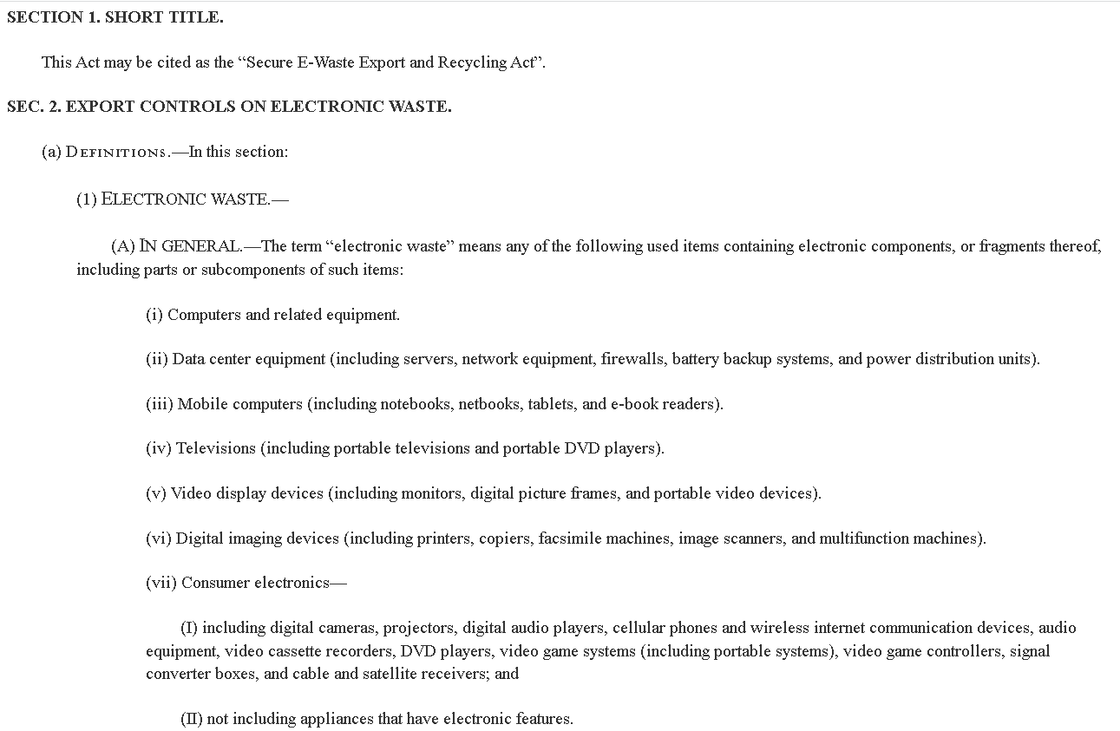
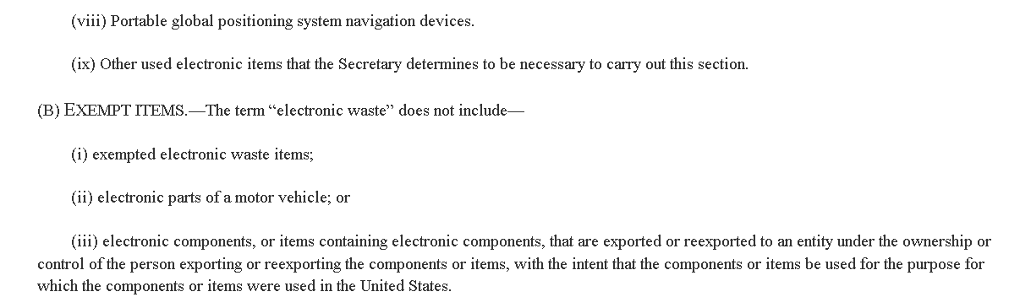
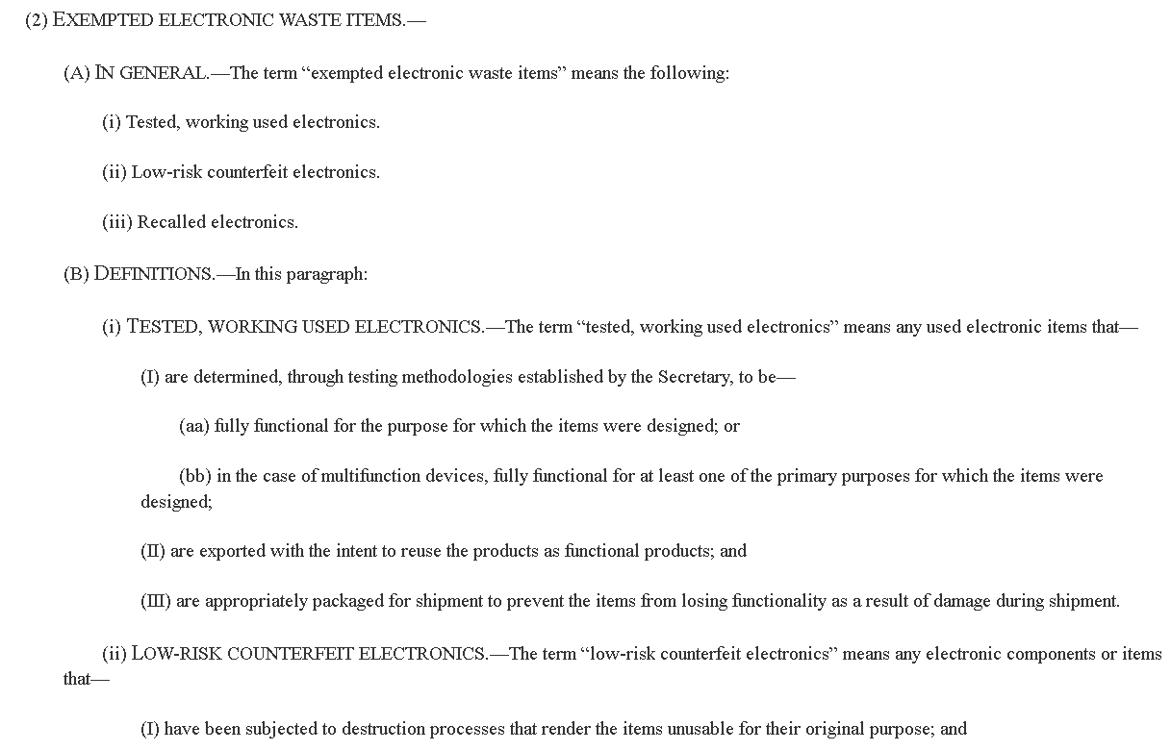

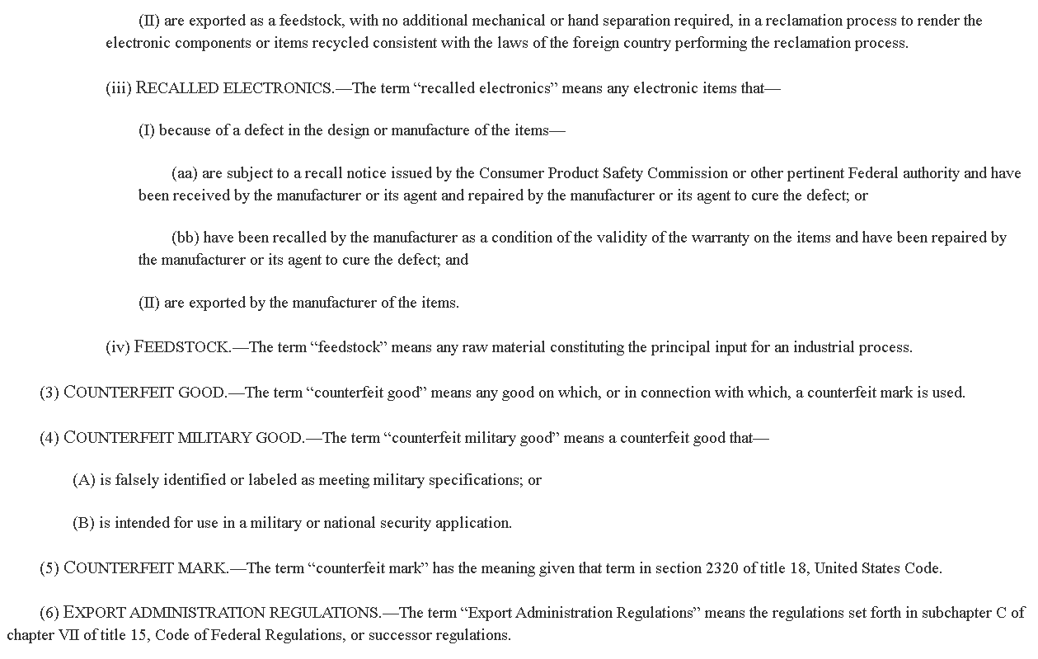
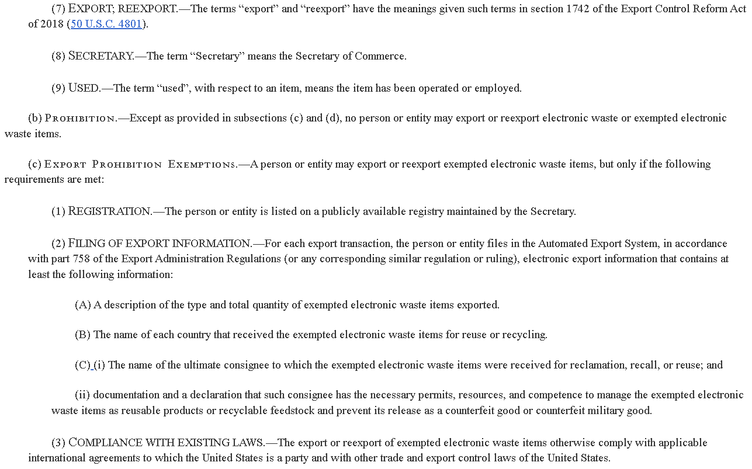
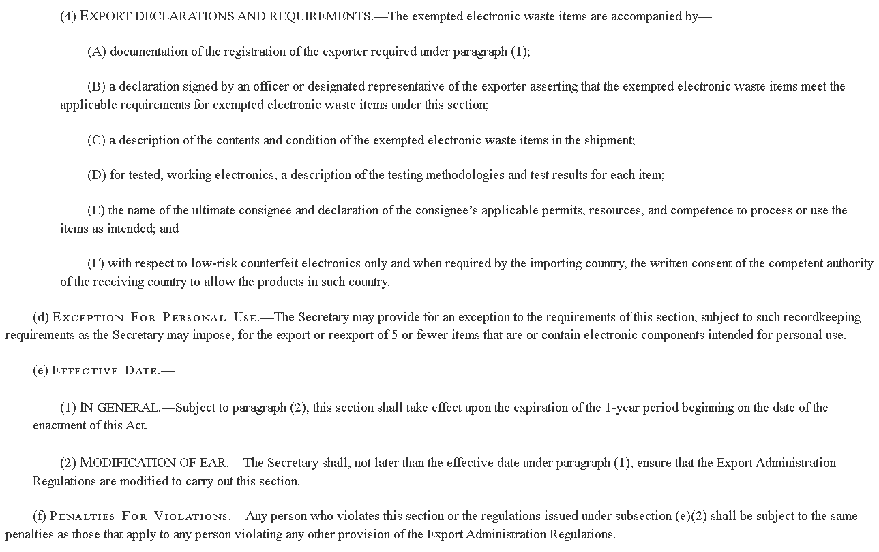

INHERENCY

State laws aren’t enough: Only the federal government can restrict exports
Tom Risen 2016. (journalist) 22 Apr 2016 “America's Toxic Electronic Waste Trade” US NEWS & WORLD REPORT https://www.usnews.com/news/articles/2016-04-22/the-rising-cost-of-recycling-not-exporting-electronic-waste (accessed 13 May 2022)
There are laws on electronic waste in 25 states and the District of Columbia, but only the federal government has the power to restrict exports.

Current US regulations insufficient to manage e-waste
Kurt Daum, Dr. Justin Stoler and Prof. Richard J. Grant 2017. (Daum - Department of Geography and Regional Studies, University of Miami. Stoler – PhD; MPH; Assistant Professor of Geography, Univ. of Miami. Grant - prog. of geography, U. of Miami) Toward a More Sustainable Trajectory for E-Waste Policy: A Review of a Decade of E-Waste Research in Accra, Ghana INTERNATIONAL JOURNAL OF ENVIRONMENTAL RESEARCH & PUBLIC HEALTH 29 Jan 2017 https://www.mdpi.com/1660-4601/14/2/135/htm (accessed 17 May 2022)
The U.S. remains the only industrialized nation not to ratify the convention’s laws, so the USEPA is the U.S.’ only exporter-end source of accountability for e-waste streams destined for Africa and other regions. USEPA’s policies for the regulation of U.S.’ used-electronic exports are hardly sufficient, thus shifting major responsibility and oversight to the Customs Division in Ghana and other importing countries.

US/China trade agreement and Customs enforcement aren’t enough: We still need SEERA
Colin Staub 2020. (journalist) 5 Mar 2020 “Companies renew call for e-scrap export ban” https://resource-recycling.com/e-scrap/2020/03/05/companies-renew-call-for-e-scrap-export-ban/ (accessed 15 May 2022)
The Coalition for American Electronics Recycling (CAER) in a statement described components of the recent U.S.-China trade agreement that address the movement of counterfeit goods into the U.S. The group, which has membership from a long list of U.S. e-scrap processors, also pointed to a new initiative by U.S. Customs and Border Protection to place penalties on e-commerce companies that do not combat counterfeit goods sales. These developments “represent progress in the fight against a wide range of fake goods,” according to CAER, but the group says the Secure E-Waste Export and Recycling Act (SEERA) is still necessary to address certain counterfeiting processes.

E-waste will reach 27 million tons / year by 2030
Rep. Adriano Espaillat 2021 (member of Congress from N.Y.) Proposed federal legislation addresses e-scrap exports 13 May 2021 quoted by journalist DeAnne Toto https://www.recyclingtoday.com/article/secure-ewaste-export-recycling-act/ (accessed 14 May 2022)
He adds, “Our e-waste flow is on track to reach 27 million tons by 2030, and until we turn it off, our national security and environment will be under threat by the malign actors in China. Furthermore, we will continue to miss out on the economic benefits from this industry as China’s e-waste industry is on track to be worth $23.8 billion by 2030. It is beyond time that we take action.”

Lack of national e-waste regulations leads to irresponsible export and dumping of e-waste in poor countries
Robert Houghton 2022. (co-founder of the Coalition for American Electronics Recycling (CAER) and the CEO of Sage Sustainable Electronics) 7 Apr 2022 “In My Opinion: Why Congress should pass SEERA” https://resource-recycling.com/e-scrap/2022/04/07/in-my-opinion-why-congress-should-pass-seera/ (accessed 13 May 2022)
With SEERA, the United States will finally join all other Organization for Economic Cooperation and Development (OECD) countries in implementing sensible, national e-waste regulation. Our customers are virtually unanimous in demanding that their electronics be processed responsibly. Nonetheless, some industry players traffic in hazardous e-waste to developing countries, in violation of international treaties, and while making claims of responsible recycling to the public. This integrity gap was laid bare by the Basel Action Network’s e-Trash Transparency Project. BAN agents concealed GPS tracking devices in nonfunctional printers and monitors before delivering them to recyclers across the country. Forty percent of the devices came to rest in unregulated e-waste scrap yards in developing countries. Without SEERA, such toxic trade will remain legal and profitable, if fraudulent.

SOURCE INDICTMENTS (on studies claiming e-waste isn’t a problem)

Lepawsky Study (Newfoundland Study): Lacked valid data, so the results weren’t reliable
Jim Puckett 2015 (executive director, Basel Action Network) “EXPORTING DECEPTION: THE DISTURBING TREND OF WASTE TRADE DENIAL” Aug 2015 https://static1.squarespace.com/static/558f1c27e4b0927589e0edad/t/56099be2e4b0bf9f935946c1/1443470306153/BAN%27sExportingDeception_E-ScrapNews_op-ed.pdf (accessed 14 May 2022)
Lepawsky begins by praising the previous investigative work of scrap electronics researchers (including BAN and Greenpeace) and rightfully notes that there is a lack of concrete data in the field to do a comprehensive study of e-scrap flows. However, despite lacking this important data, Lepawsky nevertheless goes on to do just that – make something out of nothing. His study relies on using trade data based on a single harmonized tariff code – that for used lead acid batteries (car batteries, or ULABs) as a “proxy” for all of e-waste. For anyone who knows the unique trade patterns of ULABs, this is a stunning leap of faith and not science.

MIT Study: Used the wrong numbers and admitted they have no idea what the right numbers are
Jim Puckett 2015 (executive director, Basel Action Network) “EXPORTING DECEPTION: THE DISTURBING TREND OF WASTE TRADE DENIAL” Aug 2015 https://static1.squarespace.com/static/558f1c27e4b0927589e0edad/t/56099be2e4b0bf9f935946c1/1443470306153/BAN%27sExportingDeception_E-ScrapNews_op-ed.pdf (accessed 14 May 2022)
In the MIT study, much like Lepawsky’s, the authors unfortunately based their research on the HTS codes that don’t exist for e-waste, but did not even bother to find a proxy for used or waste equipment of any kind. They simply used the codes for new electronics and then presumed those would be the same codes used by importers for used and scrap electronics. Yet this is very rarely the case because these codes, as opposed to “Scrap Plastic” or “Scrap Metal” or some other low-value HTS code, would require paying very high duties commensurate with the value of new computers and peripherals. The authors of the study readily admit that they had/have no idea about the amount of code mischaracterization that might have taken place.

US Trade Representative / International Trade Commission Study: Missing data and wrong numbers
Jim Puckett 2015 (executive director, Basel Action Network) “EXPORTING DECEPTION: THE DISTURBING TREND OF WASTE TRADE DENIAL” Aug 2015 https://static1.squarespace.com/static/558f1c27e4b0927589e0edad/t/56099be2e4b0bf9f935946c1/1443470306153/BAN%27sExportingDeception_E-ScrapNews_op-ed.pdf (accessed 14 May 2022)
Finally, the U.S. Trade Representative’s (USTR) office – known to be a very pro-free trade government agency, was given the job under the National E-Waste Strategy for Electronic Stewardship of conducting another study on global e-waste flows. The agency, in turn, asked the International Trade Commission to conduct it. Rather than letting this study be done as ITC saw fit, it was mandated by USTR that it be done via a survey of industry, despite many in the stakeholders meeting arguing that this method was not a very effective means of arriving at the truth. Nevertheless, ITC was charged with conducting a survey to be sent to recyclers and collectors asking them if they exported and if so, how much. When the ITC was asked how it was going to be sure that the responses would be honest, ITC claimed that we should not worry because it would be illegal not to respond to the survey, and that penalties of perjury would apply to dishonest responses. When the final report was published in 2013, once again, a stunningly low figure of 7 percent export was presented. But what is not well understood was that this represented 7 percent of sales amounts, not weight. Low-value material is much of what is exported in the e-waste trade and value does not correspond at all to weight. Nor does value correspond to environmental harm. We learned also that the survey did not even get sent to companies of less than 10 persons. As much of the waste trade is conducted by small brokers and collectors, the data becomes even more hopelessly skewed due to this buried fact. BAN and the Electronics TakeBack Coalition published a critique highlighting these shortcomings soon after the study was published (available at tinyurl.com/ITC-Statement). BAN decided to file a Freedom of Information Act query regarding the survey responses. What we learned was that 43 percent of the valid addresses failed to respond to the survey. Further, we learned that ITC found that there were more than 900 substantive internal errors (for example, internal figures contradicting sums in the same response) identified in the 2,760 responses that were received.

HARMS / SIGNIFICANCE
E-waste exports are “NOT” working. They’re 75% junk
Kurt Daum, Dr. Justin Stoler and Prof. Richard J. Grant 2017. (Daum - Department of Geography and Regional Studies, University of Miami. Stoler – PhD; MPH; Assistant Professor of Geography, Univ. of Miami. Grant - prog. of geography, U. of Miami) Toward a More Sustainable Trajectory for E-Waste Policy: A Review of a Decade of E-Waste Research in Accra, Ghana INTERNATIONAL JOURNAL OF ENVIRONMENTAL RESEARCH & PUBLIC HEALTH 29 Jan 2017 https://www.mdpi.com/1660-4601/14/2/135/htm (accessed 17 May 2022)
The share of working electronic goods found inside a typical e-waste shipment generally is about 25%. As a result, the amount of unusable computers, cell phones, appliances, and all other forms of e-waste entering Ghana grows annually, and the amount of e-waste in the global trade is expected to rise by about 8 million tons to 50 million tons in 2018.

US produces 30% of world E-waste, and it contains toxic chemicals – and gets exported to developing nations instead of being recycled
Andrea Kruger 2020. (journalist) Not in Anyone’s Backyard: SEERA for E-Waste Reform 16 Aug 2020 https://www.borgenmagazine.com/seera/ (accessed 14 May 2022)
The United States is currently one of the world’s biggest producers of electronic waste (e-waste), such as old cell phones, computers and even military technology. Basel Action Network (BAN), a global anti-pollution organization based in Seattle, estimates that U.S. e-waste currently makes up about 30% of the world’s total amount produced each year. This waste contains toxic chemicals like arsenic, lead and cadmium, among others, and is often exported to developing nations instead of being recycled domestically, despite BAN’s efforts to encourage more widespread recycling of post-consumer electronics.

E-waste = toxic contamination in Africa
Dr. Thomas Maes and Fiona Preston-Whyte 2022. (Maes – PhD in marine litter; Principal Scientist at the Centre for Environment, Fisheries and Aquaculture Science, UK. Preston-Whyte - Researcher. Centre for Environment, Fisheries and Aquaculture Science, UK) “E-waste it wisely: lessons from Africa” 5 Feb 2022 https://link.springer.com/article/10.1007/s42452-022-04962-9 (accessed 17 May 2022)
The toxic and cancerous pollutants released into the environment during improper treatment of e-waste at end-of-life (Fig. 2), include heavy metals such as lead, cadmium, and mercury, as well as dioxins, furans, and polycyclic aromatic hydrocarbons. Within Africa, close to e-waste processing sites, toxic elements, persistent organic pollutants (POPs), and heavy metals have been observed in elevated levels in dust, soils and vegetation, including edible plants. Further environmental effects have been observed because of higher metal and rare earth element (REEs) concentrations in downstream aquatic and marine environments, causing adverse marine consequences including smaller, sicker, and sparser fish stocks. REEs are contaminants of emerging concern.

Health risks to children from toxic chemicals near e-waste dump sites in Africa
Kurt Daum, Dr. Justin Stoler and Prof. Richard J. Grant 2017. (Daum - Department of Geography and Regional Studies, University of Miami. Stoler – PhD; MPH; Assistant Professor of Geography, Univ. of Miami. Grant - prog. of geography, U. of Miami) Toward a More Sustainable Trajectory for E-Waste Policy: A Review of a Decade of E-Waste Research in Accra, Ghana INTERNATIONAL JOURNAL OF ENVIRONMENTAL RESEARCH & PUBLIC HEALTH 29 Jan 2017 https://www.mdpi.com/1660-4601/14/2/135/htm (accessed 17 May 2022)
The health risks for fetuses and infants in Agbogbloshie are higher than those of adults because neonates and children are only beginning their bodily developmental processes. Indeed, heavy metals and chemical compounds found within electronic devices have been linked to neurodevelopmental disorders and/or fetal perturbations. Lead, mercury, and cadmium exposure as well as PBDE, polychlorinated biphenyl (PCB), PCDD/F, and PAH exposure are all linked to negative cognitive development effects in children maturing in e-waste neighborhoods; these toxins can generally be found in the air and dust among other environmental mediums. High blood lead levels have also been correlated with negative effects on mood, physical activity, and adaptability, while also affecting bone resorption and general physical development over time. Infants are highly susceptible to metal and chemical exposure in Agbogbloshie because of the abundance of exposure routes.

A/T “Africa junk piles are a hoax” – Stop calling it a hoax, there’s too much evidence that it’s real
Jim Puckett 2015 (executive director, Basel Action Network) “EXPORTING DECEPTION: THE DISTURBING TREND OF WASTE TRADE DENIAL” Aug 2015 https://static1.squarespace.com/static/558f1c27e4b0927589e0edad/t/56099be2e4b0bf9f935946c1/1443470306153/BAN%27sExportingDeception_E-ScrapNews_op-ed.pdf (accessed 14 May 2022)
I never thought I would be hearing words like “myth” and “hoax,” not after thousands of photographs have been shot, scores of video documentaries produced, and hundreds of articles written on an almost monthly basis, all depicting the global e-scrap dumping tragedy as it is displayed in various hot spots around the world.

Agbogbloshie, Ghana dump site is not a “hoax”
Jim Puckett 2015 (executive director, Basel Action Network) “EXPORTING DECEPTION: THE DISTURBING TREND OF WASTE TRADE DENIAL” Aug 2015 https://static1.squarespace.com/static/558f1c27e4b0927589e0edad/t/56099be2e4b0bf9f935946c1/1443470306153/BAN%27sExportingDeception_E-ScrapNews_op-ed.pdf (accessed 14 May 2022)
It is a fact that Agbogbloshie has not always been described with complete scientific accuracy in some of the reporting. For example, Agbogbloshie is not the “world’s biggest e-waste dump,” as has been reported. That “honor,” in my experience, still goes to the Guiyu township region in China. Dramatic scenes do lend themselves to hyperbole and, like anything dramatic, a visit to Agbogbloshie is a Rorschach test with visitors coming away with very different impressions. Different people can say different things about what is going on there, but what nobody in good conscience can say is that it is a “hoax” – something to be laughed away or its significance and harm made light of. I am certain that until the advent of the denial campaign, none of the journalists, scientists or officials that saw Agbogbloshie would ever describe what they had seen with their own eyes as a “myth.”

Most e-waste exports are junk, not “working” or “repairable” products
Dr. Thomas Maes and Fiona Preston-Whyte 2022. (Maes – PhD in marine litter; Principal Scientist at the Centre for Environment, Fisheries and Aquaculture Science, UK. Preston-Whyte - Researcher. Centre for Environment, Fisheries and Aquaculture Science, UK) “E-waste it wisely: lessons from Africa” 5 Feb 2022 https://link.springer.com/article/10.1007/s42452-022-04962-9 (accessed 17 May 2022)
A lot of this e-waste is introduced as “charitable donations” and “second-hand goods”, the implication being that these goods are functional. Workshop data from Accra, Ghana in 2019, showed that out of 0.215 Mt of e-waste imported: 30% was not waste, but “new” products (unused stocks), 14% was second-hand—possible to repair or keep using, leaving 56% as actual waste needing processing.
SOLVENCY

SEERA would bring about responsible recycling in the US
Andrea Kruger 2020. (journalist) Not in Anyone’s Backyard: SEERA for E-Waste Reform 16 Aug 2020 https://www.borgenmagazine.com/seera/ (accessed 14 May 2022)
Perhaps more importantly, the bill would force recycling companies in the U.S. to become more responsible. According to BAN, “fake recyclers” in the U.S. are responsible for sending around 1,888,500 metric tons (over 2 million U.S. tons) of electronic waste per year to the developing world. This bill could simultaneously clean up U.S. landfills and landfills in foreign countries, by legislating responsible recycling practices. This would also allow companies the more sustainable option of re-using certain metals already present in electronics, such as copper and gold, rather than having to source them again to make new products.
A/T “Europe still has leakage of e-waste despite AFF policy” – But still better off than USA
Andrea Kruger 2020. (journalist) Not in Anyone’s Backyard: SEERA for E-Waste Reform 16 Aug 2020 https://www.borgenmagazine.com/seera/ (accessed 14 May 2022)
In keeping with the provisions of the Basel Convention, the European Union (EU) has already passed legislation to clean up respective e-waste footprints by directing states to recycle domestically, though the EU has admitted that this has not entirely solved the problem of European dumping. Illegal shipments do sometimes still reach the developing world from Europe. However, European countries who defy the treaty stand to face penalties, while the U.S. is not subject to similar penalties for the same actions. Thus, U.S. e-waste stands to do the most harm in developing countries when compared to e-waste from other developed nations.

Europe ratified the Basel Convention (banning e-waste exports) and has far lower export rate than USA
Dr. Thomas Maes and Fiona Preston-Whyte 2022. (Maes – PhD in marine litter; Principal Scientist at the Centre for Environment, Fisheries and Aquaculture Science, UK. Preston-Whyte - Researcher. Centre for Environment, Fisheries and Aquaculture Science, UK) “E-waste it wisely: lessons from Africa” 5 Feb 2022 https://link.springer.com/article/10.1007/s42452-022-04962-9 (accessed 17 May 2022)
The transboundary European export rate (6%) falls far below the United States of America (USA) export rate of 40%. The USA is the only industrialised country not to ratify the Basel convention nor its amendments and has insufficient laws controlling e-waste exports.

SEERA would once and for all stop e-waste exports to poor countries
Colin Staub last updated March 29, 2021. (journalist) published 28 June 2019, last updated 29 Mar 2021; “Lawmakers revive bill to restrict e-scrap exports” https://resource-recycling.com/e-scrap/2019/06/28/lawmakers-revive-bill-to-restrict-e-scrap-exports/ (accessed 14 May 2022)
Several processors expressed strong support for the export restriction, stating that only unscrupulous recycling operations would have their businesses significantly hurt. The Basel Action Network (BAN), a nonprofit organization with a focus on e-scrap exports, praised the legislation in a statement, noting the bill would “once and for all close off the electronic waste pipeline to countries like China, India, Nigeria and Ghana.”

DISADVANTAGE RESPONSES

A/T “Lost jobs in Africa” – We’ll still be exporting to them, but only usable stuff, not junk
Dr. Thomas Maes and Fiona Preston-Whyte 2022. (Maes – PhD in marine litter; Principal Scientist at the Centre for Environment, Fisheries and Aquaculture Science, UK. Preston-Whyte - Researcher. Centre for Environment, Fisheries and Aquaculture Science, UK) “E-waste it wisely: lessons from Africa” 5 Feb 2022 https://link.springer.com/article/10.1007/s42452-022-04962-9 (accessed 17 May 2022)
Countries exporting used EEE to Africa (or elsewhere) need to ensure that their second-hand exports are working prior to export or can be easily fixed and are not damaged in transport. In other words, that the used EEE is not e-waste. Additionally, design change to facilitate repairability, reuse and recycling of e-waste is an imperative, including but not limited too; modularity, reduction, and ultimate removal of substances of very high concern (SVHC), clear ingredients, minimum standards for recycled content.
A/T “Plan Harms Africa” – African countries want reduction in e-waste
Kurt Daum, Dr. Justin Stoler and Prof. Richard J. Grant 2017. (Daum - Department of Geography and Regional Studies, University of Miami. Stoler – PhD; MPH; Assistant Professor of Geography, Univ. of Miami. Grant - prog. of geography, U. of Miami) Toward a More Sustainable Trajectory for E-Waste Policy: A Review of a Decade of E-Waste Research in Accra, Ghana INTERNATIONAL JOURNAL OF ENVIRONMENTAL RESEARCH & PUBLIC HEALTH 29 Jan 2017 https://www.mdpi.com/1660-4601/14/2/135/htm (accessed 17 May 2022)
The African region enacted an e-waste regulatory framework in 1998 under the Bamako Convention. Like the Basel Convention, this treaty aims to reduce the exploitative effects experienced by lower-income African e-waste destination hubs. Twenty-five African states have signed the convention’s treaty, but little implementation has taken place to date. The language of the Bamako Convention, while Africa-specific, reiterates and improves upon the preventative measures found in the Basel Convention. For instance, the Basel Convention contains policies on banning the transboundary movements of hazardous wastes to developing nations that lack proper e-waste management systems, but the Bamako Convention’s treaty builds on this by prohibiting the import of all hazardous and radioactive wastes into the African states that sign and ratify it. The purpose of this treaty is to minimize and control the flows of e-waste that travel within and between African states, and to ensure that electronics are disposed of and recycled in an environmentally sound manner. Unfortunately, illegal imports into Ghana (and elsewhere in Africa) have not subsided due to weak treaty enforcement.

A/T “Helping Africa” – Only reason it goes to Africa is no one else wants it
Isaac Kaledzi 2022 (journalist) “Activists slam Europe for dumping on Africa” 1 Apr 2022 https://www.dw.com/en/activists-slam-europe-for-dumping-on-africa/a-61315412 (accessed 17 May 2022)
African environmental expert Nnimmo Bassey spoke with DW from Nigeria, saying, "the trend is not just worrying but consistent with what has been going on for a long time." Bassey said Africa is becoming a dumpsite for all kinds of waste because the rest of the world is rejecting the West's garbage. "Other nations are getting more conscious about waste in their territories and they are rejecting toxic waste from polluting countries and suddenly Africa has become an attractive location," he said.

A/T “Helping Africa with recycling jobs” - It’s useless junk. They’re shipping it to Africa to AVOID recycling it
John Vidal 2013 (journalist) 16 Dec 2013 “Toxic E-Waste Dumped in Poor Nations, Says United Nations” https://ourworld.unu.edu/en/toxic-e-waste-dumped-in-poor-nations-says-united-nations (accessed 17 May 2022)
Although it is legal to export discarded goods to poor countries if they can be reused or refurbished, much is being sent to Africa or Asia under false pretences, says Interpol. “Much is falsely classified as ‘used goods’ although in reality it is non-functional. It is often diverted to the black market and disguised as used goods to avoid the costs associated with legitimate recycling,” said a spokesman.

E-Waste export to Africa is negative net beneficial for Africa
Brittany Nicole Wideman 2019. (Master’s degree candidate in Political Science at Portland State Univ ) 6 Mar 2019 “Grappling with the African E-Waste Pandemic: Contributing Factors and Future Deterrence” https://pdxscholar.library.pdx.edu/cgi/viewcontent.cgi?article=5900&context=open_access_etds (accessed 17 May 2022)
As Francis Adeola (2011) notes, the movement of e-waste travels from the Global North to the Global South (p. 57), and less frequently in the other direction. With this in mind, it is imperative to look at major urban centers in West Africa as we tend to find e-waste dumping at its most severe in major metropolitan areas. E-waste poses major environmental degradation, threatens human health and well-being, and reinforces informal economies in poor countries, which further serves to divide the developed, and developing world. International intervention from nongovernmental organizations and international laws cannot solve the problem of e-waste alone. There are micro level and macro level phenomena interacting in complicated ways from international mandates to local grassroots scavenging. The e-waste crisis in Africa is no exception to this notion and needs to be addressed to prevent lingering effects on the human population and environment.

