Negative: Managed Access (Cell Phone Blocking)
By “Coach Vance” Trefethen
The United States Federal Government should significantly reform its policies regarding convicted prisoners under federal jurisdiction
Case Summary: The AFF plan implements “Managed Access System” in federal prisons. This is a technology that is supposed to suppress the ability of inmates to make calls using illegal cell phones from inside prison. Prisoners are not allowed to have cell phones at all, but sometimes they are smuggled in. Some technologies try to block their use by jamming signals, but this is problematic because legitimate calls (by guards and prison officials, or by people in homes not far from the prison) get blocked as well. MAS is different. It lets all calls be initiated. But it creates a “white list” of approved phone numbers that may be expected to be dialing out from the prison. If a call originates from a number not on the white list, the call will simply not be connected to its intended recipient. Prison officials will all register their numbers on the white list, while no prisoner would have his illegal cell phone on the list, so prisoner calls will just ring and never complete.
Negative: Managed Access (Cell Phone Blocking) 3
TOPICALITY 3
1. No significant policy reform 3
Managed Access technology is merely a supplement to existing policies, not a significant reform 3
Best evidence: NEG has the only evidence in the round that specifically links this plan to the wording of our resolution 3
Impact: Negative ballot 3
HARMS / SIGNIFICANCE 4
1. More study needed 4
Before implementing MAS (Managed Access System), you have to do a 30-day study at each prison to determine the number of calls being made, to evaluate how big the problem is and to know whether the plan is effective at solving it 4
2. Cell phones in prison aren’t that harmful 4
Prison officials exaggerate the threat because cell phones expose deplorable conditions on the inside 4
Mississippi Study: They’re calling Mom on Mother's Day 4
Problem is exaggerated: Most calls are staying in touch with family 5
3. Staff smuggling proves no threat 5
Prisoners are getting a lot of their illicit phones from prison staff. So, the staff must not think they’re much of a threat 5
SOLVENCY 5
1. Tried & Failed in California 5
California tried Managed Access in its prisons and then abandoned it because it didn’t work well enough 5
California Study concluded: We should try at least 4 other things first before trying Managed Access Systems (MAS) 6
2. “Managed Access” means a lot of management 6
Mississippi Study: “Managed” access requires a lot of management 6
Link: Bureau of Prisons doesn’t have the manpower – they’re badly understaffed. 7
Impact: Failure. “Managed Access” only works if ongoing management works. 7
3. Corrupt staff disable the system 7
Link: BOP is full of corruption 7
Corrupt staff can disable the system 7
4. Blocking signals doesn’t solve 8
Cell phones can still be used to communicate without making calls 8
5. Many other changes needed 8
Managed Access isn’t a silver bullet – you need lots of other changes too 8
6. More Study Needed 9
Before buying a Managed Access System, we need to do a 1-year pilot project study with independent outside oversight 9
7. Requires constant, expensive upgrades 9
California study found Managed Access requires expensive deployment and even more expensive upgrades 9
8. Text messaging 10
MAS can’t stop text messaging 10
9. In-coming calls 10
In-coming calls would probably get through even with MAS activated. We need more study to find out 10
10. Technology gaps 10
Multiple gaps in MAS technology must be worked out to make it viable 10
DISADVANTAGES 11
1. Manpower diversion 11
Link: Mississippi Study found - Managed Access technology requires big commitment of manpower 11
Link & Brink: Attorney General admits federal prison staffing is “a serious problem” 11
Link: BOP can’t attract and hire new employees because pay is too low 11
Impact: Exponential increase in prison violence when staffing is lost 11
2. Masking DA: Distracts us from the right solution 12
Focus on blocking signals is bad because it distracts us from what would really work: Grabbing the contraband devices themselves 12
California confirms: MAS looked good at first, but it 1) quickly became obsolete and 2) interfered with neighboring cell phone reception. They gave up on it and went back to trying to physically keep the phones out of prison 12
3. Neighboring communities harmed 12
MAS will disrupt nearby communities’ cell phone service and 911 emergency service 12

Negative: Managed Access (Cell Phone Blocking)

TOPICALITY

1. No significant policy reform
Managed Access technology is merely a supplement to existing policies, not a significant reform
Dr. Eric Grommon, Dr. Jeremy G. Carter, Fred Frantz and Phil Harris 2015. (Grommon – PhD. Carte -, Ph.D. Frantz – with Engility Corporation. Harris - with Engility Corporation) “A Case Study of Mississippi State Penitentiary’s Managed Access Technology“ research report submitted to the U.S. Dept of Justice April 2015 https://www.ojp.gov/pdffiles1/nij/grants/250262.pdf (accessed 3 Apr 2022)
Clearly inmate use of multifunction device capabilities which fall outside of cellular communications requires mitigation using non-managed access system methods, to include physical intervention. Put simply, managed access technology should be viewed as supplemental to existing contraband policies and practices.
Best evidence: NEG has the only evidence in the round that specifically links this plan to the wording of our resolution
AFF will not read you any evidence that says Managed Access is a significant policy reform. This shows you that experts in the field, who are far better qualified than the Affirmative debaters to tell us what is or is not a significant reform – they say it isn’t. Unless AFF can provide better evidence that it is, not just their own say-so, this case is untopical and should not be debated.

Impact: Negative ballot
Affirmative isn’t upholding the resolution, so a Negative ballot is warranted, regardless of how beneficial their plan might be.

HARMS / SIGNIFICANCE

1. More study needed
Before implementing MAS (Managed Access System), you have to do a 30-day study at each prison to determine the number of calls being made, to evaluate how big the problem is and to know whether the plan is effective at solving it
California Council on Science & Technology 2012. (agency of the state government of California)“The Efficacy of Managed Access Systems to Intercept Calls from Contraband Cell Phones in California Prisons” May 2012 (accessed 3 Apr 2022) https://www.documentcloud.org/documents/355647-2012cell.html
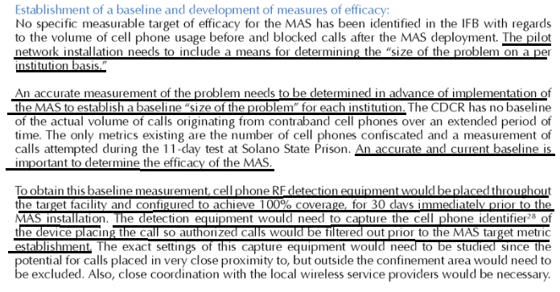

2. Cell phones in prison aren’t that harmful
Prison officials exaggerate the threat because cell phones expose deplorable conditions on the inside
Derek Gilna 2021 (Prison Legal News journalist) 1 Sept 2021 “The Fight Over Cellphones in Prisons Rages On: https://www.prisonlegalnews.org/news/2021/sep/1/fight-over-cellphones-prisons-rages/ (accessed 3 Apr 2022)
Perhaps yet another reason detention officials at the state and federal level prohibit cellphones is that it provides a way for prisoners to reveal to the outside world the depressing and often unsafe conditions in their institutions, as they did during the COVID-19 pandemic. Detention officials responded the way they always do to a crisis: locking everything down and limiting communications to the outside world. CNN, in April of 2020, broadcast prisoner video from an Alabama state prisons in the midst of a COVID-19 outbreak, where a prisoner remarked, “Death is imminent for us.” It also showed the deplorable living conditions, including non-functional toilets, expired food, and rat infestation.

Mississippi Study: They’re calling Mom on Mother's Day
Dr. Eric Grommon, Dr. Jeremy G. Carter, Fred Frantz and Phil Harris 2015. (Grommon – PhD. Carte -, Ph.D. Frantz – with Engility Corporation. Harris - with Engility Corporation) “A Case Study of Mississippi State Penitentiary’s Managed Access Technology“ research report submitted to the U.S. Dept of Justice April 2015 https://www.ojp.gov/pdffiles1/nij/grants/250262.pdf (accessed 3 Apr 2022)
Patterns in call attempt data suggest that a significant amount of call activity was for the purpose of social contact. Increased transmissions were detected by the managed access system on specific days such as Mother’s Day and federal or state holidays. Data on the patterns of call activity could not be used to identify or determine the frequency of transmissions to coordinate illegal activities.

Problem is exaggerated: Most calls are staying in touch with family
Caitlin Schneider 2009 (journalist) 27 July 2009) “Michigan not among states wanting to jam cell phone signals at prison facilities” https://www.mlive.com/news/jackson/2009/07/michigan_not_among_states_want.html (accessed 3 Apr 2022)
High-profile cases of cell phone smuggling highlight their use for criminal activity, but some have argued that secret cell phones are sometimes used simply to call friends and family. Kay Perry, executive director of the Michigan Chapter of Citizens United for the Rehabilitation of Errants, said some of the confiscated cell phones must be used for phoning relatives because not all have been linked to unlawful schemes. She called the use of cell phones for crime "exaggerated."

3. Staff smuggling proves no threat

Prisoners are getting a lot of their illicit phones from prison staff. So, the staff must not think they’re much of a threat
Derek Gilna 2021 (Prison Legal News journalist) 1 Sept 2021 “The Fight Over Cellphones in Prisons Rages On: https://www.prisonlegalnews.org/news/2021/sep/1/fight-over-cellphones-prisons-rages/ (accessed 3 Apr 2022)
Detention officials also don’t like to discuss the fact that in higher security institutions on the county, state, and federal level, the sale of overpriced cellphones, with prices climbing sometimes above $1,000, are a way for underpaid guards to supplement their income. This underground supply network, which sometimes supplies drugs and alcohol, does more to compromise prison security and prison guards than a mere phone. The widespread corruption inherent in the tens of thousands of cellphones entering prisons and jails across the country annually indicates that the staff smuggling the phones, do not feel threatened by them.

SOLVENCY

1. Tried & Failed in California
California tried Managed Access in its prisons and then abandoned it because it didn’t work well enough
Mike Hynes & Nick Jordan 2019 (journalists) 16 July 2019 “How to Cure Prisons’ Contraband Mobile Phone Epidemic” https://www.securitymagazine.com/articles/90543-how-to-cure-prisons-contraband-mobile-phone-epidemic (accessed 3 Apr 2022)
In 2012, California deployed managed access technologies at 18 of its 35 prisons, but halted expansion of the program in 2015 because other technologies were outpacing the managed access system, and is moving to other types of solutions. Managed access didn’t work because cellular service providers switched to what is commonly known as 4G or LTE (Long Term Evolution) technology, which uses new frequency bands. Carriers also are transmitting voice calls over what amounts to a Wi-Fi network. The prisons’ managed access system doesn’t capture Wi-Fi, Skype or satellite transmissions, unless inmates use Skype and other social media applications through a cellular connection.

California Study concluded: We should try at least 4 other things first before trying Managed Access Systems (MAS)
California Council on Science & Technology 2012. (agency of the state government of California)“The Efficacy of Managed Access Systems to Intercept Calls from Contraband Cell Phones in California Prisons” May 2012 (accessed 3 Apr 2022) https://www.documentcloud.org/documents/355647-2012cell.html
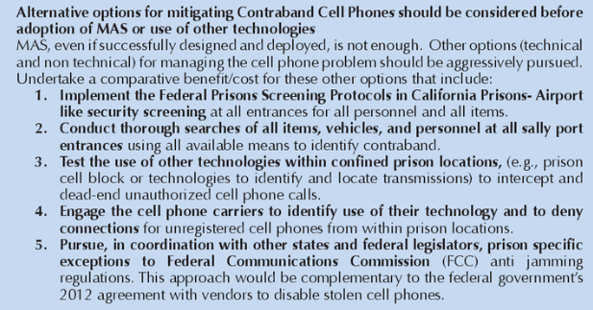

2. “Managed Access” means a lot of management
Mississippi Study: “Managed” access requires a lot of management
Dr. Eric Grommon, Dr. Jeremy G. Carter, Fred Frantz and Phil Harris 2015. (Grommon – PhD. Carte -, Ph.D. Frantz – with Engility Corporation. Harris - with Engility Corporation) “A Case Study of Mississippi State Penitentiary’s Managed Access Technology“ research report submitted to the U.S. Dept of Justice April 2015 https://www.ojp.gov/pdffiles1/nij/grants/250262.pdf (accessed 3 Apr 2022) (brackets added)
Managed access must be routinely managed. MDOC [Mississippi Dept. of Corrections] stated that they anticipated the system would be a “plug-and-play”, based on vendor information; however unexpected real-world elements came into play that changed initial expectations in regard to how the system should perform. MDOC stated that occasional system maintenance-related performance issues are addressed as they occur. MDOC stressed that confirmation of the coverage area was an ongoing maintenance task. MDOC personnel indicated that they did not anticipate the resources required to maintain and manage the authorized caller database. It was unclear what specific personnel were permitted for inclusion on the approved call list at MSP [Mississippi State Penitentiary]. No policies with respect to organizational rank or position for inclusion on the approved list were observed. Once this approved phone list was created and integrated into the managed access system, this approved list was constantly in need of updates to add or remove authorized devices as personnel were hired, given access, or were no longer employed at MSP.

Link: Bureau of Prisons doesn’t have the manpower – they’re badly understaffed.
Walter Pavlo 2022. (founder of founded Prisonology, an expert network firm of retired Bureau of Prisons professionals) 31 Mar 2022 “Bureau Of Prisons Is Overworking Its Most Critical Staff Positions During First Step Act Implementation” https://www.forbes.com/sites/walterpavlo/2022/03/31/bureau-of-prisons-is-overworking-its-most-critical-staff-positions-during-first-step-act-implementation/?sh=2b77867859e5 (accessed 3 Apr 2022)
The federal Bureau of Prisons has faced staffing shortages for years, which has led to increases in overtime, low morale and overworked staff. Nearly one-third of federal correctional officer jobs in the United States are vacant, forcing prisons to use cooks, teachers, nurses and other workers to oversee prisoners through a process known as augmentation. While there is a shortage of corrections officers, there is also a shortage of other professionals at a time when the BOP is trying to implement the First Step Act.

Impact: Failure. “Managed Access” only works if ongoing management works.
Dr. Eric Grommon, Dr. Jeremy G. Carter, Fred Frantz and Phil Harris 2015. (Grommon – PhD. Carte -, Ph.D. Frantz – with Engility Corporation. Harris - with Engility Corporation) “A Case Study of Mississippi State Penitentiary’s Managed Access Technology“ research report submitted to the U.S. Dept of Justice April 2015 https://www.ojp.gov/pdffiles1/nij/grants/250262.pdf (accessed 3 Apr 2022) (brackets added)
A correctional entity operating a managed access system or consuming services provided via a leased system must ensure that adaptations to counter carrier network changes are handled in a pro-active manner or the system will not retain its effectiveness as the surrounding cellular environment changes and new end user devices become available. Design, deployment, and operation of a managed access system is not a onetime event, it requires ongoing optimization and capability assessment in response to the surrounding environment.

3. Corrupt staff disable the system

Link: BOP is full of corruption
Hannah S. Brown 2021 (journalist) “The Bureau Of Prisons Needs New Leadership, Now” 8 Dec 2021 https://talkingpointsmemo.com/cafe/the-bureau-of-prisons-needs-new-leadership-now-carvajal-barr (accessed 3 Apr 2022)
A November 14, 2021 AP investigation revealed that the Bureau of Prisons is a “hotbed of abuse, graft and corruption,” with over 100 federal prison employees arrested, convicted or sentenced for crimes since the beginning of 2019. Since then, many have renewed their calls for Carvajal’s firing, including Senate Majority Whip Dick Durbin (D-IL). The disturbing extent of recently reported criminal behavior by prison workers is just one in a cascade of federal prison crises over the last two years.

Corrupt staff can disable the system
Mike Hynes & Nick Jordan 2019 (journalists) 16 July 2019 “How to Cure Prisons’ Contraband Mobile Phone Epidemic” https://www.securitymagazine.com/articles/90543-how-to-cure-prisons-contraband-mobile-phone-epidemic (accessed 3 Apr 2022)
Staff can disable or unplug jammers, rendering them useless. It’s not a scenario prison officials like to envision, but corrupt correctional officers and other staff can be bribed by prisoners to unplug or disable jammers temporarily to allow the inmates to make calls or send data. When it’s only a sporadic occurrence, it makes it very difficult to detect without catching the CO or inmate red-handed.

4. Blocking signals doesn’t solve

Cell phones can still be used to communicate without making calls
Mike Hynes & Nick Jordan 2019 (journalists) 16 July 2019 “How to Cure Prisons’ Contraband Mobile Phone Epidemic” https://www.securitymagazine.com/articles/90543-how-to-cure-prisons-contraband-mobile-phone-epidemic (accessed 3 Apr 2022)
While attacking contraband phones through their signals seems like a good way to ensure even phones that make it into prisons can’t be used, there are some major flaws to that solution. A cellphone can be used as a data storage device as well as for transmission. Even without signal and data access, a phone remains a useful data storage device. Inmates can record audio and video messages and arrange for the phone’s movement into and out of prison through staff, visitors and other means, using the phone itself or its SD/SIM card to carry data and continue to conduct criminal activities. The phone/data storage cards can also be used internally only, to pass information between inmates.
5. Many other changes needed

Managed Access isn’t a silver bullet – you need lots of other changes too
Dr. Eric Grommon, Dr. Jeremy G. Carter, Fred Frantz and Phil Harris 2015. (Grommon – PhD. Carte -, Ph.D. Frantz – with Engility Corporation. Harris - with Engility Corporation) “A Case Study of Mississippi State Penitentiary’s Managed Access Technology“ research report submitted to the U.S. Dept of Justice April 2015 https://www.ojp.gov/pdffiles1/nij/grants/250262.pdf (accessed 3 Apr 2022)
The corrections community must understand that managed access is not – and should not – be considered a silver bullet solution for the contraband cell phone problem. Cellular devices that cannot transmit a call or text pose potential harm in the correctional environment. Managed access should be utilized in conjunction with physical search and seizures of contraband cell phones. As noted above, multifunction device capabilities that fall outside of the scope of cellular communications simply cannot be managed with managed access technology and have to be mitigated via other means. Managed access technology serves as a tool to mitigate use of these devices by denying cellular service, diminishing the overall utility of smuggling these devices into a correctional facility.

6. More Study Needed

Before buying a Managed Access System, we need to do a 1-year pilot project study with independent outside oversight
California Council on Science & Technology 2012. (agency of the state government of California)“The Efficacy of Managed Access Systems to Intercept Calls from Contraband Cell Phones in California Prisons” May 2012 (accessed 3 Apr 2022) https://www.documentcloud.org/documents/355647-2012cell.html
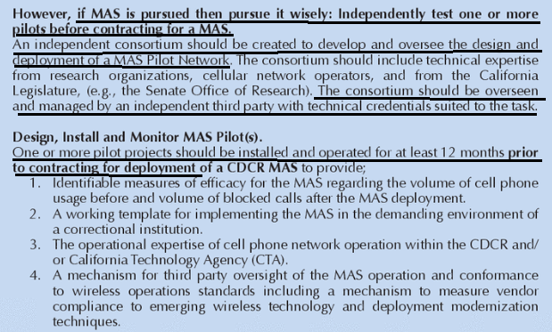

7. Requires constant, expensive upgrades

California study found Managed Access requires expensive deployment and even more expensive upgrades
Hannah S. Brown 2021 (journalist) “The Bureau Of Prisons Needs New Leadership, Now” 8 Dec 2021 https://talkingpointsmemo.com/cafe/the-bureau-of-prisons-needs-new-leadership-now-carvajal-barr (accessed 3 Apr 2022)
A nonpartisan study from the California Council on Science and Technology detailed a lengthy list of additional potential problems with managed access before the system was even deployed. The issue remains that technology is always changing, which means jamming, grabbing and managed access systems are only as good as the technology they were designed for. These systems would require constant upgrades to keep current – and not only are these methods expensive to deploy, but they’re even more costly to upgrade.

8. Text messaging

MAS can’t stop text messaging
California Council on Science & Technology 2012. (agency of the state government of California)“The Efficacy of Managed Access Systems to Intercept Calls from Contraband Cell Phones in California Prisons” May 2012 (accessed 3 Apr 2022) https://www.documentcloud.org/documents/355647-2012cell.html
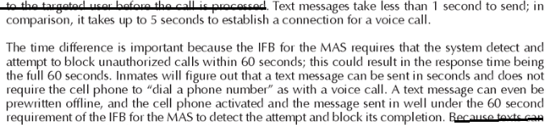

9. In-coming calls

In-coming calls would probably get through even with MAS activated. We need more study to find out
California Council on Science & Technology 2012. (agency of the state government of California)“The Efficacy of Managed Access Systems to Intercept Calls from Contraband Cell Phones in California Prisons” May 2012 (accessed 3 Apr 2022) https://www.documentcloud.org/documents/355647-2012cell.html
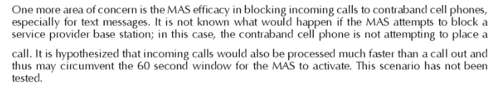

10. Technology gaps

Multiple gaps in MAS technology must be worked out to make it viable
California Council on Science & Technology 2012. (agency of the state government of California)“The Efficacy of Managed Access Systems to Intercept Calls from Contraband Cell Phones in California Prisons” May 2012 (accessed 3 Apr 2022) https://www.documentcloud.org/documents/355647-2012cell.html
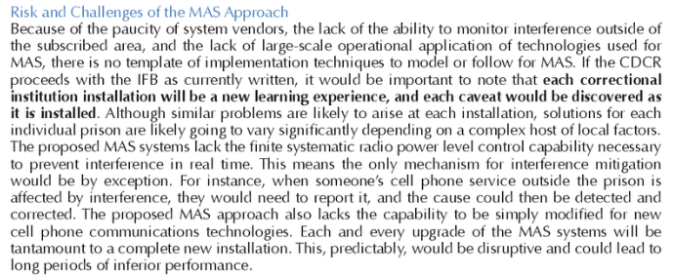

DISADVANTAGES

1. Manpower diversion

Link: Mississippi Study found - Managed Access technology requires big commitment of manpower
Dr. Eric Grommon, Dr. Jeremy G. Carter, Fred Frantz and Phil Harris 2015. (Grommon – PhD. Carte -, Ph.D. Frantz – with Engility Corporation. Harris - with Engility Corporation) “A Case Study of Mississippi State Penitentiary’s Managed Access Technology“ research report submitted to the U.S. Dept of Justice April 2015 https://www.ojp.gov/pdffiles1/nij/grants/250262.pdf (accessed 3 Apr 2022)
The present study identified the following challenges associated with deployment and operations of managed access technology: 1. Managed access has to be routinely “managed”. This task requires a significant labor commitment from the host agency, in addition to ensuring that personnel have appropriate technical skills.

Link & Brink: Attorney General admits federal prison staffing is “a serious problem”
KERI BLAKINGER, JAMILES LARTEY, BETH SCHWARTZAPFEL, MIKE SISAK and CHRISTIE THOMPSON 2021 (staff writers for The Marshall Project, a non-profit research group on criminal justice) “As Corrections Officers Quit in Droves, Prisons Get Even More Dangerous” 1 Nov 2021 https://www.themarshallproject.org/2021/11/01/as-corrections-officers-quit-in-droves-prisons-get-even-more-dangerous (accessed 3 Jan 2022)
Asked last week in a U.S. Senate hearing about federal prison staffing, Attorney General Merrick Garland said, “I agree this is a serious problem at the Bureau of Prisons.”

Link: BOP can’t attract and hire new employees because pay is too low
FEDAgent 2021. (News group for federal law enforcement employees) “Lawmakers Request BOP Director Provide Insight on Augmenting Personnel, Staff Shortages” 11 Nov 2021 https://www.fedagent.com/news/lawmakers-request-bop-director-provide-insight-on-personnel-augmentation-staff-shortages (accessed 3 Jan 2022)
GAO found that although BOP budgeted for 20,446 full-time correctional officer positions in 2020, the agency reported that it currently employs 13,762 officers. Despite efforts to attract recruits with 25 percent bonuses, there has been little progress. While there are promises of making $62,615 as a recruitment incentive, the starting salary is just under $43,500. The highest end of this salary scale is still much lower than what other federal agencies offer, especially compared with the competition from police departments, state prisons, oil refineries, and warehouses.
Impact: Exponential increase in prison violence when staffing is lost
Shane Fausey 2020. (president of the American Federation of Government Employees (AFGE) National Council of Prison Locals 33 ) 14 May 2020 “Being a prison officer is now more dangerous than ever” https://federalnewsnetwork.com/workforce/2020/05/being-a-prison-guard-now-more-dangerous-than-ever/ (accessed 2 Jan 2022)
Shane Fausey: We have been plagued with staffing concerns since about 2005. They implemented a program called mission critical, which they took about 20% of the correctional services staff or your officers in your prisons. And consistently over the years, most notably January of 2017, they executed another series of cuts. We’re down probably close to 9000 to 10,000 positions since 2005. Unfortunately, in a prison when you reduce your overall staffing numbers, your violence exponentially increases.

2. Masking DA: Distracts us from the right solution

Focus on blocking signals is bad because it distracts us from what would really work: Grabbing the contraband devices themselves
California Council on Science & Technology 2012. (agency of the state government of California)“The Efficacy of Managed Access Systems to Intercept Calls from Contraband Cell Phones in California Prisons” May 2012 (accessed 3 Apr 2022) https://www.documentcloud.org/documents/355647-2012cell.html
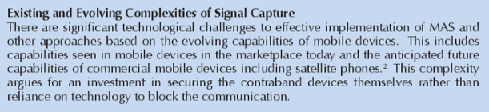

California confirms: MAS looked good at first, but it 1) quickly became obsolete and 2) interfered with neighboring cell phone reception. They gave up on it and went back to trying to physically keep the phones out of prison
Andria Borba and Leslie Donaldson 2016 (journalists with KPIX news in San Francisco) 15 Nov 2016 “Cellphones Keep Cropping Up Inside California Prisons” (accessed 3 Apr 2022) (brackets added) https://sanfrancisco.cbslocal.com/2016/11/15/cellphones-keep-cropping-up-inside-california-prisons/
In 2012, the CDCR [Calif. Dept of Corrections & Rehabilitation] rolled out to much fanfare a system to block and intercept inmate cell phone calls. But the system never made it to San Quentin. One reason is the close proximity of the prison to drivers on Highway 580 and the Richmond-San Rafael Bridge. The signal blockers could potentially interfere with emergency calls. In fact, the blocking system – known as Managed Access – was only installed in 18 of the 33 California state prisons. “It has proven to be pretty successful because it can block and interrupt about an average of 150,000 cell calls or text messaging every week,” said Waters. But as wireless technology progressed from 3G, 4G and beyond, the blockers became obsolete. CDCR has moved from call blocking to trying to keep the phones out in the first place. After the Nichols arrest, San Quentin Correctional Lt. Sam Robinson noted, “All of our mechanisms that we have in place did not catch a substantial amount of things that we do not want inside our prison.”
3. Neighboring communities harmed

MAS will disrupt nearby communities’ cell phone service and 911 emergency service
California Council on Science & Technology 2012. (agency of the state government of California)“The Efficacy of Managed Access Systems to Intercept Calls from Contraband Cell Phones in California Prisons” May 2012 (accessed 3 Apr 2022) https://www.documentcloud.org/documents/355647-2012cell.html
