Negative: Drug Tests – not a problem
By “Coach Vance” Trefethen
The United States Federal Government should significantly reform its policies regarding convicted prisoners under federal jurisdiction
Case Summary: The AFF plan bans drug test kits that are used in prison. Their theory is that they are often inaccurate and lead to prisoners being falsely accused and wrongly disciplined.
Negative: Drug Tests – not a problem 3
HARMS / SIGNIFICANCE 3
1. A/T “Solitary confinement” 3
Rarely used: Solitary population is 1/5 of 1% and it’s justified to ensure safety of staff and other inmates 3
Short duration: Only 15% of solitary prisoners are there for longer than 90 days 3
2. Not widely used 4
Urinalysis with outside lab verification is the most commonly used drug test 4
3. No rights violation 4
Use of a single drug test, even if not 100% accurate, does not violate prisoners’ due process rights 4
4. A/T “Good Time credits lost” 4
Sorry but… Good Time credits are a privilege, not a right 4
5. A/T “Lose visitation” 5
Sorry but… Visitation is a privilege, not a right 5
SOLVENCY 6
1. Alternatives tests are no better 6
The alternatives have drawbacks and also produce false alarms 6
2. Outside verification is too slow 7
Outside lab verification of prison drug tests can take 4 months 7
DISADVANTAGES 7
1. More drugs = more problems 7
Link: Other methods don’t detect many seriously dangerous drugs 7
Impact: More drugs = more danger to inmates and staff 7
Voting Impact: Correctional Officer (CO) safety should be the paramount goal. It’s more important than any AFF goal 8
2. Harmful family visits 8
Link: AFF Plan claims to restore family visits to prisoners who are denied due to drug tests 8
Link: Surprise! Criminals make bad parents, so the less time kids spend with them, the better 8
“Kids with parents in prison do poorly” – No surprise, they’re bad parents. Ohio study finds troubled kids do better when their criminal parents are in prison (where the kids can’t interact with them) 9
Methodology of the Ohio study and quantification: Having criminal parents in prison = 40% reduction in chance of child being incarcerated before age 25, compared to criminal parents not in prison 9
Ohio study finds kids with criminal parents in prison have slightly better socioeconomic status than when criminal parents are not in prison 9
Colombia and Norway studies confirm Ohio study results 10
Impact: Bad childhood leads to bad adulthood, including violence, mental health problems and substance abuse 10
3. Less time = more crime 10
Link: AFF tells you prisoners lose “good time” credits based on test results 10
Impact: Less time = more crime. Shorter sentences are bad because longer sentences reduce crime 10
4. Alternative drug solutions also harm prisoners 11
The alternative to field kits is banning mail and books 11

Negative: Drug Tests – not a problem

HARMS / SIGNIFICANCE

1. A/T “Solitary confinement”
Rarely used: Solitary population is 1/5 of 1% and it’s justified to ensure safety of staff and other inmates
Charles E. Samuels 2014. (Director, Federal Bureau of Prisons) 25 Feb 2014 Statement before the Subcommittee on the Constitution, Civil Rights and Human Rights of the Senate Judiciary Committee https://www.congress.gov/event/113th-congress/senate-event/LC60861/text?s=1&r=46 (accessed 19 Sept 2021)
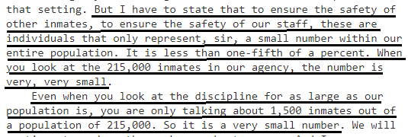

Short duration: Only 15% of solitary prisoners are there for longer than 90 days
Charles E. Samuels 2014. (Director, Federal Bureau of Prisons) 25 Feb 2014 Statement before the Subcommittee on the Constitution, Civil Rights and Human Rights of the Senate Judiciary Committee https://www.congress.gov/event/113th-congress/senate-event/LC60861/text?s=1&r=46 (accessed 19 Sept 2021)
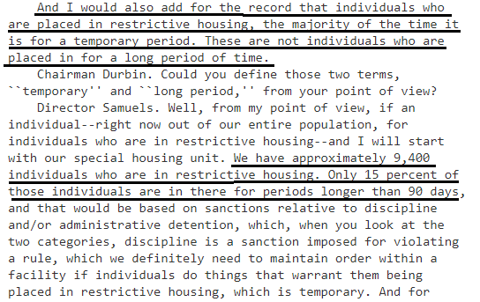

2. Not widely used
Urinalysis with outside lab verification is the most commonly used drug test
M.N. Parsons, M. Camello, T. Craig, M. Dix, M. Planty, J.D. Roper-Miller 2021. (study done on contract with US Dept of Justice) Detecting and Managing Drug Contraband: An Overview of Technologies for Managing Entry of Drug Contraband and Detecting their Use in Correctional Facilities, Sept 2021 (https://www.ojp.gov/pdffiles1/nij/grants/302135.pdf (accessed 10 Mar 2022)
Furthermore, current regulations in the Federal BOP restrict the use of opioid derivatives in correctional facilities, presently prohibiting comprehensive MAT programs. The threat that drugs intended for treatment can be hoarded and trafficked within the prison introduces additional challenges to drug mitigation efforts. Drug use in prisons can be monitored by random or scheduled drug screening. The use of drug screening in itself is not a preventive method but enables correctional authorities to audit the effectiveness of drug interdiction efforts and ultimately manage the application of treatment to inmates with drug dependencies. Urinalysis is the most common type of drug screening and is typically outsourced for laboratory analysis, which can take 5 to 10 days for results.

3. No rights violation

Use of a single drug test, even if not 100% accurate, does not violate prisoners’ due process rights
Decision of the federal 4th Circuit Court of Appeals in the case of Thompson et al. v. Maryland Dept of Corrections 1989. https://law.justia.com/cases/federal/appellate-courts/F2/883/70/350391/ (accessed 10 Mar 2022)
At the center of this controversy is the use of an Enzyme Multiplied Immunoassay Technique ("EMIT") test, unconfirmed by a secondary analytical detection method, as the sole means of detecting drug use by Maryland Prison inmates.
END QUOTE. THEY GO ON LATER IN THE CONTEXT TO WRITE QUOTE:
We hold that the EMIT test, scientifically recognized as a valid medical procedure, constitutes some evidence to support the imposition of disciplinary sanctions. See, e.g., Spence v. Farrier, 807 F.2d 753 (8th Cir. 1986); Adkins v. Martin, 699 F. Supp. 510 (W.D. Okla. 1988); Perzano v. Couglin, 675 F. Supp. 102 (S.D.N.Y. 1987); Jensen v. Lick, 589 F. Supp. 35 (D.N.D. 1984). The district court was impressed by the fact that EMIT testing does not have a 100% confidence factor. This concern is misplaced at law, however. We note that other forms of evidence, such as eyewitness testimony, universally recognized as legally sufficient, cannot be said to be 100% reliable. Further, we find no authority for the proposition that due process is a technology forcing concept rendering it incumbent upon the Government to employ the latest in scientific technology. The record clearly reflects that in pursuing legitimate penological goals, the Maryland Department of Corrections employed a well recognized scientific methodology to detect drug use. When balanced against the requirements of due process, we find that the use of such a scientifically recognized test to detect inmate drug use afforded the appellants all the process due them under the Constitution and interpreting case law.

4. A/T “Good Time credits lost”

Sorry but… Good Time credits are a privilege, not a right
Government Accountability Office 2011. Report to Congressional Committees: September 2011: Bureau of Prisons: Improved Evaluations and Increased Coordination Could Improve Cell Phone Detection 6 Sept 2011 https://www.gao.gov/assets/a322809.html (accessed 10 Mar 2022)
According to officials in BOP's Correctional Programs Division, when an inmate is caught with a cell phone, an incident report is filed and the inmate is subject to BOP's disciplinary process, which involves an administrative hearing[Footnote 20]. The inmate ultimately could face a range of sanctions from transfer to a higher-security institution to loss of "good time" or other privileges.

5. A/T “Lose visitation”
Sorry but… Visitation is a privilege, not a right
Inmate Information Handbook, Federal Bureau of Prisons 2006. (article is undated but contains material time-stamped in 2006) https://www.bop.gov/locations/institutions/spg/SPG_aohandbook.pdf (accessed 10 Mar 2022)
Once the inmates and visitors are seated, inmates may not slump in the chairs, put their feet on the tables, lay on each other, cross legs with another, embrace, massage, or anything else which involves excessive and constant touching. Visitors, with the exception of small child, will not be permitted to sit on the lap of an inmate. The officers will issue only one warning. This will be documented as your one and only warning concerning excessive contact. Any additional contact will be subject to termination of the visit, and disciplinary action will result in suspension of visiting privileges.

SOLVENCY

1. Alternatives tests are no better
The alternatives have drawbacks and also produce false alarms
M.N. Parsons, M. Camello, T. Craig, M. Dix, M. Planty, J.D. Roper-Miller 2021. (study done on contract with US Dept of Justice) Detecting and Managing Drug Contraband: An Overview of Technologies for Managing Entry of Drug Contraband and Detecting their Use in Correctional Facilities, Sept 2021 (https://www.ojp.gov/pdffiles1/nij/grants/302135.pdf (accessed 10 Mar 2022)
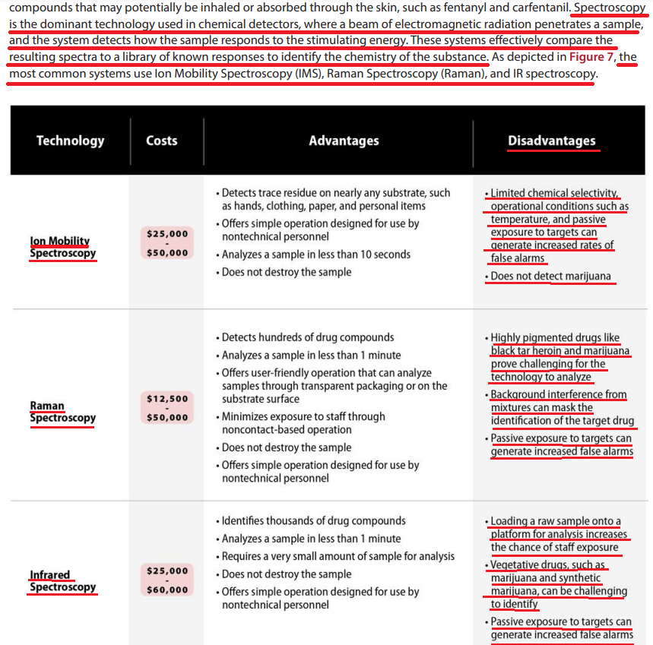

2. Outside verification is too slow

Outside lab verification of prison drug tests can take 4 months
M.N. Parsons, M. Camello, T. Craig, M. Dix, M. Planty, J.D. Roper-Miller 2021. (study done on contract with US Dept of Justice) Detecting and Managing Drug Contraband: An Overview of Technologies for Managing Entry of Drug Contraband and Detecting their Use in Correctional Facilities, Sept 2021 (https://www.ojp.gov/pdffiles1/nij/grants/302135.pdf (accessed 10 Mar 2022)
Historically, drug analysis has been performed in the laboratory, which is costly, time consuming, and requires highly trained scientific personnel. Because of the complicated laboratory process and the number of drug samples submitted to forensic toxicology laboratories, some states have observed a backlog of nearly 4 months.

DISADVANTAGES

1. More drugs = more problems

Link: Other methods don’t detect many seriously dangerous drugs
M.N. Parsons, M. Camello, T. Craig, M. Dix, M. Planty, J.D. Roper-Miller 2021. (study done on contract with US Dept of Justice) Detecting and Managing Drug Contraband: An Overview of Technologies for Managing Entry of Drug Contraband and Detecting their Use in Correctional Facilities, Sept 2021 (https://www.ojp.gov/pdffiles1/nij/grants/302135.pdf (accessed 10 Mar 2022)
Drug contraband is a constant threat within the U.S. correctional system because higher potency drugs and newly synthesized analogs, as summarized in Figure 2, are becoming increasingly difficult to detect. In addition to marijuana, cocaine, heroin, and methamphetamines, synthetic cannabinoids, cathinones, and opioid analogs are becoming more pervasive. These synthetic or designer drugs are collectively known as novel (new) psychoactive substances (NPS). The term NPS is a legal definition, and there is no universally agreed-upon way to categorize them, but generally they are grouped into three of four categories as stimulants, depressants, hallucinogens, and cannabinoids. While NPS are associated with prisoner harm, their prevalence in prisoner populations is largely undetermined. In 2020, a British report based on a voluntary questionnaire of the 186 responding prison staff indicated that 67% asserted that NPS had a deep impact on their work as they commonly witnessed prisoners exhibiting drug effects (e.g., outbursts of anger, slurred speech, hallucinations, psychosis, significant mental deterioration). Similarly, 91% have witnessed aggression at least once, with 53% experiencing direct harm. As substances emerge that are significantly more potent than traditional drugs, detection methods must evolve and adapt. Even with sophisticated detection technologies, smaller quantities of drugs are less conspicuous to correctional staff and can be challenging to detect using physical searches and body imaging technology.

Impact: More drugs = more danger to inmates and staff
US Justice Dept. Office of the Inspector General 2003. THE FEDERAL BUREAU OF PRISONS’ DRUG INTERDICTION ACTIVITIES Report Number I-2003-002, Jan 2003 https://oig.justice.gov/reports/BOP/e0302/final.pdf (accessed 10 Mar 2022)
The harm of drugs in BOP institutions is clear. Drugs disrupt the BOP from providing a safe and secure environment for inmates and staff. Drug abuse is associated with serious inmate misconduct, and it also interferes with the rehabilitative potential of BOP drug treatment programs. In addition, inmates with drug problems who have not received treatment while in prison are more likely to continue criminal activity after their release from incarceration, thereby affecting public safety.

Voting Impact: Correctional Officer (CO) safety should be the paramount goal. It’s more important than any AFF goal
Frank V. Ferdik & Hayden P. Smith 2017 (Ferdik - Department of Criminology and Criminal Justice, University of West Florida, Pensacola. Smith - Department of Criminology and Criminal Justice, University of South Carolina, Columbia) Correctional Officer Safety and Wellness Literature Synthesis, July 2017 https://www.ojp.gov/pdffiles1/nij/250484.pdf (accessed 20 Sept 2021)
Officers are tasked with demanding and often conflicting work responsibilities that increase their risk for physical and mental health problems such as injuries, stress, and even death. Officers must interact with and supervise potentially dangerous individuals such as gang members, inmates with mental illness, and those with communicable diseases, which further complicates officers’ health issues. According to the research cited above, officers, regardless of security assignment, recognize the danger to which they are subject as a result of their profession. Many scholars conclude that employment as a CO is among the most dangerous and life threatening of all professions, including law enforcement. Given how COs are heavily relied upon to supervise inmate behavior, establish order in their facilities, and maintain wider institutional security, it is paramount that correctional practitioners, researchers, administrative officials, and other interested stakeholders begin developing more effective and widely used strategies for enhancing the general well-being of this critically important workforce.

2. Harmful family visits

Link: AFF Plan claims to restore family visits to prisoners who are denied due to drug tests
That’s one of the harms they claim to be solving for. But that’s actually a bad thing because…

Link: Surprise! Criminals make bad parents, so the less time kids spend with them, the better
Charles Fain Lehman 2021 (fellow at the Manhattan Institute, working primarily on the Policing and Public Safety Initiative, and a contributing editor of City Journal) 24 May 2021 “Parents and Prisons” Institute for Family Studies https://www.manhattan-institute.org/parents-and-prisons (accessed 31 Oct 2021)
The subset of the population that ends up incarcerated is disproportionately likely to have character traits particularly adverse to good parenting. As my colleague Rafael Mangual has noted, antisocial personality disorder is 10 to 23 times more common in prisoners than it is in the general population, suggesting that prisons tend to select personalities at risk for harming their children. High rates of recidivism—more than 80% of prisoners released are rearrested within 10 years, the Bureau of Justice Statistics has found—similarly support the idea that prison populations are made up of those most prone to taking advantage of and harming others, including their children. The evidence on partner behavior in the paper, indicating that some parents make their partners more likely to commit crimes, also supports this notion that some parents are just dangerous influences.

[Background on the Ohio Study evidence below: All the parents in the study are in the criminal justice system – they’re all criminals. The study compared the kids of criminal parents where the parents were in prison versus kids with criminal parents who were not in prison (e.g. probation, or some other non-prison scenario). The kids with criminal parents IN prison turned out better than the kids with criminal parents NOT in prison.]
“Kids with parents in prison do poorly” – No surprise, they’re bad parents. Ohio study finds troubled kids do better when their criminal parents are in prison (where the kids can’t interact with them)
Charles Fain Lehman 2021 (fellow at the Manhattan Institute, working primarily on the Policing and Public Safety Initiative, and a contributing editor of City Journal) 24 May 2021 “Parents and Prisons” Institute for Family Studies https://www.manhattan-institute.org/parents-and-prisons (accessed 31 Oct 2021)
Pointing to evidence that children with incarcerated parents do worse on a host of indicators than their peers with intact families, they argue that the costs of "breaking up" a family often outweigh the benefits to public safety, and that therefore pro-family conservatives must necessarily be in favor of decarceration. Much of the evidence used to make this argument, however, is limited in its capacity to really establish a causal link between parental incarceration and worse outcomes. Children of incarcerated parents may already be on a worse path for reasons other than the fact of their parent's incarceration—a worse family environment precipitated by the same character traits that made their parent likely to be a criminal offender. To really separate out the effect of parental incarceration on children's outcomes, researchers need a source of randomness in a parent's propensity to be incarcerated, one necessarily uncorrelated with their children's outcomes. A new study, forthcoming in the American Economic Review, identifies just that, and the results are startling. Contrary to the assumption that parental incarceration is destructive to children, the paper finds that parental incarceration reduces children's propensity to be incarcerated and improves their adult neighborhood quality, while having no significant effect on their academic performance.

Methodology of the Ohio study and quantification: Having criminal parents in prison = 40% reduction in chance of child being incarcerated before age 25, compared to criminal parents not in prison
Charles Fain Lehman 2021 (fellow at the Manhattan Institute, working primarily on the Policing and Public Safety Initiative, and a contributing editor of City Journal) 24 May 2021 “Parents and Prisons” Institute for Family Studies https://www.manhattan-institute.org/parents-and-prisons (accessed 31 Oct 2021)
To reach their conclusions, the paper's authors assembled a rich array of data on prisoners and their children from the three Ohio counties home to Columbus, Cleveland, and Cincinnati. About 60% of the parents in the survey are male, with an average of 1.86 children, who range in age from 1 to 19 years old at the time of their parent's court date. Using these data, they conducted a "judge assignment" study, taking advantage of the random assignment of offenders to judges with a known variability in their propensity to incarcerate as a source of randomness that permitted isolating the effects of parental incarceration from other variables. Their biggest finding is the effect on children's future propensity to be incarcerated: parental incarceration was linked to a 20% reduction in a child's likelihood of being charged, a 22% cut in chance of being convicted, and a 40% reduction in the chance of being incarcerated before age 25. Notably, those effects are driven by the black children in their data.

Ohio study finds kids with criminal parents in prison have slightly better socioeconomic status than when criminal parents are not in prison
Charles Fain Lehman 2021 (fellow at the Manhattan Institute, working primarily on the Policing and Public Safety Initiative, and a contributing editor of City Journal) 24 May 2021 “Parents and Prisons” Institute for Family Studies https://www.manhattan-institute.org/parents-and-prisons (accessed 31 Oct 2021)
Just as surprising are the other findings. Parental incarceration actually led to a slight increase (4.1 percentiles) in the socioeconomic status of the neighborhood the child ended up living in. And it had almost-zero, non-significant effects on children's academic performance (math and reading scores, GPA, absenteeism, risk of repeating a grade) and risk of teen parenthood—parental incarceration did not improve these measures in the study, but it didn't harm them, either.

Colombia and Norway studies confirm Ohio study results
Charles Fain Lehman 2021 (fellow at the Manhattan Institute, working primarily on the Policing and Public Safety Initiative, and a contributing editor of City Journal) 24 May 2021 “Parents and Prisons” Institute for Family Studies https://www.manhattan-institute.org/parents-and-prisons (accessed 31 Oct 2021)
The Ohio study is actually not the only study to find that parental incarceration can have positive effects. Research from Colombia finds that parental incarceration increased children's years of schooling, while evidence from Norway offers similar null estimates.

Impact: Bad childhood leads to bad adulthood, including violence, mental health problems and substance abuse
Dr. James Garbarino 2017 (PhD; Dept of Psychology, Center for the Human Rights of Children, Loyola University) ACEs in the Criminal Justice System ACADEMIC PEDIATRICS September–October 2017 https://capwayne.org/wp-content/uploads/2019/09/Materials-for-10-Tips-for-Sentencing-Advocacy.pdf (accessed 4 Dec 2021)
It should not come as a surprise that childhood adversity is common and prominent among individuals who kill people. Childhood adversity leads to trauma and toxic stress, and trauma and toxic stress lead to the kind of developmental damage that in turn can lead to violence (as one among many outcomes, or other outcomes such as substance abuse and mental health that could similarly have repercussions for incarceration either as juveniles or adults) in the United States.

3. Less time = more crime

Link: AFF tells you prisoners lose “good time” credits based on test results
That means in the Status Quo they’re staying in prison for the actual duration of their sentence and not getting out early. If their plan “solves” for that, that’s a bad thing because…

Impact: Less time = more crime. Shorter sentences are bad because longer sentences reduce crime
Prof. BARRY LATZER 2020. (emeritus professor at John Jay College of Criminal Justice, New York) 17 Feb 2020 “Democrats Prefer ‘Reforming’ the Criminal-Justice System to Punishing Criminals” (accessed 1 July 2021) https://www.nationalreview.com/2020/02/democrats-prefer-reforming-criminal-justice-system-to-punishing-criminals/
The United States is still in a crime trough, with violent crime rates down 51 percent since 1991. When crime is low, pressures mount to reduce especially punitive measures, such as long prison sentences or the death penalty. Meanwhile, progressives are also motivated by the belief that the criminal-justice system is biased against African Americans, as a disproportionate number of them are in prisons and jails. Though blacks are roughly 13 percent of the United States population, they are 31 percent (see table 3 of the BJS report) of state prison inmates. (No one has convincingly demonstrated that this gap is the result of anything other than a disparity in crime rates, so the racism allegation is unsupported.) The truth is that we are already in a period of retrenchment in criminal justice, a cutting back on arrests, prosecutions and incarceration. Imprisonment rates have fallen steadily since 2007, dropping by 15 percent. For African Americans the decline was 31 percent. The Democratic candidates for president have latched on to the cutback trend, some a lot more aggressively than others, whereas President Trump, to the extent that he takes a stance at all, has chosen a more traditional road, aiming at crime control rather than system reform. The risk in the Democrats’ leniency approach is that it may fuel another crime wave, a long-term crime boom, such as the terrible ordeal the country endured from the late 1960s to the early 1990s. The weakening of the system (fewer arrests and imprisonments, shorter sentences) was a major factor in the late 60s rise in crime. On the other hand, however, past crime booms have had multiple causes in addition to a weak criminal-justice system, such as a rise in the young male population. So far at least, these other crime correlates are not currently present.

4. Alternative drug solutions also harm prisoners

The alternative to field kits is banning mail and books
C. J. Ciramella 2021 (journalist) REASON magazine July 2021 “The $2 Drug Test Keeping Inmates in Solitary” .https://reason.com/2021/06/13/the-2-drug-test-keeping-inmates-in-solitary/ (accessed 10 Mar 2022)
To combat the flood of drugs, many state prisons have taken steps like banning physical mail and used book donations, which they claim are a major source of contraband. The BOP uses Safariland's NIK field kits to check for suspected drugs.

