Negative: Pregnant Women in Solitary Confinement
By “Coach Vance” Trefethen
Resolved: The United States Federal Government should significantly reform its policies regarding convicted prisoners under federal jurisdiction
Case Summary: The AFF plan bans the use of solitary confinement for pregnant women prisoners. All AFF evidence is based on state prisons and state prison policies, not federal. On average, there might be 1 federal prisoner giving birth in solitary confinement in any given year.
Negative: Pregnant Women / Solitary Confinement 3
NEGATIVE PHILOSOPHY / GOAL 3
1. Staff safety should take priority over prisoner comfort 3
Federal prisons are dangerous for staff 3
Increased use of solitary confinement started in 1983 after killing of 2 guards at federal prison in Marion, Illinois. 3
Correctional Officer (CO) safety should be the paramount goal 4
TOPICALITY 4
1. No significant reform 4
Definition of significant 4
Definition of policy 4
Status Quo Bureau of Prisons policy: We don’t put pregnant women in restrictive housing or restraints unless there are exceptional circumstances 4
Definition of restrictive housing - includes solitary confinement 4
Impact: No one affirming the resolution means Negative ballot. 4
INHERENCY 5
1. Highly restricted and carefully monitored 5
Dept. of Justice highly restricts pregnant women in Solitary, and requires special approval and careful monitoring 5
2. Mental health safeguards in place 5
Special Housing Unit (SHU) risks to mental health are recognized, and they have extra psychology staff handling it 5
Mental health services have been upgraded for Special Housing Unit (SHU), Special Management Unit (SMU) and Supermax (ADX) 5
MINOR REPAIR – Collect more data 6
Let’s collect more data to ensure that Status Quo policy on pregnant prisoners is being followed 6
HARMS / SIGNIFICANCE 7
1. No pregnancy crisis in solitary confinement 7
Solitary for pregnant women is 1) rare (31women over 3 years) 2) short (average of 6 days duration) and 3) justified (for causing trouble) 7
2. No crisis of live births in solitary confinement 7
Link: 180 pregnant prisoners in a single year, 94 gave birth in prison 7
Only 1.4% of women are in solitary at any given time and only if there’s a threat to themselves or others 7
94 births in federal prison, of whom 1.4% of women are in solitary. 1.4% of 94 = about 1 per year, and only if they’re an exceptional threat 7
3. A/T “Medical attention arrives too late” (Affirmative’s “Hastings Journal” evidence) 8
That’s about California state prisons, not federal 8
“Medical attention arrives too late” because of California state prison regulations 8
Problems are caused by California State prison policies, not federal 8
4. A/T “Constitutional violation (8th Amendment)” – Constitution doesn’t require comfortable prisons 9
In a lawsuit over prison conditions at Federal prison in Marion, Illinois, a federal judge points out that prisons aren’t required to be comfortable 9
5. Confinement is temporary in most cases 9
Only 15% of solitary prisoners are there for longer than 90 days 9
6. Very few women in high security 9
Nearly all women are in low or minimum security facilities 9
Minimum security Dublin Federal Prison Camp for women: It’s relaxed and sounds like Summer Camp! 10
See if you can work up sympathy for the women at Dublin Federal prison camp over their “awful” conditions… 10
SOLVENCY 10
1. No safe alternative to solitary 10
Prison officials and advocates who agree with Affirmative all agree: There’s not really any safe alternative 10
DISADVANTAGES 11
1. Violence & Death 11
Solitary confinement prisoners are there because they kill other prisoners 11
At Colorado Supermax (ADX), 47% of the solitary prisoners are there because they killed an inmate or prison staff 11
When bad guys find out they can’t be put into solitary for disciplinary reasons, they’ll increase their attacks on prison staff and other inmates 12
People will die if you ban solitary confinement 12

Negative: Pregnant Women / Solitary Confinement

NEGATIVE PHILOSOPHY / GOAL

1. Staff safety should take priority over prisoner comfort
Federal prisons are dangerous for staff
Charles E. Samuels 2014. (Director, Federal Bureau of Prisons) 25 Feb 2014 Statement before the Subcommittee on the Constitution, Civil Rights and Human Rights of the Senate Judiciary Committee https://www.congress.gov/event/113th-congress/senate-event/LC60861/text?s=1&r=46 (accessed 19 Sept 2021)
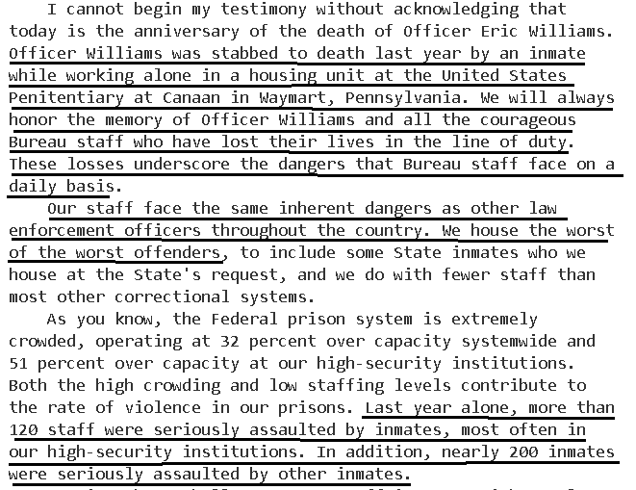

Increased use of solitary confinement started in 1983 after killing of 2 guards at federal prison in Marion, Illinois.
Natasha A. Frost, Ph.D. Carlos E. Monteiro, Ph.D. 2016. (with National Institute of Justice, part of US Dept of Justice) Restrictive Housing in the U.S.: Issues, Challenges, and Future Directions (no month given in the publication) https://www.ojp.gov/pdffiles1/nij/250316.pdf (accessed 19 Sept 2021)
Although the increase in prison violence troubled correctional administrators, correctional historians often point to the 1983 killing of two correctional officers at Marion as the trigger for the revival of total lockdown units and facilities (King, 1999; Pizarro & Stenius, 2004). In the immediate aftermath of those killings, Marion administrators rapidly reintroduced highly restrictive procedures, beginning with the immediate removal of inmates’ personal property from individual cells, followed by the placement of severe restrictions on inmates’ movements within the prison, the use of handcuffs whenever an inmate was not in the cell area, and increased use of solitary confinement (King, Steiner, & Breach, 2008). Although the conditions at Marion sparked immediate pushback from prisoner rights groups, the use of control units received judicial endorsement when, in Bruscino v. Carlson, a federal court opined that BOP had not violated inmates’ constitutional rights (Olivero & Roberts, 1987).

Correctional Officer (CO) safety should be the paramount goal
Frank V. Ferdik & Hayden P. Smith 2017 (Ferdik - Department of Criminology and Criminal Justice, University of West Florida, Pensacola. Smith - Department of Criminology and Criminal Justice, University of South Carolina, Columbia) Correctional Officer Safety and Wellness Literature Synthesis, July 2017 https://www.ojp.gov/pdffiles1/nij/250484.pdf (accessed 20 Sept 2021)
Many scholars conclude that employment as a CO is among the most dangerous and life threatening of all professions, including law enforcement. Given how COs are heavily relied upon to supervise inmate behavior, establish order in their facilities, and maintain wider institutional security, it is paramount that correctional practitioners, researchers, administrative officials, and other interested stakeholders begin developing more effective and widely used strategies for enhancing the general well-being of this critically important workforce.

TOPICALITY

1. No significant reform
Definition of significant
Merriam Webster Online Dictionary copyright 2021. https://www.merriam-webster.com/dictionary/significant
of a noticeably or measurably large amount

Definition of policy
Merriam Webster Online Dictionary copyright 2021. https://www.merriam-webster.com/dictionary/policy
a high-level overall plan embracing the general goals and acceptable procedures especially of a governmental body

Status Quo Bureau of Prisons policy: We don’t put pregnant women in restrictive housing or restraints unless there are exceptional circumstances
Government Accountability Office 2021. (GAO, agency of federal government that does audits and reports on efficiency and effectiveness of government programs) 25 Jan 2021 “Pregnant Women in DOJ Custody” https://www.gao.gov/assets/gao-21-147.pdf (accessed 25 Feb 2022)
Related to segregation, the policy states that pregnant and postpartum women should not be placed in restrictive housing; if BOP staff plan to do so, then senior facility officials must approve such a decision. Concerning the use of restraints, policy prohibits the use of restraints on pregnant women from pregnancy confirmation until the end of postpartum recovery, unless one of the three statutory exceptions applicable to BOP corrections officials under the First Step Act of 2018 is met.

Definition of restrictive housing - includes solitary confinement
Government Accountability Office 2021. (GAO, agency of federal government that does audits and reports on efficiency and effectiveness of government programs) 25 Jan 2021 “Pregnant Women in DOJ Custody” https://www.gao.gov/assets/gao-21-147.pdf (accessed 25 Feb 2022)
The Department of Justice defines restrictive housing as any type of detention that involves (1) removal from the general prisoner population, whether voluntary or involuntary; (2) placement in a locked room or cell, whether alone or with another prisoner; and (3) inability to leave the room or cell for the vast majority of the day, typically 22 hours or more.

Impact: No one affirming the resolution means Negative ballot.
Status Quo policy is that pregnant women are not put into solitary unless there is some exceptional reason to do so and it requires special approval. That’s the same as the Affirmative’s plan. That means there is no one affirming the resolution for significant reform. If no one affirms the resolution, then no matter who wins the round, you should vote Negative.

INHERENCY

1. Highly restricted and carefully monitored
Dept. of Justice highly restricts pregnant women in Solitary, and requires special approval and careful monitoring
Government Accountability Office 2021. (GAO, agency of federal government that does audits and reports on efficiency and effectiveness of government programs) 25 Jan 2021 “Pregnant Women in DOJ Custody” https://www.gao.gov/assets/gao-21-147.pdf (accessed 25 Feb 2022)
Specifically, DOJ’s 2016 Report and Recommendations Concerning the Use of Restrictive Housing states that pregnant and postpartum women should not be placed in restrictive housing except in very rare situations where the prisoner poses a serious and immediate risk of physical harm. USMS Detention Standards and the DOJ report both state that if pregnant or postpartum women are placed in restrictive housing, the decision should be made in consultation with senior management and health officials at the facility and reviewed within 24 hours of placement and reviewed on a daily basis thereafter.

2. Mental health safeguards in place

Special Housing Unit (SHU) risks to mental health are recognized, and they have extra psychology staff handling it
Office of the Inspector General, US Dept. of Justice 2017. Review of the Federal Bureau of Prisons’ Use of Restrictive Housing for Inmates with Mental Illness, July 2017 https://oig.justice.gov/reports/2017/e1705.pdf (accessed 19 Sept 2021)
The BOP recognizes that extended periods of confinement in the SHU may have an adverse effect on the overall mental status of some individuals. Therefore, any inmate confined in the SHU for 30 consecutive days or longer will be psychologically evaluated. At least one member of the Psychology Services staff will visit the SHU on a weekly basis and document this visit in the SHU visitor’s log. An inmate housed in the SHU for 30 days or longer will receive a psychological assessment at 30-day intervals.

Mental health services have been upgraded for Special Housing Unit (SHU), Special Management Unit (SMU) and Supermax (ADX)
Office of the Inspector General, US Dept. of Justice 2017. Review of the Federal Bureau of Prisons’ Use of Restrictive Housing for Inmates with Mental Illness, July 2017 https://oig.justice.gov/reports/2017/e1705.pdf (accessed 19 Sept 2021)
In addition, the revised PSM establishes enhanced psychological services offered in restrictive housing settings. For example, restrictive housing Psychologists are assigned to provide direct clinical services such as screenings, evaluations, pre-treatment, and treatment services for inmates in restrictive housing settings, including the ADX, SMU, or at the six institutions participating in the SHU pilot program (discussed in the Results of the Review). A Psychologist also reviews the psychological status of any inmate confined in a SHU, SMU, the ADX, or any other similar housing for more than 30 consecutive calendar days using data from multiple sources, including contact with the inmate, input from unit Correctional Officers, and documentation contained in the Bureau’s Electronic Medical Record System and Psychology Data System (BEMR-PDS).

MINOR REPAIR – Collect more data

Let’s collect more data to ensure that Status Quo policy on pregnant prisoners is being followed
Government Accountability Office 2021. (GAO, agency of federal government that does audits and reports on efficiency and effectiveness of government programs) 25 Jan 2021 “Pregnant Women in DOJ Custody” https://www.gao.gov/assets/gao-21-147.pdf (accessed 25 Feb 2022) (brackets added)
Standards for Internal Control in the Federal Government state that agencies should use quality information to achieve their objectives—such as ensuring pregnant or postpartum women are not placed in restrictive housing, in accordance with DOJ [Dept of Justice] guidance—and that they should identify and obtain relevant data needed to achieve such objectives on a timely basis for effective monitoring. By requiring facilities to collect data on and immediately notify USMS when pregnant and postpartum women are placed in restrictive housing, USMS’s [US Marshals Service] senior management officials will be better positioned to ensure that facilities are complying with the USMS Detention Standards and DOJ’s guidance stating that women should not be placed in restrictive housing except in very rare situations.

HARMS / SIGNIFICANCE

1. No pregnancy crisis in solitary confinement
Solitary for pregnant women is 1) rare (31women over 3 years) 2) short (average of 6 days duration) and 3) justified (for causing trouble)
Government Accountability Office 2021. (GAO, agency of federal government that does audits and reports on efficiency and effectiveness of government programs) 25 Jan 2021 “Pregnant Women in DOJ Custody” https://www.gao.gov/assets/gao-21-147.pdf (accessed 25 Feb 2022) (brackets added)
Our analysis of BOP data found that 31 of the 524 pregnant women in BOP custody were assigned to a restrictive housing unit for an average of 6 days, ranging from a minimum of 0 days to a maximum of 28 days during calendar years 2017 through 2019. According to BOP officials, pregnant women were placed in restrictive housing due to a pending incident report, among other reasons. Our analysis of BOP data found that none of the 291 women who were in BOP custody during their postpartum recovery period were placed in restrictive housing during the postpartum time. In addition, of the women we spoke with in BOP custody discussed the topic of restrictive housing and two stated they had been placed in restrictive housing in a BOP facility while they were pregnant. In each case, the woman said that the reason for being placed in restrictive housing was for fighting with another prisoner.

2. No crisis of live births in solitary confinement
Link: 180 pregnant prisoners in a single year, 94 gave birth in prison
US Dept of Justice 2021. (Bureau of Justice Statistics) Feb 2021 “Federal Prisoner Statistics Collected under the First Step Act, 2020” https://bjs.ojp.gov/content/pub/pdf/fpscfsa20.pdf (accessed 11 Sept 2021)
Of the 180 pregnant prisoners in federal custody in 2019, a total of 94 gave birth in custody and 74 were released before giving birth (table 2).

Only 1.4% of women are in solitary at any given time and only if there’s a threat to themselves or others
Sen. Dick Durbin and Charles E. Samuels 2014. (Durbin – senator from Illinois. Samuels - Director, Federal Bureau of Prisons) 25 Feb 2014 testimony before the Subcommittee on the Constitution, Civil Rights and Human Rights of the Senate Judiciary Committee https://www.congress.gov/event/113th-congress/senate-event/LC60861/text?s=1&r=46 (accessed 19 Sept 2021) (brackets added)
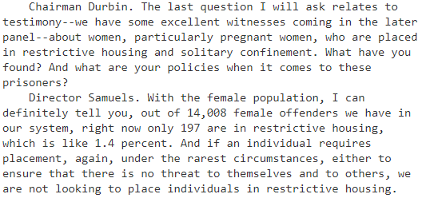

94 births in federal prison, of whom 1.4% of women are in solitary. 1.4% of 94 = about 1 per year, and only if they’re an exceptional threat
I don’t think you’re going to find a Plan this year that is less significant than a plan that on average affects 1 prisoner per year.

3. A/T “Medical attention arrives too late” (Affirmative’s “Hastings Journal” evidence)

That’s about California state prisons, not federal
The title of their article is “Unjust Isolation: The Diminishing Returns of Solitary Confinement of Pregnant Women and California’s Need to Regulate It.”

It’s talking about conditions in the California state prison system, not the federal system.

Full citation: Richard Lee, Hastings Journal of Crime & Punishment 2021 “Unjust Isolation: The Diminishing Returns of Solitary Confinement of Pregnant Women and California’s Need to Regulate It” Summer 2021 https://repository.uchastings.edu/cgi/viewcontent.cgi?article=1027&context=hastings_journal_crime_punishment (accessed 25 Feb 2022)

“Medical attention arrives too late” because of California state prison regulations
Richard Lee, Hastings Journal of Crime & Punishment 2021 “Unjust Isolation: The Diminishing Returns of Solitary Confinement of Pregnant Women and California’s Need to Regulate It” Summer 2021 https://repository.uchastings.edu/cgi/viewcontent.cgi?article=1027&context=hastings_journal_crime_punishment (accessed 25 Feb 2022) (brackets added)
When a pregnant woman is isolated, the crucial time it will take for her to obtain an officer’s attention, transfer her from her segregated unit, and finally to a healthcare official, opens up the problematic possibility that the medical attention will arrive too late—before irreparable damage to the woman and her baby may occur. It is worth noting that the risk of delayed attention could be slightly alleviated if the woman is under constant supervision and can be tended to immediately. But the CDCR [California Department of Corrections and Rehabilitations] manual states the only situations where constant supervision of an isolated prisoner is required is under the Contraband Surveillance Watch policy, which only applies to prisoners who refuse to surrender concealed contraband items to their officers.

Problems are caused by California State prison policies, not federal
Richard Lee, Hastings Journal of Crime & Punishment 2021 “Unjust Isolation: The Diminishing Returns of Solitary Confinement of Pregnant Women and California’s Need to Regulate It” Summer 2021 https://repository.uchastings.edu/cgi/viewcontent.cgi?article=1027&context=hastings_journal_crime_punishment (accessed 25 Feb 2022) (brackets added)
California’s state prison system lacks sufficient regulations to restrict the use of solitary confinement for pregnant women. Under the current system, the California Department of Corrections and Rehabilitations (CDCR) possesses broad discretion regarding the use of solitary confinement, administrative segregated housing, or other forms of isolated placement. According to the CDCR manual, prison officers may place a pregnant woman in solitary confinement as long as her medical condition does not “preclude” that placement. This standard, which vests an inappropriate amount of discretion in prison officers, is deeply insufficient to prevent the negative consequences of subjecting pregnant women to solitary confinement

4. A/T “Constitutional violation (8th Amendment)” – Constitution doesn’t require comfortable prisons
In a lawsuit over prison conditions at Federal prison in Marion, Illinois, a federal judge points out that prisons aren’t required to be comfortable
Federal Judge James L. Foreman 1987. (federal judge for the Southern District of Illinois) ruling of the court in the case of Bruscino v. Carlson, 25 Feb 1987 https://law.justia.com/cases/federal/district-courts/FSupp/654/609/1689442/ (accessed 19 Sept 2021)
"The Constitution does not mandate that prisons be comfortable, and a prison such as Marion, which houses persons convicted of serious crimes and who have demonstrated a propensity to violence or escape, cannot be free of discomfort." Id. Accordingly, the Court finds that the amount of "out of cell time" granted to prisoners for exercise and recreation is constitutionally acceptable, and that the imposed restrictions do not violate the eighth amendment.

5. Confinement is temporary in most cases

Only 15% of solitary prisoners are there for longer than 90 days
Charles E. Samuels 2014. (Director, Federal Bureau of Prisons) 25 Feb 2014 Statement before the Subcommittee on the Constitution, Civil Rights and Human Rights of the Senate Judiciary Committee https://www.congress.gov/event/113th-congress/senate-event/LC60861/text?s=1&r=46 (accessed 19 Sept 2021)
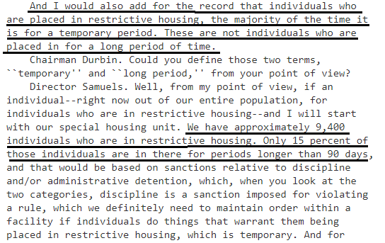

6. Very few women in high security

Nearly all women are in low or minimum security facilities
US Justice Dept. Office of the Inspector General 2018. Sept 2018 “Review of the Federal Bureau of Prisons’ Management of Its Female Inmate Population” https://oig.justice.gov/reports/2018/e1805.pdf (accessed 14 Sept 2021)
BOP has four security classification levels for inmates: high, medium, low, and minimum. Nearly all sentenced female inmates are classified as low or minimum security. BOP does not classify female inmates as medium security but does classify a small number as high security. BOP institutions are also assigned security levels, and BOP generally assigns inmates to institutions that correspond with their security level.

Minimum security Dublin Federal Prison Camp for women: It’s relaxed and sounds like Summer Camp!
Michael Santos 2021 (professor of criminal justice at San Francisco State Univ.; served 25 years in federal prison) 18 May 2021 “Women’s Federal Prison Camp” https://prisonprofessors.com/womens-federal-prison-camp/ (accessed 15 Sept 2021)
The camp is small, but staff members operate it in a relaxed way. Some may feel that there is not a whole lot to explore, that it is boring, and not many resources. But a person can easily pass time at the camp by participating in all their programs, working out, doing hobby craft projects, watching TV, reading drawing, writing. I recommend that people use the time to work on self-development and personal growth.

See if you can work up sympathy for the women at Dublin Federal prison camp over their “awful” conditions…
Federal prisoner “Tina” (no last name given) 2021. (prisoner at Dublin Federal Prison Camp, California) 18 May 2021 “Women’s Federal Prison Camp” https://prisonprofessors.com/womens-federal-prison-camp/ (accessed 15 Sept 2021)
On the weekends the girls try and get a volleyball tournament together and we all go out there and cheer them on like we are a high school cheerleading squad. The music is cranked up loud and we have a good time. A lot of the girls go out and sit in the sun, remember we are in California and read a book or just close their eyes and meditate to bring them some peace. Right now, in this age of Covid, Dublin is one of the smaller camps. We have around 90 women. That is small compared to other facilities. We all know each other, live with each other day in and day out and become sort of a family. During the holidays are the hardest. All of us try and keep each other in the spirit of the holiday season and we put on choir concerts, have a holiday party, where the ladies cook for all of the inmates with food we purchased on Commissary.

SOLVENCY

1. No safe alternative to solitary
Prison officials and advocates who agree with Affirmative all agree: There’s not really any safe alternative
Natasha A. Frost, Ph.D. Carlos E. Monteiro, Ph.D. 2016. (with National Institute of Justice, part of US Dept of Justice) Restrictive Housing in the U.S.: Issues, Challenges, and Future Directions (no month given in the publication) https://www.ojp.gov/pdffiles1/nij/250316.pdf (accessed 19 Sept 2021) (ellipses in original)
If dangerous and violent inmates represent a real threat to others within the correctional environment, the options for containing them without resorting to isolation in restrictive housing seem to be few. Correctional administrators often feel that they are left with no other option than to isolate inmates who represent a threat to themselves, other inmates, or to staff. Moreover, the most ardent critics of solitary confinement often have little to say about alternatives to the practice if and when solitary confinement were to be eliminated on evidence-based grounds or outlawed on constitutional grounds. Those charged with running prisons — even those who have argued that there are problems with the practice of confining inmates in highly restrictive environments for extended periods — lament the lack of options at their disposal for those inmates who are truly dangerous to both the prison staff and other inmates. Rick Raemisch, executive director of the Colorado Department of Corrections, spent 20 hours in solitary confinement to understand the experience and has worked to significantly reduce its use in the Colorado system but still acknowledges the need for the practice in some instances (Goode, 2014; Raemisch, 2014). Raemisch recently argued, “If someone has committed a violent assault … until you can solve that problem, that person is going to need to be isolated.” He went on to note, “There are those who say this is bad, but when you look around for an alternative, people have left the room” (Baker & Goode, 2015, p. A16).

DISADVANTAGES

1. Violence & Death

Solitary confinement prisoners are there because they kill other prisoners
Sen. Dick Durbin 2014 (D-Illinois) 25 Feb 2014 Statement before the Subcommittee on the Constitution, Civil Rights and Human Rights of the Senate Judiciary Committee https://www.congress.gov/event/113th-congress/senate-event/LC60861/text?s=1&r=46 (accessed 19 Sept 2021)
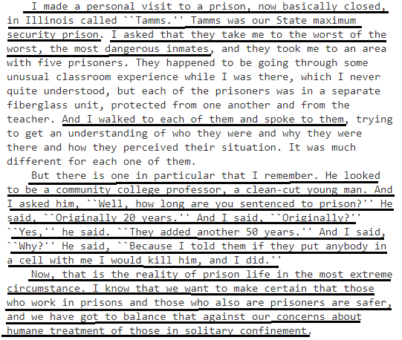
At Colorado Supermax (ADX), 47% of the solitary prisoners are there because they killed an inmate or prison staff
Charles E. Samuels 2014. (Director, Federal Bureau of Prisons) 25 Feb 2014 Statement before the Subcommittee on the Constitution, Civil Rights and Human Rights of the Senate Judiciary Committee https://www.congress.gov/event/113th-congress/senate-event/LC60861/text?s=1&r=46 (accessed 19 Sept 2021)
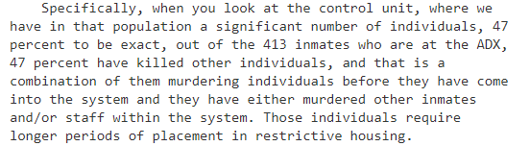

When bad guys find out they can’t be put into solitary for disciplinary reasons, they’ll increase their attacks on prison staff and other inmates
Charles E. Samuels 2014. (Director, Federal Bureau of Prisons) 25 Feb 2014 Statement before the Subcommittee on the Constitution, Civil Rights and Human Rights of the Senate Judiciary Committee https://www.congress.gov/event/113th-congress/senate-event/LC60861/text?s=1&r=46 (accessed 19 Sept 2021)
We are only interested in placing individuals in restrictive housing when there is a legitimate reason and justification. With our system being so large, we have over 20,000 gang members in our system. They are watching this hearing. They are watching our testimony very, very closely, for the reason being if they see that we will lower our standards, we will not hold individuals accountable, it puts our staff at risk, it puts other inmates at risk, and this is why I mentioned in my oral statement that not only are we looking at staff being injured and harmed, our staff are putting their lives on the line every single second of the day to protect the American public.

People will die if you ban solitary confinement
Charles E. Samuels 2014. (Director, Federal Bureau of Prisons) 25 Feb 2014 Statement before the Subcommittee on the Constitution, Civil Rights and Human Rights of the Senate Judiciary Committee https://www.congress.gov/event/113th-congress/senate-event/LC60861/text?s=1&r=46 (accessed 19 Sept 2021)
I have been in the Bureau of Prisons now going on 26 years. I have talked to inmates. I have had inmates tell me, ``If you release me to the general population or if you take me out, I will kill someone.'' I have a duty and an obligation to protect the staff, to protect the inmates. And when someone is willing to tell you, ``If you do it, this is what I am going to do,'' I mean, there are huge issues with that.

