Negative: 13th Amendment
By “Coach Vance” Trefethen
The United States Federal Government should significantly reform its policies regarding convicted prisoners under federal jurisdiction
Case Summary: The AFF case overcomes the wording of the 13th Amendment that deals with prison labor. 13A was a post-Civil War amendment that abolished “involuntary servitude” (a.k.a. slavery) “except” as punishment for a crime. Southern states, still angry about losing the War and still harboring racist views against Blacks and wishing they were still slaves, used the “exception” clause to partially reinstate slavery in the years following the War. State legislatures passed so many laws aimed specifically at Blacks that it almost made being Black itself a crime, and it was easy to arrest Black people for anything any time, anywhere. Once they were “convicted of a crime” (like being out in public for no reason), the state prisons would then contract with the property owners that used to own slaves, and they would pay very low rates for prison labor. They got their slaves back, all legally and in compliance with the 13th Amendment.
That dark racism in the prison system is long gone today. Most view prison labor (at ridiculously low wages, either in prison industries or contracted out to the benefit of outside private companies) as a means of rehabilitation (job skills) or improved inmate behavior (keep them busy and tired, and they don’t sit around idle and thinking up mischief.) In any case, that racist/slave motivation was in the Southern states, not in the federal system, so there is no slave legacy at the federal level. But AFF’s are worried that the involuntary assignment of work to federal prisoners is an echo of slavery that needs to be abolished.
Negative: 13th Amendment 3
HARMS / SIGNIFICANCE 3
A/T “Misinterpretation / Misuse of the 13th Amendment Exception Clause” 3
1. “Slave loophole” theory is wrong. Purpose of 13A was never designed to define freedom nor equality 3
2. No link to racial oppression. Racism & incarceration would have happened anyway 3
Southern states didn’t need tricky 13A loopholes to oppress Blacks. They had lots of other ways 3
3. No link to “reinstating slavery.” States that never had slavery also had the same “exception clause” 4
4. Abuses of the justice system weren’t caused by the 13th Amendment 4
5. Congress intended the 13th Amendment to include involuntary prison labor. It wasn’t a “loophole” or a misinterpretation 4
A/T “Unfair punishment” 5
1. Prison is punishment. Get over it. 5
Punishment and deterrence are fundamental goals of prison. Making prison unpleasant is a justified part of the process 5
Punishment is the correct and moral way for society to condemn wrong and destructive behavior 5
Quit complaining: Prisoners deserve to be punished 5
2. Prisoners don’t have a “right” to the same “rights” as everyone else 6
Constitutional rights can be restricted when it’s reasonably related to legitimate prison requirements 6
Prisoners cannot expect to get the same constitutional protections as law-abiding citizens, for obvious reasons 6
DISADVANTAGES 7
1. Sets back the goal of racial justice and equality 7
Confounding the difference between slavery and incarceration blocks the quest for racial equality 7
2. All prisoners released 7
The exception clause in 13A is what allows anyone to be kept in prison at all. If you believe 13A shouldn’t allow anyone to be “forced against their will,” then you have to let everyone out, since they are all forced against their will to stay in their cells, obey guards’ orders, etc. 7
Impact: Empty prisons means streets full of crime 7
3. Prison violence and reduced officer safety 8
Link: Higher wages means fewer inmates working 8
Link: Inmates simply wouldn’t be working if paid more, because it’s not profitable. Impact: Violence 8
Impact: More violence in prisons. Prison jobs are key to reducing inmate violence and assaults on guards 9
Impact: Worse inmate behavior and reduced safety of staff and prisoners, because jobs incentivize them to behave 9
4. Higher recidivism 10
Inmates who participate in Federal Prison Industries (FPI) have much lower rates of recidivism 10
5. Crime victims harmed 10
Prison work generates restitution money for crime victims 10

Negative: 13th Amendment

HARMS / SIGNIFICANCE

A/T “Misinterpretation / Misuse of the 13th Amendment Exception Clause”
1. “Slave loophole” theory is wrong. Purpose of 13A was never designed to define freedom nor equality
Prof. Patrick Rael 2016 (prof. of history at Bowdoin College) “Demystifying the 13th Amendment and Its Impact on Mass Incarceration” 9 Dec 2016 https://www.aaihs.org/demystifying-the-13th-amendment-and-its-impact-on-mass-incarceration/ (accessed 18 Feb 2022)
In a nutshell, the argument is this: The country did the right thing in passing an amendment intended to make all people equal, but some connived against that noble aim in permitting, and then exploiting, the mass incarceration loophole. When we put these claims to the test with a closer look at the Amendment and its origins, we learn that they bear little resemblance to the actual history. First, the “loophole” argument imputes to its framers and judicial interpreters a conspiracy against intentions of full equality that the amendment never included in the first place. All the Thirteenth Amendment did was abolish slavery; it stood virtually moot on the meaning of freedom. This was by design. Antislavery legislators wanted a more comprehensive measure, but only by compromising on its vision would more conservative legislators let it pass. It took later amendments and laws to define freedom: the Civil Rights Act of 1866 (civil rights), the Fourteenth Amendment of 1868 (citizenship), the Fifteenth Amendment of 1870 (voting rights), and others.

2. No link to racial oppression. Racism & incarceration would have happened anyway
Prof. Patrick Rael 2016 (prof. of history at Bowdoin College) “Demystifying the 13th Amendment and Its Impact on Mass Incarceration” 9 Dec 2016 https://www.aaihs.org/demystifying-the-13th-amendment-and-its-impact-on-mass-incarceration/ (accessed 18 Feb 2022)
The exception clause alone did nothing to promote racial oppression. Search in vain for legal cases in which the clause was used to argue for the legality of any form of punishment. Instead, we see the opposite, as in in U.S. v. Ah Sou, C.C.A.9 (1905), wherein the court used the clause to argue against deporting a Chinese woman because it would have returned her to a state slavery in China. To justify their oppression, white supremacists used much more powerful and overt legal devices than slippery language in the Thirteenth Amendment. Jim Crow and mass incarceration would’ve happened with or without the exception clause.

Southern states didn’t need tricky 13A loopholes to oppress Blacks. They had lots of other ways
Prof. Patrick Rael 2016 (prof. of history at Bowdoin College) “Demystifying the 13th Amendment and Its Impact on Mass Incarceration” 9 Dec 2016 https://www.aaihs.org/demystifying-the-13th-amendment-and-its-impact-on-mass-incarceration/ (accessed 18 Feb 2022)
But in mischaracterizing the role of the Thirteenth Amendment it underplays the depth of the problem in both history and the present. There was no need for secret language or tricky loopholes. Southern state governments worked openly to pass the legal mechanisms that criminalized blackness and poverty, from black codes and apprenticeships laws to vagrancy provisions and convict lease systems. The culprit was not the persistence of an old and rejected labor regime, but the emergence of new ones, which the state found much easier to justify.

3. No link to “reinstating slavery.” States that never had slavery also had the same “exception clause”
Prof. Patrick Rael 2016 (prof. of history at Bowdoin College) “Demystifying the 13th Amendment and Its Impact on Mass Incarceration” 9 Dec 2016 https://www.aaihs.org/demystifying-the-13th-amendment-and-its-impact-on-mass-incarceration/ (accessed 18 Feb 2022)
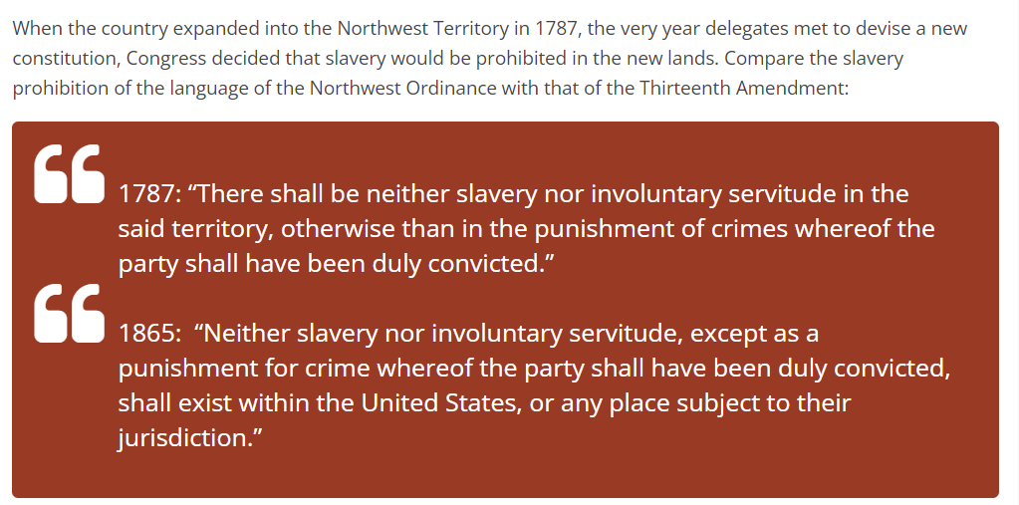

4. Abuses of the justice system weren’t caused by the 13th Amendment
Prof. Patrick Rael 2016 (prof. of history at Bowdoin College) “Demystifying the 13th Amendment and Its Impact on Mass Incarceration” 9 Dec 2016 https://www.aaihs.org/demystifying-the-13th-amendment-and-its-impact-on-mass-incarceration/ (accessed 18 Feb 2022)
The Thirteenth Amendment did nothing to promote mass incarceration in freedom, but neither did it do anything to limit abuses of the criminal justice system that stopped short of actual slavery. The law had long distinguished between slavery and incarceration, and no one intended the Thirteenth to erase that distinction. Its only intent had been to prohibit the holding of people as property.

5. Congress intended the 13th Amendment to include involuntary prison labor. It wasn’t a “loophole” or a misinterpretation
Federal Judge J. Smith Henley 1970. (federal judge for the Eastern District of Arkansas) 18 Feb 1970 decision of the court in the case of Holt v. Sarver 309 F. Supp. 362 https://law.justia.com/cases/federal/district-courts/FSupp/309/362/2096340/ (accessed 19 Feb 2022)
The State does not claim to own the bodies of its prisoners. The situation does involve "servitude," and there is no doubt whatever that the "servitude" is "involuntary." But, it is equally clear that this servitude has been imposed as punishment for crimes whereof the inmates have been duly convicted. Conceding that the work required is hard and tedious, that it is performed under harsh conditions, that the State requires it to produce income for the State, and that the system serves little other purpose, if any, the Court is not persuaded that the system violates the Thirteenth Amendment. According to Director Bennett, the idea that prisons and prisoners ought to support themselves is as old as American penology. He referred to the fact that the convict-leasing system came into existence at a very early stage as the States found that it was more profitable to lease their convicts than to work them themselves. And he pointed out that one of the best descriptions of the leasing system is to be found in Margaret Mitchell's Civil War novel, "Gone With The Wind." When Congress submitted the Thirteenth Amendment to the States, it must have been aware of generally accepted convict labor policies and practices, and the Court is persuaded that the Amendment's exception manifested a Congressional intent not to reach such policies and practices.

A/T “Unfair punishment”

1. Prison is punishment. Get over it.

Punishment and deterrence are fundamental goals of prison. Making prison unpleasant is a justified part of the process
Judge Karen L. Henderson 2003 (judge on the US Court of Appeals for the District of Columbia Circuit) concurring opinion in the case of Kimberlin v. Dept of Justice 11 Feb 2003 https://caselaw.findlaw.com/us-dc-circuit/1213362.html (accessed 18 Feb 2022)
Punishment and deterrence are not only legitimate penological interests, they are among the fundamental goals of our penological system.. See Rhodes v. Chapman, 452 U.S. 337, 352, 101 S.Ct. 2392, 2402, 69 L.Ed.2d 59 (1981) (identifying “goals of the penal function in the criminal justice system” as “to punish justly, to deter future crime, and to return imprisoned persons to society with an improved change of being useful, law-abiding citizens”); Pell v. Procunier, 417 U.S. 817, 822, 94 S.Ct. 2800, 2804, 41 L.Ed.2d 495 (1974) (“An important function of the corrections system is the deterrence of crime. The premise is that by confining criminal offenders in a facility where they are isolated from the rest of society, a condition that most people presumably find undesirable, they and others will be deterred from committing additional criminal offenses.”).

Punishment is the correct and moral way for society to condemn wrong and destructive behavior
Rafael Mangual 2019. (fellow and deputy director of legal policy at the Manhattan Institute) Everything You Don’t Know About Mass Incarceration, Summer 2019 CITY JOURNAL https://www.city-journal.org/mass-incarceration (accessed 18 Feb 2022)
When I studied criminal law as a first-year law student, my textbook defined “crime” as conduct that, “if duly shown to have taken place, will incur a formal and solemn pronouncement of the moral condemnation of the community.” Incarceration, in other words, is more than just a way to protect society from wrongdoers; it’s also a key way that society condemns wrong and destructive behavior.

Quit complaining: Prisoners deserve to be punished
Rafael Mangual 2019. (fellow and deputy director of legal policy at the Manhattan Institute) Everything You Don’t Know About Mass Incarceration, Summer 2019 CITY JOURNAL https://www.city-journal.org/mass-incarceration (accessed 18 Feb 2022)
Contrary to the decarceration narrative, most of those imprisoned in America are highly likely to reoffend; most prisoners have committed just the kinds of serious violations that most Americans agree should put them away; and plenty of criminals already walk our streets today who committed their crimes without detection, were released from prison or jail sooner than they should have been, or received too-light sentences, given the level of their actual infractions.

2. Prisoners don’t have a “right” to the same “rights” as everyone else

Constitutional rights can be restricted when it’s reasonably related to legitimate prison requirements
Judge Dineen King 1993 (US Court of Appeals, 5th Circuit) decision of the Court in the case of Brewer v. Wilkinson 22 Sept 1993 https://www.casemine.com/judgement/us/59148609add7b049344cfcaf (accessed 4 Feb 2022)

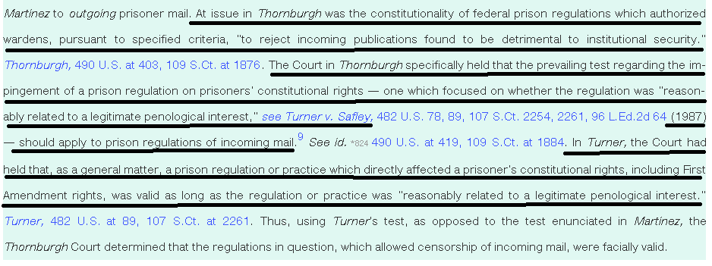

Prisoners cannot expect to get the same constitutional protections as law-abiding citizens, for obvious reasons
Sara Carter 2019 (Harvard Law School, JD candidate) 16 Oct 2019 “Strip Searches Deny Prisoners Their Constitutional Rights” https://harvardcrcl.org/strip-searches-deny-prisoners-their-constitutional-rights/ (accessed 4 Feb 2022)
The Fourth Amendment protects from unreasonable searches and seizures of persons and their property. Importantly, the Fourth Amendment applies only when a party has a subjective expectation of privacy and that expectation is “one that society is prepared to recognize as reasonable.” Courts deny incarcerated people the full extent of their Fourth Amendment rights, finding curtailment necessary for institutional purposes. While pre-trial detainees have a lower expectation of privacy than the public, prisoners post-conviction face a severely reduced expectation of privacy.

DISADVANTAGES

1. Sets back the goal of racial justice and equality

Confounding the difference between slavery and incarceration blocks the quest for racial equality
Analysis: It happens because equating incarceration with slavery makes us think mass incarceration is part of the ancient problem of slavery, rather than a problem caused by us ourselves in our modern society. That unwillingness to confront reality sets back the cause of justice because we can’t get to the solution when we don’t understand the problem.
Prof. Patrick Rael 2016 (prof. of history at Bowdoin College) “Demystifying the 13th Amendment and Its Impact on Mass Incarceration” 9 Dec 2016 https://www.aaihs.org/demystifying-the-13th-amendment-and-its-impact-on-mass-incarceration/ (accessed 18 Feb 2022)
Slavery and mass incarceration are not the same. All forms of racial oppression are not forms of slavery; rather, slavery is one form of racial oppression. Mass incarceration is another. While it may help to end it by associating it with an institution we abolished, it is not the remnant of a barbaric and outmoded system but the product of modern society. The problem isn’t the persistence of slavery; the problem is how a system that has always promised justice for all always seems to find ways to deny it to some. If we can only see ongoing racial oppression as a remnant of slavery, then we can’t see it as a problem of our own age. And if we can’t understand mass incarceration as a problem of our own age, we can’t critique the mechanisms that foster racial and economic inequality in a system that is supposed to be blind to both.

2. All prisoners released

The exception clause in 13A is what allows anyone to be kept in prison at all. If you believe 13A shouldn’t allow anyone to be “forced against their will,” then you have to let everyone out, since they are all forced against their will to stay in their cells, obey guards’ orders, etc.
Prof. Patrick Rael 2016 (prof. of history at Bowdoin College) “Demystifying the 13th Amendment and Its Impact on Mass Incarceration” 9 Dec 2016 https://www.aaihs.org/demystifying-the-13th-amendment-and-its-impact-on-mass-incarceration/ (accessed 18 Feb 2022)
Second, on its face, the language of the Thirteenth Amendment’s “exception clause” offers no mechanism to actively promote incarceration. Instead, its obvious purpose is to ensure that none mistake the prohibition on racial slavery for a prohibition on criminal incarceration. Given the novelty of emancipation at the phrase’s origin, that was not pointless: surely the abolition of slavery should not mean that no one (black or white) could ever be incarcerated for crimes they committed, right?

Impact: Empty prisons means streets full of crime
Rafael Mangual 2019. (fellow and deputy director of legal policy at the Manhattan Institute) Everything You Don’t Know About Mass Incarceration, Summer 2019 CITY JOURNAL https://www.city-journal.org/mass-incarceration (accessed 18 Feb 2022)
Scholars at the Brennan Center have called for an immediate 40 percent reduction in the number of inmates. Such drastic cuts could produce significant crime increases, as communities lose the incapacitation benefits that they currently enjoy.

3. Prison violence and reduced officer safety

Link: Higher wages means fewer inmates working
German Lopez 2015. (journalist) “Slavery or rehabilitation? The debate about cheap prison labor, explained.” 7 Sept 2015 https://www.vox.com/2015/9/7/9262649/prison-labor-wages (accessed 18 Feb 2022)
Although it seems exploitative, advocates for cheap prison labor argue that it can benefit prisoners by giving them a sense of what full-time work is like. And if it cost governments the actual minimum wage, these programs might get too expensive for prisons already strained by costs due to mass incarceration — which means few or no inmates would get paid at all.

Link: Inmates simply wouldn’t be working if paid more, because it’s not profitable. Impact: Violence
Lynn Gibson 1993. (Assoc. General Counsel, GAO) 28 Oct 1993 “Perspectives on Paying the Federal Minimum Wage” https://www.gao.gov/assets/t-ggd-94-8.pdf (accessed 18 Jan 2022)
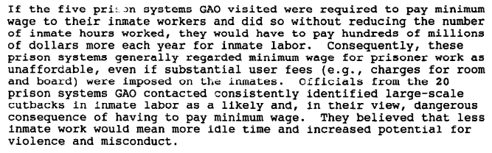

Impact: More violence in prisons. Prison jobs are key to reducing inmate violence and assaults on guards
Harley Lappin 2008 (director of the Bureau of Prisons) 6 May 2008 “FEDERAL PRISON INDUSTRIES--EXAMINING THE EFFECTS OF SECTION 827 OF THE NATIONAL DEFENSE AUTHORIZATION ACT OF 2008” HEARING BEFORE THE SUBCOMMITTEE ON CRIME, TERRORISM, AND HOMELAND SECURITY OF THE COMMITTEE ON THE JUDICIARY, HOUSE OF REPRESENTATIVES https://www.govinfo.gov/content/pkg/CHRG-110hhrg42213/html/CHRG-110hhrg42213.htm (accessed 6 Dec 2021)
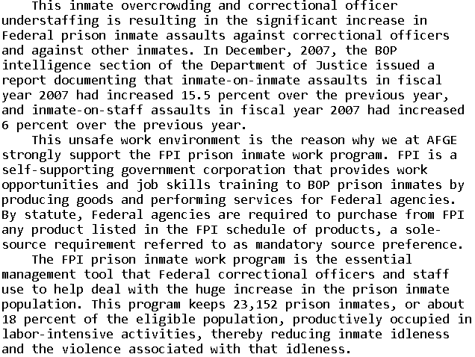

Impact: Worse inmate behavior and reduced safety of staff and prisoners, because jobs incentivize them to behave
Rep. Robert Scott 2008. (member of the House of Reps. from Virginia) 6 May 2008 “FEDERAL PRISON INDUSTRIES--EXAMINING THE EFFECTS OF SECTION 827 OF THE NATIONAL DEFENSE AUTHORIZATION ACT OF 2008” HEARING BEFORE THE SUBCOMMITTEE ON CRIME, TERRORISM, AND HOMELAND SECURITY OF THE COMMITTEE ON THE JUDICIARY, HOUSE OF REPRESENTATIVES https://www.govinfo.gov/content/pkg/CHRG-110hhrg42213/html/CHRG-110hhrg42213.htm (accessed 6 Dec 2021)
All able-bodied prisoners are required by law to work. Over 80 percent of them work for menial, mostly make-work jobs which are paid 12 cents to 40 cents per hour. In comparison, Federal Prison Industry jobs are held by about 18 percent of the prisoners and they earn from 24 cents to $1.15 per hour. This additional pay is a significant financial incentive, making FPI jobs most desirable. Also, prisoners in FPI--those on the waiting list and those seeking to be eligible for the waiting list--must have their high school diploma or a GED or show that they are making progress to obtain a GED. That is why prisoners in the FPI program are less likely to engage in institutional misconduct, thereby enhancing the safety of staff and other prisoners and lessening the management burden and expense.
4. Higher recidivism

Inmates who participate in Federal Prison Industries (FPI) have much lower rates of recidivism
Congressional Research Service 2016 (non-partisan research agency of Congress) last updated 11 May 2016 Federal Prison Industries: Background, Debate, Legislative History, and Policy Options https://crsreports.congress.gov/product/pdf/RL/RL32380 (accessed 6 Dec 2021)
Research conducted by the BOP shows that, 12 months after being released from prison, inmates who participated in the FPI were 35% less likely than inmates from a comparable control group to have recidivated (6.6% compared to 10.1%). Inmates who participated in the FPI were also 14% more likely to be employed after 12 months (71.7% compared to 63.1%). The researchers found that over the long term (between 8 and 12 years after release), inmates who participated in the FPI were 24% less likely to have recidivated than inmates in the comparison group.

5. Crime victims harmed

Prison work generates restitution money for crime victims
Harley Lappin 2008 (director of the Bureau of Prisons) 6 May 2008 “FEDERAL PRISON INDUSTRIES--EXAMINING THE EFFECTS OF SECTION 827 OF THE NATIONAL DEFENSE AUTHORIZATION ACT OF 2008” HEARING BEFORE THE SUBCOMMITTEE ON CRIME, TERRORISM, AND HOMELAND SECURITY OF THE COMMITTEE ON THE JUDICIARY, HOUSE OF REPRESENTATIVES https://www.govinfo.gov/content/pkg/CHRG-110hhrg42213/html/CHRG-110hhrg42213.htm (accessed 6 Dec 2021)
Another benefit of the FPI program is its ability to help with the effort to provide restitution to victims of crime. Inmates who work in FPI are required to contribute 50 percent of their wages to pay court-ordered fines, victim restitution, and child support.

