Negative: Minimum Wage
By “Coach Vance” Trefethen
The United States Federal Government should significantly reform its policies regarding convicted prisoners under federal jurisdiction
Case Summary: The AFF plan requires minimum wage for work programs performed by prisoners. Right now they get typically less than $1 per hour.
NEGATIVE: Minimum Wage 3
COUNTER GOAL / NEG PHILOSOPHY 3
Correctional Officer (CO) safety should be the paramount goal of prison policy 3
INHERENCY 3
1. Business competition reforms already done 3
Congress has passed several laws already to change sourcing rules and reduce Unicor/FPI impact on small businesses 3
HARMS / SIGNIFICANCE 4
1. A/T “Small businesses harmed” 4
3 responses: 1) Other factors causing those job losses besides FPI. 2) Insignificant number of jobs impacted 3) Prison benefits outweigh 4
2. Low wages are justified #1: Because of added costs 4
Prison wages are low because of additional constraints in the prison environment that create extra expenses for prison industry 4
3. Low wages are justified #2: Because prison is punishment (duh) 5
Punishment and deterrence are fundamental goals of prison. Making prison unpleasant is a justified part of the process 5
Punishment is the correct and moral way for society to condemn wrong and destructive behavior 5
Quit complaining: Prisoners deserve to be punished 5
4. Justification of low wages depends on the justice of the system 5
Josh Halladay, who advocates the AFF position, says the entire debate hinges on 1 issue: Whether the criminal justice system is, in fact, just. If it is, then Status Quo is justified. If not, then minimum wage is justified 5
Federal criminal justice system has high standards of fairness and error correction 6
US criminal justice system is the best in the world 6
5. Prisoners don’t have a “right” to the same “rights” as everyone else 6
Constitutional rights can be restricted when it’s reasonably related to legitimate prison requirements 6
Prisoners cannot expect to get the same constitutional protections as law-abiding citizens, for obvious reasons 7
DISADVANTAGES 7
1. Worse inmate behavior 7
Link: Higher wages means fewer inmates working 7
Link: Inmates simply wouldn’t be working if paid minimum wage, because it’s not profitable. Impact: Violence 7
Impact: More violence in prisons. Prison jobs are key to reducing inmate violence and assaults on guards 8
Impact: Worse inmate behavior because prison jobs incentivize them to behave 8
2. Abandonment of justice 9
Justice is lost whenever we adopt any goal that looks forward to “what will be the results of the punishment?” rather than backwards at the question of “what punishment does that crime justly deserve?” 9
The government has no right to punish criminals if the goal is anything other than justice 9
Any other goal besides giving what the criminal deserves hands the government the power of tyranny 9
3. Prisoners prioritized over taxpayers 9
Link: AFF either raises taxes or raises the deficit to pay the prisoners 9
Impact 1: Law abiding taxpayers harmed to benefit lawbreaking offenders 10
Impact 2: Every increase in the deficit hurts the economy 10

NEGATIVE: Minimum Wage

COUNTER GOAL / NEG PHILOSOPHY
Correctional Officer (CO) safety should be the paramount goal of prison policy
Frank V. Ferdik & Hayden P. Smith 2017 (Ferdik - Department of Criminology and Criminal Justice, University of West Florida, Pensacola. Smith - Department of Criminology and Criminal Justice, University of South Carolina, Columbia) Correctional Officer Safety and Wellness Literature Synthesis, July 2017 https://www.ojp.gov/pdffiles1/nij/250484.pdf (accessed 20 Sept 2021)
Officers are tasked with demanding and often conflicting work responsibilities that increase their risk for physical and mental health problems such as injuries, stress, and even death. Officers must interact with and supervise potentially dangerous individuals such as gang members, inmates with mental illness, and those with communicable diseases, which further complicates officers’ health issues. According to the research cited above, officers, regardless of security assignment, recognize the danger to which they are subject as a result of their profession. Many scholars conclude that employment as a CO is among the most dangerous and life threatening of all professions, including law enforcement. Given how COs are heavily relied upon to supervise inmate behavior, establish order in their facilities, and maintain wider institutional security, it is paramount that correctional practitioners, researchers, administrative officials, and other interested stakeholders begin developing more effective and widely used strategies for enhancing the general well-being of this critically important workforce.

INHERENCY

1. Business competition reforms already done
Congress has passed several laws already to change sourcing rules and reduce Unicor/FPI impact on small businesses
Congressional Research Service 2016 (non-partisan research agency of Congress) last updated 11 May 2016 Federal Prison Industries: Background, Debate, Legislative History, and Policy Options https://crsreports.congress.gov/product/pdf/RL/RL32380 (accessed 6 Dec 2021)
Congress has taken legislative action to lessen any adverse impact the FPI has had on small businesses. For example, in 2002, 2003, and 2004, Congress passed legislation that modified how the Department of Defense (DOD) and the Central Intelligence Agency (CIA) procured products offered by the FPI in its schedule of products. In 2004, Congress passed legislation prohibiting federal agencies from using appropriated funding for FY2004 to purchase products or services offered by the FPI unless the agency determined that the products or services are provided at the best value. This provision was extended permanently in FY2005. In the 110th Congress, the National Defense Authorization Act for Fiscal Year 2008 (P.L. 110-181) modified the way in which DOD procures products from the FPI. In addition, the Administration of President George W. Bush made several efforts to reduce the consequences the FPI’s mandatory source clause might have on the ability of private businesses to compete for federal contracts.

HARMS / SIGNIFICANCE

1. A/T “Small businesses harmed”
3 responses: 1) Other factors causing those job losses besides FPI. 2) Insignificant number of jobs impacted 3) Prison benefits outweigh
Marc H. Morial 2008 (Director, National Urban League) 6 May 2008 “FEDERAL PRISON INDUSTRIES--EXAMINING THE EFFECTS OF SECTION 827 OF THE NATIONAL DEFENSE AUTHORIZATION ACT OF 2008” HEARING BEFORE THE SUBCOMMITTEE ON CRIME, TERRORISM, AND HOMELAND SECURITY OF THE COMMITTEE ON THE JUDICIARY, HOUSE OF REPRESENTATIVES https://www.govinfo.gov/content/pkg/CHRG-110hhrg42213/html/CHRG-110hhrg42213.htm (accessed 6 Dec 2021)
I think it is important to look at the loss of jobs as not scapegoating FPI. There are larger global trade and foreign competition issues at play in a lot of the businesses where they provide services. But then secondly, the effect because of the market share of FPI is so small. Has it cost a job-loss here or there? I don't think anyone can argue that it hasn't, but the benefits, the up-side is significant. I would suggest to you that there are not a lot of initiatives out there that habilitate and give prisoners skills that don't require direct appropriations. We are spending on average on the low side probably $20,000 or $25,000 a year to incarcerate and house people. So this kind of investment is offset.

2. Low wages are justified #1: Because of added costs

Prison wages are low because of additional constraints in the prison environment that create extra expenses for prison industry
Congressional Research Service 2016 (non-partisan research agency of Congress) last updated 11 May 2016 Federal Prison Industries: Background, Debate, Legislative History, and Policy Options https://crsreports.congress.gov/product/pdf/RL/RL32380 (accessed 6 Dec 2021) (brackets added)
Proponents note that the FPI [Federal Prison Industries] faces several competitive disadvantages which might negate the fact that the FPI can pay inmate workers lower wages. While inmates receive far lower pay than workers in private industry, the FPI asserts this advantage is offset by the lower average productivity of inmates and the inefficiencies associated with operating a business in a correctional setting. In addition, the FPI contends that any advantage it might gain from lower wages is offset by statutory constraints that drive up costs. These include
• employing as many inmates as reasonably possible;
• concentrating on manufacturing products that are labor-intensive;
• providing opportunities for inmates to acquire marketable skills;
• diversifying production as much as possible to minimize competition with private industry and labor, and reduce the burden on any one industry;
• not taking more than a reasonable share of the federal market for any one product; and
• selling products only to the federal government.

3. Low wages are justified #2: Because prison is punishment (duh)

Punishment and deterrence are fundamental goals of prison. Making prison unpleasant is a justified part of the process
Judge Karen L. Henderson 2003 (judge on the US Court of Appeals for the District of Columbia Circuit) concurring opinion in the case of Kimberlin v. Dept of Justice 11 Feb 2003 https://caselaw.findlaw.com/us-dc-circuit/1213362.html (accessed 18 Feb 2022)
Punishment and deterrence are not only legitimate penological interests, they are among the fundamental goals of our penological system.. See Rhodes v. Chapman, 452 U.S. 337, 352, 101 S.Ct. 2392, 2402, 69 L.Ed.2d 59 (1981) (identifying “goals of the penal function in the criminal justice system” as “to punish justly, to deter future crime, and to return imprisoned persons to society with an improved change of being useful, law-abiding citizens”); Pell v. Procunier, 417 U.S. 817, 822, 94 S.Ct. 2800, 2804, 41 L.Ed.2d 495 (1974) (“An important function of the corrections system is the deterrence of crime. The premise is that by confining criminal offenders in a facility where they are isolated from the rest of society, a condition that most people presumably find undesirable, they and others will be deterred from committing additional criminal offenses.”).

Punishment is the correct and moral way for society to condemn wrong and destructive behavior
Rafael Mangual 2019. (fellow and deputy director of legal policy at the Manhattan Institute) Everything You Don’t Know About Mass Incarceration, Summer 2019 CITY JOURNAL https://www.city-journal.org/mass-incarceration (accessed 18 Feb 2022)
When I studied criminal law as a first-year law student, my textbook defined “crime” as conduct that, “if duly shown to have taken place, will incur a formal and solemn pronouncement of the moral condemnation of the community.” Incarceration, in other words, is more than just a way to protect society from wrongdoers; it’s also a key way that society condemns wrong and destructive behavior.

Quit complaining: Prisoners deserve to be punished
Rafael Mangual 2019. (fellow and deputy director of legal policy at the Manhattan Institute) Everything You Don’t Know About Mass Incarceration, Summer 2019 CITY JOURNAL https://www.city-journal.org/mass-incarceration (accessed 18 Feb 2022)
Contrary to the decarceration narrative, most of those imprisoned in America are highly likely to reoffend; most prisoners have committed just the kinds of serious violations that most Americans agree should put them away; and plenty of criminals already walk our streets today who committed their crimes without detection, were released from prison or jail sooner than they should have been, or received too-light sentences, given the level of their actual infractions.

4. Justification of low wages depends on the justice of the system

Josh Halladay, who advocates the AFF position, says the entire debate hinges on 1 issue: Whether the criminal justice system is, in fact, just. If it is, then Status Quo is justified. If not, then minimum wage is justified
Josh Halladay 2019. (J.D. Candidate, 2019, Seattle Univ School of Law) The Thirteenth Amendment, Prison Labor Wages, and Interrupting the Intergenerational Cycle of Subjugation, Seattle University Law Review https://digitalcommons.law.seattleu.edu/cgi/viewcontent.cgi?article=2592&context=sulr (accessed 18 Feb 2022)
The justification for charging inmates room and board fees and paying them pennies on the dollar turns on whether one believes that the criminal justice system is, in fact, just. If criminals deserve to be punished for their crimes, then surely they should contribute to the cost to literally repay their debt to society. However, if the efficacy of our criminal justice system comes into doubt, so does the justification for charging men, women, and, in some instances, children for the privilege of incapacitation.

Federal criminal justice system has high standards of fairness and error correction
Andrew McCarthy 2021 (senior fellow at National Review Institute, an NR contributing editor) “Repeal the Pardon Power” 25 January 2021 https://www.nationalreview.com/magazine/2021/01/25/repeal-the-pardon-power/ (accessed July 11, 2021)
Criminal justice is now night-and-day different from Founding-era conditions. Federal jurisprudence has yielded a revolution in the due-process rights of criminal defendants and in Eighth Amendment protections against cruel and unusual punishments. Death sentences are nearly unheard of and, despite a spurt in the last year, will return to dormancy with Joe Biden’s inauguration. The robust federal court system, furthermore, provides for multiple levels of direct appeal, then seemingly endless collateral appeal (habeas corpus). Might we still encounter a gross miscarriage of justice that’s incapable of being reversed? Yes, but the chance of that has been drastically reduced in today’s legal system. On the rare occasion when a correction is needed, the courts are far more likely than a president to proceed fairly.

US criminal justice system is the best in the world
Patrick F. Condon 2021 (President, Nebraska County Attorneys Association) LAW DAY REFLECTIONS: Patrick F. Condon 2 May 2021 https://omahadailyrecord.com/content/law-day-reflections-patrick-f-condon (accessed 18 Feb 2022)
While not perfect, the state and federal criminal justice system in this country is the best in the world. It is the rule of law within the system of checks and balances that guarantees one branch of government, one person, or one part of the criminal justice system is not more powerful than the system itself. That is something we can all celebrate.

5. Prisoners don’t have a “right” to the same “rights” as everyone else

Constitutional rights can be restricted when it’s reasonably related to legitimate prison requirements
Judge Dineen King 1993 (US Court of Appeals, 5th Circuit) decision of the Court in the case of Brewer v. Wilkinson 22 Sept 1993 https://www.casemine.com/judgement/us/59148609add7b049344cfcaf (accessed 4 Feb 2022)

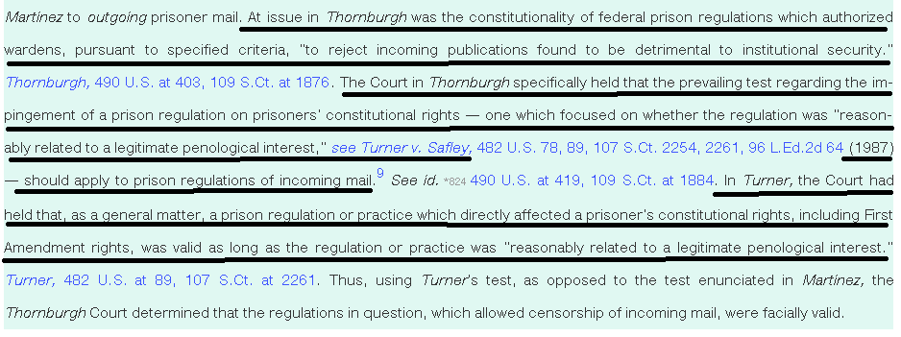

Prisoners cannot expect to get the same constitutional protections as law-abiding citizens, for obvious reasons
Sara Carter 2019 (Harvard Law School, JD candidate) 16 Oct 2019 “Strip Searches Deny Prisoners Their Constitutional Rights” https://harvardcrcl.org/strip-searches-deny-prisoners-their-constitutional-rights/ (accessed 4 Feb 2022)
The Fourth Amendment protects from unreasonable searches and seizures of persons and their property. Importantly, the Fourth Amendment applies only when a party has a subjective expectation of privacy and that expectation is “one that society is prepared to recognize as reasonable.” Courts deny incarcerated people the full extent of their Fourth Amendment rights, finding curtailment necessary for institutional purposes. While pre-trial detainees have a lower expectation of privacy than the public, prisoners post-conviction face a severely reduced expectation of privacy.

DISADVANTAGES

1. Worse inmate behavior

Link: Higher wages means fewer inmates working
German Lopez 2015. (journalist) “Slavery or rehabilitation? The debate about cheap prison labor, explained.” 7 Sept 2015 https://www.vox.com/2015/9/7/9262649/prison-labor-wages (accessed 18 Feb 2022)
Although it seems exploitative, advocates for cheap prison labor argue that it can benefit prisoners by giving them a sense of what full-time work is like. And if it cost governments the actual minimum wage, these programs might get too expensive for prisons already strained by costs due to mass incarceration — which means few or no inmates would get paid at all.

Link: Inmates simply wouldn’t be working if paid minimum wage, because it’s not profitable. Impact: Violence
Lynn Gibson 1993. (Assoc. General Counsel, GAO) 28 Oct 1993 “Perspectives on Paying the Federal Minimum Wage” https://www.gao.gov/assets/t-ggd-94-8.pdf (accessed 18 Jan 2022)
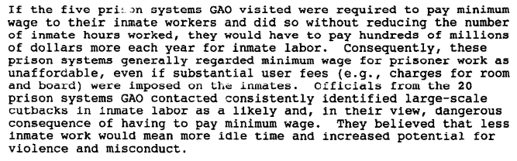

Impact: More violence in prisons. Prison jobs are key to reducing inmate violence and assaults on guards
Harley Lappin 2008 (director of the Bureau of Prisons) 6 May 2008 “FEDERAL PRISON INDUSTRIES--EXAMINING THE EFFECTS OF SECTION 827 OF THE NATIONAL DEFENSE AUTHORIZATION ACT OF 2008” HEARING BEFORE THE SUBCOMMITTEE ON CRIME, TERRORISM, AND HOMELAND SECURITY OF THE COMMITTEE ON THE JUDICIARY, HOUSE OF REPRESENTATIVES https://www.govinfo.gov/content/pkg/CHRG-110hhrg42213/html/CHRG-110hhrg42213.htm (accessed 6 Dec 2021)
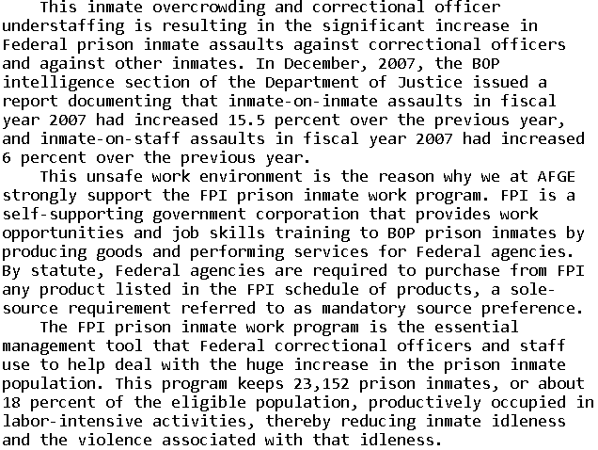

Impact: Worse inmate behavior because prison jobs incentivize them to behave
Rep. Robert Scott 2008. (member of the House of Reps. from Virginia) 6 May 2008 “FEDERAL PRISON INDUSTRIES--EXAMINING THE EFFECTS OF SECTION 827 OF THE NATIONAL DEFENSE AUTHORIZATION ACT OF 2008” HEARING BEFORE THE SUBCOMMITTEE ON CRIME, TERRORISM, AND HOMELAND SECURITY OF THE COMMITTEE ON THE JUDICIARY, HOUSE OF REPRESENTATIVES https://www.govinfo.gov/content/pkg/CHRG-110hhrg42213/html/CHRG-110hhrg42213.htm (accessed 6 Dec 2021)
All able-bodied prisoners are required by law to work. Over 80 percent of them work for menial, mostly make-work jobs which are paid 12 cents to 40 cents per hour. In comparison, Federal Prison Industry jobs are held by about 18 percent of the prisoners and they earn from 24 cents to $1.15 per hour. This additional pay is a significant financial incentive, making FPI jobs most desirable. Also, prisoners in FPI--those on the waiting list and those seeking to be eligible for the waiting list--must have their high school diploma or a GED or show that they are making progress to obtain a GED. That is why prisoners in the FPI program are less likely to engage in institutional misconduct, thereby enhancing the safety of staff and other prisoners and lessening the management burden and expense.
2. Abandonment of justice

Justice is lost whenever we adopt any goal that looks forward to “what will be the results of the punishment?” rather than backwards at the question of “what punishment does that crime justly deserve?”
Prof. Peter Karl Koritansky 2012 (associate professor of history, philosophy, and religious studies at the University of Prince Edward Island, Canada) Thomas Aquinas and the Philosophy of Punishment https://books.google.com/books?hl=en&lr=&id=CFZ6DKEw4wUC&oi=fnd&pg=PR7&ots=6Wg7jWFoUM&sig=TAefdc8Zs_mKI5C8DZqn0BCIPPo#v=onepage&q&f=false (accessed 10 Aug 2021) (Note: Prof. Koritansky is referring to criticism in general of backward looking utilitarianism, but in the article he expresses agreement with this criticism, so this quote is being used consistently with author’s intent.)
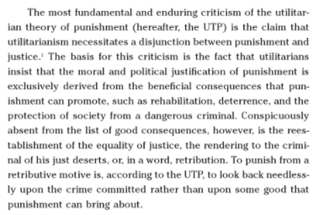
The government has no right to punish criminals if the goal is anything other than justice
John Hirschauer 2020 (former William F. Buckley Jr. Fellow in Political Journalism at National Review Institute) 27 March 2020 “Should States Punish the Insane?” https://www.nationalreview.com/2020/03/crime-mental-illness-should-states-punish-insane-offenders/ (accessed 9 Aug 2021) (brackets added)
[C.S.] Lewis argued that the utilitarian rationales for punishing criminals — deterrence, rehabilitation, incapacitation — were insufficient to justify a penal regime. If the state did not first establish that an offender deserved to be punished for punishment’s sake, forcing “rehabilitation” upon him or using his fate to deter other would-be criminals was not merely dishonest, but instrumentalist: The offender himself became a means to an end. Without a sense of retributive justice, Lewis said, an offender is made “a mere object, a patient, a ‘case.’”

Any other goal besides giving what the criminal deserves hands the government the power of tyranny
John Piper 2012 (chancellor of Bethlehem College & Seminary) “Life Is Cheap in Norway: C. S. Lewis on the Sentence of Anders Breivik” 27 Aug 2012 https://www.desiringgod.org/articles/life-is-cheap-in-norway-c-s-lewis-on-the-sentence-of-anders-breivik (accessed 9 Aug 2021)
If a criminal’s sentence does not have to accord with what he deserves, it does not have to be just. At that point we are all at the mercy of those who are in power to call anything we do a crime and give it any therapeutic or remedial solution they choose, including gas chambers and medical alterations. “The Humanitarian theory of punishment will put in their hands a finer instrument of tyranny than wickedness ever had before.”

3. Prisoners prioritized over taxpayers

Link: AFF either raises taxes or raises the deficit to pay the prisoners
Or else the plan isn’t funded and never happens.

Impact 1: Law abiding taxpayers harmed to benefit lawbreaking offenders
No, Judge, I simply don’t want more of my or your tax money going to people who don’t follow society’s rules like you and I do. I take offense at that, and you and me and our wallets are harmed by that.

Impact 2: Every increase in the deficit hurts the economy
Dr William Gale and Benjamin Harris 2010. (Gale - PhD in economics, Stanford Univ.; senior fellow at the Brookings Institution and co-director of the Urban-Brookings Tax Policy Center; former assistant professor of Economics at UCLA, and a senior economist for the Council of Economic Advisers under President George H.W. Bush; Harris - master’s degree in economics from Cornell Univ and master’s degree in quantitative methods from Columbia University; senior research associate with the Economics Studies Program at the Brookings Institution) “A VAT for the United States: Part of the Solution” (notes about the date: This article is one of several in the overall publication at this source. The publication date was 2011, but this article was written in 2010) https://www.taxpolicycenter.org/sites/default/files/alfresco/publication-pdfs/1001418-A-Value-Added-Tax-for-the-United-States-Part-of-the-Solution.PDF (accessed 26 Jan 2022)
But even in the absence of a crisis, sustained deficits have deleterious effects, as they translate into lower national savings, higher interest rates, and increased indebtedness to foreign investors, all of which serve to reduce future national income. Gale and Orszag (2004a) estimate that a 1 percent of GDP increase in the deficit will raise interest rates by 25 to 35 basis points and reduce national saving by 0.5 to 0.8 percentage points of GDP.

