Negative: Close 510K Pathway
By “Coach Vance” Trefethen
Resolved: The United States federal government substantially reform the use of Artificial Intelligence technology
Case Summary: There are 4 “pathways” a new medical device can obtain clearance by the FDA for public marketing: 510K, De Novo request, and PMA (pre-market approval).
PMA – is the most stringent type of regulation. It’s used for “Class III” devices, which are those that perform very critical functions involving risk to human life. (Classes I and II are less critical / less risky)
De Novo – is for a new medical device that is different from anything previously developed, but can be shown to be low risk and needing only minimal testing to assure safety.
510K – also known as PMN (Pre Market Notification) is the easiest approval process. The device maker submits a 510K request 90 days before selling it on the market, asserting to the FDA that the device is similar or substantially equivalent to an existing already-approved device that was previously approved without PMA.
Exempt – a Class I device that doesn’t pose any risk can be marketed without FDA approval, as long as they simply register it with FDA.
AFF probably believes too many AI devices are being approved too easily by 510K and wants them to go through the other 2 more rigorous “pathways.”
Understand one key issue: When a device that was approved under 510K breaks or causes harm to the patient, the injured patient can sue the manufacturer for compensation (that’s called “tort liability”). But a device approved under PMA is immune to such lawsuits. Anyone injured with a PMA approved device is out of luck and will be thrown out of court. Here’s the problem: FDA has no expertise or skills to evaluate AI devices. So, the same devices that are on the market today under 510K will be approved under PMA without any added safety benefit (because FDA doesn’t know what it’s doing). The only difference will be that injured patients will go uncompensated.
Negative: Close the 510k Pathway 3
TOPICALITY 3
1. The most mixed up case you will hear this year 3
The Affirmative is advocating Status Quo and the Negative is advocating change 3
Violation: Only the Negative upholds their topical burden in the round 3
Impact: Negative ballot 3
INHERENCY 4
1. AI is well scrutinized in Status Quo 4
AI gets the same scrutiny as other medical devices based on their risk class 4
2. 510K isn’t a rubber stamp 5
INHERENCY: 510K has lots of safeguards. MINOR REPAIR: Use the existing 510K “Class II with Special Controls” process for AI 5
3. Post-approval monitoring 5
After getting on the market, FDA continues to review it whenever any updates or changes happen 5
4. Tort liability under 510K 6
Manufacturers can be successfully sued if their 510K device causes harm (but can’t be sued under PMA) 6
Tort liability solves for public safety when it’s hard to regulate because the technology is complicated, like AI medical devices 6
Tort liability is a substantial deterrent slowing the release of medical devices – maybe even too much 7
Examples of drugs and medical devices that were withdrawn from the market due to tort liability 7
HARMS / SIGNIFICANCE 8
1. No harm from 501K pathway 8
Pathway doesn’t matter: 501K is just as stringent as the others to ensure risk/benefit analysis 8
SOLVENCY 9
1. Stricter FDA pre-market scrutiny of AI won’t solve anything 9
AI is so complex that most safety issues couldn’t be found pre-market. They’d only be found after widespread use 9
Stricter PMA (Pre Market Approval) pathway wouldn’t increase safety. But it would leave patients without the ability to sue for damages if they’re injured (See DA 1) 9
2. FDA incompetence and lack of capacity 9
FDA now and in the future will not be able to effectively analyze AI devices pre-market 9
FDA doesn’t have the skills to increase scrutiny of AI products with higher pathway standard (like PMA) 10
FDA doesn’t have the skills nor the manpower to manage increase in AI regulation 10
3. More study needed first before we change the pre-market review for AI medical devices 11
Need to let existing studies continue for a few years, to get the information needed to modify pre-market AI review process 11
FDA needs more time to study the AI medical device approval process. Can’t decide quickly because it’s very complex 11
DISADVANTAGES 12
1. Losing tort liability. Post-plan, AI devices will be exempt from lawsuits by injured patients 12
Link: AFF removes 510K because they want AI devices to go through stricter standards 12
Link: 510K devices are subject to tort liability, but stricter pathway PMA devices are immune to lawsuits 12
Backup evidence: PMA (Pre-Market Approval, the higher regulatory standard) means lawsuits are pre-empted 12
Impact: Uncompensated injury. People harmed by AI devices, after the AFF plan, will no longer be able to recover compensation in court 12
2. Blocks technological innovation 13
Stricter pathway review (like PMA) won’t add any safety (because FDA has no expertise). It will only block innovation and raise costs 13
Link: Innovation blocked. Increased FDA regulation would make it more difficult for startups to innovate medical AI apps 13
Impact: Health and money. More AI innovation means better health for patients at lower cost 13
3. Deaths from missing treatment 14
Link: AFF reduces / slows the availability of AI technology 14
Problem: The choice isn’t between imperfect AI diagnostics and better human diagnostics. It’s between AI and NOTHING because there is a shortage of qualified personnel. And the impact is people die from heart attacks 14
Backup evidence: Speed matters: 1) for emergency situations 2) for underserved areas with limited access to doctors 14

Negative: Close the 510k Pathway

TOPICALITY

1. The most mixed up case you will hear this year
The Affirmative is advocating Status Quo and the Negative is advocating change
Closing the 510K pathway means slowing or freezing the updates and changes to modern medical technology. The Affirmative wants to freeze or slow changes to the Status Quo.
By contrast, the Negative advocates leaving Status Quo policies alone because they are rapidly changing for the better. In a few years, if left to itself, the changes happening in current technology trends will give us a better world. If the Affirmative doesn’t get in the way, that is.

Violation: Only the Negative upholds their topical burden in the round
The Negative denies the resolution because we believe the federal government should do exactly nothing, just let current trends continue. That’s exactly what Negatives can and should do. By contrast, the Affirmative wants to freeze the Status Quo. But there’s no way an Affirmative can advocate maintaining the Status Quo and hope to win a team policy debate round.
Impact: Negative ballot
If we’re the only ones upholding our topical burden, we deserve to win the round. Both teams are denying significant federal reform of the use of AI, just denying it in different ways. If there are 2 Negative teams in the round, then no matter who wins, you should write Negative on the ballot.

INHERENCY

1. AI is well scrutinized in Status Quo
AI gets the same scrutiny as other medical devices based on their risk class
Pew Charitable Trusts 2021 (non-profit research organization) 5 Aug 2021 “How FDA Regulates Artificial Intelligence in Medical Products” https://www.pewtrusts.org/en/research-and-analysis/issue-briefs/2021/08/how-fda-regulates-artificial-intelligence-in-medical-products (accessed 17 Jan 2022)
As with any medical device, AI-enabled software is subject to FDA review based on its risk classification. Class I devices—such as software that solely displays readings from a continuous glucose monitor— pose the lowest risk. Class II devices are considered to be moderate to high risk, and may include AI software tools that analyze medical images such as mammograms and flag suspicious findings for a radiologist to review. Most Class II devices undergo what is known as a 510(k) review (named for the relevant section of the Federal Food, Drug, and Cosmetic Act), in which a manufacturer demonstrates that its device is “substantially equivalent” to an existing device on the market with the same intended use and technological characteristics. [END QUOTE] One study found that the majority of FDA-reviewed AI-based devices on the market have come through FDA’s 510(k) pathway. However, the authors note that they relied on publicly available information, and because the agency does not require companies to categorize their devices as AI/ML-based in public documents, it is difficult to know the true number. [THEY GO ON LATER IN THE CONTEXT QUOTE:] Alternatively, certain Class I and Class II device manufacturers may submit a De Novo request to FDA, which can be used for devices that are novel but whose safety and underlying technology are well understood, and which are therefore considered to be lower risk. Several AI-driven devices currently on the market—such as IDx-DR, OsteoDetect, and ContaCT (see the text box, “Examples of FDA Cleared or Approved AI-Enabled Products”)—are Class II devices that were reviewed through the De Novo pathway. Class III devices pose the highest risk. They include products that are life-supporting, life-sustaining, or substantially important in preventing impairment of human health. These devices must undergo the full premarket approval process, and developers must submit clinical evidence that the benefits of the product outweigh the risks. The continuous glucose monitoring system, Guardian Connect system, was approved through a premarket approval.

2. 510K isn’t a rubber stamp

INHERENCY: 510K has lots of safeguards. MINOR REPAIR: Use the existing 510K “Class II with Special Controls” process for AI
Duke-Margolis Center for Health Policy 2019. (The Robert J. Margolis, MD, Center for Health Policy at Duke University is directed by Mark McClellan, MD, PhD, and brings together expertise from the policy community in Washington, DC, Duke University, and Duke Health to address the most pressing issues in health policy. The mission of Duke University’s Robert J. Margolis, MD, Center for Health Policy is to improve health and the value of health care through practical innovative, and evidence-based policy solutions. ) Current State and Near-Term Priorities for AI-Enabled Diagnostic Support Software in Health Care (article is undated but references material published in 2019) https://healthpolicy.duke.edu/sites/default/files/2019-11/dukemargolisaienableddxss.pdf (accessed 17 Jan 2022)
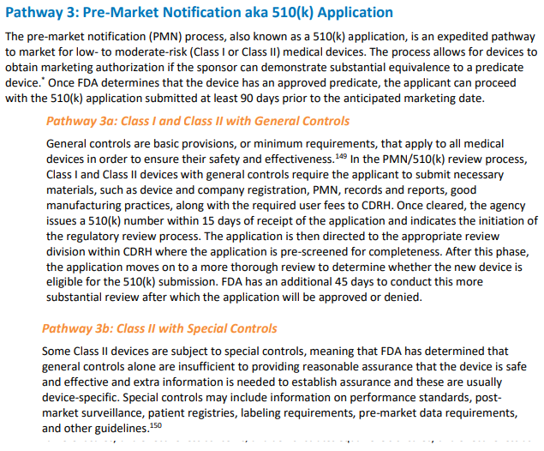
3. Post-approval monitoring

After getting on the market, FDA continues to review it whenever any updates or changes happen
Pew Charitable Trusts 2021 (non-profit research organization) 5 Aug 2021 “How FDA Regulates Artificial Intelligence in Medical Products” https://www.pewtrusts.org/en/research-and-analysis/issue-briefs/2021/08/how-fda-regulates-artificial-intelligence-in-medical-products (accessed 17 Jan 2022)
Once a device is on the market, FDA takes a risk-based approach to determine whether it will require premarket review of any changes the developer makes. In general, each time a manufacturer significantly updates the software or makes other changes that would substantially affect the device’s performance, the device may be subject to additional review by FDA, although the process for this evaluation differs depending on the device’s risk classification and the nature of the change.
4. Tort liability under 510K

[“Tort liability” means getting sued for damages in civil court if someone is injured by the wrongful or negligent actions of another.]
Manufacturers can be successfully sued if their 510K device causes harm (but can’t be sued under PMA)
Duke-Margolis Center for Health Policy 2019. (The Robert J. Margolis, MD, Center for Health Policy at Duke University is directed by Mark McClellan, MD, PhD, and brings together expertise from the policy community in Washington, DC, Duke University, and Duke Health to address the most pressing issues in health policy. The mission of Duke University’s Robert J. Margolis, MD, Center for Health Policy is to improve health and the value of health care through practical innovative, and evidence-based policy solutions. ) Current State and Near-Term Priorities for AI-Enabled Diagnostic Support Software in Health Care (article is undated but references material published in 2019) https://healthpolicy.duke.edu/sites/default/files/2019-11/dukemargolisaienableddxss.pdf (accessed 17 Jan 2022)
Current medical device law suggests that degree of regulation (i.e. which pathway used for approval/clearance) required by FDA for marketing affects the liability exposure to the manufacturer. Riegel v. Medtronic, Inc. held that medical devices approved through FDA’s PMA pathway are immune from tort liability in state court both from direct damages caused by the product as well as indirect damages (such as failure to warn) through the “pre-emption doctrine.” However, devices that go through the 510(k) pathway are not protected by the pre-emption doctrine, based on an earlier court decision Medtronic, Inc v. Lohr.

Tort liability solves for public safety when it’s hard to regulate because the technology is complicated, like AI medical devices
Prof. Charlotte A. Tschider 2021 (Assistant Professor of Law for the Loyola University School of Law and a member of the Beazley Institute for Health Law & Policy) Medical De Medical Device Artificial Intelligence: The New Tort Frontier,10 Aug 2021 BRIGHAM YOUNG UNIVERSITY LAW REVIEW https://digitalcommons.law.byu.edu/cgi/viewcontent.cgi?article=3327&context=lawreview (accessed 17 Jan 2022)
Countless human decisions result in automated decision-making via AI algorithms, including those powering low-risk and high-risk applications, from diagnostic software to surgical robotics. The depth of human ingenuity paired with machine computer power and longitudinal extensibility will revolutionize life as we know it. While the risks are high, the incentives and potential outcomes are similarly high. The most crucial step is finding the appropriate balance for incentivizing development while reducing potential issues. Where preventative regulation is undesirable or unlikely to provide safe and effective medical devices, the tort system may provide a complementary opportunity to reinforce safety while providing injury compensation.

Tort liability is a substantial deterrent slowing the release of medical devices – maybe even too much
Brent E. Johnson, Daniel B. Rogers and Victor E. Schwartz 2018. (attorneys for the Advanced Medical Tech. Assoc., American Tort Reform Assoc., Bioutah, US Chamber of Commerce, Natl. Assoc. of Manufacturers, and Pharmaceutical Research & Manufacturers of America) Oct 2018 AMICI CURIAE brief in the case of Burnigham v. Wright, in the Supreme Court of the State of Utah https://www.shb.com/-/media/files/professionals/r/rogersdaniel/amicus-brief_burningham-v-wright-med-grp.pdf?la=en (accessed 17 Jan 2022)
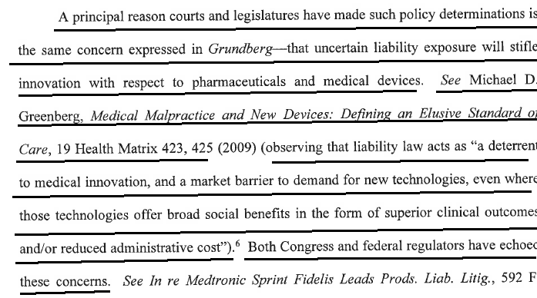

Examples of drugs and medical devices that were withdrawn from the market due to tort liability
Brent E. Johnson, Daniel B. Rogers and Victor E. Schwartz 2018. (attorneys for the Advanced Medical Tech. Assoc., American Tort Reform Assoc., Bioutah, US Chamber of Commerce, Natl. Assoc. of Manufacturers, and Pharmaceutical Research & Manufacturers of America) Oct 2018 AMICI CURIAE brief in the case of Burnigham v. Wright, in the Supreme Court of the State of Utah https://www.shb.com/-/media/files/professionals/r/rogersdaniel/amicus-brief_burningham-v-wright-med-grp.pdf?la=en (accessed 17 Jan 2022)
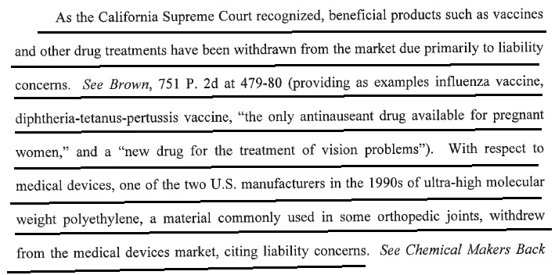

HARMS / SIGNIFICANCE

1. No harm from 501K pathway
Pathway doesn’t matter: 501K is just as stringent as the others to ensure risk/benefit analysis
Brent E. Johnson, Daniel B. Rogers and Victor E. Schwartz 2018. (attorneys for the Advanced Medical Tech. Assoc., American Tort Reform Assoc., Bioutah, US Chamber of Commerce, Natl. Assoc. of Manufacturers, and Pharmaceutical Research & Manufacturers of America) Oct 2018 AMICI CURIAE brief in the case of Burnigham v. Wright, in the Supreme Court of the State of Utah https://www.shb.com/-/media/files/professionals/r/rogersdaniel/amicus-brief_burningham-v-wright-med-grp.pdf?la=en (accessed 17 Jan 2022) (the reference to “comment k” refers to a legal principle in tort law that protects manufacturers from getting sued over products that contain unavoidable risk as part of their normal beneficial function)
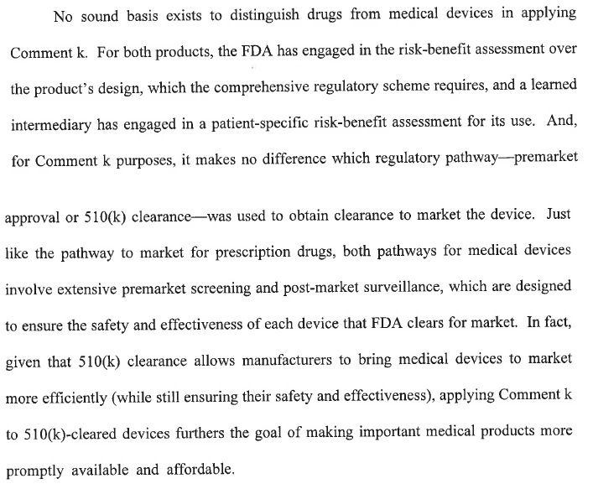

SOLVENCY

1. Stricter FDA pre-market scrutiny of AI won’t solve anything
AI is so complex that most safety issues couldn’t be found pre-market. They’d only be found after widespread use
Prof. Charlotte A. Tschider 2021 (Assistant Professor of Law for the Loyola University School of Law and a member of the Beazley Institute for Health Law & Policy) Medical De Medical Device Artificial Intelligence: The New Tort Frontier,10 Aug 2021 BRIGHAM YOUNG UNIVERSITY LAW REVIEW https://digitalcommons.law.byu.edu/cgi/viewcontent.cgi?article=3327&context=lawreview (accessed 17 Jan 2022)
The customized aspect of AI combined with its dynamic inscrutability for unlocked algorithms poses unique challenges for effective preventative oversight, as what is a perfectly reasonable design for one AI software application may not appropriately acknowledge issues for another. With AI, potential risks can only be anticipated to a limited extent because the algorithm making the decisions is a completely different algorithm in clinical trials than when used post-trial. The world is a clinical trial for health AI, full of unanticipated issues unlikely to arise in a limited clinical-trial scheme and difficult to anticipate at the time of FDA submission.

Stricter PMA (Pre Market Approval) pathway wouldn’t increase safety. But it would leave patients without the ability to sue for damages if they’re injured (See DA 1)
Prof. Charlotte A. Tschider 2021 (Assistant Professor of Law for the Loyola University School of Law and a member of the Beazley Institute for Health Law & Policy) Medical De Medical Device Artificial Intelligence: The New Tort Frontier,10 Aug 2021 BRIGHAM YOUNG UNIVERSITY LAW REVIEW https://digitalcommons.law.byu.edu/cgi/viewcontent.cgi?article=3327&context=lawreview (accessed 17 Jan 2022)
The PMA process is somewhat comprehensive for what it regulates, yet there are serious gaps, especially for AI-enabled medical devices. These systems have the potential to create safety hazards for patients but likely leave patients without any opportunity for recovery in tort. Medical devices under PMA review are often reviewed by experts, but not necessarily experts in AI or software development; components of a medical device, which are nevertheless incorporated into the final product, may not receive a Class III classification or PMA review although they may introduce new safety hazards.

2. FDA incompetence and lack of capacity
FDA now and in the future will not be able to effectively analyze AI devices pre-market
[“Ex ante” regulation = regulations that happen before it goes on sale in the market]
Prof. Charlotte A. Tschider 2021 (Assistant Professor of Law for the Loyola University School of Law and a member of the Beazley Institute for Health Law & Policy) Medical De Medical Device Artificial Intelligence: The New Tort Frontier,10 Aug 2021 BRIGHAM YOUNG UNIVERSITY LAW REVIEW https://digitalcommons.law.byu.edu/cgi/viewcontent.cgi?article=3327&context=lawreview (accessed 17 Jan 2022)
The FDA, at this time and likely in the future, is ill-prepared to effectively provide the specialized knowledge that will inform effective ex ante regulation contemplated by the MDA. It is crucial to reiterate that, based on the specificity of special controls, the lack of detailed guidance, and the existence of a singular discussion paper on AI, the FDA is clearly not positioned to guide manufacturers to produce safe AI machines. Further, the structure of the review process, including the expertise of FDA analysts and panel members, limits the potential for holistic device reviews that effectively anticipate potential patient risks.
FDA doesn’t have the skills to increase scrutiny of AI products with higher pathway standard (like PMA)
Prof. Charlotte A. Tschider 2021 (Assistant Professor of Law for the Loyola University School of Law and a member of the Beazley Institute for Health Law & Policy) Medical De Medical Device Artificial Intelligence: The New Tort Frontier,10 Aug 2021 BRIGHAM YOUNG UNIVERSITY LAW REVIEW https://digitalcommons.law.byu.edu/cgi/viewcontent.cgi?article=3327&context=lawreview (accessed 17 Jan 2022)
However, it is generally accepted that guidance operates, at least for PMA reviews, as a pseudo-requirement. Specifically, FDA personnel, for example the analyst assigned to the file, usually evaluate compliance with a special control, such as “[a]dequate consideration of privacy and security issues” through the lens of guidance documents.[END QUOTE] In this way, guidance seems to operate, at least for some types of reviews, as a rebuttable presumption: so long as organizations demonstrably meet the guidance, they also demonstrate compliance with associated special controls. If the organization does not meet the guidance, they must provide documentation to demonstrate that they still comply with the special control. [SHE GOES ON LATER IN THE CONTEXT QUOTE:] To what degree FDA personnel or panel members actually provide expert direction in this review process is unknown, though facially it seems unlikely that personnel and panel members are equipped to review software design and anticipate real patient risks for new software technology like AI from a position of deep expertise.

FDA doesn’t have the skills nor the manpower to manage increase in AI regulation
Bradley M. Thompson 2020 (General Counsel, AI Startups in Health Coalition ) 25 Mar 2020 Re: Comments on Public Workshop – Evolving Role of Artificial Intelligence in Radiological Imaging https://www.regulations.gov/comment/FDA-2019-N-5592-0012 (accessed 13 Jan 2022)
Over the next 10 years, companies deploying AI in healthcare will ramp up the data they collect postmarket by enormous amounts. We won’t try to project here exactly how much, but hopefully everyone agrees it’ll be a huge number. If FDA asks companies to start turning over to the agency even a small portion of that data, it will overwhelm the agency. We understand that FDA presently suffers from human resource constraints, particularly those with an AI software background. The agency is frankly not set up with either the manpower or information systems to read and interpret data transmitted to it on an ongoing basis postmarket. Though, conceivably, FDA could staff up or purchase and deploy its own AI system specific to this task, the expenditures are beyond FDA’s current financial resources, and supplemental appropriations for this task would likely be years in the future.

3. More study needed first before we change the pre-market review for AI medical devices

Need to let existing studies continue for a few years, to get the information needed to modify pre-market AI review process
Pew Charitable Trusts 2021. (non-profit research organization) 5 Aug 2021 “How FDA Regulates Artificial Intelligence in Medical Products “ https://www.pewtrusts.org/en/research-and-analysis/issue-briefs/2021/08/how-fda-regulates-artificial-intelligence-in-medical-products (accessed 14 Jan 2022) (our Minor Repair is to “fully implement” the streamline review/audit afterwards pilot project and let it finish before deciding on anything like the AFF plan)
In 2019, the agency began piloting an oversight framework called the Software Precertification Program, which, if fully implemented, would be a significant departure from its normal review process. Rather than reviewing devices individually, FDA would first evaluate the developer. If the organization meets certain qualifications and demonstrates it has rigorous processes to develop safe, effective devices, it would be able to undergo a significantly streamlined review process and make changes or even introduce products without going through premarket review. Nine companies participated in this pilot program. The lessons learned may help inform the development of a future regulatory model for software-based medical devices.

FDA needs more time to study the AI medical device approval process. Can’t decide quickly because it’s very complex
Pew Charitable Trusts 2021. (non-profit research organization) 5 Aug 2021 “How FDA Regulates Artificial Intelligence in Medical Products “ https://www.pewtrusts.org/en/research-and-analysis/issue-briefs/2021/08/how-fda-regulates-artificial-intelligence-in-medical-products (accessed 14 Jan 2022)
The regulatory framework governing these tools is complex. FDA regulates some—but not all—AI-enabled products used in health care, and the agency plays an important role in ensuring the safety and effectiveness of those products under its jurisdiction. The agency is currently considering how to adapt its review process for AI-enabled medical devices that have the ability to evolve rapidly in response to new data, sometimes in ways that are difficult to foresee.

DISADVANTAGES

1. Losing tort liability. Post-plan, AI devices will be exempt from lawsuits by injured patients

Link: AFF removes 510K because they want AI devices to go through stricter standards
If it doesn’t do that, it doesn’t accomplish anything

Link: 510K devices are subject to tort liability, but stricter pathway PMA devices are immune to lawsuits
[This is the same card as Inherency #4 – no need to read it again if it was already read earlier]
Duke-Margolis Center for Health Policy 2019. (The Robert J. Margolis, MD, Center for Health Policy at Duke University is directed by Mark McClellan, MD, PhD, and brings together expertise from the policy community in Washington, DC, Duke University, and Duke Health to address the most pressing issues in health policy.) Current State and Near-Term Priorities for AI-Enabled Diagnostic Support Software in Health Care (article is undated but references material published in 2019) https://healthpolicy.duke.edu/sites/default/files/2019-11/dukemargolisaienableddxss.pdf (accessed 17 Jan 2022)
Current medical device law suggests that degree of regulation (i.e. which pathway used for approval/clearance) required by FDA for marketing affects the liability exposure to the manufacturer. Riegel v. Medtronic, Inc. held that medical devices approved through FDA’s PMA pathway are immune from tort liability in state court both from direct damages caused by the product as well as indirect damages (such as failure to warn) through the “pre-emption doctrine.” However, devices that go through the 510(k) pathway are not protected by the pre-emption doctrine, based on an earlier court decision Medtronic, Inc v. Lohr.

Backup evidence: PMA (Pre-Market Approval, the higher regulatory standard) means lawsuits are pre-empted
Prof. Charlotte A. Tschider 2021 (Assistant Professor of Law for the Loyola University School of Law and a member of the Beazley Institute for Health Law & Policy) Medical De Medical Device Artificial Intelligence: The New Tort Frontier,10 Aug 2021 BRIGHAM YOUNG UNIVERSITY LAW REVIEW (accessed 17 Jan 2022) https://digitalcommons.law.byu.edu/cgi/viewcontent.cgi?article=3327&context=lawreview)
The cumulative effect of these cases is to almost completely preempt tort actions when the FDA has used a PMA or similarly stringent approval process for medical device clearance. Of course, this preemption model will likely prevent recovery for AI-enabled medical devices that are cleared through PMA or similarly stringent approval processes, regardless of whether the FDA has in fact reviewed the AI system running the medical device.

Impact: Uncompensated injury. People harmed by AI devices, after the AFF plan, will no longer be able to recover compensation in court
Prof. Charlotte A. Tschider 2021 (Assistant Professor of Law for the Loyola University School of Law and a member of the Beazley Institute for Health Law & Policy) Medical De Medical Device Artificial Intelligence: The New Tort Frontier,10 Aug 2021 BRIGHAM YOUNG UNIVERSITY LAW REVIEW(accessed 17 Jan 2022) https://digitalcommons.law.byu.edu/cgi/viewcontent.cgi?article=3327&context=lawreview
The risk allocation presented at the system level may not seem problematic. Devices undergoing more truncated review, such as Class II medical devices and Class III medical devices that are deemed substantially equivalent to a predicate device, will undergo the abbreviated 510(k) process, and tort actions will not be preempted. Claims resulting from Class I medical device injuries, devices subject to general controls and usually not reviewed by the FDA at all, will also not be preempted. This means that claims for injuries resulting from 95% of devices marketed for sale will not be preempted. However, when patients are injured by the highest-risk devices, which may use AI, their claims will most likely be preempted because presumably the FDA has comprehensively reviewed device design and attendant risks. This model may work effectively to minimize injury when the FDA is able to effectively review and prevent large-scale risks of a certain type, but it will likely leave patients using AI-enabled devices who have suffered injury uncompensated.
2. Blocks technological innovation

Stricter pathway review (like PMA) won’t add any safety (because FDA has no expertise). It will only block innovation and raise costs
Prof. Charlotte A. Tschider 2021 (Assistant Professor of Law for the Loyola University School of Law and a member of the Beazley Institute for Health Law & Policy) Medical De Medical Device Artificial Intelligence: The New Tort Frontier,10 Aug 2021 BRIGHAM YOUNG UNIVERSITY LAW REVIEW https://digitalcommons.law.byu.edu/cgi/viewcontent.cgi?article=3327&context=lawreview (accessed 17 Jan 2022)
Medical devices reviewed by the FDA under a PMA are, by definition, new and innovative technologies demanding expert knowledge, and the FDA does not, and may not desire to have, comprehensive expertise. The use of AI not only in diagnostic software but also integrated into functioning medical device software amplifies this knowledge demand because the rate of technological change for AI software is so incredibly high. Even AI experts cannot keep up with the variety of models and methods created for AI, and the cost of complete FDA regulation meriting broad preemption will likely lead to inefficiencies of cost and availability delays inconsistent with innovation goals.

Link: Innovation blocked. Increased FDA regulation would make it more difficult for startups to innovate medical AI apps
Bradley M. Thompson 2020 (General Counsel, AI Startups in Health Coalition ) 25 Mar 2020 Re: Comments on Public Workshop – Evolving Role of Artificial Intelligence in Radiological Imaging https://www.regulations.gov/comment/FDA-2019-N-5592-0012 (accessed 13 Jan 2022)
A small company simply could not operate with FDA peppering it with questions on a daily basis. This level of micromanagement by the agency would be devastating to operations. The net effect of that devastation would be the company’s inability to dedicate sufficient resources to its operations including quality assurance. It is the patient, then, that would suffer from the company’s distraction. Further, the amount of data that FDA would require of companies would require the company to expend additional (and likely, human) resources to satisfy FDA’s requests. While large companies can more easily absorb this additional headcount, smaller companies, and especially startups, cannot. Long-term, this would make it more difficult for startups to innovate important
new FDA-regulated AI.

Impact: Health and money. More AI innovation means better health for patients at lower cost
PETER MEATH 2019 (CO-HEAD OF HEALTHCARE AND LIFE SCIENCES, MIDDLE MARKET, J.P. MORGAN COMMERCIAL BANKING) 13 Mar 2019 “3 Ways Artificial Intelligence Can Help Medtech Save Lives” https://www.jpmorgan.com/commercial-banking/insights/ai-medtech-save-lives (accessed 14 Jan 2022)
Pathologists can draw on AI’s ability to cross-reference hundreds of thousands of comparable slides and data sets to both predict and evaluate different diagnoses. Cancers can be identified more accurately and efficiently, and at earlier stages of progression—ultimately leading to better treatment protocols and patient outcomes. Like pathology, medical imaging is an aspect of healthcare that has traditionally relied on human interpretation alone, but the immense volume of imaging presents an opportunity for more efficient analysis. Medical imaging—such as MRIs and CTs—essentially provide a tool for radiologists to identify underlying patterns. Since pattern analysis and recognition sit at the core of how AI is built, AI can be used by doctors in all facets of the decision process—from detection and diagnosis to decision analysis and treatment. AI can simply cross-compare and analyze a more complete data set than humans can assess by themselves. This can improve both the quality and speed of the analysis, benefiting the efficiency and cost for doctors and the health system as a whole.

3. Deaths from missing treatment

Link: AFF reduces / slows the availability of AI technology
If not, then it doesn’t accomplish anything.

Problem: The choice isn’t between imperfect AI diagnostics and better human diagnostics. It’s between AI and NOTHING because there is a shortage of qualified personnel. And the impact is people die from heart attacks
Dr. Ha Hong 2020 (PhD; Investigator/Co-founder Caption Health, Inc. ) PUBLIC WORKSHOP - EVOLVING ROLE OF ARTIFICIAL INTELLIGENCE IN RADIOLOGICAL IMAGING DAY 2 FINAL (003) FOOD AND DRUG ADMINISTRATION, CENTER FOR DEVICES AND RADIOLOGICAL HEALTH , PUBLIC WORKSHOP - EVOLVING ROLE OF ARTIFICIAL INTELLIGENCE IN RADIOLOGICAL IMAGING , February 26, 2020 https://www.regulations.gov/document/FDA-2019-N-5592-0010 (accessed 14 Jan 2022)
Heart disease can be accurately diagnosed with echocardiography or heart ultrasound scanning, but this often happens too late. Let's suppose that you wake up in the middle of the night with severe chest pain and shortness of breath, symptoms consistent with heart disease. You are in severe pain and brought to the ER, the emergency room doctor performs physical exam on you using plain old stethoscope, but the doctor does not perform ultrasound on you. In fact, the doctor cannot. Although they clearly know all the benefits and advantages of using ultrasound in this particular case, there are not that many people who can scan. This bottleneck, CDR bottlenecking, image acquisition causes delay in diagnosis and treatment, costing you a life. So why this is such a bottleneck? Why aren't more people able to scan? The problem is that ultrasound is so difficult, it's very difficult to use, especially in cardiac space. It is an unnatural hand-eye coordination problem, a tiny movement in hand positioning can dramatically change the image on the screen and the images themselves are very unintuitive. You do not know where you are, where the target is, how to navigate, and even if you hit the target, you do not know whether that is good enough or not. And to compound this problem, everyone is really different. Obesity, pathology and implanted devices can introduce significant variations on the images and also, simply everyone has different heart shapes . So that's the reason why there's a bottleneck., It takes years and years to master this and to become an ultrasound imaging professional.

Backup evidence: Speed matters: 1) for emergency situations 2) for underserved areas with limited access to doctors
Dr. BRIAN GARRA, M.D. 2020. (Physician, Division of Imaging Diagnostics and Software Reliability, Office of Science and Engineering Laboratories – FDA) PUBLIC WORKSHOP - EVOLVING ROLE OF ARTIFICIAL INTELLIGENCE IN RADIOLOGICAL IMAGING DAY 2 FINAL (003) FOOD AND DRUG ADMINISTRATION, CENTER FOR DEVICES AND RADIOLOGICAL HEALTH , PUBLIC WORKSHOP - EVOLVING ROLE OF ARTIFICIAL INTELLIGENCE IN RADIOLOGICAL IMAGING , February 26, 2020 https://www.regulations.gov/document/FDA-2019-N-5592-0010 (accessed 14 Jan 2022)
Faster is helpful in an emergency situation, for example. More access is helpful in a rural environment, for example, where people have no imaging capability whatsoever. Even in the U.S., in Appalachia, for instance, people have no access to imaging and there's a lot of potential for us to fix the third-world part of the United States by having more access and more skilled access in places where there's not much skill.

