Negative: Food Quality
By “Coach Vance” Trefethen
The United States Federal Government should significantly reform its policies regarding convicted prisoners under federal jurisdiction
Case Summary: The AFF plan tries to solve for poor quality food being sold to federal prisons for prisoner meals.
Negative: Food Quality 2
INHERENCY 2
1. Inspector General says all BOP food issues have been resolved 2
All issues in the 2020 “Notification of Concerns” about BOP Food Procurement are “resolved” because Bureau of Prisons agreed to implement the changes 2
2. Recovering from Covid 3
Of course there are problems: Covid disrupted many prison operations. But they’re getting fixed as we recover 3
HARMS / SIGNIFICANCE 3
1. Not a harm until someone gets harmed 3
AFF has to provide evidence of a prisoner getting harmed before they can call it a “Harm” 3
2. Meal quality isn’t bad 3
Federal prison food is only bad on TV. It’s nutritionally adequate and quality is good 3
SOLVENCY 4
1. Won’t solve for corrupt procurement practices 4
BOP employees are corrupt too, so don’t expect them to solve corruption. Many of them will soon be inmates 4
DISADVANTAGES 4
1. Court clog 4
Link: Congress specifically passed legislation to stop whining about prison food from clogging the courts 4
Link: AFF enforcement means these cases end up back in federal court 4
Brink: Federal appellate court caseloads have doubled since 1971 5
Impact: Justice Denied. Court clog leads to judges making decisions in inconsistent ways that deny justice 5
2. Staffing shortages 6
Link: Federal Bureau of Prisons is massively understaffed 6
Link: BOP staff must be pulled off whatever they’re doing now to do AFF’s plan. Nothing happens without staffing 6
Link & Brink: Attorney General admits federal prison staffing is “a serious problem” 6
Link: BOP can’t attract and hire new prison officers because pay is too low 6
Impact: Exponential increase in prison violence when staffing is diverted to do the AFF plan 7
Impact: Injuries and deaths. Federal prisons are very dangerous for staff. 7
A/T “Our tiny little reform won’t trigger the Disad” – Then it’s too small to be topical 7
3. Masking Disad. AFF case distracts us from the REAL problems in federal prisons 8
Bureau of Prisons either is or should be focused on reforms that deal with real emergencies 8

Negative: Food Quality

INHERENCY

1. Inspector General says all BOP food issues have been resolved
All issues in the 2020 “Notification of Concerns” about BOP Food Procurement are “resolved” because Bureau of Prisons agreed to implement the changes
[Read the evidence text below and then read the headers and text in the chart]
Office of the Inspector General, US Justice Dept. 2021. “Recommendations Issued by the Office of the Inspector General that were Not Closed as of July 31, 2021” https://oig.justice.gov/sites/default/files/reports/21-108_0.pdf (accessed 5 Jan 2022) (brackets added)
The following categories are used to describe the status of the recommendations in the report:
Response Not Yet Due – DOJ’s initial response to the recommendation is not yet due.
Resolved – DOJ has agreed to implement the recommendation or has proposed actions that will address the recommendation.
Unresolved – The initial deadline for DOJ’s response to the recommendation has passed, and DOJ has not agreed to implement the recommendation or has not proposed actions that will address the recommendation. The OIG may also convert a recommendation from “Resolved” to “Unresolved” if it determines that DOJ is not making sufficient progress towards implementation.
On Hold/Pending with OIG– The completion of the OIG’s assessment of the status of the recommendation is on hold or pending due to ongoing reviews or other factors. As of July 31, 2021, the OIG had not closed 962 recommendations, which the OIG associated with the following statuses at that time: Resolved (833 recommendations), On Hold/Pending with OIG (127 recommendations), Response Not Yet Due (1 recommendation), and Unresolved (1 recommendation). The information in the following chart is derived from the attached report and includes recommendations that are in the categories described above as of July 31, 2021.

END QUOTE. THEN FOLLOWS A CHART WITH 962 ENTRIES INCLUDING ENTRY #424:

[“Rec. No. In OIG Report” stands for “Recommendation Number in the Office of the Inspector General Report”]
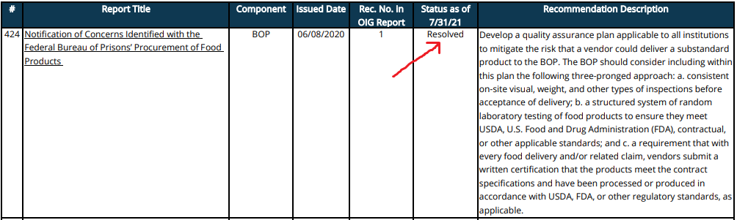

2. Recovering from Covid
Of course there are problems: Covid disrupted many prison operations. But they’re getting fixed as we recover
MICHAEL D. CARVAJAL 2021 (DIRECTOR, FEDERAL BUREAU OF PRISONS) Statement before the COMMITTEE ON THE JUDICIARY, UNITED STATES SENATE, HEARING ON “OVERSIGHT OF THE FEDERAL BUREAU OF PRISONS” 15 April 2021 https://www.judiciary.senate.gov/imo/media/doc/BOP%20Director%20-%20%20Written%20Statement%202021-04-15%20SJC%20Hearing%20.pdf (accessed 5 Jan 2022)
COVID-19 numbers have dropped significantly across nearly all institutions even as inmate movement has resumed, and despite communities re-opening. We are taking steps to normalize operations in stages as safety and security permit, including inmate movement, food service, and ramping up programing in all facilities. All of these efforts will have a positive impact on staff, inmates, and Bureau operations. And while it has been an extraordinary year with many challenges, we continue to look forward and advance our priorities.

HARMS / SIGNIFICANCE

1. Not a harm until someone gets harmed
AFF has to provide evidence of a prisoner getting harmed before they can call it a “Harm”
…and it has to be some significant number, or some awful impact like someone dying. Until they do that, they haven’t justified their plan. Just calling something a “harm” doesn’t make it one. And bad food isn’t a harm until someone is harmed by it.

2. Meal quality isn’t bad

Federal prison food is only bad on TV. It’s nutritionally adequate and quality is good
Zoukis Consulting Group 2016. (Christopher Zoukis, MBA, is the Managing Director of the Zoukis Consulting Group, a federal prison consultancy that assists attorneys, federal criminal defendants, and federal prisoners with prison preparation and in-prison matters) published 7 Apr 2016 last updated 24 Oct 2021 https://prisonerresource.com/prison-life/first-day-in-prison/what-do-you-eat-in-prison/ (accessed 5 Jan 2022)
While many TV shows and movies depict American prisoners as eating poor quality food, inmates within the Federal Bureau of Prisons are provided three nutritionally sound meals each day. For prisoners in the general population, meals are served in a dining room (which prisoners call the “Chow Hall”), where all other general population inmates eat. This is essentially a large cafeteria area with a serving bar and tables. The exceptions to this are if the prison is locked down or the prisoner is in intensive confinement (e.g., a special management unit, special housing unit, etc.). In that case, their meals might be brought to them on a tray. While the meals aren’t great, they are nutritionally adequate and will ensure that no one goes hungry or starves. While the BOP has been scaling back on food expenditures in recent years, the food quality is still good.

SOLVENCY

1. Won’t solve for corrupt procurement practices
BOP employees are corrupt too, so don’t expect them to solve corruption. Many of them will soon be inmates
Associated Press 2021 (journalist Michael Balsamo) 2 Dec 2021 “Durbin: Prisons chief has ‘no intention of reforming’ system” https://wgnradio.com/news/political-news/durbin-prisons-chief-has-no-intention-of-reforming-system/ (accessed 5 Jan 2022)
Sen. Dick Durbin doubled down on his demand that Attorney General Merrick Garland remove Director Michael Carvajal, which came days after an Associated Press investigation that detailed serious misconduct involving federal correctional officers and revealed more than 100 Bureau of Prisons workers have been arrested, convicted or sentenced for crimes since the start of 2019. “Since day one, Director Carvajal has shown no intention of reforming the institution,” Durbin said in a speech on the Senate floor. “For years, the Bureau of Prisons has been plagued by corruption, chronic understaffing, and misconduct by high-ranking officials.”

DISADVANTAGES

1. Court clog

Link: Congress specifically passed legislation to stop whining about prison food from clogging the courts
Anna Little Morris 2017 (attorney) 7 Feb 2017 “Twenty Years After Reform, Inmate Litigation Still Crowds Dockets” https://www.butlersnow.com/2017/02/twenty-years-reform-inmate-litigation-still-crowds-dockets/ (accessed 5 Dec 2021)
A million dollars in damages for melted ice cream. Cruel and unusual punishment for having to listen to country music. A suit demanding L.A. Gear or Reebock shoes instead of prison-issued Converses. An emotional distress claim for receiving crunchy, instead of creamy, peanut butter. Are these the types of lawsuits to which our courts should be devoting time and resources? Congress apparently thought otherwise when they passed – with overwhelming bipartisan support – the Prison Litigation Reform Act (PLRA).

Link: AFF enforcement means these cases end up back in federal court
If there’s no enforcement then nothing happens. If there is enforcement, it has to end up in court for someone to impose penalties for not complying with their plan. You can be sure prisoners will start reporting all kinds of violations once they hear about this new law. If even 1 case has to be enforced under their plan, that’s one person with a real legal case who will have to wait in federal court behind a prisoner’s case complaining about crunchy peanut butter.

Brink: Federal appellate court caseloads have doubled since 1971
Prof. Peter S. Menell & Prof. Ryan Vacca 2020. (Menell - Professor of Law and Director, Berkeley Center for Law & Technology, University of California. Vacca - Professor of Law, Univ of New Hampshire School of Law) Revisiting and Confronting the Federal Judiciary Capacity “Crisis”: Charting a Path for Federal Judiciary Reform 1 Jully 2020 CALIFORNIA LAW REVIEW https://scholars.unh.edu/cgi/viewcontent.cgi?article=1438&context=law_facpub
The number of filed cases per year grew 292% between 1971 and 2017, from 14,761 to 57,872. The number of cases terminated on the merits grew from 13,015 in 1971 to 36,851 in 2017, a 183% increase. As previously discussed, Congress authorized additional circuit court judgeships during this time. The number of appellate judges is based on data from Habel and Scott. These data show how many active and senior circuit court judgeships are actually filled and, as with district judges, treat senior circuit court judges as one quarter of an active-duty circuit court judge. Figure 14 illustrates how many cases were filed, on average, per appellate judge from 1971 through 2017. The average number of cases filed per judge increased from 148 (active judges only) or 142 (active and senior judges) in 1971 to 324 (active judges only) or 278 (active and senior judges) in 2017. Counting only active circuit court judges, this is a 119% increase in filings per judge. Counting active and senior judges results in a 96% increase in filings per judge. Thus, the caseload per judge has roughly doubled since 1971.

Impact: Justice Denied. Court clog leads to judges making decisions in inconsistent ways that deny justice
Dr. Cristoph Engel and Prof. Keren Weinshall 2020. (Engel - Chair of the Advisory Board, Amsterdam Center for Law and Economics; Director of Max Planck Institute for Research on Collective Goods.. Weinshall is Edward S. Silver Chair in Civil Procedure, Hebrew University, Jerusalem) 24 Nov 2020 “Manna from Heaven for Judges: Judges’ Reaction to a Quasi-Random Reduction in Caseload” JOURNAL OF EMPIRICAL LEGAL STUDIES https://onlinelibrary.wiley.com/doi/full/10.1111/jels.12265 (“heuristics” – in this context, it refers to deciding things based on past personal experience rather than looking independently at the facts of the present case)
Judges are not only rational actors striving to optimize their use of time. Although most of the aforementioned studies focus on judges’ strategic choices of the less time-consuming legal outcome, their decisions may also be affected by the physical and emotional fatigue, decline in cognitive performance, and elevated stress levels associated with high workloads. Research has shown that under time pressure, judges are more vulnerable to heuristics and biases. For example, rulings were found to be more inconsistent when judges face a high caseload (Norris 2018) and busy judges were found to expend less effort by according higher weight to non-legal cues, such as litigants’ race or gender, to determine case outcomes (Guthrie et al. 2000, 2007; Rachlinski et al. 2008).

2. Staffing shortages

Link: Federal Bureau of Prisons is massively understaffed
Associated Press 2021. (journalists Michael Sisak and Michael Balsamo) 21 May 2021 “Cooks, nurses guard inmates at federal prisons down 6,000 officers” https://www.pressherald.com/2021/05/21/cooks-nurses-guard-inmates-as-u-s-prisons-lack-thousands-of-correctional-officers/ (accessed 5 Jan 2022)
At a federal penitentiary in Texas, prisoners are locked in their cells on weekends because there are not enough guards to watch them. Elsewhere in the system, fights are breaking out, several inmates have escaped in recent months and, in Illinois, at one of the most understaffed prisons in the country, five inmates have died in homicides or suicides since March 2020. The Justice Department budgeted for 20,446 full-time correctional officer positions in 2020, but the agency that runs federal prisons said it currently employs 13,762 officers.

Link: BOP staff must be pulled off whatever they’re doing now to do AFF’s plan. Nothing happens without staffing
Associated Press 2021. (journalists Michael Sisak and Michael Balsamo) 21 May 2021 “Cooks, nurses guard inmates at federal prisons down 6,000 officers” https://www.pressherald.com/2021/05/21/cooks-nurses-guard-inmates-as-u-s-prisons-lack-thousands-of-correctional-officers/ (accessed 5 Jan 2022)
The expanded use of that practice, known as augmentation, is raising questions about whether the agency can carry out its required duties to ensure the safety of prisoners and staff members while also putting in place programs and classes such as those under the First Step Act, a criminal justice overhaul that received wide bipartisan support in Congress. “You can’t do programming, you can’t have safety, you can’t have a lot of things that make prisons operate without proper staffing,” said Kevin Ring, the president of the advocacy group Families Against Mandatory Minimums.

Link & Brink: Attorney General admits federal prison staffing is “a serious problem”
KERI BLAKINGER, JAMILES LARTEY, BETH SCHWARTZAPFEL, MIKE SISAK and CHRISTIE THOMPSON 2021 (staff writers for The Marshall Project, a non-profit research group on criminal justice) “As Corrections Officers Quit in Droves, Prisons Get Even More Dangerous” 1 Nov 2021 https://www.themarshallproject.org/2021/11/01/as-corrections-officers-quit-in-droves-prisons-get-even-more-dangerous (accessed 3 Jan 2022)
Asked last week in a U.S. Senate hearing about federal prison staffing, Attorney General Merrick Garland said, “I agree this is a serious problem at the Bureau of Prisons.”

Link: BOP can’t attract and hire new prison officers because pay is too low
FEDAgent 2021. (News group for federal law enforcement employees) “Lawmakers Request BOP Director Provide Insight on Augmenting Personnel, Staff Shortages” 11 Nov 2021 https://www.fedagent.com/news/lawmakers-request-bop-director-provide-insight-on-personnel-augmentation-staff-shortages (accessed 3 Jan 2022)
GAO found that although BOP budgeted for 20,446 full-time correctional officer positions in 2020, the agency reported that it currently employs 13,762 officers. Despite efforts to attract recruits with 25 percent bonuses, there has been little progress. While there are promises of making $62,615 as a recruitment incentive, the starting salary is just under $43,500. The highest end of this salary scale is still much lower than what other federal agencies offer, especially compared with the competition from police departments, state prisons, oil refineries, and warehouses.

Impact: Exponential increase in prison violence when staffing is diverted to do the AFF plan
Shane Fausey 2020. (president of the American Federation of Government Employees (AFGE) National Council of Prison Locals 33 ) 14 May 2020 “Being a prison officer is now more dangerous than ever” https://federalnewsnetwork.com/workforce/2020/05/being-a-prison-guard-now-more-dangerous-than-ever/ (accessed 2 Jan 2022)
Shane Fausey: We have been plagued with staffing concerns since about 2005. They implemented a program called mission critical, which they took about 20% of the correctional services staff or your officers in your prisons. And consistently over the years, most notably January of 2017, they executed another series of cuts. We’re down probably close to 9000 to 10,000 positions since 2005. Unfortunately, in a prison when you reduce your overall staffing numbers, your violence exponentially increases.

Impact: Injuries and deaths. Federal prisons are very dangerous for staff.
Charles E. Samuels 2014. (Director, Federal Bureau of Prisons) 25 Feb 2014 Statement before the Subcommittee on the Constitution, Civil Rights and Human Rights of the Senate Judiciary Committee https://www.congress.gov/event/113th-congress/senate-event/LC60861/text?s=1&r=46 (accessed 19 Sept 2021)
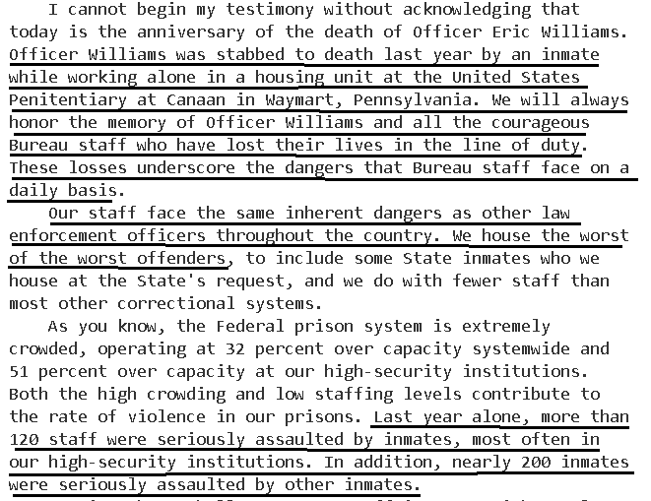

A/T “Our tiny little reform won’t trigger the Disad” – Then it’s too small to be topical
AFF’s always try to minimize the size and scope of their plan whenever they get hit with a Disadvantage about how the system doesn’t have the capacity to do their plan. But if it’s just a teensy weensy little plan that no one will notice and won’t impact anything… then it cannot possibly be a topical, substantial reform. Either they lose on topicality or else they have to accept this disadvantage, but they can’t have it both ways.

3. Masking Disad. AFF case distracts us from the REAL problems in federal prisons

Bureau of Prisons either is or should be focused on reforms that deal with real emergencies
Associated Press 2021 (journalist Michael Balsamo) 2 Dec 2021 “Durbin: Prisons chief has ‘no intention of reforming’ system” https://wgnradio.com/news/political-news/durbin-prisons-chief-has-no-intention-of-reforming-system/ (accessed 5 Jan 2022)
“Since day one, Director Carvajal has shown no intention of reforming the institution,” Durbin said in a speech on the Senate floor. “For years, the Bureau of Prisons has been plagued by corruption, chronic understaffing, and misconduct by high-ranking officials.” Under Carvajal’s leadership, the agency has experienced a multitude of crises, from the rampant spread of coronavirus inside prisons and a failed response to the pandemic to dozens of escapes, deaths and critically low staffing levels that have hampered responses to emergencies.

