Negative: Exculpatory Disclosure / Facial Recognition
By “Coach Vance” Trefethen
Resolved: The United States federal government substantially reform the use of Artificial Intelligence technology
Case Summary: The Supreme Court in the 1963 case of Brady v. Maryland required as a matter of constitutional law that prosecutors in criminal cases must hand over to the defense any potentially exculpatory information they find. “Exculpatory information” means evidence or information that would tend to help prove the defendant is innocent. For example, if the prosecutor has a star witness who is going to testify he saw the defendant at the scene of the crime, but the prosecutor also has a video tape from a security camera on the other side of town that shows the witness was 5 miles away when the crime occurred, the prosecutor must disclose that “exculpatory” video tape to the defense. Such exculpatory evidence is often referred to in the literature as “Brady material,” named after the court case above.
The increasing use of facial recognition software means more criminal cases hinge on evidence coming from the results of an AI program. When facial recognition says the picture from the camera at the scene of the crime matches suspect “Jimmy,” and Jimmy then gets arrested, Jimmy’s defense attorney might like to know some key facts: How many other people did the AI program also name as possible matches to the crime scene picture? What was the confidence level that the AI assigned to the match? For example, did the AI say it was a 30% likelihood that Jimmy matched the picture, but that was the highest percentage match they had, so they went with it and arrested him, even though it’s a 70% chance he’s innocent?
These additional facts beyond just “The AI identified Jimmy as the suspect” should be disclosed to the defense, under the Brady rule, since they might tend to prove Jimmy is innocent. AFF will argue that they are not being disclosed. They’re probably right, but here’s the problem: Status Quo law already requires it to be disclosed. So… what does the plan do that Status Quo isn’t already trying to do?
All the debate about evidence standards is a waste of time anyway, since 97% of federal and 94% of state criminal cases never go to trial and the evidence is never brought out in court. Most cases are handled by plea bargain. So evidence rarely matters and among the rare cases when it does, facial recognition evidence is rarely an issue. This impact of this case would be microscopic.
In the modern era, with ‘big data’ becoming more and more a part of investigations, there will always be multiple names that will come up in database searches. The standards of what constitutes “exculpatory” information under the Brady standards are so vague and contested that adding more standards is a sure formula for endless litigation and clogged courts.
Negative: Exculpatory Disclosure / Facial Recognition 3
SOURCE INDICTMENTS 3
ACLU - Study claiming facial recognition mistakes knowingly used wrong methodology 3
MIT Media Lab and the N.Y. Times - Misrepresented a “gender classification system” as a facial recognition system 3
INHERENCY 4
1. Inherency / Solvency Dilemma. 4
Inherency: Brady v. Maryland decision already requires disclosure. Solvency: They aren’t complying with it 4
2. Probable Cause standard 4
The standard of Probable Cause requires more than just facial recognition to make an arrest 4
HARMS / SIGNIFICANCE 5
1. No significant problem with facial recognition accuracy 5
Tests find accuracy rates greater than 99% 5
2. Most cases are resolved by plea bargain without a trial 5
Evidence rarely matters: Over 97% of federal and 94% of state cases never go to trial. They’re plea bargained instead 5
3. Exculpatory facial recognition cases are rare 6
[Among the 3%-6% of cases that go to trial…] Cases involving exculpatory facial recognition are rare 6
4. AI facial recognition evidence isn’t all that “exculpatory” 6
Lynch case in Florida is a good example. Lynch demanded to see the facial recognition details, but they more likely would have hurt his case than helped him 6
5. Non-disclosure often has no impact 7
Non-disclosure by the prosecution is not by itself a Constitutional violation. It depends on the probability that the result of the trial would have been different 7
SOLVENCY 7
1. Already tried & failed. (part 2 of the Inherency / Solvency Dilemma) 7
Status Quo law (Brady v. Maryland) requires disclosure. If prosecutors aren’t doing it, what does AFF plan do to fix that beyond what Status Quo is doing? 7
Unenforceable: Trial courts can’t or won’t enforce exculpatory disclosure 7
2. Information not available to disclose 8
Law enforcement doesn’t have access to the data they’re being asked to disclose 8
3. Can’t find the information, even if they have it 8
Prosecutors can’t find the exculpatory data in the midst of the huge data sets they are accumulating 8
Prosecutors’ systems aren’t designed to identify exculpatory material in big data sets for Brady disclosure 8
4. Exculpatory analysis is too difficult 9
Trends in “big data” make it harder and harder to figure out what’s potentially “exculpatory” 9
DISADVANTAGES 10
1. Endless litigation and court clogging 10
Link: Every single case could be argued to have “exculpatory” evidence in all the database searches, because multiple names always come up during an investigation, and it gets worse with “big data” 10
Link: Defense attorneys will use all other names in the facial recognition database for “some other guy did it” defense 11
Link: Constant flow of litigation over exculpatory disclosure (made worse by adding more after the AFF plan) 11
Link: Clogged courts. Federal appellate court caseloads have doubled since 1971 12
Impact: Justice Denied. The impact to court clog is judges making decisions in inconsistent ways that deny justice 12

Negative: Exculpatory Disclosure / Facial Recognition

SOURCE INDICTMENTS
ACLU - Study claiming facial recognition mistakes knowingly used wrong methodology
Michael McLaughlin 2020 (Research Analyst, Information Technology and Innovation Foundation) testimony Before the California State Assembly Privacy and Consumer Protection Committee and the Assembly Select Committee on Emerging Technologies and Innovation Hearing on “Shaping the Future of Facial Recognition Technology in California: Identifying Its Promises and Challenges” March 10, 2020 https://www2.itif.org/2020-california-facial-recognition-testimony.pdf (accessed 16 Oct 2021)
For example, the American Civil Liberties (ACLU) has produced two misleading reports that incorrectly suggest facial recognition systems are inaccurate. In the first report, the ACLU used Amazon’s Rekognition service to compare mugshot images of criminals to photos of members of the U.S. Congress. The ACLU said that the system had a false-positive rate of five percent. The ACLU performed a similar test using images of California lawmakers, finding that the system falsely matched 20 percent of California lawmakers with criminals. However, in each instance, the ACLU set artificially low confidence thresholds for matching faces to create these results so that many false positives were allowed. Indeed, Amazon has noted that the ACLU’s error rates for matching members of the U.S. Congress would have dropped to zero if it had used an appropriate confidence threshold of 99 percent. The ACLU repeated its test for California lawmakers even after Amazon had publicly clarified its position on the appropriate confidence thresholds. Moreover, ACLU has refused to release the data or code used to produce its reports which has allowed its claims to avoid legitimate scrutiny.

MIT Media Lab and the N.Y. Times - Misrepresented a “gender classification system” as a facial recognition system
Michael McLaughlin 2020 (Research Analyst, Information Technology and Innovation Foundation) testimony Before the California State Assembly Privacy and Consumer Protection Committee and the Assembly Select Committee on Emerging Technologies and Innovation Hearing on “Shaping the Future of Facial Recognition Technology in California: Identifying Its Promises and Challenges” March 10, 2020 https://www2.itif.org/2020-california-facial-recognition-testimony.pdf (accessed 16 Oct 2021)
Critics also frequently cite studies from MIT Media Lab that tested gender classification systems, rather than facial recognition systems, to imply the latter technology is inaccurate. However, the technologies are different, and the accuracy of one has no bearing on the other, and there are no reports of law enforcement using gender classification systems. Indeed, gender classification tools attempt to classify a person’s gender, not match faces. The New York Times published an article with the headline blaring “Amazon Is Pushing Facial Technology That a Study Says Could Be Biased” about the MIT Media Lab study. Unfortunately, this confusion has led to critiques of facial recognition by prominent figures.

INHERENCY

1. Inherency / Solvency Dilemma.

Inherency: Brady v. Maryland decision already requires disclosure. Solvency: They aren’t complying with it
Status Quo has already done the plan – that’s the inherency failure. But the problem still happens – that’s the solvency failure.
NEEMA SINGH GULIANI 2019 (SENIOR LEGISLATIVE COUNSEL,AMERICAN CIVIL LIBERTIES UNION) FACIAL RECOGNITION TECHNOLOGY: PART I ITS IMPACT ON OUR CIVIL RIGHTS AND LIBERTIES, testimony before the House COMMITTEE ON OVERSIGHT AND REFORM 22 May 2019 https://www.govinfo.gov/content/pkg/CHRG-116hhrg36663/html/CHRG-116hhrg36663.htm (accessed 17 Oct 2021)
Additionally, the government is not complying with its notice obligations. Over a 15-year period where the Pinellas County Sheriff's Office used face recognition in investigations, the county public defender reported never once receiving information as exculpatory evidence, which is required by the Supreme Court's Brady decision.

2. Probable Cause standard

The standard of Probable Cause requires more than just facial recognition to make an arrest
Michael McLaughlin 2020 (Research Analyst, Information Technology and Innovation Foundation) testimony Before the California State Assembly Privacy and Consumer Protection Committee and the Assembly Select Committee on Emerging Technologies and Innovation Hearing on “Shaping the Future of Facial Recognition Technology in California: Identifying Its Promises and Challenges” March 10, 2020 https://www2.itif.org/2020-california-facial-recognition-testimony.pdf (accessed 16 Oct 2021)
Fourth, the standard of probable cause to make an arrest protects Californians from adverse outcomes that result from the technology falsely matching an individual. For example, the Federal Bureau of Investigation (FBI) has stated it uses the Next Generation Identification System, which includes facial recognition capabilities, for investigative purposes only. The FBI stated it does not use possible matches as the sole basis for an arrest.

HARMS / SIGNIFICANCE

1. No significant problem with facial recognition accuracy

Tests find accuracy rates greater than 99%
Michael McLaughlin 2020 (Research Analyst, Information Technology and Innovation Foundation) testimony Before the California State Assembly Privacy and Consumer Protection Committee and the Assembly Select Committee on Emerging Technologies and Innovation Hearing on “Shaping the Future of Facial Recognition Technology in California: Identifying Its Promises and Challenges” March 10, 2020 https://www2.itif.org/2020-california-facial-recognition-testimony.pdf (accessed 16 Oct 2021)
Second, the National Institute of Standards and Technology (NIST) has found that the best facial recognition systems are extremely accurate. For example, NEC-2, the best 1-to-many algorithm NIST tested in a 2019 report, failed to rank the correct candidate as the most likely match only 0.12 percent of the time when performing a search of a database containing images of 3 million individuals. If an individual used the algorithm to perform 25,000 searches, it would have failed to list the correct individual as the most likely match only 30 times. Third, the best facial recognition systems have no or little bias. For example, a recent NIST report reveals that the most accurate 1-to-many algorithms have “undetectable” differences between demographic groups and that the most accurate 1-to-1 algorithms have low-false positive rates and false-negative rates across most demographic groups. For example, NIST’s testing shows that several algorithms maintained true positive and true negative accuracy rates greater than 99 percent for all races and sexes.

2. Most cases are resolved by plea bargain without a trial

Evidence rarely matters: Over 97% of federal and 94% of state cases never go to trial. They’re plea bargained instead
Clark Neily 2019 (vice president for criminal justice, Cato Institute) 8 Aug 2019 “Prisons are packed because prosecutors are coercing plea deals. And, yes, it's totally legal.” https://www.nbcnews.com/think/opinion/prisons-are-packed-because-prosecutors-are-coercing-plea-deals-yes-ncna1034201 (accessed 17 Oct 2021)
According to a recent study from the Pew Research Center, of the roughly 80,000 federal prosecutions initiated in 2018, just two percent went to trial. More than 97 percent of federal criminal convictions are obtained through plea bargains, and the states are not far behind at 94 percent.

3. Exculpatory facial recognition cases are rare

[Among the 3%-6% of cases that go to trial…] Cases involving exculpatory facial recognition are rare
[Background: The “Lynch” case was a man arrested in Florida for selling crack cocaine. The undercover police got a picture of him, but didn’t know who he was and didn’t immediately arrest him. Later, facial recognition matched the picture to a suspect, Mr. Lynch. Lynch expected under the Brady rule to have law enforcement supply the names and pictures of any other suspects that the facial recognition had found as other possible matches. But the prosecutor did not supply them. The state appellate court denied Mr. Lynch’s appeal and allowed his conviction to stand.]
Ben Conarck 2018 (journalist) 12 Mar 2018 “Police surveillance technology under fire in appeal” https://www.jacksonville.com/news/20180312/police-surveillance-technology-under-fire-in-appeal (accessed 17 Oct 2021)
The Lynch case was tried under former State Attorney Angela Corey. The current state attorney, Melissa Nelson, recently said her office has not set up policies directing line attorneys on how to manage facial recognition identifications in criminal cases because the issue doesn’t come up often enough. The Jacksonville Sheriff’s Office also does not have a policy explicitly dealing with facial recognition. Lt. Chris Brown, of the Professional Oversight Unit, said the agency treats the technology as an investigative tool to generate leads, and its utilization falls under other policies and state law.

4. AI facial recognition evidence isn’t all that “exculpatory”

Lynch case in Florida is a good example. Lynch demanded to see the facial recognition details, but they more likely would have hurt his case than helped him
Judge Mark Borello 2018 (judge on the State of Florida 1st District Court of Appeals) opinion of the Court, Willie A. Lynch v. State of Florida 27 Dec 2018 https://law.justia.com/cases/florida/first-district-court-of-appeal/2018/16-3290.html
To prevail under Brady, Lynch had to show “that there is a reasonable probability that the result of the trial would have been different if the suppressed documents had been disclosed to the defense.” Strickler v. Greene, 527 U.S. 263, 289 (1999) (marks omitted). He has not made that showing here. First, because he cannot show that the other photos the database returned resembled him, he cannot show that they would have supported his argument that someone in one of those photos was the culprit. Second, his attorney stated on the record that she did not want to call the analyst who evaluated the photos because the analyst’s testimony that Lynch was the man in the officers’ photos would only corroborate the officers’ testimony. And third, the jury convicted only after comparing the photo the officers took to Lynch himself and to confirmed photos of Lynch. Under these circumstances, we cannot conclude that Lynch met his burden to demonstrate prejudice under Brady.

5. Non-disclosure often has no impact

Non-disclosure by the prosecution is not by itself a Constitutional violation. It depends on the probability that the result of the trial would have been different
Prof. Cynthia Jones 2017 (Professor of Law, American University Washington College of Law) HERE COMES THE JUDGE: A MODEL FOR JUDICIAL OVERSIGHT AND REGULATION OF THE BRADY DISCLOSURE DUTY, HOFSTRA LAW REVIEW http://www.hofstralawreview.org/wp-content/uploads/2018/02/BB.6.Jones_.pdf (accessed 17 Oct 2021) (ellipses in original)
The Court has stated that “the Constitution is not violated every time the government fails or chooses not to disclose evidence that might prove helpful to the defense.” Nondisclosure of favorable information constitutes a denial of due process only when the government suppresses favorable information that is “material” or prejudicial. In determining materiality, the Court evaluates whether the “net effect of the evidence withheld by the State” creates “a reasonable probability that . . . the result of the proceeding would have been different.”

SOLVENCY

1. Already tried & failed. (part 2 of the Inherency / Solvency Dilemma)

Status Quo law (Brady v. Maryland) requires disclosure. If prosecutors aren’t doing it, what does AFF plan do to fix that beyond what Status Quo is doing?
Rep. Thomas Massie and Neema Singh Guliani 2019 (Massie – congressman from Kentucky. Guliani – attorney; SENIOR LEGISLATIVE COUNSEL, AMERICAN CIVIL LIBERTIES UNION) FACIAL RECOGNITION TECHNOLOGY: PART I ITS IMPACT ON OUR CIVIL RIGHTS AND LIBERTIES, testimony before the House COMMITTEE ON OVERSIGHT AND REFORM 22 May 2019 https://www.govinfo.gov/content/pkg/CHRG-116hhrg36663/html/CHRG-116hhrg36663.htm (accessed 17 Oct 2021)
Mr. Massie. Thank you, Mr. Chairman. The Supreme Court case, Brady v. Maryland, held that the government is required to release to the defense potentially exculpatory evidence that they come upon when prosecuting the case and I am worried that facial recognition technology presents a threat to that. For instance, Ms. Guliani, if multiple photos are returned during a search of the data base to the FBI and they narrow it down to a single suspect, are they--does Brady require the FBI to share those other photos that were similar to the suspect in question?
Ms. Guliani. Yes. I mean, certainly it could be exculpatory evidence to know, for example, that an algorithm has a reliability problem or that an algorithm returned, you know, similar photos with--indicating they can be the person. That could support a defense to say, look, I have been misidentified--there were other people who were similarly tagged by the system. And I think that one of the concerns is that we are not seeing Brady disclosures and we are not really seeing notice.

Unenforceable: Trial courts can’t or won’t enforce exculpatory disclosure
Prof. Cynthia Jones 2017 (Professor of Law, American University Washington College of Law) HERE COMES THE JUDGE: A MODEL FOR JUDICIAL OVERSIGHT AND REGULATION OF THE BRADY DISCLOSURE DUTY, HOFSTRA LAW REVIEW http://www.hofstralawreview.org/wp-content/uploads/2018/02/BB.6.Jones_.pdf (accessed 17 Oct 2021)
Early intervention by trial courts is crucial in preventing the suppression of favorable information by the prosecution. Although trial courts are on the front lines of Brady enforcement during pretrial litigation and throughout the trial, trial judges traditionally rely on prosecutors to self-regulate their Brady disclosure duty. Trial courts do not become involved in managing and regulating the Brady disclosure duty until the defense identifies favorable information in the government’s possession that has not been disclosed and judicial intervention is needed to compel the government to produce the information. This level of detachment and passivity by trial judges has proven ineffective in implementing the Brady mandate.
2. Information not available to disclose

Law enforcement doesn’t have access to the data they’re being asked to disclose
Clare Garvie 2019 (Senior Associate, Center on Privacy & Technology, Georgetown University Law Center) FACIAL RECOGNITION TECHNOLOGY: PART I ITS IMPACT ON OUR CIVIL RIGHTS AND LIBERTIES, testimony before the House COMMITTEE ON OVERSIGHT AND REFORM 22 May 2019 https://www.govinfo.gov/content/pkg/CHRG-116hhrg36663/html/CHRG-116hhrg36663.htm (accessed 17 Oct 2021)
In speaking to public defenders around the country we have found that they will usually not know if the algorithm was used in the first instance. Law enforcement agencies don't typically have access to the training data or to how the algorithms work as well because these are private companies that have developed these systems, and it is considered a trade secret. So it may be that the law enforcement agency says they can't turn over. So we have not seen public defenders having access.

3. Can’t find the information, even if they have it

Prosecutors can’t find the exculpatory data in the midst of the huge data sets they are accumulating
Prof. Andrew Guthrie Ferguson 2020 (Visiting Professor of Law, American Univ. Washington College of Law; Professor of Law, UDC David A. Clarke School of Law) UCLA LAW REVIEW “Big Data Prosecution and Brady” https://www.uclalawreview.org/wp-content/uploads/securepdfs/2020/07/Ferguson-67-1.pdf (accessed 17 Oct 2021)
The value for law enforcement intelligence is evident. Criminal actors can be observed, tracked, and identified. Clues can be mined from the data streams. Patterns of crime can be visualized. And all of this centralized big data policing can end up in the hands of the prosecution, including somewhere like the Manhattan District Attorney’s Office. But what about all the other information that is less helpful to the prosecution? What about exculpatory information or inconsistencies that arise from video footage that undercut the prosecution’s case? Without a system designed to flag and identify exculpatory information, not just inculpatory information, the government will effectively possess such information without the ability to find it.

Prosecutors’ systems aren’t designed to identify exculpatory material in big data sets for Brady disclosure
Prof. Andrew Guthrie Ferguson 2020 (Visiting Professor of Law, American Univ. Washington College of Law; Professor of Law, UDC David A. Clarke School of Law) UCLA LAW REVIEW “Big Data Prosecution and Brady” https://www.uclalawreview.org/wp-content/uploads/securepdfs/2020/07/Ferguson-67-1.pdf (accessed 17 Oct 2021)
Prosecutors are joining the big data revolution, adopting “intelligence-driven” strategies to target crime patterns. Structured and unstructured datasets are collecting information to track offenders, places, and groups, allowing prosecutors to link crimes by time, location, associations, or other connections. But as powerful as these new forms of centralized data systems might be for investigators, there remains a critical open issue: the systems were not designed to identify the exculpatory and impeaching material prosecutors are required to disclose under Brady v. Maryland.

4. Exculpatory analysis is too difficult

Trends in “big data” make it harder and harder to figure out what’s potentially “exculpatory”
Prof. Andrew Guthrie Ferguson 2020 (Visiting Professor of Law, American Univ. Washington College of Law; Professor of Law, UDC David A. Clarke School of Law) UCLA LAW REVIEW “Big Data Prosecution and Brady” https://www.uclalawreview.org/wp-content/uploads/securepdfs/2020/07/Ferguson-67-1.pdf (accessed 17 Oct 2021)
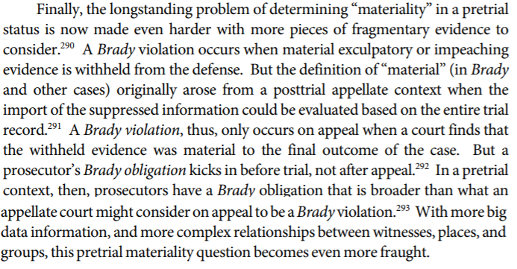

DISADVANTAGES

1. Endless litigation and court clogging

Link: Every single case could be argued to have “exculpatory” evidence in all the database searches, because multiple names always come up during an investigation, and it gets worse with “big data”
Prof. Andrew Guthrie Ferguson 2020 (Visiting Professor of Law, American Univ. Washington College of Law; Professor of Law, UDC David A. Clarke School of Law) UCLA LAW REVIEW “Big Data Prosecution and Brady” https://www.uclalawreview.org/wp-content/uploads/securepdfs/2020/07/Ferguson-67-1.pdf (accessed 17 Oct 2021)
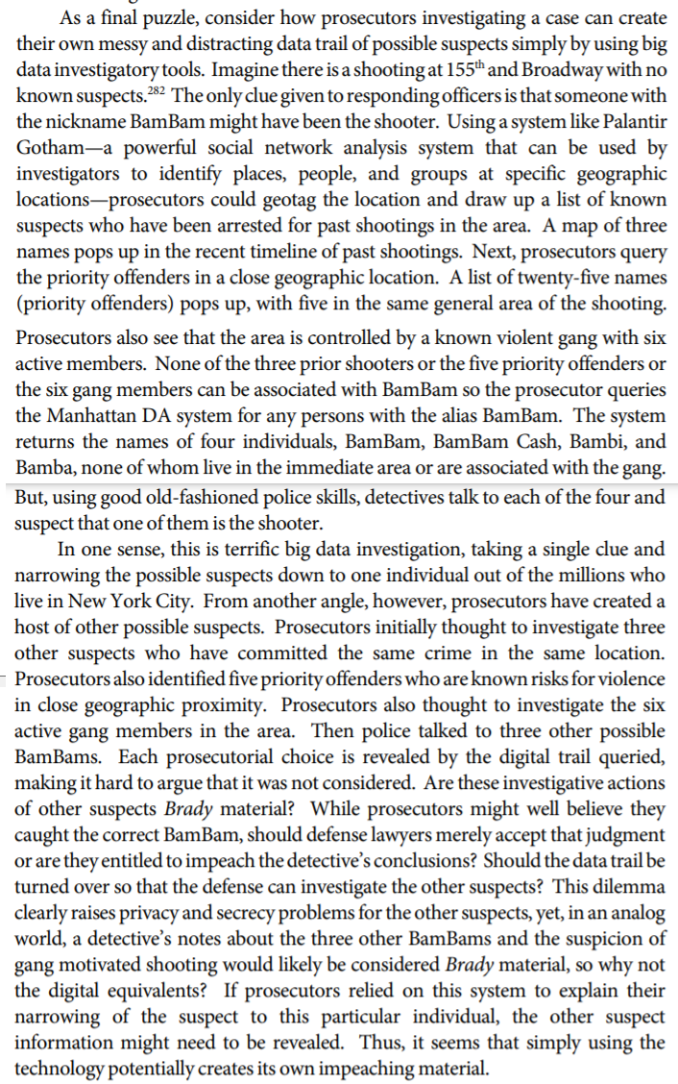
Link: Defense attorneys will use all other names in the facial recognition database for “some other guy did it” defense
Prof. Andrew Guthrie Ferguson 2020 (Visiting Professor of Law, American Univ. Washington College of Law; Professor of Law, UDC David A. Clarke School of Law) UCLA LAW REVIEW “Big Data Prosecution and Brady” https://www.uclalawreview.org/wp-content/uploads/securepdfs/2020/07/Ferguson-67-1.pdf (accessed 17 Oct 2021)
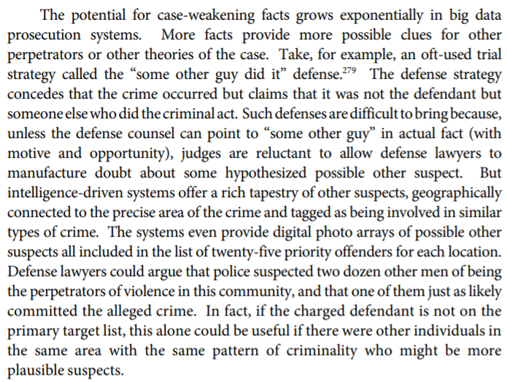

Link: Constant flow of litigation over exculpatory disclosure (made worse by adding more after the AFF plan)
Prof. Cynthia Jones 2017 (Professor of Law, American University Washington College of Law) HERE COMES THE JUDGE: A MODEL FOR JUDICIAL OVERSIGHT AND REGULATION OF THE BRADY DISCLOSURE DUTY, HOFSTRA LAW REVIEW http://www.hofstralawreview.org/wp-content/uploads/2018/02/BB.6.Jones_.pdf (accessed 17 Oct 2021)
The lack of clarity in Supreme Court cases has led to inconsistent interpretations of the Brady doctrine by lower courts and inconsistent disclosure practices among prosecutors. When the suppression of favorable information is discovered, prosecutors frequently argue that they were unaware that the information was subject to disclosure under Brady. More than fifty years after the Court decided Brady, there is still a constant flow of litigation in state and federal courts to resolve fundamental issues regarding the scope of the Brady disclosure duty.

Link: Clogged courts. Federal appellate court caseloads have doubled since 1971
Prof. Peter S. Menell & Prof. Ryan Vacca 2020. (Menell - Professor of Law and Director, Berkeley Center for Law & Technology, University of California. Vacca - Professor of Law, Univ of New Hampshire School of Law) Revisiting and Confronting the Federal Judiciary Capacity “Crisis”: Charting a Path for Federal Judiciary Reform 1 Jully 2020 CALIFORNIA LAW REVIEW https://scholars.unh.edu/cgi/viewcontent.cgi?article=1438&context=law_facpub (accessed 17 Oct 2021)
The number of filed cases per year grew 292% between 1971 and 2017, from 14,761 to 57,872. [END QUOTE] The number of cases terminated on the merits grew from 13,015 in 1971 to 36,851 in 2017, a 183% increase. As previously discussed, Congress authorized additional circuit court judgeships during this time. The number of appellate judges is based on data from Habel and Scott. These data show how many active and senior circuit court judgeships are actually filled and, as with district judges, treat senior circuit court judges as one quarter of an active-duty circuit court judge. Figure 14 illustrates how many cases were filed, on average, per appellate judge from 1971 through 2017. The average number of cases filed per judge increased from 148 (active judges only) or 142 (active and senior judges) in 1971 to 324 (active judges only) or 278 (active and senior judges) in 2017. [THEY GO ON LATER IN THE CONTEXT TO SAY QUOTE:]Counting only active circuit court judges, this is a 119% increase in filings per judge. Counting active and senior judges results in a 96% increase in filings per judge. Thus, the caseload per judge has roughly doubled since 1971.

Impact: Justice Denied. The impact to court clog is judges making decisions in inconsistent ways that deny justice
Dr. Cristoph Engel and Prof. Keren Weinshall 2020. (Engel - Chair of the Advisory Board, Amsterdam Center for Law and Economics; Director of Max Planck Institute for Research on Collective Goods.. Weinshall is Edward S. Silver Chair in Civil Procedure, Hebrew University, Jerusalem) 24 Nov 2020 “Manna from Heaven for Judges: Judges’ Reaction to a Quasi-Random Reduction in Caseload” JOURNAL OF EMPIRICAL LEGAL STUDIES https://onlinelibrary.wiley.com/doi/full/10.1111/jels.12265 (“heuristics” – in this context, it refers to deciding things based on past personal experience rather than looking independently at the facts of the present case) (accessed 17 Oct 2021)
Judges are not only rational actors striving to optimize their use of time. Although most of the aforementioned studies focus on judges’ strategic choices of the less time-consuming legal outcome, their decisions may also be affected by the physical and emotional fatigue, decline in cognitive performance, and elevated stress levels associated with high workloads. Research has shown that under time pressure, judges are more vulnerable to heuristics and biases. For example, rulings were found to be more inconsistent when judges face a high caseload (Norris 2018) and busy judges were found to expend less effort by according higher weight to non-legal cues, such as litigants’ race or gender, to determine case outcomes (Guthrie et al. 2000, 2007; Rachlinski et al. 2008).

