Negative: Unicor reform
By “Coach Vance” Trefethen
The United States Federal Government should significantly reform its policies regarding convicted prisoners under federal jurisdiction
The AFF plan is HR4671 introduced by a Michigan congressman in 2016, which does the following: “Currently, UNICOR, also known as Federal Prison Industries, automatically gets its choice of federal government contracts through a process known as mandatory sourcing. This provision prevents private sector businesses from even competing for a federal government contract. On top of this UNICOR also possesses special status to poach contracts specifically reserved for small businesses despite being a massive government-run entity that maintains a “workforce” of over 12,000 prisoners. “Small business job growth is critical to developing and maintaining a healthy economy,” said Congressman Huizenga. “UNICOR, which is owned and operated by the federal government, actively undermines the free market. The federal government does not belong in the manufacturing or services industries when there are private sector options available and law-abiding citizens are looking for work.” (from Rep Huizenga’s website)
Negative: Unicor reform 3
COUNTER GOAL / NEG PHILOSOPHY 3
Correctional Officer (CO) safety should be the paramount goal of prison policy 3
INHERENCY 3
1. Business competition reforms already done 3
Congress has passed several laws already to change sourcing rules and reduce Unicor/FPI impact on small businesses 3
Reforms “dramatically reduced” mandatory sourcing for FPI 4
Big reduction in mandatory sourcing for FPI happened in 2002 4
2. A/T “Prisoners have access to classified / sensitive information” 4
No, they don’t. It’s been prohibited since 2004 by Rule 8.608 of the regulations governing FPI 4
HARMS / SIGNIFICANCE 5
1. A/T “Small businesses harmed” 5
3 responses: 1) Other factors causing those job losses besides FPI. 2) Insignificant number of jobs impacted 3) Prison benefits outweigh 5
2. Declining in Status Quo 5
Unicor is declining in Status Quo. Only 7% of inmates now have work assignments 5
3. A/T “Cheap wages undercut private businesses” 5
Lots of additional constraints offset the lower wages and create extra expenses for FPI 5
Lots of additional worker costs FPI has that private businesses don’t have 6
SOLVENCY 6
1. No net increase in jobs (FPI doesn’t just sell things, it also buys things, and those purchases create jobs) 6
Cutting FPI would only shift jobs, not create them 6
FPI spends 75% of its revenue buying materials from private vendors – offsets any impact from its sales 6
2. Shifting cost to taxpayers 6
Reduced activity by Unicor all has to be shifted to the taxpayers 6
Failure: Shifting money around is not a net advantage 7
3. More study needed 7
Changes made to FPI in the 2018 First Step Act need to be studied -- there’s a lot of uncertainty about economic impacts 7
DISADVANTAGES 8
1. More dangerous prisons 8
Link: Reduction in FPI activities 8
Impact: More violence in prisons. FPI is key to reducing inmate violence and assaults on guards 8
Impact: Worse inmate behavior because FPI jobs incentivize them to behave 8
Federal prison guards unanimously support Unicor as highly effective and essential to obtaining better prisoner behavior 9
American Federation of Government Employees (union representing prison guards) says: Safety of guards requires NOT repealing mandatory sourcing UNLESS you replace it with job training (which AFF’s bill doesn’t do) 9
2. Crime victims harmed 9
Reducing FPI takes money away from restitution to crime victims 9
3. Recidivism 10
We should be INCREASING Unicor, not cutting it: It reduces recidivism by nearly 25% 10
Substantial reductions in recidivism for inmates who participate in FPI 10

Negative: Unicor reform

COUNTER GOAL / NEG PHILOSOPHY
Correctional Officer (CO) safety should be the paramount goal of prison policy
Frank V. Ferdik & Hayden P. Smith 2017 (Ferdik - Department of Criminology and Criminal Justice, University of West Florida, Pensacola. Smith - Department of Criminology and Criminal Justice, University of South Carolina, Columbia) Correctional Officer Safety and Wellness Literature Synthesis, July 2017 https://www.ojp.gov/pdffiles1/nij/250484.pdf (accessed 20 Sept 2021)
Officers are tasked with demanding and often conflicting work responsibilities that increase their risk for physical and mental health problems such as injuries, stress, and even death. Officers must interact with and supervise potentially dangerous individuals such as gang members, inmates with mental illness, and those with communicable diseases, which further complicates officers’ health issues. According to the research cited above, officers, regardless of security assignment, recognize the danger to which they are subject as a result of their profession. Many scholars conclude that employment as a CO is among the most dangerous and life threatening of all professions, including law enforcement. Given how COs are heavily relied upon to supervise inmate behavior, establish order in their facilities, and maintain wider institutional security, it is paramount that correctional practitioners, researchers, administrative officials, and other interested stakeholders begin developing more effective and widely used strategies for enhancing the general well-being of this critically important workforce.

INHERENCY

1. Business competition reforms already done
Congress has passed several laws already to change sourcing rules and reduce Unicor/FPI impact on small businesses
Congressional Research Service 2016 (non-partisan research agency of Congress) last updated 11 May 2016 Federal Prison Industries: Background, Debate, Legislative History, and Policy Options https://crsreports.congress.gov/product/pdf/RL/RL32380 (accessed 6 Dec 2021)
Congress has taken legislative action to lessen any adverse impact the FPI has had on small businesses. For example, in 2002, 2003, and 2004, Congress passed legislation that modified how the Department of Defense (DOD) and the Central Intelligence Agency (CIA) procured products offered by the FPI in its schedule of products. In 2004, Congress passed legislation prohibiting federal agencies from using appropriated funding for FY2004 to purchase products or services offered by the FPI unless the agency determined that the products or services are provided at the best value. This provision was extended permanently in FY2005. In the 110th Congress, the National Defense Authorization Act for Fiscal Year 2008 (P.L. 110-181) modified the way in which DOD procures products from the FPI. In addition, the Administration of President George W. Bush made several efforts to reduce the consequences the FPI’s mandatory source clause might have on the ability of private businesses to compete for federal contracts.

Reforms “dramatically reduced” mandatory sourcing for FPI
Congressional Research Service 2016 (non-partisan research agency of Congress) last updated 11 May 2016 Federal Prison Industries: Background, Debate, Legislative History, and Policy Options https://crsreports.congress.gov/product/pdf/RL/RL32380 (accessed 6 Dec 2021) (the “-“ was added to distinguish that it is CRS quoting former Bureau of Prisons Director Harley Lappin)
Former Director Lappin states that the FPI’s mandatory source clause
-does not mean that the FPI program prohibits Federal customers from purchasing from private vendors. Many of the FPI program’s products are only offered as “non-mandatory” items, meaning that competitive procurement procedures apply. Finally, for those FPI program products to which mandatory source applies, it does so only in a limited way. Recent legislation and FPI Board of Directors resolutions have dramatically reduced the effect of mandatory source.-
Big reduction in mandatory sourcing for FPI happened in 2002
Maj. Philip Mitchell 2004 (Judge Advocate in the United States Army presently assigned to the US Army Trial Defense Service; Mannheim, Germany. JD from University of Detroit Mercy School of Law. He has served as a prosecutor and a defense attorney and also served as a Contract Law Attorney with U.S. Army Tank—Automotive and Armaments Command) FEDERAL PRISON INDUSTRIES ENDING THEIR MANDATORY SOURCE STATUS, MICHIGAN BAR JOURNAL Sept 2004 https://www.michbar.org/file/barjournal/article/documents/pdf4article739.pdf (accessed 6 Dec 2021)
Through the efforts of Congressman Hoekstra and Senator Carl Levin, UNICOR’s mandatory source status ended in 2002. As amended, 10 USCS 2410n states: If the product is not comparable in price, quality, or time of delivery to products available from the private sector that best meet the Department’s needs, competitive procedures shall be used for the procurement. Senator Levin said that the change ends FPI’s ‘‘mandatory preference, and Federal Prison Industries would have to compete for future Department of Defense contracts.’’ Even though UNICOR still retains mandatory source status if it produces a product equal, or comparable, to those available in the private sector, the change requires UNICOR to compete for federal contracts when the private sector produces a similar item.

2. A/T “Prisoners have access to classified / sensitive information”

No, they don’t. It’s been prohibited since 2004 by Rule 8.608 of the regulations governing FPI
Code of Federal Regulations 2004. Subpart 8.6 - Acquisition From Federal Prison Industries, Inc. 69 FR 16149, Mar. 26, 2004 https://www.ecfr.gov/current/title-48/chapter-1/subchapter-B/part-8/subpart-8.6
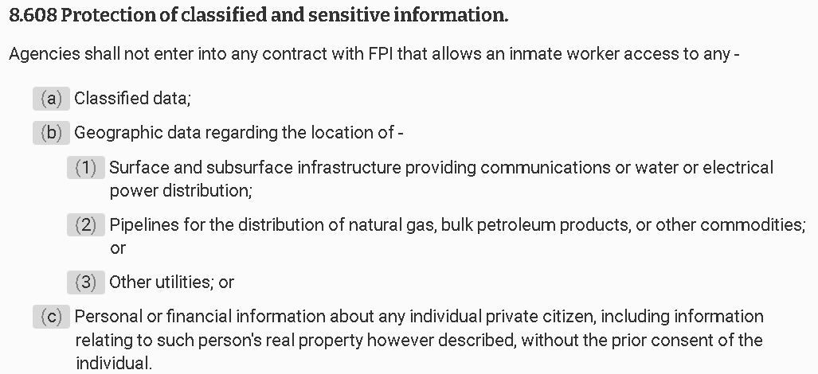

HARMS / SIGNIFICANCE

1. A/T “Small businesses harmed”
3 responses: 1) Other factors causing those job losses besides FPI. 2) Insignificant number of jobs impacted 3) Prison benefits outweigh
Marc H. Morial 2008 (Director, National Urban League) 6 May 2008 “FEDERAL PRISON INDUSTRIES--EXAMINING THE EFFECTS OF SECTION 827 OF THE NATIONAL DEFENSE AUTHORIZATION ACT OF 2008” HEARING BEFORE THE SUBCOMMITTEE ON CRIME, TERRORISM, AND HOMELAND SECURITY OF THE COMMITTEE ON THE JUDICIARY, HOUSE OF REPRESENTATIVES https://www.govinfo.gov/content/pkg/CHRG-110hhrg42213/html/CHRG-110hhrg42213.htm (accessed 6 Dec 2021)
I think it is important to look at the loss of jobs as not scapegoating FPI. There are larger global trade and foreign competition issues at play in a lot of the businesses where they provide services. But then secondly, the effect because of the market share of FPI is so small. Has it cost a job-loss here or there? I don't think anyone can argue that it hasn't, but the benefits, the up-side is significant. I would suggest to you that there are not a lot of initiatives out there that habilitate and give prisoners skills that don't require direct appropriations. We are spending on average on the low side probably $20,000 or $25,000 a year to incarcerate and house people. So this kind of investment is offset.

2. Declining in Status Quo
Unicor is declining in Status Quo. Only 7% of inmates now have work assignments
Congressional Research Service 2016 (non-partisan research agency of Congress) last updated 11 May 2016 Federal Prison Industries: Background, Debate, Legislative History, and Policy Options https://crsreports.congress.gov/product/pdf/RL/RL32380 (accessed 6 Dec 2021) (note: “steadily deceased” should read “steadily decreased” but we left the typo as it was written in the original) (brackets added)
Data show that the number of FPI [Federal Prison Industries] work assignments available to inmates has not kept pace with the growing federal inmate population. Starting in FY1988 the proportion of the federal inmate population employed by the FPI steadily deceased. In FY2015, approximately 7% of all federal inmates had an FPI work assignment.

3. A/T “Cheap wages undercut private businesses”

Lots of additional constraints offset the lower wages and create extra expenses for FPI
Congressional Research Service 2016 (non-partisan research agency of Congress) last updated 11 May 2016 Federal Prison Industries: Background, Debate, Legislative History, and Policy Options https://crsreports.congress.gov/product/pdf/RL/RL32380 (accessed 6 Dec 2021)
Proponents note that the FPI faces several competitive disadvantages which might negate the fact that the FPI can pay inmate workers lower wages. While inmates receive far lower pay than workers in private industry, the FPI asserts this advantage is offset by the lower average productivity of inmates and the inefficiencies associated with operating a business in a correctional setting. In addition, the FPI contends that any advantage it might gain from lower wages is offset by statutory constraints that drive up costs. These include
• employing as many inmates as reasonably possible;
• concentrating on manufacturing products that are labor-intensive;
• providing opportunities for inmates to acquire marketable skills;
• diversifying production as much as possible to minimize competition with private industry and labor, and reduce the burden on any one industry;
• not taking more than a reasonable share of the federal market for any one product; and
• selling products only to the federal government.

Lots of additional worker costs FPI has that private businesses don’t have
Congressional Research Service 2016 (non-partisan research agency of Congress) last updated 11 May 2016 Federal Prison Industries: Background, Debate, Legislative History, and Policy Options https://crsreports.congress.gov/product/pdf/RL/RL32380 (accessed 6 Dec 2021)
According to the FPI, additional costs also lower its competitiveness. The FPI reports that the average inmate worker, due in part to lower levels of education and a lack of regular employment, is approximately one-quarter as productive as a non-incarcerated worker. The FPI has to train (a further cost) most inmate workers how to perform their jobs while private businesses have the ability to hire workers who have the requisite job skills. The FPI notes that expenses such as supervision of inmate workers and measures necessary to maintain the security of the prison add to the cost of production.

SOLVENCY

1. No net increase in jobs (FPI doesn’t just sell things, it also buys things, and those purchases create jobs)
Cutting FPI would only shift jobs, not create them
Maj. Philip Mitchell 2004 (Judge Advocate in the United States Army presently assigned to the US Army Trial Defense Service; Mannheim, Germany. JD from University of Detroit Mercy School of Law. He has served as a prosecutor and a defense attorney and also served as a Contract Law Attorney with U.S. Army Tank—Automotive and Armaments Command) FEDERAL PRISON INDUSTRIES ENDING THEIR MANDATORY SOURCE STATUS, MICHIGAN BAR JOURNAL Sept 2004 https://www.michbar.org/file/barjournal/article/documents/pdf4article739.pdf (accessed 6 Dec 2021)
In addition, small businesses that supply FPI will also lose contracts. UNICOR buys many of its supplies from private subcontractors. Eliminating UNICOR only causes a shift in those jobs, not more jobs.

FPI spends 75% of its revenue buying materials from private vendors – offsets any impact from its sales
Congressional Research Service 2016 (non-partisan research agency of Congress) last updated 11 May 2016 Federal Prison Industries: Background, Debate, Legislative History, and Policy Options https://crsreports.congress.gov/product/pdf/RL/RL32380 (accessed 6 Dec 2021)
The FPI also argues that its operations benefit private businesses. The FPI uses revenue it generates from sales to the federal government to purchase raw materials and supplies from private vendors. In FY2015, the FPI spent 72% of its revenue, or $362 million, on purchases from the private sector.

2. Shifting cost to taxpayers

Reduced activity by Unicor all has to be shifted to the taxpayers
Maj. Philip Mitchell 2004 (Judge Advocate in the United States Army presently assigned to the US Army Trial Defense Service; Mannheim, Germany. JD from University of Detroit Mercy School of Law. He has served as a prosecutor and a defense attorney and also served as a Contract Law Attorney with U.S. Army Tank—Automotive and Armaments Command) FEDERAL PRISON INDUSTRIES ENDING THEIR MANDATORY SOURCE STATUS, MICHIGAN BAR JOURNAL Sept 2004 https://www.michbar.org/file/barjournal/article/documents/pdf4article739.pdf (accessed 6 Dec 2021)
If FPI were reduced or eliminated, the federal government still has the obligation to house, feed, secure, and occupy the time of these inmates. Using 1993 as an example, incarceration costs of FPI’s inmate workforce totaled almost $200 million. The portion of the money UNICOR receives to offset these costs will have to come from somewhere else in the federal government.

Failure: Shifting money around is not a net advantage
Whatever “costs” Unicor imposes on the economy are simply a tax to pay for the care and maintenance of federal prisoners. Every dollar cut from Unicor’s activities will have to be made up by a dollar taken from the taxpayers in some other way. There’s no net advantage to any reduction in Unicor.

3. More study needed

Changes made to FPI in the 2018 First Step Act need to be studied -- there’s a lot of uncertainty about economic impacts
Government Accountability Office 2020. (federal agency that audits activities of other federal agencies) July 2020 FEDERAL PRISON INDUSTRIES Actions Needed to Evaluate Program Effectiveness https://www.gao.gov/assets/gao-20-505.pdf (accessed 6 Dec 2021)
The First Step Act of 2018 made new, nonfederal markets and potential buyers available to Federal Prison Industries (FPI), a government corporation organized within the Bureau of Prisons (BOP); however, various challenges could limit FPI’s ability to sell to customers in these markets. FPI makes apparel, personal protective equipment, and furniture, among other products. FPI may now sell to the District of Columbia government, including, for example, to its firefighters; nonfederal, governmental entities for use in correctional settings or in response to a disaster or emergency, such as local jails and first responders; and nonprofit organizations, such as universities. However, a lack of information makes it difficult to estimate the dollar value of these new markets.
END QUOTE. THEY GO ON LATER IN THE ARTICLE TO WRITE QUOTE:
Data on the size of most of the new markets are very limited. For example, GAO found no existing national information to help estimate the size and scope of relevant spending by nonfederal entities on disaster relief and emergencies. Also, challenges related to state and local government operations, for example, could limit FPI’s ability to sell products in the new markets made available under the First Step Act. Specifically, state-level prison industries and in-state vendors often have preferential access to many of the procurement markets now available to FPI

DISADVANTAGES

1. More dangerous prisons

Link: Reduction in FPI activities
Obvious, or else the Plan doesn’t accomplish anything.

Impact: More violence in prisons. FPI is key to reducing inmate violence and assaults on guards
Harley Lappin 2008 (director of the Bureau of Prisons) 6 May 2008 “FEDERAL PRISON INDUSTRIES--EXAMINING THE EFFECTS OF SECTION 827 OF THE NATIONAL DEFENSE AUTHORIZATION ACT OF 2008” HEARING BEFORE THE SUBCOMMITTEE ON CRIME, TERRORISM, AND HOMELAND SECURITY OF THE COMMITTEE ON THE JUDICIARY, HOUSE OF REPRESENTATIVES https://www.govinfo.gov/content/pkg/CHRG-110hhrg42213/html/CHRG-110hhrg42213.htm (accessed 6 Dec 2021)
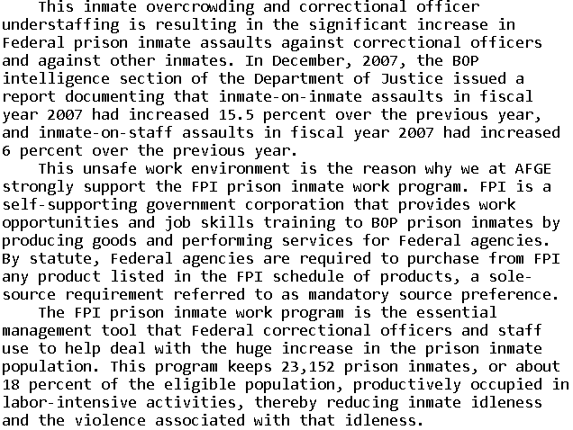

Impact: Worse inmate behavior because FPI jobs incentivize them to behave
Rep. Robert Scott 2008. (member of the House of Reps. from Virginia) 6 May 2008 “FEDERAL PRISON INDUSTRIES--EXAMINING THE EFFECTS OF SECTION 827 OF THE NATIONAL DEFENSE AUTHORIZATION ACT OF 2008” HEARING BEFORE THE SUBCOMMITTEE ON CRIME, TERRORISM, AND HOMELAND SECURITY OF THE COMMITTEE ON THE JUDICIARY, HOUSE OF REPRESENTATIVES https://www.govinfo.gov/content/pkg/CHRG-110hhrg42213/html/CHRG-110hhrg42213.htm (accessed 6 Dec 2021)
All able-bodied prisoners are required by law to work. Over 80 percent of them work for menial, mostly make-work jobs which are paid 12 cents to 40 cents per hour. In comparison, Federal Prison Industry jobs are held by about 18 percent of the prisoners and they earn from 24 cents to $1.15 per hour. This additional pay is a significant financial incentive, making FPI jobs most desirable. Also, prisoners in FPI--those on the waiting list and those seeking to be eligible for the waiting list--must have their high school diploma or a GED or show that they are making progress to obtain a GED. That is why prisoners in the FPI program are less likely to engage in institutional misconduct, thereby enhancing the safety of staff and other prisoners and lessening the management burden and expense.
Federal prison guards unanimously support Unicor as highly effective and essential to obtaining better prisoner behavior
Rep. Daniel Lungren and John Gage 2008. (Lungren – R-California, House of Rep. Gage – President of American Federation of Government Employees, the union that represents federal prison guards) 6 May 2008 “FEDERAL PRISON INDUSTRIES--EXAMINING THE EFFECTS OF SECTION 827 OF THE NATIONAL DEFENSE AUTHORIZATION ACT OF 2008” HEARING BEFORE THE SUBCOMMITTEE ON CRIME, TERRORISM, AND HOMELAND SECURITY OF THE COMMITTEE ON THE JUDICIARY, HOUSE OF REPRESENTATIVES https://www.govinfo.gov/content/pkg/CHRG-110hhrg42213/html/CHRG-110hhrg42213.htm (accessed 6 Dec 2021)
Mr. Lungren. Mr. Gage, since you represent the employees who work in the prisons, can you tell us, representing them, that this program does in any real way assist in reducing tension in the institutions, assist in any way making it a safer environment for prisoners and for your employees?
Mr. Gage. Oh, yes. There is no question about it. Talking to any of our officers, they think this program is a real carrot for the inmate. It produces better behavior. You can't just get one of these jobs. You really have to have a good record. To qualify for the program, and then to get the job and to stay out of trouble to keep the job. Our officers are, to a man and woman, committed to this program.

American Federation of Government Employees (union representing prison guards) says: Safety of guards requires NOT repealing mandatory sourcing UNLESS you replace it with job training (which AFF’s bill doesn’t do)
John Gage 2008 (National President, AMERICAN FEDERATION OF GOVERNMENT EMPLOYEES) 6 May 2008 “FEDERAL PRISON INDUSTRIES--EXAMINING THE EFFECTS OF SECTION 827 OF THE NATIONAL DEFENSE AUTHORIZATION ACT OF 2008” HEARING BEFORE THE SUBCOMMITTEE ON CRIME, TERRORISM, AND HOMELAND SECURITY OF THE COMMITTEE ON THE JUDICIARY, HOUSE OF REPRESENTATIVES https://www.govinfo.gov/content/pkg/CHRG-110hhrg42213/html/CHRG-110hhrg42213.htm (accessed 6 Dec 2021)
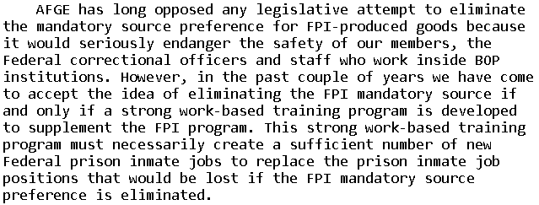

2. Crime victims harmed

Reducing FPI takes money away from restitution to crime victims
Harley Lappin 2008 (director of the Bureau of Prisons) 6 May 2008 “FEDERAL PRISON INDUSTRIES--EXAMINING THE EFFECTS OF SECTION 827 OF THE NATIONAL DEFENSE AUTHORIZATION ACT OF 2008” HEARING BEFORE THE SUBCOMMITTEE ON CRIME, TERRORISM, AND HOMELAND SECURITY OF THE COMMITTEE ON THE JUDICIARY, HOUSE OF REPRESENTATIVES https://www.govinfo.gov/content/pkg/CHRG-110hhrg42213/html/CHRG-110hhrg42213.htm (accessed 6 Dec 2021)
Another benefit of the FPI program is its ability to help with the effort to provide restitution to victims of crime. Inmates who work in FPI are required to contribute 50 percent of their wages to pay court-ordered fines, victim restitution, and child support.

3. Recidivism

We should be INCREASING Unicor, not cutting it: It reduces recidivism by nearly 25%
Brennan Center for Justice 2020 (part of New York University School of Law. Individual authors were: Ram Subramanian, Lauren-Brooke Eisen, Taryn Merkl, Leily Arzy, Hernandez Stroud, Taylor King, Jackie Fielding, and Alia Nahra) 9 Dec 2020 A Federal Agenda for Criminal Justice Reform https://www.brennancenter.org/sites/default/files/2020-12/FederalAgendaCriminalJustice.pdf (accessed 6 Dec 2021)
However, after more than a year of implementation, the BOP has not delivered on the promise to bring more programs to incarcerated people. Although the BOP has not disclosed much information on programming availability or capacity, as many as 25,000 people are wait-listed for the UNICOR work program (which has been proven to reduce recidivism by nearly 25 percent), at least 15,000 are wait-listed for education and vocational training, and at least 5,000 are wait-listed for drug treatment programs.
Substantial reductions in recidivism for inmates who participate in FPI
Congressional Research Service 2016 (non-partisan research agency of Congress) last updated 11 May 2016 Federal Prison Industries: Background, Debate, Legislative History, and Policy Options https://crsreports.congress.gov/product/pdf/RL/RL32380 (accessed 6 Dec 2021)
Research conducted by the BOP shows that, 12 months after being released from prison, inmates who participated in the FPI were 35% less likely than inmates from a comparable control group to have recidivated (6.6% compared to 10.1%). Inmates who participated in the FPI were also 14% more likely to be employed after 12 months (71.7% compared to 63.1%). The researchers found that over the long term (between 8 and 12 years after release), inmates who participated in the FPI were 24% less likely to have recidivated than inmates in the comparison group.

