Negative: IRS

By “Coach Vance” Trefethen

***Resolved: The United States federal government substantially reform the use of Artificial Intelligence technology***

Case Summary: The AFF plan would augment AI technology in the IRS to scan, analyze, and evaluate incoming tax returns. The AI will be acquired through a Request for Proposal and will be used to process tax returns. Funding: 100 million dollars in the IRS budget .  
 Biggest problem is that the Status Quo already started doing the plan in July 2021. IRS put out for bids a contract consisting of multiple incremental phases that will scan and digitize paper tax returns. The IRS is doing it on a phased incremental approach because it’s better than trying to do a big huge project all at once (like AFF wants). There are a lot of challenges to be overcome and it’s not as simple as it sounds. In additional rendering the AFF plan untopical (not reforming anything if SQ is already doing it), our evidence will argue that the Status Quo’s slow phase-in approach is better than one big clumsy project.

Negative: IRS 3

TOPICALITY 3

1. No reform 3

The long name for this argument is “2032H8-21-R-124899.” But you can tag it as: Status Quo is already doing the plan 3

Violation: Not a substantial reform if we’ve already started doing it 3

Impact: Negative ballot. 3

More details on the RFP: Phase 1 of the Status Quo plan involves scanning Gift Tax Returns (Form 709) 3

More details on the contract: It was awarded on Aug 18, 2021 for $7.5 million, and we have the names of the 5 companies that were contracted 4

2. Scanning doesn’t reform A.I. 5

An Affirmative plan advocate explains how the IRS could scan paper returns and then merge the scanned data into the pot with all the electronically filed tax returns that are processed in the Status Quo 5

AI requires making decisions 5

Violation: Scanning a document isn’t AI. If there is any AI, it’s in the existing systems that the scanned data is fed into 5

Impact: Negative ballot 5

INHERENCY 6

1. Status Quo incremental rollout is better 6

IRS pilot project is already underway and they’re working out the problems 6

Why it’s better: The IRS in their summary of the scanning contract that they put out for bids explained why we should do it incrementally, not the “quick” way AFF wants to 6

Phase 1 / Phase 2 approach is better because we verify success before spending more money on Phase 2 6

MINOR REPAIR 7

1. Remove barriers to electronic filing 7

Instead of making paper filing easier, let’s remove the barriers to electronic filing 7

HARMS / SIGNIFICANCE 7

1. Plan won’t apply to most tax returns 7

90% of returns are filed electronically, not on paper 7

SOLVENCY 7

1. IRS technology is hopeless 7

You’re dreamin’ if you think the IRS is ever going to get streamlined, working computer technology 7

2. Not as easy as it sounds 8

“Just scan it in” - Sounds easy but… the documents are different sizes, may be handwritten, may have clips… It’s actually pretty complicated 8

DISADVANTAGES 8

1. Cuts more important IRS program: Customer service representatives (CSR) 8

Link: AFF plan diverts money from the IRS budget to pay for their plan 8

Impact: Bad idea, because IRS desperately needs the money for the more important functions of Customer Service Representatives. Lack of CSRs harms taxpayers 8

Negative: IRS

TOPICALITY

1. No reform

The long name for this argument is “2032H8-21-R-124899.” But you can tag it as: Status Quo is already doing the plan

**That long number I just read is the number of a “Request for Proposal” or “RFP” that was put out by the IRS in July 2021. It’s exactly what the Affirmative team’s plan proposes to do. The only difference is that the IRS knows how complicated this is and is doing it in phases, and solving the problems incrementally rather than having a big project that blows up because it’s too complex.**

IRS 2021. “Request for Proposal 2032H8-21-R-124899” 19 July 2021 <https://sam.gov/api/prod/opps/v3/opportunities/resources/files/4205a3171c8543d5bb34b611644bbcf5/download?&status=archived&token>= (accessed 19 Oct 2021)

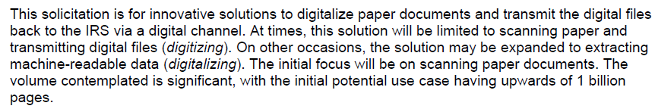

Violation: Not a substantial reform if we’ve already started doing it

That’s obvious.

Impact: Negative ballot.

The Affirmative had a duty to uphold substantial reform. Saying “let’s do more of the Status Quo” isn’t a reform, so they’re not affirming the resolution. None of the arguments in the round matter if the Affirmative isn’t affirming the resolution, and that by itself justifies a Negative ballot.

More details on the RFP: Phase 1 of the Status Quo plan involves scanning Gift Tax Returns (Form 709)

IRS 2021. “Request for Proposal 2032H8-21-R-124899” 19 July 2021 <https://sam.gov/api/prod/opps/v3/opportunities/resources/files/4205a3171c8543d5bb34b611644bbcf5/download?&status=archived&token>= (accessed 19 Oct 2021) (red annotations and strikethroughs were in the original)

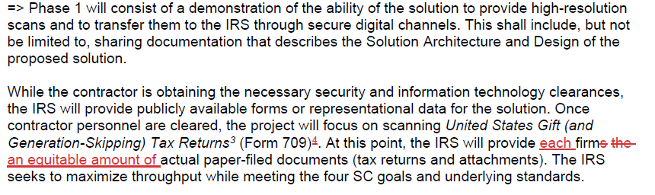

More details on the contract: It was awarded on Aug 18, 2021 for $7.5 million, and we have the names of the 5 companies that were contracted

Dept. of the Treasury 2021. Post Award Notice for for Contract Opportunity 2032H8-21-R-124899 18 Aug 2021 <https://govtribe.com/file/government-file/iv-2-postawardnotice-dot-pdf-4> (accessed 19 Oct 2021) (brackets added)

Title: Pilot IRS Request for Scanning as a Service  
Solicitation Number: 2032H8-21-R-124899  
Notice Type: Award Notice Contract Award Date: August 18, 2021  
Contract Award Numbers:  
2032H8-21-C-00026  
2032H8-21-C-00029  
2032H8-21-C-00030  
2032H8-21-C-00031  
2032H8-21-C-00032

Contract Award Dollar Amount: NTE [not to exceed] $7,500,000.00 Contractor Awardees:  
Contract No. 2032H8-21-C-00026   
Brillient Corporation  
1893 Metro Center Dr, Suite 120  
Reston, VA 20190-5298

Contract No. 2032H8-21-C-00029  
Ripcord Inc.  
30955 Huntwood Avenue  
Hayward, CA 94544-7005

Contract No. 2032H8-21-C-00030  
Government CIO LLC  
101 Constitution Avenue  
Washington, DC 20001-2133

Contract No. 2032H8-21-C-00031  
Xerox Corporation  
201 Merritt 7  
Norwalk, CT 06851-1056

Contract No. 2032H8-21-C-00032  
Resultant/ KSM Consulting, LLC  
P.O. Box 4985  
Houston, TX 77210-4985

Synopsis: Pilot IRS – Solution Challenge (SC) Six: Scanning as a Service (SCaaS) Digitalizing Paper Files

2. Scanning doesn’t reform A.I.

An Affirmative plan advocate explains how the IRS could scan paper returns and then merge the scanned data into the pot with all the electronically filed tax returns that are processed in the Status Quo

National Taxpayer Advocate 2019. (an independent organization within the IRS) 2019 Purple Book “REQUIRE THAT ELECTRONICALLY PREPARED PAPER TAX RETURNS INCLUDE A SCANNABLE CODE” <https://www.taxpayeradvocate.irs.gov/wp-content/uploads/2020/07/ARC18_PurpleBook_02_ImproveFiling_c.pdf> (accessed 18 Oct 2021)

Scanning technology is available that would allow the IRS to scan paper returns prepared with tax return preparation software and capture the data in an efficient manner. Many states have been using scanning technology for paper-based returns for many years. To allow the IRS to utilize scanning technology, a horizontal or vertical bar code containing the return information would be imprinted on paper copies of a return prepared with tax return preparation software. Upon receiving the paper return, the IRS would scan it, capture the data, decode it, and process the return just as if it had been transmitted electronically.

AI requires making decisions

Darrell West and John Allen 2018. (West - Vice President and Director - [Governance Studies](https://www.brookings.edu/program/governance-studies/) Senior Fellow - [Center for Technology Innovation](https://www.brookings.edu/center/center-for-technology-innovation/). Allen -President, The Brookings Institution) 24 Apr 2018 How artificial intelligence is transforming the world <https://www.brookings.edu/research/how-artificial-intelligence-is-transforming-the-world/> (accessed 8 Aug 2021)

Artificial intelligence algorithms are designed to make decisions, often using real-time data. They are unlike passive machines that are capable only of mechanical or predetermined responses. Using sensors, digital data, or remote inputs, they combine information from a variety of different sources, analyze the material instantly, and act on the insights derived from those data. With massive improvements in storage systems, processing speeds, and analytic techniques, they are capable of tremendous sophistication in analysis and decision-making.

Violation: Scanning a document isn’t AI. If there is any AI, it’s in the existing systems that the scanned data is fed into

Scanning a document doesn’t make any decisions. The printer on your desktop can probably scan documents, but it’s not using AI, any more than a camera does when it takes a photo. The decisions are made in the programs that analyze the data coming out of the scanned returns. But that data is already being analyzed and acted upon by the existing systems that work with electronically processed returns. Most returns the IRS handles are not on paper, they’re sent in electronically, and the IRS is already handling those and making decisions about their data. Scanning and adding more data to an existing AI system is not a substantial reform of the use of AI.

Impact: Negative ballot

Since no one in this debate round is affirming significant reform of the use of AI, no matter who wins, you should circle “Negative” on the ballot, since there are effectively 2 teams denying the resolution.

INHERENCY

1. Status Quo incremental rollout is better

IRS pilot project is already underway and they’re working out the problems

National Taxpayer Advocate 2021 (independent agency inside the IRS) Fiscal Year 2022 Objectives Report to Congress <https://aboutbtax.com/Ynu> (accessed 18 Oct 2021)

The IRS is piloting the conversion of paper returns to a digital format in the Lockbox environment. The pilot is currently working through the technical and legal questions involved. The IRS is also exploring the expanded use of optical character recognition (OCR) for paper tax returns in a separate pilot project. As part of the IRS’s digitalization strategy, the IRS may consider these and other options for some forms, correspondence, and other paper submissions. Both barcoding and OCR technology have limitations and costs. For example, barcoding does not encode all information on complex returns, and OCR may misinterpret some information, requiring quality review and manual re-entry (as does the current manual transcription process).

Why it’s better: The IRS in their summary of the scanning contract that they put out for bids explained why we should do it incrementally, not the “quick” way AFF wants to

IRS 2021. “Request for Proposal 2032H8-21-R-124899” 19 July 2021 <https://sam.gov/api/prod/opps/v3/opportunities/resources/files/4205a3171c8543d5bb34b611644bbcf5/download?&status=archived&token>= (accessed 19 Oct 2021)

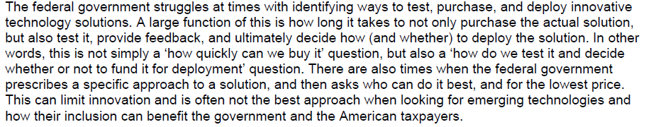

Phase 1 / Phase 2 approach is better because we verify success before spending more money on Phase 2

IRS 2021. “Request for Proposal 2032H8-21-R-124899” 19 July 2021 <https://sam.gov/api/prod/opps/v3/opportunities/resources/files/4205a3171c8543d5bb34b611644bbcf5/download?&status=archived&token>= (accessed 19 Oct 2021)

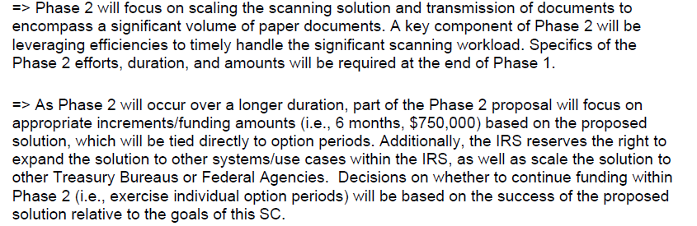

MINOR REPAIR

1. Remove barriers to electronic filing

Instead of making paper filing easier, let’s remove the barriers to electronic filing

Erin M. Collins 2021 (directs the National Taxpayer Advocate, an independent agency inside the IRS) National Taxpayer Advocate’s Introductory Remarks, June 2021 <https://www.taxpayeradvocate.irs.gov/wp-content/uploads/2021/06/JRC22_Preface.pdf> (accessed 18 Oct 2021)

One of the biggest challenges the IRS has faced over the past year has been processing paper returns. Although more than 90 percent of individual taxpayers now e-file their returns, about ten percent still mail them in on paper. Many of these taxpayers would prefer to file electronically but are prevented from doing so by IRS e-filing limitations. There are three principal limitations: (i) taxpayers sometimes are required to submit statements or other substantiation with their returns, and these attachments generally cannot be e-filed; (ii) some tax forms used by limited numbers of taxpayers are not accepted electronically; and (iii) taxpayers sometimes need to override default entries when preparing their returns with tax software, and some of these overrides render returns ineligible for e-filing. If the IRS addresses these limitations, all taxpayers will have the option of e-filing their returns.

HARMS / SIGNIFICANCE

1. Plan won’t apply to most tax returns

90% of returns are filed electronically, not on paper

IRS 2020. (written 9 April 2020, last updated 11 May 2020) “IRS urges taxpayers to use electronic options; outlines online assistance” <https://www.irs.gov/newsroom/irs-urges-taxpayers-to-use-electronic-options-outlines-online-assistance> (accessed 18 Oct 2021)

If you already have filed via paper but it has not yet been processed, do not file a second tax return or write to the IRS to inquire about the status of your return or your economic impact payment. Paper returns will be processed  once processing centers are able to reopen. This year, more than 90% of taxpayers have filed electronically.

SOLVENCY

1. IRS technology is hopeless

You’re dreamin’ if you think the IRS is ever going to get streamlined, working computer technology

Nina E. Olson 2021 (Executive Director, Center for Taxpayer Rights) testimony at the Hearing on Closing the Tax Gap: Lost Revenue from Noncompliance and the Role of Offshore Tax Evasion Before the Subcommittee on Taxation and IRS Oversight Committee on Finance, U.S. Senate 11 May 2021 <https://www.finance.senate.gov/imo/media/doc/SFC%20Subcomm%20on%20Taxation%20and%20Oversight%20Tax%20Gap%20-%20Olson%20-%2005-11-21%20(final)(rev)1.pdf> (accessed 18 Oct 2021)

Customer service representatives and other IRS employees have no access to a 360-degree view of the taxpayers account because the IRS has no database in which all taxpayer information is stored or linked. Although the IRS has been working on an Enterprise Case Management system since at least 2015, it still has 60 separate major databases containing taxpayer information. The lack of a full picture of the taxpayer’s tax life has significant consequences not only for taxpayer assistance but also for audit selection, collection prioritization, and protection of taxpayer rights. Dreams of the future IRS having purely digital communications with taxpayers will likely not materialize any time soon.

2. Not as easy as it sounds

“Just scan it in” - Sounds easy but… the documents are different sizes, may be handwritten, may have clips… It’s actually pretty complicated

IRS 2021. “Request for Proposal 2032H8-21-R-124899” 19 July 2021 <https://etc.g2xchange.com/statics/irs-rfp-pilot-irs-enterprise-digitalization-and-case-management-office-edcmo-scaas-solution-challenge/> (accessed 19 Oct 2021)

The IRS receives paper documents that can range from a single page to hundreds of pages in length. These documents are typically 8.5” by 11”, but may be 8.5” by 14”, single- or double-sided, typed or handwritten, and attachments may include dissimilar size documents or photographs. The documents may be bound; examples include, but are not limited to, two-prong metal fasteners, spiral bindings, rubber bands, binder clips, and staples. Documents may also include tabs, separators, and sticky notes, and envelopes.

DISADVANTAGES

1. Cuts more important IRS program: Customer service representatives (CSR)

Link: AFF plan diverts money from the IRS budget to pay for their plan

Impact: Bad idea, because IRS desperately needs the money for the more important functions of Customer Service Representatives. Lack of CSRs harms taxpayers

Erin M. Collins 2021 (directs the National Taxpayer Advocate, an independent agency inside the IRS) National Taxpayer Advocate’s Introductory Remarks, June 2021 <https://www.taxpayeradvocate.irs.gov/wp-content/uploads/2021/06/JRC22_Preface.pdf> (accessed 18 Oct 2021)

CSRs have experienced a very difficult year, with an unrelenting volume of calls and the inability to provide specific information on stimulus payment delays or pending refunds. These are difficult conversations to have and difficult for taxpayers to experience. In many cases, CSRs cannot determine the status of a taxpayer’s return or pending refund and are doing the best they can. Yet from the taxpayer’s perspective, the inability of the IRS to answer calls or provide answers causes frustration and undermines a fundamental taxpayer right — namely, the right to be informed. 13 Each year, Congress appropriates a budget and allocates funds for specific tasks. This year, Congress funded the IRS to provide a 60 percent level of service with its CSRs14 — meaning it was anticipated that in a normal year, pre-pandemic, CSRs would answer six out of every ten calls routed to them. I believe that percentage, even in a good year, is unacceptable. For future budgets, I urge Congress to provide funding to achieve a level of service closer to 100 percent, and I urge the IRS to continue exploring ways to achieve greater efficiencies with its phone service. In my view, phone assistance is not merely an option or a luxury. The ability to talk with an IRS employee by phone to facilitate tax compliance is a fundamental right and a cornerstone of good tax administration. Whether a taxpayer needs general information or is responding to an audit or collection notice, the IRS’s toll-free lines are often the first or second option — as evidenced by the 167 million taxpayer calls during the filing season. When so few callers can get through to a telephone assistor, problems remain unsolved and taxpayer frustration mounts. While intellectually understandable, this filing season’s telephone service was well below acceptable levels, and going forward, increased funding is required even for a “normal” filing season, let alone for a pandemic year.