Negative: Phone Calls / Communication
By “Coach Vance” Trefethen
The United States Federal Government should significantly reform its policies regarding convicted prisoners under federal jurisdiction
The AFF plan claims prisoners aren’t able to communicate with the outside world enough. Phone calls are too expensive. Plan makes it easier for them to call or communicate. Problem: Evidence about prisoners getting ripped off by abusively high phone rates is talking about States, not the federal government. The federal system works fine and only charges 6 cents a minute. Since they’re only allowed 15 minute calls, that’s less than a dollar.
Negative: Phone Calls / Communication 2
NEG PHILOSOPHY 2
States not Federal 2
INHERENCY 2
1. Federal prison calls are free during Covid 2
Federal phone calls are free. The problems are at the State and local level (where AFF has no jurisdiction) 2
2. TRULINCS 3
Federal prisoners can communicate via email using TRULINCS at very low cost 3
HARMS / SIGNIFICANCE 3
1. No kickbacks 3
Background: “Kickbacks” are what artificially inflate the cost of a call (and may be a big part of the AFF’s harms) 3
No kickbacks at the federal level 4
2. No federal cost problem 4
Federal prison calls cost 6 cents/minute local and 23 cents/minute long distance. States should follow the federal model! 4
Easy to make all calls local (6 cent/minute) when outside families use cell phones 5
3. A/T “Phone company rip-offs / lack of competition” 5
That’s State prisons, not federal 5
SOLVENCY 6
1. Nothing reduces recidivism 6
Won’t solve anything until we solve mental health and drug abuse, and even then they will mostly fail 6
2. No jurisdiction over local calls in State prisons 6
Local calls in State prisons may be expensive, but they can’t be changed by the federal government – only States can do it 6
DISADVANTAGES 6
1. Lost revenue means cutting inmate programs 6
BOP revenues from phone service fund other inmate rehabilitation and recreation programs 6
Impact: Cutting any lower would remove recreational service funding, leading to escapes, violence and disruptions 6
2. More calls = more crime 7
Prisoners use calls to promote more crime 7
New Jersey prison “hit squad” used phone calls to plan violent crime 7
3. Justice is lost 8
Justice is lost whenever we adopt any goal that looks forward to “what will be the results of the punishment?” rather than backwards at the question of “what punishment does that crime justly deserve?” 8

Negative: Phone Calls / Communication

NEG PHILOSOPHY
States not Federal
Most of the Affirmative arguments are based on evidence coming from studies or complaints about State prisons. The problem is that States’ phone call costs and policies are different from the federal government. In fact, we’ll show you evidence that this problem doesn’t exist at the federal level and that the states should be encouraged to use the federal model for their own systems.

We challenge the Affirmative team to drop all of their evidence out of the round if it’s talking about problems anywhere other than the federal prison system, or if it’s vague and non-specific about which prisons it’s talking about. The resolution only allows them to change federal prison policies, so their evidence justifying such a change has to pertain to federal prisons only. Otherwise, it’s irrelevant to this debate.

INHERENCY

1. Federal prison calls are free during Covid
Federal phone calls are free. The problems are at the State and local level (where AFF has no jurisdiction)
Sylvia Harvey 2020 (journalist) 29 Sept 2020 Making a Phone Call from Behind Bars Shouldn’t Send Your Family into Debt https://www.politico.com/news/agenda/2020/09/29/prison-telecom-costs-422774 (accessed 28 Sept 2021)
At the start of the pandemic, the federal prison system made all phone calls free, but most local and state systems haven’t followed suit. The result is a national patchwork that makes an already unfair system even more punishing. People in federal prisons still get free phone calls, until the National Emergency has been lifted; people in state and local facilities are subject to whatever rates their local systems charge.

2. TRULINCS

Federal prisoners can communicate via email using TRULINCS at very low cost
G.V. Profetta 2014. (former federal prisoner) It’s Only Hell If You Make It That Way: Surviving in Federal Prison (accessed 30 Sept 2021) https://books.google.com/books?id=J8ITBAAAQBAJ&pg=PT67&lpg=PT67&dq=prison+federal+%22$0.06+per+minute%22&source=bl&ots=UScMCpuByl&sig=ACfU3U3xWYy8byDcurqxQeWVsm36QGclUQ&hl=en&sa=X&ved=2ahUKEwiVvIyP3abzAhXuTDABHW4lDrYQ6AF6BAgSEAM#v=onepage&q=prison%20federal%20%22%240.06%20per%20minute%22&f=false
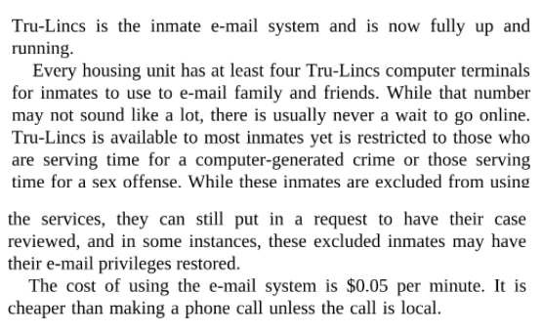

HARMS / SIGNIFICANCE
1. No kickbacks

Background: “Kickbacks” are what artificially inflate the cost of a call (and may be a big part of the AFF’s harms)
Human Rights Defense Center 2021. (advocacy group for rights of prisoners) “Prison Phone Justice” (article is undated but the page contains material dated in Sept 2021) https://www.prisonphonejustice.org/ (accessed 30 Sept 2021)
Prison phone contracts are based on a "commission" model, where the phone service provider pays a commission (kickback) to the contracting government agency, such as a state prison system or county jail. These kickbacks inflate the costs of prison and jail phone calls, which in the vast majority of cases are paid not by prisoners but by their family members.
No kickbacks at the federal level
We can’t show you a visual chart, but we can describe its contents and make it available to the Affirmative team and the Judge if you want to verify it. For “Federal Bureau of Prisons” under “Kickbacks paid by families” it says “No kickbacks.”
Human Rights Defense Center 2021. (advocacy group for rights of prisoners) “Prison Phone Justice” (article is undated but the page contains material dated in Sept 2021) https://www.prisonphonejustice.org/ (accessed 30 Sept 2021)

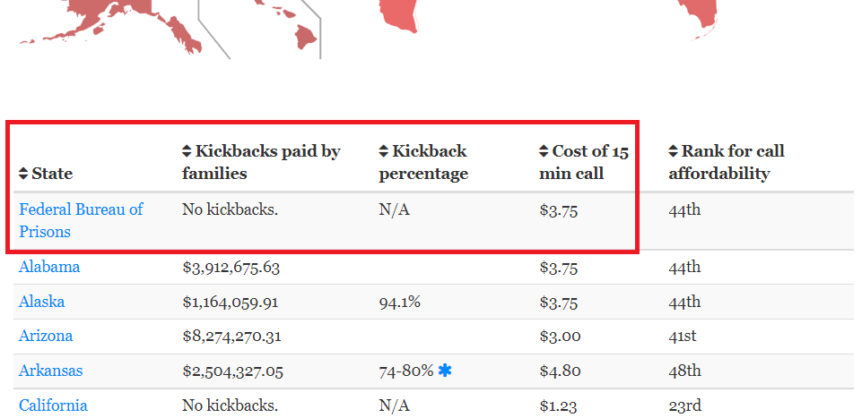

2. No federal cost problem

Federal prison calls cost 6 cents/minute local and 23 cents/minute long distance. States should follow the federal model!
Drew Kukorowski 2012 (law degree from University of North Carolina School of Law; research associate at the Prison Policy Initiative.) 11 Sept 2012 “The price to call home: state-sanctioned monopolization in the prison phone industry” https://www.prisonpolicy.org/phones/report.html (accessed 30 Sept 2021)
Correctional departments argue that revenue from kickbacks provides for prison amenities that would otherwise go unfunded by state legislatures. This argument fails to stand up to scrutiny when considering that the federal prison system charges comparatively low rates: $0.06/minute local and $0.23/minute long-distance, and still generates enormous revenue. As a recent Government Accountability Office report points out, the federal prison phone rates were sufficient to cover costs and generate $34 million in profit in 2010. Thus, profits can still be generated when prices are capped at relatively low levels. Both prison phone companies and state prison systems would be able to cover costs and generate revenue even with price caps.

Easy to make all calls local (6 cent/minute) when outside families use cell phones
G.V. Profetta 2014. (former federal prisoner) It’s Only Hell If You Make It That Way: Surviving in Federal Prison (accessed 30 Sept 2021) https://books.google.com/books?id=J8ITBAAAQBAJ&pg=PT67&lpg=PT67&dq=prison+federal+%22$0.06+per+minute%22&source=bl&ots=UScMCpuByl&sig=ACfU3U3xWYy8byDcurqxQeWVsm36QGclUQ&hl=en&sa=X&ved=2ahUKEwiVvIyP3abzAhXuTDABHW4lDrYQ6AF6BAgSEAM#v=onepage&q=prison%20federal%20%22%240.06%20per%20minute%22&f=false
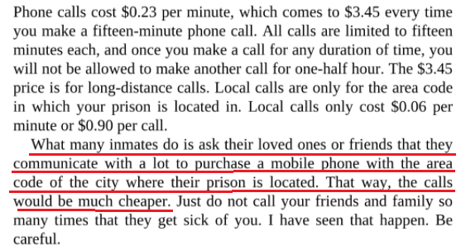

3. A/T “Phone company rip-offs / lack of competition”
That’s State prisons, not federal
Sylvia Harvey 2020 (journalist) 29 Sept 2020 Making a Phone Call from Behind Bars Shouldn’t Send Your Family into Debt https://www.politico.com/news/agenda/2020/09/29/prison-telecom-costs-422774 (accessed 28 Sept 2021)
The $1.2 billion prison telecom industry is dominated by a handful of private companies, though two key players, Securus Technologies LLC, which serves 3,400 facilities, and Global Tel Link, GTL, which serves over 2,400, gained an oligopoly over the industry by buying out their major competitors. Together, they own 70 percent of the non-federal prison telecom market, and they’re able to maintain that hold on the market, while also setting rates and fees significantly higher than regular commercial providers, because of a system of concession fees, essentially kickbacks, paid by the phone companies to the very facilities that award them exclusive contracts.

SOLVENCY
1. Nothing reduces recidivism

Won’t solve anything until we solve mental health and drug abuse, and even then they will mostly fail
Leonard Adam Sipes, Jr. 2019 (Retired federal senior spokesperson. Thirty-five years of award-winning public relations for national and state criminal justice agencies. Former Senior Specialist for Crime Prevention for the Department of Justice’s clearinghouse. Former Director of Information Services, National Crime Prevention Council. Former Adjunct Associate Professor of criminology and public affairs-Univ. of Maryland) 3 June 2019 Nothing Works For Offender Rehabilitation? https://www.crimeinamerica.net/nothing-works-for-offender-rehabilitation/ (accessed 9 Sept 2021)
Offenders, especially those released from prison, carry massive problems that are not going to be amended by employment or educational programs. The President’s The Council of Economic Advisers is probably right, the best hope we have is to address mental health and substance abuse issues and even there, they suggest that the vast majority of offenders are still going to fail.

2. No jurisdiction over local calls in State prisons
Local calls in State prisons may be expensive, but they can’t be changed by the federal government – only States can do it
Sylvia Harvey 2020 (journalist) 29 Sept 2020 Making a Phone Call from Behind Bars Shouldn’t Send Your Family into Debt https://www.politico.com/news/agenda/2020/09/29/prison-telecom-costs-422774 (accessed 28 Sept 2021)
On Aug. 6, 2020, Trump-appointed FCC Commissioner Ajit Pai announced a Notice of Proposed Rulemaking to further cap rates for interstate calls, which would lower prison call rates by up to 44 percent. The goal, Pai wrote, was “to do what we can do as a matter of law and what we should do as a matter of justice.” He called on state government to cap intrastate call prices, which the FCC lacks authority to change. In addition, commissioners will vote to cap ancillary service charges.
DISADVANTAGES

1. Lost revenue means cutting inmate programs

BOP revenues from phone service fund other inmate rehabilitation and recreation programs
Government Accountability Office 2011. (Federal agency that audits government agencies and programs) Septe 2011 “Bureau of Prisons: Improved Evaluations and Increased Coordination Could Improve Cell Phone Detection: GAO-11-893” https://www.gao.gov/assets/a322809.html
BOP uses the profits (the amount of revenue that exceeds expenses) from operating the inmate telephone service, as well as those from the commissary and other services, to provide inmate amenities, such as employment opportunities and educational and recreational activities, that are not currently supported through appropriations.

Impact: Cutting any lower would remove recreational service funding, leading to escapes, violence and disruptions
Government Accountability Office 2011. (Federal agency that audits government agencies and programs) Septe 2011 “Bureau of Prisons: Improved Evaluations and Increased Coordination Could Improve Cell Phone Detection: GAO-11-893” https://www.gao.gov/assets/a322809.html
BOP’s rates for inmate telephone calls typically are lower than selected state and military branch systems that also use telephone revenues to support inmate activities; lowering rates would have several implications. Inmates would benefit from the ability to make cheaper phone calls, but lower rates could result in less revenue and
lower profits, and therefore fewer funds available for inmate wages and recreational activities. According to BOP officials, when inmates have fewer opportunities for physical activity, idleness increases, and the risk of violence, escapes, and other disruptions also rises.

2. More calls = more crime

Prisoners use calls to promote more crime
Chris Francescani 2019 (journalist with ABC News) 24 Oct 2019 “US prisons and jails using AI to mass-monitor millions of inmate calls” https://abcnews.go.com/Technology/us-prisons-jails-ai-mass-monitor-millions-inmate/story?id=66370244 (accessed 30 Sept 2021)
In another recently-identified conversation, an inmate was recorded on a video call with a 16-year old girl who had been suspended from school, according to officials with the technology company. The student said she was going to return to the school to “even the score.” When the video call was flagged and reviewed, investigators determined that while making the threat “she was holding a Glock [9 mm pistol] in her hand,” said LEO Technologies CEO Scott Kernan, a former secretary of the California Department of Corrections and Rehabilitation. Kernan declined to identify the region where the incident took place, citing an ongoing investigation. In Alabama, corrections officials said they caught an inmate teaching his wife how to smuggle Suboxone, which aids in opiate withdrawal, into the jail -- by dissolving the drug in water and then using a makeup brush to paint the drug onto the back of postcards that would be mailed to the jail. Another recently-uncovered alleged plot involved smuggling narcotics into a facility by secreting them inside the soles of orthopedic shoes being delivered to an inmate who had been authorized to wear them by a county doctor, according to LEO internal reports.
New Jersey prison “hit squad” used phone calls to plan violent crime
Blake Nelson 2021 (journalist) 29 Apr 2021 “N.J. charges 9 with forming a ‘hit squad’ behind bars to attack officers and prisoners https://www.nj.com/crime/2021/04/nj-charges-9-with-forming-a-hit-squad-behind-bars-to-attack-officers-and-prisoners.html
New Jersey officials have accused a group of prisoners of forming a “hit squad” to attack both officers and others locked up around the state. One prisoner was beaten so badly last year he suffered a traumatic brain injury, and members of the gang discussed attacking investigators at their homes, authorities said. Another prisoner targeted by the gang was moved to protective custody before he could be hurt. Nine people have been charged so far, according to a press release. The only person charged who is not in prison was the group’s leader, Frank Blake, 33, of Hillside, officials said. He was in charge of the Elizabeth chapter of the Almighty Latin King and Queen Nation street gang, according to the release. Officials said Blake directed gang members through phone calls and letters, particularly at Northern State Prison in Newark and New Jersey State Prison in Trenton.

3. Justice is lost

Justice is lost whenever we adopt any goal that looks forward to “what will be the results of the punishment?” rather than backwards at the question of “what punishment does that crime justly deserve?”
Prof. Peter Karl Koritansky 2012 (associate professor of history, philosophy, and religious studies at the University of Prince Edward Island, Canada) Thomas Aquinas and the Philosophy of Punishment https://books.google.com/books?hl=en&lr=&id=CFZ6DKEw4wUC&oi=fnd&pg=PR7&ots=6Wg7jWFoUM&sig=TAefdc8Zs_mKI5C8DZqn0BCIPPo#v=onepage&q&f=false (accessed 10 Aug 2021) (Note: Prof. Koritansky is referring to criticism in general of backward looking utilitarianism, but in the article he expresses agreement with this criticism, so this quote is being used consistently with author’s intent.)
