Negative: Cocaine Sentencing Disparity
By Josiah Hemp & “Coach Vance” Trefethen
Resolved: The United States Federal Government should significantly reform its policies regarding convicted prisoners under federal jurisdiction
The Affirmative teams plan is to pass the EQUAL Act, which would remove the 18:1 sentencing disparity under which the mandatory minimum sentencing for “Crack” cocaine is significantly higher than the mandatory minimum sentencing for the same amount of powder cocaine. “Crack” is a concentrated form of cocaine that (NEG will argue) is more powerful and more addictive and therefore more destructive in the communities where it is sold and used. Crack became an epidemic in large cities in the US in the mid-1980’s and early 1990s. It’s never gone away, though it has been eclipsed in the last generation by methamphetamines and by the opioid epidemic, including heroin.
AFF argues that it is unjust to have the sentencing disparity between Crack and powder cocaine because these drugs are, from a chemical standpoint, the same. Further, AFF argues that the sentencing disparity is racist because it leads to blacks being sentenced worse than whites. NEG turns this around by pointing out that the original push for cracking down on crack came from the black community and black members of Congress themselves, because they saw the devastation it was causing in minority communities among their constituents. It’s disingenuous to say the disparity is racist when it was the black community demanding the disparity in the first place.
This brief argues that crack is in fact worse than powder cocaine for a variety of reasons, and thus it deserves to have a higher sentence.
Negative: Cocaine Sentencing Disparity 3
OPENING QUOTES / NEG PHILOSOPHY 3
Inequality 3
HARMS / SIGNIFICANCE 3
1. A/T “Crack = Powder, no difference” – No, Crack is more dangerous 3
Crack is more likely to lead to immediate death due to overdose 3
Even if the chemicals are the same, there’s a difference in the way they’re used that affects the addictive properties 3
Even if the chemicals are the same, the sentencing difference is justified because of the behavioral effects of crack 3
Crack is more addictive than powder cocaine 4
Crack has more violence than powder. Addicts resort to violence because they’re desperate for drug money 4
2. A/T “Racism” – Crack sentencing was requested by black communities, not imposed by white racists 5
Black congressman Charles Rangel wrote the bill that created the Crack/Powder disparity 5
Black leaders lobbied for tougher crack cocaine sentences in the 1980s and praised Pres. Reagan for signing the law 5
Black community leaders and elected politicians supported tough-on-drugs federal legislation in the 1990s 6
Hypocrisy: The ones calling crack sentencing “racist” were the same black leaders who supported it in the 1980s 6
Impacts of crack were worse in black communities than for whites 6
“NOT” coming down on crack is the real discrimination. Black communities want long sentences for dealers 7
3. Crack criminals aren’t really serving extra long sentences 7
Federal prisoners convicted for crack aren’t really serving the long sentences because they plea bargain down to lesser crimes 7
Even when the crack/powder sentencing ratio was 100:1 on the books, federal crack prisoners were serving between 1 to 6.3 ratio sentences, not 100 8
DISADVANTAGES 8
1. Unjust – because it treats different crimes the same 8
Affirmative advocate admits: If impacts are different, then different sentences are justified 8
Problems of crack & powder are different – so the differences are justified 8
But the problem is: Crack is worse (ALSO: Cross apply cards under significance point 1: “Crack is Worse”) 8
Impact: Justice violated 9
2. More overdose deaths & crime 9
EQUAL Act would release bad guys from prison and increase overdose deaths and violent crime 9
Releasing drug dealers from federal prison early = more crime 10
Historical precedent: First Step Act reduced drug sentences and sent criminals home early. Result was more crime and more drug overdose deaths 10
Tough sentences are an effective way to keep crack dealers from damaging our communities 10
Link & Impact: Equalizing crack & powder means more incentive to sell crack, leading to more addicts and more violence 11
3. Less effective law enforcement 11
Equalizing the sentences would block enforcement against crack at the retail level 11
EQUAL Act would prevent prosecutors from effectively going after bad guys 11
High Sentences necessary to get lower-level dealers to reveal who the leaders are 12
Impact: Crime and violence. They go down when we get tough on crack with longer sentences 12
Impact: More crime. Tougher crack sentencing helped law enforcement dramatically reduce crime 13
Impact: The bad old days. Ending the disparity takes us back to the violence and terrible impacts of the crack epidemic in the 1980s 13
4. Mindset Critique: Criminals versus victims 14
The entire mindset of the Affirmative position is wrong and justifies a Negative ballot 14

Negative: Cocaine Sentencing Disparity

OPENING QUOTES / NEG PHILOSOPHY
Inequality
Aristotle "Aristotle Quotes." BrainyQuote.com. BrainyMedia Inc, 2021. 5 October 2021. https://www.brainyquote.com/quotes/aristotle_140848 (accessed October 5, 2021).
The worst form of inequality is to try to make unequal things equal.

HARMS / SIGNIFICANCE
1. A/T “Crack = Powder, no difference” – No, Crack is more dangerous

Crack is more likely to lead to immediate death due to overdose
Sunrise House Treatment Center 2020 (addiction treatment center) 14 Oct 2020 “Is Cocaine or Crack More Damaging to the Body?” https://sunrisehouse.com/cocaine-addiction-treatment/more-damage-crack/ (accessed 10 Oct 2021)
Both pure cocaine and crack cocaine are extremely dangerous, highly addictive, and cause overdose easily. Crack cocaine, due to the rapid onset of euphoria and extreme differences in dose, is slightly more dangerous. While powdered cocaine can be measured in specific doses, crack cocaine rocks have no uniform percentage of cocaine to other chemicals, so it is very easy to overdose accidentally. However, cocaine is often cut with other drugs, most recently fentanyl, which induces a much different high and can also quickly lead to overdose.

Even if the chemicals are the same, there’s a difference in the way they’re used that affects the addictive properties
Oxford Treatment Center 2019 (addiction treatment clinic) 27 Aug 2019 Differences Between Crack and Cocaine (& Myths) https://oxfordtreatment.com/substance-abuse/cocaine/crack-vs-cocaine/ (accessed 10 Oct 2021)
The difference is due to the way the drug is taken (smoked or injected versus snorted) and not due to the chemical composition of different forms of cocaine. Because individuals who smoke drugs like cocaine often experience the effects as being very strong and short-lived, they may be more likely to binge on the drug to maintain the psychoactive effects, but again, this is due more to the method of administration and not to chemical differences in the forms of cocaine.

Even if the chemicals are the same, the sentencing difference is justified because of the behavioral effects of crack
Bob Bushman 2009 (Vice President, National Narcotics Officers Association Coalition UNFAIRNESS IN FEDERAL COCAINE SENTENCING: IS IT TIME TO CRACK THE 100 TO 1 DISPARITY?, HEARING BEFORE THE SUBCOMMITTEE ON CRIME, TERRORISM, AND HOMELAND SECURITY OF THE COMMITTEE ON THE JUDICIARY HOUSE OF REPRESENTATIVES 21 May 2009 https://www.govinfo.gov/content/pkg/CHRG-111hhrg49783/html/CHRG-111hhrg49783.htm (accessed 10 Oct 2021)
Why should we continue to maintain tougher sentences for crack down for coke powder? Smoking crack leads to a sudden, short-lived high, causing an intense immediate desire for more of it. Just last month the director of NIDA, Dr. Nora Volkow, testified before a Senate Judiciary Committee that, ``research consistently shows that the form of a drug is not the crucial variable. Rather it is the route of administration that accounts for the differences in its behavioral effects.''

Crack is more addictive than powder cocaine
Casa Palmera, 2012 (A drug rehabilitation facility) “7 Differences Between Cocaine And Crack” Casa Palmera September 17, 2012. https://casapalmera.com/blog/differences-between-cocaine-and-crack/ (accessed October 5, 2021).
Crack is considered a more dangerous and addictive substance in comparison to cocaine. This is partially due to the fact that it takes far less time to take full effect in the human body when it is inhaled, in addition to the higher purity levels common in crack.

Crack has more violence than powder. Addicts resort to violence because they’re desperate for drug money
Joseph I. Cassilly 2009 (Maryland state prosecutor; President of the National District Attorneys Association) UNFAIRNESS IN FEDERAL COCAINE SENTENCING: IS IT TIME TO CRACK THE 100 TO 1 DISPARITY?, HEARING BEFORE THE SUBCOMMITTEE ON CRIME, TERRORISM, AND HOMELAND SECURITY OF THE COMMITTEE ON THE JUDICIARY HOUSE OF REPRESENTATIVES 21 May 2009 https://www.govinfo.gov/content/pkg/CHRG-111hhrg49783/html/CHRG-111hhrg49783.htm (accessed 10 Oct 2021)
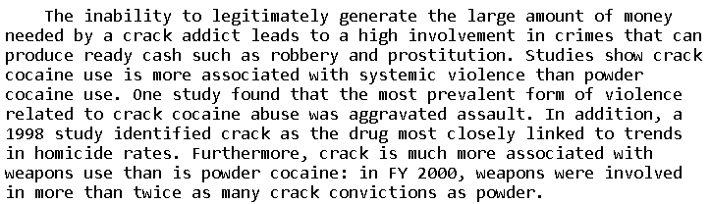

2. A/T “Racism” – Crack sentencing was requested by black communities, not imposed by white racists
Black congressman Charles Rangel wrote the bill that created the Crack/Powder disparity
Dr. Michael Javen Fortner, 2021 (a senior fellow at the Niskanen Center, a Political Science Professor, and author of a book about drugs and black communities. Professor at City University of New York’s Graduate Center. PhD in government and social policy from Harvard Univ.) “Letter to Dick Durbin and Chuck Grassley” Niskanen Center, June 21, 2021. Footnotes Omitted. https://www.niskanencenter.org/wp-content/uploads/2021/06/Niskanen-Center-EQUAL-Act-Testimony-Final-Draft-1.pdf (accessed October 5, 2021) (ellipses and brackets in original)
Although some scholars attribute the disparity to a moral panic created by the death of famous athletes and sensationalized media accounts, crack use and trafficking generated real problems for urban black communities. As one Harlem resident recalled,
Crack was something else and I don't mean the drug itself…[What] I mean is what it did to the community, to the family. People couldn’t trust their own kids. It was like prison. Nobody wanted to let their children leave the house because you never knew what was gonna be waiting outside.
An elderly resident put it this way: The crack was the worst…[T]hat was the end. Those that could get git [left], well the rest, peoples like me, we just had to stay inside. Crackheads would steal everything. You wouldn't even go outside soon as it got dark. It was worse than dope. Seemed like every other person or [their] children or somebody they [knew] was on crack.
In July 1986, a few months before the passage of the Anti-Drug Abuse Act, the United Black Church Appeal, a coalition of African American religious and civic leaders, organized vigils and rallies across New York City to publicize the crack problem and pressure public officials to act. The Reverend Wendell Foster, an African American city councilman and the president of the United Black Church Appeal, declared, “We are engaged in a new form of genocide.” He added, “As devastating as drugs may be in the white community, they are 10 times worse in the black community.” Charles Hughes, African American president of Local 372, District Council 37 of the American Federation of State, County and Municipal Employees, hoped the rallies would send “a clear message to our elected officials” and demand “an end to the [heyday] that CRACK dealers have enjoyed until now.” He explained, “Penalties must replace profits for those who are trafficking in drugs and the [high-level] drug [kingpins] must be apprehended and brought to justice as well as [street-level] pushers.” New York City was not unique. Anti-drug campaigns emerged in black communities across the United States. Not only did Harlem’s U.S. Representative Charles Rangel help draft the broader bill; most members of the Congressional Black Caucus co-sponsored and voted for it. Additionally, historian David Farber reports that “none of the bill’s opponents cited the disparity in punishment for dealers of crack and powder cocaine as reason for their disapproval.”

Black leaders lobbied for tougher crack cocaine sentences in the 1980s and praised Pres. Reagan for signing the law
Larry Elder 2018 (nationally syndicated radio talk show host) 18 June 2018 “Complicated past for anti-drug laws” BOSTON HERALD https://www.bostonherald.com/2018/06/18/complicated-past-for-anti-drug-laws/
In the ’80s and ’90s, many black leaders supported tough anti-drug laws. Facing an inner-city explosion of gang activity, violent crime and a crack epidemic, black politicians pressured Congress to pass these laws. The Rev. George McMurray was pastor of Harlem’s Mother A.M.E. Zion Church in the ’70s, a time when New York City faced a major heroin epidemic. He favored life sentences for convicted drug dealers. “When you send a few men to prison for life, someone’s going to pass the word down, ‘It’s not too good over here,’ ” McMurray said. “So instead of robbery and selling dope, (they’ll think) ‘I want to go to school and live a good life.’ ” When President Ronald Reagan signed the Anti-Drug Abuse Act of 1986 into law — the law that punished crack cocaine dealers far more harshly than powder cocaine dealers — Harlem’s Rep. Charlie Rangel stood right behind Reagan. Crack dealers, many of whom were black, got harsher sentences than those who dealt powder cocaine, many of whom were white. And Congressional Black Caucus members pushed Reagan to create the Office of National Drug Control Policy.

Black community leaders and elected politicians supported tough-on-drugs federal legislation in the 1990s
Larry Elder 2018 (nationally syndicated radio talk show host) 18 June 2018 “Complicated past for anti-drug laws” BOSTON HERALD https://www.bostonherald.com/2018/06/18/complicated-past-for-anti-drug-laws/
Then came the massive 1994 Violent Crime Control and Law Enforcement Act, which included longer sentences for first-time offenders. An influential group of black pastors wrote to the Congressional Black Caucus, “While we do not agree with every provision in the crime bill, we do believe and emphatically support the bill’s goal to save our communities, and most importantly, our children.” The black mayor of Baltimore, Kurt Schmoke, said: “I believe the crime bill … is part of the answer, and the crime bill should be supported by us. We do need to send a signal throughout our communities that certain types of activities will not be tolerated, that people will be held accountable and that if there is evil manifested by actions taken by individuals who choose to prey upon our residents that that evil will be responded to quickly and correctly.” The majority of the Congressional Black Caucus supported Congress’ final bill.

Hypocrisy: The ones calling crack sentencing “racist” were the same black leaders who supported it in the 1980s
Wayne Rocques 1997. (federal drug enforcement agent; served as an acting group supervisor on the Vice President's Joint Task Force in the 1980s) 29 Apr 1997 WALL STREET JOURNAL “Why a Crack Crackdown Isn't Unjust” https://www.wsj.com/articles/SB862260372760622500 (accessed 10 Oct 2021)
Unfortunately, two prominent black leaders, the Rev. Jesse Jackson and Rep. Charles Rangel (D., N.Y.), have bought into this scam and declared the sentencing laws racist. Yet Messrs. Jackson and Rangel held a news conference in 1986 demanding that the federal government do something about the crack epidemic that was raging through inner-city neighborhoods. They understood that the introduction of this cheap, rapidly addicting form of cocaine posed a particular danger to the weakest denizens of those areas. Mr. Rangel, in fact, voted for the statute imposing tougher sentences for crack cocaine. Now, it appears that these two gentlemen have forgotten whence the statute came.

Impacts of crack were worse in black communities than for whites
William N. Evans, Craig Garthwaite & Timothy J. Moore 2018 (National Bureau of Economic Research. Evans – Research Associate, Univ. of Notre Dame. Garthwaite – Research Associate, Northwestern Univ. Moore – Research Associate, Purdue Univ.) July 2018 Guns and Violence: The Enduring Impact of Crack Cocaine Markets on Young Black Males https://www.nber.org/papers/w24819 (accessed 10 Oct 2021)
We estimate that the murder rate of young black males doubled soon after crack’s entrance into a city, and that these rates were still 70 percent higher 17 years after crack’s arrival. We document the role of increased gun possession as a mechanism for this increase. Following previous work, we show that the fraction of suicides by firearms is a good proxy for gun availability and that this variable among young black males follows a similar trajectory to murder rates. Access to guns by young black males explains their elevated murder rates today compared to older cohorts. The long run effects of this increase in violence are large. We attribute nearly eight percent of the murders in 2000 to the long-run effects of the emergence of crack markets. Elevated murder rates for younger black males continue through to today and can explain approximately one tenth of the gap in life expectancy between black and white males.

“NOT” coming down on crack is the real discrimination. Black communities want long sentences for dealers
Joseph I. Cassilly 2009 (Maryland state prosecutor; President of the National District Attorneys Association) UNFAIRNESS IN FEDERAL COCAINE SENTENCING: IS IT TIME TO CRACK THE 100 TO 1 DISPARITY?, HEARING BEFORE THE SUBCOMMITTEE ON CRIME, TERRORISM, AND HOMELAND SECURITY OF THE COMMITTEE ON THE JUDICIARY HOUSE OF REPRESENTATIVES 21 May 2009 https://www.govinfo.gov/content/pkg/CHRG-111hhrg49783/html/CHRG-111hhrg49783.htm (accessed 10 Oct 2021)
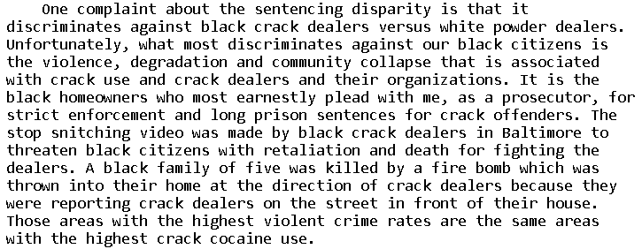
3. Crack criminals aren’t really serving extra long sentences

Federal prisoners convicted for crack aren’t really serving the long sentences because they plea bargain down to lesser crimes
Joseph I. Cassilly 2009 (Maryland state prosecutor; President of the National District Attorneys Association) UNFAIRNESS IN FEDERAL COCAINE SENTENCING: IS IT TIME TO CRACK THE 100 TO 1 DISPARITY?, HEARING BEFORE THE SUBCOMMITTEE ON CRIME, TERRORISM, AND HOMELAND SECURITY OF THE COMMITTEE ON THE JUDICIARY HOUSE OF REPRESENTATIVES 21 May 2009 https://www.govinfo.gov/content/pkg/CHRG-111hhrg49783/html/CHRG-111hhrg49783.htm (accessed 10 Oct 2021)
In recent years local prosecutors have brought hundreds of large quantity dealers for Federal prosecution, primarily because of the discretion of Federal prosecutors in dealing with these cases. This discretion allows for pleas to lesser amounts of cocaine or the option of not seeking sentence enhancements. The end result is that the majority of these cases are ultimately resolved by a guilty plea to a sentence below the statutory amount. The practical effect of guilty pleas is that serious violent criminals are immediately removed from our communities, they spend less time free on bail or in pre-trial detention, civilian witnesses are not needed for trial or sentencing hearings and are therefore not subject to threats and intimidation and undercover officers are not called as witnesses: all of which would happen if we were forced to proceed with these cases in courts. Yet meaningful sentences are imposed, which punish the offender but also protect the community. The plea agreements often call for testimony against higher ups in the crack organization. It is critical that Federal sentences for serious crack dealers remain stricter than State laws if this coordinated interaction is to continue.

Even when the crack/powder sentencing ratio was 100:1 on the books, federal crack prisoners were serving between 1 to 6.3 ratio sentences, not 100
Joseph I. Cassilly 2009 (Maryland state prosecutor; President of the National District Attorneys Association) UNFAIRNESS IN FEDERAL COCAINE SENTENCING: IS IT TIME TO CRACK THE 100 TO 1 DISPARITY?, HEARING BEFORE THE SUBCOMMITTEE ON CRIME, TERRORISM, AND HOMELAND SECURITY OF THE COMMITTEE ON THE JUDICIARY HOUSE OF REPRESENTATIVES 21 May 2009 https://www.govinfo.gov/content/pkg/CHRG-111hhrg49783/html/CHRG-111hhrg49783.htm (accessed 10 Oct 2021)
The cooperation of Federal and State prosecutors and law enforcement that has developed over the years is due in large part to the interplay of Federal and State laws. Maryland state statutes differentiate sentences between crack and powder cocaine offenders on a 9:1 ratio based on the amount that would indicate a major dealer. There is not in reality a 100:1 difference in the sentences given to crack versus powder offenders. A DOJ report states, ``A facial comparison of the guideline ranges for equal amounts of crack and powder cocaine reveals that crack penalties range from 6.3 times greater to approximately equal to powder sentences.''
DISADVANTAGES

1. Unjust – because it treats different crimes the same

Affirmative advocate admits: If impacts are different, then different sentences are justified
Jeremiah Mosteller agrees with the Affirmative sentencing equalization plan. But he admits in 2021:
Affirmative advocate - Jeremiah Mosteller 2021. (J.D.; Senior Policy Analyst for criminal justice at Americans for Prosperity) 7 July 2021 “This criminal justice solution was well-intentioned. It still failed.” https://americansforprosperity.org/sentencing-disparity-between-crack-powder-cocaine/ (accessed 29 July 2021)
Accountability is an essential component of justice, but that accountability must be proportional based on the harm caused to a victim or the local community. For example, theft crimes are punished differently based on the value of the items stolen. This makes complete sense given the different level of harm imposed on the victim.

Problems of crack & powder are different – so the differences are justified
Wayne Rocques 1997. (federal drug enforcement agent; served as an acting group supervisor on the Vice President's Joint Task Force in the 1980s) 29 Apr 1997 WALL STREET JOURNAL “Why a Crack Crackdown Isn't Unjust” https://www.wsj.com/articles/SB862260372760622500 (accessed 10 Oct 2021)
Crack, which is smoked rather than snorted, is far cheaper and more rapidly addictive than powder cocaine, and it renders its users more prone to violence. The only effective way to combat it is by going after the retail end of the market. With powder cocaine, on the other hand, the federal government generally reserves its limited resources for wholesale operations. That's why cases involving wholesale distributors of powder cocaine normally involve multiple kilograms of the drug, while crack cocaine cases generally are measured in grams. The average amount of powder cocaine per inmate in federal prison on a powder cocaine violation is about 183 pounds. The average amount of crack cocaine per convict is about 700 grams, which converts to approximately 7,000 "rocks" (dosages), hardly the stock of a small-time pusher or addict.

But the problem is: Crack is worse (ALSO: Cross apply cards under significance point 1: “Crack is Worse”)
Rep. Ken Buck 2021 (member of Congress from Colorado, R-CO. JD, Univ of Wyoming School of Law. Former County District Attorney). “Transcript of MARKUP OF: 7 H.R. 1693, THE "ELIMINATING A 8 QUANTIFIABLY UNJUST APPLICATION OF THE LAW 9 ACT" OR THE "EQUAL ACT" House of Representatives Committee on the Judiciary. Wednesday, July 21, 2021. https://docs.house.gov/meetings/JU/JU00/20210721/113949/HMKP-117-JU00-Transcript-20210721.pdf (Accessed October 5, 2021)
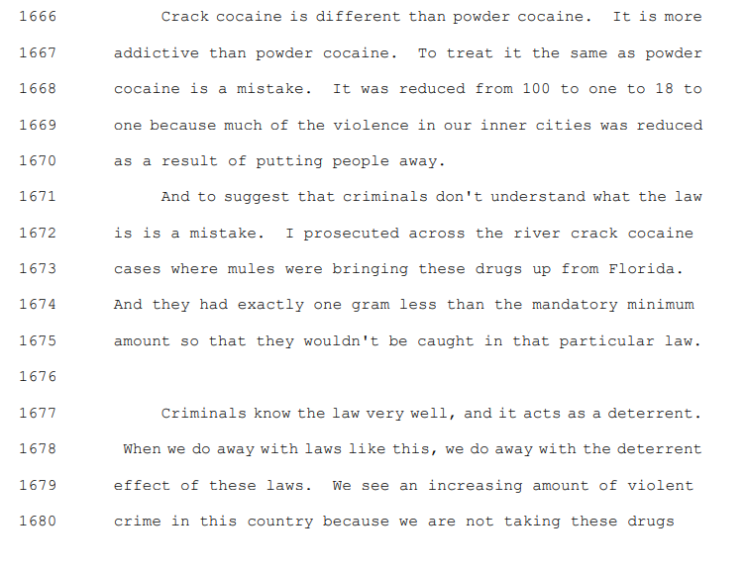
Impact: Justice violated
Justice requires that the punishment fit the crime. It is unjust to punish someone who commits one crime the same as someone else who commits a worse crime. This is exactly what the affirmative’s plan does, and thus we ask you to vote against it.

2. More overdose deaths & crime

EQUAL Act would release bad guys from prison and increase overdose deaths and violent crime
Sen. Tom Cotton 2021 (US Senator, R-Arkansas) 20 Sept 2021 “No More Jailbreaks” NATIONAL REVIEW https://www.nationalreview.com/2021/09/no-more-jailbreaks/ (accessed 10 Oct 2021)
Recently, the Senate Judiciary Committee has approved several bills that would take criminal leniency to new extremes and public safety to new lows. These bills would shorten sentences for heroin and fentanyl traffickers, grant early release to thousands of drug dealers, expand house arrest for drug kingpins, and prohibit judges from taking into account certain past criminal activity in sentencing. Unwise even in a normal year, this salvo of pro-crime policies will exacerbate record-high overdose deaths and violent crime. Some Senate Judiciary Committee members are also pushing a badly misnamed bill, the Eliminating a Quantifiably Unjust Application of the Law (EQUAL) Act, which would retroactively reduce prison sentences for convicted crack-cocaine traffickers and force prosecutors to treat crack- and powder-cocaine-trafficking equally. Not all illegal drugs inflict the same damage on society, and we shouldn’t treat them as though they do. However, if activists demand equality, we should increase sentences for powder cocaine to match crack sentences, not reduce sentences on crack to match those for powder cocaine.

Releasing drug dealers from federal prison early = more crime
Sen. Tom Cotton 2021 (US Senator, R-Arkansas) 20 Sept 2021 “No More Jailbreaks” NATIONAL REVIEW https://www.nationalreview.com/2021/09/no-more-jailbreaks/ (accessed 10 Oct 2021)
For decades, the federal prison system delivered firm and effective sentences to drug traffickers and violent criminals. Indeed, our federal prisons stop the greatest menaces to society by keeping them away from the communities that they victimized. Soft-on-crime policies undermine these necessary institutions. For example, states and localities might reduce their cooperation with federal authorities if criminals are treated more leniently at the federal level than on the state level. This would hurt the American rule of law and render our federal prison system impotent. Criminals do not respect or appreciate weakness; they exploit and abuse it. Leniency has once again failed, with truly heartbreaking consequences. It is time to get tough on crime, end the jailbreaks, and lock up the murderers and merchants of misery who have inflicted such harm on our nation. The crime wave will not recede until we do.

Historical precedent: First Step Act reduced drug sentences and sent criminals home early. Result was more crime and more drug overdose deaths
Sen. Tom Cotton 2021 (US Senator, R-Arkansas) 20 Sept 2021 “No More Jailbreaks” NATIONAL REVIEW https://www.nationalreview.com/2021/09/no-more-jailbreaks/ (accessed 10 Oct 2021)
In 2018, I warned that the First Step Act was a jailbreak bill that would cause more crime and suffering in American communities. I was right. Since its passage in 2018, drug-overdose deaths have skyrocketed. In particular, cocaine-overdose deaths have surged over 30 percent to become the second-most deadly drug threat. The Department of Justice has also conspicuously refused to release recidivism data on First Step Act beneficiaries. Thousands of released drug traffickers undoubtedly contributed to last year’s massive upswing in drug deaths and the growing gang violence in our cities. This criminal-leniency law was a step backward in the administration of justice — and we should ensure that this first step is also the last.

Tough sentences are an effective way to keep crack dealers from damaging our communities
Bob Bushman 2009 (Vice President, National Narcotics Officers Association Coalition UNFAIRNESS IN FEDERAL COCAINE SENTENCING: IS IT TIME TO CRACK THE 100 TO 1 DISPARITY?, HEARING BEFORE THE SUBCOMMITTEE ON CRIME, TERRORISM, AND HOMELAND SECURITY OF THE COMMITTEE ON THE JUDICIARY HOUSE OF REPRESENTATIVES 21 May 2009 https://www.govinfo.gov/content/pkg/CHRG-111hhrg49783/html/CHRG-111hhrg49783.htm (accessed 10 Oct 2021)
We are caught in the middle on this issue. It is difficult to protect the citizens of the drug-infested, high-crime areas, who need us the most, when we cannot rid those neighborhoods of the ones who abuse them the most, the drug dealers and gangs. We are criticized by some for not doing enough and by others for being too aggressive in our prosecution of drug violators. Tough drug sentences are a very effective way of getting predators off the streets, the people who do the most damage to our communities.

Link & Impact: Equalizing crack & powder means more incentive to sell crack, leading to more addicts and more violence
Bob Bushman 2009 (Vice President, National Narcotics Officers Association Coalition UNFAIRNESS IN FEDERAL COCAINE SENTENCING: IS IT TIME TO CRACK THE 100 TO 1 DISPARITY?, HEARING BEFORE THE SUBCOMMITTEE ON CRIME, TERRORISM, AND HOMELAND SECURITY OF THE COMMITTEE ON THE JUDICIARY HOUSE OF REPRESENTATIVES 21 May 2009 https://www.govinfo.gov/content/pkg/CHRG-111hhrg49783/html/CHRG-111hhrg49783.htm (accessed 10 Oct 2021)
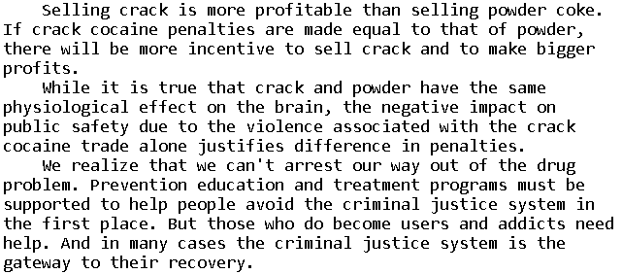

3. Less effective law enforcement

Equalizing the sentences would block enforcement against crack at the retail level
Wayne Rocques 1997. (federal drug enforcement agent; served as an acting group supervisor on the Vice President's Joint Task Force in the 1980s) 29 Apr 1997 WALL STREET JOURNAL “Why a Crack Crackdown Isn't Unjust” https://www.wsj.com/articles/SB862260372760622500 (accessed 10 Oct 2021)
There has been a great deal of sophistry in the discussion of the relative sentences for crack cocaine vs. powder cocaine. In truth, the sentencing statute doesn't impose longer sentences for crack cocaine. Rather, it establishes a lower weight threshold to get to an equivalent sentence for crack cocaine as compared with powder cocaine. It is predicated on the relative importance of the defendant in the phase of the market in which he operates. If federal agents were subject to the same quantity thresholds for crack cocaine investigations as they are for powder, they simply wouldn't be able to work the retail crack market. In the Southern District of Florida, for example, the threshold for powder cocaine cases is three kilograms. The same amount of crack is the equivalent of 30,000 rocks. It is unlikely that a crack cocaine dealer would ever have sufficient quantity to meet such a threshold.
EQUAL Act would prevent prosecutors from effectively going after bad guys
Sarah Anderson, (Program Manager, Criminal Justice & Civil Liberties) Jillian Snider, 2021 (Policy Director, Criminal Justice & Civil Liberties, “THE EQUAL ACT AND THE FEDERAL COCAINE SENTENCING DISPARITY” R Street September 2021 https://www.rstreet.org/wp-content/uploads/2021/09/Final-Equal-Act-R-Sheet.pdf (accessed October 5, 2021).
Opponents of advancing the EQUAL Act raise concerns about increases in crime and the potential of hamstringing law enforcement. During the HJC markup of the EQUAL Act, Rep. Chip Roy (R-Texas) expressed this, vocalizing his concerns about preventing law enforcement and prosecutors from effectively going after bad actors. He addressed the question of the disparity, proposing increasing penalties for powder instead of lowering them for crack, which is a proposal echoed by other opponents as well, such as Sen. Tom Cotton (R-Ark.), who has introduced legislation to this effect.

High Sentences necessary to get lower-level dealers to reveal who the leaders are
Congressman Steve Chabot 2021 (R-OH. BA, College of William and Mary, JD, Northern Kentucky University Salmon P. Chase College of Law) “Transcript of MARKUP OF: 7 H.R. 1693, THE "ELIMINATING A 8 QUANTIFIABLY UNJUST APPLICATION OF THE LAW 9 ACT" OR THE "EQUAL ACT" House of Representatives Committee on the Judiciary. Wednesday, July 21, 2021. https://docs.house.gov/meetings/JU/JU00/20210721/113949/HMKP-117-JU00-Transcript-20210721.pdf (Accessed October 5, 2021)
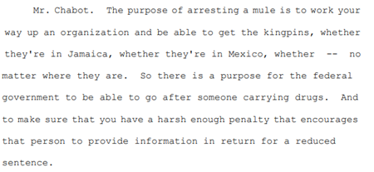
Impact: Crime and violence. They go down when we get tough on crack with longer sentences
Bob Bushman 2009 (Vice President, National Narcotics Officers Association Coalition UNFAIRNESS IN FEDERAL COCAINE SENTENCING: IS IT TIME TO CRACK THE 100 TO 1 DISPARITY?, HEARING BEFORE THE SUBCOMMITTEE ON CRIME, TERRORISM, AND HOMELAND SECURITY OF THE COMMITTEE ON THE JUDICIARY HOUSE OF REPRESENTATIVES 21 May 2009 https://www.govinfo.gov/content/pkg/CHRG-111hhrg49783/html/CHRG-111hhrg49783.htm (accessed 10 Oct 2021)
The devastation I saw it in the 1980's and 1990's as a cop working crack cases was unlike anything we have ever seen. The crack trade was responsible for dramatic increases in violent crime in our communities. Drive-by shootings, gang wars and home invasions became common. Citizens demanded tough measures to bring the situation under control, and the current laws related to sentencing of crack offenders were a direct response to the desperate pleas of the law-abiding citizens and the families. Yes, we continue to have a significant drug problem in this problem. We know that. But crack and cocaine use has declined in the past 25 years due in part, we believe, to tough criminal sanctions that both prevent drug use and compel cooperation of individuals to take down drug rings.

Impact: More crime. Tougher crack sentencing helped law enforcement dramatically reduce crime
Rep. Lamar Smith 2009 (congressman from Texas) UNFAIRNESS IN FEDERAL COCAINE SENTENCING: IS IT TIME TO CRACK THE 100 TO 1 DISPARITY?, HEARING BEFORE THE SUBCOMMITTEE ON CRIME, TERRORISM, AND HOMELAND SECURITY OF THE COMMITTEE ON THE JUDICIARY HOUSE OF REPRESENTATIVES 21 May 2009 https://www.govinfo.gov/content/pkg/CHRG-111hhrg49783/html/CHRG-111hhrg49783.htm (accessed 10 Oct 2021)
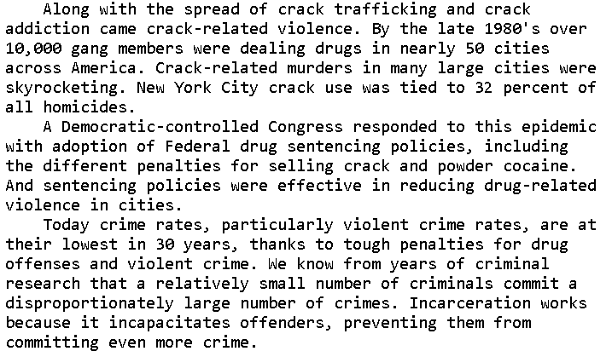

Impact: The bad old days. Ending the disparity takes us back to the violence and terrible impacts of the crack epidemic in the 1980s
Rep. Lamar Smith 2009 (congressman from Texas) UNFAIRNESS IN FEDERAL COCAINE SENTENCING: IS IT TIME TO CRACK THE 100 TO 1 DISPARITY?, HEARING BEFORE THE SUBCOMMITTEE ON CRIME, TERRORISM, AND HOMELAND SECURITY OF THE COMMITTEE ON THE JUDICIARY HOUSE OF REPRESENTATIVES 21 May 2009 https://www.govinfo.gov/content/pkg/CHRG-111hhrg49783/html/CHRG-111hhrg49783.htm (accessed 10 Oct 2021)
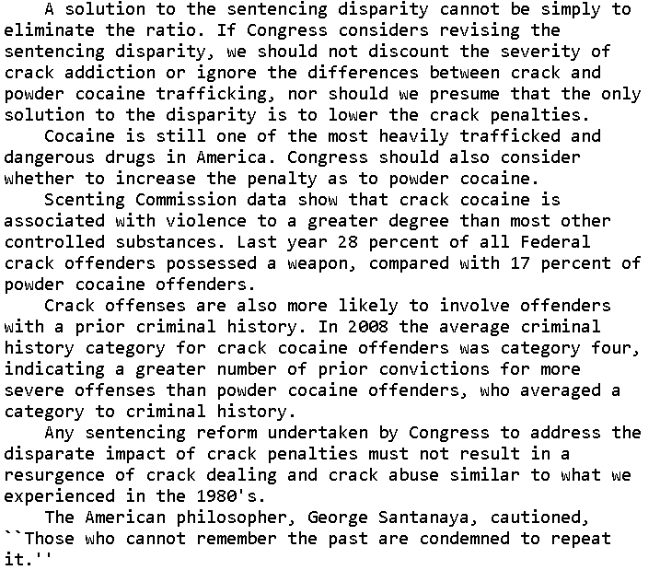

4. Mindset Critique: Criminals versus victims

The entire mindset of the Affirmative position is wrong and justifies a Negative ballot
Wayne Rocques 1997. (federal drug enforcement agent; served as an acting group supervisor on the Vice President's Joint Task Force in the 1980s) 29 Apr 1997 WALL STREET JOURNAL “Why a Crack Crackdown Isn't Unjust” https://www.wsj.com/articles/SB862260372760622500 (accessed 10 Oct 2021)
And the most important question is this: Why are we focusing all this time and energy on the "plight" of drug criminals? The object of our efforts and devotion should be the victims of crack cocaine--children who are seduced by it or addicted even before birth, and law-abiding citizens whose communities are devastated by its effects--not those who profit by the misery and harm they visit on our society.

