Man Behind the Curtain: Regulate Investment Robo Advisors
By “Coach Vance” Trefethen
Resolved: The United States federal government substantially reform the use of Artificial Intelligence technology
Case Summary: Investment firms and their clients are turning more and more to AI-driven “Robo Advisors,” rather than human advisors. Robo Advisors give the potential client a questionnaire with a dozen questions about things like their age, investment goals, tolerance for risk, and then come up with an investment strategy that, when accepted by the client, allocates the client’s savings into the stock and bond markets based on the AI’s formulas and calculations of what is appropriate. There are 2 problems with this:
1) Inappropriate investments. A Robo Advisor cannot “know” a client well enough from a questionnaire to be able to accurately counsel someone on how to invest their life savings. It may well make inappropriate investments, or not be able to counsel an investor when questions or problems come up. An example of inappropriate investment would be an elderly widow who is scared of losing her savings and wants it invested safely at low risk. But the Robo invests it in gold mines or African junk bonds or a hot new internet startup that may fail tomorrow or make a trillion dollars next year. Her money probably should have been invested in US Treasury bonds.
2) Conflict of interest. This problem has already been known to have happened at Charles Schwab. The Robo invests in mutual funds or other investments owned by the company that is providing the Robo service, regardless of whether that’s the best investment for the client. The client thinks the Robo is acting in the client’s best interest, but the Robo is unknowingly directing investments in a way that increases the Robo owner’s profitability at the expense of the client.
Money : Regulate Investment Robo Advisers 3
OBSERVATION 1. DEFINITIONS 3
Substantial 3
Reform 3
Artificial Intelligence 3
Robo Advisers 3
OBSERVATION 2. INHERENCY, the structure of the Status Quo. Several key FACTS 4
FACT 1. Growing industry 4
Robo advisers manage $460 billion and growing 4
FACT 2. Inadequate regulations 4
Robo Advisers operate in a legal gray area. Status Quo regulations are unclear and confusing 4
OBSERVATION 3. HARMS 5
HARM 1. Inappropriate investments 5
A. Lack of understanding. Robos can’t meet an adviser’s duty to give advice based on the goals and risk tolerance of the investor 5
B. Catastrophic impact. Bad robo investment advice can have catastrophic individual and systemic impacts 5
HARM 2. Conflicts of interest 6
Robo-advisors significantly harm clients when they misallocate investments to their own firm’s products 6
OBSERVATION 4. We offer the following PLAN implemented by Congress, the President and the Securities & Exchange Commission 6
OBSERVATION 5. ADVANTAGES 7
ADVANTAGE 1. More appropriate investment advice 7
“Know Your Customer,” or KYC, standards give us the tools to fix inadequate knowledge 7
ADVANTAGE 2. Resolving conflict of interest 7
Mandatory disclosure of programmed conflicts of interest and their costs is the solution 7
2A Evidence: Investment Robo Advisors 8
BACKGROUND & DEFINITIONS 8
Definition of Robo Advisors and how they work 8
Definition of “Investment Advisers” 8
Definition of “fiduciary duty” 8
Definition of “fiduciary duty” 9
Fiduciary duty requires advisers to place interests of clients ahead of their own, and disclose or eliminate conflicts of interest 9
Robo Advisers are regulated under the Investment Advisers Act of 1940 and owe a duty as fiduciaries to their clients 9
Investment advisers, by law, owe a “fiduciary” duty to their clients 9
INHERENCY 10
Robo Advisers may pose unforeseen risks to investors because of their new technology and new business models 10
Robo Advisers try to avoid fiduciary duties and end up confusing investors 10
Consumers by themselves can’t solve for the risks –they don’t have adequate knowledge 10
Investment Advisers Act of 1940 was designed for human behavior. It needs to be updated for Robo Advisers 11
Status Quo investment advice law is scattered and standards are unclear 11
Robo Advisers are the next big thing in the investment world 11
A/T “SQ is prosecuting Robo advisors under existing law” – Only for routine stuff, not problems related to AI. And it’s not because it’s not needed, it’s because they haven’t given it adequate scrutiny 12
HARMS / SIGNIFICANCE 12
Significance / Risk 12
Significant problem: Risk of Robo Advisers is sufficiently large to justify regulatory attention 12
Significance: Need for regulation justified by number of investors, severity of consequences, and systemic risk to financial markets 13
Can’t Know the Customer / Bad Advice 13
Investment advisers must make extensive efforts to understand their clients in order to give appropriate advice 13
Investment advisers must collect sufficient information to make appropriate recommendations, resolve conflicts of interest, and ensure best execution of clients’ transactions 14
“Know Your Customer,” or KYC, information is lacking with Robo Advisers 14
Rapid development and growth of robo-advisors in today’s investment market 15
Conflict of Interest 15
Law requires investment advisers to disclose conflicts of interest to their clients 15
Robo advisors can have conflicts of interest and may do what’s best for their firm rather than the client investor 16
A/T “Schwab fixed their broken SIP conflict of interest” – They’re just one example. Conflicts are common in the industry 16
Robo advisors can have conflicts of interest with larger and more certain impacts than human advisor conflicts 16
A number of robo-advisors have an affiliated broker-dealer that can disadvantage their clients 17
SOLVENCY / ADVOCACY / ADVANTAGES 17
Regulators should examine adequacy of information and appropriateness of robo-advice for customer’s needs 18
Conflict programming disclosure solves for Robo Advisor conflicts of interest 19
Conflict impact disclosure should be required for Robo Advisors 19
Robo Advisers should be required to disclose embedded conflicts of interest 20
Risk of conflict of interest and the potential impact justifies regulation of robo advisors 20
A/T “More study needed” – Smart thing is to act now BEFORE risks expand 20
A/T “More study needed” – Urgency of conflict of interest problem means we should act now 21
A/T “More study needed” – Now is the perfect time to adopt regulations, before robo advisers get more complex 21
DISADVANTAGE RESPONSES 22
A/T “Higher compliance/advisor costs if we regulate now” 22
Turn: Costs will be a lot worse if we wait until later to regulate, because over-reaction will occur 22

Man Behind the Curtain: Regulate Investment Robo Advisers
More and more investors are turning to artificial intelligence “Robo Advisers” to manage their securities portfolios. But there are two substantial risks that experts agree justify policy reform. First, investment advisers must understand their clients’ circumstances and give advice that is appropriate to their specific needs. And second, they must disclose or eliminate conflicts of interest that might have them recommending investments in order to profit for themselves. Human investment advisers are accountable today under federal law if they fail at these duties. Advice given by artificial intelligence should follow the same rules. That’s why my partner and I are affirming that: The United States Federal Government should substantially reform the use of artificial intelligence technology.

OBSERVATION 1. DEFINITIONS
Substantial
Merriam Webster Online Dictionary copyright 2021. https://www.merriam-webster.com/dictionary/substantially (accessed 28 May 2021)
: considerable in quantity : significantly great
Reform
Merriam Webster Online Dictionary copyright 2021 https://www.merriam-webster.com/dictionary/reform (accessed 28 May 2021)
: to put or change into an improved form or condition
Artificial Intelligence
Merriam Webster Online Dictionary copyright 2021. https://www.merriam-webster.com/dictionary/artificial%20intelligence (accessed 28 May 2021)
: the capability of a machine to imitate intelligent human behavior

Robo Advisers
Ihsan Ibrahim Daldaban 2019 (LLM candidate, Univ. of Manitoba law school, Canada) ARTIFICIALLY INTELLIGENT INVESTMENT ADVISERS AND THE FIDUCIARY DUTY PROBLEM: RISKS, CHALLENGES, AND REGULATORY SOLUTIONS https://mspace.lib.umanitoba.ca/bitstream/handle/1993/34609/Daldaban_Ihsan_Ibrahim.pdf;jsessionid=A0D921312CB0FA500333D8C9B3965738?sequence=4 (accessed 24 Aug 2021)
Robo-advisers are online platforms that employ Artificial Intelligence (“AI”) and Machine Learning (“ML”) algorithms to provide wealth management services to investors. Each investment strategy created by a robo-adviser is based on the analysis of the market data and the data provided investors. For generating an investment strategy, in the initial phase, robo-advisers generally provide their clients with online questionnaires that ask for information such as the age, savings rate, net income, investment targets, value of the current investments, and the risk appetite of investors. Once the questionnaire is filled and submitted, the robo-adviser generates the investment strategy, constructs the portfolio, and makes the investment on behalf of its client.

OBSERVATION 2. INHERENCY, the structure of the Status Quo. Several key FACTS

FACT 1. Growing industry
Robo advisers manage $460 billion and growing
Nathaniel Lee 2021 (journalist) 12 Apr 2021 “Why robo-advisors are striving toward a ‘hybrid model,’ as the industry passes the $460 billion mark” https://www.cnbc.com/2021/04/12/why-robo-advisors-may-never-replace-human-financial-advisors.html (accessed 24 Aug 2021)
Since launching more than a decade ago, robo-advisors – online investment services that offer financial advice driven by algorithms – have grown into an industry that managed $460 billion in 2020. That’s a 30% increase from 2019. Some analysts predict robo-advising will become a $1.2 trillion industry by 2024.

FACT 2. Inadequate regulations

Robo Advisers operate in a legal gray area. Status Quo regulations are unclear and confusing
Jake Rifkin 2019 (JD candidate, Univ. of N.C. Law School) Robo-Advisers Jumping on the Bandwagon: Yet Another Cry for a Uniform Standard, 1 Mar 2019 NORTH CAROLINA LAW REVIEW https://scholarship.law.unc.edu/cgi/viewcontent.cgi?article=6716&context=nclr (accessed 23 Aug 2021) (brackets and ellipses in original) (SEC=Securities & Exchange Commission, the federal investment regulatory agency)
Robo-advisers employ a sizeable range of business models. For example, “[s]ome robo-advisers provide investment advice directly to the client with limited, if any, direct human interaction . . . .” Others provide investment advice after parameters are set with human advisory personnel. Furthermore, the methods of collecting client information upon which to base the investment advice differs as well. These differences in business models create a gray area that the SEC has yet to clarify and will confuse clients even more with respect to the differences between legal standards owed to them.

OBSERVATION 3. HARMS

HARM 1. Inappropriate investments

A. Lack of understanding. Robos can’t meet an adviser’s duty to give advice based on the goals and risk tolerance of the investor
Scott MacKillop 2017 (J.D.) Sept/Oct 2017 “Can a Robot Be a Fiduciary?” INVESTMENTS & WEALTH MONITOR https://investmentsandwealth.org/getattachment/aeef62ac-4780-4afd-8cdf-316082f73bda/IWM17SepOct-CanRobotBeFiduciary.pdf (accessed 26 Aug 2021)
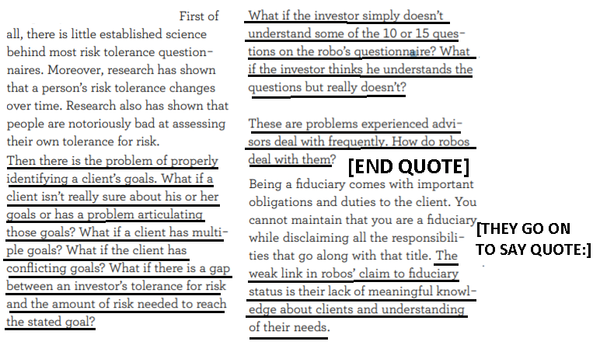
B. Catastrophic impact. Bad robo investment advice can have catastrophic individual and systemic impacts
Tom Baker & Benedict Dellaert 2018 (Baker is William Maul Measey Professor at the University of Pennsylvania Law School; co-founder of Picwell, a data analytics company that makes insurance robo advisors. Dellaert is Professor, Department of Business Economics, Marketing Section, School of Economics, Erasmus University Rotterdam and a member of the board of supervisors of Independer.nl, the largest on-line insurance broker in the Netherlands) Regulating Robo Advice Across the Financial Services Industry https://scholarship.law.upenn.edu/cgi/viewcontent.cgi?article=2742&context=faculty_scholarship (accessed 7 Sept 2021)
To further illustrate this line of reasoning, consider the impact of Google or Yelp on tourists’ search for a restaurant in a new town as compared to the traditional approach of asking the hotel concierge for a restaurant recommendation. Google’s scale compared to the concierge is tremendous. [END QUOTE] It provides access to restaurant information to all tourists in all towns, and it is easily accessible to everyone. If it gives systematically bad restaurant advice, the impact will be much greater than bad advice given by any individual concierge. Even if the advice given by hotel concierges is on average just as bad, the advice given by many individual concierges would be bad in many different ways. [THEY GO ON TO CONCLUDE QUOTE:] Of course, the consequences of providing poor restaurant advice even on a large scale seem sufficiently small that regulating Google’s or Yelp’s restaurant reviews seems unlikely to be necessary. However, the consequences of poor financial advice can be severe even in an individual instance, and potentially catastrophic on a large scale.

HARM 2. Conflicts of interest
Robo-advisors significantly harm clients when they misallocate investments to their own firm’s products
Megan Ji 2017. (JD candidate, Columbia Univ. Law School) “ARE ROBOTS GOOD FIDUCIARIES? REGULATING ROBO-ADVISORS UNDER THE INVESTMENT ADVISERS ACT OF 1940” Columbia Law Review Vol 117 No. 6 https://columbialawreview.org/content/are-robots-good-fiduciaries-regulating-robo-advisors-under-the-investment-advisers-act-of-1940-2/ (accessed 24 Aug 2021)
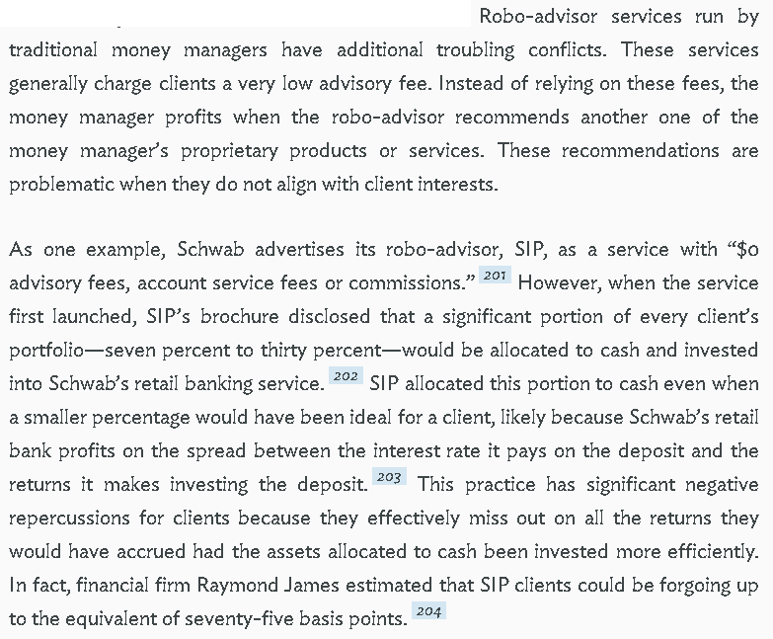

OBSERVATION 4. We offer the following PLAN implemented by Congress, the President and the Securities & Exchange Commission

1. Mandatory “Know Your Customer” standards for Robo Advisers to include adequate understanding of goals, risk tolerance, and any other duties currently required for human advisers.
2. Mandatory disclosure of all Robo Adviser programmed potential conflicts of interest and their costs.
2. Funding through general federal revenues and the existing budget of the Securities & Exchange Commission
3. Enforcement through the Securities and Exchange Commission with penalties equal to those for existing violations of fiduciary standards.
4. Timeline: Plan takes effect 90 days after an affirmative ballot.
5. All Affirmative speeches may clarify

OBSERVATION 5. ADVANTAGES
ADVANTAGE 1. More appropriate investment advice

“Know Your Customer,” or KYC, standards give us the tools to fix inadequate knowledge
Ihsan Ibrahim Daldaban 2019 (LLM candidate, Univ. of Manitoba law school, Canada) ARTIFICIALLY INTELLIGENT INVESTMENT ADVISERS AND THE FIDUCIARY DUTY PROBLEM: RISKS, CHALLENGES, AND REGULATORY SOLUTIONS https://mspace.lib.umanitoba.ca/bitstream/handle/1993/34609/Daldaban_Ihsan_Ibrahim.pdf;jsessionid=A0D921312CB0FA500333D8C9B3965738?sequence=4 (accessed 24 Aug 2021)
In this regard, regulators are advised to employ experts from relevant disciplines, such as behavior scientists, computer scientists, and web designers, and explore how a well-designed online questionnaire would function and interpret the behaviors of users, and prepare exemplary questionnaires and share them with robo-advisers. Based on these examples, robo-advisers can make necessary adjustments in their questionnaires. In addition to providing guidance in this regard, regulators should also consider itemizing all data points that must be obtained by robo-advisers through online questionnaires. A clear itemization of these data points would lead to the establishment of certain standards for robo-advisers, and this would help regulators detect non-compliant KYC methods and take actions in such situations.

ADVANTAGE 2. Resolving conflict of interest

Mandatory disclosure of programmed conflicts of interest and their costs is the solution
Megan Ji 2017. (JD candidate, Columbia Univ. Law School) “ARE ROBOTS GOOD FIDUCIARIES? REGULATING ROBO-ADVISORS UNDER THE INVESTMENT ADVISERS ACT OF 1940” Columbia Law Review Vol 117 No. 6 https://columbialawreview.org/content/are-robots-good-fiduciaries-regulating-robo-advisors-under-the-investment-advisers-act-of-1940-2/ (accessed 24 Aug 2021)(ellipses in original)
Specifically, the Commission should impose a rule that requires robo-advisors to explicitly indicate when conflicting incentives are intentionally programmed into asset allocation algorithms. For these intentional conflicts, robo-advisors should be required to disclose a “shadow commission,” which would quantify for clients how much biased algorithms are costing them. Such a disclosure would give consumers access to more information so that they are in a better position to decide whether to reap the potential benefits of robo-advice.

2A Evidence: Investment Robo Advisors

BACKGROUND & DEFINITIONS
Definition of Robo Advisors and how they work
Megan Ji 2017. (JD candidate, Columbia Univ. Law School) “ARE ROBOTS GOOD FIDUCIARIES? REGULATING ROBO-ADVISORS UNDER THE INVESTMENT ADVISERS ACT OF 1940” Columbia Law Review Vol 117 No. 6 https://columbialawreview.org/content/are-robots-good-fiduciaries-regulating-robo-advisors-under-the-investment-advisers-act-of-1940-2/ (accessed 24 Aug 2021)
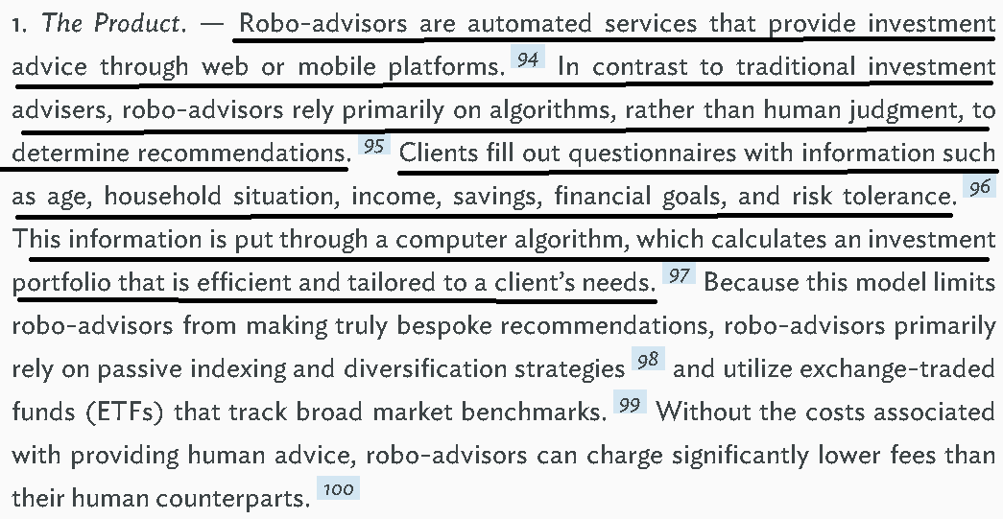

Definition of “Investment Advisers”
Jake Rifkin 2019 (JD candidate, Univ. of N.C. Law School) Robo-Advisers Jumping on the Bandwagon: Yet Another Cry for a Uniform Standard, 1 Mar 2019 NORTH CAROLINA LAW REVIEW https://scholarship.law.unc.edu/cgi/viewcontent.cgi?article=6716&context=nclr (accessed 23 Aug 2021) (ellipses in original)
Investment advisers are regulated under the Advisers Act, which imposes a fiduciary duty standard on all advisers registered with the SEC. The Advisers Act defines an “investment adviser” as
any person who, for compensation, engages in the business of advising others, either directly or through publications or writings, as to the value of securities or as to the advisability of investing in, purchasing, or selling securities, or who, for compensation and as part of a regular business, issues or promulgates analyses or reports concerning securities . . . .

Definition of “fiduciary duty”
Coryanne Hicks 2021 (investing and personal finance journalist ) 15 Apr 2021 “What Is a Fiduciary Financial Advisor?” US NEWS & WORLD REPORT https://money.usnews.com/investing/investing-101/articles/what-is-a-fiduciary-financial-advisor-a-guide-to-the-fiduciary-duty (accessed 24 Aug 2021)
According to the Cornell Law Dictionary, "A fiduciary duty is the highest standard of care." It entails always acting in your beneficiary's best interest, even if doing so is contrary to yours. For a financial advisor, this may mean recommending a product that results in reduced or no compensation because it's the best option for the client.

Definition of “fiduciary duty”
Ihsan Ibrahim Daldaban 2019 (LLM candidate, Univ. of Manitoba law school, Canada) ARTIFICIALLY INTELLIGENT INVESTMENT ADVISERS AND THE FIDUCIARY DUTY PROBLEM: RISKS, CHALLENGES, AND REGULATORY SOLUTIONS https://mspace.lib.umanitoba.ca/bitstream/handle/1993/34609/Daldaban_Ihsan_Ibrahim.pdf;jsessionid=A0D921312CB0FA500333D8C9B3965738?sequence=4 (accessed 24 Aug 2021)
The fiduciary duty is defined as the “the duty of the finest loyalty” and the persons acting under a fiduciary duty, as fiduciaries, are “held to something stricter than the morals of the market place.” Under the fiduciary duty, an investment adviser should seek its clients’ best interests and avoid subordinating its clients’ interests to its interests.

Fiduciary duty requires advisers to place interests of clients ahead of their own, and disclose or eliminate conflicts of interest
Jake Rifkin 2019 (JD candidate, Univ. of N.C. Law School) Robo-Advisers Jumping on the Bandwagon: Yet Another Cry for a Uniform Standard, 1 Mar 2019 NORTH CAROLINA LAW REVIEW https://scholarship.law.unc.edu/cgi/viewcontent.cgi?article=6716&context=nclr (accessed 23 Aug 2021)
The SEC has also recognized that the fiduciary duty owed to clients requires investment advisers to place the interests of their clients ahead of their own, which necessitates disclosure or elimination of material conflicts of interest. Compared to the duty of care, the SEC “is far more rigorous in its governance of the investment adviser duty of loyalty.” In Capital Gains, the Court tacitly recognized the unique importance of the duty of loyalty within the Advisers Act. Indeed, in enacting the Advisers Act, Congress was “deeply concerned about conflicts of interest in the advisory relationship.” Thus, “under Section 206, advisers have an affirmative obligation of utmost good faith and full and fair disclosure of all material facts to their clients, as well as a duty to avoid misleading them.” The SEC strictly enforces the disclosure requirement by disallowing any waiver for conflicted investment advisers in certain circumstances. The SEC has promulgated specific rules pertaining to disclosures.

Robo Advisers are regulated under the Investment Advisers Act of 1940 and owe a duty as fiduciaries to their clients
Jake Rifkin 2019 (JD candidate, Univ. of N.C. Law School) Robo-Advisers Jumping on the Bandwagon: Yet Another Cry for a Uniform Standard, 1 Mar 2019 NORTH CAROLINA LAW REVIEW https://scholarship.law.unc.edu/cgi/viewcontent.cgi?article=6716&context=nclr (accessed 23 Aug 2021)
The conversation in legal academia surrounding robo-advisers currently pertains to the legal obligations that robo-advisers owe their clients: whether robo-advisers can or cannot fulfill their duties as fiduciaries under the Investment Advisers Act of 1940 (“Advisers Act”). As it currently stands, pursuant to SEC guidance, robo-advisers are regulated as investment advisers under the Advisers Act, thus sparking debate over whether robots can adequately perform the fiduciary duties owed to their clients.

Investment advisers, by law, owe a “fiduciary” duty to their clients
Jake Rifkin 2019 (JD candidate, Univ. of N.C. Law School) Robo-Advisers Jumping on the Bandwagon: Yet Another Cry for a Uniform Standard, 1 Mar 2019 NORTH CAROLINA LAW REVIEW https://scholarship.law.unc.edu/cgi/viewcontent.cgi?article=6716&context=nclr (accessed 23 Aug 2021)
Perhaps the single most important case was SEC v. Capital Gains Research Bureau, Inc., in which the Supreme Court read the investment adviser fiduciary duty into the Advisers Act. The Court observed: The Investment Advisers Act of 1940 thus reflects a congressional recognition “of the delicate fiduciary nature of an investment advisory relationship,” as well as a congressional intent to eliminate, or at least to expose, all conflicts of interest which might incline an investment adviser—consciously or unconsciously—to render advice which was not disinterested.

INHERENCY
Robo Advisers may pose unforeseen risks to investors because of their new technology and new business models
Ihsan Ibrahim Daldaban 2019 (LLM candidate, Univ. of Manitoba law school, Canada) ARTIFICIALLY INTELLIGENT INVESTMENT ADVISERS AND THE FIDUCIARY DUTY PROBLEM: RISKS, CHALLENGES, AND REGULATORY SOLUTIONS https://mspace.lib.umanitoba.ca/bitstream/handle/1993/34609/Daldaban_Ihsan_Ibrahim.pdf;jsessionid=A0D921312CB0FA500333D8C9B3965738?sequence=4
Robo-advisers, the artificially intelligent investment advisers, are subject to the same question. The AI and ML algorithms are now replacing human investment advisers and can formulate investment strategies by analyzing vast amount of data in the blink of an eye. It goes without saying that this innovation is facilitating investments, creating new possibilities for financial markets, and most importantly, making investment possible for previously underserved people; however, as a matter of fact, robo-advisers may pose unforeseen risks to investors and financial markets as they are still relatively new business models and their capability of meeting certain standards set for human investment advisers is still vague.
Robo Advisers try to avoid fiduciary duties and end up confusing investors
Jake Rifkin 2019 (JD candidate, Univ. of N.C. Law School) Robo-Advisers Jumping on the Bandwagon: Yet Another Cry for a Uniform Standard, 1 Mar 2019 NORTH CAROLINA LAW REVIEW https://scholarship.law.unc.edu/cgi/viewcontent.cgi?article=6716&context=nclr (accessed 23 Aug 2021) (brackets in original)
Currently, it is clear that investor confusion surrounding the duties that investment advisers and broker-dealers owe them is a critical issue. Both the RAND Report and Section 913 Study recognize this point clearly. Now, robo-advisers hold themselves out to be an entity that may give investment advice, which further blurs the lines of exactly what duties are owed to their clients. In fact, robo-advisers often aim to minimize the fiduciary duties owed to their clients through the use of customer agreements with clauses that perform this function. One robo-adviser expressly disclaims that it has any relationship with the client, except as an independent contractor:
[Robo-advisor] is and will hereafter act as an independent contractor and not as an employee of Client, and nothing in this Agreement may be interpreted or construed to create any employment, partnership, joint venture or other relationship between [Robo-advisor] and Client.
Other customer agreements seek to limit the fiduciary duty owed or seek to disown it altogether. This inevitably leads down the path of investor confusion, broadening the impact of the disparate standards altogether.

Consumers by themselves can’t solve for the risks –they don’t have adequate knowledge
Tom Baker & Benedict Dellaert 2018 (Baker is William Maul Measey Professor at the University of Pennsylvania Law School; co-founder of Picwell, a data analytics company that makes insurance robo advisors. Dellaert is Professor, Department of Business Economics, Marketing Section, School of Economics, Erasmus University Rotterdam and a member of the board of supervisors of Independer.nl, the largest on-line insurance broker in the Netherlands) Regulating Robo Advice Across the Financial Services Industry https://scholarship.law.upenn.edu/cgi/viewcontent.cgi?article=2742&context=faculty_scholarship (accessed 7 Sept 2021)
Consumers are almost as poorly equipped to identify the quality of an intermediary as they are to evaluate the quality of the financial products. For example, because they need the help of the intermediary to evaluate those products, they cannot evaluate the quality of the intermediary by evaluating the quality of the intermediary’s recommendations. Moreover, the prevailing commission-based compensation for intermediaries creates significant conflicts of interests that lead to biased advice. Finally, the diversity and complexity of financial products makes it difficult to be sufficiently expert to consistently offer good advice, especially across the range of financial services.

Investment Advisers Act of 1940 was designed for human behavior. It needs to be updated for Robo Advisers
Megan Ji 2017. (JD candidate, Columbia Univ. Law School) “ARE ROBOTS GOOD FIDUCIARIES? REGULATING ROBO-ADVISORS UNDER THE INVESTMENT ADVISERS ACT OF 1940” Columbia Law Review Vol 117 No. 6 https://columbialawreview.org/content/are-robots-good-fiduciaries-regulating-robo-advisors-under-the-investment-advisers-act-of-1940-2/ (accessed 24 Aug 2021)
In the past decade, robo-advisors—online platforms providing investment advice driven by algorithms—have emerged as a low-cost alternative to traditional, human investment advisers. This presents a regulatory wrinkle for the Investment Advisers Act, the primary federal statute governing investment advice. Enacted in 1940, the Advisers Act was devised with human behavior in mind. Regulators now must determine how an automated alternative fits into the Act’s framework.

Status Quo investment advice law is scattered and standards are unclear
Megan Ji 2017. (JD candidate, Columbia Univ. Law School) “ARE ROBOTS GOOD FIDUCIARIES? REGULATING ROBO-ADVISORS UNDER THE INVESTMENT ADVISERS ACT OF 1940” Columbia Law Review Vol 117 No. 6 https://columbialawreview.org/content/are-robots-good-fiduciaries-regulating-robo-advisors-under-the-investment-advisers-act-of-1940-2/ (accessed 24 Aug 2021)
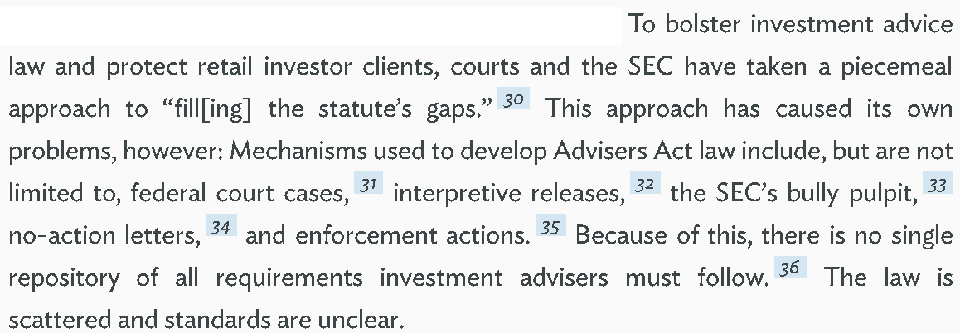

Robo Advisers are the next big thing in the investment world
Jake Rifkin 2019 (JD candidate, Univ. of N.C. Law School) Robo-Advisers Jumping on the Bandwagon: Yet Another Cry for a Uniform Standard, 1 Mar 2019 NORTH CAROLINA LAW REVIEW https://scholarship.law.unc.edu/cgi/viewcontent.cgi?article=6716&context=nclr (accessed 23 Aug 2021)
Industry professionals are beginning to recognize that roboadvice technology has a good chance of “revolutionizing how individuals receive investment advice.” These “sophisticated machine learning algorithms [are utilized] to provide personalized investment advice and monitoring 24-7.” Simply put, robo-advisers are “online services that use algorithms to generate investment recommendations for clients.” Due to the absence of human oversight and cost of human advice, robo-advisers generally charge significantly lower fees than other investment professionals. In addition, the robo-adviser business model realizes efficiencies beyond just lower fees. Roboadvisers can actively and accurately perform common advisory functions, such as rebalancing and tax-loss harvesting. As of the beginning of 2017, the total assets under management (“AUM”) of the six largest robo-advisers ranged from $1 billion (Future Advisor, a subsidiary of BlackRock) to $60 billion (Vanguard Personal Advisor).

A/T “SQ is prosecuting Robo advisors under existing law” – Only for routine stuff, not problems related to AI. And it’s not because it’s not needed, it’s because they haven’t given it adequate scrutiny
Kurt Wolfe 2020 (attorney with Troutman Sanders LLP) “Robo-Advisors: Regulators May Be Closer Than You Think” https://www.thinkadvisor.com/2020/04/21/robo-advisors-regulators-may-be-closer-than-you-think/
But regulators haven’t kept up with innovation in the robo-advisory space. There has been precious little scrutiny of robo-advisory firms or platforms, and the few examples of enforcement actions involving robo-advisors largely reflect instances of regulators applying elements of the existing regulatory framework to these innovative investment platforms. Indeed, there have been only six noteworthy enforcement actions against robo-advisors (four by the Financial Industry Regulatory Authority and two by the Securities and Exchange Commission), and all involve fairly routine charges: failure to create or provide customer records, failure to report trade data, failure to preserve electronic communications, reliance on misleading marketing materials or advertisements that overstate performance and, reliably, failure to develop or implement adequate written supervisory procedures.

HARMS / SIGNIFICANCE

Significance / Risk
Significant problem: Risk of Robo Advisers is sufficiently large to justify regulatory attention
Tom Baker & Benedict Dellaert 2018 (Baker is William Maul Measey Professor at the University of Pennsylvania Law School; co-founder of Picwell, a data analytics company that makes insurance robo advisors. Dellaert is Professor, Department of Business Economics, Marketing Section, School of Economics, Erasmus University Rotterdam and a member of the board of supervisors of Independer.nl, the largest on-line insurance broker in the Netherlands) Regulating Robo Advice Across the Financial Services Industry https://scholarship.law.upenn.edu/cgi/viewcontent.cgi?article=2742&context=faculty_scholarship (accessed 7 Sept 2021)
The benefits to developing these capacities almost certainly exceed the costs because the same returns to scale that make an automated advisor cost-effective lead to similar returns to scale in assessing the quality of automated advisors. An expert administrative agency is well situated to realize those returns to scale. Moreover, the potential solvency and systemic risks posed by hundreds of thousands, or even millions, of consumers choosing their financial products based on the same or similar models are sufficiently large and different in kind from those traditionally posed by consumer financial product intermediaries that some regulatory attention is justified on those grounds alone.

Significance: Need for regulation justified by number of investors, severity of consequences, and systemic risk to financial markets
Tom Baker & Benedict Dellaert 2018 (Baker is William Maul Measey Professor at the University of Pennsylvania Law School; co-founder of Picwell, a data analytics company that makes insurance robo advisors. Dellaert is Professor, Department of Business Economics, Marketing Section, School of Economics, Erasmus University Rotterdam and a member of the board of supervisors of Independer.nl, the largest on-line insurance broker in the Netherlands) Regulating Robo Advice Across the Financial Services Industry https://scholarship.law.upenn.edu/cgi/viewcontent.cgi?article=2742&context=faculty_scholarship
At a general level, the benefits of closer regulation of consumer financial product advice depend on the amount of harm that the advice could cause to consumers. Conceptually, the amount of this harm is a function of three factors: (1) the number of consumers affected by the potentially harmful action; (2) the probability of the harmful action occurring in the market, and (3) the severity of the consequence of the harmful action to the consumer. When more consumers are affected, when the harmful action is easy to introduce into the market, and when the severity of harm from the action is high, the need for regulation is greater. All three factors have the potential to increase along with the market share of robo advisors. First, a successful robo advisor has the capacity to reach many more consumers than any single human advisor. Second, as the market share of robo advisors increases, there will be greater opportunities for robo advisors to fail. Third, because robo advisors may give more comprehensive and detailed advice than any single human advisor, the potential harmful consequences of the robo advice to the individual consumer may be larger than that of a human advisor who operates within a narrower domain. Fourth, if one robo advisor gains truly massive market share, or if the models underlying competing robo advisors are sufficiently alike, there is a risk of highly correlated losses that could even pose systemic risk. Finally, as robo advisors gain scale, there may be collective-action problems that arise from ranking and matching services that are individually rational but have perverse consequences for financial product markets.

Can’t Know the Customer / Bad Advice
Investment advisers must make extensive efforts to understand their clients in order to give appropriate advice
Ihsan Ibrahim Daldaban 2019 (LLM candidate, Univ. of Manitoba law school, Canada) ARTIFICIALLY INTELLIGENT INVESTMENT ADVISERS AND THE FIDUCIARY DUTY PROBLEM: RISKS, CHALLENGES, AND REGULATORY SOLUTIONS https://mspace.lib.umanitoba.ca/bitstream/handle/1993/34609/Daldaban_Ihsan_Ibrahim.pdf;jsessionid=A0D921312CB0FA500333D8C9B3965738?sequence=4 (accessed 24 Aug 2021)
Under the fiduciary duty, investment advisers are required to recommend investment instruments that are suitable for a client’s investment objectives and in the best interest of the client. In order to provide suitable advices, an investment adviser must firstly collect sufficient information from its clients regarding their financial status and investment targets, as the suitability of an investment decision heavily depends on the nature of the client’s circumstances and its targets. The information to be obtained from an investor must provide the investment adviser with the understanding of, at least: (i) the investor’s financial condition, (ii) investment targets, (iii) previous experience in investing, and (iv) level of knowledge in finance.

Investment advisers must collect sufficient information to make appropriate recommendations, resolve conflicts of interest, and ensure best execution of clients’ transactions
Ihsan Ibrahim Daldaban 2019 (LLM candidate, Univ. of Manitoba law school, Canada) ARTIFICIALLY INTELLIGENT INVESTMENT ADVISERS AND THE FIDUCIARY DUTY PROBLEM: RISKS, CHALLENGES, AND REGULATORY SOLUTIONS https://mspace.lib.umanitoba.ca/bitstream/handle/1993/34609/Daldaban_Ihsan_Ibrahim.pdf;jsessionid=A0D921312CB0FA500333D8C9B3965738?sequence=4 (accessed 24 Aug 2021)
In order to satisfy this obligation, an adviser must always avoid conflicts of interest with its clients, and under any circumstances, cannot use its clients’ trust for its own benefits. Further, the fiduciary duty requires an investment adviser to employ a high level of care which goes beyond a simple honesty and good faith, and accordingly, an investment adviser must avoid even the possibility of unintentional harms it may cause to its clients through the advices it provides. In order to ensure the satisfaction of these duties, investments advisers must comply with five fundamental requirements under the fiduciary duty: (i) disclosing all material facts to clients, (ii) collecting sufficient information from clients regarding their financial status and investment targets, (iii) providing a suitable advice through meticulously investigating the basis and background of the recommendations, and monitoring the client’s investments to ensure the investment advice is suitable and in the best interest of the client, (iv) disclosing, eliminating, and avoiding conflicts of interest, (v) ensuring the best execution of clients’ transactions.

“Know Your Customer,” or KYC, information is lacking with Robo Advisers
Ihsan Ibrahim Daldaban 2019 (LLM candidate, Univ. of Manitoba law school, Canada) ARTIFICIALLY INTELLIGENT INVESTMENT ADVISERS AND THE FIDUCIARY DUTY PROBLEM: RISKS, CHALLENGES, AND REGULATORY SOLUTIONS https://mspace.lib.umanitoba.ca/bitstream/handle/1993/34609/Daldaban_Ihsan_Ibrahim.pdf;jsessionid=A0D921312CB0FA500333D8C9B3965738?sequence=4 (accessed 24 Aug 2021)
On the contrary, as there is no restriction to operate fully-automated robo-advisers in the USA, the requirements set forth by the US regulators do not necessitate the involvement of a human in the gathering of KYC information. Accordingly, robo-advisers, in the USA, may totally omit the human intervention in the gathering of KYC information; yet, they may also choose to operate hybrid models depending on their business preferences and enable human intervention in this process. The most significant factor that may limit a robo-adviser’s capacity to sufficiently and accurately collect KYC information is the absence or limitedness of human interaction in online questionnaires.

Rapid development and growth of robo-advisors in today’s investment market
Megan Ji 2017. (JD candidate, Columbia Univ. Law School) “ARE ROBOTS GOOD FIDUCIARIES? REGULATING ROBO-ADVISORS UNDER THE INVESTMENT ADVISERS ACT OF 1940” Columbia Law Review Vol 117 No. 6 https://columbialawreview.org/content/are-robots-good-fiduciaries-regulating-robo-advisors-under-the-investment-advisers-act-of-1940-2/ (accessed 24 Aug 2021)
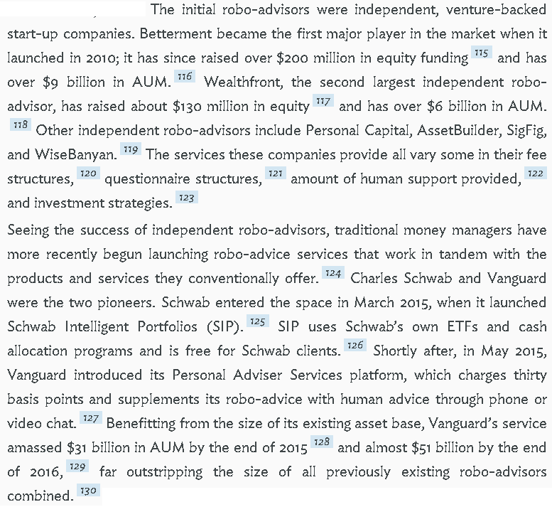
Conflict of Interest

Law requires investment advisers to disclose conflicts of interest to their clients
Megan Ji 2017. (JD candidate, Columbia Univ. Law School) “ARE ROBOTS GOOD FIDUCIARIES? REGULATING ROBO-ADVISORS UNDER THE INVESTMENT ADVISERS ACT OF 1940” Columbia Law Review Vol 117 No. 6 https://columbialawreview.org/content/are-robots-good-fiduciaries-regulating-robo-advisors-under-the-investment-advisers-act-of-1940-2/ (accessed 24 Aug 2021)
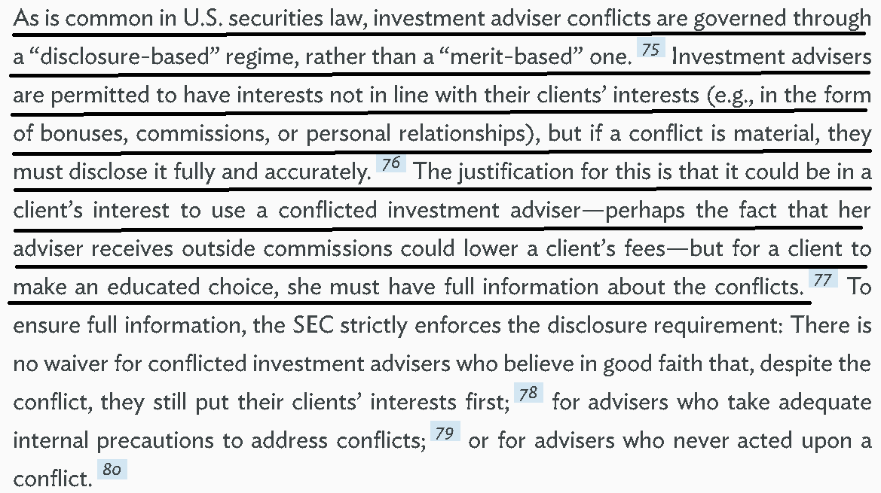

Robo advisors can have conflicts of interest and may do what’s best for their firm rather than the client investor
Megan Ji 2017. (JD candidate, Columbia Univ. Law School) “ARE ROBOTS GOOD FIDUCIARIES? REGULATING ROBO-ADVISORS UNDER THE INVESTMENT ADVISERS ACT OF 1940” Columbia Law Review Vol 117 No. 6 https://columbialawreview.org/content/are-robots-good-fiduciaries-regulating-robo-advisors-under-the-investment-advisers-act-of-1940-2/ (accessed 24 Aug 2021)
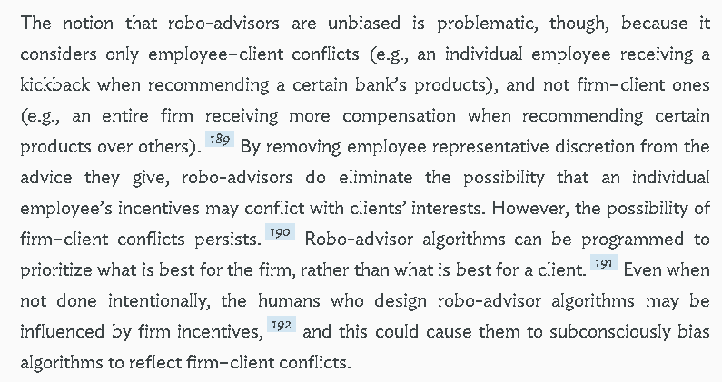

A/T “Schwab fixed their broken SIP conflict of interest” – They’re just one example. Conflicts are common in the industry
Megan Ji 2017. (JD candidate, Columbia Univ. Law School) “ARE ROBOTS GOOD FIDUCIARIES? REGULATING ROBO-ADVISORS UNDER THE INVESTMENT ADVISERS ACT OF 1940” Columbia Law Review Vol 117 No. 6 https://columbialawreview.org/content/are-robots-good-fiduciaries-regulating-robo-advisors-under-the-investment-advisers-act-of-1940-2/ (accessed 24 Aug 2021)
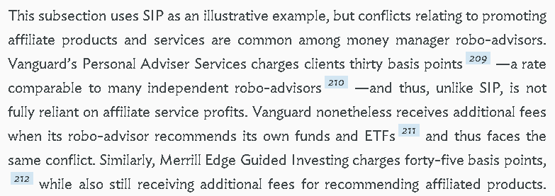

Robo advisors can have conflicts of interest with larger and more certain impacts than human advisor conflicts
Megan Ji 2017. (JD candidate, Columbia Univ. Law School) “ARE ROBOTS GOOD FIDUCIARIES? REGULATING ROBO-ADVISORS UNDER THE INVESTMENT ADVISERS ACT OF 1940” Columbia Law Review Vol 117 No. 6 https://columbialawreview.org/content/are-robots-good-fiduciaries-regulating-robo-advisors-under-the-investment-advisers-act-of-1940-2/ (accessed 24 Aug 2021)
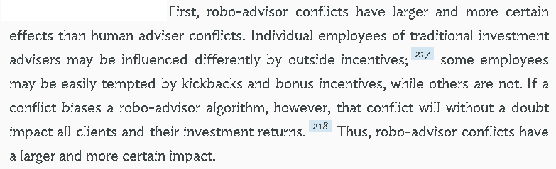
A number of robo-advisors have an affiliated broker-dealer that can disadvantage their clients
Megan Ji 2017. (JD candidate, Columbia Univ. Law School) “ARE ROBOTS GOOD FIDUCIARIES? REGULATING ROBO-ADVISORS UNDER THE INVESTMENT ADVISERS ACT OF 1940” Columbia Law Review Vol 117 No. 6 https://columbialawreview.org/content/are-robots-good-fiduciaries-regulating-robo-advisors-under-the-investment-advisers-act-of-1940-2/ (accessed 24 Aug 2021)
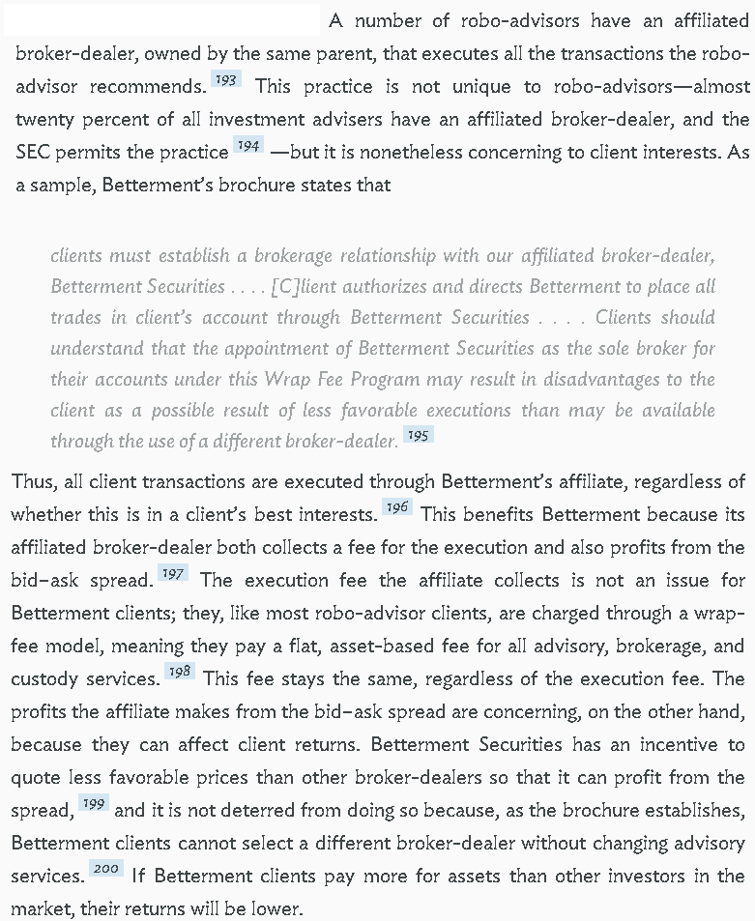

SOLVENCY / ADVOCACY / ADVANTAGES

Regulators should examine adequacy of information and appropriateness of robo-advice for customer’s needs
Tom Baker & Benedict Dellaert 2018 (Baker is William Maul Measey Professor at the University of Pennsylvania Law School; co-founder of Picwell, a data analytics company that makes insurance robo advisors. Dellaert is Professor, Department of Business Economics, Marketing Section, School of Economics, Erasmus University Rotterdam and a member of the board of supervisors of Independer.nl, the largest on-line insurance broker in the Netherlands) Regulating Robo Advice Across the Financial Services Industry https://scholarship.law.upenn.edu/cgi/viewcontent.cgi?article=2742&context=faculty_scholarship
Regulators should be asking three kinds of questions related to accessing data. First, has the robo advisor obtained access to reasonable sources of data, and are there any concerns that inability to obtain data, particularly regarding products, will bias the rankings and matching in a way that disadvantages consumers in relation to intermediaries and sellers? Second, where there are gaps in data, what are the strategies that the robo advisor considered to address those gaps, why did the robo advisor choose the strategy(ies) that it employed, and was that choice reasonable? Third, does the regulator have the authority, whether formal or informal, to increase access to data and thereby improve the quality of the robo advice?

Megan Ji 2017. (JD candidate, Columbia Univ. Law School) “ARE ROBOTS GOOD FIDUCIARIES? REGULATING ROBO-ADVISORS UNDER THE INVESTMENT ADVISERS ACT OF 1940” Columbia Law Review Vol 117 No. 6 https://columbialawreview.org/content/are-robots-good-fiduciaries-regulating-robo-advisors-under-the-investment-advisers-act-of-1940-2/ (accessed 24 Aug 2021)
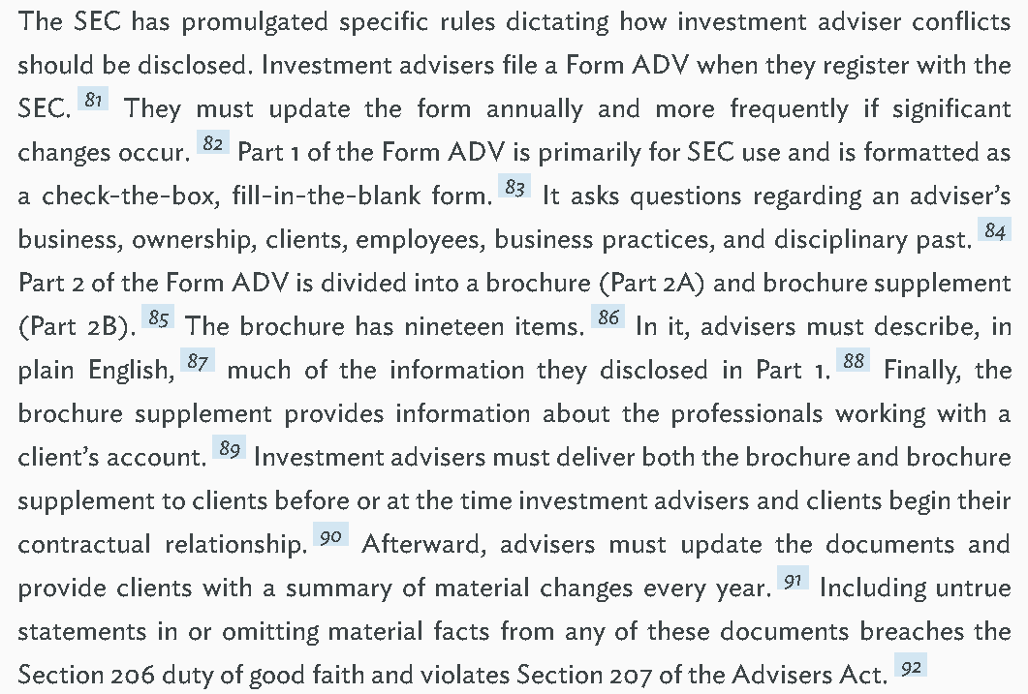

Conflict programming disclosure solves for Robo Advisor conflicts of interest
Megan Ji 2017. (JD candidate, Columbia Univ. Law School) “ARE ROBOTS GOOD FIDUCIARIES? REGULATING ROBO-ADVISORS UNDER THE INVESTMENT ADVISERS ACT OF 1940” Columbia Law Review Vol 117 No. 6 https://columbialawreview.org/content/are-robots-good-fiduciaries-regulating-robo-advisors-under-the-investment-advisers-act-of-1940-2/ (accessed 24 Aug 2021)(ellipses in original)
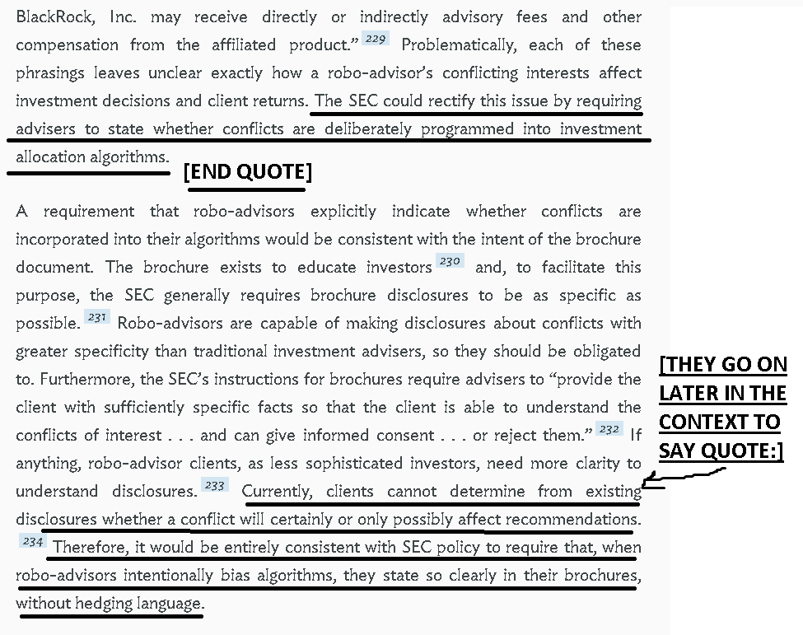

Conflict impact disclosure should be required for Robo Advisors
Megan Ji 2017. (JD candidate, Columbia Univ. Law School) “ARE ROBOTS GOOD FIDUCIARIES? REGULATING ROBO-ADVISORS UNDER THE INVESTMENT ADVISERS ACT OF 1940” Columbia Law Review Vol 117 No. 6 https://columbialawreview.org/content/are-robots-good-fiduciaries-regulating-robo-advisors-under-the-investment-advisers-act-of-1940-2/ (accessed 24 Aug 2021)
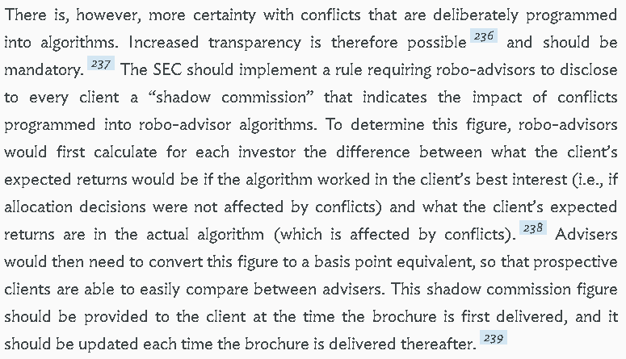

Robo Advisers should be required to disclose embedded conflicts of interest
Ihsan Ibrahim Daldaban 2019 (LLM candidate, Univ. of Manitoba law school, Canada) ARTIFICIALLY INTELLIGENT INVESTMENT ADVISERS AND THE FIDUCIARY DUTY PROBLEM: RISKS, CHALLENGES, AND REGULATORY SOLUTIONS https://mspace.lib.umanitoba.ca/bitstream/handle/1993/34609/Daldaban_Ihsan_Ibrahim.pdf;jsessionid=A0D921312CB0FA500333D8C9B3965738?sequence=4 (accessed 24 Aug 2021)
For a reasonable investor, being unable to understand the reasoning applied by an algorithm that is instructed to achieve a balance between two competing interests in the provision of the investment recommendations may be concerning as to whether the algorithm indeed is striking a perfect balance between the interests of the firm and client and refraining from prioritizing the interests of the firm. Therefore, in this situation, too, the robo-adviser implementing such a system should inform its clients as to the competing interests included in the algorithm and how the potential risks that may arise due to the changes that may occur through the learning process of the algorithm or malfunctions or bugs in the system are mitigated. In short, in addition to the conflicts that are intentionally embedded into the algorithms, robo-advisers should also identify and disclose any other material event that may affect an algorithm’s decision-making and the impartiality of the investment advice it generates.

Risk of conflict of interest and the potential impact justifies regulation of robo advisors
Tom Baker & Benedict Dellaert 2018 (Baker is William Maul Measey Professor at the University of Pennsylvania Law School; co-founder of Picwell, a data analytics company that makes insurance robo advisors. Dellaert is Professor, Department of Business Economics, Marketing Section, School of Economics, Erasmus University Rotterdam and a member of the board of supervisors of Independer.nl, the largest on-line insurance broker in the Netherlands) Regulating Robo Advice Across the Financial Services Industry https://scholarship.law.upenn.edu/cgi/viewcontent.cgi?article=2742&context=faculty_scholarship
While robo advisors have the potential to outperform humans in matching consumers to mass market financial products, they are not inherently immune from the misalignment of incentives that has historically affected financial product intermediaries. A robo advisor can be designed to ignore those incentives, but many consumer financial product intermediaries that develop or purchase robo advisors are subject to those incentives. It would be naïve to simply assume that intermediaries will always choose the algorithms and choice architecture that are best for consumers, rather than those that are best for the intermediaries. This means that regulators should take a more active role in assessing robo advisors as robo advisors grow in scale. Indeed, the same returns to scale that make a robo advisor cost-effective lead to similar returns to scale in assessing the quality of a robo advisor. An expert administrative agency is well situated to realize those returns to scale. Moreover, the potential solvency and systemic risks posed by hundreds of thousands, or even millions, of consumers choosing their financial products based on the same or similar models are sufficiently large and different in kind from those traditionally posed by consumer financial product intermediaries to justify regulatory attention on those grounds alone.

A/T “More study needed” – Smart thing is to act now BEFORE risks expand
Tom Baker & Benedict Dellaert 2018 (Baker is William Maul Measey Professor at the University of Pennsylvania Law School; co-founder of Picwell, a data analytics company that makes insurance robo advisors. Dellaert is Professor, Department of Business Economics, Marketing Section, School of Economics, Erasmus University Rotterdam and a member of the board of supervisors of Independer.nl, the largest on-line insurance broker in the Netherlands) Regulating Robo Advice Across the Financial Services Industry https://scholarship.law.upenn.edu/cgi/viewcontent.cgi?article=2742&context=faculty_scholarship (accessed 7 Sept 2021)
The smart thing for regulators to do is to start developing the necessary capacities now, when the stakes are lower, and when consumers are still sufficiently uncertain about robo advisors that some firms may actually welcome the legitimation that could accompany independent certification of the quality of robo advice. Indeed, we predict that at least some powerful actors in the financial services sector will decide to support such regulatory initiatives in order to be in a position to shape them in a manner that they believe is sensible, as the largest asset management company in the United States has already signaled that it is prepared to do.
A/T “More study needed” – Urgency of conflict of interest problem means we should act now
Megan Ji 2017. (JD candidate, Columbia Univ. Law School) “ARE ROBOTS GOOD FIDUCIARIES? REGULATING ROBO-ADVISORS UNDER THE INVESTMENT ADVISERS ACT OF 1940” Columbia Law Review Vol 117 No. 6 https://columbialawreview.org/content/are-robots-good-fiduciaries-regulating-robo-advisors-under-the-investment-advisers-act-of-1940-2/ (accessed 24 Aug 2021)
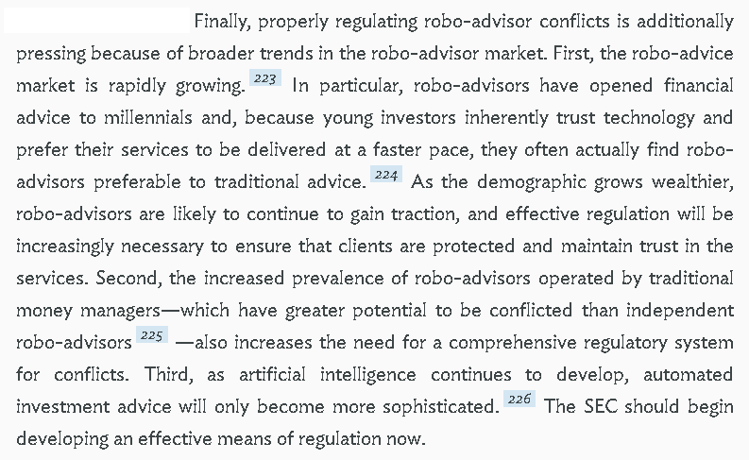

A/T “More study needed” – Now is the perfect time to adopt regulations, before robo advisers get more complex
Ihsan Ibrahim Daldaban 2019 (LLM candidate, Univ. of Manitoba law school, Canada) ARTIFICIALLY INTELLIGENT INVESTMENT ADVISERS AND THE FIDUCIARY DUTY PROBLEM: RISKS, CHALLENGES, AND REGULATORY SOLUTIONS https://mspace.lib.umanitoba.ca/bitstream/handle/1993/34609/Daldaban_Ihsan_Ibrahim.pdf;jsessionid=A0D921312CB0FA500333D8C9B3965738?sequence=4 (accessed 24 Aug 2021)
It is likely that robo-adviser technology will develop following the advancements in the AI and ML research; in other words, the robo-advisers of the future may be providing advisory services through more complex tools and algorithms; accordingly, the challenges and risks arising from the use and operation of robo-advisers may be more complicated and intricate. Therefore, before robo-advisers evolve into a far more complex investment tool, now is the perfect time for regulators to adopt and implement policies to ensure and monitor robo-advisers’ compliance with the fiduciary obligations and to address the challenges and risks that occur at the intervention of the algorithmic systems and AI as investment advisers in the capital markets.

DISADVANTAGE RESPONSES

A/T “Higher compliance/advisor costs if we regulate now”

Turn: Costs will be a lot worse if we wait until later to regulate, because over-reaction will occur
Dr. John Truby, Rafael Brown & Dr. Andrew Dahdal 2020. (Truby, PhD, Associate Professor of Law and Director of the Centre for Law & Development, College of Law, Qatar Univ. Brown - Brown, JD, Clinical Assistant Professor of Law, Centre for Law & Development, College of Law, Qatar Univ. PhD, Assistant Professor of Law, Centre for Law & Development, College of Law, Qatar Univ.) “Banking on AI: mandating a proactive approach to AI regulation in the financial sector” May 2020 LAW & FINANCIAL MARKETS REVIEW https://www.tandfonline.com/doi/full/10.1080/17521440.2020.1760454 (accessed 7 Sept 2021)
Despite an emerging international consensus on principles of AI governance, lawmakers have so far failed to translate those principles into regulations in the financial sector. Perhaps, in order to remain competitive in the global race for AI supremacy without being typecast as stifling innovation, typically cautious financial regulators are unusually allowing the introduction of experimental AI technology into the financial sector, with few controls on the unprecedented risks to consumers and financial stability. Once an unregulated AI software causes serious economic harm, a public and regulatory backlash would lead to over-regulation that could harm innovation of this potentially beneficial technology. Artificial intelligence is rapidly influencing the financial sector with innumerable potential benefits, such as enhancing financial services and improving regulatory compliance. This article argues that the best way to encourage a sustainable future in AI innovation in the financial sector is to support a proactive regulatory approach prior to any financial harm occurring.

