Negative: Solitary Confinement – not a problem
By “Coach Vance” Trefethen
Resolved: The United States Federal Government should significantly reform its policies regarding convicted prisoners under federal jurisdiction
Case Summary: The AFF plan reduces or eliminates the use of solitary confinement in federal prisons. This is a huge crisis because 1/5 of 1% of all federal inmates are held in solitary, and of those, 15% of them are held for more than 90 days! So, this case deals with a total of 0.03% of all federal prisoners. It’s a waste because our focus should be on the safety of the staff, not making prisoners more comfortable.
Negative: Solitary Confinement – not a problem 3
NEGATIVE PHILOSOPHY / GOAL 3
1. Staff safety should take priority over prisoner comfort 3
Federal prisons are dangerous for staff 3
Increased use of solitary confinement started in 1983 after killing of 2 guards at federal prison in Marion, Illinois. 3
Correctional Officer (CO) safety should be the paramount goal 4
INHERENCY 4
1. Reforms already done 4
Bureau of Prisons reformed their policy on solitary confinement in 2014. Large majority of prisoners are not in Solitary 4
2. Mental health safeguards in place 4
Special Housing Unit (SHU) risks to mental health are recognized, and they have extra psychology staff handling it 4
Mental health services have been upgraded for Special Housing Unit (SHU), Special Management Unit (SMU) and Supermax (ADX) 5
HARMS / SIGNIFICANCE 5
1. Solitary prisoner numbers are tiny 5
Solitary population is 1/5 of 1% and it’s justified to ensure safety of staff and other inmates 5
2. No constitutional requirement for comfortable prisons 5
In a lawsuit over prison conditions at Federal prison in Marion, Illinois, a federal judge points out that prisons aren’t required to be comfortable 5
3. Cost of solitary confinement – not a problem. It’s 0.6% of the BOP budget 6
Link: Special housing added at most $45 million in costs (over medium-security) or $37 million in costs (over max security) 6
Link: Total Bureau of Prisons budget is $7.1 billion 6
Do the math: The cost is miniscule 6
4. No link to solitary causing “increased recidivism” 6
A/T “Solitary prisoners re-offend after release more often” - No surprise: The solitary prisoners are the worst of the worst 6
5. Women / Pregnancy in solitary 7
Only 1.4% of women are in solitary and only if there’s a threat to themselves or others 7
6. Confinement is temporary in most cases 7
Only 15% of solitary prisoners are there for longer than 90 days 7
7. Mental illness 8
Seriously mentally ill prisoners are not put into Special Management Units (= SMU / restrictive housing) unless there are extraordinary security concerns, and they are carefully managed 8
8. Juveniles 8
Policy was changed in 2016 to end juveniles in federal solitary confinement 8
Never was a big problem: In 2014, they only had 1 juvenile in solitary, lots of safeguards, and removed as quickly as possible 8
Didn’t have long-term placement of juveniles in solitary before it was ended 9
SOLVENCY 9
1. No safe alternative to solitary 9
Prison officials and advocates who agree with Affirmative all agree: There’s not really any safe alternative 9
DISADVANTAGES 10
1. Violence & Death 10
Solitary confinement prisoners are there because they kill other prisoners 10
At Colorado Supermax (ADX), 47% of the solitary prisoners are there because they killed an inmate or prison staff 10
When bad guys find out they can’t be put into solitary for disciplinary reasons, they’ll increase their attacks on prison staff and other inmates 11
People will die if you ban solitary confinement 11
2. Rehabilitation is unjust 11
Link: Goal of abolishing solitary is rehabilitation 11
Link & Impact: Justice is lost. Goal of rehabilitation mean abandoning justice and the moral foundations of the universe 11
Link & Impact: Justice is lost whenever we adopt any goal that looks forward to “what will be the results of the punishment?” rather than backwards at the question of “what punishment does that crime justly deserve?” 12

Negative: Solitary Confinement – not a problem

NEGATIVE PHILOSOPHY / GOAL

1. Staff safety should take priority over prisoner comfort
Federal prisons are dangerous for staff
Charles E. Samuels 2014. (Director, Federal Bureau of Prisons) 25 Feb 2014 Statement before the Subcommittee on the Constitution, Civil Rights and Human Rights of the Senate Judiciary Committee https://www.congress.gov/event/113th-congress/senate-event/LC60861/text?s=1&r=46 (accessed 19 Sept 2021)
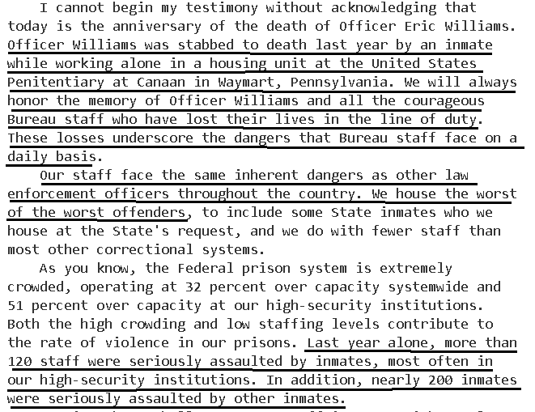

Increased use of solitary confinement started in 1983 after killing of 2 guards at federal prison in Marion, Illinois.
Natasha A. Frost, Ph.D. Carlos E. Monteiro, Ph.D. 2016. (with National Institute of Justice, part of US Dept of Justice) Restrictive Housing in the U.S.: Issues, Challenges, and Future Directions (no month given in the publication) https://www.ojp.gov/pdffiles1/nij/250316.pdf (accessed 19 Sept 2021)
Although the increase in prison violence troubled correctional administrators, correctional historians often point to the 1983 killing of two correctional officers at Marion as the trigger for the revival of total lockdown units and facilities (King, 1999; Pizarro & Stenius, 2004). In the immediate aftermath of those killings, Marion administrators rapidly reintroduced highly restrictive procedures, beginning with the immediate removal of inmates’ personal property from individual cells, followed by the placement of severe restrictions on inmates’ movements within the prison, the use of handcuffs whenever an inmate was not in the cell area, and increased use of solitary confinement (King, Steiner, & Breach, 2008). Although the conditions at Marion sparked immediate pushback from prisoner rights groups, the use of control units received judicial endorsement when, in Bruscino v. Carlson, a federal court opined that BOP had not violated inmates’ constitutional rights (Olivero & Roberts, 1987).

Correctional Officer (CO) safety should be the paramount goal
Frank V. Ferdik & Hayden P. Smith 2017 (Ferdik - Department of Criminology and Criminal Justice, University of West Florida, Pensacola. Smith - Department of Criminology and Criminal Justice, University of South Carolina, Columbia) Correctional Officer Safety and Wellness Literature Synthesis, July 2017 https://www.ojp.gov/pdffiles1/nij/250484.pdf (accessed 20 Sept 2021)
Officers are tasked with demanding and often conflicting work responsibilities that increase their risk for physical and mental health problems such as injuries, stress, and even death. Officers must interact with and supervise potentially dangerous individuals such as gang members, inmates with mental illness, and those with communicable diseases, which further complicates officers’ health issues. According to the research cited above, officers, regardless of security assignment, recognize the danger to which they are subject as a result of their profession. Many scholars conclude that employment as a CO is among the most dangerous and life threatening of all professions, including law enforcement. Given how COs are heavily relied upon to supervise inmate behavior, establish order in their facilities, and maintain wider institutional security, it is paramount that correctional practitioners, researchers, administrative officials, and other interested stakeholders begin developing more effective and widely used strategies for enhancing the general well-being of this critically important workforce.

INHERENCY

1. Reforms already done
Bureau of Prisons reformed their policy on solitary confinement in 2014. Large majority of prisoners are not in Solitary
Charles E. Samuels 2014. (Director, Federal Bureau of Prisons) 25 Feb 2014 Statement before the Subcommittee on the Constitution, Civil Rights and Human Rights of the Senate Judiciary Committee https://www.congress.gov/event/113th-congress/senate-event/LC60861/text?s=1&r=46 (accessed 19 Sept 2021)
Since the hearing held by this Subcommittee in June 2012, I have focused attention and resources on our use of restrictive housing. Over the past 18 months, we have accomplished a great deal in terms of reviewing, assessing, and refining our approach to restrictive housing. We understand the various negative consequences that can result from housing inmates in restrictive housing. Such placement can interfere with re-entry programming and limit interactions with friends and family. However, please note that the large majority of inmates remain in the general population for their entire prison term.

2. Mental health safeguards in place

Special Housing Unit (SHU) risks to mental health are recognized, and they have extra psychology staff handling it
Office of the Inspector General, US Dept. of Justice 2017. Review of the Federal Bureau of Prisons’ Use of Restrictive Housing for Inmates with Mental Illness, July 2017 https://oig.justice.gov/reports/2017/e1705.pdf (accessed 19 Sept 2021)
The BOP recognizes that extended periods of confinement in the SHU may have an adverse effect on the overall mental status of some individuals. Therefore, any inmate confined in the SHU for 30 consecutive days or longer will be psychologically evaluated. At least one member of the Psychology Services staff will visit the SHU on a weekly basis and document this visit in the SHU visitor’s log. An inmate housed in the SHU for 30 days or longer will receive a psychological assessment at 30-day intervals.

Mental health services have been upgraded for Special Housing Unit (SHU), Special Management Unit (SMU) and Supermax (ADX)
Office of the Inspector General, US Dept. of Justice 2017. Review of the Federal Bureau of Prisons’ Use of Restrictive Housing for Inmates with Mental Illness, July 2017 https://oig.justice.gov/reports/2017/e1705.pdf (accessed 19 Sept 2021)
In addition, the revised PSM establishes enhanced psychological services offered in restrictive housing settings. For example, restrictive housing Psychologists are assigned to provide direct clinical services such as screenings, evaluations, pre-treatment, and treatment services for inmates in restrictive housing settings, including the ADX, SMU, or at the six institutions participating in the SHU pilot program (discussed in the Results of the Review). A Psychologist also reviews the psychological status of any inmate confined in a SHU, SMU, the ADX, or any other similar housing for more than 30 consecutive calendar days using data from multiple sources, including contact with the inmate, input from unit Correctional Officers, and documentation contained in the Bureau’s Electronic Medical Record System and Psychology Data System (BEMR-PDS).

HARMS / SIGNIFICANCE

1. Solitary prisoner numbers are tiny
Solitary population is 1/5 of 1% and it’s justified to ensure safety of staff and other inmates
Charles E. Samuels 2014. (Director, Federal Bureau of Prisons) 25 Feb 2014 Statement before the Subcommittee on the Constitution, Civil Rights and Human Rights of the Senate Judiciary Committee https://www.congress.gov/event/113th-congress/senate-event/LC60861/text?s=1&r=46 (accessed 19 Sept 2021)
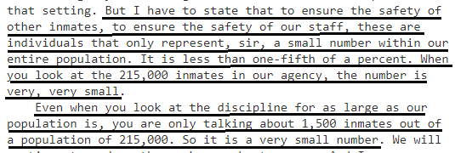

2. No constitutional requirement for comfortable prisons
In a lawsuit over prison conditions at Federal prison in Marion, Illinois, a federal judge points out that prisons aren’t required to be comfortable
Federal Judge James L. Foreman 1987. (federal judge for the Southern District of Illinois) ruling of the court in the case of Bruscino v. Carlson, 25 Feb 1987 https://law.justia.com/cases/federal/district-courts/FSupp/654/609/1689442/ (accessed 19 Sept 2021)
"The Constitution does not mandate that prisons be comfortable, and a prison such as Marion, which houses persons convicted of serious crimes and who have demonstrated a propensity to violence or escape, cannot be free of discomfort." Id. Accordingly, the Court finds that the amount of "out of cell time" granted to prisoners for exercise and recreation is constitutionally acceptable, and that the imposed restrictions do not violate the eighth amendment.

3. Cost of solitary confinement – not a problem. It’s 0.6% of the BOP budget
Link: Special housing added at most $45 million in costs (over medium-security) or $37 million in costs (over max security)
White House press release 2016. “FACT SHEET: Department of Justice Review of Solitary Confinement” 25 Jan 2016 https://obamawhitehouse.archives.gov/the-press-office/2016/01/25/fact-sheet-department-justice-review-solitary-confinement (accessed 19 Sept 2021)
The GAO report found that per-capita cost estimates for housing inmates in segregation were higher than in non-segregated or general population housing. Specifically, the GAO report found that, for fiscal year 2012, the total cost of housing 1,987 inmates in SMUs was $87 million (it would have cost approximately $42 million to house those same inmates in a medium-security facility; $50 million in a high-security facility).
Link: Total Bureau of Prisons budget is $7.1 billion
US Dept of Justice 2019. Federal Prison System (BOP) https://www.justice.gov/jmd/page/file/1142606/download (accessed 20 Sept 2021)
The FY 2020 budget request for BOP totals $7,161 million, which is a 1.6% decrease from the FY 2019 Continuing Resolution.
Do the math: The cost is miniscule
$45 million divided by $7.1 billion = 0.6%

4. No link to solitary causing “increased recidivism”

A/T “Solitary prisoners re-offend after release more often” - No surprise: The solitary prisoners are the worst of the worst
Anjali Tsui 2017 (journalist) 18 Apr 2017 “Does Solitary Confinement Make Inmates More Likely to Reoffend?” https://www.pbs.org/wgbh/frontline/article/does-solitary-confinement-make-inmates-more-likely-to-reoffend/ (accessed 20 Sept 2021)
Data from Connecticut in 2001 revealed that 66 percent of regular inmates were rearrested within three years, compared to a staggering 92 percent of inmates who were kept in solitary confinement for disciplinary problems or violent behavior. Members of the Connecticut general assembly who commissioned the report, wrote that the high rate of recidivism among inmates who spend time in solitary confinement is “not surprising” and that the primary aim of solitary confinement was “management of the inmate’s behavior while in prison and not rehabilitation.” These numbers, however, do not show a causal relationship between time spent in solitary confinement and the likelihood that an inmate will return to crime.

5. Women / Pregnancy in solitary

Only 1.4% of women are in solitary and only if there’s a threat to themselves or others
Sen. Dick Durbin and Charles E. Samuels 2014. (Durbin – senator from Illinois. Samuels - Director, Federal Bureau of Prisons) 25 Feb 2014 testimony before the Subcommittee on the Constitution, Civil Rights and Human Rights of the Senate Judiciary Committee https://www.congress.gov/event/113th-congress/senate-event/LC60861/text?s=1&r=46 (accessed 19 Sept 2021) (brackets added)
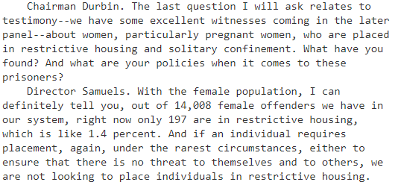

6. Confinement is temporary in most cases

Only 15% of solitary prisoners are there for longer than 90 days
Charles E. Samuels 2014. (Director, Federal Bureau of Prisons) 25 Feb 2014 Statement before the Subcommittee on the Constitution, Civil Rights and Human Rights of the Senate Judiciary Committee https://www.congress.gov/event/113th-congress/senate-event/LC60861/text?s=1&r=46 (accessed 19 Sept 2021)
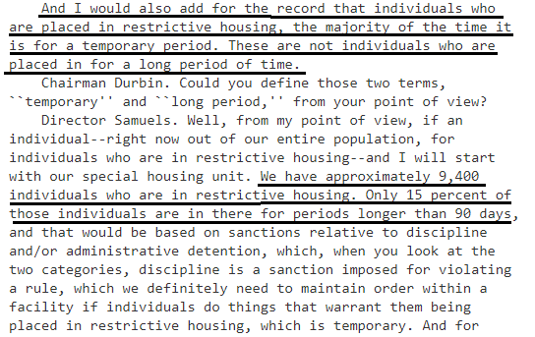

7. Mental illness

Seriously mentally ill prisoners are not put into Special Management Units (= SMU / restrictive housing) unless there are extraordinary security concerns, and they are carefully managed
Office of the Inspector General, US Dept. of Justice 2017. Review of the Federal Bureau of Prisons’ Use of Restrictive Housing for Inmates with Mental Illness, July 2017 https://oig.justice.gov/reports/2017/e1705.pdf (accessed 19 Sept 2021)
The BOP’s mental health policy excludes the placement of inmates with serious mental illness in the SMU unless there are extraordinary security concerns that prevent their placement elsewhere. According to the BOP’s SMU policy, the BOP designates an inmate to a SMU when greater management of the inmate’s interaction is necessary to ensure the safety, security, or orderly operation of BOP institutions, or for the protection of the public. Conditions of confinement are more restrictive for SMU inmates than for general population inmates, though the conditions become less restrictive as the inmate progresses through the phases of the SMU program. Each inmate is evaluated by mental health staff every 30 days, and emergency mental health care must always be available at the institution or from the community.

8. Juveniles
Policy was changed in 2016 to end juveniles in federal solitary confinement
White House press release 2016. “FACT SHEET: Department of Justice Review of Solitary Confinement” 25 Jan 2016 https://obamawhitehouse.archives.gov/the-press-office/2016/01/25/fact-sheet-department-justice-review-solitary-confinement (accessed 19 Sept 2021)
Ending restrictive housing for juveniles. BOP is ending the practice of placing juveniles in restrictive housing—in line with the standards outlined in the Sentencing Reform and Corrections Act, now pending in the U.S. Senate.
Never was a big problem: In 2014, they only had 1 juvenile in solitary, lots of safeguards, and removed as quickly as possible
Sen. Dick Durbin and Charles E. Samuels 2014. (Durbin – senator from Illinois. Samuels - Director, Federal Bureau of Prisons) 25 Feb 2014 testimony before the Subcommittee on the Constitution, Civil Rights and Human Rights of the Senate Judiciary Committee https://www.congress.gov/event/113th-congress/senate-event/LC60861/text?s=1&r=46 (accessed 19 Sept 2021) (brackets added)
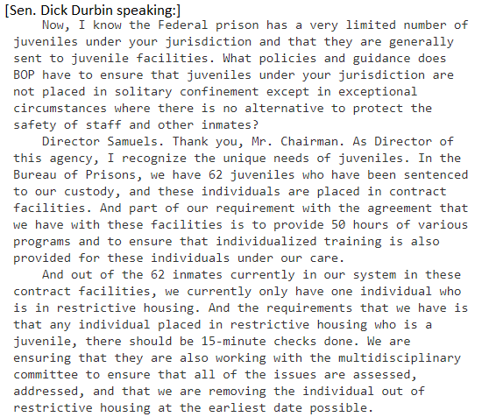

Didn’t have long-term placement of juveniles in solitary before it was ended
Charles E. Samuels 2014. (Director, Federal Bureau of Prisons) 25 Feb 2014 Statement before the Subcommittee on the Constitution, Civil Rights and Human Rights of the Senate Judiciary Committee https://www.congress.gov/event/113th-congress/senate-event/LC60861/text?s=1&r=46 (accessed 19 Sept 2021)
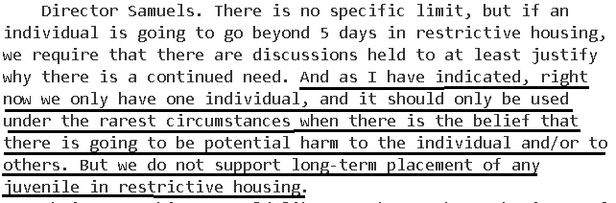

SOLVENCY

1. No safe alternative to solitary
Prison officials and advocates who agree with Affirmative all agree: There’s not really any safe alternative
Natasha A. Frost, Ph.D. Carlos E. Monteiro, Ph.D. 2016. (with National Institute of Justice, part of US Dept of Justice) Restrictive Housing in the U.S.: Issues, Challenges, and Future Directions (no month given in the publication) https://www.ojp.gov/pdffiles1/nij/250316.pdf (accessed 19 Sept 2021) (ellipses in original)
If dangerous and violent inmates represent a real threat to others within the correctional environment, the options for containing them without resorting to isolation in restrictive housing seem to be few. Correctional administrators often feel that they are left with no other option than to isolate inmates who represent a threat to themselves, other inmates, or to staff. Moreover, the most ardent critics of solitary confinement often have little to say about alternatives to the practice if and when solitary confinement were to be eliminated on evidence-based grounds or outlawed on constitutional grounds. Those charged with running prisons — even those who have argued that there are problems with the practice of confining inmates in highly restrictive environments for extended periods — lament the lack of options at their disposal for those inmates who are truly dangerous to both the prison staff and other inmates. Rick Raemisch, executive director of the Colorado Department of Corrections, spent 20 hours in solitary confinement to understand the experience and has worked to significantly reduce its use in the Colorado system but still acknowledges the need for the practice in some instances (Goode, 2014; Raemisch, 2014). Raemisch recently argued, “If someone has committed a violent assault … until you can solve that problem, that person is going to need to be isolated.” He went on to note, “There are those who say this is bad, but when you look around for an alternative, people have left the room” (Baker & Goode, 2015, p. A16).

DISADVANTAGES

1. Violence & Death

Solitary confinement prisoners are there because they kill other prisoners
Sen. Dick Durbin 2014 (D-Illinois) 25 Feb 2014 Statement before the Subcommittee on the Constitution, Civil Rights and Human Rights of the Senate Judiciary Committee https://www.congress.gov/event/113th-congress/senate-event/LC60861/text?s=1&r=46 (accessed 19 Sept 2021)
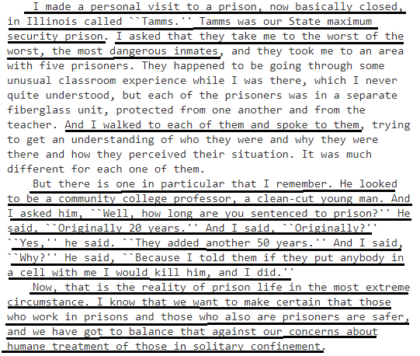

At Colorado Supermax (ADX), 47% of the solitary prisoners are there because they killed an inmate or prison staff
Charles E. Samuels 2014. (Director, Federal Bureau of Prisons) 25 Feb 2014 Statement before the Subcommittee on the Constitution, Civil Rights and Human Rights of the Senate Judiciary Committee https://www.congress.gov/event/113th-congress/senate-event/LC60861/text?s=1&r=46 (accessed 19 Sept 2021)
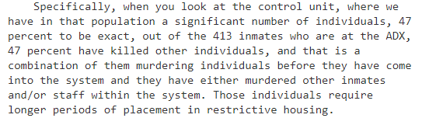

When bad guys find out they can’t be put into solitary for disciplinary reasons, they’ll increase their attacks on prison staff and other inmates
Charles E. Samuels 2014. (Director, Federal Bureau of Prisons) 25 Feb 2014 Statement before the Subcommittee on the Constitution, Civil Rights and Human Rights of the Senate Judiciary Committee https://www.congress.gov/event/113th-congress/senate-event/LC60861/text?s=1&r=46 (accessed 19 Sept 2021)
We are only interested in placing individuals in restrictive housing when there is a legitimate reason and justification. With our system being so large, we have over 20,000 gang members in our system. They are watching this hearing. They are watching our testimony very, very closely, for the reason being if they see that we will lower our standards, we will not hold individuals accountable, it puts our staff at risk, it puts other inmates at risk, and this is why I mentioned in my oral statement that not only are we looking at staff being injured and harmed, our staff are putting their lives on the line every single second of the day to protect the American public.

People will die if you ban solitary confinement
Charles E. Samuels 2014. (Director, Federal Bureau of Prisons) 25 Feb 2014 Statement before the Subcommittee on the Constitution, Civil Rights and Human Rights of the Senate Judiciary Committee https://www.congress.gov/event/113th-congress/senate-event/LC60861/text?s=1&r=46 (accessed 19 Sept 2021)
I have been in the Bureau of Prisons now going on 26 years. I have talked to inmates. I have had inmates tell me, ``If you release me to the general population or if you take me out, I will kill someone.'' I have a duty and an obligation to protect the staff, to protect the inmates. And when someone is willing to tell you, ``If you do it, this is what I am going to do,'' I mean, there are huge issues with that.

2. Rehabilitation is unjust

Link: Goal of abolishing solitary is rehabilitation
Affirmative claims this as one of their goals

Link & Impact: Justice is lost. Goal of rehabilitation mean abandoning justice and the moral foundations of the universe
Dr. Stuart B. Babbage 1973 (PhD theology) “C.S. LEWIS AND THE HUMANITARIAN THEORY OF PUNISHMENT” (Spring 1973) https://biblicalstudies.org.uk/pdf/churchman/087-01_036.pdf (accessed 29 June 2021)
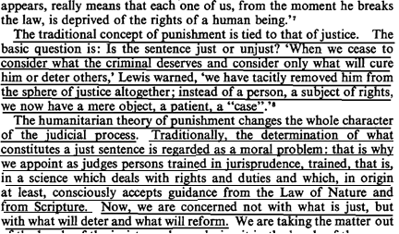

Link & Impact: Justice is lost whenever we adopt any goal that looks forward to “what will be the results of the punishment?” rather than backwards at the question of “what punishment does that crime justly deserve?”
To uphold Justice, the Affirmative has to be able to tell you that these prisoners, based on the crimes they committed, deserve to be guaranteed never to be placed in solitary confinement. If their justification is anything other than that, then they are acting contrary to Justice and deserve to lose the round.
Prof. Peter Karl Koritansky 2012 (associate professor of history, philosophy, and religious studies at the University of Prince Edward Island, Canada) Thomas Aquinas and the Philosophy of Punishment https://books.google.com/books?hl=en&lr=&id=CFZ6DKEw4wUC&oi=fnd&pg=PR7&ots=6Wg7jWFoUM&sig=TAefdc8Zs_mKI5C8DZqn0BCIPPo#v=onepage&q&f=false (accessed 10 Aug 2021) (Note: Prof. Koritansky is referring to criticism in general of backward looking utilitarianism, but in the article he expresses agreement with this criticism, so this quote is being used consistently with author’s intent.)
