Negative Generic: Rehabilitation Fails
By “Coach Vance” Trefethen
Resolved: The United States federal government substantially reform the use of Artificial Intelligence technology
This is a generic Negative brief to be used when you don’t have any Negative evidence specific to the case AFF is running. If AFF case is based on anything involving rehabilitation of prisoners, this brief likely will apply. Rehabilitation and reform programs in prison have all been tried and they’ve all failed. We need to stop advocating for more until we do a study that finds out why everything so far has failed.
Negative: Rehabilitation Fails 2
NEGATIVE PHILOSOPHY / GOAL RESPONSE 2
Rehabilitation Goal is bad: It’s so 1960’s and was discredited long ago 2
SOLVENCY 3
1. More study needed 3
California study: Untested rehab programs failed. Let’s stop trying things without studying them first 3
We need more study and we need to implement programs only after study shows they are effective 3
We shouldn’t do any more rehab programs until we do a study to find out why nothing we’ve done so far works 4
2. Prisons cannot rehabilitate 4
Expecting prisons to rehabilitate is like expecting flowers to grow in the desert: Might happen rarely, but don’t plan on it 4
3. Specific programs fail 5
California Study: Drug abuse, anger management, job skills, literacy rehab programs massively funded didn’t work 5
Second Chance Act (2008) failed. 2 studies found SCA rehab/re-entry programs did not reduce recidivism 5
Post-release employment failed to reduce recidivism (Second Chance Act study) 6
Education programs 87% failure rate. 6
Education and employment programs have never worked for state nor federal prisoners 6
4. All programs fail 7
Every program that’s ever been tried has failed to reduce recidivism 7
Lots of good intentions… but there are zero prison rehab programs that actually make society safer 7
A/T “Lack of funding is why they don’t work” – Turn: They’re not funded because they don’t work 7
Won’t solve anything until we solve mental health and drug abuse, and even then they will mostly fail 7
DISADVANTAGES 8
1. Tyranny 8
Rehabilitation goal = tyranny because judges become all-powerful to decide whether someone is rehabilitated 8
2. Moves us away from what actually works: Imprisonment 8
Link: Locking offenders up is the only thing guaranteed to stop them from committing more crimes 8
Impact: More crime 8
3. Justice abandoned 9
All considerations of rehabilitation and deterrence mean abandoning justice and the moral foundations of the universe 9
Justice is lost whenever we adopt any goal that looks forward to “what will be the results of the punishment?” rather than backwards at the question of “what punishment does that crime justly deserve?” 9

Negative: Rehabilitation Fails

NEGATIVE PHILOSOPHY / GOAL RESPONSE

Rehabilitation Goal is bad: It’s so 1960’s and was discredited long ago
[This evidence is old, but that’s a good thing. It proves how far out of touch AFF is with their emphasis on “rehabilitation,” when that goal was already being discredited and abandoned in the 1970s]
Joseph Weiler 1978. (faculty of the Allard School of Law at the University of British Columbia) Why Do We Punish?: The Case for Retributive Justice, UNIV. OF BRITISH COLUMBIA LAW REVIEW https://commons.allard.ubc.ca/cgi/viewcontent.cgi?article=1348&context=fac_pubs (accessed 10 Aug 2021)

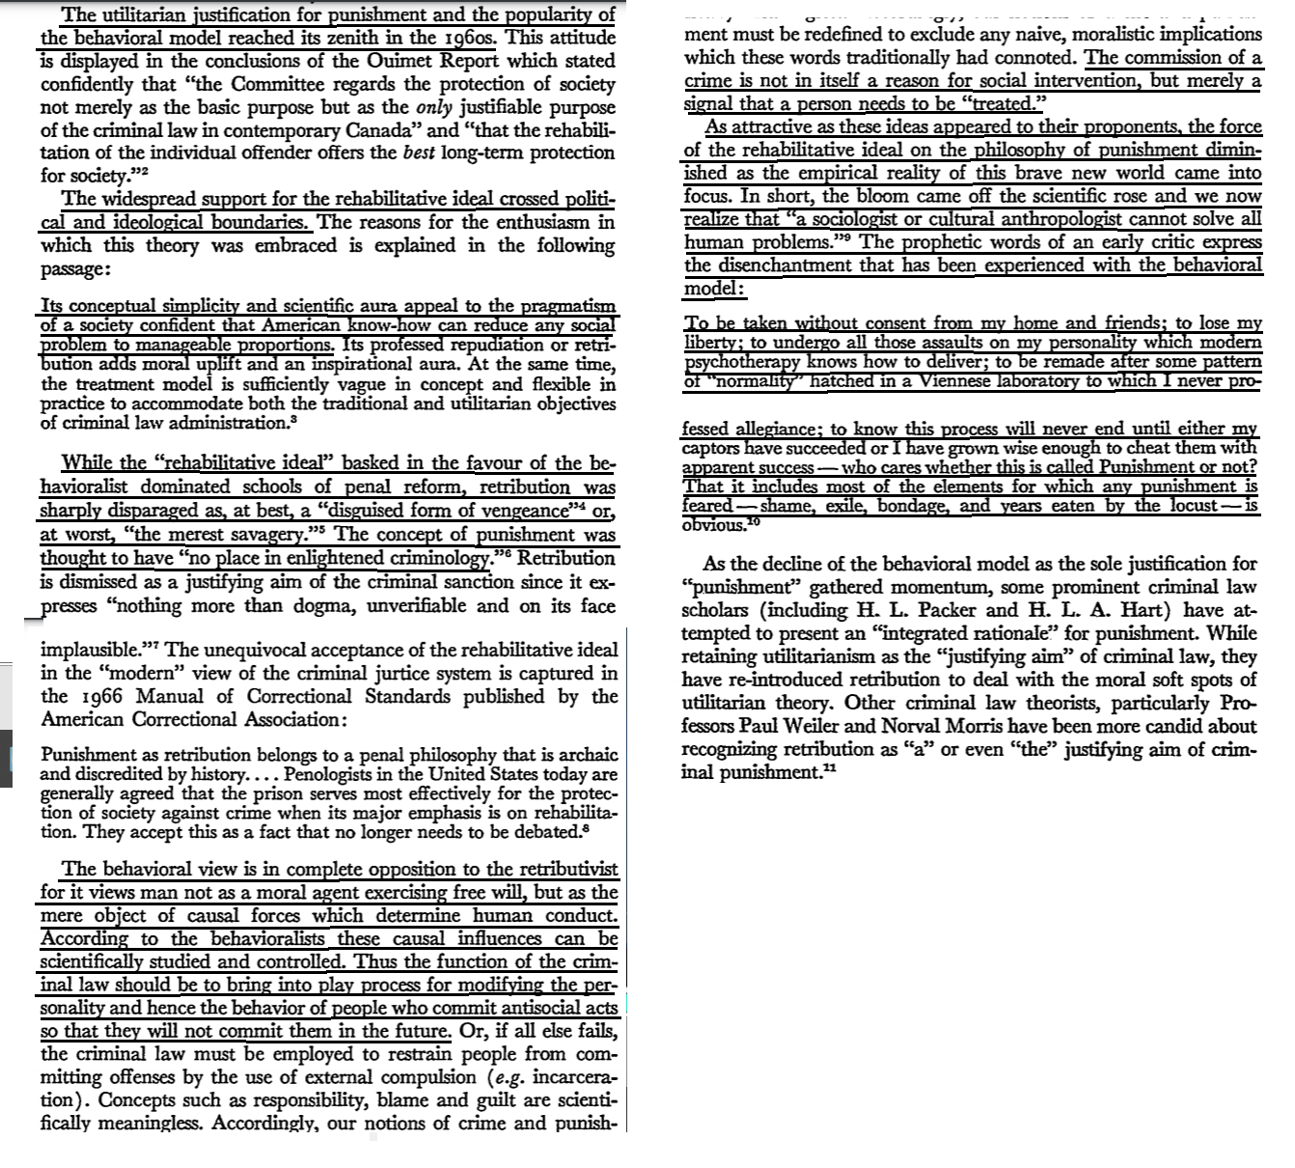

SOLVENCY

1. More study needed

California study: Untested rehab programs failed. Let’s stop trying things without studying them first
Dan Walters 2019. (journalist) “So far, prison inmate rehab isn’t working” 4 Feb 2019 https://calmatters.org/commentary/2019/02/so-far-prison-inmate-rehab-isnt-working/ (accessed 8 Sept 2019)
Fifteen years ago, the Department of Corrections became the Department of Corrections and Rehabilitation, supposedly signaling a new emphasis on reducing its revolving door culture. Nothing much happened, however, until Brown returned to the governorship in 2011. He, along with a more liberal Legislature and penal reform groups pushed to reduce sentences, make parole easier, divert more felons into local jails and probation, and ramp up rehabilitation programs inside prisons – thereby, it was said, reducing prison overcrowding and “recidivism” by those returning to the streets. The prison population has declined sharply, down at least 50,000 inmates from its peak, but a new report from State Auditor Elaine Howle indicates that the department isn’t living up to its “corrections and rehabilitation” title. “Our analysis of inmates released from prison in fiscal year 2015–16 did not find an overall relationship between inmates completing CBT (cognitive behavioral therapy) rehabilitation programs and their recidivism rates,” Howle told the Legislature, which ordered her study. “In fact, inmates who completed their recommended CBT rehabilitation programs recidivated at about the same rate as inmates who were not assigned to those rehabilitation programs.” Why? She suggests that the corrections department adopted rehab programs without fully delving into what works and what doesn’t, saying that the department “has not revalidated the accuracy of the tools it uses to assess inmates’ rehabilitative needs since recent statutory changes caused a major shift in the state’s prison population. Another potential reason is that Corrections has not ensured that vendors provide consistent and effective CBT programs that have been proven through research to reduce recidivism.”

We need more study and we need to implement programs only after study shows they are effective
National Institute of Justice 2018 (part of the federal Dept. of Justice) Lessons Learned from the Second Chance Act: Moving Forward to Strengthen Offender Reentry 3 June 2018 https://nij.ojp.gov/topics/articles/lessons-learned-second-chance-act-moving-forward-strengthen-offender-reentry (accessed 8 Sept 2021)
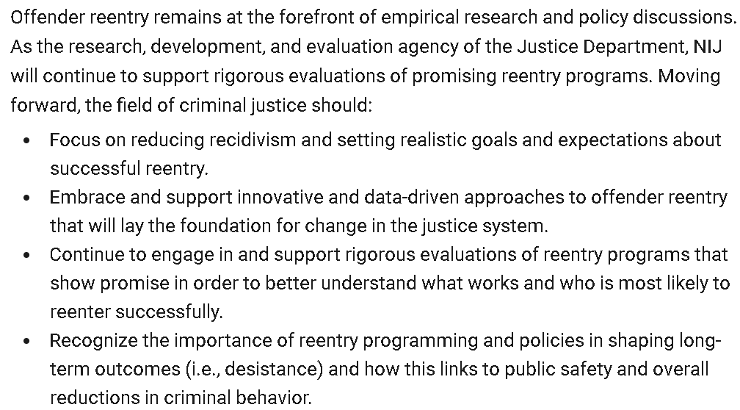

We shouldn’t do any more rehab programs until we do a study to find out why nothing we’ve done so far works
Leonard Adam Sipes, Jr. 2019 (Retired federal senior spokesperson. Thirty-five years of award-winning public relations for national and state criminal justice agencies. Former Senior Specialist for Crime Prevention for the Department of Justice’s clearinghouse. Former Director of Information Services, National Crime Prevention Council. Former Adjunct Associate Professor of criminology and public affairs-Univ. of Maryland) 3 June 2019 Nothing Works For Offender Rehabilitation? https://www.crimeinamerica.net/nothing-works-for-offender-rehabilitation/ (accessed 9 Sept 2021)
There needs to be an immediate call for a national conference on programs for offenders to examine why the results are so disappointing. We need to do better. Cancer results were small in the past but we kept trying, and data now indicate some improvement (i.e., the remarkable improvement in deaths from breast cancer). But until we figure out why programs for offenders have questionable value, we need to be skeptical of those claiming success. If we support offender rehabilitation, we need to question results. We need to demand better answers. If we don’t, incarceration will be our only answer.

2. Prisons cannot rehabilitate

Expecting prisons to rehabilitate is like expecting flowers to grow in the desert: Might happen rarely, but don’t plan on it
Dr J.M. Moore 2016 (Senior Lecturer in Criminology, Newman University, Birmingham, England) 10 Nov 2016 “Dr JM Moore is Senior Lecturer in Criminology, Newman University, Birmingham https://www.crimeandjustice.org.uk/resources/prisons-cannot-be-places-rehabilitation (accessed 8 Sept 2021)
Prison is a punishment, it is ultimately about the deliberate infliction of pain. The epidemic of self-harm and record levels of self-inflicted deaths being experienced in our prisons is clear evidence that imprisonment is experienced as pain. For the prison to maintain legitimacy requires that its infliction of pain is seen as necessary and beneficial. Whilst the ideologies of retribution and deterrence routinely contribute to this, they are inadequate at times of crisis. The ideology of rehabilitation tends to be deployed to provide a justification that the pain is being inflicted for the benefit of its recipients. Alongside many other examples of prison’s failure, the RSA highlights high reoffending rates. This, it argues, represents prison's failure to rehabilitate. To remedy this failure, it proposes that government ‘create a rehabilitation requirement’ and impose it on prisons. If only it were that simple! From Fenner Brockway’s observation, in the 1920s, that ‘if reform is to become the principal object, the prison system must be scrapped altogether’, to Frances Crook's acknowledgement, in 2016, that ‘the idea that we can create a structure that rehabilitates people is flawed’, reformers have acknowledged that prison cannot rehabilitate. The report offers no new theory of rehabilitation, or indeed practical proposals for achieving it. Ultimately, all it can offer is a belief in the prison system's ‘potential impact on reducing reoffending’, together with some isolated examples of current initiatives which suggest rehabilitative benefits. These examples are generally on a small scale and generously resourced. Flowers do grow in the desert, particularly if well-watered, but that is no reason to believe deserts are appropriate places for the cultivation of flowers.

3. Specific programs fail

California Study: Drug abuse, anger management, job skills, literacy rehab programs massively funded didn’t work
Michele Hanisee 2019 (President of the Association of Los Angeles Deputy District Attorneys, the collective bargaining agent representing nearly 1,000 Deputy District Attorneys who work for the County of Los Angeles) “CDCR Rehabilitation Programs Documented to be Total Failure” https://www.laadda.com/cdcr-rehabilitation-programs-documented-to-be-total-failure/ (accessed 8 Sept 2021) (article is undated but references a study published in January 2019 as a “scathing new audit.”)
In its review, the California State Auditor examined a range of programs that the CDCR implemented over the past several years. The state poured tens of millions of dollars into this effort. The budget for these initiatives at California’s 36 prisons ballooned 27 percent over the past five years, to $298 million from $234 million. Ostensibly, the idea was to provide inmates with rehabilitation programs targeted toward an individual’s specific needs: drug abuse, anger management, job skills, literacy etc. But the audit, released last week, determined the effort is a disaster. Inmates who completed cognitive behavioral therapy programs had about the same rate of recidivism as inmates who didn’t complete the programs. That’s right – the recidivism rates for those who are “rehabilitated” is nearly the same as for those who were not. The overall recidivism rate for inmates released from prison remains at a staggering 50% despite the increased funding of and emphasis on rehabilitation. But then, it’s not rehabilitation if it doesn’t work.

Second Chance Act (2008) failed. 2 studies found SCA rehab/re-entry programs did not reduce recidivism
National Institute of Justice 2018 (part of the federal Dept. of Justice) Lessons Learned from the Second Chance Act: Moving Forward to Strengthen Offender Reentry 3 June 2018 https://nij.ojp.gov/topics/articles/lessons-learned-second-chance-act-moving-forward-strengthen-offender-reentry (accessed 8 Sept 2021)
Signed into law in April 2008, the Second Chance Act (SCA) aims to enhance public safety by breaking the cycle of criminal recidivism and improving outcomes for people returning from prisons, jails, and juvenile facilities. The SCA authorizes the awarding of federal grants to government agencies and nonprofit organizations to provide reentry services and programs, including employment and housing assistance, victim support, and substance abuse treatment. Additionally, SCA funds may be used to support general criminal justice system improvements.
What is NIJ’s role?
Under the SCA, the Bureau of Justice Assistance (BJA) started funding offender reentry demonstration projects, and the National Institute of Justice (NIJ) was directed to evaluate the effectiveness of BJA’s projects. Since the passage of this important legislation and in collaboration with BJA, NIJ has supported two rigorous, independent evaluations of SCA adult offender reentry demonstration projects.
What did we learn?
The two NIJ-supported evaluations, led by Social Policy Research Associates and RTI International, produced similar results. In general, and with a few exceptions, participation in an SCA program did not affect a range of reentry outcomes, for example, substance use and compliance with supervision. Participation in an SCA program did, however, increase access to and receipt of reentry services and programs for participants and improve partnerships with community agencies. Importantly, participation in SCA programming did not significantly reduce the likelihood of recidivism.

Post-release employment failed to reduce recidivism (Second Chance Act study)
Leonard Adam Sipes, Jr. 2019 (Retired federal senior spokesperson. Thirty-five years of award-winning public relations for national and state criminal justice agencies. Former Senior Specialist for Crime Prevention for the Department of Justice’s clearinghouse. Former Director of Information Services, National Crime Prevention Council. Former Adjunct Associate Professor of criminology and public affairs-Univ. of Maryland) 3 June 2019 Nothing Works For Offender Rehabilitation? https://www.crimeinamerica.net/nothing-works-for-offender-rehabilitation/ (accessed 9 Sept 2021)
Do significant gains in employment mean less recidivism? The Second Chance Act evaluation states that, “Being in the program group increased earnings. In each of those same quarters, those in the program group earned, on average, $780 to $1,000 more than those in the control group. This represents a boost in earnings of between 64 percent and 83 percent. The differences are statistically significant in both quarters.” Yet there was no impact on recidivism.

Education programs 87% failure rate.
Leonard Adam Sipes, Jr. 2019 (Retired federal senior spokesperson. Thirty-five years of award-winning public relations for national and state criminal justice agencies. Former Senior Specialist for Crime Prevention for the Department of Justice’s clearinghouse. Former Director of Information Services, National Crime Prevention Council. Former Adjunct Associate Professor of criminology and public affairs-Univ. of Maryland) 3 June 2019 Nothing Works For Offender Rehabilitation? https://www.crimeinamerica.net/nothing-works-for-offender-rehabilitation/ (accessed 9 Sept 2021)
Advocates are disingenuous in the extreme when they insist that education programs reduce recidivism by 43 percent; it’s simply not true. “Inmates who participate in correctional education programs had a 43 percent lower odds of recidivating (emphasis added) than those who did not. This translates to a reduction in the risk of recidivating of 13 percentage points as to reincarceration,” Rand. Thus Rand’s documentation of a thirteen percent reduction in recidivism is in line with the assertion that treatment programs either show no impact, or a very small effect. Per Rand, the vast majority of “educated” offenders will recidivate. “When applying these estimated odds to the most recently reported national rates of reincarceration (43.3 percent within three years of release), correctional education would reduce reincarceration rates by 12.9 percentage points on average, although effectiveness does appear to differ by program,” Rand. In any other field, an 87 percent failure rate would be considered a national disgrace.

Education and employment programs have never worked for state nor federal prisoners
Leonard Adam Sipes, Jr. 2019 (Retired federal senior spokesperson. Thirty-five years of award-winning public relations for national and state criminal justice agencies. Former Senior Specialist for Crime Prevention for the Department of Justice’s clearinghouse. Former Director of Information Services, National Crime Prevention Council. Former Adjunct Associate Professor of criminology and public affairs-Univ. of Maryland) 3 June 2019 Nothing Works For Offender Rehabilitation? https://www.crimeinamerica.net/nothing-works-for-offender-rehabilitation/ (accessed 9 Sept 2021)
Our approach to assisting offenders hasn’t made a difference. It’s gotten to the point where offender rehabilitation programs either do not work, or they do not work very well with less than a ten percent difference in recidivism, Crime in America. Offenders, especially those receiving prison terms, have horrific histories of child abuse and neglect, sexual abuse (especially for female offenders), brain injuries, massive exposure to violence in the home and community and significant histories of PTSD. Mental illness medicated through substance abuse is a daily occurrence for most people caught up in the criminal justice system, Crime in America. Some consider offenders the equivalent of the walking wounded. Recidivism is massive. Five out of six released prisoners are rearrested with an average of five arrests, Crime in America. New data from the US Sentencing Commission suggest an average of six convictions for those in federal prisons, Crime in America. Data for state prisoners indicate that most have conviction histories and multiple convictions are common. Offenders, especially those released from prison, carry massive problems that are not going to be amended by employment or educational programs.

4. All programs fail

Every program that’s ever been tried has failed to reduce recidivism
Leonard Adam Sipes, Jr. 2019 (Retired federal senior spokesperson. Thirty-five years of award-winning public relations for national and state criminal justice agencies. Former Senior Specialist for Crime Prevention for the Department of Justice’s clearinghouse. Former Director of Information Services, National Crime Prevention Council. Former Adjunct Associate Professor of criminology and public affairs-Univ. of Maryland) 3 June 2019 Nothing Works For Offender Rehabilitation? https://www.crimeinamerica.net/nothing-works-for-offender-rehabilitation/ (accessed 9 Sept 2021)
But the issue isn’t the Second Chance Act, it’s EVERY program evaluated by the US Department of Justice and most from other sources. They either don’t reduce recidivism, make things worse or have a marginal impact of less than ten percent. What this means is that when there are reductions in recidivism, over ninety percent of people fail. They are rearrested or reincarcerated. Some multiple times. If over ninety percent of people taking an experimental drug showed no results, the CDC would stop the experiment immediately; continuance would be harmful to society.

Lots of good intentions… but there are zero prison rehab programs that actually make society safer
Leonard Adam Sipes, Jr. 2019 (Retired federal senior spokesperson. Thirty-five years of award-winning public relations for national and state criminal justice agencies. Former Senior Specialist for Crime Prevention for the Department of Justice’s clearinghouse. Former Director of Information Services, National Crime Prevention Council. Former Adjunct Associate Professor of criminology and public affairs-Univ. of Maryland) 3 June 2019 Nothing Works For Offender Rehabilitation? https://www.crimeinamerica.net/nothing-works-for-offender-rehabilitation/ (accessed 9 Sept 2021)
There are dozens of national criminological or advocacy associations pleading for treatment programs, and I understand why. They are humanistic or religious efforts to assist people. They make prisons safer, saner places. But we have no business suggesting that programs make society safer. Blind advocacy of programs doesn’t help anyone, Advocacy. If not programs, what options do we have? The answer beyond sentencing reform is none.

A/T “Lack of funding is why they don’t work” – Turn: They’re not funded because they don’t work
Leonard Adam Sipes, Jr. 2019 (Retired federal senior spokesperson. Thirty-five years of award-winning public relations for national and state criminal justice agencies. Former Senior Specialist for Crime Prevention for the Department of Justice’s clearinghouse. Former Director of Information Services, National Crime Prevention Council. Former Adjunct Associate Professor of criminology and public affairs-Univ. of Maryland) 3 June 2019 Nothing Works For Offender Rehabilitation? https://www.crimeinamerica.net/nothing-works-for-offender-rehabilitation/ (accessed 9 Sept 2021)
By the way, why does the data show that programs for offenders are so underfunded? It’s because most who fund them do not believe they work. It’s just that simple.

Won’t solve anything until we solve mental health and drug abuse, and even then they will mostly fail
Leonard Adam Sipes, Jr. 2019 (Retired federal senior spokesperson. Thirty-five years of award-winning public relations for national and state criminal justice agencies. Former Senior Specialist for Crime Prevention for the Department of Justice’s clearinghouse. Former Director of Information Services, National Crime Prevention Council. Former Adjunct Associate Professor of criminology and public affairs-Univ. of Maryland) 3 June 2019 Nothing Works For Offender Rehabilitation? https://www.crimeinamerica.net/nothing-works-for-offender-rehabilitation/ (accessed 9 Sept 2021)
Offenders, especially those released from prison, carry massive problems that are not going to be amended by employment or educational programs. The President’s The Council of Economic Advisers is probably right, the best hope we have is to address mental health and substance abuse issues and even there, they suggest that the vast majority of offenders are still going to fail.
DISADVANTAGES

1. Tyranny

Rehabilitation goal = tyranny because judges become all-powerful to decide whether someone is rehabilitated
John Piper 2012 (chancellor of Bethlehem College & Seminary) “Life Is Cheap in Norway: C. S. Lewis on the Sentence of Anders Breivik” 27 Aug 2012 https://www.desiringgod.org/articles/life-is-cheap-in-norway-c-s-lewis-on-the-sentence-of-anders-breivik (accessed 9 Aug 2021) (ellipses in original)
The issue is not what he deserves. The issue is not justice. The issue is power in the hands of judges who will decide if he has been “rehabilitated” sufficiently, and if his detainment has served the community to a suitable degree. This is the seedbed of tyranny. To be sure, there is a place for rehabilitation and deterrence. But only under the humanizing sway of justice. Lewis explains the relation:
I am ready to make both protection of society and the “cure” of the criminal as important as you please in punishment, but only on a certain condition; namely, that the initial act of thus interfering with a man’s liberty be justified on grounds of desert. . . . It is this and (I believe) this alone, which legitimizes our proceeding and makes it an instance of punishment at all, instead of an instance of tyranny — or, perhaps, of war. (“On Punishment: A Reply by C. S. Lewis,” Essay Collection: And Other Short Pieces, 707)

2. Moves us away from what actually works: Imprisonment

Link: Locking offenders up is the only thing guaranteed to stop them from committing more crimes
Leonard Adam Sipes, Jr. 2019 (Retired federal senior spokesperson. Thirty-five years of award-winning public relations for national and state criminal justice agencies. Former Senior Specialist for Crime Prevention for the Department of Justice’s clearinghouse. Former Director of Information Services, National Crime Prevention Council. Former Adjunct Associate Professor of criminology and public affairs-Univ. of Maryland) 3 June 2019 Nothing Works For Offender Rehabilitation? https://www.crimeinamerica.net/nothing-works-for-offender-rehabilitation/ (accessed 9 Sept 2021)
If not programs, what options do we have? The answer beyond sentencing reform is none. Decades of discussion have produced modest reductions in the prison population and most of the decrease is probably due to historical lows in crime over the last twenty years, Incarceration. It’s either incarceration or programs or sentencing reform and all have less than stellar results. At least with incarceration, we know that while there, he’s not going to inflict additional harm on society.

Impact: More crime
Moving toward a policy that doesn’t work (rehabilitation) and away from what does (imprisonment) means we get less effective efforts against crime. The only possible result is more crime.

3. Justice abandoned

All considerations of rehabilitation and deterrence mean abandoning justice and the moral foundations of the universe
Dr. Stuart B. Babbage 1973 (PhD theology) “C.S. LEWIS AND THE HUMANITARIAN THEORY OF PUNISHMENT” (Spring 1973) https://biblicalstudies.org.uk/pdf/churchman/087-01_036.pdf (accessed 29 June 2021)
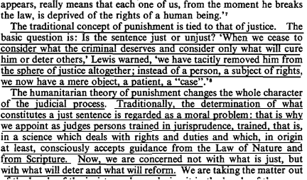

Justice is lost whenever we adopt any goal that looks forward to “what will be the results of the punishment?” rather than backwards at the question of “what punishment does that crime justly deserve?”
Prof. Peter Karl Koritansky 2012 (associate professor of history, philosophy, and religious studies at the University of Prince Edward Island, Canada) Thomas Aquinas and the Philosophy of Punishment https://books.google.com/books?hl=en&lr=&id=CFZ6DKEw4wUC&oi=fnd&pg=PR7&ots=6Wg7jWFoUM&sig=TAefdc8Zs_mKI5C8DZqn0BCIPPo#v=onepage&q&f=false (accessed 10 Aug 2021) (Note: Prof. Koritansky is referring to criticism in general of backward looking utilitarianism, but in the article he expresses agreement with this criticism, so this quote is being used consistently with author’s intent.)
