Negative Generic: Justice is all that matters
By “Coach Vance” Trefethen
Resolved: The United States federal government substantially reform the use of Artificial Intelligence technology
This is a generic Negative brief to be used when you don’t have any Negative evidence specific to the case AFF is running. If AFF case is based on any philosophy of criminal sentencing “other than” Justice, you can run this brief. Other philosophies are things like: Deterrence of crime, rehabilitation, incapacitation of criminals. This brief argues that these other AFF goals/philosophies are wrong, don’t matter, and shouldn’t be the basis of any policy. Affirmatives who run plans based on any goal other than Justice are misguided and their plans should be rejected with a Negative ballot.
Justice means punishing the criminal exactly as he deserves.
Deterrence doesn’t matter: It doesn’t matter whether the punishment would be deterring others from committing the same crime or not. For example, we could have a death penalty for expired parking meters, and it would probably deter people from staying too long at parking meter spaces. But executing someone over a 25 cent fee would be unjust. And if deterrence is the goal, we could punish innocent people and just tell everyone they’re guilty. But that would be unjust. Justice trumps deterrence.
Rehabilitation doesn’t matter: The only people the government forcibly rehabilitates are those who deserve it – criminals. Determining who deserves to be rehabilitated and who doesn’t means we have to solve justice first and foremost. And the mindset of rehabilitation is that crime is a disease rather than an evil choice. Evil choices need to be punished with a penalty that justly fits the crime. Justice trumps rehabilitation.
Negative: Justice is all that matters 2
ALL OTHER MODELS BESIDES JUSTICE FAIL 2
All considerations of rehabilitation and deterrence mean abandoning justice and the moral foundations of the universe 2
Justice is lost whenever we adopt any goal that looks forward to “what will be the results of the punishment?” rather than backwards at the question of “what punishment does that crime justly deserve?” 2
The government has no right to punish criminals if the goal is anything other than justice 3
Any other goal besides giving what the criminal deserves hands the government the power of tyranny 3
A/T “Mercy” – Mercy requires a foundation of justice first 3
REHABILITATION MODEL FAILS 3
Rehabilitation goal = tyranny because judges become all-powerful to decide whether someone is rehabilitated 3
Rehabilitation model – it’s so 1960’s and was discredited long ago 4
DETERRENCE MODEL FAILS 5
Deterrence isn’t a valid primary goal: If it were, we could achieve it by punishing innocent people 5
Justice trumps deterrence: Deterrence can’t be the goal because it would justify wrongly punishing the innocent 5

Negative: Justice is all that matters

ALL OTHER MODELS BESIDES JUSTICE FAIL

All considerations of rehabilitation and deterrence mean abandoning justice and the moral foundations of the universe
Dr. Stuart B. Babbage 1973 (PhD theology) “C.S. LEWIS AND THE HUMANITARIAN THEORY OF PUNISHMENT” (Spring 1973) https://biblicalstudies.org.uk/pdf/churchman/087-01_036.pdf (accessed 29 June 2021)
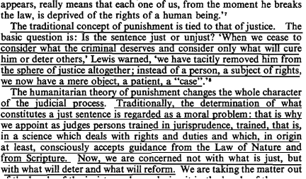

Justice is lost whenever we adopt any goal that looks forward to “what will be the results of the punishment?” rather than backwards at the question of “what punishment does that crime justly deserve?”
Prof. Peter Karl Koritansky 2012 (associate professor of history, philosophy, and religious studies at the University of Prince Edward Island, Canada) Thomas Aquinas and the Philosophy of Punishment https://books.google.com/books?hl=en&lr=&id=CFZ6DKEw4wUC&oi=fnd&pg=PR7&ots=6Wg7jWFoUM&sig=TAefdc8Zs_mKI5C8DZqn0BCIPPo#v=onepage&q&f=false (accessed 10 Aug 2021) (Note: Prof. Koritansky is referring to criticism in general of backward looking utilitarianism, but in the article he expresses agreement with this criticism, so this quote is being used consistently with author’s intent.)
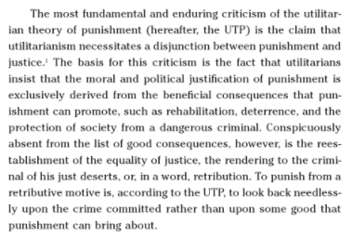

The government has no right to punish criminals if the goal is anything other than justice
John Hirschauer 2020 (former William F. Buckley Jr. Fellow in Political Journalism at National Review Institute) 27 March 2020 “Should States Punish the Insane?” https://www.nationalreview.com/2020/03/crime-mental-illness-should-states-punish-insane-offenders/ (accessed 9 Aug 2021) (brackets added)
[C.S.] Lewis argued that the utilitarian rationales for punishing criminals — deterrence, rehabilitation, incapacitation — were insufficient to justify a penal regime. If the state did not first establish that an offender deserved to be punished for punishment’s sake, forcing “rehabilitation” upon him or using his fate to deter other would-be criminals was not merely dishonest, but instrumentalist: The offender himself became a means to an end. Without a sense of retributive justice, Lewis said, an offender is made “a mere object, a patient, a ‘case.’”

Any other goal besides giving what the criminal deserves hands the government the power of tyranny
John Piper 2012 (chancellor of Bethlehem College & Seminary) “Life Is Cheap in Norway: C. S. Lewis on the Sentence of Anders Breivik” 27 Aug 2012 https://www.desiringgod.org/articles/life-is-cheap-in-norway-c-s-lewis-on-the-sentence-of-anders-breivik (accessed 9 Aug 2021)
If a criminal’s sentence does not have to accord with what he deserves, it does not have to be just. At that point we are all at the mercy of those who are in power to call anything we do a crime and give it any therapeutic or remedial solution they choose, including gas chambers and medical alterations. “The Humanitarian theory of punishment will put in their hands a finer instrument of tyranny than wickedness ever had before.”

A/T “Mercy” – Mercy requires a foundation of justice first
John Piper 2012 (chancellor of Bethlehem College & Seminary) “Life Is Cheap in Norway: C. S. Lewis on the Sentence of Anders Breivik” 27 Aug 2012 https://www.desiringgod.org/articles/life-is-cheap-in-norway-c-s-lewis-on-the-sentence-of-anders-breivik (accessed 9 Aug 2021) (brackets added)
And what of mercy? We are Christians. We don’t treat each other merely on the basis of justice, but of mercy, since we have been treated that way by God in Christ. Yes. And the Christian — the biblical — concept of mercy toward wrongdoers only exists in relation to justice. Showing mercy, in relation to wrongdoing, means treating someone better than they deserve. If the concept of ill-desert, and with it the concept of justice, is lost, mercy ceases to be. It is replaced by sentiment and caprice. As [C.S.] Lewis observes, “The essential act of mercy was to pardon; and pardon in its very essence involves the recognition of guilt and ill-desert in the recipient.” There may be good reasons for commuting or mollifying just sentences, but those reasons, if they are merciful, will give an account of themselves before the bar of precious and unimpeachable justice.

REHABILITATION MODEL FAILS

Rehabilitation goal = tyranny because judges become all-powerful to decide whether someone is rehabilitated
John Piper 2012 (chancellor of Bethlehem College & Seminary) “Life Is Cheap in Norway: C. S. Lewis on the Sentence of Anders Breivik” 27 Aug 2012 https://www.desiringgod.org/articles/life-is-cheap-in-norway-c-s-lewis-on-the-sentence-of-anders-breivik (accessed 9 Aug 2021) (ellipses in original)
The issue is not what he deserves. The issue is not justice. The issue is power in the hands of judges who will decide if he has been “rehabilitated” sufficiently, and if his detainment has served the community to a suitable degree. This is the seedbed of tyranny. To be sure, there is a place for rehabilitation and deterrence. But only under the humanizing sway of justice. Lewis explains the relation:
I am ready to make both protection of society and the “cure” of the criminal as important as you please in punishment, but only on a certain condition; namely, that the initial act of thus interfering with a man’s liberty be justified on grounds of desert. . . . It is this and (I believe) this alone, which legitimizes our proceeding and makes it an instance of punishment at all, instead of an instance of tyranny — or, perhaps, of war. (“On Punishment: A Reply by C. S. Lewis,” Essay Collection: And Other Short Pieces, 707)

Rehabilitation model – it’s so 1960’s and was discredited long ago
[This evidence is old, but that’s a good thing. It proves how far out of touch AFF is with their emphasis on “rehabilitation,” when that goal was already being discredited and abandoned in the 1970s]
Joseph Weiler 1978. (faculty of the Allard School of Law at the University of British Columbia) Why Do We Punish?: The Case for Retributive Justice, UNIV. OF BRITISH COLUMBIA LAW REVIEW https://commons.allard.ubc.ca/cgi/viewcontent.cgi?article=1348&context=fac_pubs (accessed 10 Aug 2021)

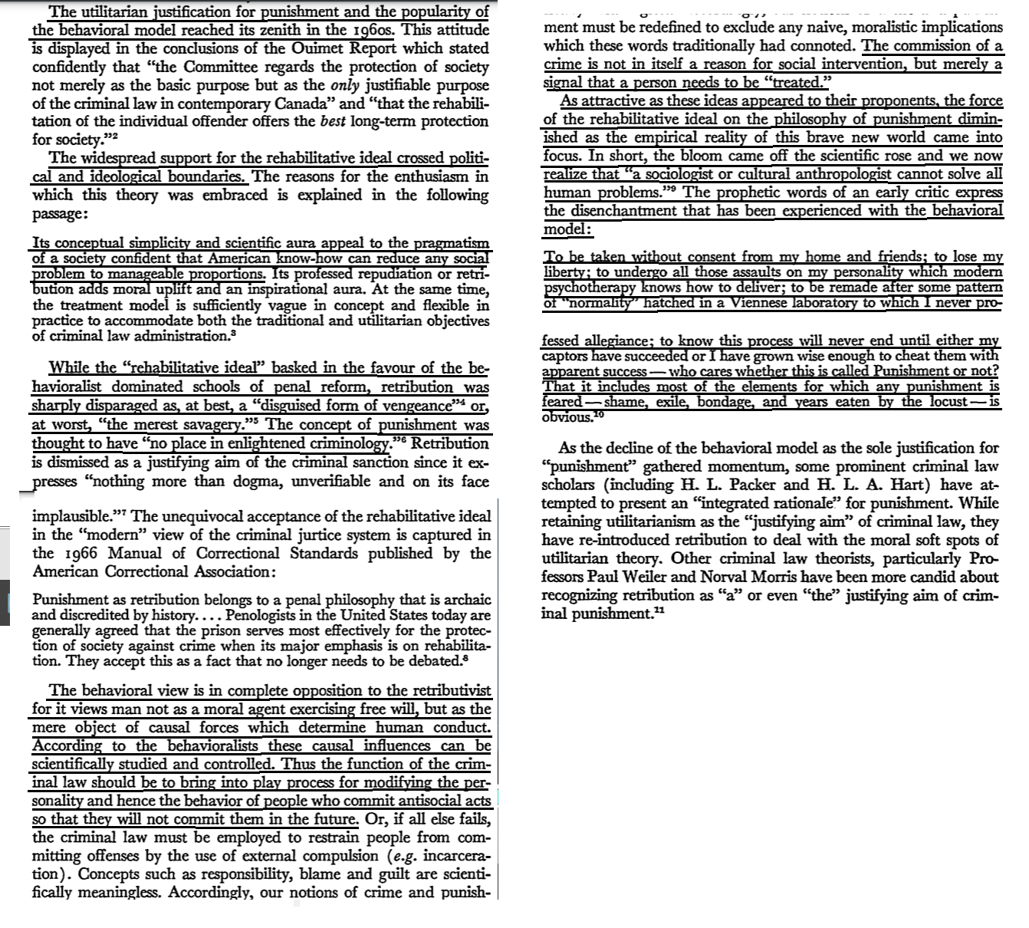

DETERRENCE MODEL FAILS

Deterrence isn’t a valid primary goal: If it were, we could achieve it by punishing innocent people
Prof. Peter Karl Koritansky 2019 (associate professor of history, philosophy, and religious studies at the University of Prince Edward Island, Canada) “Retributive Justice and Natural Law” July 2019 https://muse.jhu.edu/article/755809/pdf (accessed 9 Aug 2021) (ellipses in original)
Lewis goes on to argue that the problems with eliminating retribution are even worse if we consider deterrence, because, here, the eclipse of justice is even more evident. As Lewis puts it, when deterrence becomes the sole or even the primary goal of punishment,
it is not absolutely necessary that the man we punish should even have committed the crime. . . . The punishment of a man actually guilty whom the public think innocent will not have the desired effect; the punishment of a man actually innocent will, provided the public think him guilty.

Justice trumps deterrence: Deterrence can’t be the goal because it would justify wrongly punishing the innocent
Prof. Peter Karl Koritansky 2012 (associate professor of history, philosophy, and religious studies at the University of Prince Edward Island, Canada) Thomas Aquinas and the Philosophy of Punishment https://books.google.com/books?hl=en&lr=&id=CFZ6DKEw4wUC&oi=fnd&pg=PR7&ots=6Wg7jWFoUM&sig=TAefdc8Zs_mKI5C8DZqn0BCIPPo#v=onepage&q&f=false (accessed 9 Aug 2021)
