Negative Case: Reason
By Josiah Hemp

In the context of innovation, the proactionary principle ought to be valued above the precautionary principle.
This case builds on the most common arguments in the literature on the topic—it argues that the precautionary principle is more reasonable. Although you might not be used to using a standard/value like “reasonableness” it is certainly a valid standard to use. A value/weighing mechanism/standard simply exists to help the judge evaluate the resolution and make their decision. Considering that reasonableness seems to be the most common “value” used by experts when evaluating this topic, it seems appropriate to use it in debate as well.
Ethos will be very important to winning with this case. This is not necessarily the best case for a passionate delivery style. This case plays the best to the debater who seems to be the most credible person in the room. You want yourself (and more importantly, the precautionary principle) to be as credible as possible.
The precautionary principle is a well-reasoned, time-tested standard for determining the limits of innovation. In contrast, the proactionary principle was created by a strange, disturbing, and dangerous group and is itself very dangerous. It is because of this that in the context of innovation, the proactionary principle ought not to be valued above the precautionary principle.

STANDARD: Reasonableness
The precautionary and proactionary principles are both intended to be used as guiding principles. Each group advocates for their principle because they think it is a more reasonable standard. Thus we should look to which standard is more reasonable in determining which side of the resolution to value.

CONTENTION 1: The Precautionary Principle is a Well-Reasoned Standard
A. Re: Unreasonable Versions of the Precautionary Principle
Dr. Sven O. Hansson (Holds a PhD in theoretical philosophy and a second PhD in practical philosophy. Division of Philosophy, Royal Institute of Technology (KTH), Teknikringen Stockholm, Sweden) “How Extreme Is the Precautionary Principle?” Nanoethics 14, 245–257 (2020). https://doi.org/10.1007/s11569-020-00373-5
“The common claims that the precautionary principle is irrational, goes against science, stifles innovation, etc. are based on interpretations of the principle that deviate drastically from the official interpretations in international treaties and in legislation and other binding documents adopted by the European Union. In its official versions, the precautionary principle is a guideline for the use of certain types of scientific evidence when making decisions. Importantly, it assumes that policy decisions should be based on science, and it does not leave room for decisions based on suppositions or fears that have no scientific backing. The basic message of the precautionary principle is that preventive measures can be justified by scientific evidence indicating a danger, even if that evidence is not sufficient to prove conclusively that the danger exists. This approach to uncertainty conforms with general principles of practical reasoning, and it can be explicated in detail with the help of a model of the scientific corpus and the science-policy interface. However, like other decision-making principles, the precautionary principle has its limitations. Based on an analysis of some problems arising in its use, we have identified three conditions that should be satisfied for an application of the precautionary principle to serve its purpose:
(1) The precautionary principle cannot adjudicate between competing top priorities. In cases with such a priority structure, it may therefore have to be supplemented with decision principles suitable for weighing different potential outcomes against each other.
(2) All precautionary actions should be based on the current state of science. Therefore, procedures for the scientific update of background information must be in place.
(3) Potential dangers whose plausibility does not rise sufficiently above the level of “mere possibility” must be excluded from serious consideration.”
B. The Precautionary Principle is Reasonable and Necessary
Dr. Hansson explained, the precautionary principle is a principle based on science rather than irrational fears. It does say that we ought to exercise caution even when we are uncertain of danger. But as Dr. Hansson said, this is reasonable.
It is not certain that you will end up in a car crash, but we still wear seatbelts. It is not certain that a new medicine will be harmful, but we still use clinical trials to test its safety. It is not certain that another nation will attack the United States, but we still have a military in case it does happen. We take precautionary measures in virtually every field even though we cannot prove that something bad will happen. The precautionary principle is really just common-sense reasoning. However, we cannot say the same about the proactionary principle.

CONTENTION 2: The Proactionary Principle is a Poor Standard
A. The Proactioary Principle is Commonly Dismissed
Although some thoughtful people have criticized the precautionary principle, the proactionary principle remains a fringe view that is most often ignored by the academic community.
For example, the Guardian invited three different thinkers to write on the subject of the precautionary principle: Andy Stirling, who supports the precautionary principle, Tracey Brown, who criticized it, and Steve Fuller, who argued for the proactionary principle. Then they were given an opportunity to respond to each other. Dr. Stirling dismissed the proactionary principle, writing
Dr. Andy Stirling, quoted by Alice Bell, “What's all the fuss about the precautionary principle?” July 12, 2013. Accessed August 3, 2021 https://www.theguardian.com/science/political-science/2013/jul/12/precautionary-principle-science-policy
“It's striking that so much criticism of "precaution", is based on casual – sometimes cynical – fantasy. As other critics, neither Steve nor Tracey make reference to any of hundreds of legal instruments developed over decades around the world, nor the vast associated literature. Instead we get Steve's preoccupation with an individual whim (a so-called "proactionary principle"). Tracey's contrivance of precautionary acknowledgement of uncertainty and complexity as a "childish desire to simplify" is – under any view – utterly spurious.”
Similarly, Tracey Brown entirely ignored Steve Fuller’s article in her response.
Tracey Brown, quoted by Alice Bell, “What's all the fuss about the precautionary principle?” July 12, 2013. Accessed August 3, 2021 https://www.theguardian.com/science/political-science/2013/jul/12/precautionary-principle-science-policy
“The problems and irresponsible tunnel vision engendered by the precautionary principle aren't some unfortunate intervention of politics in its practice; they are the inevitable, unavoidable consequence of elevating precaution to the status of a principle. This opens a regulatory route to be exploited with a "ban X" campaign, making it no one's responsibility that we're left with Y. Science fiction futures won't solve it. We need to engage pragmatically with current problems like crops being damaged if we don't want to take more land to grow them. "What shall we ban" won't get us there.”
Why is this? Because the proactionary principle, far from being reasonable principle, is a strange idea that comes from an even stranger group of thinkers.
B. The Proactionary Principle’s Roots
Steve Fuller (Steve Fuller is the Auguste Comte Professor of Social Epistemology at the University of Warwick. He is the author (with Veronika Lipinska) of The Proactionary Imperative: A Foundation for Transhumanism (Palgrave Macmillan). This article is reprinted with permission from the author, and first appeared on the Guardian Political Science blog.) The Breakthrough Institute. August 8, 2013. Accessed August 2, 2021. https://thebreakthrough.org/articles/the-proactionary-principle
But some critics would reverse the priority of protection over promotion of humanity as the goal of government. In one of the seminal meetings of the transhumanist movement, the philosopher Max More (now CEO of Alcor, the leading US cryonics company) advanced the "proactionary principle" as a foil to the precautionary principle. The proactionary principle valorizes calculated risk-taking as essential to human progress, where the capacity for progress is taken to define us as a species.
As Fuller notes, the proactionary principle was created by the transhumanist movement. Further, the proactionary principle is inherently connected to transhumanism. Steve Fuller and Veronika Lipinska titled their definitive book on the proactionary principle The Proactionary Imperitive: A Foundation For Transhumanism.
Citation: “The Proactionary Imperative” Palgrave Macmillan. (The publishers page for the book) accessed August 2, 2021. https://www.palgrave.com/gp/book/9781137302977#
What even is transhumanism? According to
Dr. John C. Lennox (John C. Lennox is professor of mathematics (emeritus) at the University of Oxford, fellow in mathematics and the philosophy of science, and pastoral adviser at Green Templeton College, Oxford. Former Senior Scholar at Emmanuel College, Cambridge University from which he took his MA, MMath and PhD. He lectures extensively on mathematics, the philosophy of science, and the intellectual defense of Christianity. Lennox is the author of many books, including 2084: Artificial Intelligence and the Future of Humanity.) “Replacing Humanity: The Dangers of Transhumanist Though” WORLD Magazine, April 26, 2021, Accessed August 2, 2021. https://wng.org/roundups/replacing-humanity-1619879978
“This is the transhumanist project whose visionaries’ aims are summed up by Mark O’Connell in his book To Be a Machine, which won the Wellcome Book Prize in 2018: “It is their belief that we can and should eradicate aging as a cause of death; that we can and should use technology to augment our bodies and our minds; that we can and should merge with machines, remaking ourselves, finally, in the image of our own higher ideals.””
But wait, this movement is even stranger than that. Max More, the man who invented the proactionary principle, is the former President of an organization whose sole purpose is to freeze dead people. Yes, freeze dead people. The Alcor Life Extension Foundation currently has 182 dead people frozen in its vaults in Scottsdale Arizona, hoping that they will be able to be resuscitate them with better medicine in the future.
Citations: “About” The Alcor Life Extension Foundation. No Date. Accessed August 3, 2021. https://www.alcor.org/about/ AND Chana Phaedra “Alcor Member Profile: Max More, PhD” Cyronics. January-February 2012. Accessed August 3, 2021. https://www.alcor.org/library/alcor-member-profiles/max-more/
This is the roots of the proactionary principle. Now it is not that hard to realize why most simply dismiss the proactionary principle. Even if we do take a closer look we will see that the proactionary principle is a bad standard.
C. The Dangerous Standard of the Proactionary Principle
Max More, creator of the proactionary principle quoted by Judith Curry, “Proactionary Principle” Climate Etc. (Judith Curry’s personal blog). August 19, 2013. Accessed July 26, 2021 https://judithcurry.com/2013/08/19/proactionary-principle/
“Most activities involving technology will have undesired effects as well as desirable ones. Whereas the precautionary principle is often used to take an absolutist stand against an activity, the Proactionary Principle allows for handling mixed effects through compensation and remediation instead of prohibition. The Proactionary Principle recognizes that nature is not always kind, that improving our world is both natural and essential for humanity, and that stagnation is not a realistic or worthy option.”
Essentially, More is saying that rather than prohibiting risky actions, we should deal with problems after they happen. Basically, it’s a shoot first, ask questions later approach.
The problem is that damage is often irreversible. If we take an unsafe action that leads to the death of millions, we can’t have “compensation and remediation” solve that problem. Although More seems to think that we could just freeze the dead people and bring them back to life later, most of us realize that is not a real solution.
This isn’t just a hypothetical. According to data from the CDC, 136 people die every day from an opioid overdose. That means that during this debate round more than four people will die from opioids.
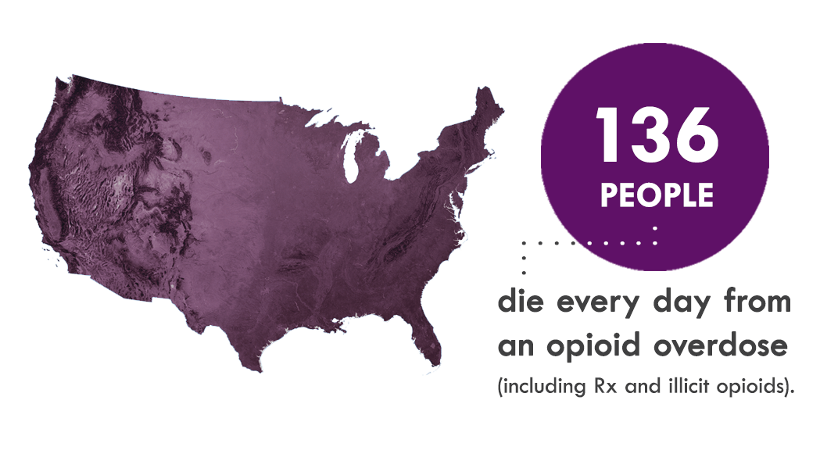
Citation: “Understanding the Epidemic” Center for Disease Control and Prevention (CDC) March 17, 2021. Accessed August 3, 2021. https://www.cdc.gov/opioids/basics/epidemic.html
Although many things caused this tragic problem, one major cause was the failure of the FDA to make sure that opioids were actually safe.
Andrew Kolodny, MD “How FDA Failures Contributed to the Opioid Crisis” American Medical Association Journal of Ethics August 2020. Accessed August 3, 2021. https://journalofethics.ama-assn.org/article/how-fda-failures-contributed-opioid-crisis/2020-08
“The FDA’s regulatory failures with respect to opioids have not gone unnoticed. In 2017, the President’s Commission on Combatting Drug Addiction and the Opioid Crisis found that the opioid crisis was caused in part by “inadequate oversight by the Food and Drug Administration,” and the National Academy of Sciences (NAS) publicly called on the FDA to overhaul its opioid policies. Last year, a former FDA Commissioner rebuked the agency he had previously led, saying on the television program 60 Minutes that the FDA was wrong to allow promotion of opioid use for chronic pain.”
When we fail to ensure that our innovations are safe, we can cause tragic, irreversible consequences. This is why the approach of the proactionary principle is dangerous and not reasonable.

How To Respond
The following is advice on how to respond to the case. Don’t think that these are the only possible responses (or even the best responses—these are just a few ideas to help you get started in responding to the case.

Reason
The advocates of the proactionary principle think that their position is the reasonable one, so this value framework is certainly one you can work in. It would probably be best to continue to defend whatever value you brought up in your case, and then also argue that the proactionary principle is more valuable. Thus, whichever side wins the value clash, you still can win.

Definition of the precautionary principle
One area you will likely want to attack is the definition of the precautionary principle. If your case is based on the claim that the precautionary principle requires absolute certainty, you will need to argue against Contention 1.

Dismissal of the Proactionary Principle
There is a good bit of potential for you to turn the “experts dismiss the proactionary principle” around to support your side. You could do this if you successfully change the meaning from “the proactionary principle is such a bad principle that nobody considers it worth debating” to “the proactionary principle is ignored, and that is why the experts don’t like it. They aren’t really understanding it or considering the arguments for it.”

Opioid Epidemic
It could be helpful to argue that the opioid epidemic example is not actually an example of the proactionary principle. (Note to Negatives using this case: this example is primarily intended to illustrate how you can’t solve deaths by “remediation and compensation.” Don’t let the aff shift the focus onto other aspects of this example.)

Note: the following section on the proactionary principle and transhumanism is also published as part of NEG: Human Dignity. If you have already read that section, you may want to skip this. However, I would re-read the “ad hominin” section because it is slightly different.

The Proactionary Principle and Transhumanism
To beat this case, you will almost certainly need to distance the proactionary principle from transhumanism. This is a difficult task, but it is an easier one than defending transhumanism. How do we do this? There are no easy answers. Here are a few ideas that you could use to start building responses.
Ad Hominin?
One potential is to paint this case as an ad hominin attack. Ad hominin attacks attack the person making an argument rather than the argument itself. If I were to say “the proactionary principle is bad because the people who argue for it (Max More, Steve Fuller, etc.) are transhumanists and transhumanism is bad” that could be an ad hominin fallacy—I would be attacking the people, not the argument. If someone is running a case similar to this where they make ad hominin mistakes, make sure to point that out—that sort of case will not be nearly as difficult to respond to. Point out that a broken clock is right twice a day. Then bring the focus back onto your arguments.
Although this case is a lot more susceptible to accusations that it is making an ad hominin attack than the way these arguments are presented in NEG: Human Dignity, this case is still quite arguably not making an ad hominin. Pointing out that a source is not credible is not always making an ad hominin argument, especially if the criticism is valid. However, you may be able to convince the judge that this is an ad hominin, and it may indeed be an ad hominin—it is not a perfectly clear-cut situation. (Note to debaters planning to run this case—make sure you have a plan for how you will respond to claims that you are making an ad hominin attack).
Gloss over it
One strategy could be to ignore this issue as much as possible. Although this is a very weak way to deal with an argument, sometimes you can de-emphasize an argument enough that the other arguments (the arguments you can win) are the ones the judge pays attention to. I would caution against only glossing over this issue—good negatives won’t let you, and you will learn a lot more by grappling with tough arguments than by ignoring them—but in combination with other strategies, it could be helpful. So you could respond to the argument as best as you can, then shift the focus back to your arguments.
Argue that the Proactionary Principle is not transhumanist
This will be a very hard argument to win, but you could try. You could attempt something along the lines of acknowledging that the proactionary principle was initially transhumanist, but arguing that the resolution is simply speaking about the narrow definition of the proactionary principle as meaning that we follow the 5 sub-principles—without the transhumanist baggage. This has potential to be a strong argument if developed further. However, you still have a problem other issues in those five principles, as this case argues.
If I had to guess, this will be an issue that affirmatives struggle with well into the season—we will see what responses end up working.

