Season 22
—
Debating the 2021-2022 Stoa Policy Resolution

Policy debaters should be aware of current issues being discussed in this year’s topic area. The purpose of this article is to give competitors the underlying knowledge of current issues relating to the following resolution:

Resolved: The United States federal government should substantially reform the use of Artificial Intelligence technology

Table of Contents
Policy Issues in Artificial Intelligence 2
Resolutional Analysis: Artificial Intelligence 2
What AI is 3
What AI is not 3
Resolutional Analysis: Use 4
The limits of “use”? 4
Whose use? 5
Intellectual Property Rights (IPR) 5
Economics 7
Bias 8
Privacy 9
Military 9
Geopolitical Implications 10
Generic Issues 11

Content collected and written by Vance Trefethen.

Policy Issues in Artificial Intelligence
By “Coach Vance” Trefethen

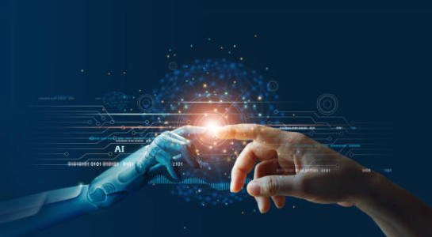
“Everything we love about civilization is a product of intelligence, so amplifying our human intelligence with artificial intelligence has the potential of helping civilization flourish like never before – as long as we manage to keep the technology beneficial.“
Max Tegmark, President of the Future of Life Institute
Stoa’s 2021-2022 Policy Resolution:
Resolved: The United States federal government should substantially reform the use of Artificial Intelligence technology

Resolutional Analysis: Artificial Intelligence
Let’s start by focusing on the key words in this resolution: “artificial intelligence.” This concept, though we might instinctively understand it, is notoriously difficult to define.
“Defining artificial intelligence isn’t just difficult; it’s impossible, not the least because we don’t really understand human intelligence.”

What AI is
Expect conflicts over topicality to be more common than usual this year. On the one hand, there are simple-sounding definitions like these:
Merriam Webster online dictionary copyright 2021. https://www.merriam-webster.com/dictionary/artificial%20intelligence (accessed 26 June 2021)
1: a branch of computer science dealing with the simulation of intelligent behavior in computers
2: the capability of a machine to imitate intelligent human behavior
But wait. How is that different from anything computers (and lots of other machines) do? A pocket calculator adds 2+2 and gets 4, which is just what a human would do within their heads. Does that mean a pocket calculator is AI? No, there’s more to it:
Amazon builds a lot of its business on machine-learning systems (as a subset of AI) and defines AI as “the field of computer science dedicated to solving cognitive problems commonly associated with human intelligence, such as learning, problem solving, and pattern recognition.”
AI has some “value added” beyond rote calculation. Proposing options to solve problems, recognizing patterns, making decisions, and learning from past results to guide future results are all features of AI. A calculator adds 2+2. AI looks at trends in all the additional data you have entered and gives guidance (or actually makes the decision for you) on what you should do about it.
Flexible response is another key aspect of AI differentiating it from rote calculation.
“Artificial intelligence is an entity (or collective set of cooperative entities), able to receive inputs from the environment, interpret and learn from such inputs, and exhibit related and flexible behaviors and actions that help the entity achieve a particular goal or objective over a period of time.”

What AI is not
I predict that there will be many Affirmative cases reforming things that have tangential or “effects topical” relationships to artificial intelligence, but will not actually affirm the resolution. Since this topic is so unusual compared to past topics, both debaters and judges may be confused about what it includes or doesn’t include. I strongly recommend bringing an extensive topicality brief with you when you debate Negative rounds so you can clearly explain to the judge the boundaries of this resolution.
AI is not computer parts/components/hardware.
Computers allow AI to exist and function, but that does not mean anything to do with the physical construction of computers is AI. First, the fact that something is essential to make something else work doesn’t make the component topical. Humans must breathe air to engage in criminal justice reform, for example, but we would all agree that cleaning up air pollution would not be a topical plan if the resolution called for reforming the criminal justice system. Breathable air is also used for lots of other purposes and would be necessary to just about any topic. Likewise, computer hardware components can be used for lots of things besides AI. They might be used in computers that would store information about prisoners in the criminal justice system. But computer components wouldn’t be a criminal justice reform, nor an AI reform.
AI is not just anything done with computers.
Computers do lots of things besides AI. They can do rote calculations that involve no artificial intelligence. They run spreadsheets, do word processing, and play video games that do not involve any of the additional technologies considered characteristic of AI. Reforming something just because it involves the use of computers would involve many extra-topical changes that go far beyond the limits intended by the terms of the resolution.
Likewise, AI is not just anything involving computer software. Some computer programs involve AI, many don’t. Negatives need to carefully parse what the Affirmative is doing and demand that any extra-topical actions be dropped from the round, and that the ballot be judged only on the basis of what the Plan does that stays within the resolution.

Resolutional Analysis: Use

The limits of “use”?
The noun “use” is a small word but it may be the biggest word in the resolution. Negatives may have a lot of ground to claim for themselves by ruling out everything that isn’t strictly “use of” artificial intelligence technology. For example, is research and development (which are essential to its creation) part of its “use”? It’s essential to make use possible, but then so is the air the programmers breathe and the food they eat, so we’re back on the slippery slope of air pollution and agriculture cases becoming topical.
Skills needed for development of AI might also be debated. Some argue the US lacks science and math graduates who could develop AI to keep our economy competitive. If that’s true, and a policy is enacted to stimulate more of them, has the “use” of AI been changed? Or just the number of people who might later develop it? And how would we tell all those science and math graduates that they could “only” work on AI (because that’s all the resolution allows)?
Negatives need to get used to asking this question: After this Plan is enacted, what changes about the way AI is used?

Whose use?
The resolution cleverly does not define whose use of AI should be reformed. Normally we would expect the resolution to have the word “its” in front of “use,” where the federal government would reform “its use” of AI. But no, we’re allowed to reform anyone’s use that can be reached by the federal government. Of course, the federal government’s use (military, law enforcement, research, border control, etc.) can be changed. But we might also consider how state governments could be (mis)using AI and how the federal government might motivate (coerce?) them with threats of reduced federal funding if they don’t change their ways. There could be foreign trade or foreign aid implications. Private industry could be banned, regulated, or stimulated by federal actions to do more, less, or different things with AI.

Intellectual Property Rights (IPR)
Intellectual property rights are claims to exclusive use of an idea, invention, or artistic creation. They are monopolies granted by a government so that the owner of the IPR can market his idea or products using the idea without competition from anyone else who might want to copy it. In theory, it should create an incentive for development of new ideas by allowing substantial profits to be made during the limited time when the IPR owner is protected by this monopoly.
Article 1 Section 8 of the US Constitution says Congress has the power “To promote the progress of science and useful arts, by securing for limited times to authors and inventors the exclusive right to their respective writings and discoveries.” As a result, IPR law falls under the jurisdiction of the federal government and, to the extent that it could apply to AI, could be a fertile area for Affirmative policy reform proposals.
Examples of IPR include things like patents, copyrights, and trademarks. The first two of these have some bearing on Artificial Intelligence. Patents are given for inventions that do something new, or substantially improve on an existing process in a new way, are not obvious, are not already in common use, and are more than just an abstract idea. In the U.S., some software can be patented, depending on what it does and how it works.
Copyright is an IPR granted on copies of a work of the human mind. To understand the difference between patents and copyrights, imagine the difference between inventing a piano and writing a song. The inventor of a piano might file for a patent, and, if granted, anyone who wants to build a musical instrument that works like a piano would either have to get (and pay for) his permission, or else be prohibited from doing so, until the term of the patent expires. A song writer could not patent song-writing (because the concept of writing songs is not a new discovery and songs have been around for millennia). But he could copyright each song he writes and demand royalty payments from each person who wants to copy the song or perform it.
Claims for monetary compensation under patents and copyrights could be enforced in federal courts under federal copyright or patent law. Policies changing copyright or patent rules would be under the jurisdiction of Congress and the federal courts.
Software that does AI can be patented. But the creative output of AI cannot be copyrighted. Federal policy and recent federal court cases are consistently denying copyright to things produced by non-human authors, including AI. Today, AI has begun producing food recipes, artwork, and music. The Associated Press has begun publishing news stories written by AI, leaving open the question of whether they can be copied and reused by just anyone. AI may someday produce formulas for even more advanced (and potentially profitable) new medications or other scientific advances. It may be that IPR needs to be reformed to make these advances possible.
But IPR has downsides, too. Some view it as a tool to enrich lawyers, as big corporations patent everything and anything and then sue each other whenever they see new products coming onto the market. Some patents are downright silly and seem to invite litigation as sharp operators try to patent things, not for the purpose of inventing something, but only for the purpose of suing people. Just to prove the point, in 2001 an Australian named John Keogh managed to patent a “circular transportation facilitation device” in that country. He calls it a “wheel.”
Sometimes IPR blocks as much innovation as it stimulates by prohibiting the use of new technologies. Competition might be better at fostering innovation than monopolies. And since when is IPR needed for artistic creativity? Beethoven and Mozart created timeless music without any copyright protections at all. Clothing fashions cannot be copyrighted, yet new designs are turned out every year.

Economics
What happens when machines take the place of humans in the workplace? We have two centuries of experience with that problem/opportunity. The Industrial Revolution that transformed life in the 19th century faced the very same issues we face today with the possible wide scale replacement of humans by machines. When shoe factories turn out hundreds of shoes per day, cobblers are no longer needed (but factory workers are). When farm machinery produces more grain with fewer farm workers, the workers are no longer needed and head to the cities to look for industrial jobs.
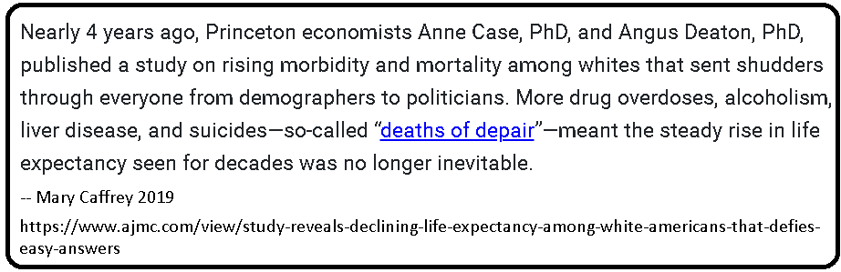
In the past, menial jobs were replaced with menial work by machines. That trend continues today, as more and more manufacturing is still being done, but with fewer workers thanks to automation and more advanced technology. When technology doesn’t replace the workers, often lower-paid workers in other countries replace them instead.
Where do the workers go who used to earn a middle-class living working on the assembly lines and factory floors of a generation ago? Are they being retrained to get better jobs that pay as much in a different field? Or are they in despair dropping out of the workforce, turning to welfare dependency, idleness, drug addiction, and possibly early death?
And whose jobs are targeted for replacement next? AI threatens to replace highly skilled jobs like legal research, doctors, and customer service. If self-driving AI controlled cars become widespread, will we need chauffeurs or taxi drivers any longer?
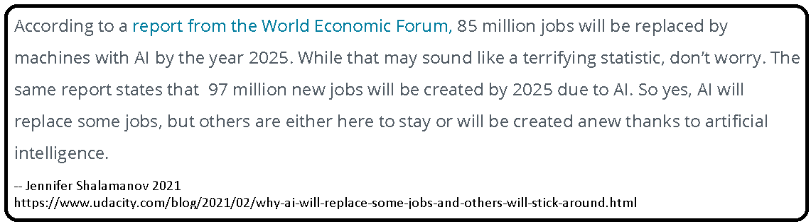
There are upsides to these changes as well. Factories produce shoes much faster and cheaper than cobblers do, and everyone today can afford multiple pairs of shoes – which might have been a luxury 200 years ago. Technological development cannot be stopped just because we fear cars make horse-drawn buggies and horseshoes virtually obsolete. Economies adapt, as workers move to new industries no one even thought of a generation earlier. Canceling the automobile to save blacksmiths’ jobs making horseshoes would have also canceled millions of new jobs that the automobile gave rise to that no one could have foreseen: car repair shops, gas stations, oil refineries, highway construction, motels, tire factories, and many more. It cannot be the end of the story to say that some people will lose jobs because AI will replace them, therefore we shouldn’t do AI. We today cannot imagine all the new industries and jobs that AI may generate tomorrow.

Bias
Artificial intelligence could be a useful tool to make decisions where humans are subject to conscious or unconscious bias. Computers and software, having no vision to such things, cannot view the race, ethnicity, religion or other personal characteristics of a potential customer, job applicant, loan applicant, or anyone else seeking approval from a decision-maker. People in such situations, where unfair biases have historically been a problem, might rejoice to have a computer analyzing and making the approval decision about their mortgage application, for example. They would have every reason to believe their application will be judged purely on its financial merits.
Or will it? What if the AI reads the loan application and sees that the applicant resides in zip code 77081. It looks up in its database to find the percentage of people in 77081 over the last 10 years who have paid their mortgages on time or have fallen behind on payments. It then takes this into account when it calculates all the pluses and minuses to the total score that will make the up or down decision on the mortgage loan. Did we say anything about race or ethnicity? No. But if people in 77081 historically have higher default rates, this borrower’s AI evaluation will be penalized, and his application possibly denied, without the AI or anyone else knowing that the residents of 77081 are 75% Hispanic. This borrower (who has a 75% chance of being Hispanic) will be denied the loan, potentially, due to bias even though a color-blind computer made the decision.
Even if there was no conscious bias, the outcome described above is sometimes referred to as “disparate impact.” In other words, the results of the process have the same effect as if someone were consciously applying bias, even though we can’t prove anyone was. You can debate what public policies, if any, should be reformed to deal with this type of situation.

Privacy
Artificial intelligence can be used to invade privacy in ways not possible before with only human analysis. Law enforcement may use artificial intelligence to sift through pictures from license plate readers in order to look for patterns of movement or behavior – patterns that never would have been found by individuals looking through the data with only human intelligence. The same could be done with cell phone location data coming from cell towers.
China has already started using facial recognition software, collecting billions of images from cameras in public places, to exert greater state control over the population.
“China’s use of facial recognition as a tool of authoritarian control in Xinjiang and elsewhere has awakened opposition to this expansion and calls for a ban on the use of facial recognition. Owing to concerns over facial recognition, the cities of Oakland, Berkeley, and San Francisco in California, as well as Brookline, Cambridge, Northampton, and Somerville in Massachusetts, have adopted bans on the technology. California, New Hampshire, and Oregon all have enacted legislation banning use of facial recognition with police body cameras.”
And it’s not just governments that might (mis)use data from the public. Concern is mounting over businesses collecting and using data from all the myriad ways it drips from our phones, online accounts, social media, etc. as we click through all the little “consent” agreements that we never read. Public policy might be justified in greater regulation of business use of our data as it pertains to AI in the private sector.

Military
The US military has been increasingly automating weapons for decades, since computers can make decisions faster and more accurately than humans in difficult combat situations. If I were a military pilot, I would much rather have the computer aim weapons at the target than have to do it myself in the split second of combat when a decision must be made. This partial use of AI, with a human military person “in the loop,” has long been accepted as a normal part of combat, and it has no doubt increased the battles won and reduced US casualties lost.
But do we want the AI to autonomously decide whether to fire and which targets to engage? Lethal Autonomous Weapons Systems (LAWS) are on the horizon. The computer decides that something looks like a bad guy and decides to fire the weapon and destroy it, without humans being in the loop at all on the targeting or the decision to shoot. Not everyone is sure this is a good idea. Maybe AI can be trained to distinguish between a hospital and a terrorist training camp. But how many hospitals will get blown up in the meanwhile? A farmer with a pitchfork and a soldier with a rifle might look much alike to the visual recognition software. Shoot or don’t shoot? A human might make a better decision. On the other hand they might not. Humans in combat have accidentally made bad decisions to shoot villagers, bomb embassies and hospitals, and other tragic mistakes. If AI makes the same mistakes, but fewer of them, should we go ahead and use it? Or should we wait until it is perfect and keep making human mistakes in the meanwhile?
And what does it mean when war is outsourced to machines? Do we lose humanity and accountability when we send machines to kill for us?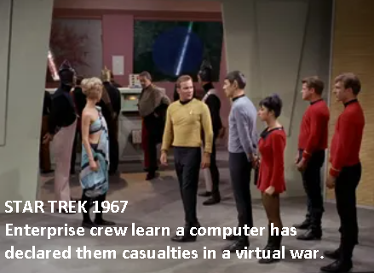 An eerily prophetic 1967 episode of the original Star Trek series described a war between two planets conducted entirely by computer AI. The warring parties realized that actually bombing each other would destroy their civilizations, so they came to an agreement. Their computers would launch virtual attacks, put up virtual defenses, and calculate the resulting virtual casualties. Lists were calculated of all the individuals who “would have been” killed in the attack, and the casualties report peacefully to their execution. The moral to the story was that the warring parties were able to continue killing each other for many decades, long after they would have been forced to come to a peace settlement had they actually had to fight the war themselves.

Geopolitical Implications
Competition with China is the “next big thing” many analysts are concerned about in US foreign policy. Many believe China is on the rise to obtaining either regional and/or global hegemony (certainly debatable) and that if that happens, the US will lose global influence (also debatable), and if that happens, the world will be a much less happy place without US hegemony (also debatable).
AI is often listed as one of the factors that may be key to US/China geopolitical competition. The Chinese government has openly declared its intention to make China the global leader in AI in the next few years. They are graduating many new math and science students and investing billions in research and development of AI systems.
Some of these system are military, which obviously would have direct threats to US security if Chinese AI-enabled military advances beyond US military capabilities. But economic concerns are vital as well. If the Chinese economy leaps ahead of ours because they achieve a technological revolution in AI, and lead the world in the new industries, jobs and technologies that AI creates, China could gain global hegemony without firing any shots.

Generic Issues
This outline has only scratched the surface, and no matter how far you research, someone will find obscure programs and policies of which you were unaware. The sharp debater will prepare an arsenal of generic Negative briefs that could be useful against many Affirmative cases. We intend to help you with that by issuing some through Monument as the year unfolds, but we suggest you look into briefing these issues:
PRIVACY MORE IMPORTANT THAN SECURITY
PRIVACY DOESN’T MATTER
CHINA NO THREAT / US HEGEMONY NOT IMPORTANT
CHINA BIG THREAT / US HEGEMONY CRITICAL
MORE STUDY NEEDED (AI is too complex, don’t understand it well enough yet to regulate it)
TOPICALITY (“use of” applications, “artificial intelligence” definition)
AI CREATES JOBS
AI DESTROYS JOBS
AI THREAT TO HUMANITY – SUPER-INTELLIGENT COMPUTERS TAKE OVER
AI NO THREAT TO HUMANITY
AI OVERHYPED – SIGNIFICANT IMPACTS YEARS OR DECADES AWAY

Mike Loukides & Ben Lorica 2016 https://www.oreilly.com/radar/what-is-artificial-intelligence/
https://www.forbes.com/sites/bernardmarr/2018/02/14/the-key-definitions-of-artificial-intelligence-ai-that-explain-its-importance/?sh=26186a454f5d
https://emerj.com/ai-glossary-terms/what-is-artificial-intelligence-an-informed-definition/
For more background, look up the case of Naruto the Macaque, a monkey whose cute selfies were denied copyright protection in a federal lawsuit someone filed on his behalf about 10 years ago. A native of Africa, it may be that his English language skills were not sufficient to file the suit himself. In any case, the court ruled that copyright required an element of human creativity, which Naruto allegedly lacked, although his pictures are better than some I’ve seen taken by humans.
And some of its songs are quite entertaining. Search Youtube for “artificial intelligence” + music and listen for yourself.
https://www.newscientist.com/article/dn965-wheel-patented-in-australia/
Cameron F. Kerry 2020 https://www.brookings.edu/research/protecting-privacy-in-an-ai-driven-world/

