Season 22
—
Debating the 2021-2022 NCFCA Policy Resolution

The purpose of this article is to give competitors an overview of the terms, issues and potential cases that could be debated under the following resolution:

Resolved: The United States Federal Government should significantly reform its policies regarding convicted prisoners under federal jurisdiction
Table of Contents
Current Issues for Debating Federal Prisons & Prisoners 2
Topicality challenges 2
Key words in the resolution 3
Federal government 3
Regarding Convicted 3
Prisoners 5
Under federal jurisdiction 5
Sentencing reform 6
Prison conditions 6
The 8th Amendment 6
Work 7
Physical & mental health care 7
Solitary confinement 7
Programs, education, rehabilitation 7
Visitation 8
Avenues of release 8
Appeals and exonerations 9
Philosophy and goals of the prison system 9
Justice / Retribution 10
Deterrence 10
Incapacitation 10
Rehabilitation 10

Content collected and written by Vance Trefethen.

Current Issues for Debating
Federal Prisons & Prisoners
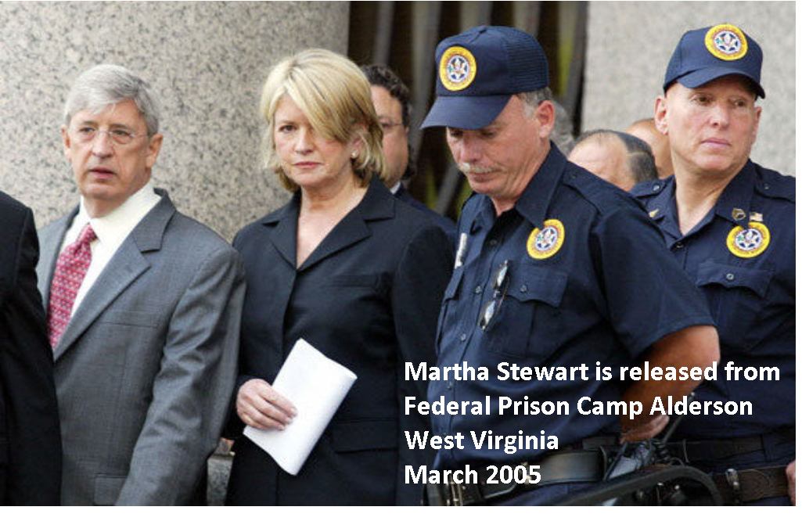

NCFCA 2021-2022 Policy Resolution
Resolved: The United States Federal Government should significantly reform its policies regarding convicted prisoners under federal jurisdiction
This year’s resolution, though carefully worded with some clear limits on its scope, contains a great variety of policy issues that could be debated. In this article, we will examine carefully the scope of the resolution, see how it fits into a limited segment of the federal criminal justice system, and discuss potential areas of reform that could appear in team policy debates this year.

Topicality challenges
I predict that topicality arguments will make more of an appearance this season than in past seasons, for three reasons. First, homeschool debate resolutions historically have been very broad (e.g. reforming the entire federal criminal justice system), so debaters and coaches may need to adjust their thinking to ensure their Affirmative cases fit the narrower wording of this resolution. Some will not succeed at this task. Second, the federal criminal justice system is not well understood by the average American, and there will potentially be confusion about policies that sound good but don’t meet the definitions of the terms in the resolution. And third, the ever-present temptation to run cases that operate by “effects topicality” will be even more powerful this year. This resolution does not allow Affirmative plans that might or might not end up having an effect on convicted federal prisoners by changing some policy that happens long before they were arrested or convicted. Negative debaters need to be on the lookout for these types of problems.

Key words in the resolution

Federal government
The federal government controls only about 10% of all the prisoners currently incarcerated in the U.S. today. This has implications for debating the evidence used in debate rounds. For example, if an Affirmative cites a study showing 90% of prisoners aren’t getting decent medical care, the first question we need to ask is whether that study was state prisoners or federal. State policies and funding are very different from federal. It’s entirely possible that 90% of state prisoners are getting poor medical care, while 90% of federal prisoners are getting good care.
If the U.S. has a problem with over-incarceration – that is, we imprison too high a percentage of our population – even completely emptying all federal prisons tomorrow wouldn’t solve it. We’d still have 90% as many prisoners locked up as we have today.

Regarding Convicted
The chart below shows an over-simplified view (we will add some more complications to it later) of the typical lifecycle of a federal criminal case. The story starts at the lower left where Congress or federal regulatory agencies put criminal laws on the books, which may be violated by some perpetrators. If caught, they will be arrested and charged in one of the 94 federal district courts throughout the country. They may or may not be eligible for bail to be granted so they can be out of jail while awaiting a resolution. And contrary to what you may have thought, most charges are not resolved by a trial. That pretty much only happens on TV and in the text of the Constitution. Instead, 97% of all federal criminal convictions are handled without trial and result from plea bargains between the prosecutor and the defense. The prosecutor typically presents a list of charges he could file, with their associated sentences if convicted, and offers to drop some of them, or reduce them to lesser charges, if the defendant will agree to plead guilty and give up his right to a trial.
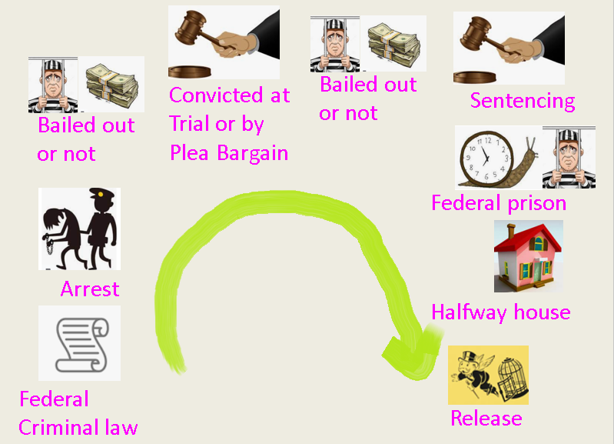
Once the defendant has either signed the plea agreement or received a guilty verdict from the jury, he is now “convicted.” His fate between now and the day he is released from federal custody is the subject of this resolution. Things that happened before this point, though interesting and probably ripe for reform, are extra-topical to NCFCA debaters this year. This means you cannot affirm policy reforms regarding changing or repealing criminal laws, law enforcement arrest or interrogations, indictments, pre-trial bail, trial procedures, plea bargaining procedures, or anything else that happens before conviction.
The word “convicted” is in the past tense in the resolution for a reason, and it limits the scope of Affirmative plans to rule out scenarios where a person has not yet been convicted. For example, changing federal criminal laws to legalize marijuana would be designed to affect people not yet arrested or convicted, since the policy itself is a change in criminal law, not a change regarding convicted prisoners. Instead, the limitations of the topic might suggest an Affirmative should concern themselves with reducing sentences for those already convicted of marijuana offenses.

Prisoners
The term “prisoners” is sure to be controversial this year. When someone is convicted but let out on bail pending their sentencing or their appeal, are they “prisoners” at that moment? When a prisoner is transitioning out of incarceration near the end of his sentence and he spends his remaining months in a halfway house – still under federal jurisdiction and still subject to strict rules, but no longer in a building known as a prison – is he still a “prisoner”? When the prisoner is sent home to finish his sentence under home confinement (e.g. with an ankle bracelet), are they still a “prisoner”? When an offender is sentenced to probation, but not prison, is he a “prisoner” during his probation period? The best way to handle these questions is to research and gather evidence to support whichever view you need for your Affirmative or Negative rounds.

Under federal jurisdiction
This handy phrase was a wise addition to the resolution by its authors and it requires the prisoners subject to the plan to be federal prisoners. It blocks Affirmatives from running plans to have the federal government change state level policies by granting or withholding federal funding to the states. If the prisoners themselves have to be under federal jurisdiction, Affirmatives cannot in any way attempt to modify conditions for state prisoners.
NO:
- State prisons / prisoners
- County jails
- Federal funding to influence state policies
- Ex-convicts released after completing their federal sentence
- Plans changing things that happen before someone is convicted
YES:
- Convicted of federal crimes
- Convicted in military courts-martial
- Crimes committed on Indian reservations
- Convicted in the District of Columbia
- Other areas under federal jurisdiction (military bases, US territories, US waters offshore/Coast Guard interdiction)

Sentencing reform
There are any number of proposals for federal sentencing reform in the literature on this topic. Much of it comes from the pendulum swing back away from the harsh drug sentencing enacted in the 1980s. We’ve had 30 years to review the results of that policy mindset, and many believe it’s time to reconsider. Have harsh sentences solved or reduced drug abuse in America by now? Are the sentences fair considering the severity of the offenses?
Affirmatives may want to amend or repeal the federal sentencing guidelines, which, though now only “guidelines,” are still the standard for sentencing most crimes, not just drugs. They may also want to repeal mandatory minimum sentences, since they take away discretion from federal judges to account for the unique circumstances that may exist for each defendant.

Prison conditions

The 8th Amendment
It’s easy to develop the mindset that prisoners are there because they deserve to be there and society shouldn’t waste any time or money worrying about their comfort or safety. But while prison isn’t supposed to be a hotel, neither should it be torture. The 8th Amendment to the Constitution bans the government from imposing any “cruel or unusual punishment.” The sentence imposed by the judge to a term of confinement is the defined punishment, and our basic humanity and sense of fairness ought to forbid us from tolerating additional suffering, torture, violence, abuse, or neglect in any prison. A sentence of 10 years imprisonment should mean just that, not 10 years imprisonment plus violence, plus mental abuse, plus unsanitary conditions, etc.

Work
Federal prisons typically have jobs prisoners must do (at a very low rate of pay) to keep them busy during the day. There is also a federal program called UNICOR, a government corporation that employs federal prisoners at manufacturing products and then sells the products on the outside.

Physical & mental health care
Prisons are responsible for providing health care to their inmates, but they are notorious for doing a poor job. If you were a well qualified and capable doctor, would you want to work in a prison and make what the federal government is willing to pay for it? Would the government be able to hire enough qualified staff to adequately treat the medical needs of all prisoners?
Mental health is also a concern. In 2014, the Bureau of Prisons greatly reduced the number of prisoners receiving mental health care services, and many are concerned about the effects it is having. Inadequate medical or mental health care could put a prison in violation of the 8th Amendment.

Solitary confinement
Solitary confinement might be a good thing if it reduces prison violence. But it could be a bad thing if it has detrimental effects on the mental health and sanity of those subjected to it. It’s difficult for “normal” people to imagine life confined in a cell 23 hours a day with no human interaction, and only one hour per day alone outdoors for recreation.

Programs, education, rehabilitation
The 2018 “First Step Act” authorized a number of education and rehabilitation programs in federal prisons. Some say much more remains to be done, if the goal is to truly reduce recidivism and rehabilitate offenders. Congress recently restored Pell grants for prisoners to pay tuition for remote learning towards a college degree. Many advocate for more and better drug rehabilitation and addiction counseling and recovery programs, since a large percentage of prisoners enter with drug problems and could easily go back to them after their release if left untreated. Vocational and job training programs could also be areas to look for reforms, if those programs could be improved to better rehabilitate prisoners.

Visitation
Maintaining contact between inmates and their families outside could be important for upholding the morale and motivation of inmates to better themselves and prepare for successful re-entry into society after their release. Currently the federal Bureau of Prisons has a policy of attempting, not always successfully, to house prisoners within 500 air miles (straight line on the map) of their last residence before their conviction. This may turn out to be longer in practice (driving can’t happen in a straight line), and 500 miles is still at least 9 hours of driving for potential visitors. Offenders from the District of Columbia are often housed far away from DC, leading to calls to reform the prisoner location policy.

Avenues of release
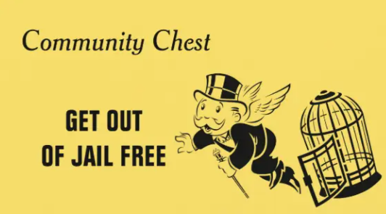
We saw in the previous article that federal parole was abolished in 1987. Reduction of time for good behavior can net a prisoner up to 54 days per year of their imposed sentence in the Status Quo. Many advocate for increasing the opportunities for further sentence reductions, either by restoring federal parole or by increasing the good behavior credits. Reductions could also be granted based on participation in rehabilitation or educational programs.
Another avenue of release is clemency. This occurs under Article II Section 1 of the Constitution, where the President is empowered to offer commutations (reduction in sentence) and pardons (elimination of punishment and other consequences) for federal crimes. This is an absolute, unconditional and unchecked power of the President that cannot be vetoed, reviewed, or denied by anyone else. The President can pardon anyone, at any time, for any federal crime, including before they have been charged, before they have been convicted, after they have been convicted, or after they have served their sentence. Perhaps policies could be enacted to increase the number of presidential pardons granted to federal prisoners as a means of correcting some of the perceived injustice of overly harsh sentencing. The Founders intended for pardons to be used as a safety valve to correct unjust results coming out of the judicial system. Pardons and commutations are rare events and most clemency requests that come to the President are denied.
For those whose sentences are not commuted or pardoned, prisoners approaching their end dates normally will enter a “Residential Re-Entry Center,” better known as a “halfway house,” to finish out their sentence. This community-based residence is not a release from punishment but a program of transition, where inmates get access to programs and assistance at finding jobs and re-entering normal society.

Appeals and exonerations
Most federal prisoners would, if asked, like a second or third chance at having their case re-tried or re-examined in the hope of reducing their sentence or being found not-guilty. For most of them, this will never happen. Appeals from the federal district courts (where trials or plea bargains are adjudicated) to the federal Circuit Courts of Appeal must be based on some identifiable error in the process that led to their conviction. Examples include: Incompetent defense attorney, mistakes in procedure by the district court judge, misconduct by the prosecutor, violation of constitutional rights, etc. Simply asserting “I’m innocent of the crime!” is not a grounds for appeal, even if it were factually true.
But since courts are run by humans and humans are fallible, we should not expect courts to adjudicate guilt with 100% accuracy. It can happen and it has happened that prisoners some time after their conviction may be exonerated and proven innocent of the crime. You should note that this happens with greater frequency in the state systems than in the federal system, so be careful with your evidence and support for arguments involving reform in this area. The federal government already has on the books today a program of financial compensation for wrongfully convicted prisoners upon their release. Some argue that because this correction of a mistake is not possible with the death penalty, capital punishment should be abolished.

Philosophy and goals of the prison system
What’s the goal of a prison system and what is it supposed to accomplish? That value debate/LD question itself is likely to be debated this year as the subtext to various specific policy reforms. Negative debaters should be briefed on the various alternatives so they can oppose the Affirmative at the deeper philosophical level, and as a generic position that can be used against plans for which specific evidence is not available. There are multiple possible objectives of a prison system, some of which may be mutually exclusive (you can debate that), and Negatives can argue that an Affirmative plan promoting one of these goals is bad because it moves us away from a different (better) goal.

Justice / Retribution
Prison (or any punishment) expresses society’s sense of justice, outrage, and retribution for those who threaten public order, menace public safety, or cause damage to others. Prison fulfills the goal of simply upholding what’s right, fair and just to maintain an orderly society.

Deterrence
Prison can deter crime (prevent it before it happens) in two ways. First, the prisoner himself may regret his actions upon finding himself in his unhappy imprisoned condition and resolve never to do again whatever it was he did that landed him there. Second, the existence of prison (or any other type of punishment) may motivate potential offenders to reconsider their actions and dissuade them from committing crimes if they fear the consequences.

Incapacitation
As long as bad guys are locked up, they are incapable, incapacitated, from posing any further threat to society. Prison and the death penalty are the only two punishments that can accomplish this goal.

Rehabilitation
Most (96%) of the federal prison population will at some point be released back into society. The prison system may have a duty and a goal to rehabilitate them so as to change their mindset, give them some useful skills, or otherwise mold them into potentially law-abiding and productive members of society.
In conclusion, there are likely numerous other areas of research you should pursue under this year’s resolution. But we hope this overview gives you a useful introduction to the topic and helps guide you on that journey.

We left out the indictment process from the chart. The 5th Amendment requires a grand jury indictment before someone can be charged with a federal felony. We left this out of the chart because: 1) indictments aren’t required for misdemeanor federal offenses; 2) most federal felonies are handled by plea bargain, which often bypasses the need for an indictment; 3) it happens pre-conviction, so the indictment process has no bearing on this year’s resolution, and its discussion would add several more pages of unneeded complexity to this introductory article about the resolution.
Federal prosecutors are also known as “U.S. Attorneys.”
DC has local ordinances like any city or state, which are not specifically federal laws. Violators of those ordinances, however, are prosecuted by federal prosecutors and those found guilty are sent to federal prison.
In 1974, Pres. Gerald Ford pardoned Richard Nixon before Nixon was charged with any federal crime. In 2001, Pres. Clinton pardoned Patricia Hearst 22 years after she left prison following her conviction for bank robbery. Her seven-year prison sentence imposed in 1976 had been commuted by Pres. Carter, who freed her in 1979. Hearst’s situation was a rare scenario of getting a commutation from one President and a pardon from another.

