Season 22
—
Debating the 2021-2022 NCFCA Policy Resolution

Policy debaters must have a solid understanding of the history of the year’s topic of study. The purpose of this article is to give competitors the underlying knowledge of that history while relating it to the following resolution:

Resolved: The United States Federal Government should significantly reform its policies regarding convicted prisoners under federal jurisdiction

Table of Contents
History of Federal Prisons & Prisoners 2
Origin of federal criminal law 2
Post-Civil War Expansion 3
Post-Depression Expansion 4
The War on Drugs 5
Federal Death Penalty 7
Crime Rates and Crime Policies 8
First Step Act of 2018 9
Worksheet: History of Federal Prison Policies 11
Answers 12

Content collected and written by Vance Trefethen.

History of Federal Prisons & Prisoners
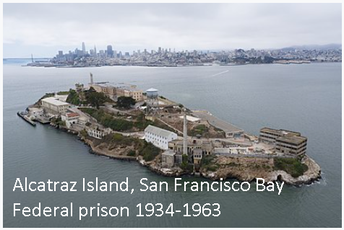

NCFCA 2021-2022 Policy Resolution
Resolved: The United States Federal Government should significantly reform its policies regarding convicted prisoners under federal jurisdiction
This year’s resolution calls our attention to federal prisons and prisoners. Past resolutions, perhaps over-broadly written, included the entire federal criminal justice system; but this resolution wisely restricts itself to one segment of that system. Let’s review the history and background of federal prisons and prisoners, along with some of the terminology in order to be able to debate this topic more effectively.

Origin of federal criminal law
When the US federal government was established by the ratification of our Constitution in 1789, there were no federal crimes. Criminal justice was handled entirely by the 13 newly independent states, which had existing laws and procedures on the books that they carried forward after separating from Britain. The first Congress enacted laws defining a minimal set of federal crimes and, in many cases, also legislating the associated punishments.
But in that age, it was rare that the average citizen, or even the average criminal, would encounter the federal criminal justice system. Federal crimes were mostly limited to specific bad things a person might do in their interaction directly with the federal government itself. Examples included treason, tax evasion, counterfeiting, bribing federal officials, or perjury in federal court. With some limited exceptions, the federal government had no mandate in the Constitution to go after “ordinary” crime, “street” crime, or the other types of everyday offenses that we associate with keeping our neighborhoods and streets safe. Those were left to the States.
But there were some exceptions, which still apply today and may affect your debating, where the federal government did have to concern itself with “ordinary” law and order. One was in US-owned territories that were not yet admitted to the Union as States, where Congress has plenary jurisdiction under Article IV of the Constitution. Another is the District of Columbia, over which Congress also has plenary jurisdiction according to Article I Section 8. Congress also has power to define crimes committed in the military services and to operate prisons to contain those convicted. And Congress also has jurisdiction over crimes committed on Indian reservations.

Post-Civil War Expansion
National crises always seem to expand (more or less permanently) the scope, size and power of the federal government. Some legal and cultural events following the Civil War did just that, in regard to the federal government’s role in criminal justice and the accompanying growth of federal prisons and prisoners.
Rapid industrialization and expansion of the network of railroads across the continent meant an increase in the number of things related to interstate commerce (Art. 1 Sec. 8) for which Congress could establish regulations and criminal laws. Post-Civil War Americans began to see themselves more as citizens of the nation rather than of their home state. And state sovereignty began to lose its shine, given the fractures that had led to the War and the ongoing failure of Southern states to respect the civil rights that were supposed to have been guaranteed to African-Americans in the 13th, 14th and 15th Amendments enacted in the aftermath of the War.
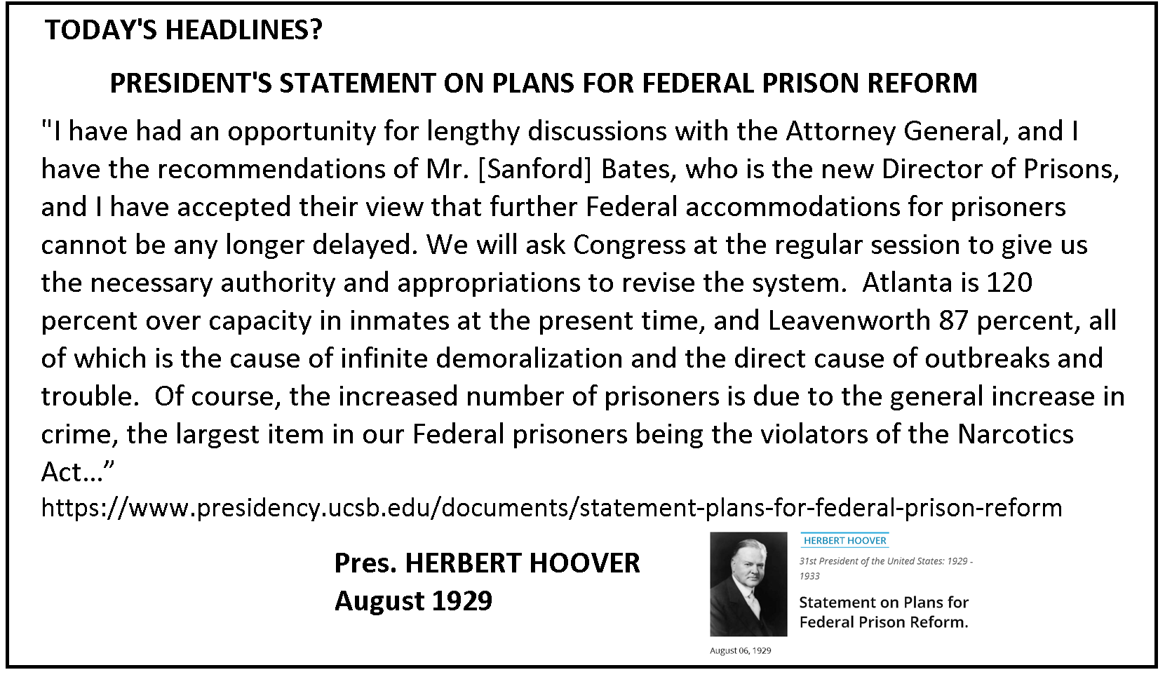
Congress began creating more federal criminal laws to deal with new, or newly discovered, social problems that formerly had been left to the states or simply ignored. Examples included crimes involving mail fraud, interstate transportation, unsafe food and drugs, the income tax, and the biggest of all: prohibition of alcoholic beverages (1920-1933).
The increasing number of federal crimes and federal prisoners led Congress to pass, in 1891, the “Three Prisons Act.” It created the first federal prisons (three, as you might have guessed), but three grew to 11 before long as the scope of federal criminal jurisdiction grew. As that growth occurred, the Justice Department (the federal cabinet-level department headed by the Attorney General) recognized a need for a dedicated organization to manage it. Federal prisons were filled far over capacity, morale was low, and conditions were poor. Pres. Herbert Hoover, in a quote sounding eerily like today’s headlines, reported these disturbing facts in 1929 and blamed them on high rates of crime, much of it related to illegal drugs. Congress responded in 1930 by creating the Federal Bureau of Prisons (BOP) within the Justice Dept.

Post-Depression Expansion
While Prohibition was repealed in 1933, Congress and federal law enforcement continued to find ways to create federal prisoners after drinking alcohol was no longer a crime. As with past crises, the Depression greatly expanded the scope of federal authority, concurrently expanding the scope of things that could be made into federal crimes. Labor laws, securities regulations, bank robbery, firearms, occupational safety, and many more things came under the expanding scope of federal criminal law. A growing view that the states were incapable of managing these issues led to greater reliance on the federal government. The federal government’s nearly infinite resources (they can print money, while states have to tax people for it) affords it a more robust enforcement and punishment apparatus. State legislatures might be happy to offload the costs of law and order away from the burdens they have to impose on their own taxpaying citizens. And some welcomed a uniform nationwide standard to replace patchworks of state laws that may or may not solve the social problems of the day. Imagine the compliance burdens and costs, and lost business opportunities, if all 50 states had separate laws regarding the issuance of corporate stock, with criminal penalties for selling stock in their state in violation of their laws.
An increasing focus on the menace of organized crime starting in the 1950s, with new federal criminal laws to match, accompanied stepped up federal law enforcement efforts during that era. But the 1970s brought about a new trend in federal prisons and their population.

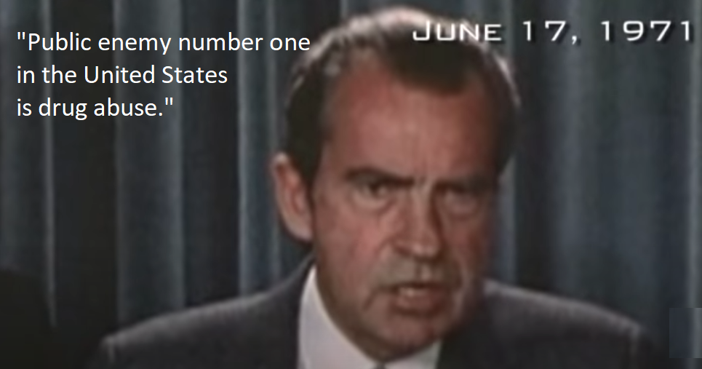
The War on Drugs
In 1971, Pres. Nixon came on TV and announced that “Public enemy number one in the United States is drug abuse.” Laws against recreational drugs were already on the books at both the federal and state level. But his announcement signaled the start of a massive effort to ramp up enforcement and solve drug use and addiction through the criminal justice system.
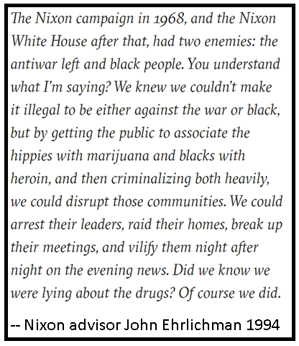
Happily, after 50 years of strict federal law enforcement, hundreds of thousands of convictions and prisoners, hundreds of deaths of citizens, drug dealers, and law enforcement officials, we can report that no one today uses illegal drugs and the problem has been solved. Not exactly.
In the 1980s and ‘90s, recognizing that the War on Drugs wasn’t being won, the federal government doubled down on the war effort.
“As a result of Federal law enforcement efforts and new legislation that dramatically altered sentencing in the Federal criminal justice system, the 1980's brought a significant increase in the number of Federal inmates. The Sentencing Reform Act of 1984 established determinate sentencing, abolished parole, and reduced good time; additionally, several mandatory minimum sentencing provisions were enacted in 1986, 1988, and 1990. From 1980 to 1989, the inmate population more than doubled, from just over 24,000 to almost 58,000, and the number of federal prisons increased to 62. During the 1990's, the population more than doubled again, reaching approximately 136,000 at the end of 1999 as efforts to combat illegal drugs and illegal immigration contributed to significantly increased conviction rates. By the end of the decade, the Bureau was operating 95 institutions.”
These changes had substantial impact. Federal parole was phased out by 1987, such that prisoners convicted since then cannot get their sentence reduced by parole reviews. Federal prisoners must now rely on “good time” (a reduction of their prison time based on good behavior while imprisoned), and even with that, they will serve at least 85% of their sentence.
And those sentences are longer than they were before the 1980s. Congress slapped “mandatory minimum” sentences on various federal crimes, requiring offenders to serve lengthy time with no chance of leniency by judges and no chance of early release by parole.
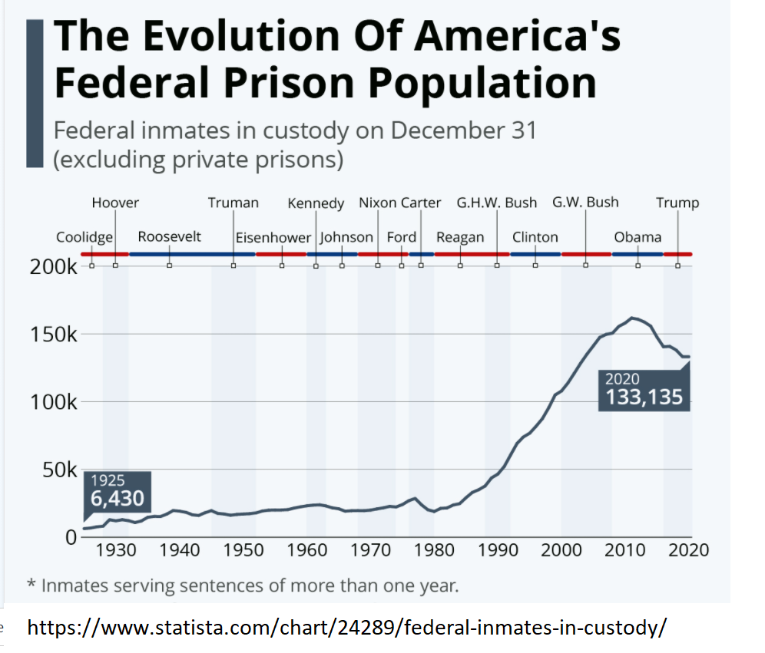

Federal Death Penalty
The death penalty has been part of the federal criminal justice system since 1790, when Congress specified it as the punishment for some of the first federal crimes. It came into question, however, in the 1960s and early 1970s as doubts about the fairness of its application began to arise. In 1972, the Supreme Court ruled in the case of Furman v. Georgia that the death penalty as it was then being practiced was unconstitutional. It did not rule out, however, that it could be practiced in a manner consistent with the Constitution, and allowed for its reinstatement.
The Furman case invalidated existing death penalty statutes and forced the federal government and the states to halt executions for several years. Miraculously, all the problems were fixed in just four years, as we discover in the 1976 case of Gregg v. Georgia, when the Supreme Court ruled that capital punishment could safely be reinstated. Numerous states quickly did so.
The federal government waited until 1988 to reinstate the death penalty for a limited number of crimes. But in 1994, responding to the popular mood to get tough on crime (crime rates in the U.S. were peaking at that time), Congress passed the Federal Death Penalty Act. It named 60 federal crimes as eligible for the death penalty. And these death sentences, since they happen at the federal level, can be imposed on convicted criminals who lived and committed their crimes in states that do not have the death penalty.
But despite the tough talk, federal executions are rare. There have only been 50 federal executions since 1927, and of those, 13 of them were in the last 6 months of the Trump administration. There are currently 46 prisoners awaiting their fate on death row at the federal prison in Terre Haute, Indiana. In July, 2021, Attorney General Merrick Garland announced a Biden administration policy of suspending federal executions. This suspension does not, however, repeal the federal death penalty (only Congress can do that), nor does it prevent these prisoners from facing their sentence at some future time, perhaps under a different President. Pres. Biden could, if he wished, commute the sentences of all current death row prisoners and change their status to life imprisonment or some other lesser punishment.

Crime Rates and Crime Policies

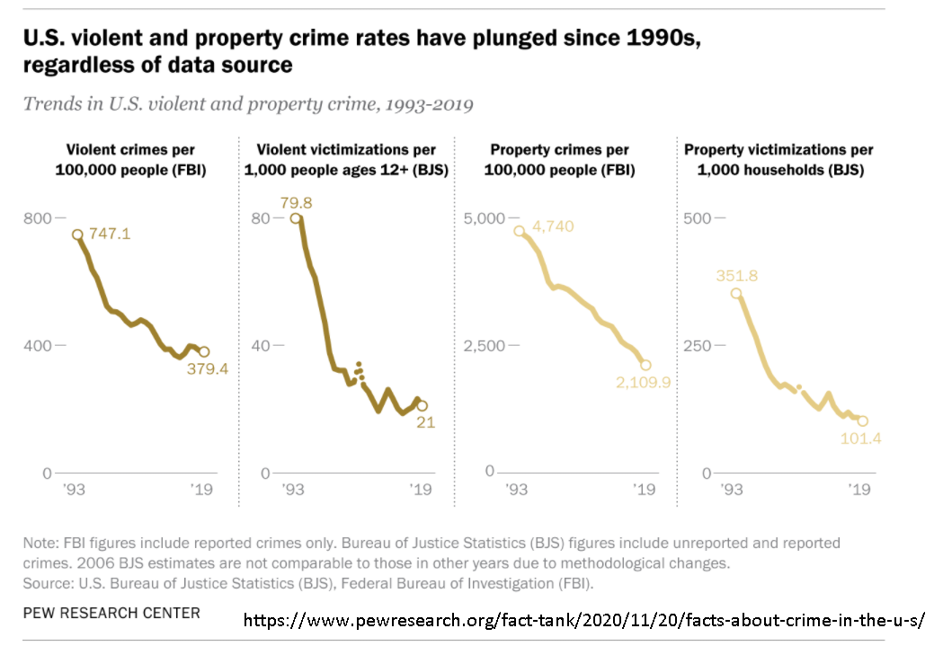
Crime rates peaked in this country in 1993 and declined dramatically in the 25 years following. No one knows for sure why. Some believe the tough-on-crime mentality that kicked in during the ‘70s and ‘80s bore fruit and took enough bad guys off the streets to make a substantial difference in public safety. Another theory matches the age of likely offenders (young adults commit a lot more crime than old folks) with the population movement through time of the “Baby Boom” generation (those born between 1946-1964). The mid-1990s is right where the youngest remaining Baby Boomers would be entering their 30s in age, and no longer as likely to commit crimes. Another theory is the federal mandate for new cars starting in the 1975 model year to burn only unleaded gasoline, which substantially reduced the presence of lead in the bloodstreams of Americans after that year. It is possible the reduced lead levels in the generation of young people that was born or grew up following that event produced better mental capabilities by eliminating low-level lead poisoning, leading to lower crime rates. Others have remarked that 1993 coincides with the 20th anniversary of the Roe v. Wade decision, in which the Supreme Court declared abortion to be a constitutionally protected right. Some believe that a generation of “unwanted” babies that wasn’t born due to increased availability of abortion would have been prone to crime had they been born, and their absence reduced the crime rate. I am not endorsing or agreeing with any of these theories or policies, simply pointing them out.
There are probably any number of other theories, and whatever the correct explanation is might well be a combination of factors, not simply one unique event. However, they matter to the extent that the debater must be careful not to confound correlation with causation. “We increased prison sentences, and crime went down, therefore tough prison sentences reduce crime” may or may not be true. The two happened in that order, but we don’t know whether one caused the other.

First Step Act of 2018
It appears the pendulum may have begun swinging back the other direction from the tough-on-crime mentality regarding federal prisons and prisoners. In 2018, Pres. Trump signed the “First Step Act,” a bipartisan bill passed by Congress that was designed to increase the focus on rehabilitation and reform and reverse the previous trend toward lengthy punishment. It contained four key categories of reform:
1) Recidivism reduction evaluations, programs and incentives to reduce the likelihood of prisoners returning to crime after their sentences are completed.
2) Modified mandatory minimum prison sentences for some drug traffickers, including retroactive reductions for some.
3) Reauthorized substance abuse treatment programs and transitional service programs, as well as placing some elderly and terminally ill prisoners on home confinement.
4) A miscellaneous list of smaller reforms, including:
- Prohibit use of restraints on pregnant women inmates
- Good time calculated so prisoners can earn 54 days / year of imposed sentence
- BOP to place prisoners within 500 driving miles of their primary residence
- Allow Federal Prison Industries to sell products to public entities for use in correctional facilities, disaster relief, or emergency response, to the District of Columbia government, and to nonprofit organizations
- Prohibit solitary confinement for juveniles in federal custody
- Helping prisoners obtain identification before release
In the next release, we will discuss current issues debaters will encounter this year regarding policy concerns about federal prisons and prisoners.

Plenary = full, complete. Congress can make laws for US territories that are not part of any State and run them as if Congress were their State legislature. They often delegate power to local legislative bodies, but Congress never gives up its sovereignty over territorial laws and can exert its power at any time. For example, if Congress wanted all the STOP signs in Puerto Rico to be purple instead of red, they could pass a law making it so; but they could not do that for Florida.
Federal Bureau of Prisons https://www.bop.gov/about/history/
A number of states also phased out parole during that time as well, starting with Maine in 1976. Today 16 states have mostly or completely abolished parole.
And territories, like Puerto Rico.
Its cumbersome official name is “Formerly Incarcerated Re-enter Society Transformed Safely Transitioning Every Person Act.”
List is adapted from Congressional Research Service at https://crsreports.congress.gov/product/pdf/R/R45558
Retroactive = reaching back in time. Some prisoners who were sentenced years ago are now having their sentences modified to match what the prisoner would have gotten if they had been convicted today instead of under the old rules. If they have already served time equal to the new reduced sentencing rules, they can be set free.

