Season 22
—
Debating the 2021-2022 Stoa Policy Resolution

Policy debaters must have a solid understanding of the history of the year’s topic of study. The purpose of this article is to give competitors the underlying knowledge of that history while relating it to the following resolution:

Resolved: The United States federal government should substantially reform the use of Artificial Intelligence technology

Table of Contents
History of Artificial Intelligence 2
It all began with the abacus 2
World War II and the necessity of invention 4
Talking about my generation 4
Early AI concepts and initial development 5
AI decision-making 6
Deep learning 8
AI in today’s world 10
Worksheet: History of Artificial Intelligence 13
Answers 14

Content collected and written by Tracey Eagan and Vance Trefethen.

History of Artificial Intelligence
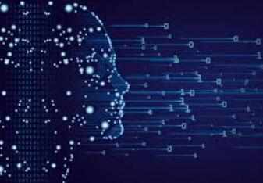

Stoa’s 2021-2022 Policy Resolution
Resolved: The United States federal government substantially reform the use of Artificial Intelligence technology
This year’s resolution calls our attention to the use of artificial intelligence technology. This is an unusual topic never before pursued by the homeschool debate leagues, although a few cases may have touched the edges of it over the years. Let’s review the history of computing technology and artificial intelligence so that you can understand the background and some of the terminology in order to be able to debate this topic more effectively.

It all began with the abacus
The goal of expediting rote manual tasks of the human body goes back to prehistoric inventions like the wheel, inclined plane, and pulley. Expediting tasks of the human mind took longer, but developed with inventions like writing, decimal numbers and machines to help with mathematical calculations. The first of these was the abacus.
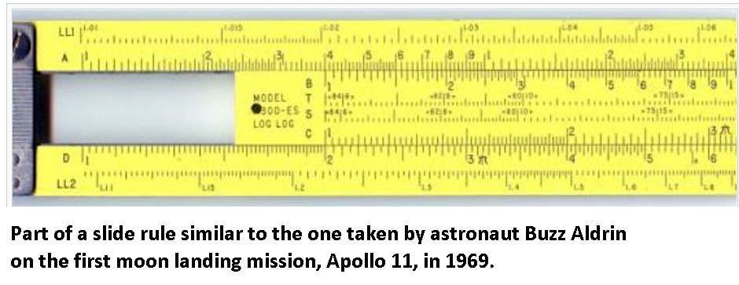
“The history of computers begins with the birth of (the) abacus which is believed to be the first computer. It is said that Chinese invented abacus around 4,000 years ago.”
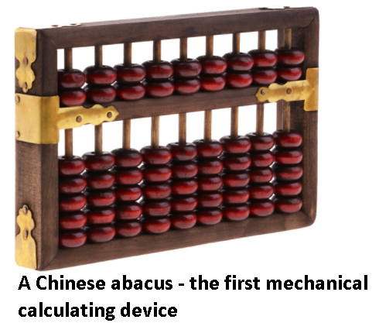
The slide rule was invented in the 17th century and became a mainstay of science, engineering, and mathematics for 300 years. Slide rules featured prominently (and with historical accuracy) in the movie “Apollo 13,” set in 1970, as NASA and its contractor engineers feverishly do calculations to determine the trajectory of a damaged spacecraft. By the time Coach Vance learned how to use one in 1977, they were obsolete and had been replaced by the hand-held calculator.
But these tools, useful though they were, still relied on human brainpower and manual manipulation to solve mathematical problems. The Industrial Revolution in the 1800’s began awakening man’s understanding of what machines were capable of doing. In the early 1820’s, Charles Babbage, who is known as “Father of The Computer,” designed but never successfully completed in his lifetime, a steam-driven mechanical computer that could perform simple calculations. In 1890, Herman Hollerith invented a tabulating machine that could sort and count data using punched cards. It demonstrated its value by processing the data from the 1890 U.S. Census. Hollerith also started the business that later became known as IBM.

World War II and the necessity of invention
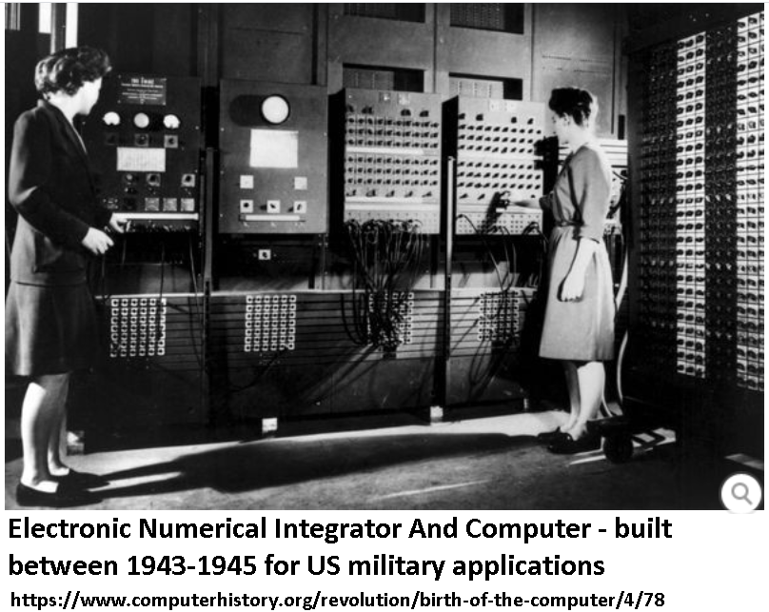
Wars come at an awful cost to humanity, but out of the necessities they bring, sometimes useful and beneficial inventions arise. World War II motivated engineers and mathematicians in the U.S. to develop (by today’s standards) a primitive computer to calculate ballistic trajectories. In Britain, mathematician Alan Turing helped win the war by developing a computer that was able to decrypt the “Enigma” code used by the German military. The U.S. effort to build the first atomic bomb, the “Manhattan Project,” also used early computers and stimulated advances in the field to meet the necessities of its pioneering research and the urgency of achieving its results before any foreign power could do so first. The “Mark 1,” the world’s first programmable computer, came out of the Manhattan Project in 1944 and was based on Charles Babbage’s old designs from the 19th century.

Talking about my generation
In the years of industrial growth and technological development following World War II, computing power began to grow. Several “generations” of computer technology led to faster processing and larger capacity with each new advance.
1946-1959 First generation computers coming from World War II technology; these were slow, very large and expensive.
1959-1965 Second generation computers used transistors instead of vacuum tubes. Since transistors were less expensive and smaller, it made second generation computers faster.
1959-1971. Third generation computers used integrated circuits (IC’s) which increased the power of a computer and were less expensive. These computers were more reliable, better able to perform and smaller. High-level programming languages like FORTRAN and COBOL began to be used.
1971-1980. Fourth generation computers used very large scale integrated (VLSI) circuits. These were chips containing millions of transistors and other elements that made these computers smaller, more powerful, fast and affordable. Computing power began to become small enough and affordable enough for people to begin buying the first computers for home use.
1980’s-present day. Fifth generation computers replaced VLSI technology with ULSI (Ultra Large Scale Integration). These computers can use parallel processing hardware and AI (Artificial Intelligence) software.
The rapid growth of computing power was summarized in a maxim known as “Moore’s Law,” which suggests that computing power doubles every two years.
“Gordon Moore’s 1965 forecast that the number of components on an integrated circuit would double every year until it reached an astonishing 65,000 by 1975 is the greatest technological prediction of the last half-century. When it proved correct in 1975, he revised what has become known as Moore’s Law to a doubling of transistors on a chip every two years. Since then, his prediction has defined the trajectory of technology and, in many ways, of progress itself.”
This matters because Artificial Intelligence requires huge amounts of computing power to process the quantities of data with the speed necessary to accomplish anything important. We are now, in the last few years, finally arriving at the point where computer speed and capacity can process information at a rate that makes Artificial Intelligence a viable commercial possibility for numerous applications.

Early AI concepts and initial development
Alan Turing prophetically proposed in 1950 that computers would come closer to doing what humans are able to do and suggested a test to determine when they had succeeded. Known as the “Turing Test,” it’s a contest between a human interrogator, a computer and another human. The computer passes the test when an interrogator who cannot see the responders asks the same question, both a human and computer respond in writing, and the interrogator cannot (more often than chance) guess which is the human responder and which is the computer.
The term “Artificial Intelligence” (AI) was first used in 1956 by Prof. John McCarthy:
“In the year 1956, John McCarthy (computer scientist), a renowned professor of mathematics at Dartmouth College, came up with a proposal about a research project with a basis on the belief that every element of learning or other features of intelligence can principally be so accurately described to enable simulation by a machine.”
As a result of that project, research laboratories focusing on artificial intelligence technology emerged at leading universities including Stanford and MIT. The research mainly focused on computer chess, natural language communication and robotics. In 1958, McCarthy invented the computer programming language LISP, which is still in use today in the field of AI.
In the 1960’s, the U.S. Department of Defense took interest and began training computers to mimic basic human reasoning. The Defense Advanced Research Projects Agency (DARPA) completed street mapping projects in the 1970’s and produced intelligent personal assistants in 2003, long before Siri or Alexa. They also developed in the 1960’s the technology that became known later as the “internet.”
This early work paved the way for the automation and reasoning we see in computers today. Artificial Intelligence has become more popular due to increased data volumes, advanced algorithms and improvements in computing power and storage. Artificial Intelligence is now able to provide many specific benefits in nearly every industry.

AI decision-making
What separates AI from other forms of computer skill or processing is that AI expects the computer not only to calculate but to make decisions and choices based on the input it receives and to make those decisions and choices as well as or preferably better than a human would make them if presented with the same scenario of input data. For example, a spreadsheet program on your home computer can add up the list of numbers in a column and put the resulting sum in a field at the bottom of the sheet. It will not tell you what decisions you should take based on that resulting output, because it’s merely computing, not doing artificial intelligence. A small function calculator could have done the same thing.
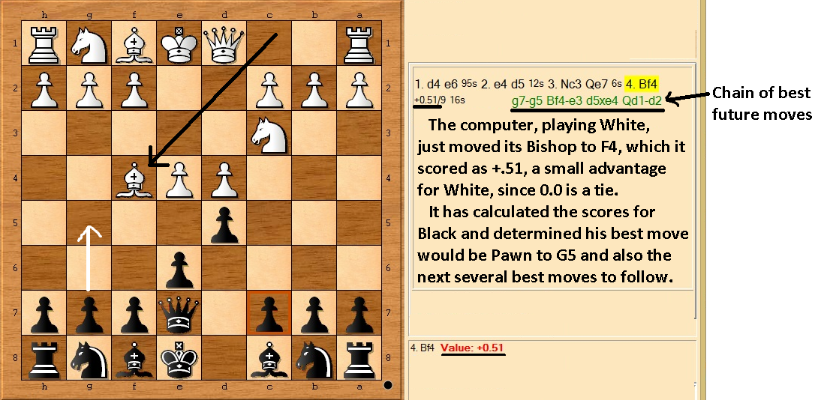
Artificial intelligence at the most basic level uses formulas and a lengthy series of “if/then” choices to try to imitate what humans do when making decisions. Chess is a good example of programming a computer to make decisions as a human would. Chess has trillions of potential situations, moves, choices and decisions that could be made. No human being has ever seen every potential chess position. When faced with a situation on the board, the decision about what move to make depends on a lot of variable factors that an experienced player evaluates in his mind in a few seconds. A computer programmer might attempt to reduce all of these to a list of if/then statements and assign scores to the amount that this factor should weigh in making the decision about a potential next move. If there are 100 possible legal moves in the current board position, the programmer will give the computer instructions to go through every legal move and score it with numbers to simulate how a human chess player would evaluate it. A very oversimplified analysis might be something like this:
“If the move allows opponent’s next move to checkmate me” -1000
“If the move allows me to capture opponent’s Queen” +300
“If the move loses a pawn” -25
“If the move captures a bishop” +100
“If the move links pawns in a better pawn structure” +15
“If the move puts a pawn on the 7th row” +150
“If the move loses a rook” -150
Etc., going through all the possible things we can think of that influence whether a move on a chess board is “good” or “bad.” Each potential move gets a final score and all 100 moves are compared. The one with the best score is chosen as the computer’s next move.
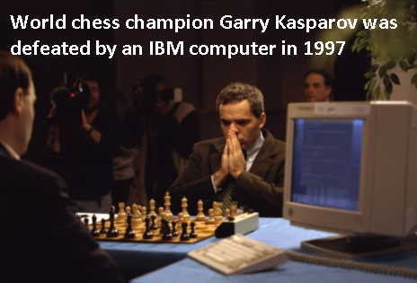
As computing power increases, computers can look more and more moves ahead. And since they do not get fatigued, they will evaluate board positions with the same accuracy every time, unlike human players, who get tired and may overlook key possibilities. This ultimately led to the 1996 and 1997 matches between world chess champion Garry Kasparov, to showcase the arrival of sufficient computing power and artificial intelligence to mimic and even exceed human capabilities. Kasparov won the 1996 tournament (though he did not win all the games), but was defeated in the 1997 rematch after the programming was improved.
This process of scoring and decision-making obviously can be applied to many other situations. But the development of AI hasn’t stopped there.

Deep learning
The next step in AI is having the computer analyze large amounts of data, develop the scoring and pattern recognition by experience with past outcomes, and use lessons learned to make new or better decisions in the future. This leads to the concept of “Deep Learning.”
“Deep learning is a type of machine learning that trains a computer to perform human-like tasks, such as recognizing speech, identifying images or making predictions. Instead of organizing data to run through predefined equations, deep learning sets up basic parameters about the data and trains the computer to learn on its own by recognizing patterns using many layers of processing.”
By using these technologies, computers can be trained to perform tasks by processing data and recognizing patterns in the data.
“Deep learning craves big data because big data is necessary to isolate hidden patterns and to find answers without over-fitting the data. The more good quality data you have, the better the results.”
In the case with Kasparov and IBM above, the programmers themselves took lessons learned from the 1996 match, changed the software a bit, and then won the rematch in 1997. But what if the computer’s own software were programmed to learn those lessons and improve itself, by itself?
Google developed such a chess program, AlphaZero, just a few years ago. Its programmers gave it no scoring or strategy guidance at all, just the rules of the game. With fast processing computer power, AlphaZero played millions of games against itself, making any combination of legal moves with no strategy at all, and developing its own history of how successful the moves were, based on won/loss records. After “learning” with its own massive database of successful and unsuccessful moves, it began making moves similar to those used by grand masters, since humans over the centuries also found that those moves more likely lead to success. But it also developed strategies that no one had ever seen before. In a tournament against the best human-designed chess program, AlphaZero won handily, sometimes making bizarre moves that were ultimately successful. Some described it as making moves that were neither human nor computer but as if an “alien” intelligence were playing chess.
Natural language processing (NLP) is a branch of AI that helps computers understand, interpret and manipulate human language. NLP makes it possible to do things such as converse with virtual assistants like Siri or Alexa, read automatic transcripts of voicemail or navigate a website using the built-in search bar.
Researchers are working on Natural Language Understanding (NLU) which will help computers go beyond the structural understanding of language to understand the intended meaning of human speech or written word. NLU algorithms must tackle the complex problem of understanding all the subtleties, context and inferences that humans comprehend. Try talking to Alexa in a sarcastic tone, she will remain just as sweet. But imagine the possibilities that will open up when an algorithm can understand the meaning and nuance of human speech.

AI in today’s world
Artificial Intelligence is a divisive subject. Some say it is the solution to everything, others say it will be the end of humanity. One thing is for certain though: AI is here to stay and its impacts are everywhere.
Businesses increasingly will use AI because it can work 24/7 to improve productivity and can do human-like tasks much faster than humans can do them. If businesses find ways to use AI to cover mundane tasks then people are freed up to do higher level tasks. They might also find it profitable to discharge the employees who used to do those mundane tasks, once their jobs have been replaced by AI.
“Virtual Assistants” like Siri, Alexa and Cortana are gaining popularity due to the convenience they provide. Amazon’s Echo uses speech recognition and NLP to perform a wide range of tasks on user’s commands. Virtual assistants can play your favorite songs, book cabs, order food and check the weather, as well as many other tasks.
Some of the most advanced form of applications of artificial intelligence in the real world are being implemented in “smart homes.” Devices like smart locks and smart switches are becoming more compatible with various devices. Smart home applications are becoming more accessible to the general public daily.
Healthcare research is being done to use AI to analyze data and discover patterns that could lead to improved medical care. AI applications can provide x-ray readings, remind you to take your medicines or even help you remember to exercise. In some cases, AI applications have been known to provide operating assistance to doctors, and even perform surgery themselves.
Transportation is another area with wide potential for AI use. Although self-driving vehicles are not yet the norm, everyone believes they soon will be. Some cars already use AI-powered safety functions like assistance with parking and detection of nearby hazards. Google Maps can analyze the speed and movement of traffic at any given time, thus reducing commute time to your destination.
Airlines already use AI to improve air safety and airplane maintenance, to improve customer service, to handle crew management and to cut waste on food and fuel. But can AI replace the pilots? Data-driven sophisticated algorithms will have an enormous impact on more advanced technology such as autonomous vision-based navigation, or planes flying without pilots on board.
On January 16, 2020, Airbus completed the first fully automatic vision-based take-off and landing within the framework of its Autonomous Taxi, Take-Off and Landing (ATTOL) project. The AI-controlled take-off was governed by image-recognition software installed on the aircraft. However, Airbus has stated that its goal is for autonomous technologies to improve flight operations and over-all performance, not to replace pilots in the cockpit. Several other aircraft manufacturers including Boeing are working on using AI technologies to improve flights. However, the lack of public trust in automated systems may keep human pilots in the cockpit for many years to come.
Space exploration is another fruitful area of research, particularly given the lengthy distances, long time required, and extreme hazards of humans venturing into space. After rigorous research, astronomers used AI to sift through years of data obtained by the Kepler telescope to identify a distant eight-planet solar system. AI is also being used for NASA’s rover mission to Mars. The AEGIS, an AI-based rover, is on the red planet using autonomous targeting of cameras to explore it.
National defense and security are increasingly relying on AI. Military drones are remote controlled vehicles (with a human remote pilot, at least today) that carry out many tasks. They can channel video and audio communication to ground troops and military bases, track enemy movement and conduct reconnaissance in unknown areas of a war zone, assist with mitigation procedures after a war by searching for lost or injured soldiers, and attack enemy targets. They also aid in border surveillance. AI can assist in all of these tasks or even begin taking them on autonomously with no human remote pilot.
The first successful well-known use of AI weapons was in 1991, when the US used smart bombs and other smart weapons against Iraq in Desert Storm. Bombs become “smart” when, after a human pushes the button to launch them, they can conduct measurements while in flight and make adjustments to their course in real time to improve the likelihood of hitting their target.
The US Defense Department has plans to push AI in every corner of the military, including operations, training, sustainment, force protection, recruiting and healthcare. And military applications of AI are becoming more sophisticated. A recent joint exercise by US and British forces involved remotely controlled robots clearing a path for forces, supported by armored vehicles. The unmanned systems disabled land mines and built a land bridge, enabling infantry to navigate a tank trench.
The ongoing evolution of AI is definitely revolutionizing the battlefield with automated weapons. And other nations, like South Korea, China, Russia, India and Israel, are making significant investments in AI for military purposes. South Korea has developed Samsung SGR-A1, a sentry gun that can track movement and fire without human intervention. They are using it at their border. China is developing AI cyber weapons and killer robots. Russia is developing tanks and drones which will be able to operate autonomously. Israelis have IAI Harpy systems, trained to keep monitoring along with detecting and engaging targets. India is developing robots for their armed forces that can function as a team. This includes a wheeled robot with passive suspension, snake robots, legged robots and wall-climbing robots.
AI in modern warfare may be the next big technological revolution, changing strategies and the calculus of casualties, civilian and military, just as did previous technologies like the long bow, gunpowder, the machine gun, the airplane, and the atomic bomb.
In the next release, we will discuss current issues debaters will encounter this year regarding policy concerns about the use of artificial intelligence technology.

javapoint.com/history-of-computer
One of the Mark 1’s programmers was Grace Hopper of the US Navy, who retired in 1986 at age 79 with the rank of Rear Admiral. She invented the term “bug” for a computer problem after finding a moth causing trouble inside the Mark 2 version of the computer in 1947.
https://www.technologyreview.com/2020/02/24/905789/were-not-prepared-for-the-end-of-moores-law/
bestaiproducts.com/how-ai-technology-work
An algorithm is a process or set of rules to be followed in calculations or other problem-solving operations, especially by a computer.
Way oversimplified. Modern chess engines look multiple moves ahead and score each move not just by what it does but based on what the best opponent move would be after that, what the best computer move would be after that, what the best opponent move would be after that… etc., and then pick the one with the best score after all those evaluations are done.
https://www.sas.com/en_us/insights/analytics/deep-learning.html#:~:text=Deep%20learning%20is%20a%20type,identifying%20images%20or%20making%20predictions.
Wayne Thompson, SAS Product Manager
https://www.technologyreview.com/2017/12/08/147199/alpha-zeros-alien-chess-shows-the-power-and-the-peculiarity-of-ai/
https://www.nytimes.com/1991/02/26/science/invention-that-shaped-the-gulf-war-the-laser-guided-bomb.html

