Introduction to Lincoln-Douglas Debate for Season 22
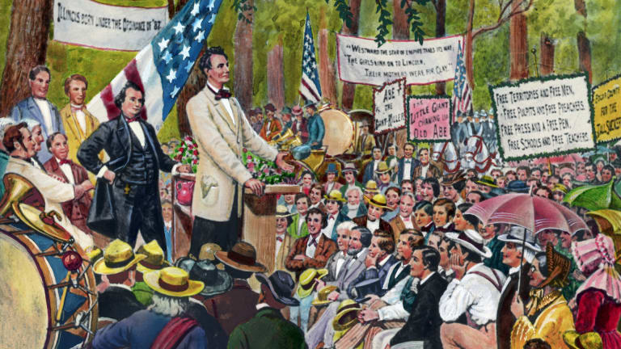
Debate is a sport, a competition of the mind, that brings out the best from students.
Lincoln-Douglas debate resolutions are published by participating leagues. Students planning to participate in tournaments will prepare affirmative and negative cases responding to the resolution they will be debating. At the tournament, postings show which side the students will be on. They enter the room, introduce themselves to the judge or panel of judges, and then go through speeches to commence the debate round. The judge renders a balloted decision and awards speaker points to the debaters.

Reasons for Lincoln-Douglas Debate
As stated, the “Lincoln” and the “Douglas” in the name from LD are Abraham Lincoln and Stephen Douglas. The two competed for the senate seat of Illinois in 1858. As part of their campaigning, they scheduled a number of one-on-one debates throughout Illinois. The debates became quite popular, attracting thousands of people to gather in the hot sun and hear the two politicians argue over political issues of the day. Slavery — or, at least, whether Illinois should be neutral in the divisive issue of the times — was one such issue that separated the candidates. Lincoln lost the election, but historians credit the Lincoln-Douglas debates as training grounds for Abe’s successful run for President of the United States.
In the same spirit, Lincoln-Douglas debate students participate in one-on-one debates for judges. Most leagues differentiate from the political nature of the original debates and focus instead on the values of the debate. Some areas of the country and some collegiate leagues adopt “Lincoln-Douglas Policy,” meaning they adopt policy resolutions within a one-on-one format.
There is much to be gained from learning value debate. The league assigns a resolution of value, meaning there are reasons both sides can give to justify the side they are arguing. The debaters persuade the judge to either affirm the resolution (that is, declare it is right) or negate the resolution (declare that it is not right).
You will want to visit your league’s website to read the resolution that you will be preparing for competition. Tournaments often will list the resolution on their invitation, and sometimes ballots have the resolutions printed at the top. Here are some examples of Lincoln-Douglas debate resolutions:
- Resolved: When in conflict, governments should value fair trade above free trade.
- Resolved: Criminal procedure should value truth-seeking over individual privacy.
- Resolved: Civil Disobedience in a democracy is morally justified.
Pause and reflect on what debaters learn from this activity. You can imagine the discussions that follow these debates. All of these resolutions challenge the conscience of the debaters, pushing them to embrace values that transcend conventional wisdom or even stated law. Students will explain complex philosophical dilemmas and advocate for wise decision making based on values they articulate. Lincoln-Douglas debate trains young people to not only do what is right, but to give a reason for what they choose. Arguably, there are few better activities that encourage students to think through the choices they make from day to day than Lincoln-Douglas debate.

Structure of Lincoln-Douglas Debate
LD debates are one-on-one timed sessions over the course of approximately 45 minutes. Students are assigned either the affirmative or negative side to the resolution, and tournaments try to have the debaters debate both sides evenly throughout. Here’s how rounds unfold:
- Affirmative Constructive (AC) - 6 min.
The affirmative gives a prepared six-minute speech presenting her case to the judge. This is followed by a three-minute cross-examination.
- Negative Constructive (NC) + First Negative rebuttal (1NR) - 7 min.
The negative builds a case of his own within the seven-minute timeframe, but also leaves time to rebut the affirmative’s case. This is followed with a three-minute cross-examination by the affirmative.
- First Affirmative Rebuttal (1AR) - 4 min.
The affirmative refutes the negative’s speech within four minutes.
- Second Negative Rebuttal (2NR) - 6 min.
The negative refutes the affirmative’s speech within six minutes.
- Second Affirmative Rebuttal (2AR) - 3 min.
The affirmative has the last word on the debate within three minutes.
Notice that each speaker gets the same amount of speaking time and the affirmative gets the first and last word. Both sides get to lead (ask) and follow (answer) cross-examination.

Example of a Lincoln-Douglas Debate
Recall that Lincoln-Douglas debate is “value” debate: philosophical in nature, not political or necessarily factual (or truthful). Students are tasked to analyze the resolution within the framework of a value. They have a burden to prove how their value best upholds or negates the resolution, depending on which side they are on (affirmative or negative).
One of the example resolutions above is stated, “Resolved: Criminal procedure should value truth-seeking over individual privacy.” All debaters will prepare cases both for (affirmative) and against (negative) this resolution. Judges will weigh the debating and declare which side best showed the resolution right or wrong. Consider how students and coaches will build their cases.
The affirmative side will try to convince the judge that criminal procedure should value truth-seeking even at the expense of individual privacy. They may value justice or the common good to justify times when individual privacy needs to be compromised for the sake of seeking the truth. Examples like search warrants or special courts that are set up to help law enforcement find the truth would be used to promote the affirmative side of the resolution.
The negative side will try to convince the judge of the exact opposite: that criminal procedure should value individual privacy even at the expense of truth-seeking. The negative may value justice, but sees it in the eyes of the individual being prosecuted by the state. Abuses of individual rights should not be justified in a just world, at least when considering criminal procedure, so the negative side of the resolution is more justified.
Do you see how this debate can unfold into a robust exchange? It’s impressive when you see a hot debate between two sharp debaters. As resolutions change, Lincoln-Douglas debaters prepare arguments and cases for tournaments and continue through the year in LD competition.

Resolutions for Season 22
At the time of this document’s publishing date (August 9, 2021), two of the three leagues (NCFCA and Stoa) have released value resolutions for the year of competition. These are the two leagues that Monument Members actively supports throughout the year. Other resolutions may have material written in the Libraries of the membership. For now, here are the two resolutions for NCFCA and Stoa debaters:
- NCFCA: "Resolved: In the context of innovation, the proactionary principle ought to be valued above the precautionary principle."
- Stoa: "Resolved: In the field of biomedical engineering, restraint ought to be prioritized over scientific advancement."
The overview for NCFCA and Stoa is currently available in the membership, and cases and briefs will begin releasing August 30, 2021.

