Negative Brief: Rendition
By “Coach Vance” Trefethen
“Rendition” is where agents of the US government (either CIA or military or something similar) are overseas looking for bad guys. When they find one, instead of arresting him through normal law enforcement channels and prosecuting him in court, they capture him and send him to some mysterious “black” site (possibly owned by another country) where he can be interrogated, tortured, or otherwise mistreated until he either gives up vital information or dies or everyone forgets about him. If the sites are owned by another country, the US can deny responsibility, since torture may not be against the law in the country we send them to, and the ones doing the torture may be US allies, not US employees themselves.
The Aff plan cancels all such “renditions.” One small problem: They were all canceled and ended in 2006.
Negative: Rendition 2
TOPICALITY 2
1. No “commitment” - It’s already been eliminated 2
Pres. Obama ended it immediately upon taking office in 2009 2
Overseas “Black Sites” have been shut down since 2006 2
No commitment to rendition because it’s already illegal under existing law: Public Law 105-277, 8 United States Code Section 1231 3
Impact: No possible topical affirmative plan 3
AFF’s evidence saying it “continues to this day” is from 2005. 4
2. CIA, not military 5
CIA created and operated the rendition program 5
Law says CIA is not military. They are not covered by the Uniform Code of Military Justice 5
Benefit of the doubt goes to the Negative. Geneva Convention, Article 50, says if you’re not sure, consider them a civilian 6
Impact: No Affirmative team means automatic Negative ballot 6
MINOR REPAIR 6
Declassify, study and have public accountability for mistakes of the past 6
HARMS / SIGNIFICANCE 7
1. A/T “Harms US relationships with allies” – Empirically denied. Claims of harm didn’t pan out 7
The Claim: Biden claimed in 2007 that rendition was harming US alliance with Britain 7
The Results: 14 years later, Biden is getting along fine with Britain – US/UK relations are doing great. 7
The Conclusion: Either the problem’s been solved or it never existed 7
DISADVANTAGES 8
1. Mistakenly labeling CIA civilians as military 8
AFF’s mislabeling of CIA civilians as if they were military violates a key principle in the Geneva Convention: “distinction” between military and civilian. 8
Impact #1: Turn the harms – values and principles are undermined by the AFF plan 8
Impact #2: Puts more civilians at risk of attack. Labeling civilians (who have similar jobs to military) as if they were military creates incentive for enemies to attack more civilians. They will have to assume that all civilians are potentially legitimate military targets 9
Negative: Rendition
TOPICALITY
1. No “commitment” - It’s already been eliminated
Pres. Obama ended it immediately upon taking office in 2009
Andrea Prasow 2021. (Deputy Washington Director of Human Rights Watch) Declassify the Post-9/11 Torture Program 25 Jan 2021 “https://www.hrw.org/news/2021/01/25/declassify-post-9/11-torture-program#
When President Obama took office, he immediately acted to end the torture program and close the secret CIA detention facilities. But he pledged to “look forward, as opposed to looking backward,” a folksy remark that signaled a widespread policy. Not only has almost no one been held to account for detainee abuse, the torture program itself remains classified.
Overseas “Black Sites” have been shut down since 2006
David Corn 2009. (journalist) 24 Oct 2009 “Whatever Happened to the CIA’s Black Sites?” https://www.motherjones.com/politics/2009/11/whatever-happened-cias-black-sites/
Whatever happened to the so-called “black sites,” where suspected terrorists were held overseas by the CIA and submitted to harsh interrogations that included torture? On April 9, CIA chief Leon Panetta issued a statement notifying CIA employees that the agency “no longer operates detention facilities or black sites”—which were effectively shut down in the fall of 2006—”and has proposed a plan to decommission the remaining sites.”
No commitment to rendition because it’s already illegal under existing law: Public Law 105-277, 8 United States Code Section 1231
ACLU Fact Sheet 2005. (American Civil Liberties Union, non-profit civil rights advocacy group) (article is not dated but references events in 2005 and none later) https://www.aclu.org/other/fact-sheet-extraordinary-rendition#:~:text=In%20the%20words%20of%20former,you%20send%20them%20to%20Egypt.%22
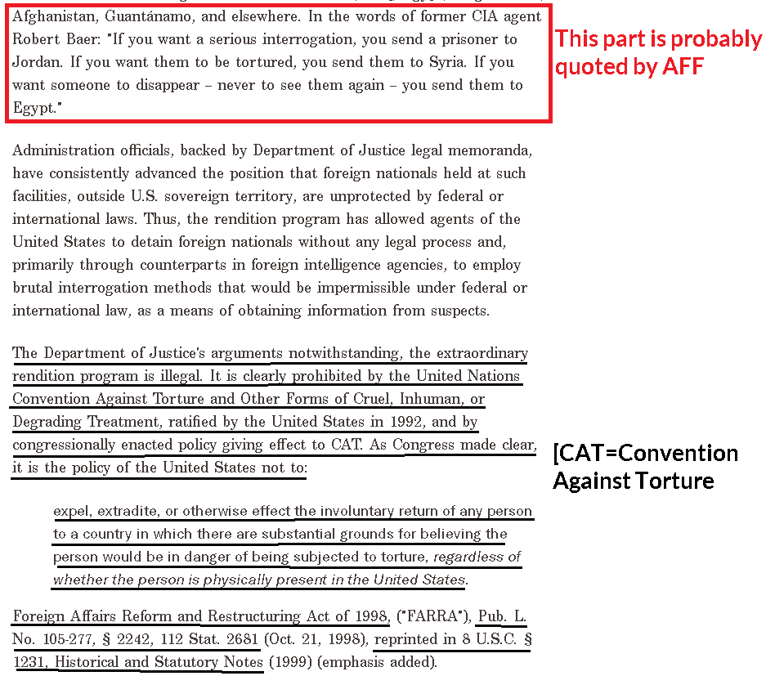
Impact: No possible topical affirmative plan
You cannot substantially reduce something that was abolished 15 years ago. There’s no topical way to do any Affirmative plan on the Rendition program in 2021, so there’s no way to justify any Affirmative ballot on this subject.

AFF’s evidence saying it “continues to this day” is from 2005.
[Not sure about this: AFF may be reading from an undated ACLU article that hasn’t been updated online in a long time. It references events in 2005 as “recent” and says the CIA rendition program “continues to this day.” But since that article was written in 2005 and our other evidence says CIA terminated the program in 2006, any reference to this ACLU article is mistaken as to the issue of it ongoing. Check the dates on AFF’s citations of this article or any article claiming it continues today. They may be citing the copyright date on the web page or the date they looked it up online.]
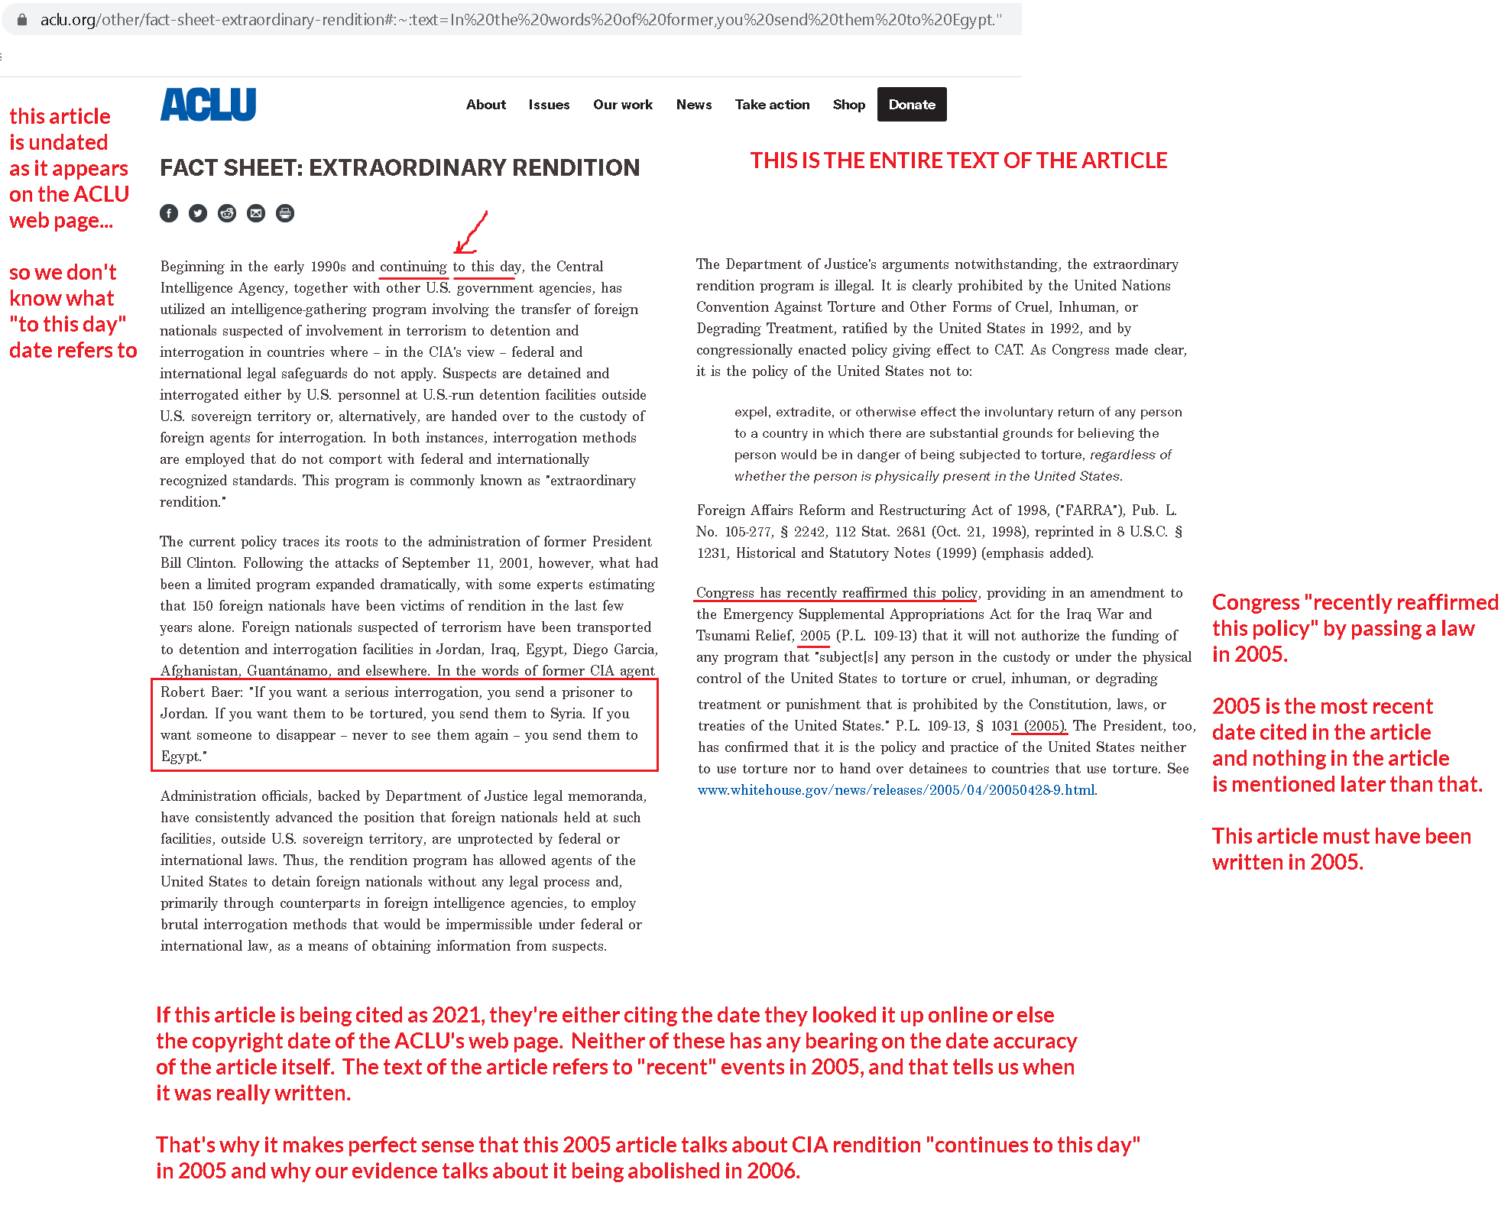

2. CIA, not military
CIA created and operated the rendition program
Univ of North Carolina Law School, Human Rights Policy Lab 2017 (under the direction of Prof. Deborah M. Weissman) Nov 2017 Extraordinary Rendition and Torture What the Narratives of Victims Reveal and Require https://law.unc.edu/wp-content/uploads/2019/10/narrativethemes.pdf (brackets in original)
The terrorist attacks of September 11, 2001, provided the impetus needed to further alter and greatly expand the rendition program yet again, transforming it into what is now referred to as the extraordinary rendition program. The goal was no longer criminal prosecution but instead simply detention and interrogation. “After 9/11 the gloves came off,” described Cofer Black, former head of the CIA’s Counterterrorism Center, before Congress. Another official remarked: “We don’t kick the [expletive] out of them. We send them to other countries so they can kick the [expletive] out of them.” On September 17, 2001, six days after the attacks, President George W. Bush signed the Memorandum of Notification providing “unprecedented authorities, granting the CIA significant discretion in determining whom to detain, the factual basis for the detention, and the length of detention.”
Law says CIA is not military. They are not covered by the Uniform Code of Military Justice
Lt. Col. Scott Ecton 2011. (US Air Force attorney) UNLAWFUL COMBATANTS AT THE CONTROLS: THE CIA, ARMED RPAS AND LOAC 16 Feb 2011 https://apps.dtic.mil/sti/pdfs/AD1018753.pdf (brackets added)
In addition to operating under very specific ROE [rules of engagement] and other guidance, the armed forces fall under a well-recognized judicial establishment. The Uniform Code of Military Justice (UCMJ) provides an in-place system of accountability when US military personnel fail to abide by standards set for the conduct of the armed forces. For matters that fail to rise to the level of judicial accountability, military members remain accountable to their chain of command. CIA personnel, on the other hand, are not subject to the UCMJ and their actions are often beyond the reach of any court of competent jurisdiction.

Benefit of the doubt goes to the Negative. Geneva Convention, Article 50, says if you’re not sure, consider them a civilian
Lt. Col. Scott Ecton 2011. (US Air Force attorney) UNLAWFUL COMBATANTS AT THE CONTROLS: THE CIA, ARMED RPAS AND LOAC 16 Feb 2011 https://apps.dtic.mil/sti/pdfs/AD1018753.pdf
It was not until Protocol I that “civilian” was classified, albeit by exclusion. Article 50 of Protocol I defines a “civilian” as any person not a member of the armed forces as defined in Geneva III or a civilian not part of a levee en masse. Under Geneva III, this would include “persons who accompany the armed forces without actually being members thereof.” Furthermore, Article 50 states “in case of doubt whether a person is a civilian, that person shall be considered to be a civilian.”
Impact: No Affirmative team means automatic Negative ballot
Since no one showed up in the round to affirm we should reduce any “military” commitments, there is effectively no Affirmative team. No matter who wins, you should vote Negative.
MINOR REPAIR
Declassify, study and have public accountability for mistakes of the past
Andrea Prasow 2021. (Deputy Washington Director of Human Rights Watch) Declassify the Post-9/11 Torture Program 25 Jan 2021 “https://www.hrw.org/news/2021/01/25/declassify-post-9/11-torture-program#
Continued classification of the entire program serves only to shield the names of the torturers from their victims, prevent the victims from obtaining adequate medical care, and create tremendous logistical burdens in the military commissions before which some of the victims are being prosecuted. Even if some information must remain classified, such as agreements between countries, an effort to make the rest public would allow Americans and the U.S. government to grapple with this dark chapter in history, which continues to have ramifications for the United States and the world.

HARMS / SIGNIFICANCE
1. A/T “Harms US relationships with allies” – Empirically denied. Claims of harm didn’t pan out
The Claim: Biden claimed in 2007 that rendition was harming US alliance with Britain
Sen. Joe Biden 2007. (D-Delaware) 26 July 2007 Hearing before the Senate Foreign Relations Committee, EXTRAORDINARY RENDITION, EXTRATERRITORIAL DETENTION, AND TREATMENT OF DETAINEES: RESTORING OUR MORAL CREDIBILITY AND STRENGTHENING DIPLOMATIC STANDING https://www.govinfo.gov/content/pkg/CHRG-110shrg40379/html/CHRG-110shrg40379.htm#:~:text=Rendition%20is%20the%20practice%20of,on%20occasion%2C%20some%20valuable%20information.
Just yesterday, the United Kingdom issued a report on the United States rendition program, concluding that it would have, ``serious implications,'' for future intelligence relationships between the United States and the United Kingdom, one of our most important partners.
The Results: 14 years later, Biden is getting along fine with Britain – US/UK relations are doing great.
Lorenzo Gazzola 2021 (Political Risk Analys, Atlas Institute for International Affairs; experience working at think tanks like the Council on Foreign Relations and the Hudson Institute. B.A. in Politics and History from New York University. MSc International Relations candidate at the London School of Economics and Political Science) “Under Biden, the ‘Special Relationship’ Is Stronger Than Expected” 26 Mar 2021 https://www.internationalaffairshouse.org/under-biden-the-special-relationship-is-stronger-than-expected/
When Joe Biden was elected president of the United States, many observers thought the US-UK ‘special relationship’ was in a for a bumpy ride. British Prime Minister Boris Johnson, some argued, would struggle to develop a close relationship with Biden, especially since the American president had called Johnson a “physical and emotional clone” of Donald Trump. And while the United Kingdom talked up the prospects of a post-Brexit trade deal with the United States, the Biden team made it clear it would not be a priority for Washington. Yet nearly two months into the Biden Administration, there has been a surprising alignment between Washington and London. The UK has put on hold its effort to secure a trade deal and the two countries have come together around an agenda focused on common interests and global purpose.
The Conclusion: Either the problem’s been solved or it never existed
Either way, the worry was a lot of hype and certainly no justification for any Affirmative plan today.
DISADVANTAGES
1. Mistakenly labeling CIA civilians as military
AFF’s mislabeling of CIA civilians as if they were military violates a key principle in the Geneva Convention: “distinction” between military and civilian.
Lt. Col. Scott Ecton 2011. (US Air Force attorney) UNLAWFUL COMBATANTS AT THE CONTROLS: THE CIA, ARMED RPAS AND LOAC 16 Feb 2011 https://apps.dtic.mil/sti/pdfs/AD1018753.pdf (“LOAC” = Law of Armed Conflict) (brackets and ellipses in original)
Second, increased reliance on technology along with decreasing military funding will only further draw a broader array of “civilians” into the reality of modern armed conflict. The participation by such civilians, particularly those that are remote from the battlefield, is not likely to be deemed direct participation in hostilities any time soon by the international legal community, as evidenced by the recently issued Interpretive Guidance. In broadening the definition of “armed forces” while restricting the definition of “direct participation in hostilities,” Protocol I and the Interpretive Guidance have arguably been counter to US interests and any attempt by the US to change the law would unlikely be resolved in favor of the US. [END QUOTE] Finally, many believe that the law is “fundamentally defective” for the current conflict and enemy and our actions are justified to level the playing field. Democracies must recognize “that adherence to the law of war is not based upon strict reciprocity.” “It affords parties to international armed conflicts strategic and tactical advantages from the combination of their own noncompliance with the law of war and their adversaries’ observance of the law. Nations should not be placed at a strategic or tactical disadvantage for following international humanitarian law or for their enemies’ failure to do so.” Maintaining the status quo, however, runs contrary to our stated ideals and interests. [HE GOES ON TO SAY QUOTE:] During his acceptance speech for the Nobel Peace Prize, President Obama “reaffirmed America’s commitment to abide by the Geneva Conventions.” The President went on to state, “[E]ven as we confront a vicious adversary that abides by no rules…the United States of America must remain a standard bearer in the conduct of war.”[END QUOTE] Unfortunately, deviating from the laws of war has been justified by the present conflict. In the same speech previously noted, legal advisor Koh stated that “construing what is ‘necessary and appropriate’ under the AUMF requires some ‘translation,’ or analogizing principles from the laws of war governing traditional international conflicts.” [LATER HE CONCLUDES QUOTE:] Construing what is “necessary and appropriate” should not include a translation that deviates from one of LOAC’s most basic tenets, that of distinction.
Impact #1: Turn the harms – values and principles are undermined by the AFF plan
To whatever extent you believe American values and principles are worthwhile as AFF has advocated for them, their plan sets back those values by violating the Geneva Convention’s distinction between civilians and military. Mislabeling civilians as “military” just to try to make their case topical violates the very values they claim to be upholding.
Impact #2: Puts more civilians at risk of attack. Labeling civilians (who have similar jobs to military) as if they were military creates incentive for enemies to attack more civilians. They will have to assume that all civilians are potentially legitimate military targets
Lt. Col. Scott Ecton 2011. (US Air Force attorney) UNLAWFUL COMBATANTS AT THE CONTROLS: THE CIA, ARMED RPAS AND LOAC 16 Feb 2011 https://apps.dtic.mil/sti/pdfs/AD1018753.pdf (“LOAC” = Law of Armed Conflict) (brackets and ellipses in original)
A civilian with a quasi-combatant status who does not otherwise distinguish himself as a combatant will put others unnecessarily at risk by so doing. “When the distinction requirement is disregarded, opposing combatants cannot discern fighters from civilians, opposing shooters from friendly shooters, good guys from bad guys, eroding the lawful combatant’s presumption that civilians he encounters are noncombatants who present no danger.” While this may seem illogical or unlikely when discussing remotely-located RPA pilots, the argument for quasi-combatant status must be equally applicable to any civilian who directly participates in hostilities, particularly those performing a “continuous combat function.” Performing functions indistinguishable from military units is alone an inadequate basis to advocate combatant-type status for an entity that has noticeably civilian characteristics.

