Negative Brief: MFF Funding Reallocation
By “Coach Vance” Trefethen
Resolved: The European Union should substantially reform its immigration policy.
The multiannual financial framework (MFF) is a long-term budgeting process used by the EU to distribute money to EU countries. AFF is concerned that funds for managing inflows of migrants are allocated years in advance, and thus don’t accurately keep up with current trends. A country might be getting too much or too little money for today’s immigration needs because the statistics they’re using for the budget came from several years ago when the influx was much higher or lower. This brief shows why none of that matters. AFF’s own evidence source who says the budget process is messed up also says it wouldn’t matter anyway because countries with a lot of migrants won’t spend any money on them, and have even refused it when it was offered. And the Status Quo already has an additional fund beyond MFF that provides flexible and emergency response whenever a sudden influx of migrants pops up, to give money to any Member State that faces a sudden need.
Negative: MFF Funding Reallocation 3
INHERENCY – Status Quo already has programs that are solving 3
1. New AMF – Asylum & Migration Fund - accomplishes AFF plan in Status Quo 3
AMF was enacted in Dec 2020 [compare to 2018 dates in AFF plan] with €8.7 billion in funding to supplement MFF 3
AMF provides flexible response funding based on immigration flows over the coming years 3
HARMS / SIGNIFICANCE 3
1. There aren’t any 3
It isn’t a harm until someone gets harmed 3
2. Other funds available besides MFF 4
AFF’s expert who says MFF budget is “out of step” also says other funds are available a little further on in the same context 4
SOLVENCY 4
1. Many other reforms (at Member State level) needed to solve 4
EU Commission lists 5 other reforms Member States should take for funds to meet needs: 1) integration policy framework 2) labor market integration 3) education 4) housing discrimination 5) fragmented policy departments 4
2. Affected Member States don’t want the money and won’t take it 5
AFF’s own source about the “out of step” budget goes on to say Member States having a lot of migrants don’t really want more money 5
Impact: AFF’s own source says plan won’t solve 5
3. EU Member States’ attitudes block effective use of funds 6
Affirmative source admits: EU Member States have anti-immigrant attitudes, so they won’t spend allocated funds for anything helpful on immigration 6
4. Funding allocation by migrant count is impossible 7
Each country counts “migrants” differently, so it’s “essentially impossible to determine” whether money is spent correctly 7
5. More Study Needed on Funding Effectiveness before Funding Allocation Reform 8
Before we worry about reallocating funding, we first need to study what it’s being spent on and which programs work. Otherwise, we’re simply reallocating funding among programs that don’t work 8
6. Lack of funding 8
Link: AFF says they’re not increasing funding, just re-allocating it 8
Failure: Can’t solve EU immigration problems without more funding 8
DISADVANTAGES 9
1. Worse treatment of migrants 9
Link: AFF tries to increase funding to countries that have more migrants (by decreasing from those that don’t) 9
Impact: Worse treatment of migrants. When EU countries get more funding for migrants, they spend it on policing and anti-immigrant policies 9
2. Worse treatment of taxpayers / Increased human rights violations. [This happens everywhere DA 1 doesn’t happen] 10
Link: AFF tries to increase funding to countries that have more migrants (by decreasing from those that don’t) 10
Link: EU believes immigrants have a “right” to other people’s money to guarantee them an ever increasing standard of living at government expense 10
Link: Ever-expanding list of things the government has to give people (labeled as "rights") conflicts with individual liberty and freedom 10
Link: Taking property away from one to give to another to meet some "right" they claim but cannot afford, violates property rights and no offsetting worthy goal can justify it 11
Impact: All other vital human rights disappear when property rights are lost 11
Impact: Human rights violation, corruption and injustice abound when we give people "rights" to someone else's money 11

Negative: MFF Funding Reallocation
INHERENCY – Status Quo already has programs that are solving

1. New AMF – Asylum & Migration Fund - accomplishes AFF plan in Status Quo
AMF was enacted in Dec 2020 [compare to 2018 dates in AFF plan] with €8.7 billion in funding to supplement MFF
Tanja Fajon 2020 (Rapporteur for the EU Parliament) 20 Dec 2020 PROPOSAL ESTABLISHING THE ASYLUM AND MIGRATION FUND“ https://www.europarl.europa.eu/legislative-train/theme-new-boost-for-jobs-growth-and-investment/file-mff-asylum-and-migration-fund#:~:text=The%20AMF%20will%20be%20allocated,References%3A&text=European%20Parliament%2C%20Deal%20on%20EU,Press%20release%2C%209%20December%202020 (accessed 9 Feb 2021)
On 10 November, The European Parliament and German Presidency of the Council reached a political agreement on the 2021-2027 MFF and new own resources. On 17 December, the European Parliament gave its consent to the next multiannual financial framework. The AMF will be allocated a budget of €8.705 billion (in 2018 prices) for the 2021-2027 period.

AMF provides flexible response funding based on immigration flows over the coming years
Tanja Fajon 2020 (Rapporteur for the EU Parliament) 20 Dec 2020 PROPOSAL ESTABLISHING THE ASYLUM AND MIGRATION FUND“ https://www.europarl.europa.eu/legislative-train/theme-new-boost-for-jobs-growth-and-investment/file-mff-asylum-and-migration-fund#:~:text=The%20AMF%20will%20be%20allocated,References%3A&text=European%20Parliament%2C%20Deal%20on%20EU,Press%20release%2C%209%20December%202020 (accessed 9 Feb 2021) (Note: The AMF budget in this card adds up to 10.5 billion euros, which is more than the 8.7 billion in the first card. It’s may be because the first one is referring to constant 2018 value of the euro, whereas this card may be including the effects of inflation moving the numbers higher over future years)
The Fund will address the continuing needs in the areas of asylum (30%), early integration (30%) and return (40%), through supporting Member States' long-term funding (EUR 6,3 billion) and responding to targeted thematic action and urgent needs (EUR 4,2 billion). Member States will receive a fixed sum of EUR 5 million and an additional amount based on a distribution criteria that reflect the needs and the pressure experienced by different Member States. The thematic facility, intended as a flexible and fast response, will be used for the following actions: specific actions; Union actions; emergency assistance; resettlement; support to Member States contributing to solidarity and responsibility efforts and European Migration network.

HARMS / SIGNIFICANCE

1. There aren’t any

It isn’t a harm until someone gets harmed
“Countries don’t have enough money” or “Countries have too much money” may be interesting facts, but they’re not harms. Who was hurt in those countries? Did someone starve or die of frostbite? Did someone’s back get thrown out by having a wallet with too much money in it? Until they read evidence of someone getting harmed, there’s no harm.

2. Other funds available besides MFF

AFF’s expert who says MFF budget is “out of step” also says other funds are available a little further on in the same context
(AFFIRMATIVE SOURCE) Prof. Nicos Trimikliniotis 2020. (professor of sociology at the School of Humanities and Social Sciences, University of Nicosia, Cyprus) (no month given in publication date) Migration and the Refugee Dissensus in Europe: Borders, Security and Austerity https://books.google.com/books?id=fsyxDwAAQBAJ&pg=PT112&lpg=PT112&dq=%22the+EU+parliament+committee+on+budgets+regarding+funding+notes%22&source=bl&ots=GIKD235P0J&sig=ACfU3U3FxzVcnGW8TH4qbnn-_xuTj8gCdA&hl=en&sa=X&ved=2ahUKEwjJwdGH1NvuAhXDneAKHQOxBm8Q6AEwAHoECAIQAg#v=onepage&q=%22the%20EU%20parliament%20committee%20on%20budgets%20regarding%20funding%20notes%22&f=false (access date 8 Feb 2021)
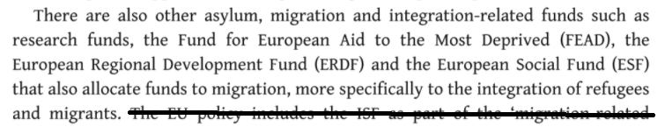

SOLVENCY

1. Many other reforms (at Member State level) needed to solve

EU Commission lists 5 other reforms Member States should take for funds to meet needs: 1) integration policy framework 2) labor market integration 3) education 4) housing discrimination 5) fragmented policy departments
European Union Commission 2018. (agency of the EU government) TOOLKIT ON THE USE OF EU FUNDS FOR THE INTEGRATION OF PEOPLE WITH A MIGRANT BACKGROUND, Jan 2018 file:///C:/Users/vth/Downloads/toolkit-integration-of-migrants.pdf (accessed 8 Feb 2021)
To maximise the synergies between the EU funds, an integration policy framework is recommended at national, regional and local level encompassing all the different thematic fields where people with a migrant background may face challenges. This may fall under the responsibility of the national, regional or local policy departments. The national/regional/local strategic policy framework should also take into consideration Country Specific Recommendations (CSRs). In fact, since 2011, within the scope of the European Semester process, several challenges have been identified in the CSRs with specific reference to people with a migrant background in the areas of labour market integration, equal participation into quality education, protection from discrimination and access to housing. Funding authorities may consider working with policymakers to develop these strategic policy frameworks. At times, the policy of a Member State is not collated in one document but may be fragmented across different sectors (e.g. housing, education, employment, etc.). Where fragmented policies occur, funding authorities may also support the relevant departments in policymaking. If strategic policy frameworks are updated, funding authorities should consider the potential need to adjust the EU funds programmes. This closer cooperation between the funding and policy departments would enable a better alignment between the funding and policy objectives.

2. Affected Member States don’t want the money and won’t take it

AFF’s own source about the “out of step” budget goes on to say Member States having a lot of migrants don’t really want more money
(AFFIRMATIVE SOURCE) Prof. Nicos Trimikliniotis 2020. (professor of sociology at the School of Humanities and Social Sciences, University of Nicosia, Cyprus) (no month given in publication date) Migration and the Refugee Dissensus in Europe: Borders, Security and Austerity https://books.google.com/books?id=fsyxDwAAQBAJ&pg=PT112&lpg=PT112&dq=%22the+EU+parliament+committee+on+budgets+regarding+funding+notes%22&source=bl&ots=GIKD235P0J&sig=ACfU3U3FxzVcnGW8TH4qbnn-_xuTj8gCdA&hl=en&sa=X&ved=2ahUKEwjJwdGH1NvuAhXDneAKHQOxBm8Q6AEwAHoECAIQAg#v=onepage&q=%22the%20EU%20parliament%20committee%20on%20budgets%20regarding%20funding%20notes%22&f=false (access date 8 Feb 2021)
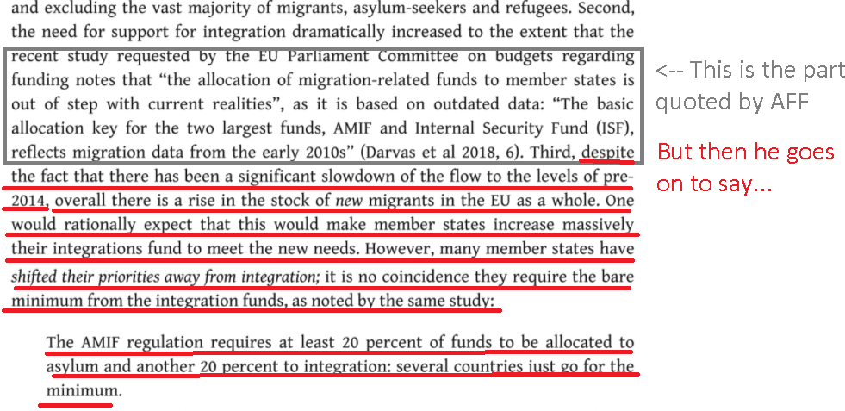

Impact: AFF’s own source says plan won’t solve
Reallocating funding so that countries with extra migrants get extra money won’t work, according to their source, because those countries don’t want the money and won’t spend it because their political priorities have shifted.

3. EU Member States’ attitudes block effective use of funds

Affirmative source admits: EU Member States have anti-immigrant attitudes, so they won’t spend allocated funds for anything helpful on immigration
(AFFIRMATIVE SOURCE) Prof. Nicos Trimikliniotis 2020. (professor of sociology at the School of Humanities and Social Sciences, University of Nicosia, Cyprus) (no month given in publication date) Migration and the Refugee Dissensus in Europe: Borders, Security and Austerity https://books.google.com/books?id=fsyxDwAAQBAJ&pg=PT112&lpg=PT112&dq=%22the+EU+parliament+committee+on+budgets+regarding+funding+notes%22&source=bl&ots=GIKD235P0J&sig=ACfU3U3FxzVcnGW8TH4qbnn-_xuTj8gCdA&hl=en&sa=X&ved=2ahUKEwjJwdGH1NvuAhXDneAKHQOxBm8Q6AEwAHoECAIQAg#v=onepage&q=%22the%20EU%20parliament%20committee%20on%20budgets%20regarding%20funding%20notes%22&f=false (access date 8 Feb 2021)
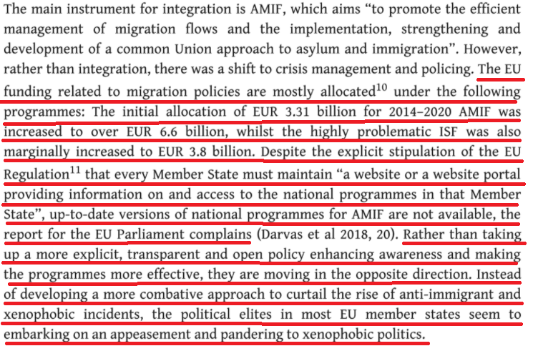

4. Funding allocation by migrant count is impossible

Each country counts “migrants” differently, so it’s “essentially impossible to determine” whether money is spent correctly
[Analysis: AFF will never know whether the reallocation of funds is being done correctly, if there is no way to accurately count the “migrant” population. To really solve, we need the EU to come up with standardized definition of what a “migrant” is and then do studies to find out those numbers.]
Dr. Hanne Beirens and Aliyyah Ahad 2019 (Beirens – Associate Director of the Migration Policy Institute, Europe. PhD in sociology. Ahad – Associate Policy Analyst at Migration Policy Institute; Master’s degree in public policy from Oxford.) March 2019 MONEY WISE – Improving how EU funds support migration policy objectives https://www.migrationpolicy.org/sites/default/files/publications/MPIE-EUfunds-migrationpolicy-Final-WEB.pdf (brackets added) (accessed 9 Feb 2021)
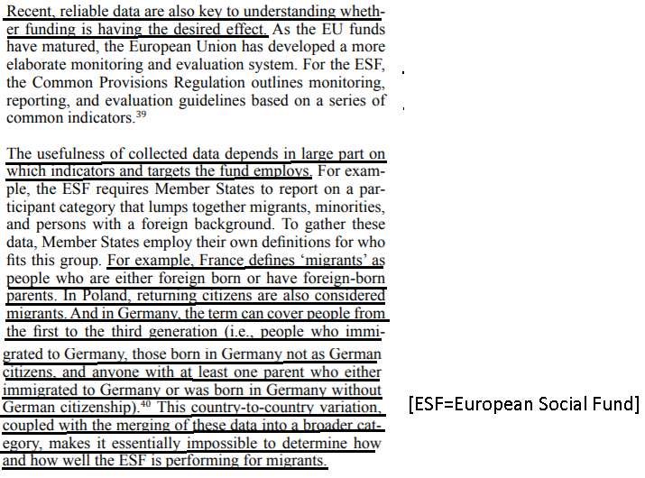
5. More Study Needed on Funding Effectiveness before Funding Allocation Reform

Before we worry about reallocating funding, we first need to study what it’s being spent on and which programs work. Otherwise, we’re simply reallocating funding among programs that don’t work
Dr. Hanne Beirens and Aliyyah Ahad 2019 (Beirens – Associate Director of the Migration Policy Institute, Europe. PhD in sociology. Ahad – Associate Policy Analyst at Migration Policy Institute; Master’s degree in public policy from Oxford.) March 2019 MONEY WISE – Improving how EU funds support migration policy objectives https://www.migrationpolicy.org/sites/default/files/publications/MPIE-EUfunds-migrationpolicy-Final-WEB.pdf (accessed 9 Feb 2021)
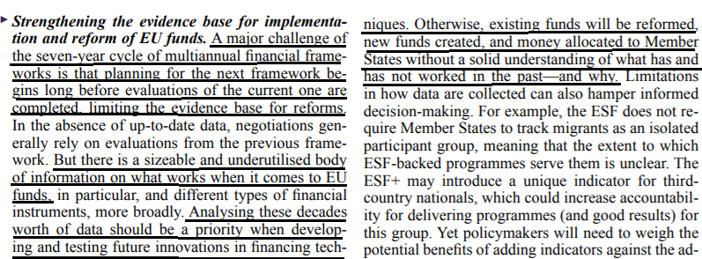

6. Lack of funding

Link: AFF says they’re not increasing funding, just re-allocating it
It’s in their mandates

Failure: Can’t solve EU immigration problems without more funding
Prof. Iris G. Lang 2021. (Professor of EU Law and Holder of the UNESCO Chair on Free Movement of People, Migration and Inter-Cultural Dialogue, University of Zagreb. ) 27 Jan 2021 “Financial Implications of the New Pact on Migration and Asylum: Will the Next MFF Cover the Costs?” http://eumigrationlawblog.eu/financial-implications-of-the-new-pact-on-migration-and-asylum-will-the-next-mff-cover-the-costs/#:~:text=A%20more%20ambitious%20asylum%20and,with%20the%202021%2D2027%20MFF.&text=Second%2C%20the%20amount%20of%20%E2%82%AC,spent%20on%20migration%20and%20asylum. (accessed 9 Feb 2021)
Finally, whereas the EU budget plays only a complementary role and is not intended to replace national expenditures in the areas of migration and asylum, the fact remains that the general EU budget – including funds for migration and asylum – remains too modest to cover the actual needs. Only a more radical reshaping of EU resources would enable the EU budget to cover the costs more substantially than it does today.

DISADVANTAGES

1. Worse treatment of migrants

Link: AFF tries to increase funding to countries that have more migrants (by decreasing from those that don’t)
Reallocation of funding is supposed to achieve this objective, that countries with more migrants get more money to deal with them.
Impact: Worse treatment of migrants. When EU countries get more funding for migrants, they spend it on policing and anti-immigrant policies
(AFFIRMATIVE SOURCE) Prof. Nicos Trimikliniotis 2020. (professor of sociology at the School of Humanities and Social Sciences, University of Nicosia, Cyprus) (no month given in publication date) Migration and the Refugee Dissensus in Europe: Borders, Security and Austerity https://books.google.com/books?id=fsyxDwAAQBAJ&pg=PT112&lpg=PT112&dq=%22the+EU+parliament+committee+on+budgets+regarding+funding+notes%22&source=bl&ots=GIKD235P0J&sig=ACfU3U3FxzVcnGW8TH4qbnn-_xuTj8gCdA&hl=en&sa=X&ved=2ahUKEwjJwdGH1NvuAhXDneAKHQOxBm8Q6AEwAHoECAIQAg#v=onepage&q=%22the%20EU%20parliament%20committee%20on%20budgets%20regarding%20funding%20notes%22&f=false (accessed 8 Feb 2021) (brackets added)
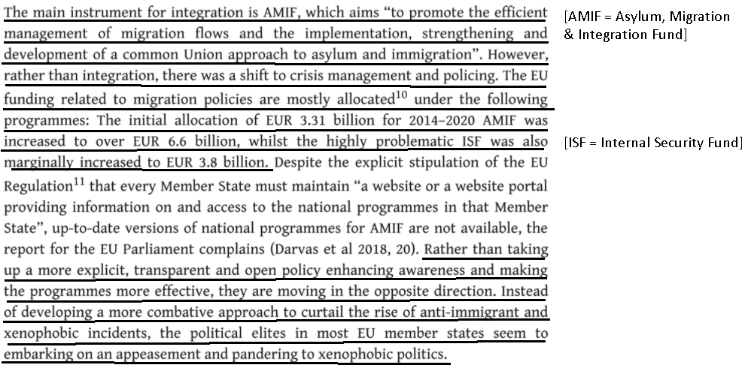

2. Worse treatment of taxpayers / Increased human rights violations. [This happens everywhere DA 1 doesn’t happen]

Link: AFF tries to increase funding to countries that have more migrants (by decreasing from those that don’t)
Reallocation of funding is supposed to achieve this objective, that countries with more migrants get more money to deal with them. If they don’t spend it making immigrants lives worse as in DA 1, they’ll spend it on the next link, which is…

Link: EU believes immigrants have a “right” to other people’s money to guarantee them an ever increasing standard of living at government expense
Caoimhe Sheridan 2015 (with the European Council on Refugees and Exiles) Reception and Detention Conditions of applicants for international protection in light of the Charter of Fundamental Rights of the EU, Jan 2015 https://www.refworld.org/pdfid/5506a3d44.pdf (accessed 9 Feb 2021) (brackets added)
The right to human dignity requires that the quality of life of an applicant for international protection must be one that is of a sufficient standard. Applicants must be placed in conditions that respect the personal sphere of an individual, which also links with the prohibition of over-crowding in terms of Article 3 ECHR. The essence of the right to human dignity is that you cannot treat a human as an object; you must respect their intrinsic worth. The ECtHR has also found that in certain instances (such as when a person is in state care) minimum materials need to be provided (food, access to adequate sanitary conditions, clothes and bedding) to meet the standard in Article 3.65 In addition, the onus cannot be placed on the applicant to ensure that their essential needs are met. In Saciri, the CJEU [Court of Justice of the European Union] looked at what level of support a Member State should provide when they opt to provide material support in the form of a financial allowance as per Article 13 (5) of that Directive. It found that the amount must be sufficient to ensure a dignified standard of living and adequate for the health of applicants and capable of ensuring their subsistence. It also linked it to the specific needs of individuals, and accordingly, ‘the financial allowances must be sufficient to preserve family unity and the best interests of the child which, pursuant to Article 18(1), are to be a primary consideration’. In terms of what is specifically meant by ‘adequate standard of living’ is open to interpretation. Guidance can however be found in other instruments, such as the European Social Charter; Article 31 thereof provides the right to housing. Article 11 of the International Covenant of Economic Social and Cultural Rights (ICESCR) provides that everyone has the right to ‘an adequate standard of living for himself and his family including adequate food, clothing and housing, and to the continuous improvement of living conditions’. According to the travaux preparatoires, the provision is of broad scope and not limited to food, shelter and clothing alone and other factors should be taken into consideration
Link: Ever-expanding list of things the government has to give people (labeled as "rights") conflicts with individual liberty and freedom
Prof. Philipp Bagus 2008. (professor at Rey Juan Carlos University) 13 Oct 2008 Human Rights Inflation and Property Rights Devaluation https://www.independent.org/students/essay/essay.asp?id=2341 (accessed 9 Feb 2021)
The continuously expanding list of human rights is especially alarming from a classical liberal perspective as represented by Smith (1776), Bastiat (1850), Mises (1927) and Hayek (1960), in that it causes a devaluing of important human rights. More precisely, these more recent human rights deal mainly with social welfare, entailing positive duties for the government, requiring its expansion. These more recent human rights stand in contrast to individual liberty and progressively undermine property rights and freedom.

Link: Taking property away from one to give to another to meet some "right" they claim but cannot afford, violates property rights and no offsetting worthy goal can justify it
Prof. Philipp Bagus 2008. (professor at Rey Juan Carlos University) 13 Oct 2008 Human Rights Inflation and Property Rights Devaluation https://www.independent.org/students/essay/essay.asp?id=2341 (accessed 9 Feb 2021)
Second-generation rights require providing a service to those who cannot afford that service. If no one is willing to voluntarily finance these services, second-generation rights imply the use of coercion in order to provide such services. In such cases, second-generation rights violate property rights, as it is impossible to honor both of them at the same time. It should be added, that property rights are not prima facie rights that can be restricted or balanced at discretion against some important goal, be it equality, “dignity,” or citizenship. Property rights are natural rights. They restrain the justifiable use of force in society. Their infringement would violate the self-ownership or the homesteading principle and as such stand against human nature. These violations are unjustifiable independent of any noble goals sought to be achieved by them.

Impact: All other vital human rights disappear when property rights are lost
Prof. Philipp Bagus 2008. (professor at Rey Juan Carlos University) 13 Oct 2008 Human Rights Inflation and Property Rights Devaluation https://www.independent.org/students/essay/essay.asp?id=2341 (accessed 9 Feb 2021)
Before turning to second-generation human rights, we can state that property rights do imply many of the first-generation human rights, like security of life, freedom of association, and freedom of speech. In fact, these rights are not separable from property rights. Furthermore, when property rights are infringed upon, these human rights disappear along with them.
Impact: Human rights violation, corruption and injustice abound when we give people "rights" to someone else's money
Prof. Philipp Bagus 2008. (professor at Rey Juan Carlos University) 13 Oct 2008 Human Rights Inflation and Property Rights Devaluation https://www.independent.org/students/essay/essay.asp?id=2341 (accessed 9 Feb 2021)
Consequently, property rights imply equality before the law. In contrast, pseudo human rights imply certain redistribution from the rich to those who cannot afford the alleged rights. Someone has to provide a service to those who cannot afford the right. Therefore, pseudo human rights demand an unequal treatment before the law. Some are taxed in order to pay for the welfare of others. The interpretation of the particular situation and person gives the government discretion. The specific circumstances of a person call for a different treatment. Individuals make use of the coercive measures of the state to improve their welfare. The particular legislation and vague definitions give room for discretion by the government and violates, consequently, the rule of law. By violating the rule of law, the traditional sense of justice in the population is perverted. As a consequence, corruption flourishes and the population no longer follows universal rules but tries to gain advantages by demanding and interpreting pseudo human rights.

