America Superpower
CON Case by Tabitha Sleeger
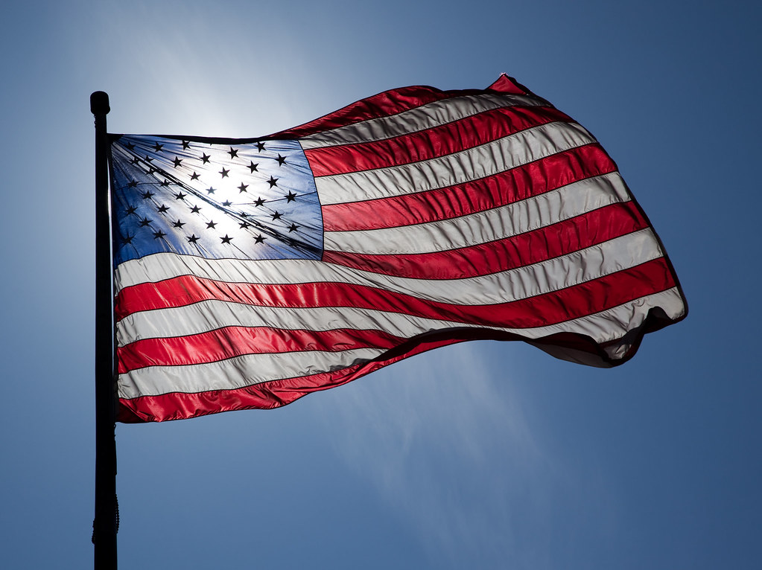

Throughout history, America has been the world’s superpower by standing up for the little countries and standing up to the bullies of this world. However, the United States has been consistent in that it makes sure to only get involved in wars in which it is absolutely necessary. Only when the war involves the US does it take action to end the war. Nuclear weapons have revolutionized the way that this happens. Before nuclear weapons, thousands of men and women would have to give their lives fighting for their countries. Now, it can easily be ended with one swift move that halts further destruction and saves the lives of troops. The prime example of this is the bombing of Japan in World War II. This CON case will center around the WWII example and show how it was necessary for the US to be able to strike another country with a nuclear weapon even though they had not fired first.

America Superpower
The entire reason that the United States has a no first use policy today is to protect each and every one of its citizens from the event of a catastrophic, non-nuclear strike against the US without having the ability to use nuclear weapons. Without a first-use policy, America’s adversaries would attack with no fear of nuclear retaliation. America needs to stand strong, lay down the law and continue to be the superpower in the world. It is for this reason that I ask you to negate the resolution and stand resolved: The United States should NOT adopt a declaratory nuclear policy of no first use.
There are three reasons for negating the resolution today. These reasons will be shown through our contentions of which there are three:
1 – No-first-use is an irresponsible policy
2 – The United States has a moral obligation to have a first-use policy
3 – First-Use is necessary in maintaining peace
Let’s begin with…

Contention 1. Irresponsible Policy
The no-first-use policy is irresponsible, especially in a country where there are clear consequences for what exactly we chose to do and what we chose not to do. This policy has been upheld in America since WWII for a reason. It has only been under scrutiny recently. President Obama revisited the policy in 2010 and decided to maintain it as first-use. President Trump followed Obama’s lead and kept it the same as well.
According to an expert in nuclear weapons and national security issues, John Harvey said in 2019,
QUOTE “Over the past few decades, the United States has weighed the risks and benefits to both its nuclear deterrence posture and its non-proliferation policy goals of renouncing first-use of nuclear weapons in a conflict. In President Barack Obama’s 2010 Nuclear Posture Review and, later, near the end of Obama’s second term as part of a mini-nuclear review, the adoption of a so-called “no-first-use” pledge was considered. Both times, Obama rejected adopting such a policy. The 2018 Nuclear Posture Review carried out by the Trump administration reviewed the policy and reaffirmed Obama’s decision.” END QUOTE
Democrat and Republicans alike have supported the current policy. Why is this? From the same source as above, there are three main reasons that the US has not declared a nuclear policy of no first use:
QUOTE: “There are three major risks in adopting a nuclear declaratory policy of no-first-use. The first risk is to deterrence: Adversaries, absent a fear of reprisal, could be emboldened to act against U.S. interests. The second risk is to U.S. assurances to its allies: If America adopts no-first-use, then allies could lose confidence in America’s extended deterrence commitments. The third risk is to the goal of non-proliferation: Such lost confidence among America’s allies could spur them to develop and field their own nuclear weapons. The purported benefits of adopting a no-first-use policy, which I discuss below, are insufficient to offset these inherent risks.” UNQUOTE
The three reasons listed in this article are: (1) loss of deterrence (2) loss of ally confidence and (3) lost goal of non-proliferation. The impact of this could not only spread the development of nuclear weapons, but it could lead to war on U.S. soil without America being able to use nuclear power as a threat and as a defense. If our enemies knew that we are unwilling and unable to use nuclear weapons, they will attack.
These quotes show clearly that this is an irresponsible policy and there is reason why it has not been done or advocated. This is a reason against no-first-use, but what is a reason for first-use? This will come in…

Contention 2. Moral Obligation
For this contention we will analyze the one and only time that the United States has used nuclear weapons. The only two weapons that the United States has ever used were dropped on Japan on November 1, 1945 to end World War Two. The bombs were dropped on Hiroshima and Nagasaki after the attack on Pearl Harbor. Without a declaratory no-first-use policy, America would have never been able to step in and end the war once and for all. Some argue, however, that it would have been better for America to invade Japan and end the war instead of bombing them.
This is of historical debate. However it makes sense that the war would have been prolonged if America had not dropped the bombs.
QUOTE “One U.S. government estimate, based upon the fierce Japanese resistance encountered in the island fighting so far, predicted the war would last another year and a half, and another had the ultimate cost of the invasion as 1.7 to 4 million Allied casualties, of which 400,000 to 800,000 were expected to be fatalities. [Between December 1941 and August 1945, the war in Europe and the Pacific had already resulted in 407,000 U.S. deaths.] These enormous casualties were spared by the Japanese decision to end the war when they did.” UNQUOTE.
If we had continued fighting any longer, we would have gone on until one side won; causing unnecessary deaths and prolonging war.
NPR reports that in those two cities where we used atomic weapons, Hiroshima and Nagasaki, over 200,000 people were estimated to have been killed. In a book called “Hell to Pay” the argument of whether or not the US should have used nuclear weapons, is deeply explored by author D.M. Giangreco who estimates the cost of troops if the US would have invaded instead. He says,
QUOTE: American military planners estimated that the invasion of Japan would "functionally be a duplication of the casualty surge in Europe," Giangreco explains. And that was "not a pleasant prospect."
American war planners projected that a land invasion of Japan could cost the lives of up to a million U.S. soldiers and many more Japanese. These figures, Giangreco explains, were estimated based on terrain, the number of units fielded, and the number of enemy units they would have to fight.
"Around 1944," Giangreco says, "they ultimately came to the conclusion that the casualties on the low end would be somewhere around the neighborhood of a quarter-million, and on the upper end, in through the million range." END QUOTE.
Although it may sound counter intuitive, being able to strike first means that we can actually save lives! It ended the war sooner, it saved American soldier’s lives and it saved the lives of our allies. This is the reason it has been so strongly supported in America. Because we tried it and it worked. This is the second reason for negating the resolution.
Let’s go into one more reason in…

Contention 3. Peace
For the same reasons stated in contention 1 and contention 2, a nuclear policy of first-use has been used over and over again to ensure safety of U.S. citizens. By keeping enemies in check and at bay encourages world peace. In addition to the Second World War example given above, also consider North Korea.
Expert John Harvey gives the reasons against no-first-use by saying…
QUOTE: “The main concern in adopting a policy of no-first-use is that it could lead an enemy to believe that it could launch a catastrophic, non-nuclear strike against the United States, its allies, or U.S. overseas forces without fear of nuclear reprisal.” END QUOTE.
Harvey continues with the example of North Korea by saying:
QUOTE: “Consider, for example, a North Korean biological attack on an American city that kills hundreds of thousands, or an artillery bombardment of Seoul with chemical weapons, resulting in the deaths of tens of thousands of Korean and U.S. forces and citizens. Would North Korea be more willing to contemplate such attacks if it thought it was immune to a U.S. nuclear response? Recent presidents have been unwilling to accept the risk to deterrence that would accompany a pledge of no-first-use. END QUOTE
Like we saw above in both the World War II example and now the North Korean example, it is better for the US to be able to preemptively strike with nuclear weapons. Even with just a threat of nuclear weapons, it keeps our allies in check and this reaps peace.
As mentioned in the first contention as well, another reason that this would mean peace is due to the nonproliferation argument. From the same source as above,
QUOTE: “Would U.S. adoption of no-first-use cause other countries to be more inclined to cooperate with the United States to work toward a strengthened nonproliferation regime and less likely to acquire nuclear weapons of their own? No evidence exists to support such a contention and, as noted above, allied perceptions of weakened extended deterrence could actually spur proliferation.” END QUOTE.
In order to maintain peace, there has to be good people with the power to stand up against evil. If the United States were to adopt a nuclear no-first-use policy, we would see a lack of justice and therefore no peace. With the current policy, however, we are able to deter our enemies, stand by and protect our allies and decrease proliferation.

Conclusion
In the first contention we analyzed how a nuclear policy of no first use is not supported by the current administration and it has not been accepted by past administrations, and for good reason. We saw that the policy is irresponsible and dangerous for the United States.
In the second contention, we saw that the US has the moral obligation to have a first-use policy because otherwise we would lose thousands of lives and prolong war. And finally, in the third contention we looked at how the US being able to preemptively strike is one of the key elements that is keeping our enemies in check. By being the strength that the world needs, the US provides peace. It is for these reasons that I strongly urge that you vote against the resolution and stand resolved: The United States should NOT adopt a declaratory nuclear policy of no first use

John R. Harvey (physicist with over 35 years of experience working nuclear weapons and national security issues, first at Lawrence Livermore National Laboratory, then at Stanford University's Center for International Security and Arms Control and in senior positions in the Departments of Defense (twice) and Energy) “ASSESSING THE RISKS OF A NUCLEAR ‘NO FIRST USE’ POLICY” War on the Rocks. July 5, 2019 https://warontherocks.com/2019/07/assessing-the-risks-of-a-nuclear-no-first-use-policy/
John C. Hopkins and Clay Dillingham. (October 27, 2019) “What If The U.S. Had Invaded Japan On Nov. 1, 1945?” Daily Post. https://ladailypost.com/what-if-the-u-s-had-invaded-japan-on-nov-1-1945/#:~:text=One%20U.S.%20government%20estimate%2C%20based,were%20expected%20to%20be%20fatalities.
NPR “'Hell To Pay' Sheds New Light On A-Bomb Decision” January 16, 2010 https://www.npr.org/templates/story/story.php?storyId=122591119
Ibid
John R. Harvey (physicist with over 35 years of experience working nuclear weapons and national security issues, first at Lawrence Livermore National Laboratory, then at Stanford University's Center for International Security and Arms Control and in senior positions in the Departments of Defense (twice) and Energy) “ASSESSING THE RISKS OF A NUCLEAR ‘NO FIRST USE’ POLICY” War on the Rocks. July 5, 2019 https://warontherocks.com/2019/07/assessing-the-risks-of-a-nuclear-no-first-use-policy/
Ibid

