Mutually Assured Destruction  
PRO Case by Tabitha Sleeger

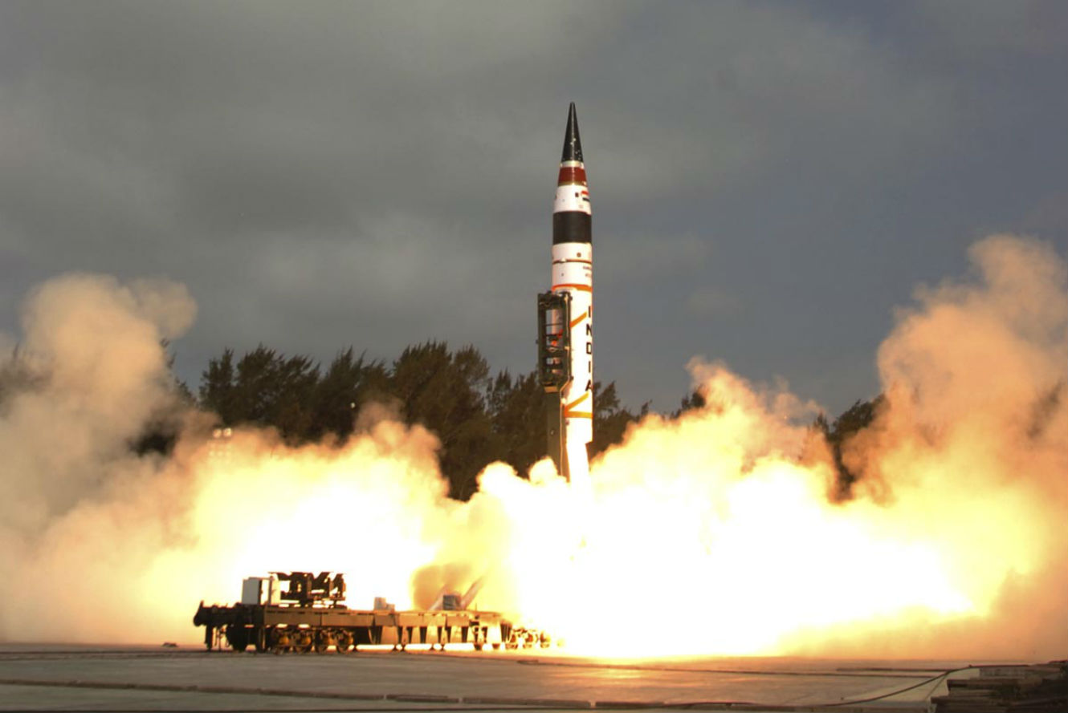

Declaring “no first use” is no longer radical. Many leading countries have adapted this as their policy regarding nuclear weapons. Having the power to use a nuclear weapon is a huge responsibility and there needs to come a point where a country decides not to be the first one to strike. Mutually assured destruction (MAD) was a theory that surfaced during the Cold War the in the 1960s. The theory is that if one country strikes, another country will strike back and as a result, both countries will be destroyed. The United States should adapt a No First Use policy for its nuclear weapons so that it can avoid being destroyed. As of right now the United States has a Negative Security Assurance policy that agrees not to nuke non-nuclear countries that are members of the NPT [Nuclear Nonproliferation Treaty]. However, this policy is vague and does not go far enough.

Mutually Assured Destruction

In the Status Quo, many leading countries have a nuclear policy of no first use. This means that they agree to never strike first with a nuclear weapon. It's time to affirm that **the United States should adopt a declaratory nuclear policy of no first use**.

First, let’s define what we’re affirming. The Union of Concerned Scientists in May 2020 define the current issue by saying, “A no-first-use nuclear policy means that the United States would commit to never being the first nation to use nuclear weapons in any conflict, a change from its current policy.”[1]

And what is America’s current policy in regard to Nuclear warfare? From the same article from above, it continues to explain that, “Under current policy, the United States will not use nuclear weapons against the vast majority of the world's countries in any circumstances. Longstanding US policy, re-affirmed in the Trump administration's 2018 Nuclear Posture Review (NPR), says that the United States "will not use or threaten to use nuclear weapons against non-nuclear weapons states that are party to the NPT [Nuclear Nonproliferation Treaty] and in compliance with their nuclear nonproliferation obligations"; this promise covers more than 180 countries (OSD 2018). This policy is known as a "negative security assurance."”[2]

Now that we understand the definition and the current US policy, we will look at three reasons for affirming the resolution:

There are three reasons you should support a No First Use policy:  
1 – The current policy is vague   
2 – No Longer needed for security  
3 – No First Use is a Strategic Advantage   
Let’s start with…

# Contention 1. The Current Policy is Vague

# If any policy is the United States should be clear, it should be something as important as nuclear weapons. The higher the potential for destruction, the clearer the policy should be. Unfortunately, the policy that the United States currently has in regard to nuclear warfare is vague. The reason for this is because the Trump administration has changed the definition of when nuclear weapon use is permissible. President Obama used to have the definition narrowly tailored with a clear goal. Today, however, President Trump has broadened the definition and therefore broadened the permissibility of using nuclear weapons. The Union of Concerned Scientists summarize the Trump Administration’s Nuclear Posture Review (NPR) by saying:

# QUOTE: “One noteworthy thing about today’s landscape is that the Trump administration's NPR has significantly expanded the definition of "extreme." Both the Obama and Trump administration NPRs state that the United States “would only consider the use of nuclear weapons in extreme circumstances to defend the vital interests of the United States or its allies and partners.” However, the Obama version stated that use would be limited to “a narrow range of contingencies” and emphasized that the goal was to continue to “reduce the role of nuclear weapons in deterring non-nuclear attacks, with the objective of making deterrence of nuclear attack on the United States or our allies and partners the sole purpose of US nuclear weapons.”

# The Trump NPR broadens the definition of “extreme circumstances,” saying these “could include significant non-nuclear attacks. Significant non-nuclear attacks include, but are not limited to, attacks on the U.S., allies, or partner civilian population or infrastructure, and attacks on U.S. or allied nuclear forces, their command and control, or warning and attack assessment.” This could potentially include cyber attacks as a valid reason for nuclear use under US policy.[3] END QUOTE.

# If America were to adopt a No-First-Use Policy, it would be very clear when we are allow to strike and when we are prohibited. Unfortunately, in the status quo, there is currently ambiguity and vagueness. If any policy is going to be vague, it should not be a policy that is as vital as nuclear weapons. This is the first reason to join me in affirming the resolution. The second reason is…

# Contention 2. First-Use Policy is No Longer Needed

One argument that you will hear from opponents of the First-Use policy is that it makes America strong and that it allows America the freedom to stand up for itself and its allies. The idea here is that it keeps US enemies in check because they are threatened by the possibility of nuclear weapons. However, this is simply not true. Consider the fact that China would be glad to go to war with us over Taiwan, despite our threat of nuclear weapons. Also consider the fact that North Korea has been boldly testing nuclear weapons—again, despite the United States’ nuclear policy.

Let’s consider 3 examples to prove that other countries have not stood down despite our current first-use nuclear policy.

A Nuclear Security expert, Bruce Blair explains that,

QUOTE:

Would taking a nuclear first strike off the table encourage conventional aggression? Hardly, given that potential adversaries already believe they could wage limited conventional warfare with the United States without triggering escalation to the nuclear level. The threat of nuclear escalation rings hollow; it is certainly not credible enough to dampen aggression at the low end of the conflict spectrum—such as cyberattacks, covert special operations like Russia’s stealthy incursion into Ukraine and likely infiltration of the Baltic NATO states, and North Korea’s routine assaults on South Korea. Nor have nuclear first-strike plans against countries like Iran, Syria, Iraq and Libya discouraged them from fighting the United States and our allies directly or through proxies. END QUOTE.[4]

Russia’s cyber-attacks, North Koreas’ assaults on South Korea and the continuous disturbances from the Middle East are three clear examples that the current policy is not doing what it is supposed to be doing. This nuclear security expert gives the example of China as well in the same context:

QUOTE:

One could imagine that nuclear first-use threats affect behavior at the high end of the spectrum. But again, the facts suggest otherwise. The threat of nuclear escalation has not weighed heavily on anyone’s readiness to wage limited conventional war if their vital interests or sovereignty are threatened. For instance, China undoubtedly would initiate head-to-head combat with U.S. forces protecting Taiwan if the latter declares independence with America’s approval. In the case of Russia, while it seeks to avoid a conventional war with NATO, it certainly envisions a conventional phase of war with NATO. That its nuclear doctrine allows Russia to initiate the use of nuclear weapons, probably for demonstration purposes, if the survival of the state is threatened clearly indicates that Russia entertains waging war with NATO below the nuclear threshold.

END QUOTE.

The first two contentions have been reasons why the current policy is bad, but the third contention will be why a no-first-use policy would be beneficial for the United States.

# Contention 3. Strategic Advantage

When the US has a policy like strike-first when it comes to nuclear weapons, it sends a message to other countries that it is normal. Countries like North Korea and Pakistan especially, follow America’s lead to use their own weapons

Consider this argument,

QUOTE:

But many of the arguments both for and against no-first-use misunderstand it: The policy reflects the power to set the rules of war, rather than some wayward pacifist ideal to end all war. Countries that issue no-first-use pledges boast strong conventional militaries. These states want to encourage a model of war where their army meets the enemy on a conventional battlefield with clearly defined rules—the kind of war, in other words, that they usually win. Nuclear weapons upend this model, because they help weaker actors, the North Koreas and Pakistans of the world, produce extraordinary destruction, level the playing field, and cast victory into doubt. Therefore, a no-first-use pledge could potentially reinforce a powerful state’s strategic advantage by discouraging other countries from developing nuclear arsenals, and by dissuading nuclear-armed countries from pushing the button. This would happen with the assurance that America would not fire first—thereby keeping war safely bound and safely winnable, on the powerful state’s terms.

The same logic helps explain why the United States is far more concerned if 1,000 Syrians die from chemical weapons than if 100,000 Syrians die from guns and explosives. Normalizing the use of chemical weapons around the world is not in the U.S. strategic interest because Washington wants to keep conflict in its comfort zone of conventional warfare. If U.S. officials concluded that chemical weapons were, in fact, of critical strategic value, they would likely soon abandon their moral reservations over their use. END QUOTE.[5]

The strategic advantage that this would give the US is clear. The article gives the example of China later in the same context saying,

QUOTE:

Countries that contemplate or introduce a no-first-use policy are almost always strong states that enjoy a conventional-weapons edge. Since its first nuclear test in 1964, China has repeatedly declared that it “undertakes not to be the first to use nuclear weapons at any time or under any circumstances.” It’s no coincidence that China is the most powerful East Asian country, and would hold the advantage in any conventional war with South Korea, Vietnam, Japan, or Taiwan (assuming, of course, that the United States stayed out). The spread of nuclear weapons in East Asia would diminish China’s strategic advantage; therefore, Beijing seeks to prevent this outcome with a no-first-use policy. END QUOTE.[6]

It’s important to remember that adopting a no-first-use policy does not mean that the US cannot retaliate with a nuclear weapon or defend itself with nuclear capabilities, it would only restrict the US from attacking first. From the same source above, the article talks about India and how they made their NFU policy very clear:

QUOTE:

Meanwhile, India announced in 1999 that it “will not be the first to initiate a nuclear strike, but will respond with punitive retaliation should deterrence fail.” In 2003, India qualified its no-first-use pledge by stating, “in the event of a major attack against India, or Indian forces anywhere, by biological or chemical weapons, India will retain the option of retaliating with nuclear weapons.” Again, it’s no coincidence that India is very likely to prevail over Pakistan in a future conventional war. India has a history of winning previous contests, and currently spends about $50 billion per year on defense compared to Pakistan’s $9.5 billion. New Delhi can safely issue a no-first-use pledge in the hope of keeping the strategic terrain favorable.

END QUOTE.

# Conclusion…

In conclusion, there are three solid reason why the current United States nuclear policy is outdated and does do what it is intended to do. For all these reasons, join me in affirming that the United States should adopt a declaratory nuclear policy of no first use for the reasons that the current policy is vague, the United States no longer needs it for security and there is no strategic advantage.

1. Union of Concerned Scientists. May 7, 2020 “No-First-Use Policy Explained”

   <https://www.ucsusa.org/resources/no-first-use-explained#:~:text=nuclear%20weapons%20first-,A%20no%2Dfirst%2Duse%20nuclear%20policy%20means%20that%20the%20United,to%20a%20non%2Dnuclear%20attack>.

  
2. ibid
3. Ibid
4. Bruce Blair, 28 September 2016 “The Flimsy Case Against No-First-Use of Nuclear Weapons” Politico Magazine

   <https://www.politico.com/magazine/story/2016/09/nuclear-weapons-no-first-use-debate-214300>
5. Dominic Tierney, 14 September 2016. “Refusing to Nuke First” The Atlantic <https://www.theatlantic.com/international/archive/2016/09/nuclear-obama-north-korea-pakistan/499676/>
6. Ibid