Just Say No
PRO Case by "Coach Vance" Trefethen
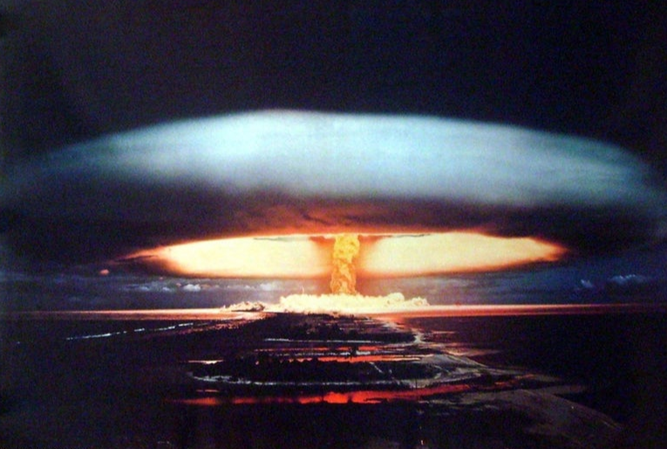
Declaring “No First Use” of nuclear weapons is a common sense idea whose time has come. There’s no time when either threatening or actually using nuclear weapons first is a good idea. Coming out and declaring NFU as our policy would de-escalate global tensions and reduce the risk of nuclear war.

Just Say No
A “No first use” policy would produce all benefits and no drawbacks. Please affirm with us that the United States should adopt a declaratory nuclear policy of no first use. First, let’s define what we mean. The Council on Foreign Relations published this definition of No First Use, or NFU, in 2018 QUOTE:
“A so-called NFU pledge, first publicly made by China in 1964, refers to any authoritative statement by a nuclear weapon state to never be the first to use these weapons in a conflict, reserving them strictly to retaliate in the aftermath of a nuclear attack against its territory or military personnel.”
There are three reasons why it’s the right policy and we’ll outline them in 3 Contentions…

Contention 1. No good scenario
There is absolutely no legitimate scenario where first use of nuclear weapons would make any situation better. First use of nuclear weapons can only make a bad situation infinitely worse. Darryl Kimball explained why in 2018 when he said QUOTE:
“Retaining the option to use nuclear weapons first is fraught with unnecessary peril. Given the overwhelming conventional military edge of the United States and its allies, there is no plausible circumstance that could justify legally, morally, or militarily the use of nuclear weapons to deal with a non-nuclear threat. Even in the event of a conventional military conflict with Russia, China, or North Korea, the first use of nuclear weapons would be counterproductive because it likely would trigger an uncontrollable, potentially suicidal all-out nuclear exchange.”
END QUOTE. Not only is there never a good time to introduce nuclear weapons in response to a non-nuclear conflict, there’s also not a good time to even suggest or threaten first use, as we see in…

Contention 2. No deterrence
The threat of “first use” does not deter aggression. One of the big justifications for not declaring NFU policy is that we will lose deterrence against bad guys on the world scene. But that simply isn’t the case, as Kingston Reif explains in 2016 QUOTE:
“In order for a no-first-use declaration to undermine deterrence of a large-scale non-nuclear threat, U.S. adversaries would have to believe that the United States and its allies would be unwilling or incapable of responding with devastating non-nuclear force. Given the current balances of forces and the concerns Russia and China have publicly expressed about the conventional prowess of the U.S.-led alliance system, this is a hard argument to make. In certain areas and in a few scenarios—such as a conflict with China over Taiwan, or a confrontation with Russia in the Baltic region—the United States and its allies could have difficulty promptly countering an attack with conventional weapons. Yet retaining the option to use nuclear weapons first in defense of allies in such cases is not an effective or credible solution to this problem, in part because both Russia and China do not appear willing to forgo the ability to challenge and impose costs on the United States in a relatively limited conventional conflict in their respective near abroads.”
END QUOTE. So, the “first use” threat fails to deter in both scenarios. In the scenario where we have conventional superiority, we don’t need the threat. And the scenario where we don’t have conventional superiority, the threat isn’t credible.
By contrast, declaring No First Use would produce benefits in all scenarios, as we see in…

Contention 3. Reduced risk of nuclear war
We see this in 2 sub-points.

A. Reduced risk of miscalculation and escalation during a crisis
Declaring NFU would reduce the risk of miscalculation during a tense international situation because it would alleviate concerns and prevent escalation. Kingston Reif explained in 2016 QUOTE:
“For these reasons and more, the United States already has a de facto no-first-use policy. But it is not accruing the benefits that an official policy of no first use would provide. For example, a clear U.S. no-first-use policy would reduce the risk of Russian or Chinese nuclear miscalculation during a crisis by alleviating concerns about a devastating U.S. nuclear first-strike. Such risks could grow in the future, as Washington develops offensive cyber capabilities that can confuse nuclear command and control systems, and augments conventional strike and ballistic missile defense capabilities, which Russia and China believe may degrade their nuclear retaliatory potential.”
END QUOTE. We see in Sub-point…

B. Reduced international tensions and global de-escalation all the time
Darryl Kimball explains in 2016 QUOTE:
“Nevertheless, current policy still leaves several dangerous and destabilizing nuclear weapons-use options on the table, including the option to use nuclear weapons first in a conflict to pre-empt a real or suspected nuclear attack, to counter the possible use of chemical or biological weapons, or to halt a massive conventional military threat against U.S. forces or allies. Today, the United States and Russia still deploy thousands of nuclear warheads on hundreds of bombers, missiles, and submarines. Current U.S. strategy requires that there are enough nuclear forces available to destroy nearly 1,000 enemy targets, many in urban areas, and that these weapons can be launched within minutes of a decision to do so. Maintaining such a capability plays a large role in compelling Russia—and may soon help to lead China—to field a sizable portion of their nuclear forces in a launch-under-attack mode in order to avoid a disarming nuclear strike. This, in turn, increases the chance that nuclear weapons might be used or dispersed by U.S. adversaries in a crisis. As Obama correctly said in 2008, the requirement for prompt launch is “a dangerous relic of the Cold War. Such policies increase the risk of catastrophic accidents or miscalculation.” By adopting a no-first-use policy, the United States could positively influence the nuclear doctrines of other nuclear-armed states, particularly in Asia. Such a shift in U.S. declaratory policy could also alleviate concerns that U.S. ballistic missile defenses might be used to negate the retaliatory potential of China and Russia following a pre-emptive U.S. nuclear attack against their strategic forces.”
END QUOTE. And that brings us to our...

Conclusion.
There’s no situation where first use of nuclear weapons would be beneficial and no situation where threatening first use is beneficial. Declaring No First Use would de-escalate and reduce the risk of nuclear war, and we should adopt this resolution.

Ankit Panda 2018 (award-winning American writer, analyst, and researcher specializing in international security, defense, geopolitics, and economics) COUNCIL ON FOREIGN RELATIONS “‘No First Use’ and Nuclear Weapons” 17 July 2018 https://www.cfr.org/backgrounder/no-first-use-and-nuclear-weapons
Darryl Kimball 2018 (Executive Director, Arms Control Association) Oct 2018 “The Case for a U.S. No-First-Use Policy” https://www.armscontrol.org/act/2018-10/focus/case-us-first-use-policy
Kingston Reif 2016 (Director for Disarmament and Threat Reduction Policy at the Arms Control Association) “The Case for No-First-Use” Oct 2016 https://www.armscontrol.org/blog/2016-10-05/case-first-use
Kingston Reif 2016 (Director for Disarmament and Threat Reduction Policy at the Arms Control Association) “The Case for No-First-Use” Oct 2016 https://www.armscontrol.org/blog/2016-10-05/case-first-use
Darryl Kimball 2016 (Executive Director, Arms Control Association) https://www.armscontrol.org/act/2016-06/focus/take-nuclear-first-use-table

