Welcome Mat: Reception Capacity Benchmarks
By “Coach Vance” Trefethen
Resolved: The European Union should substantially reform its immigration policy.
Capacity for housing immigrants and refugees is a perennial problem in the European Union. The root cause of much of the problem is inaccurate or unknown information about reception (initial housing and care) capacity for incoming migrants.
Regardless of whether their claims are good or bad, regardless of how many immigrants or refugees Europe should accept, when they show up at the border, a European government has to do “something” to feed and house them until they can figure out what to do with them. They can’t let them freeze or starve to death or dump them back into the ocean. That interim period while immigrants are in “reception” facilities is the focus of this plan. Bad conditions and inadequate capacity in these reception facilities are directly caused by the fact that there are no EU-wide benchmarks that define what an adequate reception capacity is and how many they have.
Countries may have incentives to make up, exaggerate, or fudge numbers on the size of their immigrant reception capacity, for several reasons. They might falsely exaggerate their capacity in order to make it sound like they’re “doing their fair share” compared to other EU countries (but when the refugees arrive, they end up in the streets or in tents, because the reception beds don’t really exist). They might falsely reduce their stated capacity to make it sound like they just can’t take any more refugees, giving them an excuse to ship them off to some other EU country and avoid the expense of housing them. Other countries may simply use different or erroneous standards for measuring their capacity – for example, counting an unsanitary unsafe location as reception capacity. Phony or incorrect numbers create or exacerbate the problem of inadequate and unsafe conditions for refugees.
The EU needs accurate numbers to properly plan and care for migrants, and this plan establishes a policy to get them those numbers.
Welcome Mat: Reception Capacity Benchmarks 3
OBSERVATION 1. DEFINITIONS 3
Substantial 3
Reform 3
Immigration policy 3
“Reception” 3
OBSERVATION 1. INHERENCY, the structure of the Status Quo. 4
FACT 1. No uniform standard for measuring reception capacity 4
FACT 2. Inadequate investment in reception capacity. 4
FACT 3. Uniform benchmarks are the key to accurate reception capacity planning 4
OBSERVATION 3. We offer the following PLAN implemented by European Union member governments, the Council of the European Union, the European Parliament and any other necessary agencies 5
OBSERVATION 4. ADVANTAGES 5
ADVANTAGE 1. Human rights protected 5
A. The Link: Inadequate reception capacity. Misrepresentations of reception capacity lead to the assignment of migrants to countries that can’t actually handle them. A good example is Greece 5
B. The Impact: Human rights. Decent reception facilities are a guaranteed human right in European law 5
ADVANTAGE 2. Boom/Bust Cycle Mitigated 6
A. Link: Irresponsible expansion and contraction of reception capacity leads to waste of funds and loss of expertise 6
B. Impact: Poor planning = poor treatment of migrants 6
2A Evidence: Reception Capacity Benchmarks 7
INHERENCY 7
No EU-wide standards for immigrant reception 7
Lack of EU-wide reception capacity benchmarks blocks efforts to share the burden among EU states 7
Lessons not learned from the refugee crisis and CEAS didn’t help either 7
Status Quo efforts at common reception standards haven’t worked 8
A/T “Refugee influx has decreased” 8
Capacity problems still persist 8
Since 2019 the numbers are trending back up again 8
Can’t count on low numbers: Reception is not a stable activity, the numbers will always ebb and flow 9
HARMS / SIGNIFICANCE 9
Boom/bust cycle: Poor planning = poor housing conditions. Example: Hungary 9
Inadequate reception capacity = destitution and homelessness. Example: Italy 9
Refugees’ right to housing is required by international law 9
SOLVENCY / ADVOCACY 10
Funding: EU spends $65 billion/year on farm subsidies. Most of it goes to the connected and powerful few 10
Funding: EU spends $65 billion/year on farm subsidies, and it goes to corrupt politicians 10
Quality standards exist and are well defined. What’s not defined are measurements and quality monitoring, and that’s what we need 10
Measurement and definition of reception capacity are the missing piece for solving shortages, boom/bust mitigation, and migrant maltreatment 11
Boom/Bust mitigation can happen: We know how to do it, we just need better measurement and assessments 11
Works Cited 12

Welcome Mat: Reception Capacity Benchmarks
The big disorderly influx of refugees into the European Union a few years ago shed light on a problem that has been ongoing for many years but never solved. Accurately measuring and planning EU nations’ reception capacity for receiving an inflow of immigrants is widely known as a serious problem whose solution is key to solving many other immigration issues the EU faces today. Please join us in affirming that: The European Union should substantially reform its immigration policy.

OBSERVATION 1. DEFINITIONS
Substantial
Merriam Webster Online Dictionary copyright 2020. https://www.merriam-webster.com/dictionary/substantially
considerable in quantity : significantly great

Reform
Merriam Webster Online Dictionary copyright 2020 https://www.merriam-webster.com/dictionary/reform
to put or change into an improved form or condition
Immigration policy
Prof. Marc Helbling, Liv Bjerre, Friederike Römer and Malisa Zobel 2014 (Helbling - professor in political sociology at the Department of Political Science at the University of Bamberg. Bjerre – PhD student, WZD Berlin Social Science Center. Romer - doctoral researcher at the Berlin Social Science Center. Zobel - research assistant at Berlin Social Science Center) April 2014 Conceptualizing and Measuring Immigration Policies. A Comparative Perspective https://papers.ssrn.com/sol3/papers.cfm?abstract_id=2423075
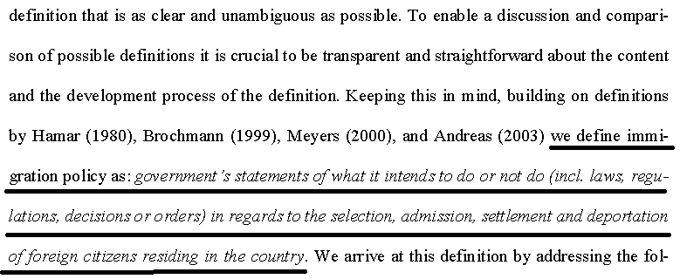
“Reception”
Minos Mouzourakis and Amanda Taylor 2016 (both are with the European Council on Refugees and Exiles) March 2016 “Wrong counts and closing doors The reception of refugees and asylum seekers in Europe” http://www.asylumineurope.org/sites/default/files/shadow-reports/aida_wrong_counts_and_closing_doors.pdf
However, some guidance as to an appropriate understanding of the meaning of reception may be found in the Directive, which provides that “material reception conditions” need to “provide an adequate standard of living for applicants, which guarantees their subsistence and protects their physical and mental health”.4 The Court of Justice of the European Union (CJEU) has clarified that, as a set of measures apt to guarantee asylum seekers dignified living, subsistence and physical and mental health, reception must therefore be sufficiently stable and adequately satisfy health and other material needs of those undergoing an (often lengthy) asylum procedure.

OBSERVATION 1. INHERENCY, the structure of the Status Quo.
FACT 1. No uniform standard for measuring reception capacity
When immigrants, particularly a large influx of refugees, arrive at a border, a nation has to temporarily house and feed them somewhere somehow. The European Union lacks an agreed standard for measuring each nation’s capacity for housing an influx of immigrants in safe and sanitary conditions while their application for entrance is being adjudicated.
Dr. Hanne Beirens 2020 (PhD sociology & ethnic relations; Director of the Migration Policy Institute (MPI) Europe) March 2020 Chasing Efficiency - Can operational changes fix European asylum systems? https://www.migrationpolicy.org/research/operational-changes-european-asylum-systems
The question Member States and the European Union were unable to solve—or attain any level of agreement on—is what constitutes sufficient reception capacity. How many beds should a Member State have available on a continuous basis (i.e., the baseline), and how quickly should it be able to increase this stock (i.e., flexibility)? Being able to define baseline capacity and the degree of flexibility needed is not only essential for running functional and cost-efficient reception systems, it is also crucial for any policy initiative that aims to spread responsibility for receiving newcomers evenly, or at least fairly, across a region.

FACT 2. Inadequate investment in reception capacity.
Lack of a benchmark causes under-investment in reception capacity and blocks solutions to reception capacity shortfalls.
Dr. Hanne Beirens 2020 (PhD sociology & ethnic relations; Director of the Migration Policy Institute (MPI) Europe) March 2020 Chasing Efficiency - Can operational changes fix European asylum systems? https://www.migrationpolicy.org/research/operational-changes-european-asylum-systems
Without a benchmark for reception capacity, it is difficult for publics to understand and assess their governments’ claims about public spending on asylum or reassurances that they have regained control over migration flows to their territory. Without such metrics, it is also easier for decisionmakers to dismiss warnings that asylum seekers are not being adequately received upon arrival, and potentially driving up costs if new beds have to be found at short notice. This has fostered nearly two decades of chronic underinvestment in reception systems across Europe, leaving them unable to respond to changing asylum inflows and often in need of ‘emergency support’.

FACT 3. Uniform benchmarks are the key to accurate reception capacity planning
Dr. Hanne Beirens 2020 (PhD sociology & ethnic relations; Director of the Migration Policy Institute (MPI) Europe) March 2020 Chasing Efficiency - Can operational changes fix European asylum systems? https://www.migrationpolicy.org/research/operational-changes-european-asylum-systems
Closer monitoring of reception capacity is needed so it is known at all times how many places are available and how quickly these levels may rise or fall. Doing so enables swift and strategic decision-making, yet few Member States check occupancy levels on a daily basis. Potential avenues forward include supporting national authorities in building monitoring and early warning systems and investing in EASO as it identifies common indicators of reception capacity and quality that Member States can use. ► The missing piece is clarity on how to define and assess optimal reception capacity. This includes how many beds a Member State should have available on a continuous basis (i.e., the baseline) and how quickly it should be able to increase this capacity (i.e., flexibility). Without such benchmarks, policymakers move on thin ground whenever they assess, support, or counter concerns that some Member States purposively keep the number of reception places low or ignore maltreatment in reception facilities to prevent asylum seekers from arriving or being returned to their territory via the Dublin system, or to avoid having to take a (fair) part in solidarity mechanisms.

OBSERVATION 3. We offer the following PLAN implemented by European Union member governments, the Council of the European Union, the European Parliament and any other necessary agencies

1. The European Asylum Support Office (EASO) and any other necessary EU agencies establish EU-wide monitoring of immigrant reception capacity and a standardized EU-wide benchmark for measuring reception capacity that complies with minimal standards of decency under existing European law.
2. EASO sets binding standards on quality, capacity and flexibility of reception facilities.
3. Funding from cutting EU farm subsidies.
4. Timeline: Plan takes effect 30 days after an affirmative ballot.
5. Enforcement through the EU member governments and EASO through normal administrative discipline.
6. All Affirmative speeches may clarify

OBSERVATION 4. ADVANTAGES
ADVANTAGE 1. Human rights protected

A. The Link: Inadequate reception capacity. Misrepresentations of reception capacity lead to the assignment of migrants to countries that can’t actually handle them. A good example is Greece
Minos Mouzourakis and Amanda Taylor 2016 (both are with the European Council on Refugees and Exiles) March 2016 “Wrong counts and closing doors The reception of refugees and asylum seekers in Europe” http://www.asylumineurope.org/sites/default/files/shadow-reports/aida_wrong_counts_and_closing_doors.pdf
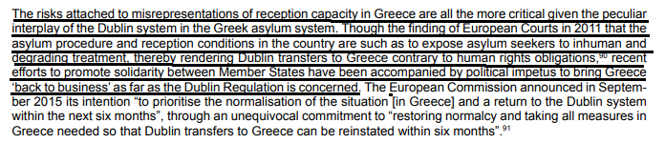
B. The Impact: Human rights. Decent reception facilities are a guaranteed human right in European law
Minos Mouzourakis, Kris Pollet and Jean-David Ott 2019 (with the European Council on Refugees & Exiles) 30 Apr 2019 Housing out of reach? The reception of refugees and asylum seekers in Europe http://www.asylumineurope.org/sites/default/files/shadow-reports/aida_housing_out_of_reach.pdf
Access to adequate accommodation for people seeking and granted international protection is part and parcel of any functioning asylum system. Within the context of the Common European Asylum System (CEAS) the recast Reception Conditions Directive, and the recast Qualification Directive set the standards to be observed by EU Member States in this regard. Applicants for international protection are entitled to “material reception conditions” which include housing, food and clothing. The right to material reception conditions starts from the moment the asylum claim is made, and entails conditions that “provide an adequate standard of living for applicants, which guarantees their subsistence and protects their physical and mental health”

ADVANTAGE 2. Boom/Bust Cycle Mitigated
A. Link: Irresponsible expansion and contraction of reception capacity leads to waste of funds and loss of expertise
Michael Kegels 2016 (Operational Director of Fedasil, the Belgian reception agency; responsible for the management of the Belgian reception system; master’s degrees in international politics and public management) Getting the Balance Right: Strengthening Asylum Reception Capacity at National and EU Levels, Feb 2016 https://www.migrationpolicy.org/research/getting-balance-right-strengthening-asylum-reception-capacity-national-and-eu-levels
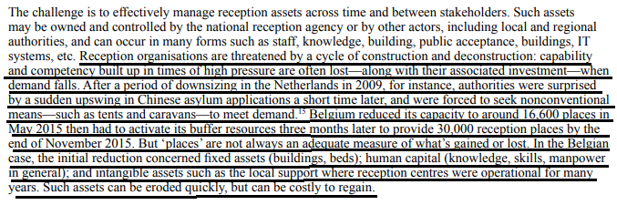
B. Impact: Poor planning = poor treatment of migrants
Minos Mouzourakis and Amanda Taylor 2016 (both are with the European Council on Refugees and Exiles) March 2016 “Wrong counts and closing doors The reception of refugees and asylum seekers in Europe” http://www.asylumineurope.org/sites/default/files/shadow-reports/aida_wrong_counts_and_closing_doors.pdf
Overcrowding is also reported in the United Kingdom, as the 6 Initial Accommodation Centres, set at a maximum capacity of 1,200 places, were hosting 1,985 asylum seekers at the end of 2015. Cyprus, for its part, faced difficulties in providing appropriate reception as a result of a rapid increase in newly arriving persons following a sea rescue in September 2015. This emergency exposed planning and coordination flaws on the part of the authorities in ensuring preparedness to receive higher numbers, leading to a shortage in material supplies such as clothes, detergents, sanitation products and baby food in the country’s main reception centre, Kofinou.

2A Evidence: Reception Capacity Benchmarks

INHERENCY
No EU-wide standards for immigrant reception
Minos Mouzourakis and Amanda Taylor 2016 (both are with the European Council on Refugees and Exiles) March 2016 “Wrong counts and closing doors The reception of refugees and asylum seekers in Europe” http://www.asylumineurope.org/sites/default/files/shadow-reports/aida_wrong_counts_and_closing_doors.pdf
Against the backdrop of divergent institutional arrangements and conceptualisations of reception obligations across Europe, it becomes highly difficult to establish comparable standards with a view to assessing Member States’ compliance with their protection duties vis-à-vis those hosted on their territory. Turning to the assessment of European countries’ respective capacities to accommodate asylum seekers, the aforementioned conceptual difficulties and their implications in practice become all the more visible.
Lack of EU-wide reception capacity benchmarks blocks efforts to share the burden among EU states
Dr. Hanne Beirens 2020 (PhD sociology & ethnic relations; Director of the Migration Policy Institute (MPI) Europe) March 2020 Chasing Efficiency - Can operational changes fix European asylum systems? https://www.migrationpolicy.org/research/operational-changes-european-asylum-systems
The lack of national or EU-wide benchmarks for optimal reception capacity also impedes the smooth running of a solidarity mechanism or other forms of (local, regional, or national) cooperation to spread reception efforts. For example, each solidarity mechanism set up by the European Union to deal with large inflows, whether ad hoc (e.g., relocation mechanism) or regulated (e.g., the Temporary Protection Directive), has been rooted in the practice of asking Member States to propose the number of persons they could receive. It is no surprise that Member States such as Sweden and Germany, which generally run quality reception systems with high capacity, can offer more reception places than countries such as Latvia, where the average number of asylum applications each year remains below the 100 mark and reception capacity is comparably low.

Lessons not learned from the refugee crisis and CEAS didn’t help either
Minos Mouzourakis and Amanda Taylor 2016 (both are with the European Council on Refugees and Exiles) March 2016 “Wrong counts and closing doors The reception of refugees and asylum seekers in Europe” http://www.asylumineurope.org/sites/default/files/shadow-reports/aida_wrong_counts_and_closing_doors.pdf
The limited available data on reception systems undoubtedly reveal an unequal distribution of accommodation capacity for asylum seekers across Europe. Despite the existence of a Common European Asylum System (CEAS) largely imposing the same set of obligations on EU Member States, several countries have been less prepared than others to develop sufficiently resilient systems so as to respond to high influxes of refugees and migrants, even in the aftermath of the “refugee crisis” in 2015. This issue has prominently figured in political debates in the EU and beyond.

Status Quo efforts at common reception standards haven’t worked
Michael Kegels 2016 (Operational Director of Fedasil, the Belgian reception agency; responsible for the management of the Belgian reception system; master’s degrees in international politics and public management) Getting the Balance Right: Strengthening Asylum Reception Capacity at National and EU Levels, Feb 2016 https://www.migrationpolicy.org/research/getting-balance-right-strengthening-asylum-reception-capacity-national-and-eu-levels
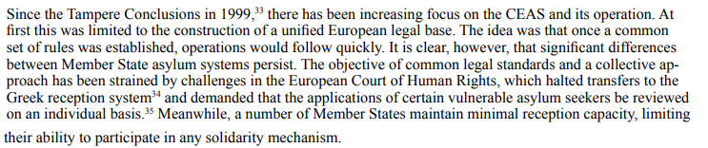

A/T “Refugee influx has decreased”

Capacity problems still persist
Minos Mouzourakis, Kris Pollet and Jean-David Ott 2019 (with the European Council on Refugees & Exiles) 30 Apr 2019 Housing out of reach? The reception of refugees and asylum seekers in Europe http://www.asylumineurope.org/sites/default/files/shadow-reports/aida_housing_out_of_reach.pdf
Despite the general decreasing trend, several countries have experienced an increase in asylum applications and demonstrated low levels of preparedness to deal with fluctuations in arrivals. At the same time, chronic lack of investment in reception capacity in some countries has resulted in permanent gaps in reception capacity, regardless of fluctuations in arrivals. As a result, many asylum seekers continue to be confronted with deficient reception systems or to face outright destitution in Europe.

Since 2019 the numbers are trending back up again
Ali Cain 2020 (Ali Cain is the Program Coordinator for the Cardozo Law Institute in Holocaust and Human Rights, and an M.A. Candidate in the European History, Politics and Society Program at Columbia University) “A Fresh Start in EU Migration Policy: Re-examining the Dublin Regulation”(“714,2000 applications” was the number in the original, obviously a typo. It’s probably supposed to be 714,200) 28 Feb 2020 http://blogs.cuit.columbia.edu/rightsviews/2020/02/28/a-fresh-start-in-eu-migration-policy-re-examining-the-dublin-regulation/
To complicate issues further, the EU received its highest numbers of asylum applications since 2015; the European Asylum Support Office reported that 714,2000 applications were received in 2019. Future migration crises are inevitable, especially given climate change as an increasingly central driver of forced displacement. Commission President von der Leyen must prioritize the reform of the Dublin Regulation to create a cohesive asylum process in Europe.

Can’t count on low numbers: Reception is not a stable activity, the numbers will always ebb and flow
Michael Kegels 2016 (Operational Director of Fedasil, the Belgian reception agency; responsible for the management of the Belgian reception system; master’s degrees in international politics and public management) Getting the Balance Right: Strengthening Asylum Reception Capacity at National and EU Levels, Feb 2016 https://www.migrationpolicy.org/research/getting-balance-right-strengthening-asylum-reception-capacity-national-and-eu-levels
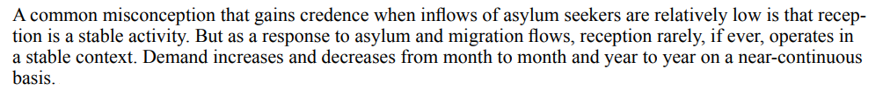

HARMS / SIGNIFICANCE
Boom/bust cycle: Poor planning = poor housing conditions. Example: Hungary
Minos Mouzourakis and Amanda Taylor 2016 (both are with the European Council on Refugees and Exiles) March 2016 “Wrong counts and closing doors The reception of refugees and asylum seekers in Europe” http://www.asylumineurope.org/sites/default/files/shadow-reports/aida_wrong_counts_and_closing_doors.pdf
The precarious reception situation in Hungary merits particular attention. Following a sharp decrease in the number of arrivals ensuing the closure of the Serbian and Croatian borders after October 2015, the largest open reception in the country, Debrecen, was closed in December, while Nagyfa is planned to be closed down as well. However, increasing restrictions in the passage along the Western Balkan route to Croatia and further afield – discussed in Chapter II, Section 3 – have led again to an increase in arrivals of refugees and migrants to Hungary in 2016. Should this trend continue without any plan to establish additional reception centres, asylum seekers risk being exposed to situations of severe overcrowding; at the end of February, two of the four reception centres, Bicske and Vámosszabadi, were already overcrowded.

Inadequate reception capacity = destitution and homelessness. Example: Italy
Minos Mouzourakis and Amanda Taylor 2016 (both are with the European Council on Refugees and Exiles) March 2016 “Wrong counts and closing doors The reception of refugees and asylum seekers in Europe” http://www.asylumineurope.org/sites/default/files/shadow-reports/aida_wrong_counts_and_closing_doors.pdf
Risks of destitution and homelessness are also identified in Italy, particularly affecting entrants who have not been rescued at sea. In Puglia, the Hub (former CARA) of Bari is only available to persons rescued at sea,194 forcing others to travel to the Northern regions of the country in order to apply for asylum and find accommodation. The same obstacles are faced in Friuli Venezia Giulia, near the Eastern border, by those coming from the Balkan route. In Udine, most asylum seekers arriving in 2016 have had to take shelter in the subway train station.1

Refugees’ right to housing is required by international law
Minos Mouzourakis, Kris Pollet and Jean-David Ott 2019 (with the European Council on Refugees & Exiles) 30 Apr 2019 Housing out of reach? The reception of refugees and asylum seekers in Europe http://www.asylumineurope.org/sites/default/files/shadow-reports/aida_housing_out_of_reach.pdf
The 1951 Refugee Convention also requires states to “accord to refugees lawfully staying in their territory treatment as favourable as possible and, in any event, not less favourable than that accorded to aliens generally in the same circumstances.” The right to housing is also enshrined in different instruments of human rights law.

SOLVENCY / ADVOCACY
Funding: EU spends $65 billion/year on farm subsidies. Most of it goes to the connected and powerful few
NEW YORK TIMES 2019. (journalists Selam Gebrekidan, Matt Apuzzo and Benjamin Novak) “The Money Farmers: How Oligarchs and Populists Milk the E.U. for Millions” 3 Nov 2019 https://www.nytimes.com/2019/11/03/world/europe/eu-farm-subsidy-hungary.html
Every year, the 28-country bloc pays out $65 billion in farm subsidies intended to support farmers around the Continent and keep rural communities alive. But across Hungary and much of Central and Eastern Europe, the bulk goes to a connected and powerful few. The prime minister of the Czech Republic collected tens of millions of dollars in subsidies just last year. Subsidies have underwritten Mafia-style land grabs in Slovakia and Bulgaria. Europe’s farm program, a system that was instrumental in forming the European Union, is now being exploited by the same antidemocratic forces that threaten the bloc from within. This is because governments in Central and Eastern Europe, several led by populists, have wide latitude in how the subsidies, funded by taxpayers across Europe, are distributed — even as the entire system is shrouded in secrecy.

Funding: EU spends $65 billion/year on farm subsidies, and it goes to corrupt politicians
NEW YORK TIMES 2019. (journalists Selam Gebrekidan, Matt Apuzzo and Benjamin Novak) “The Money Farmers: How Oligarchs and Populists Milk the E.U. for Millions” 3 Nov 2019 https://www.nytimes.com/2019/11/03/world/europe/eu-farm-subsidy-hungary.html
The European Union spends $65 billion a year subsidizing agriculture. But a chunk of that money emboldens strongmen, enriches politicians and finances corrupt dealing.

Quality standards exist and are well defined. What’s not defined are measurements and quality monitoring, and that’s what we need
Michael Kegels 2016 (Operational Director of Fedasil, the Belgian reception agency; responsible for the management of the Belgian reception system; master’s degrees in international politics and public management) Getting the Balance Right: Strengthening Asylum Reception Capacity at National and EU Levels, Feb 2016 https://www.migrationpolicy.org/research/getting-balance-right-strengthening-asylum-reception-capacity-national-and-eu-levels
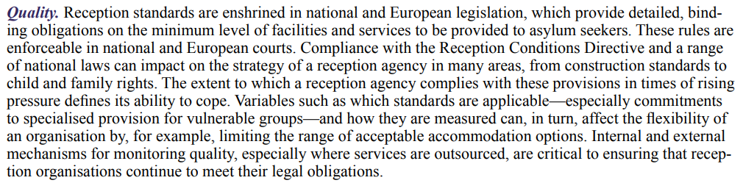

Measurement and definition of reception capacity are the missing piece for solving shortages, boom/bust mitigation, and migrant maltreatment
Dr. Hanne Beirens 2020 (PhD sociology & ethnic relations; Director of the Migration Policy Institute (MPI) Europe) March 2020 Chasing Efficiency - Can operational changes fix European asylum systems? https://www.migrationpolicy.org/research/operational-changes-european-asylum-systems
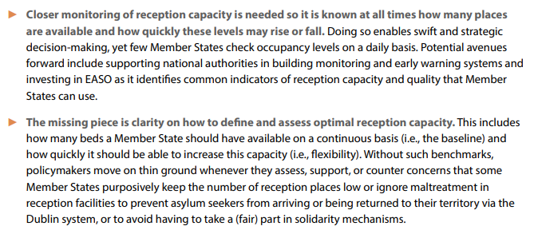

Boom/Bust mitigation can happen: We know how to do it, we just need better measurement and assessments
Dr. Hanne Beirens 2020 (PhD sociology & ethnic relations; Director of the Migration Policy Institute (MPI) Europe) March 2020 Chasing Efficiency - Can operational changes fix European asylum systems? https://www.migrationpolicy.org/research/operational-changes-european-asylum-systems
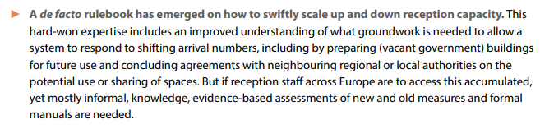

Works Cited
- Merriam Webster Online Dictionary copyright 2020. https://www.merriam-webster.com/dictionary/substantially
- Merriam Webster Online Dictionary copyright 2020 https://www.merriam-webster.com/dictionary/reform
- Prof. Marc Helbling, Liv Bjerre, Friederike Römer and Malisa Zobel 2013 (Helbling - professor in political sociology at the Department of Political Science at the University of Bamberg. Bjerre – PhD student, WZD Berlin Social Science Center. Romer - doctoral researcher at the Berlin Social Science Center. Zobel - research assistant at Berlin Social Science Center) Conceptualizing and Measuring Immigration Policies. A Comparative Perspective https://www.cesifo-group.de/dms/ifodoc/docs/Akad_Conf/CFP_CONF/CFP_CONF_2013/Conf-es13_Poutvaara/Paper/es13_Helbling__19100698_en.pdf
- Minos Mouzourakis and Amanda Taylor 2016 (both are with the European Council on Refugees and Exiles) March 2016 http://www.asylumineurope.org/sites/default/files/shadow-reports/aida_wrong_counts_and_closing_doors.pdf
- Dr. Hanne Beirens 2020 (PhD sociology & ethnic relations; Director of the Migration Policy Institute (MPI) Europe) Chasing Efficiency - Can operational changes fix European asylum systems? https://www.migrationpolicy.org/research/operational-changes-european-asylum-systems
- Michael Kegels 2016 (Operational Director of Fedasil, the Belgian reception agency; responsible for the management of the Belgian reception system; master’s degrees in international politics and public management) Getting the Balance Right: Strengthening Asylum Reception Capacity at National and EU Levels, Feb 2016 https://www.migrationpolicy.org/research/getting-balance-right-strengthening-asylum-reception-capacity-national-and-eu-levels
- Dr. Hanne Beirens 2020 (PhD sociology & ethnic relations; Director of the Migration Policy Institute (MPI) Europe) Chasing Efficiency - Can operational changes fix European asylum systems? https://www.migrationpolicy.org/research/operational-changes-european-asylum-systems
- Ali Cain 2020 (Ali Cain is the Program Coordinator for the Cardozo Law Institute in Holocaust and Human Rights, and an M.A. Candidate in the European History, Politics and Society Program at Columbia University) “A Fresh Start in EU Migration Policy: Re-examining the Dublin Regulation”(“714,2000 applications” was the number in the original, obviously a typo. It’s probably supposed to be 714,200) http://blogs.cuit.columbia.edu/rightsviews/2020/02/28/a-fresh-start-in-eu-migration-policy-re-examining-the-dublin-regulation/
- NEW YORK TIMES 2019. (journalists Selam Gebrekidan, Matt Apuzzo and Benjamin Novak) “The Money Farmers: How Oligarchs and Populists Milk the E.U. for Millions” 3 Nov 2019 https://www.nytimes.com/2019/11/03/world/europe/eu-farm-subsidy-hungary.html

