History of European Immigration Policy
By “Coach Vance” Trefethen
Resolved: The European Union should substantially reform its immigration policy.

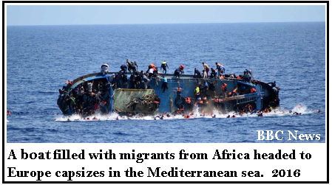

Introduction

In this chapter, we will introduce you to some of the most common topics that will come up in your policy debates this year. The topics below are certainly not exhaustive, but they are representative of the areas that will come up in many debates about European Union immigration policies.

Internal migration

The EU member nations are not all created equal. They have a wide diversity of economic well-being, and the lowering of barriers and the freedom of movement means that poor or unemployed citizens in less well-off countries can easily move to wealthier nations. They may or may not find work, and they may or may not be able to afford housing. And the richer nations may or may not welcome the quantity of poor arrivals they must now accept under EU law. Recall in the previous article that the unexpected quantity of poorer migrants was one of the political motivations behind Brexit.

“The free movement of workers is one of the four fundamental freedoms guaranteed by Article 45 of the amended EC Treaty. The free movement pillar provides workers with the right to free movement and residence, the right of entry and residence for family members, the right to work in another EU Member State, and the right to equal treatment in respect of access to employment and working conditions. While the right to free movement has led to some economic and employment benefits, it has also had a negative impact. Following EU enlargement, the migration of people with a disadvantaged background from the new, less well-off Member States to more prosperous EU countries has led to a significant increase in the number of homeless people.”

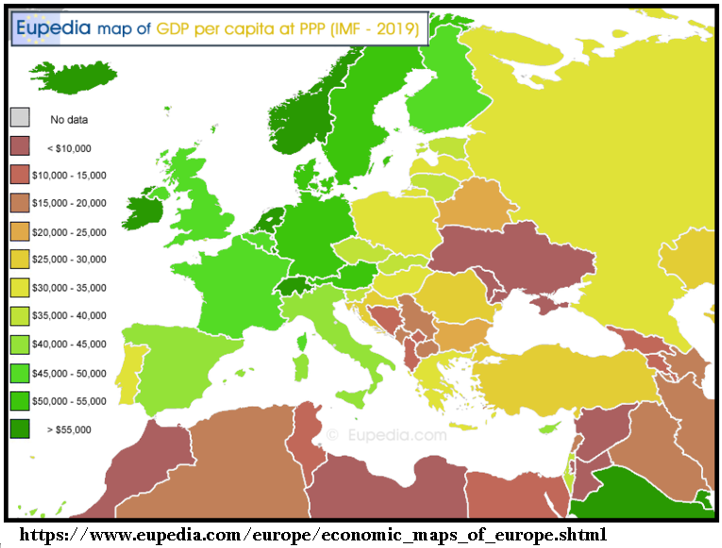

One such group of internal migrants is the Roma, sometimes known as Gypsies. You may be familiar with a romantic image of the “Gypsy,” but the reality is far different. Roma are the descendants of a group that migrated from India many centuries ago and settled in Eastern Europe. They continue to migrate and maintain an ethnic identity separate from the mainstream cultures of modern Europe. Within the European Union, they are the largest “stateless” ethnic group: there are more Roma than there are Danish people, for example. Targeted for extermination along with Jews and other groups by the Nazis during the Holocaust, they are still today widely subjected to hatred and discrimination. They are often ascribed with a reputation for begging, thievery, dirtiness, criminality, and seeking to sponge off public welfare benefits without working. Nonetheless, Roma who are born in EU countries and are citizens of those countries are entitled to all the rights, including movement and migration, to which any other EU citizen is entitled. Some EU countries have a habit of ignoring these rights and conducting mass deportations of Roma in violation of EU law and human rights obligations.

Some EU officials see a link between internal migration within the Union and external migration into the Union. After all, once bad guys or undesirable characters immigrate from the outside, they can then migrate wherever they want through unlimited internal immigration.

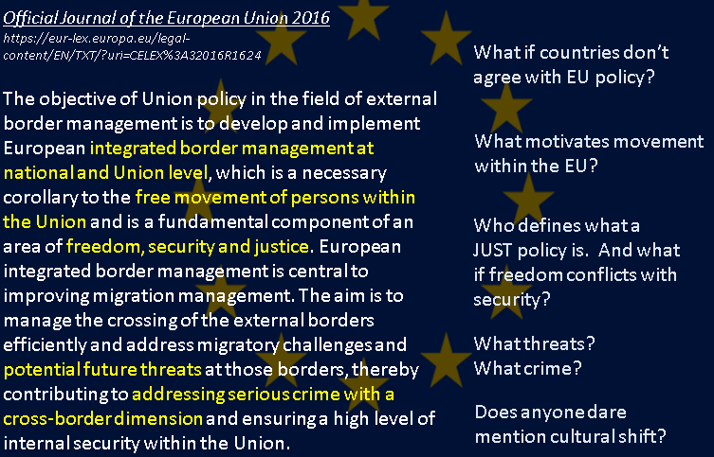

One of the unspoken, yet probably significant, aspects of concern about migration (internal and external) is the potential for cultural shift or dilution of the culture of a country receiving immigrants. Immigrants who speak different languages, practice different religions, and different customs from the dominant culture can be frightening. And this fear can be a source of concern to voters who may want to elect political leaders who will promise to reduce the flow of immigration to preserve their cultural heritage. They may not care that their nation has signed away its right to limit this flow by joining the EU or by ratifying the 1951 Refugee Convention.

Dangerous Crossings

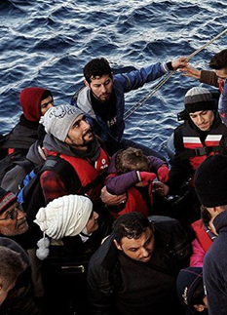
“Each year, hundreds of men, women and children board overcrowded and ill-equipped boats in an attempt to reach Europe, a phenomenon that started in the late 1980s after European countries tightened immigration policies and made it more difficult to enter such countries in a regular way. They may be fleeing violence and persecution or seeking improved opportunities for themselves and their families. Many do not survive the trip, never reaching their destination, as documented by media headlines and substantiated by several reports. Others are intercepted and turned back. Those who do make it may be detained until their legal status is clarified.”

In the previous article we noted the 2015 spike in “irregular” migration from certain Middle Eastern countries troubled by war (and those migration patterns, while they have abated, have not stopped). Many of these are coming to Turkey and hoping to get into the EU through Greece. Languishing in squalid refugee camps in Turkey and Greece, these migrants may or may not be eligible for asylum, but the Refugee Convention requires each of them to be given an individual hearing and a judgment based on their situation, and to be housed and fed in safe and sanitary accommodations until that happens. Turkey and Greece are getting tired of maintaining them and lack the funds of their own to pay for it. Compassion fatigue is setting in and something has to give.

And wars in the Middle East are not the only migration pressures. Immigrants are also coming from poor countries in Africa plagued with poverty, civil war, famine, and other distress. These are washing up on the shores of southern Europe on leaky boats and rafts, and many die on the dangerous crossing. How should the European Union respond?

Responses & Backlash

Not only are Turkey and Greece tired of thousands of unexpected migrants showing up on their borders, but Italy has reached the breaking point as well. The Refugee Convention requires standards of treatment for irregular migrants who arrive and claim refugee status, so one ingenious solution is simply to make sure they never arrive.

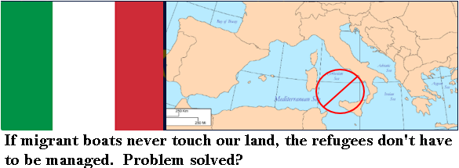
“Italy has refused this month to let two charity ships carrying immigrants into port, with [Italian Interior Minister, Matteo] Salvini saying such vessels “cannot dictate Italy’s immigration policy.” He said on Monday that if it were up to him, the Italian coastguard would not respond to distress calls from migrant boats. A poll last week showed that two thirds of Italians agreed with the policy of blocking rescue boats from the ports, and the League’s support has nearly doubled in the last month. The League also built on its support at local elections this month.”

Some countries have gone so far as to criminalize humanitarian actions involving the rescue or aid of distressed refugees. They do so under the theory that aiding someone immigrating illegally constitutes “human trafficking,” even though the rescuers being prosecuted are not making any money and are only responding after the fact of seeing someone drowning or in distress. Current EU law allows its member countries to get away with this because the EU standards of “human trafficking” contain this loophole. Some countries are using it in the disturbing hope that discouraging rescues and letting migrants die will send a signal back to the source countries that the passage is too dangerous and potential migrants will be more likely to stay home. Note Interior Minister Salvini’s statement above that he would prefer a policy of never responding to migrant boats in distress at all.

Perhaps EU countries should be looking for a new replacement for the Refugee Convention that would set new standards they would be willing to follow, if they don’t like the standards they signed up for in 1951.

Frontex

Another part of the EU response to increases in illegal immigration has been the beefing up of its fledgling coast guard and border patrol agency known as Frontex. While each EU member nation has its own border patrol and coastal states have their own navies and coast guards, the EU is adding manpower and muscle to the interdiction process.

Frontex has been greatly expanded and better funded in recent years in response to the migration crisis five years ago, but with that expansion, there has not been an expansion in oversight and accountability. In fact, Frontex routinely violates human rights, European law, and international treaties governing the treatment of migrants (legal or illegal).

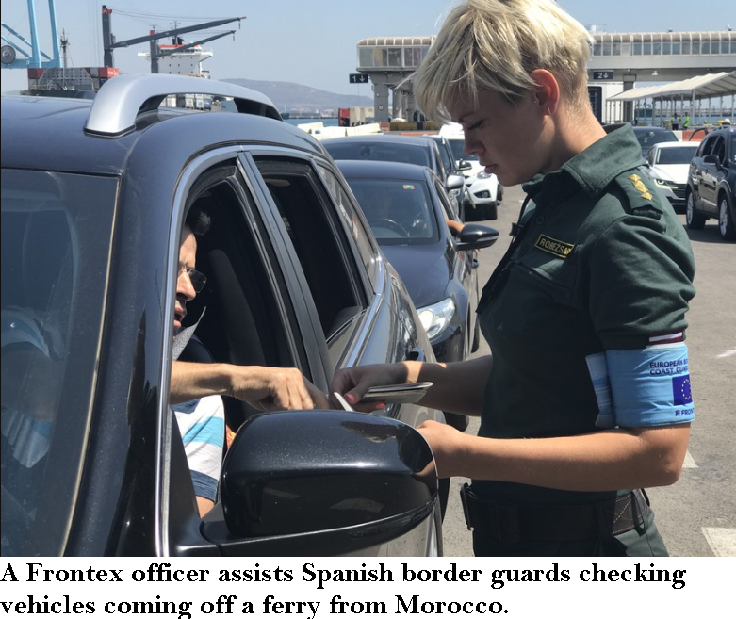
Frontex is called in to provide extra manpower when there is a surge in traffic at a border (e.g. during the summer tourism season) or when large unexpected migrant groups show up at borders or seashores. Sometimes Frontex joins forces with external non-EU countries on migrant interdiction missions. As noted before, treaties signed and ratified by EU members, as well as EU law, require border agencies to give hearings and adjudicate the situation of each migrant to determine if they are valid, deserving refugees who merit consideration for immigration. They should be sorted out one by one. Rounding up all of them and deporting all of them (or worse, abusing them and then deporting them) without a hearing is a violation of human rights, but many argue that Frontex does it anyway.

And when someone has a complaint about Frontex behavior, the only one they can turn to for filing a complaint is Frontex itself. “Internal investigations” of law enforcement are always problematic: Imagine you and your family are driving a long and get stopped for speeding. The driver tells the officer: “Don’t worry officer, our family will conduct an internal investigation and if there’s any problem with our speed, we‘ll resolve it internally.” If that sounds silly…it is, so why do we allow law enforcement to do it? Some believe Frontex needs better training, oversight, transparency, and independent monitoring to ensure it complies with human rights.

The Dublin Rule

Is it really fair for “frontline” countries like Greece and Italy to have to deal with hundreds of thousands of immigrants just because of the accident of their geographical location, when there are dozens of other EU nations that should be available to share the burden? Didn’t we all join the EU to mutually support one another in times of crisis like this?

The “Dublin Regulation” is an EU law that sets the rules for processing a migrant who arrives under irregular circumstances claiming asylum. The problem with the Dublin rule is that it mostly assumes the first country a migrant arrives in should take ownership of their situation. If you‘re in an interior country or in the far north of Europe, you are insulated from these unexpected arrivals (migrants have to pass through other countries first to get to you, so you have every right to send them back).

If you are in the Mediterranean (like Italy or Greece), everyone finds you first. If you are a country with generous welfare benefits, you might want the status quo Dublin rule enforced to keep migrants from passing through other nations to get to you in search of the best deal. But sending everyone back to the first country creates unfair burdens on the nations closest to where the migrants are coming from (Italy and Greece). Reforming the Dublin Rule could be a popular debate case this year.

Reception

We noted above that the Refugee Convention requires nations to provide adequate sanitary housing and food to arriving migrants until their claims can be adjudicated. Reception capacity is a big issue in the EU: how it’s measured, what countries claim to have or to be able to have, or claim to have reached their limits, what the standards of food and cleanliness are and whether they are being met.

When migrants wash up on the shore or get caught at the border of EU countries, they get taken into immigration custody. They may have a claim of asylum or some other valid claim to be accepted for immigration, or they may end up deported, but to find out, it takes time to investigate. The default policy is that they are locked up in immigration detention. But some argue there’s a better way: Sweden and Australia have systems of handling such cases called “Case Management,” and many experts advocate that the EU should use it as well. Case Management lets the migrant free from detention and assigns a social worker to work with them to find housing, get health care, file their paperwork, and understand the system, ensuring they get a fair hearing and fair treatment.

Related to the Dublin Rule reforms mentioned above, the literature is full of ideas for reform of the asylum reception and housing process. Greek islands are full of stranded migrants with nowhere to go: The Greek government can’t send them back (the rule against refoulement) and can’t take them in (they don’t have legal “refugee” or asylum status because their claims haven’t been investigated) and can’t afford to feed and house them properly (too expensive) and can’t send them to other EU countries (Dublin rule and/or other countries don’t want them).

What about Turkey?

Recall from the earlier article that Turkey is not a member of the EU, though it applied for membership in 1987 and has been waiting patiently ever since. In 2016, the EU cut a deal with Turkey to help manage the sudden burst of migration into the EU coming from the Syrian civil war.

“Agreed in March 2016, the EU-Turkey deal is a statement of cooperation between European states and the Turkish government. It seeks to control the crossing of refugees and migrants from Turkey to the Greek islands, and was initially intended to curb the large numbers of refugees arriving in Europe – or losing their lives on the way – in 2015. The crux of the deal was that every person arriving irregularly (i.e. by boat, without official permission or passage) to the Greek islands – including asylum-seekers – would be returned to Turkey. In exchange, EU Member States would take one Syrian refugee from Turkey for every Syrian returned from the islands.”

The deal also included up to 6.7 billion euros in EU funding granted to Turkey to pay for the millions of refugees already housed there – funding Turkey desperately needed and wanted. The deal was controversial because many consider Turkey an unsafe country for refugees, hence the EU may be violating the non-refoulement rule by sending them there.
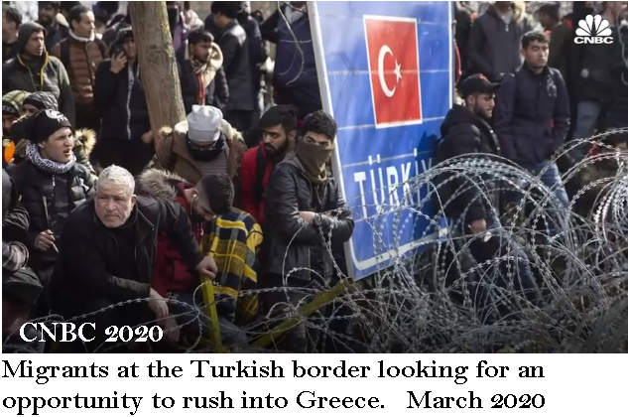
Turkey has not always been happy with the implementation of the agreement, however. They complain that the euros have not always arrived in the quantity or on the time schedule as promised. They also point out that the total cost of managing the refugees far exceeds the sums proposed or paid by the EU thus far. With 3 million displaced Syrians in their country, Turkey already hosts more refugees than any other country in the world.

As such, the lifespan of the EU-Turkey agreement depends de facto on how long Turkey will be able to endure the world’s biggest migratory pressure. However, what seems to be a burden for Turkey is also a factor of leverage. In order to prompt the EU side to favourable action, President Erdogan occasionally warns that Turkey might consider “re-opening its borders for the Syrians”, or, that the Syrians will sooner or later “start knocking on the EU’s door”. So far Ankara has not withdrawn from the agreement as it still expects EU’s cooperation. Above all, the Turkish government plans to send back as many Syrian refugees as possible and needs EU’s support, at least diplomatically, in creating safe zones in Syria where they can be transferred.

Indeed, in moments of pique, the Turkish government has announced reopening of the border with Greece, and even bused migrants up to the border, pointed them in the direction of Greece, and told them goodbye. Scuffles and fights broke out as the Greek border guards sent them back.

The deal with Turkey was never a formal legal agreement, but it did have consequences. Migrants were crowded into E.U. “hot spots” — camps on several Greek islands — where they were supposed to be registered and screened before their fate was decided on. But Greek officials allowed few to transfer to the mainland and few were accepted by other E.U. countries. The migrants that remained had to live in unsanitary and dangerous conditions, in perpetual fear of being returned to Turkey or their home country. By late 2019, there were about 40,000 migrants throughout the Greek islands.

Outsourcing the Borders

Another controversial strategy the EU has pursued recently to stem the flow of immigration might be called outsourcing the problem. Many in the EU believe that if they can fund programs in or close to the source of the problem, in the countries where the migrants are coming from, they can halt the flow at the source rather than dealing with it on their own shores. Refugees who never arrive on the soil of EU nations will thus not be a problem for the EU. Problem solved?

We noted above the deal with Turkey to manage the flow on Turkish soil, but Turkey is not the only place where such arrangements are happening. The EU has provided funding to Libya for its coast guard to catch and return migrant boats off its shores. It is also funding detention camps in Libya that house tens of thousands of African migrants under squalid conditions.

The EU is also funding law enforcement/military efforts in places like Niger to shut down human smuggling routes known for transporting migrants north across the Sahara Desert on their way to the Mediterranean for the passage to Europe. Some argue that shutting down the known routes motivates migrants to take the lesser known routes – a dangerous proposition when crossing a vast desert.

https://cor.europa.eu/en/engage/studies/Documents/internal-migration-homelessness.pdf
The term “Gypsy” is becoming more disfavored and considered somewhat pejorative and impolite by many.
Some controversy may exist over the reasons for the historical position of the Roma. Are they poor and begging because they have been despised and denied opportunities for advancement? Or are they despised because they choose to remain poor and beg rather than working for a living?
https://www.bbc.com/news/world-europe-34471858
https://www.reuters.com/article/us-europe-migrants-italy-salvini/echoes-of-trump-as-italys-salvini-gets-tough-on-migrants-idUSKBN1JM24H (brackets added)
https://helprefugees.org/news/eu-turkey-deal-explained/?gclid=Cj0KCQjwyJn5BRDrARIsADZ9ykGZ0sp66d1q2RlAnLBAsWsCK5GwF-ybSpb1Jpw_lcuIcJAZjk19TjAaAmamEALw_wcB
One estimate puts the total cost to Turkey at around €30 billion https://www.globalutmaning.se/utblick/eu-turkey-statement-migration-three-years/
https://www.globalutmaning.se/utblick/eu-turkey-statement-migration-three-years/
And you should know that, despite both being members of NATO, Greece and Turkey are bitter enemies, with disputes and grievances going back centuries. The two nations almost went to war in 1974 over the Turkish invasion and occupation of the northern part of Cyprus.
WASHINGTON POST, 25 March 2020. https://www.washingtonpost.com/politics/2020/03/25/europe-has-relied-turkey-stem-another-migration-crisis-that-plan-backfired/

