Current Issues of US Military Commitments
By “Coach Vance” Trefethen
Resolved: The United States federal government should considerably decrease its military commitments.

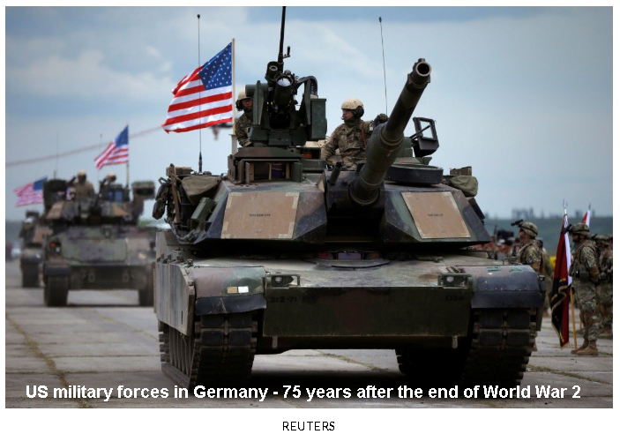

Resolutional Analysis

What are “Military Commitments”?

COMMITMENT
“1a: an agreement or pledge to do something in the future a commitment to improve conditions at the prison especially : an engagement to assume a financial obligation at a future date
b: something pledged the commitment of troops to the war
c: the state or an instance of being obligated or emotionally impelled.”
Some military commitments are formal treaties we have with other countries, in which we have given them assurances in writing that we will protect them with military power in case of trouble. Examples include Japan, the Philippines, South Korea, and the NATO alliance.

Other types of military commitments may be informal or based on longstanding relationships or traditional aspects of our foreign policy. The U.S. has no official defense treaty with Saudi Arabia or with Israel, yet there have been assurances made and actions taken over the years indicating that the United States is committed to the military defense of these nations. This type of foreign policy can be described with words like “security relationship,” “mutual understanding,” “friendship,” or “cooperation.”

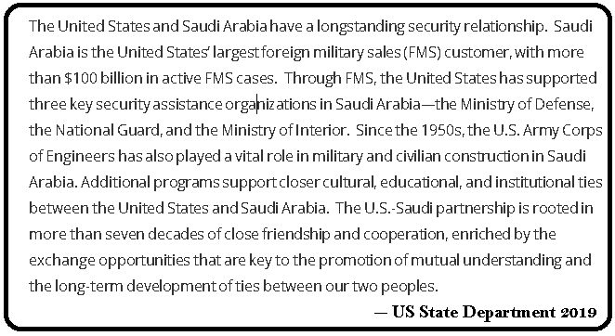

In other cases, the mere presence of US troops deployed in a country might indicate a commitment to a military mission or military strategy, given that sending troops indicates a “commitment” beyond just words, press releases, negotiations or foreign aid.

Stretching the resolution a little further, we might also ask whether the furnishing of military aid is also a “military commitment.” Some countries are long-term recipients of US military aid (e.g. Egypt, Israel) and these long-term aid relationships might be described as military commitments. The resolution authors didn’t really rule this out, since the resolution doesn’t specify the commitment of “troops” or “forces” by the U.S., hence a commitment to provide military aid might qualify as a “military commitment.” You can certainly debate that.

What is “considerably decrease”?

CONSIDERABLE
“1: worth consideration: SIGNIFICANT - a considerable artist
2: large in extent or degree”

The two simplest ways to decrease a military commitment would be to remove troops or to drop out of a treaty that promises a military commitment. Another way might be declaring a policy of no longer being committed to the defense of a country or region (where no formal treaty exists but long-standing practice and policy has made such a commitment over the years). Canceling foreign military aid might also qualify.

Note the importance of the phraseology of this part of the resolution and how it differs from past resolutions you may have debated. It is a “unidirectional” resolution; that is, it requires all Affirmative debaters to “decrease” something. You can’t just “reform” it and you can’t “increase” it. This has very large implications for research and preparation by debate teams this season.

Negative teams only have to prepare for debates involving all existing US military commitments (still a very large topic), and do not have to research any possible new ones that might be proposed. And they only have to defend their existence in the Status Quo against considerably decreasing them; they do not have to prepare for all possible ways they could be reformed.

For example, imagine we are studying US military commitments to South Korea. There are basically two things an Affirmative could do: remove US troops deployed there, and/or cancel the defense treaty we have with S. Korea where we promise to come to their aid if they are attacked. This rules out “reforming” our presence (relocating troop deployments, new equipment, etc.) and rules out “increasing” our presence (sending in more troops). More than 2/3 of all possible Affirmative debate cases involving S. Korea are ruled out by the unidirectional nature (decrease-only) of the resolution. This makes life much easier for all debaters in terms of the research burden involved in being adequately prepared for tournaments.

Negative debaters also benefit from the clear counterplan ground established by the unidirectional nature of the resolution. Negatives can always propose “increase instead” as a counterplan, with assurance that they will not have to spend time debating whether “topical counterplans” are a valid tactic or not. Negatives can also propose “reform instead” and fix whatever problems US military commitments are causing without decreasing them and without agreeing with the resolution.

The unidirectional resolution also makes generic Negative brief-writing easier. It won’t be hard to write a generic Negative brief (to be used against almost any surprise AFF plan for which you don’t have a specific NEG brief) linking reduced US military commitments to reduced US global hegemony and increased influence of some global bad guys (like Russia and China, or terrorists). Then, with enough links and enough evidence, you can argue that US hegemony is key to world peace and prosperity, while increased influence of bad guys will have bad impacts.

The resolution authors have given some very nice gifts to Negative debaters this year. Be sure to use them!

Scope of current US military commitments

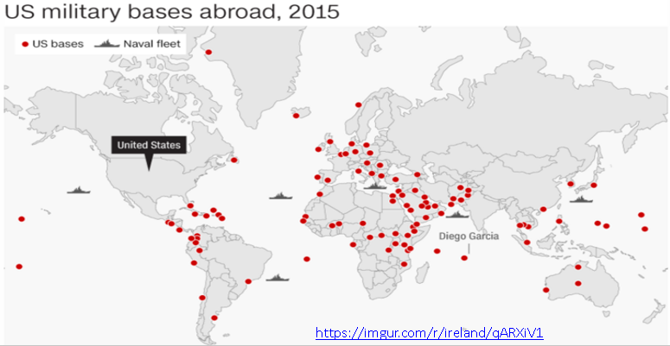

Even with a narrower resolution, the scope of this resolution is still broad. The map above shows how many locations in the world could potentially be affected by it. And this map should remind you that US military commitments aren’t just about troop deployments, they also include naval sea lane patrols in various hot spots on the globe (e.g. Persian Gulf, South China Sea).

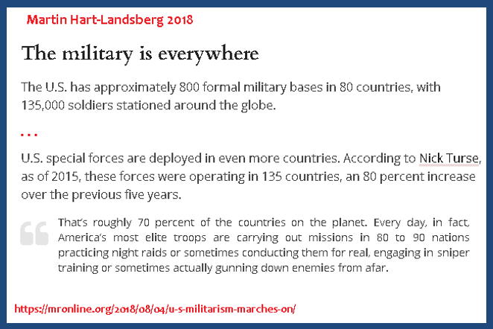

Of course, US forces are not evenly spread throughout the globe. The legacy of historical events mentioned in the previous chapter, particularly World War 2, the Cold War, and the wars in Iraq and Afghanistan, define the majority of present day US military deployments.

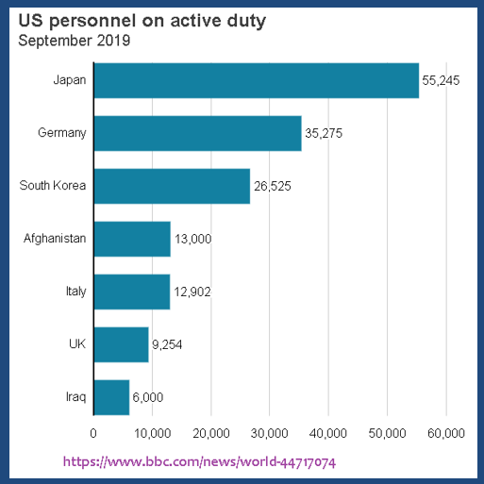

NATO and Europe

The first question we might rightly ask about NATO is: why does it even still exist? Its Cold War mission, to oppose a Soviet-bloc invasion of Western Europe like a second coming of Hitler, was successfully accomplished when communism collapsed in Eastern Europe starting in 1990. But instead of declaring victory, mission accomplished, and going home, NATO instead expanded!
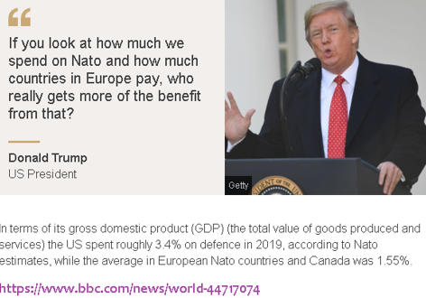
Affirmative teams concerned about reducing US military commitments will have several critiques of the US commitment to NATO. First, who is committed to whom? NATO members are committed to having the US defend them, but not always very committed to spending their own money to defend themselves, or each other.

When asked if their country should defend a fellow NATO ally against a potential attack from Russia, a median of 50% across 16 NATO member states say their country should not defend an ally, compared with 38% who say their country should defend an ally against a Russian attack.

Second, what’s the threat? Is a Russian invasion of Western Europe really a serious threat today? The cost would be substantial, the benefits to Russia highly doubtful, and success in the long run extremely unlikely, given Russia’s military weakness. Some experts, however, point to aggressive moves by Russia recently against Ukraine and Georgia that suggest small eastern European countries still have much to fear from Russia.

A reduction of US military commitments might not have to involve a complete rejection of NATO, but merely a decrease in troops or weapons deployment. Experts have advocated for years the final removal of remaining US tactical nuclear weapons deployed in five NATO countries – a lethal legacy of the Cold War that no one really expects to be used for any legitimate purpose.

And just recently Pres. Trump announced the reduction of US troops deployed in Germany.

The U.S. military plans to move nearly 12,000 troops from Germany, relocate its major European headquarters to Belgium, and send F-16 fighters to Italy, to implement President Trump’s decision to shrink the U.S. military footprint in the NATO ally, Defense Secretary Mark Esper said Wednesday.

Seventy-five years after Germany’s defeat in World War 2, perhaps it is indeed time to ask why we still have any troops deployed there at all.

Africa

The US has about 5000 troops deployed across Africa, creating some possible debate cases for creative Affirmative debaters. The eastern and western parts of Africa each have their own challenges.

In the eastern part of the continent (also known as the “Horn of Africa,” the area around Somalia and Ethiopia), much of the US effort is focused on stabilizing the fledgling (some say, unsustainable, ineffective) government of Somalia. An Islamic militant group known as Al Shabab has been menacing the region for a decade, and many believe US forces are key to defeating it. Others believe US presence and intervention are partly what fuels it, given that they represent the strongest movement against outside occupation forces.

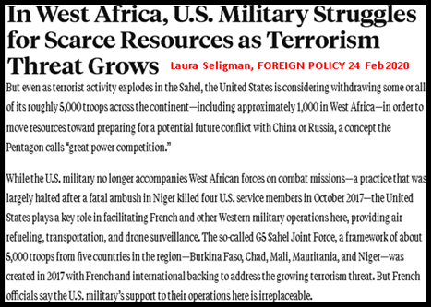
Western African countries (e.g. Nigeria, Mali, Niger) have rebel movements and terrorists that spring up in various places, and those countries have requested US military assistance to combat these threats. The same question can be raised about US involvement there: Does the US military presence create more terrorists than it destroys, when local groups resent foreign military operations on their soil? Imagine if Nigeria deployed 5000 troops next week in the United States and they began hunting down and killing people they deem responsible for destabilizing our country. How would the average American react? Joy at the assistance? Or resentful of the outside interference?

US military adventures in Africa not only have implications for terrorism, national stability of African countries, and settlement of civil wars and conflict. They also arguably play a role in “Great Power” competition. The presence of the US military may or may not reduce the influence of China on the African continent as it tries to expand its global influence. And blocking China may or may not be a good thing; you get to debate that.

Japan

When the U.S. defeated and occupied Japan in 1945, the victors gave the defeated nation a new constitution and a new attitude. Whereas Japan had previously been expansionist and militaristic about building an East Asian empire, they would now be banned from having more than a token self-defense force. The United States assumed responsibility for the military defense of Japan, in order to assure both ourselves and other nations that Japan would not rise up to threaten world peace again.
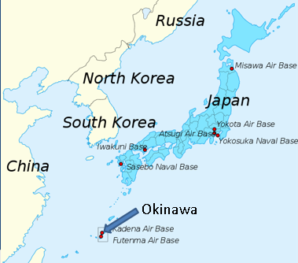
The 1960 “Treaty of Mutual Cooperation and Security” between the US and Japan requires the US to defend Japan, but not the reverse – Japan has no requirement to defend the US. US troops have been stationed continuously in Japan since the end of World War 2 to fulfill that commitment. They have also provided a forward military capability for US forces to react to other scenarios, such as Cold War confrontation with Russia, the Vietnam War, tensions between North and South Korea, and modern confrontations with China.

A number of issues can be raised with regard to the US military commitment to Japan. Japan pays some of the cost of US military protection, but there are doubtless costs remaining to the US taxpayer to protect another of the richest countries in the world. Residents of Okinawa have long resented the noise and disruptions to their lives by the presence of US forces and their loud aircraft (and sometimes misbehaving service-members).

Maybe it’s time for the US to back away and let Japan grow its own military forces and defend itself.

Korea

The U.S. maintains around 28,000 troops in South Korea as a legacy of the (still unresolved) 1950-1953 Korean War. The reclusive communist regime in North Korea, with its nuclear weapons and long-range missile programs, constantly issues threats and bluster against the more populous and prosperous South, as well as against the United States. Negotiations over nuclear weapons, reducing tensions, a final settlement to the Korean War, and other issues are always ebbing and flowing without ever reaching a conclusion. North Korean dictator Kim Jong Un issues threats, offers reconciliations, and says all kinds of things that make it difficult to manage the potentially explosive Korean situation.
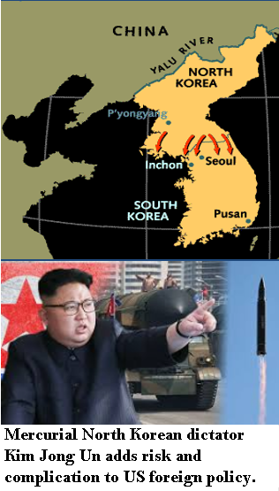
Maybe it’s time we stopped trying to manage it? The South has a big army, better technology, and far more resources than the North, and should be able to easily defend itself against a repeat of the North’s 1950 invasion, were it to happen today. The remaining US troops in South Korea mostly serve as a “trip wire,” rather than an actual military force to be reckoned with. That is, they’re in South Korea for the purpose of getting shot at by the North so that the US would of necessity be drawn in to defend the South in case of a conflict breaking out. Pulling them out would send a signal to the South that the US is not as committed to their defense as we once were, and might require them to spend sufficient sums on military preparations out of their own budget, rather than relying on Uncle Sam. You get to debate whether this would be a good or a bad thing.

Philippines

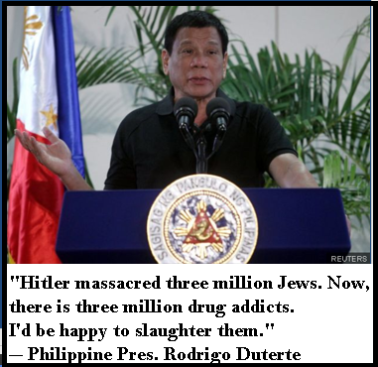
The U.S. drove Japanese forces out of the Philippines during World War 2 and maintained a close relationship with the island nation after the war. The US and the Philippines signed a Mutual Defense Treaty in 1951 (where “mutual” means we defend them and they probably can’t or won’t do very much for us). The Philippine government demanded the removal of all US military bases in 1992. But since 2012, US/Philippine military cooperation has been increasing.

The Philippines has active armed insurgencies with both communist and Islamic militants posing threats to various islands and regions. US troops and equipment have been assigned to the Philippines to assist the government in suppressing these threats. The Philippine government has also massively escalated its internal “war on drugs,” using violent means to try to suppress illegal drug use.

The Philippines has territorial claims on sea lanes and islands that conflict with China’s claims, and the U.S. hopes to maintain a good relationship with the Philippines in order to keep China in check. Philippine President Rodrigo Duterte makes this difficult, however, by his violent behavior and contradictory statements. He favorably compares himself with Hitler, saying that he’d like to kill three million of his own citizens that abuse drugs. He sometimes declares that he would like to align his country with China, then reverses course and announces loyalty to the U.S.

Saudi Arabia and the Persian Gulf

Pres. Franklin D. Roosevelt initiated a relationship with Saudi Arabia during World War 2 to assure their military protection in exchange for access to their oil. Pres. Jimmy Carter declared the Persian Gulf essential to US national security in 1980. The resulting US military commitments and interventions in the decades since have cost our nation dearly in blood and treasure, in addition to making the problem worse that it was supposed to solve. The Persian Gulf is not more stable today than it was in 1980, the pernicious influence of Iran is far worse, and the cost in dollars and lives has been colossal. The wars we’ve fought over it (for sure Gulf War I and Gulf War II) plus the annual cost of naval patrols and military bases in the region have run into hundreds of billions of borrowed deficit dollars. And the negative view in the region of our outside intervention has been a magnet for terrorism.

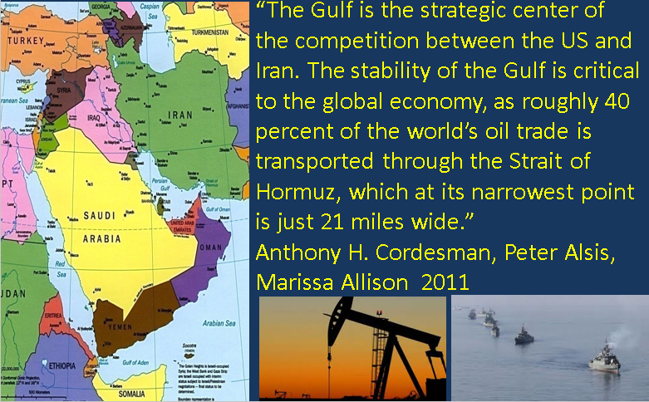
Support for Saudi Arabia (and neighboring Gulf states like Kuwait and Bahrain) puts America in a difficult position. While we declare our foreign policy to be supportive of democracy and human rights, we ignore those priorities if a country has lots of oil. We potentially make ourselves hypocrites at best and active supporters of oppression at worst.

Affirmatives can argue that oil doesn’t need US military protection to arrive on world markets any more than any other commodity does. The countries that produce and sell oil have every incentive to find ways to safeguard their product, since they are the ones who profit from it. The US produces its own oil, and most oil in the Persian Gulf goes to other nations like China. Removal of the heavy US military footprint from the region will solve one of the main causes of terrorism and eliminate a huge unnecessary expense for US taxpayers. If China needs Persian Gulf oil and thinks it needs military protection, maybe China should provide and pay for that protection.

Negatives will argue that the situation in the Persian Gulf would be far worse without the US military security guarantees created by the Carter Doctrine. Gulf oil facilities are vulnerable to attack, either by terrorists or by Iran. The Strait of Hormuz, where a large percentage of the world’s oil passes each day, could easily be choked or threatened. Even the threat of these scenarios, and even more, their fulfillment, would cause an immediate spike in the price of oil, with big impacts on the US and world economies. In addition, US presence in the region deters Iran from gaining influence and blocks it from bullying its neighbors. Given the dangers of the Iranian regime, including its nuclear weapon building program, now is not the time to be removing the security guarantee that has kept the region stable until now.

Naval Patrols

Don’t forget that naval deployments are also a form of “military commitment” in addition to the more traditional “boots on the ground.” The US Navy has a presence worldwide, but two major deployments may be ripe for change under this year’s resolution. The first is the US Navy’s policy of patrolling the Persian Gulf and neighboring sea lanes to safeguard the flow of oil. The issues surrounding this are covered in the previous section regarding Saudi Arabia and the Persian Gulf.

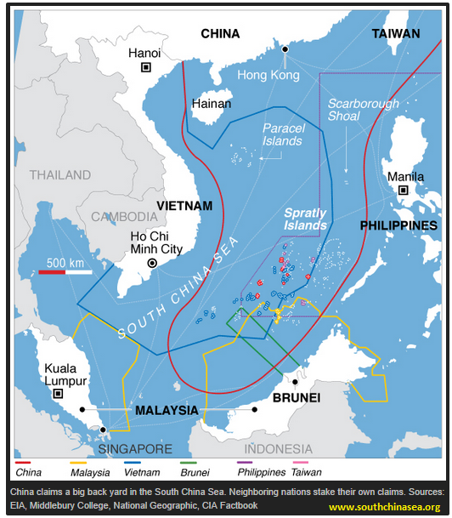
The US Navy also has an active role in patrolling the South China Sea. This too is controversial because it can be viewed as a direct “in your face” confrontation with the People’s Republic of China. The PRC has made a number of claims of exclusive rights to various disputed islands and waterways in the South China Sea – claims that are not recognized by other nations. China is also building artificial islands to increase their control, presence and claims. The US Navy intentionally sails through areas claimed by China just to make the point that we and other nations don’t recognize those claims.

This could be a good policy by keeping China in check and blocking it from exerting pressure and control over its smaller neighbors like the Philippines and Vietnam. If China’s influence in the world is bad, limiting that influence could be good. On the other hand, remote islands that have no bearing on US national security seem hardly worth risking a war and losing US lives in a conflict with China. If those sea lanes and islands are really valuable, the nations who dispute China’s claims should build up their navies and protect their claims themselves.

US Hegemony: Good or Bad?

“Hegemony” is a term often found in the political literature that refers to dominance, leadership, strong influence, or other ways in which a Great Power nation gets other, smaller nations to go along with its will. A nation like the U.S., due to the presence of its military and guarantees of military protection, can exercise hegemony over many parts of the world. That is to say, the world functions, not completely, but in many more ways as the U.S. government would wish it to function than it would absent such hegemony.

If the presence of US military troops, or the commitment to supply them, or the commitment to come to the military defense of certain nations gives the US such hegemony, what happens if such is withdrawn? Negatives can argue generically that withdrawal reduces US hegemony and that such reduction is a bad thing. It’s possible that world peace, prosperity, and civilization as we know it depend on US leadership in the world.

“Critics of U.S. global dominance should pause and consider the alternative. If the United States retreats from its hegemonic role, who would supplant it? Not Europe, not China, not the Muslim world, and certainly not the United Nations. Unfortunately, the alternative to a single superpower is not a multilateral utopia, but the anarchic nightmare of a new Dark Age.”

On the other hand, it’s also possible that the US is “overstretched.” Maybe our nation is trying to do too many things in too many places. Even before the corona virus hit, our nation was running massive federal budgetary deficits every year, and these will get massively worse during and post-pandemic. The money to pay for global military commitments, troop deployments, and naval patrols simply doesn’t exist: we’re either printing it or borrowing it at an alarming rate. An old saying in economics is that when something cannot go on forever, it will stop.

And sometimes U.S. intervention triggers the very thing it was intended to prevent. Sending in the troops not only doesn’t calm down a region, it creates anger and resentment on the part of those now being ruled (or killed) by Americans coming in from thousands of miles away.

Al-Qaeda, the world’s most notorious terrorist network, was, in a sense, a response to the most obvious manifestation of global hegemony, namely, military power. As soon as the United States had established a military base in Dhahran, Saudi Arabia, in 1991…Osama bin Laden, announced to the world that he would attack Dhahran. He considered the establishment of an “infidel” military base in Islam’s holiest land—Saudi Arabia, where Islam’s two holiest cities, Mecca and Media, are situated—an act of sacrilege.

Conclusions

There are potentially many other areas where US military commitments could be decreased. The ones listed here are some of the bigger ones you need to know about, but reviewing the map shown earlier about US military stationed abroad shows there could be lots of others. As with every debate season, many debates will be won or lost in the month preceding the tournament, depending on how hard and how extensively the debaters research and prepare in advance.

Merriam-Webster online dictionary
Merriam-Webster online dictionary
Pew Research Center 2020.
Wall Street Journal 29 July 2020 https://www.wsj.com/articles/pentagon-to-detail-plans-for-u-s-troop-cuts-in-germany-11596026413
Prof. Niall Ferguson 2004.
Prof. Chandra Muzaffar 2007. Ellipses added

