History of European Immigration Policy
By “Coach Vance” Trefethen
Resolved: The European Union should substantially reform its immigration policy.
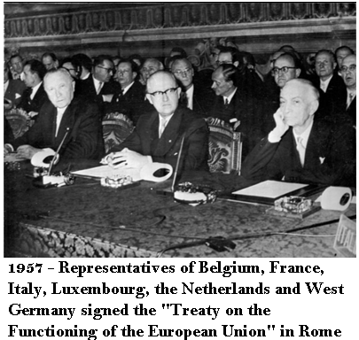

Introduction
In this chapter, we will give you some preparation for this year’s debates by going over historical events related to the establishment and development of the European Union and its immigration policies. I’ve been involved in high school debate for decades, and this is the first time I have ever seen a resolution2 using the European Union as the actor for the policy change. I believe debaters will find it a tremendous learning experience, but it comes at a cost: You must start basically from scratch to understand a new and complicated system of government that is alien to our political history and foreign to our geography.

Origins and Background
The two devastating world wars (WWI 1914-1918 and WW2 1939-1945) each produced mass death and destruction on a wide scale, along with severe economic hardship. After each war, repairing the damage and rebuilding the economies of both the victors and the vanquished came at great cost. After World War 2 ended, many in Europe hoped for some kind of mechanism that would hold European nations together in ways that would counteract the forces that so often drove them to conflict.
America was, to some degree, a role model, as a union of 48 states that had started from 13 independent colonies choosing to give up some of their sovereignty to a federal government in exchange for the benefits they gained by standing together united and breaking down trade and financial barriers between them. Could the diverse nations of Europe try something similar, giving up some of their sovereignty to find a way to unite themselves under a single banner for the common good?
It couldn’t happen all at once, but it began with small steps. The first was the establishment of the European Coal & Steel Community in 1951. That agreement joined the coal and steel industries of Belgium, France, (West) Germany, Italy, Luxembourg and the Netherlands into a common market. Eliminating competition over such key industrial resources was viewed by its founders as a way to reduce the risk of future wars, given that such competition had factored into past conflicts. It also allowed these industries to grow into a scale large enough to compete with the “great powers,” something these smaller nations could not foreseeably do on their own.
The next step was for these same six nations to expand their economic cooperation in 1957 with the formation of the European Economic Community, or “Common Market.” The EEC eliminated customs duties (tariffs on imports) and moved these countries toward forming a customs union (an arrangement by which the nations agree on a single tariff toward outside nations and none amongst themselves). The ultimate goal was integration of all the economies of its members.
In 1958, the EEC formed the “European Parliament” (EP) to manage the new arrangement. It consisted of representatives taken from each member country’s existing parliaments and was not elected directly by the citizens. Additional nations joined the EEC in the 1960s and 1970s. Direct election of EP members was established in 1979. EP parliament representation is proportional to the population of the EU member countries (much like the US House of Representatives).
“On March 25, 1957, representatives of six European nations signed two treaties in Rome. One created the European Atomic Energy Community (Euratom) for the common and peaceful development of Europe’s nuclear resources. The other created the EEC. In the Common Market, trade barriers between member nations were gradually eliminated, and common policies regarding transportation, agriculture, and economic relations with nonmember countries were implemented. Eventually, labor and capital were permitted to move freely within the boundaries of the community. The EEC, the ECSC, and Euratom were served by a single council of ministers, representative assembly, and court of justice. In 1967, the three organizations were fully merged as the European Community (EC).”
The 1970s saw the EC become more concerned with social welfare and business regulation. Programs transferring wealth from richer to poorer regions were enacted. European environmental regulations also came into effect. And the EC nations began the process of planning for a single European currency.
In the 1980s, more nations joined the EC, one left (Greenland), and one submitted an application for membership in 1987 that is still pending 33 years later (Turkey). During the ‘80s, the EC began enacting tighter restrictions on immigration as well. Doubtless this was at least in part due to the increasing emphasis on social welfare policies (generous unemployment benefits, poverty relief programs, subsidized housing, public health insurance, etc.). European citizens, having experienced post-war economic growth, had achieved a comfortable standard of living and were willing to pay the taxes necessary to buy the security of a comforting, but expensive, welfare state that could insure them against distress. But such generous benefits attract newcomers like bees to honey, motivating non-taxpaying or low-income (low tax paying ability) outsiders to swarm into the social welfare system to enjoy its benefits without paying for them. Immigration thus becomes a concern to European taxpayers who are willing to pay for their own social benefits, but not for the rest of the poverty-stricken world.

Development of the European Union
In 1993 the nations comprising the EC signed the Maastricht Treaty to complete the integration of their market and officially change their identity to the “European Union.” The new Union was based on “Four Freedoms of Movement”:
- Goods
- Services
- Money
- People
The first three of these were facilitated by plans for creating the European Central Bank (ECB, in 1998) and a common currency (the Euro, 2002), which came about in the following decade as well as by the elimination of trade barriers within Europe (much like the free movement of goods in interstate commerce in the USA; there are no customs checkpoints at state borders to inspect or tax the movement of products across state lines).
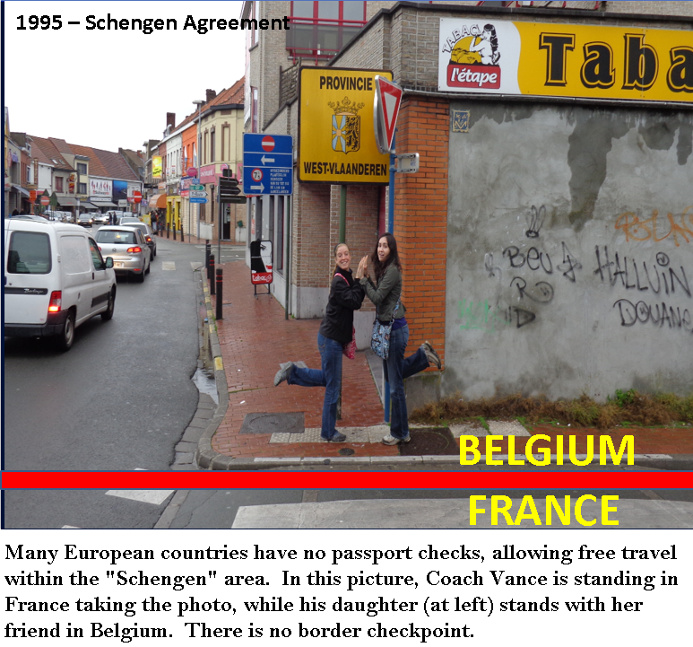
The last (movement of people) is the one that pertains to our topic. The “Schengen Agreement” of 1995 is also pertinent here, though it is not the same as the EU. Both the EU and Schengen break down barriers of travel between European nations by abolishing customs checkpoints and passport controls at the borders. Today you can cross from France into Belgium, for example, by simply walking across a city street or driving down a highway, much like passing from North Carolina to South Carolina on the interstate. There is a road sign indicating you have crossed a border, but no guard shack and no passport check.
This means that when we talk about “European Union immigration policy,” we must be prepared to talk about two different types of policies. First, we must prepare to debate immigration between and amongst countries within the EU. Second, we must learn about immigration of non-Europeans from outside Europe trying to come into the EU.
The “free movement” of people also has three aspects to it that must be distinguished: freedom to travel, freedom to reside, and freedom to work. A nation might drop its border checks and allow anyone to enter from another friendly neighboring nation, but what happens when that foreign visitor applies for a job? Or wants government-funded medical care? Or a welfare check? Suddenly that freedom of movement might hit an abrupt barrier.

The Euro
The EU single currency, the euro, was created by the European Union but is not synonymous with it. Several EU member nations never adopted the euro as their currency and simply continued using their original historical currencies after joining the EU. The euro is also used by a few small states that are not EU members. But the adoption of a single currency across many countries that formerly had diverse currencies has expedited the flow of trade and eased the hassles of travel among those nations.
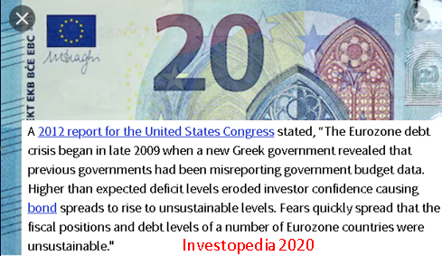
It has also created some unexpected side-effects among countries in the Eurozone (as these nations are called). Abolishing a national currency and adopting the euro means that a nation loses control of its monetary policy and hands it over to the European Central Bank. Nations that formerly issued bonds (government debt) in their own currency had to pay interest rates commensurate with the risks investors perceived in their local economy (higher risk countries = higher interest rate bonds). But after adopting the euro, nations at least believed that they could issue government debt at rates similar to EU bulwarks France and Germany. For a while they could, until investors caught on to the fact that some of them could not pay these debts back.
Had Greece, for example, been outside the Eurozone during its debt crisis 10 years ago, it would have been issuing high-interest government bonds denominated in drachmas (its old currency). And when the bonds came due, the Greek government could have printed enough drachmas to pay back bondholders. This would have run inflation through the roof as it greatly devalues the currency, but you do what you have to do…as long as it doesn’t involve raising taxes or cutting government spending, which are sure ways not to get your political party re-elected. But since Greek bonds were denominated in euros, the Greek government actually had to come up with the euros to pay the interest and principle on the bonds. When it couldn’t find them in the budget and couldn’t print them, a crisis ensued that involved investors losing money and other EU governments providing bailouts (to rescue confidence in their own currency). A sovereign debt crisis in one Eurozone country now has implications across the continent, whereas before it would have simply been Greece’s problem. The collapse of the drachma would have harmed 10 million Greeks. A collapse of the euro would harm 400 million Europeans.
As of 31 July 2020, one euro = $1.18 in US currency. This may help give you some perspective when reading evidence citing the cost of various things in your debate evidence this season.

European Union Government
The EU proposed an official Constitution to be ratified by its members in 2005, but it was rejected by voters in France and the Netherlands, so it was never put into effect. Instead, the EU is governed by rules laid down in various treaties that its members have signed. The bad news is that the system is complicated (most EU citizens probably don’t understand it and couldn’t explain it). The good news is that Affirmative debaters have an easy escape from the complexity, since they can simply name one or two EU government agencies and then put “…and any other necessary EU agencies will enact the following plan.” Debate should focus on the policy itself, not the details of which agency of the EU government enacted the law or should have enacted it. I can assure you, TP debate judges do not want to hear debates that get bogged down in those types of issues.
EU laws are officially supposed to originate with proposals from the European Commission, which is run by a committee of 27 commissioners, one appointed (not elected) from each EU country. Once the European Commission drafts a bill, they send it simultaneously to the Council of the European Union, the EU Parliament, and the national parliaments of all 27 member nations.
The Council of the European Union is made up of policy ministers from the national governments of the member states. These leaders meet to review legislation pertaining to their assigned field; for example, the “Finance Ministers” of the EU countries might meet to discuss a proposed EU banking law.
If the Council and the Parliament accept the Commission’s proposal, it is enacted into law. They might also send it back for amendments, or simply reject it. While all of this is going on, the national parliaments of the EU countries also have the right to review the proposal. If a sufficient number of them vote to object to the legislation, the legislation can be delayed for further review or stopped altogether.
In 2009, the Treaty of Lisbon came into effect, which updated previous EU treaties and modified some of the mechanisms of legislative procedures and the balance of power between the Parliament and the Council. It also established a “Charter of Fundamental Rights,” which would have been enacted by the 2005 Constitution, had it been ratified then.
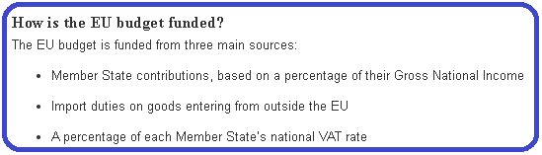

Laws and Jurisdiction
What are the boundaries of where EU law ends and national member state law begins? Even in the U.S., we struggle sometimes with working out the limits of federal versus state jurisdiction, and the EU has similar problems. The chart below outlines these boundaries.

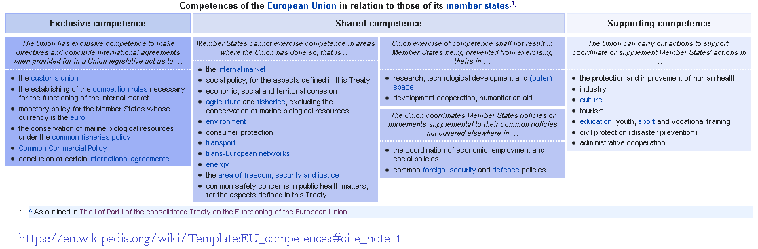
In the chart above, “Exclusive Competence” items are those on which the EU and only the EU can legislate for its members. For example, only the EU can modify monetary policy for the euro, and the individual member nations cannot do anything about it. This is similar to the US constitution’s insistence that the federal government has exclusive jurisdiction over issuance of currency, and the states cannot do anything about it.
The first “Shared Competence” column lists areas where member states can enact their own laws but only if they do not conflict with EU law. For example, a member state could enact within its own boundaries an environmental protection regulation that covers additional hazards not mentioned in any EU law.
The second “Shared Competence” column describes things the EU can do that do not override EU member states’ policies. For example, if the EU launches a space exploration program, the nation of France could also launch its own space program simultaneously and separately if it wanted to do so.
The final “Supporting Competence” column describes activities the EU does where it merely assists or adds onto policies enacted by member states, but does not override, modify or regulate them. For example, if the EU funded a youth soccer league, it might coordinate with local soccer leagues in the various member nations that wanted to participate.
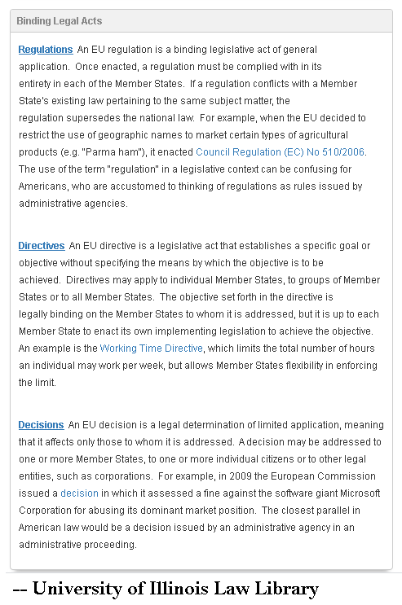

Immigration Policies
Here’s how the European Union defines its jurisdiction relative to the jurisdictions of the member states (“Competent” in this context means “we have the jurisdiction and authority to make rules”):
“Regular immigration: the EU is competent to lay down the conditions governing entry into and legal residence in a Member State, including for the purposes of family reunification, for third-country nationals. Member States retain the right to determine volumes of admission for people coming from third countries to seek work. Integration: the EU may provide incentives and support for measures taken by Member States to promote the integration of legally resident third-country nationals; EU law makes no provision for the harmonisation of national laws and regulations, however. Combating irregular immigration: the European Union is required to prevent and reduce irregular immigration, in particular by means of an effective return policy, in a manner consistent with fundamental rights. Readmission agreements: the European Union is competent to conclude agreements with third countries for the readmission to their country of origin or provenance of third-country nationals who do not fulfil or no longer fulfil the conditions for entry into, or presence or residence in, a Member State.”
Individuals who wish to immigrate (legally) into an EU country must apply to the government of the country in which they wish to establish residency or obtain employment. As they follow that nation’s rules for immigration, they will ultimately obtain the same privileges as any other EU citizen once they have residency or citizenship in their adopted nation.
The European Union also establishes immigration policies through its law enforcement agencies, setting rules on the movement of citizens between EU countries, and collectively managing the arrival of asylum seekers (a.k.a. refugees) and/or illegal immigrants (a.k.a. “irregular” migrants) as they arrive unexpectedly, irregularly or illegally from places outside the EU.
Although they have open borders within the Schengen area, just like in the United States (where we have open travel between the 50 states), it is illegal to enter the EU from outside without going through an official customs checkpoint (just as it is illegal to enter the US from Canada or Mexico without stopping and being inspected at the border). However, there is an overriding law, unknown to many members of the public in both the US and Europe, that (at least on the books) can instantly and magically transform an “illegal immigrant” into a protected refugee with the right to remain in the country he illegally entered.
That law is the 1951 Refugee Convention. That treaty (along with its later update, the 1967 Protocols) is binding law in both the European Union and the United States, since its members have signed and ratified it as an international treaty. Treaties signed and ratified have the force of law and cannot (legally) be ignored or overridden by a member nation without first dropping out of the treaty. The chart below contains selected provisions of the Refugee Convention, and should make you think twice about signing any legal document without reading it carefully.
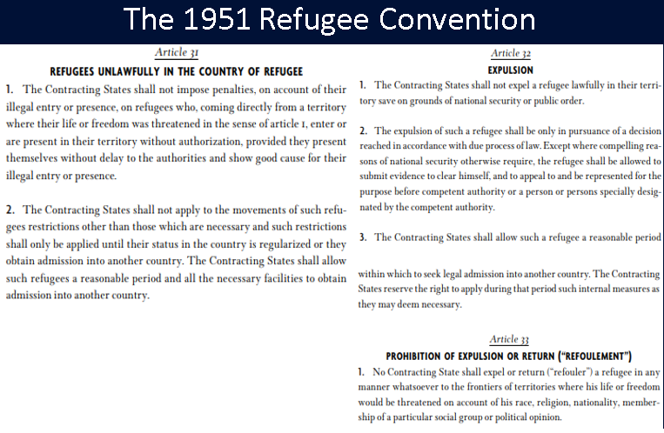
Note carefully the provisions regarding how migrants arriving “without authorization” or under conditions of “illegal entry” are entitled to stay in the country and be given the opportunity to apply for legal status, if they have some kind of claim to refugee status. It is illegal under this treaty to simply tell the migrant, “We caught you arriving illegally, so we’re kicking you out.” The process of taking their application for asylum, reviewing their claims, and accepting them if their claim is valid or rejecting them if it isn’t has to play out before the status of the refugee can be finalized.
This doesn’t mean everyone who shows up must be accepted. Migrants arriving from a poor country looking for a better job are not “refugees” under this treaty (though they may claim to be, and they may be in the same, literal, boat with others who legitimately are refugees). Their claims may be rejected, but they have to be investigated first. And nations may use the reason of “national security” or maintaining “public order” as a reason to expel a potential refugee without giving him a hearing. This loophole, as you can imagine, could be used by a nation weary of thousands of unexpected migrants washing up on its shores and the costs associated with housing and maintaining them indefinitely until their claims can be adjudicated.
Note also the prohibition of “refoulement.” This is an important term of art that you will hear in debates this year. It refers to sending a migrant back into a situation of danger, and it is one of the major concerns in current immigration policy and the treatment of arriving migrants. Even if a migrant arrives illegally, it is illegal to send them back if doing so would expose them to persecution.

2015 Migration Crisis
A number of events, escalating particularly in 2011, led to a “migration crisis” in 2015. Near the end of 2010 and beginning of 2011, the movement of rebellion, reform and revolution known as the “Arab Spring,” took hold and began reshaping the Middle East. The overthrow of dictatorial governments in Tunisia and Egypt led to a similar movement against Libyan dictator Muammar Gaddafi. When the rebel assault against government forces began flagging, the UN authorized NATO to enter the war with air power. The bombing weakened the Libyan government, and it was overthrown by rebels. No single faction, however, was able take control and a civil war among the factions continues to this day, resulting in the displacement of numerous civilians, some of whom wish to escape the violence by fleeing north across the Mediterranean to Italy.
The “Arab Spring” also triggered a civil war in Syria, as rebel movements rose up to fight evil dictator Bashar Al Assad. The country was devastated as residents in numerous cities fled the fighting between the government and the various rebel groups. Many of those displaced Syrians ended up migrating to Turkey and either staying there or seeking refuge in the European Union.
On top of these crises, the ongoing conflicts in Iraq (ISIS) and Afghanistan also generated thousands of displaced refugees who joined the swelling movement trying to find safety in Europe.
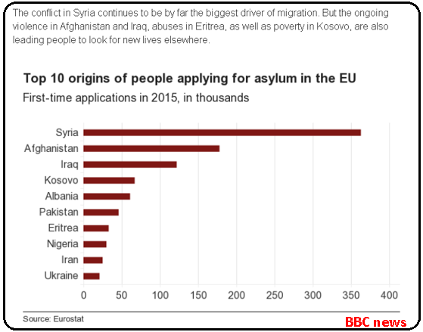
While the massive influx of migrants five years ago has subsided, the memory of the costs, social upheavals, and human suffering it created has not faded. Migration to the EU is still substantial, and no one thinks another mass influx can be ruled out.

Discipline & Enforcement: Article 7
What if an EU member nation violates provisions of the EU treaties, deviates from democracy and human rights, or otherwise misbehaves in such a way as to threaten the integrity of the Union? Article 7 of the Lisbon Treaty is the enforcement mechanism that is supposed to kick in.
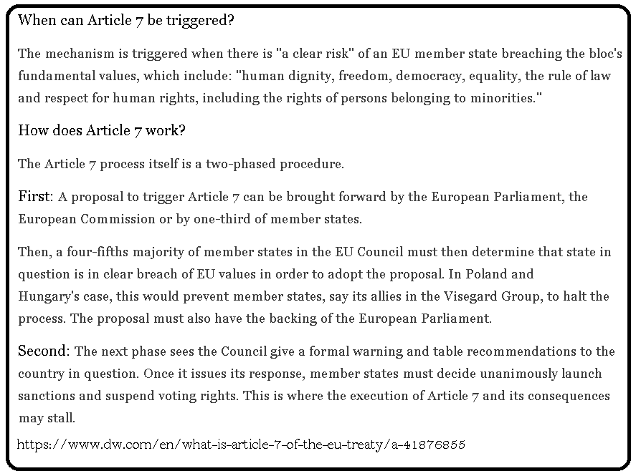
Article 7 contains no mechanism to expel any member state from the European Union; in fact, there is no way to accomplish that in any EU governing law. The more likely scenario is that an Article 7 sanctioned member would either straighten up or else get mad and voluntarily leave the Union on their own.
The Article 7 process has recently been started against Poland (December 2017) and Hungary (September 2018) due to controversial internal policies seen by many as violating human rights and rule of law. No final decision on sanctions has been made yet for either nation.

“Brexit” – The Exit of Great Britain 2016-2020
Disgruntled by the perception of over-regulation from unelected Eurocrats and worried about the rising tide of immigrants/refugees and the taxpayer costs of maintaining them, a political movement began gathering steam in Great Britain to exit the European Union. In June 2016, British voters approved by 51.9% majority a referendum to exit the EU. The vote sent shockwaves throughout the world, given the size of the British economy and the potential consequences on business, travel, immigration, foreign workers, and many other factors.
Countries that join the EU spend years integrating their laws, trade policies, labor policies, and regulations into compliance with EU policies. Now, the entire process must be undone, which would also take years to accomplish. The negotiations dragged on seemingly forever until a final conclusion was reached that had Britain’s exit begin on 31 January 2020 and would be concluded on 31 December 2020.
Brexit raises the prospect of a “domino” effect, whereby other nations that become disgruntled with any EU policy might also follow Britain’s example and head for the exits. Some point to the Article 7 process as a potential motive for Poland and/or Hungary to consider their own exit. Some fear the EU is on the brink of dissolving.

https://www.history.com/this-day-in-history/common-market-founded
Recall that before the US constitution was enacted, the 13 states had their own currencies, creating inconveniences and expenses for interstate trade and travel, hence the Founders’ insistence on the US federal government being the only one constitutionally authorized to issue money and denying that power to the states.
They involve many of the same countries but not all the same. For example, Switzerland is in Schengen but not in the EU. Ireland is in the EU but not in Schengen.
One sage described Switzerland’s open border and tight immigration policy with an adaptation from the Eagles’ hit song “Hotel California”: You can check in any time you like, but you can never stay.
The symbol € is for the Euro just like $ symbolizes the dollar. “€500” is read as “five hundred euros.” Sometimes you may see it written as EUR500. For comparison, US dollar amounts are sometimes written as USD500.
Although other groups have the right to petition the Commission to draft new laws, such as the EU Parliament.
In the US we might call them “Cabinet secretaries,” like the Secretary of Defense or the Secretary of the Treasury.
Do not confuse the Council of the EU with the “European Council.” They are not the same thing at all. The European Council is a meeting of the heads of government of the EU member states and determines high-level political priorities and direction. It does not vote on any specific legislation. Also, do not confuse it with the “Council of Europe,” which is a human rights advocacy organization and is technically separate from the EU. All members of the EU are members of the Council of Europe, but not all members of the Council of Europe are members of the EU.
http://m.eu2013.ie/ireland-and-the-presidency/abouttheeu/theeuexplained/howtheeuisfinanced/ “VAT” refers to “Value Added Tax,” a tax similar to a sales tax on goods and services. The US does not have a national VAT, but European countries do.
https://www.europarl.europa.eu/factsheets/en/sheet/152/immigration-policy
The U.S. signed and ratified only the 1967 Protocol, but since the ’67 agreement includes the provisions of the 1951 agreement, the U.S. is bound by the same rules. This is a side note for your edification, since US laws and policies are not part of the debate resolution.
There is always the perennial question of: Who enforces international law? If a nation ignores a treaty it signed, and God doesn’t come down from heaven to announce judgments on the offending nation, who, then, has superior power over a nation to tell them they did wrong? And to punish them for doing so?

