Stability or Growth? Historical Applications
By “Coach Vance” Trefethen
Resolved: Economic stability is more important than economic growth.
This LD resolution has more than just philosophical interest, since it has numerous economic impacts, consequences and historical examples in the real world. It sounds a lot like policy, and as an old TP coach with a degree in economics, it appears to me to be a fascinating and rich topic.
In this Monument release we will evaluate historical applications of the principles contained in this resolution in four major categories in which this stability/growth tradeoff can occur. This is not to say there are not other areas, but these are the most obvious and will give you an overview of some of the major battlegrounds on which this resolution can be fought. It may also give you ideas for research into less well-known areas that you can explore on your own. The four areas to be addressed here are: Monetary Policy, Fiscal Policy, Social Welfare Policy, and Foreign Trade Policy. If you are an LD’er afraid of the word “policy,” rest assured that discussions of policy will be rooted in the underlying principles that can be applied in general to the resolution. The wording of this resolution necessarily implies that government policies must at least be discussed (even if no specific policy is advocated), since individual decisions, personal beliefs, or public attitudes by themselves do not really determine whether we have economic stability or economic growth. Narrowing down the application of the resolution to one of these four areas (or another subset of public economic policies that you find on your own) can help your Affirmative case by allowing you to argue that “even if” the resolution doesn’t work in other areas, it is still true because it works in the one you are advocating. You don’t have to prove stability “always” outweighs growth (the word “always” isn’t in the resolution), only that there are one or more important situations where it does.
PART I: Monetary Policy
The earlier article in this series by Mr. Csoros (Stability or Growth? Resolutional Overview) introduced you to the concept of monetary policy, pointing out that it involves the amount of money and credit available in an economy. US monetary policy is managed by the Federal Reserve, and other nations have similar “central banks” (like the Bank of Japan controlling the Japanese yen or the European Central Bank for the Eurozone). We will avoid discussion of the specific policies the Fed uses to influence the money/credit supply because you will not have to advocate for or against these in an LD round. Instead, let’s examine in general the stability vs. growth implications of increases and decreases in the supply of money and credit, along with some historical examples of how monetary policy has impacted people in the real world.

Debates about money supply and its impact on the growth and stability of the economy fueled intense political conflict in the second half of the 19th century in the United States. While many today romantically view the 19th century as a period of unbridled economic growth, the growth was not uniformly or universally achieved and was vulnerable to periods of stagnation, contraction, panic, and crisis. The US economy did, indeed, grow in total over the long term, but not without a lot of intervals of short term pain, and not without a lot of individuals mired in poverty even as vast riches were accumulated at the top of the upper class.

In 1871, German Chancellor Otto von Bismarck decided to demonetize silver, taking it out of his nation’s monetary system. The resulting drop in world demand for silver devalued it relative to other commodities (particularly gold), risking inflationary effects in nations that continued to use it.
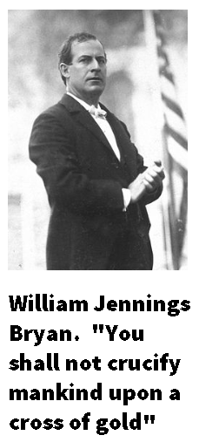
In 1873, Congress passed the Coinage Act, in which the U.S. followed Germany’s lead and decided to stop coining silver, putting US currency entirely on a gold standard. Taking silver out of the money supply had an immediate deflationary effect, with the predictable result of contraction of the economy and widespread unemployment. The “Panic of 1873” was the worst depression in the U.S. economy up to that time.

Advocates for returning silver to the monetary system urged the federal government to increase the money supply, which would have occurred at a rapid pace had the large quantities of silver found in the American West been utilised. Inflation typically benefits debtors and hurts creditors, and so politicians wanting to be seen as supporting the common man, the laborers, the farmers and the poor advocated for silver. William Jennings Bryan campaigned for President in the 1896 election on a platform of opposing the strict gold standard, in favor of bringing back silver along with gold to inflate the money supply. In one of the most famous political speeches in American history, he pleaded:
“Having behind us the producing masses of this nation and the world, supported by the commercial interests, the laboring interests, and the toilers everywhere, we will answer their demand for a gold standard by saying to them: ‘You shall not press down upon the brow of labor this crown of thorns; you shall not crucify mankind upon a cross of gold.’”
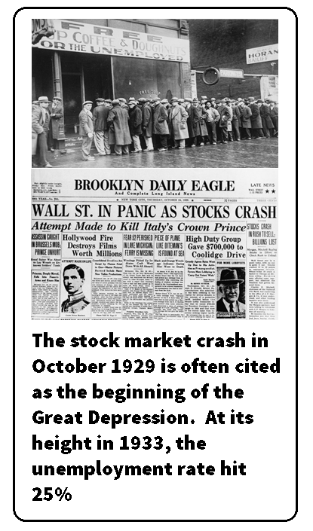
Bryan lost the 1896 election and the gold standard remained in place for another generation. Bankers and conservative politicians argued that the gold standard guaranteed economic stability. Farmers and debtors believed that increasing the money supply with silver would have allowed greater economic growth, since under a strict gold standard the economy can only grow as fast as the amount of gold mined from the earth. Those harmed by the Crash of 1873 might have argued that monetary policy had harmed both “stability” and “growth” at the same time, since all the people who lost their jobs and businesses in the unstable conditions created by the crash could not contribute to economic growth.

Two more historical examples of the tradeoff between monetary policy “stability” versus “growth” came in the lead-up to and the aftermath of the Great Depression. The run-up to 1929 was a widely celebrated decade of economic growth and increasing prosperity. The country certainly valued growth and paid little attention to stability, as evidenced by two factors related to monetary policy and the easy availability of credit: consumer credit and stock market speculation.
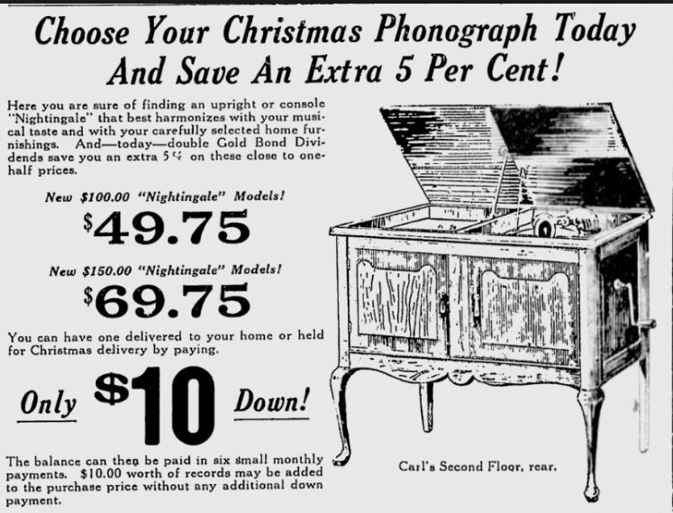
The 1920s were the first generation in which widespread use of credit to buy consumer goods became available. Although credit cards didn’t really exist yet, installment plans and consumer loans exploded onto the market. It didn’t take long before many people bought new gadgets like refrigerators, record players, and mass-produced automobiles at affordable prices. Affordable, that is, as long as you could make the payments. Any small downturn in the economy becomes worse if the economy is built on credit, because buyers who can’t pay back their loans not only stop buying stuff (slowing down factory orders, leading to layoffs), but also can’t pay for what they’ve already bought (leading to consumer and business bankruptcies). Consumer credit speeds up economic growth, but also carries with it the high risk of instability and crash if anything interrupts the cycle of borrowing, spending, and repayment.

Second, stock market speculation fueled by easy credit also led to disaster. In the economic boom of the 1920s, the stock market was perceived to be heading only in one direction – up! People were buying because prices were going up and prices went up because people were buying. On top of that, the practice of buying stock “on margin”– that is, paying only a small percentage of the actual cost of a stock purchase and promising to pay the rest later – exploded (an extension of the “easy credit” problem above). It works fine when you resell your stock a short time later at a profit, repay the borrowed unpaid balance, and pocket the profits. It gets everyone in trouble when stocks stop going up, brokers call their clients and demand payment for the unpaid balances, clients sell stocks to raise funds, but the stocks are worth less than before, they rush to the bank to get more money, but the bank doesn’t have the money because everyone else is doing the same thing. The stock market crashes, banks crash, and people go bankrupt and jump out of office buildings when their life’s savings are gone. So, the run-up and arguably some of the causes of the origin of the Depression may have been because our economic system favored growth over stability. Nobody had the courage to put the brakes on unbridled growth, which ultimately, in hindsight, proved to be an unsustainable bubble.

The Federal Reserve’s response to the Depression, however, may arguably have prolonged the suffering by doing the opposite: favoring stability over growth. Many blame the Federal Reserve for not lowering interest rates and taking other steps to increase the money supply to combat the deflationary effects of the stock market and business contractions that were occurring at the beginning of the Depression. It might have been the case that accepting the risk of inflation of the money supply could have increased the availability of credit and money in the economy and might have stimulated economic growth and created a faster recovery. Some argue that the Federal Reserve’s attachment to stability blocked the economic growth needed for recovery from the Depression.
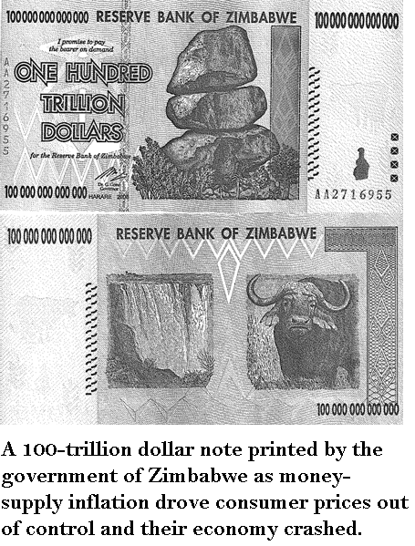
On the other hand, a too-rapid increase in the money supply presents the risk of inflation (rise in prices for goods and services), which, at some point, can be extremely destabilizing. Countries that have experienced hyperinflation (e.g. Germany in the 1920s and Zimbabwe in 2007-2008), rapidly came to economic ruin. And the consequences of that instability are not only poverty and suffering for the common people, but dangerous political backlash. The rise of the (democratically elected) Nazi party in Germany in the late 1920s and early 1930s may have been in part fueled by public anger over the inflation-induced economic crash and the desire for someone, anyone, who could provide stability at any price.
PART II: Fiscal Policy
Fiscal policy is defined as “the means by which a government adjusts its spending levels and tax rates to monitor and influence a nation's economy. It is the sister strategy to monetary policy through which a central bank influences a nation's money supply. These two policies are used in various combinations to direct a country's economic goals.” Notice carefully how fiscal and monetary are “two policies” and are not the same thing. For LD debate, this distinction will not matter for questions of topicality or plan mandates, since these are not LD issues, but it does matter for preserving your credibility as you explain difficult concepts to a Judge who may not take you seriously if you make mistakes in your analysis of monetary and/or fiscal policies.
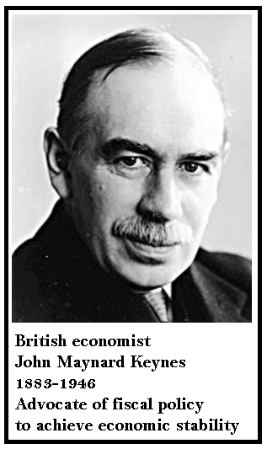
Fiscal policy to promote economic stability is often associated with the theories of noted British economist John Maynard Keynes (1883-1946). Keynes taught that levels of government spending, financed by deficits if necessary, could act as a gas pedal on the economy by stimulating demand for goods and services. If consumers are not spending enough to keep everyone fully employed (perhaps many have lost their jobs or are afraid of losing them), the government fills the gap by increasing its spending. This could prevent a minor downturn from turning into another Depression, hence promoting stability. When the economy recovers, government dials back its spending and lets consumer demand take over again.

There are numerous debates over the assumptions built into Keynes’ theories as well as disagreements over their effectiveness in practice. But for the purpose of this resolution, the tradeoff of accepting Keynesian demand-stimulus stabilization policies is that they come at the potential expense of long-term economic growth. Higher government deficits borrow money out of the economy that could have been used elsewhere -- for business growth, for example. Businesses and government compete for the same pool of borrowed funds from investors. Money borrowed by the government potentially raises interest rates by raising demand for borrowed funds, making it harder for businesses to grow long-term, since they must eventually offer higher rates of return to attract investment money from investors who could otherwise get a safe, but low, rate of return from government bonds. At higher interest rates, some businesses will simply choose not to expand. Long-term economic growth could thus be penalized as the cost of achieving short-term stability.
“But even in the absence of a crisis, sustained deficits have deleterious effects, as they translate into lower national savings, higher interest rates, and increased indebtedness to foreign investors, all of which serve to reduce future national income. Gale and Orszag (2004a) estimate that a 1 percent of GDP increase in the deficit will raise interest rates by 25 to 35 basis points and reduce national saving by 0.5 to 0.8 percentage points of GDP.”

A good example of fiscal policy for economic stability was the American Recovery & Reinvestment Act, signed into law by Pres. Barack Obama in 2009. The financial and housing market crash of 2008 motivated the federal government to enact deficit-fueled fiscal stimulus to prevent the “Great Recession” from turning into “Great Depression II.” Some believe it did exactly that.
“President Barack Obama outlined the economic stimulus package during his 2008 campaign. Congress approved the American Recovery and Reinvestment Act (ARRA) in February 2009. ﻿ The Congressional Budget Office estimated it would add $787 billion in budget deficits by 2019. The economic stimulus package ended the Great Recession by spurring consumer spending. Most importantly, it instilled the confidence needed to boost economic growth.”
PART III: Social Welfare Policy
By “social welfare policy,” we simply mean government programs that transfer wealth from the richer to the poorer. Such programs include things like food stamps, housing subsidies, unemployment insurance, free school lunches, the Earned Income Tax Credit, and Medicaid, among others. Those at the poorer levels of our society could arguably be said to suffer from economic instability. They may not be able to find jobs (or find well-paying jobs) due to the poor neighborhoods they live in, bad social influences affecting their upbringing, or lack of educational opportunities. Their poor circumstances could also be the direct or indirect result of bad choices they’ve made in their own lives, since as drug abuse, criminal record, laziness, or out-of-wedlock pregnancy. These factors create economic instability for the poor in this country.
“At the other end of the spectrum, the “worst” way to become a parent is to have a baby as an adolescent or young adult …. These parents typically have not finished schooling, do not have a steady or well-paying job, do not have a stable marriage or steady partnership, and likely never had a life plan for raising their children. They have less education (high school or less), are younger and less skilled, have lower wages and fewer benefits, have far less partnership experience, and will have more multiple-partner fertility. The result is less social and economic stability and fewer resources and opportunities for their children (Smeeding, Garfinkel, and Mincy 2011; Smeeding 2016).”
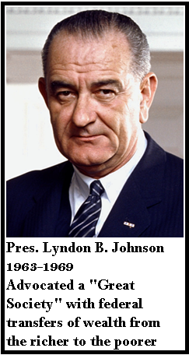
Stabilizing the economic circumstances of the poor may be a noble desire but it can have disadvantages. If social welfare policies are too generous, they risk incentivizing recipients to simply stay out of the workforce and be rewarded for not working. The marginal benefits of the extra income they could have earned by working might not, for them, outweigh the comforts of a life of leisure at government expense. In addition, every dollar borrowed or taxed to give to the poor is arguably taken away from more productive uses that could have benefited the economy in general. Imagine if all of the taxpayer dollars or deficit dollars spent on welfare had been instead left in the private sector and invested in productive businesses. Perhaps the economic growth that would have obtained in that case might have instead benefited the entire economy and lifted untold numbers out of poverty by providing jobs to those willing to work.

An historical example of this dilemma is the now more than half-century track record of results coming from Pres. Lyndon Johnson’s “Great Society.”
“…we have the opportunity to move not only toward the rich society and the powerful society, but upward to the Great Society. The Great Society rests on abundance and liberty for all. It demands an end to poverty and racial injustice, to which we are totally committed in our time.”

Pres. Johnson’s Great Society and its “War on Poverty” created or expanded massive federal transfers of wealth from richer to poorer Americans. But unfortunately, it did not end poverty nor racial injustice as predicted.
“The War on Poverty created negative incentives. Instead of promoting the growth of healthy families, the welfare system discouraged them. A single mother could receive larger payments from Uncle Sam by remaining single than by marrying the father of her child. Over time, many fatherless children entered the world. The welfare checks showed up month after month, regardless of how their parents spent their days. As these boys and girls grew up without fathers around, they came to regard such households as natural. The social safety net, designed to be a temporary help to the people in need, instead kept them trapped in government dependency.”
Welfare program recipients achieved economic “stability,” but at a terrible cost to the recipients themselves and to society as a whole.
“Today the federal government runs roughly 80 means-tested welfare programs providing cash, food, housing and social services to low-income persons, but it fails to help the recipients become able to provide for themselves. As a result … the United States will spend approximately $14 trillion on means-tested welfare over the next decade.”
One can certainly argue that society as a whole would benefit more from the economic growth those $14 trillion would have produced, and welfare recipients themselves, the long run, would benefit from learning not to be reliant on government.
PART IV: Foreign Trade Policy
Finally, we turn our attention to foreign trade as another area where public policy tradeoffs may occur between stability and growth. Trade, by definition and in it purest form, is a mutually beneficial exchange of value between consenting parties. Parties engage in trade because both parties believe they would be better off giving up what they have to obtain what the other party has. When you buy a coffee at Starbucks, you derive more satisfaction from the hot cup of coffee than you do from the $5 that you give them, so you make the trade. Starbucks would prefer to have your $5 bill more so than their beans and hot water, so they are happy to make the trade. Both parties are thus better off.

Economic growth occurs (and resulting prosperity increases) because people are no longer limited to goods and services that they or their immediate family can produce. If you and your family had to produce everything you need, and weren’t allowed to trade with any outside parties, perhaps you could make your own shoes and grow your own food. But things like generating your own electricity and making your own car might be more of a challenge. Your standard of living would fall dramatically. When each party does what they are good at and trades for other commodities they are not able to make (or not able to make as efficiently as someone else), economic growth rises along with standards of living.

Foreign trade is arguably no different. By extending this principle of mutually beneficial exchange to billions of additional potential trading partners, such opportunities for trade and economic growth increase dramatically. Some countries have resources, skilled workers or corporations that are particularly efficient at producing specific goods. Perhaps the Chinese are best in the world at making silk and Americans are best in the world at making steel. Instead of the Chinese taking some of their silk workers off the job and having them make steel, they could simply produce silk efficiently and trade for the American steel they want. Likewise, the steel workers would be ill-advised to shift to silk production, when they can produce steel cheaply and efficiently and trade some of it for Chinese silk. Under this framework, and with all other things being equal, free and open trade produces the best economic growth scenario as everyone does what they do most efficiently and everyone gains the most possible benefit from the production of goods and services.

That’s the economic growth model. Stability comes into play when things change and “all other things” stop being equal. Skills, resources, governments and corporations do not remain static. Perhaps new Chinese corporations begin developing their own steel manufacturing capabilities, and perhaps they have some assistance in the form of subsidies from the Chinese government. New Chinese steel production can now compete globally with American steel and undercut the price, since Chinese taxpayers (perhaps unwittingly) are paying some of the cost.
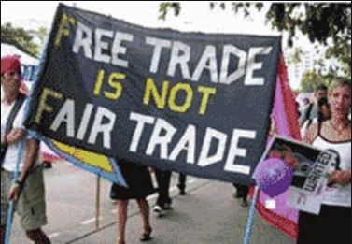
With enough subsidies, Chinese steel might even be cheap enough to be sold on foreign markets for less than the cost of producing it, a practice known as “dumping.” A government might do this for one of at least three reasons. First, they might do it to help an “infant industry” grow out of the cradle. Protecting a new industry with tariffs until it is ready to compete on its own is an old theory that even Alexander Hamilton advocated.

Second, they might do it as a means of rapidly entering the market to drive out competitors, gain a monopoly, and then raise prices later. If all their competitors are bankrupted by failing to compete with artificially cheap subsidized products, when those competitors go away the subsidized company can drop its subsidies, raise prices to anything they want and collect excess profits as the sole monopoly supplier.

And third, they might do it for political/social welfare reasons. Maybe it’s cheaper for taxpayers to subsidize the factories than it would be to let them compete fairly, have them fail, and have all the workers end up on public assistance collecting even more free money from the government. Or maybe the political consequences of having thousands of angry unemployed former factory workers would be too great of a risk, so it’s easier to keep them artificially employed in a money-losing factory. For the troubled factory requesting government subsidies, this is where their argument for stability might be persuasive over what would otherwise be the “growth” arguments for letting them fail and having their workers and resources find their way to more efficient industries where they could contribute to genuine economic growth and long-term prosperity.

On the consumers’ end, countries that import products from these subsidized factories might adjust their trade policies to impose import tariffs (taxes on imported goods) to offset the subsidies and make the trade “fair.” American steel producers might do so, for example, by lobbying the Administration to tax Chinese steel so that the effects of their subsidies disappears and American steel can compete “fairly” with Chinese steel. If not, American steel workers will lose their jobs (= lose economic stability). Consumers, on the other hand, would not be benefited by such a transaction, since they would be happy to purchase steel for which part of its cost is paid for by Chinese taxpayers. Hey, free money for us! And the difference we save could be spent elsewhere and generate economic growth.

The tradeoff between stability (preserving American factory jobs) versus growth (new jobs that could be created by consumers spending on cheaper foreign products) is a hot one in today’s economy. The new jobs created by lower consumer prices might indeed create new jobs, but what kind of jobs? If an American steel worker is laid off from his good paying factory job and in return three new jobs are created working for minimum wage at Wal-Mart, is his community really better off? This potential for “deindustrialization” even with apparent economic growth is of concern to some economists who argue that stability would have been better.

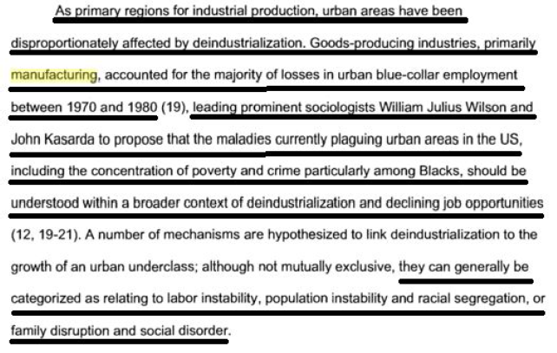

William Jennings Bryan at the Democratic Party convention in Chicago, 9 July 1896.
In all discussions of the Great Depression, keep in mind that the specific causes of the Great Depression are still being debated today, and none of them are mutually exclusive of one another. It is possible that a “perfect storm” of events occurred simultaneously which, taken individually, might not have created the Depression by themselves. It is also possible that some of these factors may not have caused the initial economic downturn, but may have made it worse and last longer than it would have otherwise.
“The most important explanations of Federal Reserve behavior during the Depression, however, appear to be the dedication of policymakers to preserving the gold standard and their attachment to policy guides that gave erroneous information about monetary conditions. » Prof. David C. Wheelock « Monetary Policy in the Great Depression: What the Fed Did, and Why » https://fraser.stlouisfed.org/files/docs/meltzer/whemon92.pdf
https://www.investopedia.com/insights/what-is-fiscal-policy/
Of course, a Keynesian would reply : If the money would have been used elsewhere, why wasn’t it ? How did we get into an economic downturn, recession, or depression if the economy was doing such a fine job of using that money on its own?
Dr William Gale and Benjamin Harris 2010. ttp://www.taxcareerdigest.com/articles/VATReader.pdf
Kimberly Amadeo 2020. https://www.thebalance.com/what-was-obama-s-stimulus-package-3305625
Timothy M. Smeeding 2016 https://www.ncbi.nlm.nih.gov/pmc/articles/PMC6095670/ ellipses added=\\=
Pres. Lyndon B. Johnson, May 1964.
Dr. Edwin J. Feulner 2014 https://www.heritage.org/poverty-and-inequality/commentary/assessing-the-great-society
Feulner, ellipses added.
A dangerous assumption that we will challenge in a minute.
Arijit Nandi 2008 (PhD candidate, Johns Hopkins Univ ) PhD Dissertation, “Deindustrialization, Socioeconomic Deprivation, and Injection Drug Use Cessation in Baltimore”

