Stability or Growth? Resolutional Overview
By Mark Csoros
Resolved: Economic stability is more important than economic growth.
Hello, and welcome to a new year of Lincoln Douglas debate! This article is a resolutional overview that’s designed to help you jumpstart your preparation for the upcoming competitive season. High-level LD debaters need a depth and a breadth of knowledge about the resolution, no matter what topic it covers, but that knowledge is especially necessary for this year’s resolution. Economics is a complex science without many absolutes. Economic principles that apply in one situation may be totally wrong in another situation, which is part of the reason why economists are almost always in disagreement (another part of the reason is that economists just like to argue). This article will establish a foundation of basic knowledge that will help you gain the necessary knowledge to help you have a successful start in the debate season.

Part I is a crash course in economics designed to get you acquainted with the terms and principles that underlie this year’s topic area, Part II builds on that newfound economic knowledge to introduce the key terms that are explicitly listed in the resolution, and Part III sums things up. Let’s dive in.

PART I: Economics 101
Throughout this year, you’ll encounter a lot of economic policy and the terms and principles that come with it. Now, I’m a relatively dedicated LD purist, so I would much rather leave policy to the TPers and keep LD focused on the values, since this is “Lincoln-Douglas Value Debate.” However, because of how this resolution is written, you’ll need a solid grasp of economic policy in order to access the values at the resolution’s core. So, paradoxically, obtaining a TP-like level of policy knowledge is the best way to approach this value resolution. This section is designed to help you do just that.
Keep in mind that this is an introduction, not a comprehensive list or explanation of everything you need to know, so I highly recommend that you dig deeper into these concepts and develop a more thorough understanding. Following my citations and reading the full articles that I take excerpts from would be an excellent way to jumpstart your research.

Supply and Demand
This concept is the foundation of all economics, which is why I’m always shocked at how many people don’t understand it well. The Encyclopedia Britannica writes:
“Supply and demand, in economics, [is the] relationship between the quantity of a commodity that producers wish to sell at various prices and the quantity that consumers wish to buy. It is the main model of price determination used in economic theory. The price of a commodity is determined by the interaction of supply and demand in a market. The resulting price is referred to as the equilibrium price and represents an agreement between producers and consumers of the good. In equilibrium the quantity of a good supplied by producers equals the quantity demanded by consumers.”
Let’s break that down a little bit. Supply “describes the total amount of a specific good or service that is available to consumers. Supply can relate to the amount available at a specific price or the amount available across a range of prices if displayed on a graph.” Conversely, demand refers to “a consumer's desire to purchase goods and services and willingness to pay a price for a specific good or service. Holding all other factors constant, an increase in the price of a good or service will decrease the quantity demanded, and vice versa.”
Supply, demand, and price are all interrelated and codependent to varying degrees. Paper clips are so cheap because they’re easy to make, meaning that we can supply way more paper clips than we could ever want or need (supply is high relative to demand, so price is low). Diamonds are very expensive because a lot of people want them and they’re hard to obtain (demand is high relative to supply, so price is high). In the U.S., meat is relatively cheap, so the American demand for meat is pretty high, but meat is relatively expensive in Africa, so African consumers demand much less meat.

This three-way relationship is visually expressed by the following graph (see below). Curves D1 and D2 (I know they look like they should be called lines, but economists call them curves, and the only reason these are perfectly straight is because this is a simplified example) represent levels of demand, and curves S1 and S2 represent levels of supply. The vertical axis reflects the price level, and the horizontal axis reflects the quantity level.
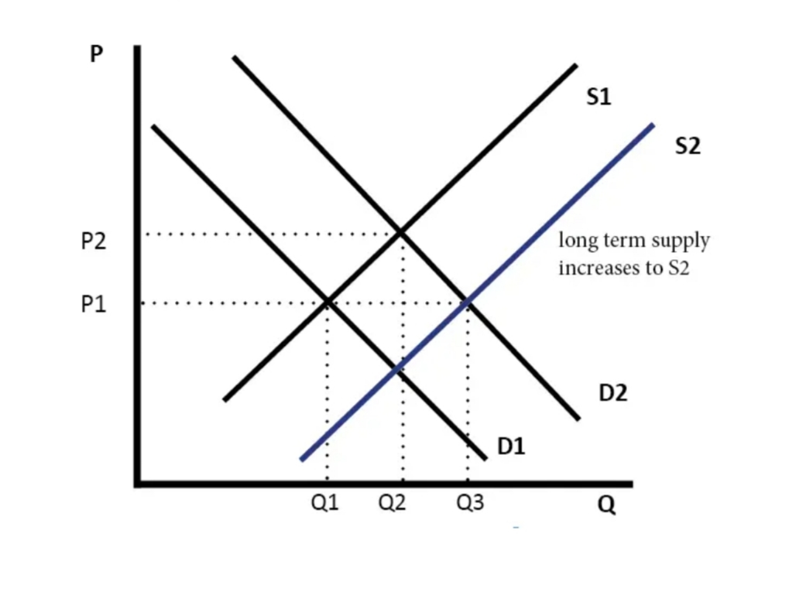
At the supply level S1, demand level D1, and price level P1, the demand and supply curves intersect at the quantity level Q1, and this market is in equilibrium. If the price rises to level P2, then the amount supplied will move up to Q2 (the quantity level at the intersection of P2 and S1), but the amount demanded will be less than Q1 (the quantity level at the intersection of P2 and D1). Now the market is not in equilibrium, but over time the price will decrease (as suppliers lower prices to get more people to buy their product) until the price reaches P1 again, and the market will return to equilibrium.

If the level of supply changes from S1 to S2 (this is called shifting outward) and demand stays constant at D1, then we get a new equilibrium, at quantity Q2 and a price below P1. This would happen if the supply of diamonds suddenly increased, causing the price to go down and the quantity sold to go up, since more people who wanted diamonds could buy them. If the level of demand shifts outward from D1 to D2, and the supply stays constant at S1, then we get a new equilibrium at the higher quantity Q2 and the higher price P2. This would happen if more couples suddenly started getting engaged, because the increased demand for diamonds would make people willing to pay more for them, so jewelry stores would be willing to supply more diamonds. Can you look at the graph and figure out what would happen if both supply and demand shifted outward (from S1 to S2 and D1 to D2) at the same time? If you can’t figure that out, or if you’re confused by any aspect of supply and demand, I recommend that you spend the time to develop a good understanding of this principle before you read or research any further. I know it can be confusing, but mastering the concept of supply and demand will make your research process much easier, give you a huge leg up in competition, and help you understand the real-world economic behaviors that you see every single day.

Measuring Output: GDP and GNP
GDP stands for “Gross Domestic Product,” and it’s by far the most common measure of a nation’s economic performance. The International Monetary Fund writes that:
“GDP measures the monetary value of final goods and services—that is, those that are bought by the final user—produced in a country in a given period of time (say a quarter or a year). It counts all of the output generated within the borders of a country. GDP is composed of goods and services produced for sale in the market and also includes some nonmarket production, such as defense or education services provided by the government.”
At the most basic level, a nation’s GDP is equal to the total value of everything that a country produces. The U.S. produces the most value of any country in the world, so we have a very high GDP. In 2019, our GDP was (approximately) $21.7 trillion. At the other end of the spectrum, some small nations don’t even break the $100 million mark in GDP.

GNP stands for “Gross National Product,” and it’s very similar to GDP, but much less commonly used. The difference between the two metrics is that GNP only measures the output of a country’s nationals (its citizens and legal residents), so it wouldn’t include investments or output created within U.S. borders by foreigners. GDP includes output produced by foreign nationals, but doesn’t include output produced by a country’s citizens abroad. For example, since Toyota is a Japanese company, the production from a Toyota plant in America would count towards U.S. GDP, but not U.S. GNP. By the same token, the production from a Ford plant in Mexico would count toward U.S. GNP, but not U.S. GDP. In 1991, the U.S. stopped using GNP for economic measurement and started using GDP, which is why you probably won’t run into GNP very many times this year. However, it is important that you know the difference between the two metrics.

Measuring Growth: Inflation and Nominal vs. Real GDP
GDP growth over time will certainly factor into a lot of rounds this year, because it’s the most common method of measuring a nation’s economic growth rate. Deriving GDP growth is a simple calculation: you take the GDP from one period (say 2019), divide it by the GDP of a preceding period (say 2018), then subtract 1 from that result. If 2019’s GDP was six dollars, and 2018’s GDP was five dollars, then:
6 ÷ 5 = 1.2
1.2 – 1 = .2 = 20% GDP growth
But, we have to be careful here. Remember that GDP measures the total value of everything that a country produces. We measure value in dollar amounts, and dollar amounts don’t stay constant. That’s because of something called “inflation.” Merriam Webster defines inflation as: “a continuing rise in the general price level usually attributed to an increase in the volume of money and credit relative to available goods and services.” Put simply, inflation is the reason why spending one dollar in 1920 would get you the same amount of stuff that spending $12.82 would get you today. Over time, as governments print more and more money, each dollar becomes worth less and less, and prices steadily rise in order to keep up. So, we have to wonder if GDP increased between 2018 and 2019 because everything got more expensive, or if it increased because people actually produced more things.

In reality, inflation and output growth both factor into almost every increase in GDP. To figure out how much GDP growth is coming from each factor, economists developed a tool to figure out exactly how much “true” growth occurred, and how much growth is due to inflation. That tool is called “real GDP.” While “nominal GDP” only tells us how much, in dollars, a country’s total output is worth, real GDP takes the nominal GDP and adjusts it for inflation, which lets us measure economic growth in an apples-to-apples sort of way. The Khan Academy article in footnote 10 offers a great explanation of the details involved in GDP adjustment.

Monetary Policy: The Federal Reserve and Interest Rates
The U.S. Federal Reserve, commonly known as the Federal Reserve or just the Fed, is the central bank of the United States. There are twelve Federal Reserve Districts, each with a Federal Reserve Bank responsible for implementing the strategies set by the Federal Reserve Board. The Fed is an independent, non-partisan body tasked with three key functions: conducting monetary policy, providing and maintaining an effective payments system, and supervising and regulating banking operations. Of those three tasks, the most relevant one for this resolution is the first one. The Fed defines monetary policy as “the strategic actions taken by the Federal Reserve to influence the supply of money and credit in order to foster price stability and maintain maximum sustainable economic growth.” So, interestingly enough, the Fed’s two policy goals of price stability (meaning limited inflation) and maximum sustainable economic growth are extremely similar to the two sides of this resolution.

To accomplish its dual monetary mandate, the Fed sets a target for the federal funds rate and then uses open market operations, changes in the discount rate, and adjustments to banks’ reserve requirements to try to reach that target federal funds rate. I know that was a lot of new terms all in one sentence, so let’s go through them one by one. First, we need to understand interest. The best way to understand interest is just to remember that it’s the price of borrowing money. More technically, it’s the extra money that a borrower repays to compensate a lender for the use of his money. For example, whenever I pay back my student loans, I have to give the government the amount that I borrowed, plus a little extra (about 6% extra for every year until the loan is paid off). When you deposit your money in a bank, the bank pays you interest (a very small amount of interest) on the money, since you’re technically loaning the bank that money.

Banks also loan and borrow money, and pay interest to each other. All banks, credit unions, and other “depository institutions” are required to always have certain minimum amounts of money in accounts at regional Federal Reserve Banks. Often, an individual bank doesn’t have enough money in reserve to meet the minimum requirement, so the bank will borrow money overnight from another bank that has more than the required reserve. The lending bank charges the borrowing bank interest, and that interest rate is the federal funds rate that the Fed sets targets for and tries to adjust to meet the target. Why does the Fed care what interest rate banks are charging each other? Well, as the Fed itself explains:
“Changes in the federal funds rate are intended to cause changes in other short-term interest rates. Indirectly, the federal funds rate also affects long-term interest rates, the total amount of money and credit in the economy, and ultimately, employment, output, and inflation. To keep inflation in check, the Fed can use its monetary policy tools to raise the federal funds rate. Monetary policy in this case is said to be “tight” or “contractionary.” To fight recessions, the Fed can use its monetary policy tools to lower the federal funds rate. Monetary policy is then said to be “easy,” “expansionary,” or “accommodative.””

How does the federal funds rate affect so much of the economy? Supply and demand. A higher federal funds rate (under a “tight” or “contractionary” policy) means that the price of borrowing money increases, which means that fewer entities can afford to borrow, which has the net effect of decreasing the amount of money in the economy. As we learned in the section on inflation, less money in the economy means a lower rate of inflation, and it also means a slower rate of economic growth. A lower federal funds rate (under an “expansionary” type monetary policy) lowers the cost of borrowing money, increasing the amount of inflation and speeding up the economic growth rate.

In the interest of time, I won’t go into how the Fed’s open market operations, adjustments to the discount rate, or changes in the reserve requirement affect the federal funds rate, but it’s fascinating to learn about and I highly recommend you delve a little deeper into the topic. For now, though, you just need to know that the Fed’s job is to find the optimal balance between stability and growth and implement monetary policies to achieve that balance.

PART II: Resolutional Terms
This part should be pretty easy to grasp, because we’ve already done all the hard work. We built a foundation of economic knowledge in Part 1, so the resolutional terms in this section should be a piece of cake. The definitions of economic stability and economic growth won’t use any words we don’t already know, they’ll just arrange the words in a new way that explains exactly what the resolution is asking of us.

Economic Stability
According to Business Dictionary, economic stability is:
“A term used to describe the financial system of a nation that displays only minor fluctuations in output growth and exhibits a consistently low inflation rate. Economic stability is usually seen as a desirable state for a developed country that is often encouraged by the policies and actions of its central bank.”
The Mises Institute, an economic think tank, further explains that:
“Economic stability refers to an absence of excessive fluctuations in the overall economy. An economy with constant output growth and low and stable price inflation is likely to be regarded as stable. An economy with frequent boom-bust cycles and variable price inflation would be considered as unstable.”
I like both these definitions, but I like the for different reasons. The second one, from the Von Mises Institute, is a bit more comprehensive and gives examples for what counts as a stable or unstable economy. The first one, from Business Dictionary, has a spectacular and succinct first sentence, and a second sentence that gives us a pretty good idea of the resolution’s actor.

Economic Growth
Economist Jim Chappelow, writing for Investopedia, tells us that:
“Economic growth is an increase in the production of economic goods and services, compared from one period of time to another. It can be measured in nominal or real (adjusted for inflation) terms. Traditionally, aggregate economic growth is measured in terms of gross national product (GNP) or gross domestic product (GDP), although alternative metrics are sometimes used.”
The Encyclopedia Britannica defines economic growth as:
“the process by which a nation’s wealth increases over time. Although the term is often used in discussions of short-term economic performance, in the context of economic theory it generally refers to an increase in wealth over an extended period.”
Finally, the Oxford Reference dictionary defines economic growth as:
“The expansion of the output of an economy, usually expressed in terms of the increase of national income. Nations experience different rates of economic growth mainly because of differences in population growth, investment, and technical progress.”
Of these three definitions, I like the first one the best, but the other two have some unique and valuable information to offer. I appreciate the use of the phrase “over time” in the Encyclopedia Britannica definition because it specifies that economic growth doesn’t have to be frenetically paced over a short period of time; it can occur at a more reasonable pace over a longer time period. I like that the Oxford Reference definition points to the reasons that economies have different rates of economic growth, and in so doing list some of the causes of that economic growth.
There is one thing to watch out for with these definitions: Don’t confuse economic growth with economic growth per capita. “Per capita” is a phrase that we borrowed from Latin, where it literally means “per head,” but really means “per person.” There is a site called “Lexico” that has some affiliation with Oxford, and this site defines economic growth as an increase in goods and services produced per head of the population over a period of time. This is a great definition of growth in economic productivity, but it’s a deeply flawed definition of true economic growth. Economic productivity measures output per person, and economic growth measures the increase of total output. Just make sure your definition of economic growth doesn’t mention “per capita,” “per head,” or “per person,” because that will steer you in the wrong direction.

Part III: In Conclusion
I’m excited for this season of LD debate. I think this resolution has great potential, and I think that researching and mastering the material of this topic will serve you well for the rest of your life, or at least until you need to write college term papers. Remember that this article is just an overview, and you need to use it as such. Don’t read this and stop or decelerate your preparation, read this article and accelerate your research to expand on the things you’ve learned here. Best of luck this year, from all of us here at Monument.

The Encyclopedia Britannica. “Supply and Demand”. (Brackets added for clarity) https://www.britannica.com/topic/supply-and-demand
Author and economist Will Kenton, Jun 25 2019. (Kenton has an M.A. in Economics from The New School for Social Research, and an M.A. and Ph.D. in English from New York University. He has over a decade of experience writing and editing for various publications.) “Supply”; Investopedia. https://www.investopedia.com/terms/s/supply.asp
Economist Jim Chappelow, Jun 25, 2019. (Chappelow has a B.A. from the University of Alaska and an M.A. from the University of Maine, both in Economics. He has worked and taught widely in the fields of business and economics.) “Demand”; Investopedia. https://www.investopedia.com/terms/d/demand.asp
The International Monetary Fund, Feb 24, 2020. “Gross Domestic Product: An Economy’s All”; written by Tim Callen. (Callen is an Assistant Director in the IMF’s External Relations Department.) https://www.imf.org/external/pubs/ft/fandd/basics/gdp.htm
The Federal Reserve Bank of St. Louis, May 31, 2020. “Gross Domestic Product”; Data originally published by the U.S. Bureau of Economic Analysis. https://fred.stlouisfed.org/series/GDP
The Encyclopedia Britannica. “Gross National Product.” https://www.britannica.com/topic/gross-national-product
Merriam Webster Dictionary. “Inflation.” https://www.merriam-webster.com/dictionary/inflation
Data Engineer Ian Webster, 2020. (Webster is an engineer and data expert who has worked for Google and NASA, and consulted on data pipelines and analysis for governments around the world). “$1 in 1920 is worth $12.82 today”; in2013dollars.com. Data sourced from Bureau of Labor Statistics’ Consumer Price Index. https://www.in2013dollars.com/us/inflation/1920?amount=1
Note: The book Whatever Happened to Penny Candy, by Richard Maybury, offers an excellent explanation of this concept and many other economic principles. I would highly recommend you read it before the start of competition.
Khan Academy. “Lesson summary: Real vs. nominal GDP” https://www.khanacademy.org/economics-finance-domain/ap-macroeconomics/economic-iondicators-and-the-business-cycle/real-vs-nominal-gdp/a/lesson-summary-real-vs-nominal-gdp
The Federal Reserve Bank of Kansas City. “The Federal Reserve System.” https://www.kansascityfed.org/aboutus/federalreservesystem
The Federal Reserve Bank of Kansas City. “The Federal Reserve System.” https://www.kansascityfed.org/aboutus/federalreservesystem
The Federal Reserve Bank of Kansas City. “The Federal Reserve System.” https://www.kansascityfed.org/aboutus/federalreservesystem
Business Dictionary. “Economic Stability.” http://www.businessdictionary.com/definition/economic-stability.html
Ph.D. of Economics Frank Shostak, Apr 10 2019. (Shostak is an Associated Scholar of the Mises Institute. He owns a consulting firm, and has taught economics at two South African universities. His Ph.D. in Economics was completed at Rands Afrikaanse University) “Does Economic Stability Contribute to Growth?”; The Mises Institute. https://mises.org/wire/does-economic-stability-contribute-growth
Economist Jim Chappelow, Apr 16, 2019. (Chappelow has a B.A. from the University of Alaska and an M.A. from the University of Maine, both in Economics. He has worked and taught widely in the fields of business and economics.) “Economic Growth”; Investopedia. https://www.investopedia.com/terms/e/economicgrowth.asp
The Encyclopedia Britannica. “Economic growth”; written by John L. Cornwall. (Cornwall was a Harvard Ph.D. of Economics and a professor of Economics at Dalhousie University.) https://www.britannica.com/topic/economic-growth
Oxford Reference. “Economic Growth” https://www.oxfordreference.com/view/10.1093/oi/authority.20110803095741367

