Introduction to Public Forum
for Season 21
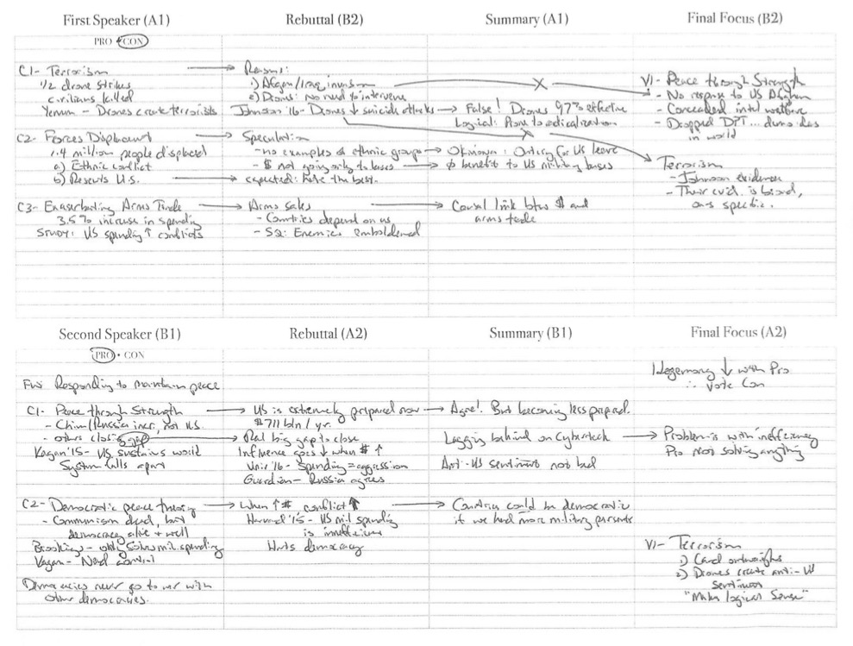
Public Forum Debate is a 2-on-2 debate format hosted by the National Speech and Debate Association. They debate balanced resolutions that are released monthly by the league. This preseason document introduces you to this most exciting debate event.
- Simple Explanation of Public Forum Debate
- The Reason for Public Forum Debate
- The Structure of Public Forum Debate
- Understanding the Release of Resolutions for Season 21
- Monument Member Resources
- Sample Download

Simple Explanation of Public Forum Debate
Public forum debate is the exciting educational opportunity where you and a partner get to develop cases to advocate for and against a particular topic. You will also scrimmage against other teams who are doing the same, whereas you get to oppose their cases. Judges and teachers rank how well you debated and they declare a winner of your debate round.

The Reason for Public Forum Debate
Public forum debate started in 2002 in the largest speech and debate league in the United States, the National Speech and Debate Association (NSDA). Today thousands of students participate in classrooms and competitions all over the country in this most invigorating activity. While it may appear complicated to those not familiar with the activity, we believe there is a structure to public forum debate that is actually quite simple.
Public forum debate is an academic and competitive exercise that has a common framework and follows a specific format in every debate round. Not knowing the framework and format may give you some anxiety. Like any sport or classroom exercise, most anxiety has to do with a lack of understanding. Not knowing what to expect, the idea of standing in front of a judge or teacher, and debating an opponent is the most terrifying thing in the world.
Relax. Every debater starts out wondering where to start. This unit walks you through four expectations you can have that will form the framework and structure of public forum debate.
Let’s get started.

The Structure of Public Forum Debate
Debaters find the subject of discussion in the “proposition,” also called the “resolution.” The proposition is what all debate competitors will be debating. It is a statement that one side will support as the “proposition” or “PRO” team, and the other team (the “CON”) will oppose. All teams (consisting of two students) must prepare to support (PRO) and negate (CON) the resolution, since they may choose either position right before a debate round starts. The entire stage is set around the resolution.
When you begin a public forum debate round, two directives need to be determined: (1) the side of the resolution you will be arguing, and (2) the speaker order you will be taking. NSDA rules require each round to begin with a coin toss to determine which of each of these you will take. You will enter the room prepared to win the toss (and make the best choice for you) or lose the toss (and get the worst choice for you). The winning team of the coin toss will get to choose first—which side of the resolution (PRO or CON) or which speaker order (first or second). The losing team gets to choose the one the winning team didn’t pick.
Envision four debaters—two on the PRO and two on the CON—sitting at two tables, each on the side of a lectern. The lectern faces the judge, typically a teacher, an alumni graduate debater, a parent, or a community member who has been asked to participate. The judge has a ballot and a flowsheet to take notes during the debate. The round will last 35-45 minutes, of which each speaker will speak only for 6 minutes, plus 6 minutes of crossfire (where speakers ask each other questions). Total speaking time: 12 minutes each.
Here are the speeches and the time they are allotted. You and your partner must decide before you start debating who will be in the first or second position. For now, understand the four speaker positions: A1, A2, B1 and B2.
Team A, 1st Speaker (A1) – “Constructive Speech” – 4 minutes
Team B, 1st Speaker (B1) – “Constructive Speech” – 4 minutes
Crossfire: A1 and B1 ask questions of one another – 3 minutes
Team A, 2nd Speaker (A2) – “Rebuttal Speech” – 4 minutes
Team B, 2nd Speaker (B2) – “Rebuttal Speech” – 4 minutes
Crossfire: A2 and B2 ask questions of one another – 3 minutes
Team A, 1st Speaker (A1) – “Summary” – 2 minutes
Team B, 1st Speaker (B1) – “Summary” – 2 minutes
Grand Crossfire: All four speakers ask questions of each other – 3 minutes
Team A, 2nd Speaker (A2) – “Final Focus” – 2 minutes
Team B, 2nd Speaker (B2) – “Final Focus” – 2 minutes

There is also an allotment of two minutes for each team that is measured throughout the round that can be used in between speeches for preparation (“prep time”). During the time between the end of the previous speech and the beginning of prep time, the debater can ask to see any evidence read in the previous speeches. While waiting for the team to produce this evidence, debaters do not prep. After evidence is exchanged, prep time begins. The two minutes can be budgeted in any fashion by each team—they can use a little bit of it before each speech, or they could use it all before one speech and none before any of the others.
You will be one of four speakers. This doesn’t seem so bad, does it?

Understanding the Release of Resolutions for Season 21
The NSDA releases their resolutions a month ahead of when tournaments run. This gives students and coaches time to study and prepare for competition. The resolutions can be seen at Speechanddebate.org/topics. Note the following change to how resolutions are released this season:
NEW IN 2020-2021: The Public Forum Wording Committee will create a topic area with two resolutions for each topic cycle. The committee will assign each topic area to a topic cycle, and the two resolutions that exist within that topic area will be the two resolutions that are voted on for that topic cycle. There are no longer starter resolutions; all topics that are released on Monday, June 22 are final. In June, coaches and students will know “Sept/Oct will be this topic area, and I will vote between these two resolutions. January will be this topic area, and I will vote between these two resolutions” etc. One week prior to the topic being released for that topic cycle, chapter advisors and member students will vote on which of the two topics they prefer. The topic that receives the most votes will be the topic for that cycle. This change was made to increase transparency about the topic process and introduce new possibilities for coaches who teach debate in the classroom. The NSDA will continue to pilot a November/December topic for Public Forum Debate (as is done for September/October).
This gives debaters an expectation as to what topics will be debated. For Season 21, you can expect one of the two in each timeframe for debates:
September/October 2020: Healthcare
- Resolved: The United States federal government should enact the Medicare-For-All Act of 2019.
- Resolved: On balance, centralized national responses to pandemics are more beneficial than decentralized responses.
November/December 2020: Non-Proliferation Efforts
- Resolved: The United States should adopt a declaratory nuclear policy of no first use.
- Resolved: The United States should substantially modernize its nuclear command, control, and communications (NC3) systems.
January 2021: Data Privacy
- Resolved: The NSA should end its surveillance of U.S. citizens and lawful permanent residents.
- Resolved: The United States should establish a federal data protection agency.
February 2021: Intra-African Policy
- Resolved: On balance, the benefits of urbanization in West Africa outweigh the harms.
- Resolved: Exclusive rights to the use of the Nile River are harmful to African stability.
March 2021: U.S. Space Policy
- Resolved: Article IV of the Outer Space Treaty should be amended to ban anti-satellite weapons.
- Resolved: On balance, the benefits of creating the United States Space Force outweigh the harms.
April 2021: International Economies
- Resolved: The benefits of the International Monetary Fund outweigh the harms.
- Resolved: On balance, cryptocurrency benefits emerging economies.
National Tournament 2021: Free Speech
- Resolved: In the United States, social media is beneficial for democratic values.
- Resolved: The United States federal government should no longer apply Section 230 of the Communications Decency Act to Big Tech.

Monument Member Resources
Monument Writers consist of championship debaters and their coaches. They are a team of professionals who publish cases and briefs for debaters to utilize in their rounds. We call this “source material,” prepared documents that students can use to help validate their claims within rounds. Our authors are paid to do the research, paste the research into their documents, and present material that debaters can utilize.
Here’s how the Monument Member receives source material. You receive a weekly email every Monday morning at 7:00 a.m. The email lists all Monument releases for that week. We will be releasing documents every Monday throughout Semester 1 (the end of the calendar year). This is perfect to give you a foundational understanding of what to debate during these months. Simply click through the email link, download your material, and get to work.
If you missed the email, or if you want to reach back into the archive for the year, simply visit the public forum debate category on the website. Be sure to check out the “Quick Links” page under debate. We list all current downloads in one area to make it easy to download the source material.
Beware: Study the material! Some debaters merely download the material and file it away for later. These debaters are seldom in final rounds at tournaments. The purpose of the source material is to “model” the champions, not “copy” the champions. Take time to read through the evidence, touch up the tags to meet your needs, and get to know what the Monument Writers have already studied. They spent hours and hours to prepare the document, so give them the respect of spending 30-60 minutes studying what they prepared.
If you form the consistent habit of studying the weekly download every single week, there will be nothing stopping you from crushing it at the next tournament. You will know more than the best of them! But it takes the habit of studying the downloads and knowing the material.

Release Schedule for Season 21
Here is an explanation of what will be coming for public forum debaters:
- July 27, 2020 – The “Introduction to Public Forum for Season 21” releases.
- August – Introductory installments for Public Forum debaters.
- August 25, 2020 – NSDA releases the September/October resolution.
- September-October – Monument releases articles and cases on the first resolution.
- October 25, 2020 – NSDA releases the November/December resolution.
- November-December – Monument releases articles and cases on the second resolution.
- January 1 through Nationals – As competition revs up, Monument will release downloads on an as-needed basis.
- NSDA Nationals in June 2021.

Some tournaments allow for a different amount of prep time, sometimes allowing 4 minutes.

