Video #1 of Mastering the Monument Method
“Misguided Methods (and a Roadmap for Mastery)”
Watch Video 1

MASTERING THE MONUMENT METHOD is a video course designed for competitors who want to master the art of writing and research.

Mastering the Monument Method
“What Is Mastery?”
Hi, I’m Chris Jeub, the owner and operator of Monument Members. Welcome to the first video of the third course being offered this year. I’m taking all my students to a third level — what I call the “mastery” level — of speech and debate competition.
I have a friend who’s into martial arts. He’s really into it! A multi-level black belt who owns Freedom School of Martial Arts in Monument, Colorado. We got into a great conversation about “mastery” of an art. He’s a “master,” meaning students come to him for training in martial arts. I’m not into martial arts (I’m into the martial arts of the mind!), but he is. He gets together with other masters and learns techniques and styles and methods, and then those moments these “masters” adjust and adapt and build on the martial arts that they already know. My friend is a “master” in the martial arts.
Here’s perhaps a seventh myth: The master is some fuddy-duddy hermit in a cave, and we wait for you low-lives to climb up to us and sit and learn from our greatness. Not so. We are constantly learning, and we often learn from other masters. As you grow to that mastery level of thinking, you will craft your own techniques, and I will seek YOU out to learn what YOU know! The master is not some pharisee in a temple somewhere, he is a servant and a commoner among the people, humbly ready to learn something new.
Pretty deep, eh?

Preview
These videos will be released every Monday through the month of July 2020. After that, this video course will be the complimentary video course within Monument Membership’s PLUS Membership.
- VIDEO #1: The BAD Methods (and Roadmap for the Course)
- VIDEO #2: Write Crystal Clear Objectives (How to write solid speeches)
- BONUS VIDEO: Walking Through Micah’s Speech and How It Was Coached
- VIDEO #3: Let the Research Guide You (How to write air-tight debate cases)
- VIDEO #4: Enter the Community of Masters (Contributing to the Community of Masters)

Mastering the Monument Method
“How This Monument Course Is Set Up”
This course will be walking through that which I have been teaching for the past 30 years. But don’t let me fool you: I was an awful coach when I first started. I didn’t know what I was doing! The Monument Method is a holistic method of trial and error over nearly 30 years of coaching, competing, reading, learning, growing, failing, frustration, etc. What I have today — and what Monument has to offer competitors in Season 21 — is remarkably effective and efficient.
You have likely been the recipient of the Monument Method in some form or fashion, but I have never before created a full-fledged course to teach it. This is the course. I couldn’t have written it years ago because I didn’t know it yet. I have coached countless kids to championship levels, many of my own children have experienced the highest awards across many leagues (you should see my family’s trophy shelf!), but at the core I’m not a champion coach. I’m a teacher. I love to teach anyone who is eager to learn.
This course is the third of four courses offered during Season 21, but it is going to release much differently than the first two. The first course is EASY ENTRY TO THE WORLD OF SPEECH AND DEBATE, intended for those brand new to the world of speech and debate. The second course is KEYS TO SPEECH AND DEBATE SUCCESS; its purpose is to prepare competitors for their first tournament.
MASTERING THE MONUMENT METHOD is going to be different than other Monument courses in a few of key aspects. First, I’m not going to end with a sales pitch like I usually do. The first two classes really lead you to the trough of becoming a Monument Member. Which is great! — we have tons of material for you to download and implement to help you succeed. This video course instead is meant for those who have already joined and are convinced of the value of being a Monument Member. This course teaches them how to become a contributor to the Monument community (more on that later in the course).
The second aspect is how I’m setting the course up. The other courses are tight, short videos that introduce important concepts that can be figured out quickly to set you in the right direction. This course is going to release tight, short videos, too (I believe there is value in that way of teaching), but I will be releasing them a week apart from each other. The reason: We dig deep into the fundamentals, the foundational methodology of championship competition. We are not going to simply “breeze through” the material. We going deep! And I want everyone taking this course to take an entire week to let the concepts I teach to percolate and grow and become the habit-forming method that helps you become a champion.
This leads to the third aspect of the course (and this may upset some of you who haven’t yet put up the funds to become members): I’m only opening this first class up to non-members. Why? For one, being a Monument Member is fundamentally helpful to your success. Truthfully, I don’t know how some competitors do it. Competition could be so, so much simpler if they were members — we have tons to offer. But more importantly is the depth we will be going with this course. The week I encourage between classes will be times for you to access the online material we’re releasing, download them and study them, to ask questions of me your teacher, and bring the discussions back into the course. I don’t want students to fall behind because they aren’t accessing the best material they can get online for the events they are preparing for. Therefore, this course is not being offered for free — well, they are free only for paid members. (Click here to join Season 21)
And remember, if you follow along through the month of July, you will have the opportunity to win valuable resources that will help you build the library of material that will ultimately help you succeed this year in competition. Let’s get started!

Mastering the Monument Method
“Misguided Mastery Methods”
I’m going to tell you what the next three weeks will hold for you in this course in a minute, but first let me tell you what doesn’t work. There are “mastery” methods out there that actually do people a disservice. I call these methods “misguided” in that they lead these competitors down the wrong path, and correcting their direction is often difficult and painful.
- Misguided: Speech and Debate teaches harmful skills (you’re already convinced this isn’t true). Truth: speech and debate — especially how I teach it — teaches incredibly effective skills. The best! Some have taken my teaching to do great harm to themselves and the world, and that has caused much alarm in me. I have plenty of examples of rock-stars (I’ll share some later!), but the few examples of disappointments have been personally devastating. But I have not lost sight of the truth: Speech and debate will make a powerful communicator out of YOU. My hope (and prayer!) is that you use it to do great things in life. That, my friend, is entirely up to you.
- Misguided: Speech and Debate takes talent. Speaking is about speaking style (which some are naturally gifted). Truth: Speaking is about thinking! (Which can be learned! Examples of champions who have learning disabilities.)
- Misguided (on speech writing): There are two types of speaking (persuasive and informational). Truth: All objectives in speech and debate must be persuasive (we call “informational” theses “boring”).
- Misguided (on debating): Strive to write the unbeatable case. The idea is that there are unbeatable cases out there (and you think you’re out to craft it).Truth: ALL cases are beatable! You need to write bullet proof cases, and you need to know how to take down cases that you may think is unbeatable. How to do this is at the heart of the Monument Method.
- Misguided: Monument’s Method encourages dependency on Monument’s cases and briefs. If you watched Keys to Speech and Debate Success you know of how I have been accused of cheating because I write cases and briefs and hand them off to students. No, modeling how to do speech and debate is not cheating (I’m so over that misguided thinking, and I trust you are too). But the accusation assumes this: That I’m out to create dependency in speakers and debaters. Also not true! I know for a fact that champions learn from the masters, but they end up developing their own style. Mastering the Monument Method is more of an art than a drill.
Understanding these misguided mastery theories is the foundation for this course. You are entering a “mastery” level of competitive success. You will learn the mastery that I have gathered in 30-odd years of teaching, but you will adapt and adjust the theories that I am teaching to make it your own. You will enter into the community of masters.

Mastering the Monument Method
“Roadmap for the Class”
By the end of MASTERING THE MONUMENT METHOD, you will…
- Mastery Principle #1: “Let Your Objective Guide You.” Every speech (oratories, impromptus, interps and debate speeches) must have persuasive objectives as the heart of their entire speech. I will teach you how to develop these objectives.
- Mastery Principle #2: “Let the Research Guide You.” Every debate case and every debate brief needs to put research first. Do not start with advocacy or (especially!) the basic knowledge in your head. I will teach you how to kick off your research.
- Mastery Principle #3: “Enter the Community of Masters.” To receive the best coaching, you must be willing to give back. “Give and you shall receive” applies to speech and debate competition more than you think. I will show you a pathway on how to get the coaching you need to launch your year off right.
These three principles are the next three videos (see the top of the screen). Remember, I’m pacing these videos out over the entire month, giving you ample time to dive deep into each principle. And together with your membership, you’ll have plenty of material to explore.

Freebie (time-sensitive)!
Get a FREE Pack of Gold Cards
Gold Cards are awesome little cards that I will be using in Video #2. If you comment on the front page of the course — introduce yourself, ask a question, share a quick bio or story, anything — I will send you a packet of Gold Cards in the mail. I want you to use these cards as you prepare speeches! I’ll explain more about that in Video #2, but for now, tap out a note on the page and I’ll get these cards to you promptly.

Mastering the Monument Method
“Review the Benefits of Membership”
This course is different in that I’m starting with the sales pitch rather than ending with it. The rest of the course will not be allowed for anyone other than PLUS or INFINITY members. Truth is, most people are upgrading to these levels, and for good reasons. Here’s a rundown of the four levels of memberships, and you will see the value of the top two tiers.
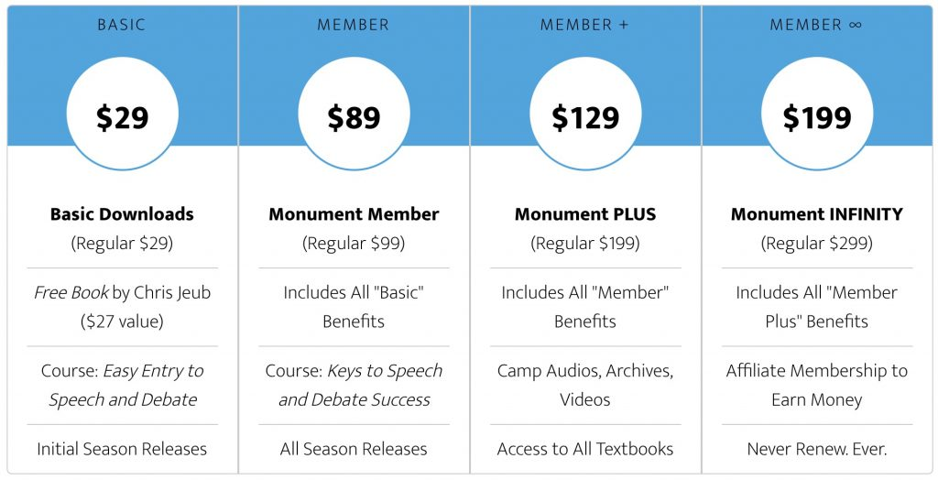

As a PLUS or INVINITY Member, you’ll have access to the rest of this course. See you next week!

Proof of Completion
(For students required to take this class for school or club.)
Assignment: Make a comment on the website for Day 1. Take a screenshot of the comment and send it to your teacher or coach as “proof of completion.”

