Video #1 of Easy Entry to the World of Speech and Debate
“Step 1: Setting Your Foundation”
Watch Video 1

EASY ENTRY TO THE WORLD OF SPEECH AND DEBATE is a compact video course designed to welcome new participants into the world of speech and debate competition…and make it “easy” to succeed at it.

Preview
These videos will be released May 25-29, available for free through June 4. After that, this video course will be a free resource within Monument Membership’s BASIC DOWNLOADS.
- VIDEO #1: Setting YOUR Foundation (Step 1)
- VIDEO #2: Schools and Leagues (Step 2)
- BONUS VIDEO: Interview with Tabitha Jeub
- VIDEO #3: Speech and Debate Events (Step 3)
- VIDEO #4: Entering Your First Tournament – And Doing Well! (Step 4)

FREE Book!
My latest book Easy Entry to the World of Speech and Debate released in March. It sells for $27 on Amazon, Monument Publishing, and my personal blog. As a registrant to this course, you get the book for FREE!
At the end of this video, I’ll show you how to get one shipped to you for free, too. No shipping cost required, either. My gift to you! But you have to stick around till the end.

Step 1 to Easy Entry
“Setting Your Foundation”
This first step is all about YOU and how you set up your understanding of speech and debate. There are biased folks who will try to persuade you to go a specific route, but that route worked for them but they may not work for you. I’m more into helping YOU set your FOUNDATION to best route the journey you’re about to embark upon.
Let me bring you back several decades to…

My Humble Beginnings
I’ll never forget the first debate round I witnessed 25 years ago. I was a young teacher shoved into a coaching position that no one else wanted, so I “shadowed” another coach from another school. I was blown away at the depth and articulation of a couple of 14-15 year old kids debating. I wanted to know what they knew! And I wanted it for my own students and my own children.
Trouble was, this was competition. The coach I shadowed was nice to have me join her, but she was hesitant to help me too much. Coaches are naturally tight-lipped about their techniques and strategies, at least the ones that really work! I needed help, my kids deserved adequate coaching, but true guidance was hard to find.
This led me on a journey that I have been on for nearly three decades. I became a gatherer, a collector, a developer of speech and debate curricula that ensured tournament wins. I figured out what I needed to know through trial-and-error, till I got to a level of excellence. My family alone has secured five title wins in two different leagues, and countless individual awards and hundreds of tournaments along the way. You should see my trophy shelf!
All winning aside, I cannot say enough about the community of speech and debate. My family has participated in several leagues over the years, and we have made friends with countless numbers of fantastic people. My family has traveled the country, coast-to-coast, meeting new people along the way. And, I’m proud to say, my kids have grown into adults with impeccable communication skills — all inherent in the community of speech and debate.
Isn’t this what you want? To join a community of excellent people, raise your children to be excellent communicators, and perhaps see the world through competitions? Of course you do, just as I did 30 years ago when I couldn’t even understand what was going on.
I was such a clueless teacher back then, and my students floundered through their speech and debate rounds with high hopes and consistent let-downs. That’s a distant memory today. I’m now fully integrated into the world of speech and debate, just as you are, too.
I want you to have the same. I want to equip you with the tools that I have developed over the last three decades. And as an added bonus, I’m going to make it incredibly EASY.

By the End of This Class
By the end of EASY ENTRY TO THE WORLD OF SPEECH AND DEBATE, you will…
- Know which leagues or organizations that will give you the best return for your time and investment.
- Know the categories of speech and debate events that are best suited to you or your students.
- Know how to sign up for your first tournament AND how to succeed in competition.
Committing to speech and debate is a big deal, especially if you have only so much educational funds at your disposal. This is all the more reason to get started with as much information as you need to make the best decisions.
And you will make decisions! Your first decisions will come in Day 2, but for now I want to bust some common myths about the world of speech and debate. Chances are you have come to believe these untruths, and they have been holding you back from success.

Why Speech and Debate Is So Important
I’m in the center of the speech and debate world, and this course is my attempt to bring you into it with me. I’m paving a clear path for you, but perhaps you are asking whether you should go down this path. You may be wondering, “Why does Jeub get so pumped over speech and debate?” Let me get personal with you as I explain why I do.
I have a large family, half of my children now adults. I am humbled when I stop and reflect at the incredible blessing speech has been for my family. All of my adult children are exceptional speakers. Others have tended to write this off as inherently a Jeub trait or something, but I don’t believe it. Some of my children have learning disabilities. One of my children, in fact, has extreme dyslexia and was not able to read till he was 15. Guess what he did? He wrote an oratory about it and qualified the speech to Nationals. He didn't debate because of his disability, but he won three titles in literary interpretation.
Speech and debate are the best extracurricular activities in which you can participate.
That’s right. The best. I used to think the written word was the best – still very important, which is why I got an English teaching degree decades ago. As I mentioned earlier, my first teaching job threw me into speech and debate. I found that these extracurricular events had it all! Critical thinking, public speaking, persuasion, rhetoric — the list of skills mastered by the speech and debate student was long. Those years of coaching in the upper Midwest taught me how to teach speech and debate activities, and the following decades launched me into publishing curriculum. I’ve literally made speech and debate my life. Why? Because...
Students who master speech and debate will master life and become the leaders our world needs.
Speech and debate changed my entire pedagogical outlook. And you know what? I believe it should change yours, too. Whether you’re a student, teacher, parent or administrator, I want you to consider:
- Students: Chase after the first-place prizes during your competitive years.
- Teachers: Award your best students and volunteer at every tournament.
- Parents: Be your kid’s #1 fan and #1 coach and #1 teacher.
- Administrators: Make sure academic speech is valued just as high (if not, higher!) than other sports.
None of the above? You can participate as a judge at tournaments, volunteer to help, and ask clubs to be a part of the training. Young people are eager to perform speeches for people who believe in them. That could be you!

Myths About Speech and Debate
I have heard plenty of excuses from competitors, educators, administrators, and parents of the myriad reasons not to get involved in speech and debate. These reasons are unfortunately used to avoid activities that could greatly benefit young people and their schools. I have answers (and nearly 30 years of examples) for these excuses. Here are some of the most common.
1. I have a speech impediment.
I have coached kids with lisps, stutters, clefts, and all sorts of speech disorders, many of them to championship level. One of my daughters had a hefty overbite before getting braces, and she had trouble speaking through the trial. She did very well in competition. In fact, parents who place their children in competitive speech events find that their children overcome their impediments, often better than therapy — expensive therapy! It makes perfect sense that it does. Those kids with speech impediments will grow with leaps and bounds when involved in speech and debate.
2. I’m shy / introverted.
Truth be known, I believe the best speakers and debaters are introverts. They get into research and analysis. “Shy” is a negative connotation to healthy retrospection and usually deep thinking. Quiet people actually appreciate the structured speech and debate atmosphere, and they often overcome any dysfunctional “shyness” as they prepare to speak. Shy or introverted kids typically excel in speech and debate.
3. I’m too cool.
My heavens, this was my excuse growing up. I regret thinking I was “too cool” to participate because I would have truly enjoyed the community of speakers and debaters as an adolescent. Think about it. Club meetings are places where young people lift up and encourage one another to engage in what most people believe to be the scariest activity in life: public speaking. Naturally, the friendships that form are the strongest of bonds. Perhaps looking in from the outside does make us look a little “uncool,” but we’re having the time of our lives. To me, that’s pretty darn cool.
4. I’m more into sports.
And what do you suppose speech and debate is? It's a competition of the mind, the best sort of sport. Besides, the two usually aren’t exclusive of one another. I’ve had football players, wrestlers, golfers, boxers, and many other athletes on my team. Late-winter and spring sports often get in the way of competitions, but they are usually manageable to the committed speaker and debater. Sports and forensics are mutually supportive.
5. I don’t like to argue.
Perhaps debate isn’t for you, but literary interps and oratories are wonderful opportunities. I’ll get to that soon, but let it be known here: there is something for everyone in speech and debate. But I wonder if you know what a true “argument” is? It isn’t a shouting match or people screaming at each other. It is sound, reasonable discussion that leads to a resolution. Who wouldn’t want that? If anything, speech and debate helps make you the “smart” person in any conflict, giving you the skills necessary to communicate and influence others. “Argumentation” is a necessary development of proper thinking that everyone should master.
6. Speech and debate is hard.
Yes, it is, just as any new activity is. I’ve got plenty of pointers in making it EASY (that’s the name of this book, isn’t it?), but step back a second and ask yourself, “Is there anything worth doing that is easy?” Admit it: The best things in life take some hard-to-earn effort. Just wait till you win your first trophy, you’ll see. When you walk across the stage being applauded for your hard work and dedication, you’ll fall in love with speech and debate. And that will make you work even harder!
Like I said, speech and debate has something for every young person. The myths some people cling to are just plain wrong. The last myth should blow them all away and pave the path to successful speech and debate competition:
7. I don’t know how to do speech and debate.
This excuse is forever behind you. You’ve got this book! Easy Entry lays out the path to successful participation in speech and debate. Let’s now venture into the details you need to know to easily enter the wonderful world of speech and debate. The rest of the book will essentially show you exactly how to “do it,” and you’ll learn how to do it well.
Let’s get started!

Freebie (time-sensitive)!
Get a Book for FREE
Want to get a book sent to you for free? No postage necessary, either. All you need to do is post on this Video #1’s web page in the comment section. Introduce yourself! You can say whatever you want. Consider these ideas:
- Share about your experience with speech and debate.
- Tell us what events you plan to participate this year.
- Let us know what you think of the idea of “structure and strategy.”
- Etc.
Here are some examples from one of my other courses. And notice that I responded to some who had really good questions:
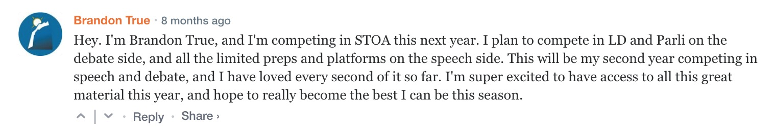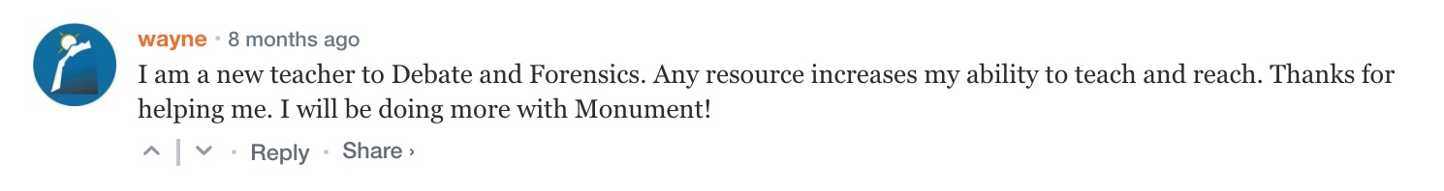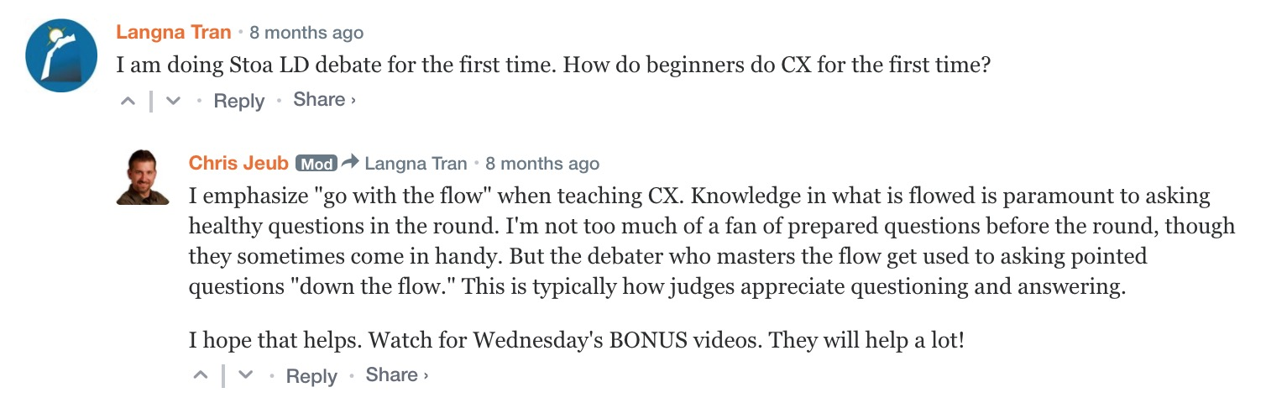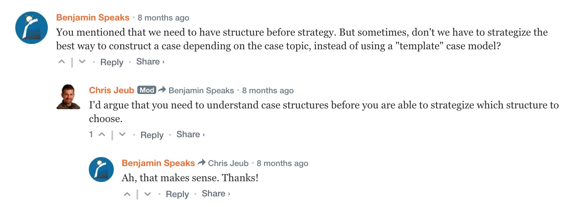
This is time sensitive: Comments must be made by 5:00 AM on Tuesday, May 26, 2020. Comments will still be allowed following this deal, but they won’t receive the free book.

Proof of Completion
(For students required to take this class for school or club.)
Assignment: Make a comment on the website for Day 1. Model the examples above. Take a screenshot of the comment and send it to your teacher or coach as “proof of completion.”

