At the Back of the North Wind
Source Material of a Champion Open Interpretation
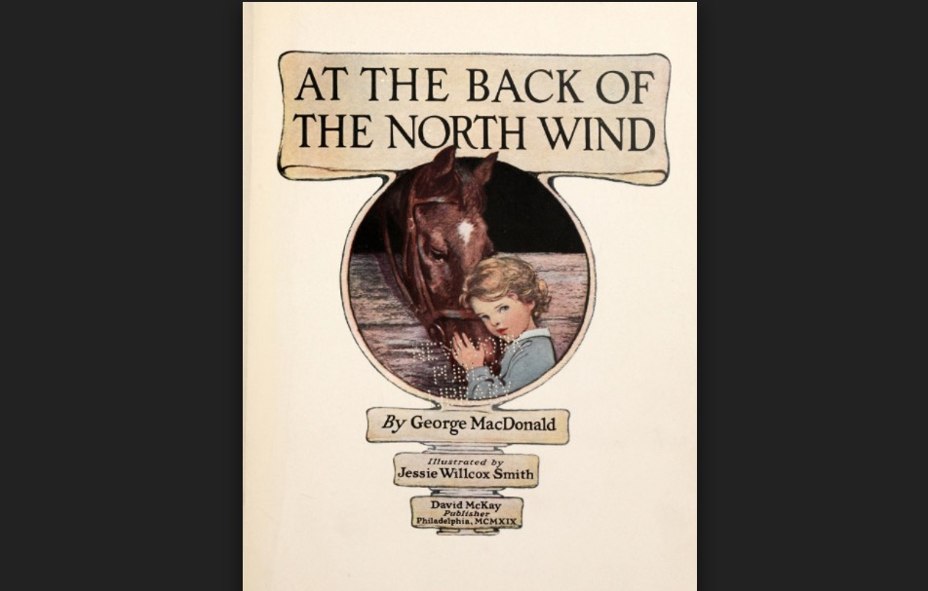
September 2, 2019
This speech was performed by Karlyn Leander as an Open Interpretation. She took 1st place at almost every Colorado tournament and made it to the Semifinal round at Stoa’s National Invitational Tournament of Champions. She finished the season by being ranked 1st in Colorado on Speechranks.
Stoa explains OI in this way on their website https://stoausa.org/speech-events/
In Open Interpretation selections may be in the whole range from dramatic to humorous genres, including narrative storytelling, single voice monologues, thematic compilations, or self-written pieces.

Directions: Use this source material to enhance your understanding of Open. This speech is an excellent example of champion speaking. You may want to consider doing this event in Season 20.
At the Back of the North Wind
by Karlyn Leander

Keys to Characterization
If you are reading this article right now you are one of two kinds of speakers. You are either a bright-eyed, bushy-tailed beginner or a seasoned and battle-scarred veteran (okay, perhaps somewhere in between). Either way, you are here to improve your interp game and I can assure you that you have come to the right place. My fellow bronze book writers and I are experienced in the ways of the judge and knowledgeable of the heart of the spectator. We who pen these pages have wisdom to pass on to you. However, that is not to say we know everything. Every speaker interprets their experiences slightly differently. If we suggest a method, please know that it isn’t the only way to be successful in reaching your goals. You can take or leave any of it but keep in mind that it has worked for us and it might just be the thing for you. With that said, I will endeavor to pass on what I have acquired during my five years of competition and I hope, with the addition of your own experience, it will help you to grow as a speaker and actor.
I specifically want to help you hone your powers of characterization. Strong characters will make or break a piece. This chapter will take you through some of the basic forms and elements of developing a character and explore the more advanced theories and techniques of truly engaging your audience. So, without further ado…

How to Create an Amazing Character
Start with what you know.
Let’s go back to the very beginning. Look first to your script: your character should fit your story. Keep in mind the details provided. If you are planning on trying a story such as “The Many Adventures of Peter Rabbit” there are a few non-negotiables implied in the title. First, your main character is a rabbit, not a human. Therefore, he most likely does not jog or walk or cock his hips to the side. He is a rabbit and hops like one. There are many subtle but effective ways to physically suggest “rabbitness.” Once you have a good idea of the clues found in your script, flesh them out with extra detail. Peter has a coat but how does it fit him? Is it too big? Does it have pockets? Does it make him trip when he hops? These details can add a tremendous strength to your characters. They provide humor or astonishing realism to any character.
Take a moment to read through your script and write down everything that implies physical appearance or behavior, and then brainstorm ways of putting it in your blocking.
Fact | Is a rabbit | Wears a coat | Has large feet
Interpretation | - Hops  - Holds hands in front  - Twitches nose  - Large round eyes | - Fiddles with buttons  - Pushes up sleeves | - Thumps ground  - Scratches ears
These details are the building blocks of a great character. They become your “props” and “costume.” Play with them. Use any subtleties that might improve the illusion and make your characters more life-like.
A Quick Thought…
Irony is one form of humor, but its antithesis is also very effective. Exaggerating the stereotypes gives the viewer something they can relate to. Keep in mind however that some people could be offended by certain portrayals. We should always be considerate of others.

Take apart what you know
So far you have physically created your character. You’ve taken what you can from your cutting and fleshed out the details. Your audience will have a feel for your character, and you should too. It might be beneficial to touch on a very common use of humor: irony. A great example of one of the most adorably ironic characters is the hulking evil henchman Kronk from the Emperor's New Groove. We witness his moral struggle over his job, his tender heart, and his passion for cooking. While irony can be an effective form of humor, beware of overusing it. It can become obnoxious if not done in taste; it is always more important to be appealing to your judges than to push a joke too far.

Developing Your Amazing Character (Into An Even More Amazing Character)
You now have a script and some very intricately designed characters. It is now time to make these characters real, as if they could be your friends. One might carry on an intelligent conversation and exchange ideas and feelings with them. It is now time …to develop their SOUL! Cue scary music.

What makes a good character?
- Likable. Your Judges need to be on your character’s side, rooting for him to win! Even an antihero can be lovable.
- Identifiable. When a character reminds us of ourselves we are able to commiserate with him. From losing a loved one to stubbing your tow, if the judge has some personal experience relating to your character, it will make him all the more memorable.
- Complex Emotions. While I am a huge fan of Dr. Seuss and Winnie the Pooh, there is a distinct advantage gained by having a complex piece with complex emotions. My OI featured a character whose two natures were constantly bumping into each other. On one hand, she was a loving maternal, angel while on the other a fierce messenger of death. There were many times when I had to show both of these extremes at once, which drove home the deep philosophical nature of the piece.
Now look back to the method we used when creating the character: take what’s already in the script and build on that.
- First, we need to know the character’s situation. What trials must he endure? Is a giant snowstorm trapping him underground? Did his pants catch on fire? Did he lose the buttons on his jacket?
- Now taking everything you know about your character into account, decide his response to each event. Is John a brave person who has no qualms about miniature snow-filled tunnels? Has the man had some past experience with heat that might make him more susceptible to hysteria? Perhaps Peter is very vain and he is upset about his buttons. Often evidence of the reaction to the problem is already provided by the script. This step is not limited to the big, obvious climaxes of the story. Everything the character says and does is based on a reaction to something. Take the time to figure out what that reaction is and use it to paint the most vivid and mind-capturing story.
- Lastly, you need to diversify and expound on the emotions you have created. Here's an easy exercise: say the phrase "I will go to the store.” Now say it like this: "I will go to the store.” Continue to say the same phrase but accent different words. It changes the meaning, doesn't it? This little game is a great way to explore the different possibilities of inflection and emotion. It will show you new ways of approaching your script. Try to use it when you are discovering your character for the first time or when you need to freshen up your delivery.

Stepping into Your Character
Now that you have a well-presented and sophisticated character you have to get inside his/her head. It’s time for you to take what you know and what you have created and make them personal to you. I like to call this step “acting.”
We’ve all heard some director or actor boast about the way they “dive deep into the psyche of a character.” They literally become the role they are portraying. While it can sound a little silly, this acting technique really brings the duo alive. The best preparation for acting that I’ve ever had was all the hours of prancing about the back yard pretending to be Indians, dragons, and fairies with my friends. A child at play is a great actor because they get lost in the story they have created. They have no inhibitions holding them back from complete engagement with their character. Before I even began speech and debate, I had already given hundreds of interps. You shouldn’t necessarily get down on your hands and knees and gallop around the house screaming “HI HO SILVER!!!!” But you should learn from the ways of the wise, in this case, children. So what exactly can we learn from the days of our youth?
Completely abandon your sense of dignity. If you are too embarrassed to act like a bunny in front of people, your judges will also be disengaged. We all feel too cool to truly get into character, but as soon as you step outside of your comfort zone you will light up like a Christmas tree! As you relax, so will your judges and soon you’ll be having just as much fun as a kid.
Make it real. As a kid, lost in your own imagination, you knew exactly how to make the most dramatic scenes. For me, the climax of horror was the scene in which Mia (that was the name I always used) watched her beloved blankie drift down the stream, never to be seen again! I could literally make myself cry by replaying that scene over and over again. The point is, it was real to me! I connected to the real emotions I would feel if such tragedy had actually happened.
Like your characters. This is a great thing to take into consideration when you are choosing a piece. If you don’t like your characters, neither will your judges. That’s why I always, always was a cat when I played pretend! For example: a cat (probably named Mia) was my ideal character. Your characters don’t always need to be the ultimate superhero, with the power to do anything or. However, if it’s at all possible for you to be friends with your characters, your speech will be all the more enjoyable (for you and your judges).

How to Make Yourself Cry…
There are three main techniques to making yourself cry appropriately. 1. You can spray lemon juice in your eyes (not recommended). 2. Take some time before your round to think of a time in your life in which you were in a similar situation to that of your character. Use this memory to fuel your tears. Keep in mind that both of these techniques can be needlessly painful. That’s why I prefer 3. Recreate the physical posture of crying. For instance, you could wrinkle your nose or force the air from your lungs or contract your core and double over. Mirror whatever actions you take when you really cry, and it will almost always produce tears.
Next, consider some techniques of authentic emotion. “Inner dialogue” is a great way to follow the logical train of reaction that has been drilled in my head by every drama teacher I’ve ever had. To fully engage your character, you must be thinking their thoughts. If you spoke them out loud it might sound like this: “Oh, what a lovely day in the woods! I love the smell of the flowers! What was that rustling sound? Oh no! It’s a big bad woof! He’s gonna eat me! I must run away! AAAAAAAH!” You get the picture. It sounds a little silly, but if you show each subtle change on your face, it creates a more believable presentation. Inner dialogues can be scripted or unscripted, continuous or situational depending on what you are most comfortable with. Unscripted dialogue gives a great amount of freedom to change the feel of the piece while staying within the bounds of common sense.
And there you have it folks! I hope each of you feel better equipped to create, develop, and present the most realistic, personable character you possibly can.

