Video #2 of Keys to Speech and Debate Success
“The Practical Key”
Watch Video 2

KEYS TO SPEECH AND DEBATE SUCCESS is a compact video course designed to prepare you for a successful speech and debate season.

Last Video
The Key shared yesterday: “Structure first, then Strategy.” If you haven’t seen that video, it is foundational. Watch Video 1 here.

Key #2: The Practical
“Study the Methods.”
I’m a school teacher with a bachelors degree in education, so I can “nerd out” on teaching methodologies. A “methodology” is basically a process that someone has developed that YOU can follow. Don’t enter speech and debate thinking you’re awesome; instead, study the masters and figure out the “methods” they used to become champions.
I’m going to teach you THREE methods that prove extremely useful in speech and debate competition.

Method #1: The S.C.O.R.R.E. Method
SCORRE is an acronym based on the methodology developed by Ken Davis, a comedian and friend of the work I do for speakers and debaters (he was a high school speech competitor years ago). See ScorreConference.tv for more information. The method is as follows:
- S = Subject. Every speech needs to narrow down to a specific subject.
- C = Central Theme. Take your subject and narrow it down even further.
- O = Objective. The heart of your speech, a strong statement of objective.
- R = Rationale. The steps or processes to fulfilling the objective.
- R = Resources. The evidence, statistics, research, etc. to your rationale.
- E = Evaluation. The process of going back and tweaking the SCORRE steps.
The SCORRE method can be applied to any speech, including oratory, extemp, apologetics, impromptu, even some debate speeches. I apply SCORRE to all my communications (books, articles, blog posts, even emails).

Method #2: The Flowing Method
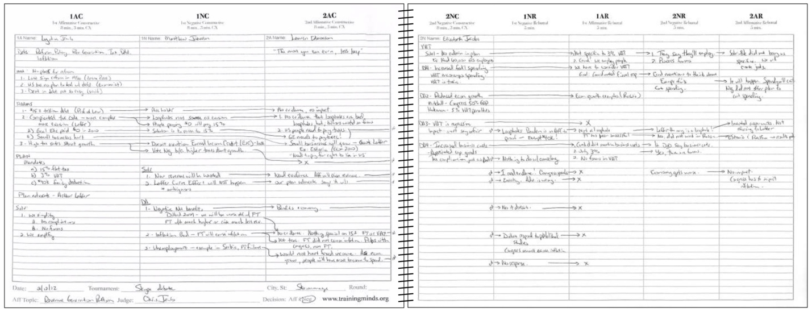
Here’s a picture of one of my flows. Looks like a chaotic mess, doesn’t it? But there is a “method to the madness” (a methodology!) that helps every debater become a master debater.
Every debate format has a “structure” to it, and the champions study this structure and make it their responsibility to copy the structure. Let’s take policy debate as an example:
- First Affirmative Constructive: The first column is for writing the affirmative case. Cases will vary, but you will likely list definitions, criteria, inherency, harms, plan, and advantages.
- First Negative Constructive: The negative team will likely attack case specifics. Draw arrows to the affirmative case sections he/she attacks.
- 2nd Affirmative Constructive: Like the negative, the affirmative will want to defend the attacks made in the 1NC.
- 2nd Negative Constructive: Neg will run disads to the affirmative plan and may extend some arguments from the 2AC.
- First Negative Rebuttal: The negative will likely return to on-case arguments made in the 2AC.
- First Affirmative Rebuttal: The 1A has a lot of ground to cover in five minutes. Attacks 2NC and 1NR arguments.
- 2nd Negative Rebuttal: Defends the attacks in the 1AR and reaffirms the key voting issues the negative is claiming to win.
- 2nd Affirmative Rebuttal: Crystalizes why the affirmative ballot is justified. Defends plan and makes case for a win.
If you have not been flowing your debate rounds, this is the reason you are not winning. And if you are a coach, you should make your flow absolutely paramount in everything you teach.

NEXT: Bonus + Strategic Key!
We will take a break from the 4-video course to release some bonuses tomorrow, followed by the STRATEGIC KEY, a most overlooked key that has been so successful that fellow coaches have claimed I’m almost cheating. This key is the way champion speakers and debaters establish a winning record.

Freebie (time-sensitive)!
Get Library Access to Flowing Videos
Part of our advanced membership includes a video library of resources. Three videos specifically cover the flowing method for three different debate formats (Lincoln-Douglas, Policy, and Public Forum), plus one that covers all sorts of strategies on flowing in general. I have officially made these videos part of KEYS TO SPEECH AND DEBATE SUCCESS. Dig deeper and study up! These videos are accessible from Monument Members Club Page.
This is time sensitive: Access will expire on May 11 when this course goes away. Thereafter, access will only be allowed for Monument PLUS members.

Proof of Completion
(For students required to take this class for school or club.)
Assignment: Visit one of the flowing videos highlighted above. Take a screenshot of one of the pages you now have access to, perhaps the debate format that you will be competing in Season 21. Send your screenshot to your teacher or coach as “proof of completion.”

