Video #1 of Keys to Speech and Debate Success
“The Foundational Key”
Watch Video 1

About Chris Jeub
I’m a teacher and writer. Have been since 1993. I have had the honor and privilege of coaching countless hundreds (maybe thousands?) of students through my personal coaching, my camps, and the curriculum I publish. Several have become national champions in their events, and some even my own children. This course distills down my decades of experience into basic, foundational KEYS TO SPEECH AND DEBATE SUCCESS.
Those who apply the KEYS TO SPEECH AND DEBATE SUCCESS set themselves up for scholarships, careers, etc. and do great things in life.

About KEYS TO SPEECH AND DEBATE SUCCESS
KEYS TO SPEECH AND DEBATE SUCCESS is a compact video course designed to prepare you for a successful speech and debate season.
These are BASIC FUNDAMENTALS that are MOSTLY OVERLOOKED.
You are likely two types of speaker/debater:
- You are brand new and are scared to death. This course is for you!
- You are experienced, but you aren’t experiencing the success you desire. This course is for you, too!
Ultimately, these four videos help start your year off RIGHT.
Logistics for the Course:
- I’m going fast! So download the handout (LEARN!)
- Make comments on the page (PARTICIPATE!)
- Win free resources (HAVE FUN!)

Key #1: The Foundation
“Structure first, then strategy.”
Structure = “rules of the game.” Understanding the structure of the game of speech and debate should be paramount to learning. Doing this inversed (strategy first, then structure) will lead to frustration and burnout. Clubs and schools that teach strategy first will be small and likely underfunded.
Strategy = “modeling the champions.” Those who end up in the top tier of competitors apply specific tactics and practices to win every round. This must follow a clear understanding of the structure of speech and debate (which you may not have learned correctly).
This KEY TO SPEECH AND DEBATE SUCCESS models “structure and style,” a professional curriculum for writers. All source material published at MONUMENT follows this model as “structure and strategy.”
What does this mean for you? It means you must master the basic foundations of the event you compete, and then study those who mastered the event before you.

Freebie (time-sensitive)!
Get a Book for FREE
My latest book Easy Entry to the World of Speech and Debate released in March. It sells for $27 on Amazon, Monument Publishing, and my personal blog. I want to send all my students one for FREE! No shipping required, either. My gift to you!
One thing you must do: Post on this Key #1’s web page in the comment section. Introduce yourself! You can say whatever you want. Consider these ideas:
- Share about your experience with speech and debate.
- Tell us what events you plan to participate this year.
- Let us know what you think of the idea of “structure and strategy.”
- Etc.
Here are some examples from last year that you can model after, and notice that I responded to some who had really good questions:
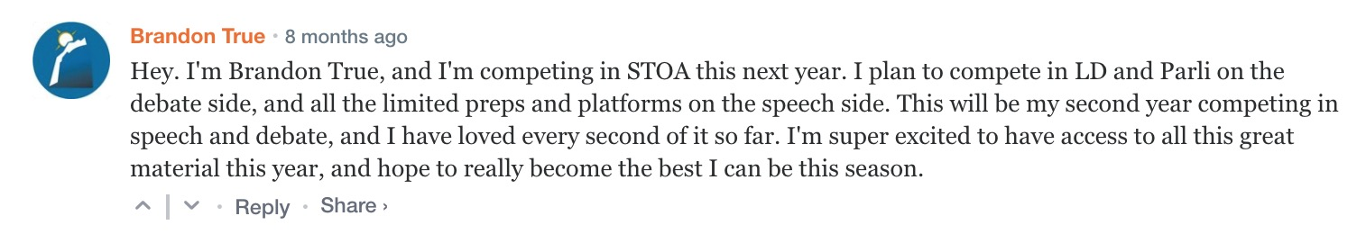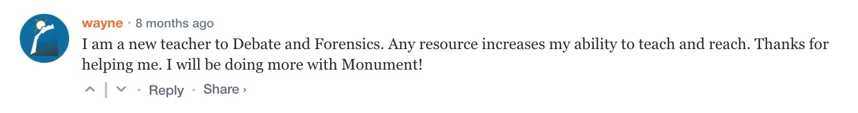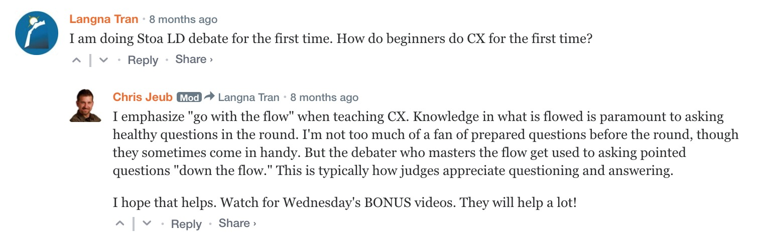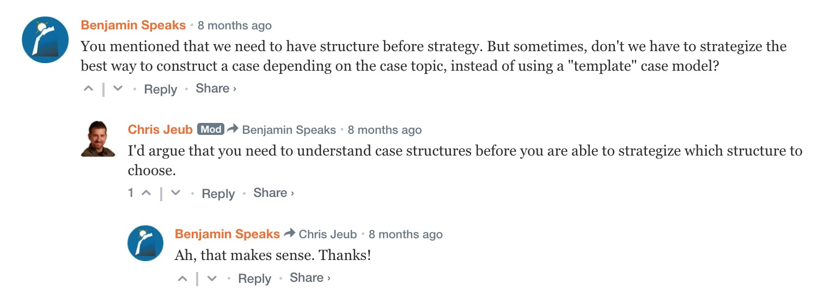
This is time sensitive: Comments must be made by 5:00 AM on Tuesday, April 28, 2020. Comments will still be allowed following this deal, but they won’t receive the free book.

Proof of Completion
(For students required to take this class for school or club.)
Assignment: Make a comment on the website for Day 1. Model the examples above. Take a screenshot of the comment and send it to your teacher or coach as “proof of completion.”

